INTEGRATIVE CAPSTONE PROJECT
Customer Churn Prediction and Segmentation
An end-to-end Data Science pipeline in Python: acquisition, cleaning, EDA, supervised and unsupervised modelling, evaluation and recommendations
Data Science with Python Internship | Week 6 Final Task
Prepared by: Minuku Chethan Sai
September 2026

Contents
1. Problem Statement
2. Methodological Approach
3. Data Collection
4. Data Cleaning and Feature Engineering
5. Exploratory Data Analysis
6. Modelling (Supervised and Unsupervised)
7. Evaluation of Results
8. Insights and Recommendations
9. Reflection: Challenges and Successes
10. Further Work and Conclusion
Appendix A: Complete Python Code
Appendix B: References

Executive Summary
This project applies the full data science workflow to a real business problem: customer churn at a telecommunications provider. Using the publicly available IBM Telco Customer Churn dataset (7,043 customers, 21 raw columns), I cleaned the data, explored it visually, trained and compared three supervised classifiers, tuned the best one, and used K-Means clustering to segment the customer base.
Overall 26.54% of customers churned. The strongest drivers were month-to-month contracts (42.7% churn versus 2.8% on two-year contracts), short tenure, fibre-optic internet, electronic-check payment and lack of tech support. The tuned Gradient Boosting model reached a test ROC-AUC of 0.8449. After adjusting the decision threshold to 0.322, it identified 73.8% of churners (recall) with 55.5% precision. K-Means produced four interpretable segments whose churn rates range from 4% to 43%, which supports targeted retention actions.

1. Problem Statement
Acquiring a new telecom customer is generally far more expensive than retaining an existing one, so an operator that can predict who is about to leave, and understand why, can spend its retention budget where it matters most. The business question addressed here is:
Which customers are most likely to churn, what characteristics drive that behaviour, and how can the customer base be grouped so that retention actions can be targeted?

1.1 Objectives
- Descriptive: understand which customer, service and billing attributes are associated with churn.
- Predictive (supervised): build a binary classifier that estimates the probability that a customer churns.
- Segmentation (unsupervised): group customers into behaviourally distinct segments using clustering.
- Prescriptive: translate the findings into concrete, prioritised retention recommendations.

1.2 Success Criteria
A model is considered useful if it achieves a test ROC-AUC above 0.80 and can be tuned to catch a large share of churners (high recall) while keeping precision at a level that makes outreach economical. Because only about one customer in four churns, plain accuracy is not an adequate yardstick: a model that predicts "nobody churns" would already score 73.5% accuracy.

2. Methodological Approach
The project follows a standard, reproducible pipeline. Each stage is implemented in Python and the same random seed (42) is used throughout.
Stage | What was done | Main tools
1. Acquisition | Downloaded public CSV from GitHub; inspected shape and types | pandas
2. Cleaning | Fixed data types, handled blanks, removed identifiers, encoded target | pandas, numpy
3. Feature engineering | Created NumAddOns and AvgMonthlySpend | pandas
4. EDA | Distributions, churn rates by category, correlations | matplotlib, seaborn
5. Supervised modelling | Logistic Regression, Random Forest, Gradient Boosting; CV; grid search; threshold tuning | scikit-learn
6. Unsupervised modelling | K-Means with elbow and silhouette selection; PCA for visualisation | scikit-learn
7. Evaluation | Accuracy, precision, recall, F1, ROC-AUC, confusion matrix, feature importance | scikit-learn
8. Recommendations | Business actions per driver and per segment | n/a

Two design decisions protect the validity of the results. First, the data is split into training (80%) and test (20%) sets before any model fitting, using stratification so both parts keep the 26.5% churn rate. Second, all preprocessing (scaling and one-hot encoding) lives inside a scikit-learn `Pipeline`, so it is fitted only on training folds and no information leaks from the test set.

3. Data Collection
The data is the Telco Customer Churn sample dataset published by IBM and hosted in a public GitHub repository. It contains one row per customer of a fictional telecommunications company offering phone and internet services. The file has 7,043 rows and 21 columns.
Group | Columns
Identifier | customerID (unique, dropped before modelling)
Demographics | gender, SeniorCitizen, Partner, Dependents
Account | tenure (months), Contract, PaperlessBilling, PaymentMethod
Services | PhoneService, MultipleLines, InternetService, OnlineSecurity, OnlineBackup, DeviceProtection, TechSupport, StreamingTV, StreamingMovies
Charges | MonthlyCharges, TotalCharges
Target | Churn (Yes / No)

Code 1: Data acquisition
URL = ("https://raw.githubusercontent.com/IBM/telco-customer-churn-on-icp4d/"
"master/data/Telco-Customer-Churn.csv")
df = pd.read_csv("telco.csv") # downloaded from URL above
RES["shape_raw"] = list(df.shape)
RES["dtypes_object"] = int((df.dtypes == "object").sum())

4. Data Cleaning and Feature Engineering

4.1 Quality Checks and Fixes
- Hidden missing values. `TotalCharges` was read as text because it contained blank strings. Converting it to numeric revealed 11 missing values. All 11 belong to customers with tenure = 0, i.e. new customers who have not yet been billed, so the correct value is 0 rather than an imputed mean.
- Duplicates. 0 duplicate rows and 0 duplicate customer IDs were found.
- Identifier removed. `customerID` carries no predictive information and would only add noise.
- Target encoded. Churn was converted to 1 (Yes) and 0 (No).
- Consistency. `SeniorCitizen` (0/1) was mapped to No/Yes so that it is treated like the other categorical features.
- Categories such as "No internet service" and "No phone service" were deliberately kept, because they describe a distinct customer situation.

4.2 Feature Engineering
- NumAddOns: count of subscribed add-on services (security, backup, device protection, tech support, streaming TV, streaming movies).
- AvgMonthlySpend: TotalCharges divided by tenure. In hindsight this is almost identical to MonthlyCharges (correlation with churn 0.193 for both), so it adds little new information.
- TenureGroup: tenure bands (0-12, 13-24, 25-48, 49-72 months) created for optional group-level reporting and excluded from the model to avoid duplicating tenure.
Code 2: Cleaning and feature engineering
df["TotalCharges"] = pd.to_numeric(df["TotalCharges"], errors="coerce")
RES["missing_total_charges"] = int(df["TotalCharges"].isna().sum())
RES["missing_tenure_of_those"] = df.loc[df["TotalCharges"].isna(), "tenure"].tolist()
df["TotalCharges"] = df["TotalCharges"].fillna(0)
RES["duplicates"] = int(df.duplicated().sum())
RES["dup_ids"] = int(df["customerID"].duplicated().sum())
df = df.drop(columns="customerID")
df["Churn"] = (df["Churn"] == "Yes").astype(int)
df["SeniorCitizen"] = df["SeniorCitizen"].map({0: "No", 1: "Yes"})
RES["churn_rate"] = round(df["Churn"].mean() * 100, 2)
RES["churn_counts"] = df["Churn"].value_counts().to_dict()

# Feature engineering
svc = ["OnlineSecurity", "OnlineBackup", "DeviceProtection", "TechSupport", "StreamingTV", "StreamingMovies"]
df["NumAddOns"] = (df[svc] == "Yes").sum(axis=1)
df["AvgMonthlySpend"] = np.where(df["tenure"] > 0, df["TotalCharges"] / df["tenure"], df["MonthlyCharges"])
df["TenureGroup"] = pd.cut(df["tenure"], [-1, 12, 24, 48, 72], labels=["0-12", "13-24", "25-48", "49-72"])
RES["shape_clean"] = list(df.shape)
RES["describe"] = df[["tenure", "MonthlyCharges", "TotalCharges"]].describe().round(2).to_dict()

After cleaning, the dataset has 7,043 rows and 23 columns (including the engineered features and target).

5. Exploratory Data Analysis

5.1 Target Distribution
Of 7,043 customers, 1,869 churned (26.54%) and 5,174 stayed. The classes are moderately imbalanced, which is why stratified splitting, class weights and recall/precision/AUC are used later instead of accuracy alone.
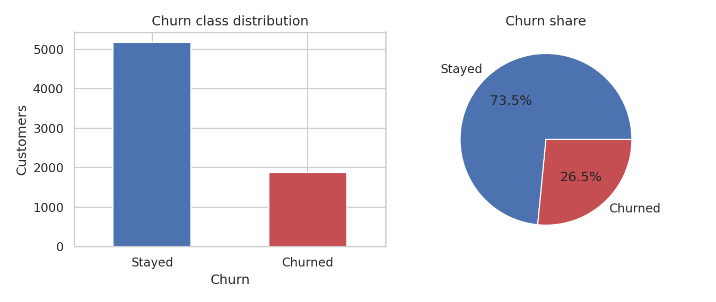
Figure 1: Distribution of the target variable

5.2 Numerical Features
Churners have far shorter relationships with the company (mean tenure 17.98 months versus 37.57 for loyal customers) and pay higher monthly bills (74.44 versus 61.27). They also subscribe to fewer add-on services on average (1.77 versus 2.14). Tenure has the strongest linear relationship with churn (r = -0.352).
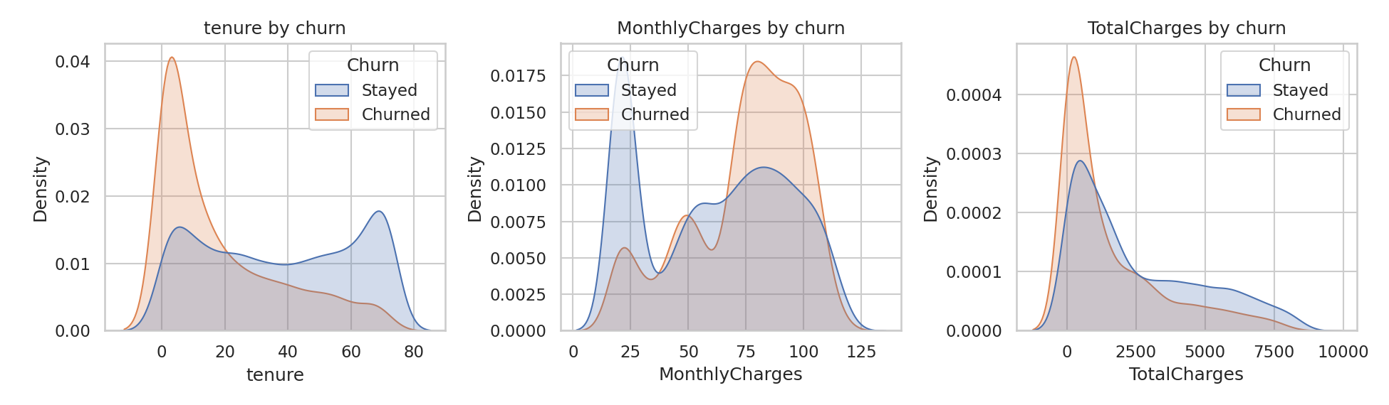
Figure 2: Density of tenure, monthly charges and total charges by churn status
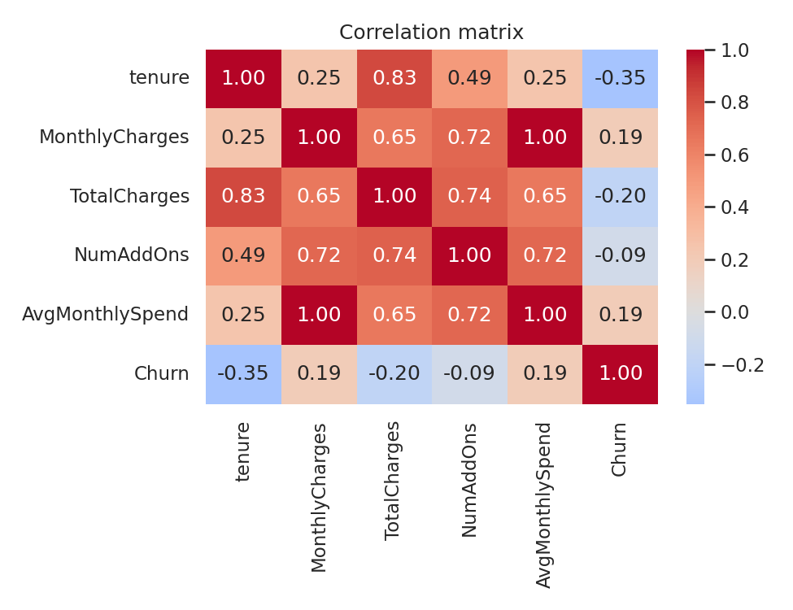
Figure 3: Correlation matrix of numerical features and churn
TotalCharges is strongly correlated with tenure (it is roughly tenure multiplied by monthly charge), and AvgMonthlySpend mirrors MonthlyCharges. Such collinearity does not harm tree-based models much but affects the interpretation of linear coefficients, which is discussed in Section 7.

5.3 Categorical Features
Code 3: Churn rate by categorical feature
cats = ["Contract", "InternetService", "PaymentMethod", "TechSupport", "PaperlessBilling", "SeniorCitizen"]
fig, axes = plt.subplots(2, 3, figsize=(13, 7))
churn_by = {}
for a, c in zip(axes.ravel(), cats):
r = df.groupby(c)["Churn"].mean().mul(100).sort_values(ascending=False)
churn_by[c] = r.round(1).to_dict()
sns.barplot(x=r.values, y=r.index, ax=a, color="#C44E52")
a.set_title(f"Churn % by {c}"); a.set_xlabel("Churn rate (%)"); a.set_ylabel("")
for i, v in enumerate(r.values):
a.text(v + 0.5, i, f"{v:.1f}", va="center", fontsize=8)
plt.tight_layout(); plt.savefig(FIG + "eda_categorical.png", dpi=150); plt.close()

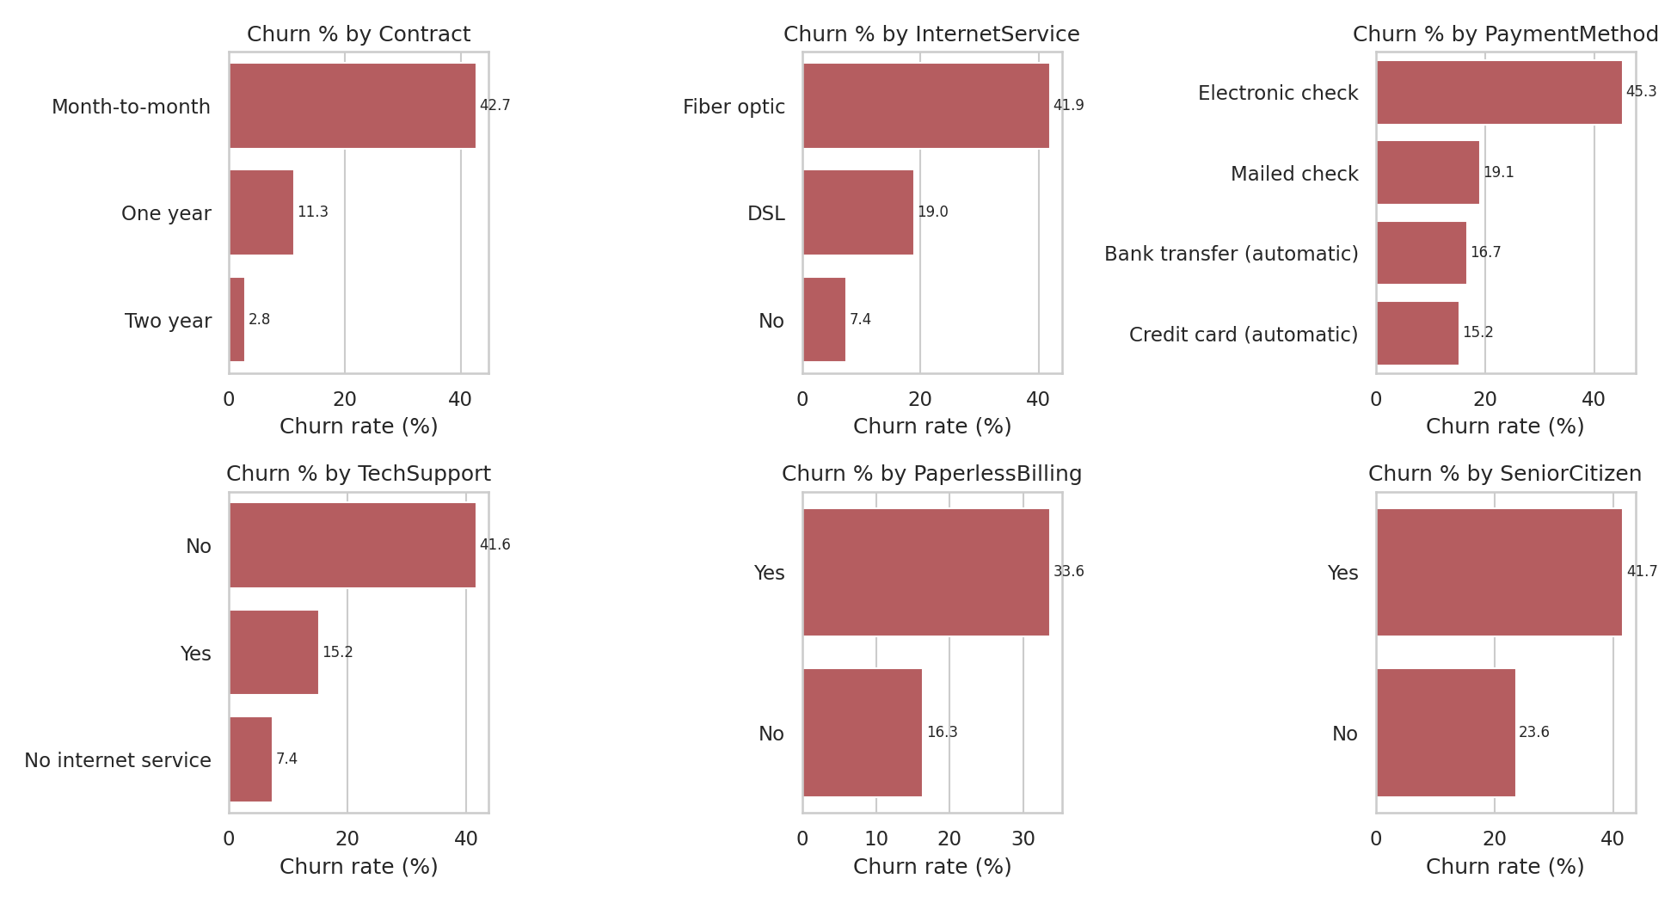
Figure 4: Churn rate (%) by key categorical features
Key observations:
- Contract type is the most powerful separator: 42.7% churn on month-to-month plans, 11.3% on one-year and only 2.8% on two-year contracts.
- Internet service: fibre-optic customers churn at 41.9%, more than double DSL (19%). Customers without internet churn least (7.4%).
- Payment method: electronic-check payers churn at 45.3%, versus 15.2-19.1% for other methods.
- Tech support: customers without it churn at 41.6% compared with 15.2% for those who have it.
- Paperless billing (33.6% vs 16.3%) and senior citizens (41.7% vs 23.6%) also show elevated churn.
These are associations, not proof of causation. For example, fibre customers may churn because of price, competition or service quality, and the data cannot separate these explanations.

6. Modelling

6.1 Supervised Learning: Churn Classification
The problem is binary classification. The data was split 80/20 with stratification (5,634 training rows, 1,409 test rows). Numerical features (5) were standardised and categorical features (16) were one-hot encoded inside a `ColumnTransformer`. Three models of increasing flexibility were compared, each with class weighting where supported to compensate for the imbalance:
- Logistic Regression: a transparent linear baseline.
- Random Forest: a bagged ensemble of decision trees that captures non-linear effects and interactions.
- Gradient Boosting: a sequential ensemble that fits each tree to the errors of the previous ones.
Code 4: Preprocessing, split and model comparison with 5-fold cross-validation
X, y = df.drop(columns=["Churn", "TenureGroup"]), df["Churn"]
num_cols = X.select_dtypes(include="number").columns.tolist()
cat_cols = X.select_dtypes(exclude="number").columns.tolist()
RES["num_cols"], RES["n_cat_cols"] = num_cols, len(cat_cols)
pre = ColumnTransformer([("num", StandardScaler(), num_cols),
("cat", OneHotEncoder(handle_unknown="ignore"), cat_cols)])
Xtr, Xte, ytr, yte = train_test_split(X, y, test_size=0.2, stratify=y, random_state=RS)
RES["split"] = [len(Xtr), len(Xte)]

models = {
"Logistic Regression": LogisticRegression(max_iter=1000, class_weight="balanced", random_state=RS),
"Random Forest": RandomForestClassifier(n_estimators=300, min_samples_leaf=5, class_weight="balanced", random_state=RS, n_jobs=-1),
"Gradient Boosting": GradientBoostingClassifier(random_state=RS),
}
skf = StratifiedKFold(5, shuffle=True, random_state=RS)
fitted, rows, probs = {}, [], {}
for n, m in models.items():
p = Pipeline([("pre", pre), ("clf", m)])
cv = cross_val_score(p, Xtr, ytr, cv=skf, scoring="roc_auc").mean()
p.fit(Xtr, ytr); fitted[n] = p
pr = p.predict_proba(Xte)[:, 1]; probs[n] = pr; pd_ = (pr >= 0.5).astype(int)
rows.append(dict(Model=n, CV_AUC=round(cv, 4), Accuracy=round(accuracy_score(yte, pd_), 4),
Precision=round(precision_score(yte, pd_), 4), Recall=round(recall_score(yte, pd_), 4),
F1=round(f1_score(yte, pd_), 4), ROC_AUC=round(roc_auc_score(yte, pr), 4)))

6.2 Hyperparameter Tuning and Threshold Selection
Gradient Boosting had the best cross-validated AUC, so it was tuned with a grid search over learning rate, number of trees and tree depth (5-fold stratified CV, scoring on ROC-AUC). The best configuration was learning rate 0.05, max depth 3 and 100 trees, with a cross-validated AUC of 0.8498.
By default a classifier flags a customer as a churner when the predicted probability is at least 0.50. With a minority class this is usually too conservative. I therefore chose the threshold that maximises F1 on out-of-fold predictions from the training set (not the test set, to avoid optimistic bias). This gave a threshold of 0.322.
Code 5: Grid search and threshold tuning
# hyper-parameter tuning on best (small grid)
from sklearn.model_selection import GridSearchCV
grid = {"clf__learning_rate": [0.03, 0.05, 0.1], "clf__n_estimators": [100, 200], "clf__max_depth": [2, 3]}
gs = GridSearchCV(Pipeline([("pre", pre), ("clf", GradientBoostingClassifier(random_state=RS))]),
grid, cv=skf, scoring="roc_auc", n_jobs=-1).fit(Xtr, ytr)
RES["gs_best_params"] = {k.replace("clf__", ""): v for k, v in gs.best_params_.items()}
RES["gs_best_cv_auc"] = round(gs.best_score_, 4)
oof = cross_val_predict(tuned, Xtr, ytr, cv=skf, method="predict_proba")[:, 1]
pp, rr, tt = precision_recall_curve(ytr, oof)
f1s = 2 * pp * rr / (pp + rr + 1e-9)
thr = float(tt[np.argmax(f1s[:-1])])

6.3 Unsupervised Learning: Customer Segmentation
To describe the customer base without using the churn label, K-Means clustering was applied to four standardised behavioural features: tenure, MonthlyCharges, TotalCharges and NumAddOns. The number of clusters was examined with the elbow method and the silhouette score.
Code 6: K-Means model selection and final clustering
cl_cols = ["tenure", "MonthlyCharges", "TotalCharges", "NumAddOns"]
Z = StandardScaler().fit_transform(df[cl_cols])
ks, inertia, sil = range(2, 9), [], []
for k in ks:
km = KMeans(k, n_init=10, random_state=RS).fit(Z)
inertia.append(km.inertia_); sil.append(silhouette_score(Z, km.labels_, sample_size=3000, random_state=RS))

K = 4
km = KMeans(K, n_init=10, random_state=RS).fit(Z)
df["Cluster"] = km.labels_

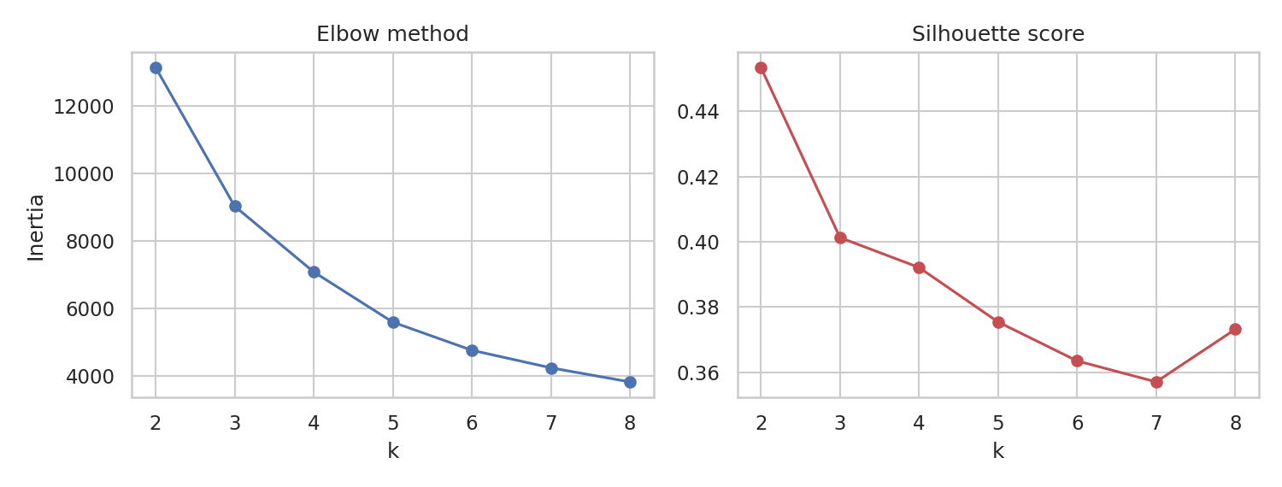
Figure 5: Elbow curve and silhouette scores for k = 2 to 8
The silhouette score is highest at k = 2 (0.4534) but two groups are too coarse to guide different actions. I selected k = 4 (silhouette 0.3921), which still gives reasonably separated clusters and a much richer business interpretation. The first two principal components explain 71.7% and 20.7% of the variance (92.4% in total), so the 2-D projection below is a faithful picture of the clusters.
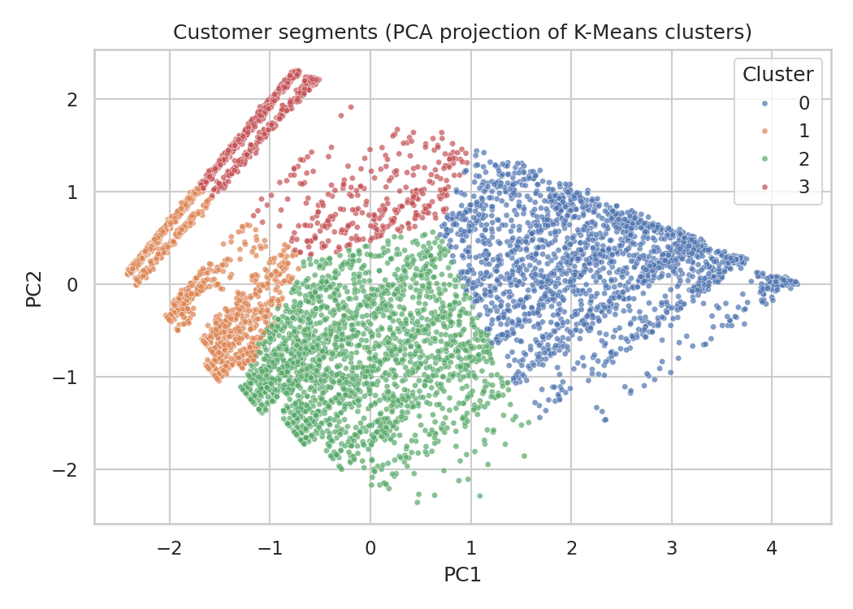
Figure 6: K-Means segments projected onto the first two principal components
Table: Cluster profiles (mean values; churn rate is computed afterwards and was not used for clustering)
Cluster | Label | Customers | Tenure (months) | Monthly charge | Add-ons | Churn rate
0 | Loyal high-value | 1,982 | 59.79 | 91.26 | 4.1 | 14.0%
1 | New low-spend | 1,884 | 8.78 | 37.81 | 0.32 | 32.0%
2 | At-risk mid-tenure, high-bill | 2,185 | 18.35 | 79.78 | 2.34 | 43.0%
3 | Long-tenure budget | 992 | 53.28 | 29.94 | 0.53 | 4.0%

7. Evaluation of Results

7.1 Model Comparison
All figures below are computed on the 20% hold-out test set (1,409 customers, 374 of whom churned), except CV AUC, which is the mean of 5-fold cross-validation on the training data. The default 0.50 threshold is used for the first four rows.
Model | CV AUC | Accuracy | Precision | Recall | F1 | ROC-AUC
Logistic Regression | 0.8456 | 0.7381 | 0.5043 | 0.7834 | 0.6136 | 0.8417
Random Forest | 0.8445 | 0.7708 | 0.5517 | 0.7273 | 0.6275 | 0.8408
Gradient Boosting | 0.8477 | 0.8013 | 0.6621 | 0.5134 | 0.5783 | 0.8412
Tuned Gradient Boosting | 0.8498 | 0.8013 | 0.6679 | 0.5000 | 0.5719 | 0.8449
Tuned GB @ threshold 0.322 | - | 0.7736 | 0.5553 | 0.7380 | 0.6338 | 0.8449

The most important lesson from this table is that the three algorithms are almost indistinguishable in ROC-AUC (0.841 to 0.845). The differences are small enough to be within normal sampling noise, so the choice between them should be driven by other factors, such as interpretability and the operating point, rather than by the third decimal place. Tuned Gradient Boosting was retained because it has the best AUC on both cross-validation and the test set, and it exceeds the 0.80 success criterion comfortably.
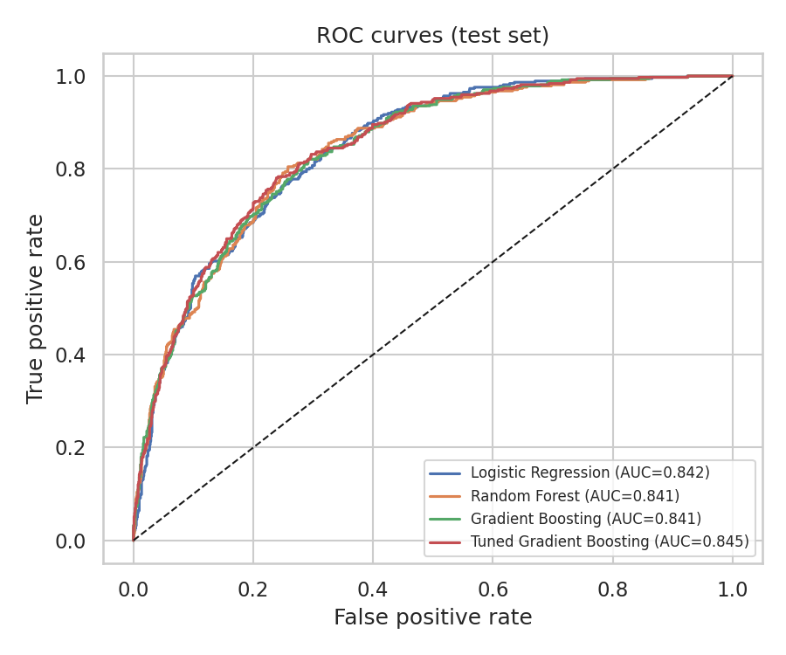
Figure 7: ROC curves of all models on the test set

7.2 Confusion Matrix and the Precision-Recall Trade-off
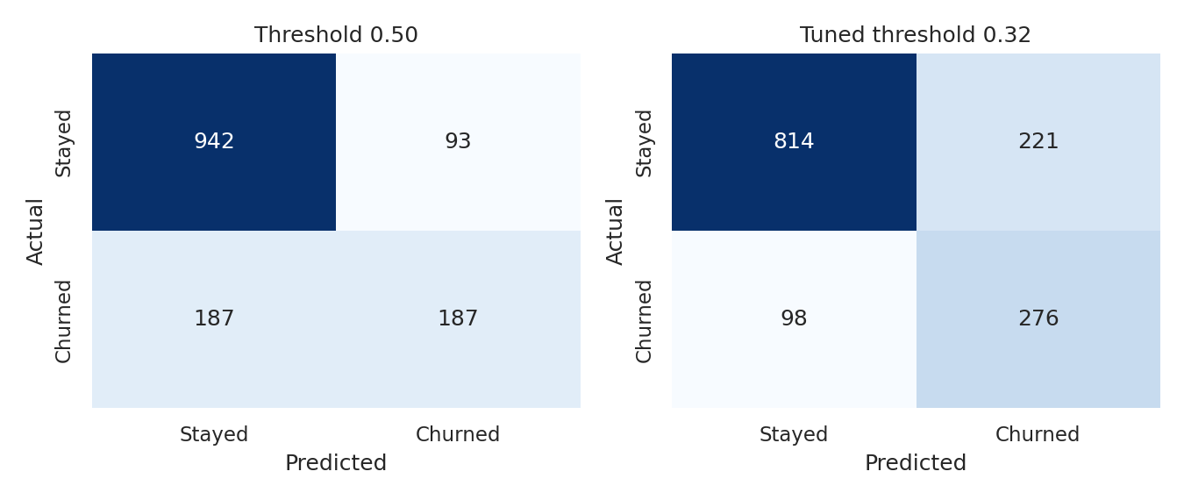
Figure 8: Confusion matrices of the tuned model at threshold 0.50 and at the tuned threshold
At threshold 0.50 the tuned model achieves the highest accuracy (80.1%) but finds only 187 of the 374 churners (recall 50.0%). Lowering the threshold to 0.322 changes the picture: it catches 276 of 374 churners (recall 73.8%), reducing missed churners from 187 to 98. The price is more false alarms (221 versus 93), so precision falls to 55.5% and accuracy to 77.4%.
This trade-off is a business decision. If a retention offer is cheap relative to the lifetime value of a customer, the lower threshold is preferable because missing a churner is more costly than contacting a customer who would have stayed. Accuracy alone would have picked the wrong operating point here: it is higher at 0.50, yet that model misses half of the customers the business most wants to find.

7.3 What Drives Churn? Feature Importance
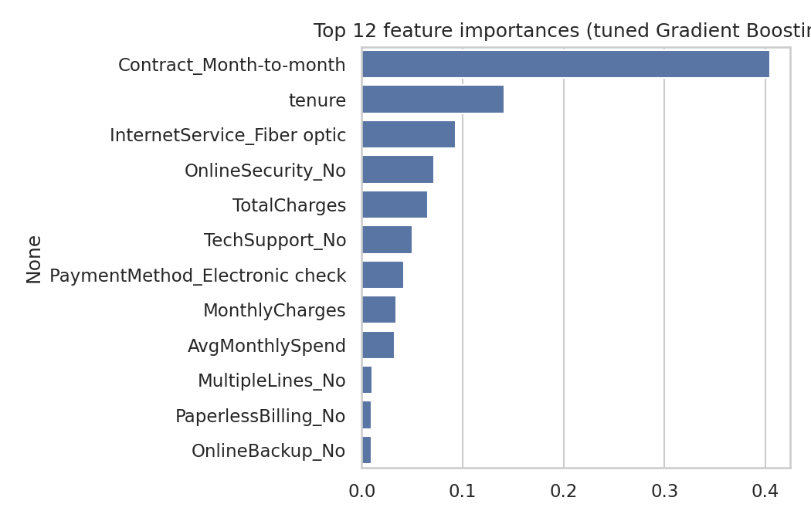
Figure 9: Top 12 feature importances of the tuned Gradient Boosting model
Month-to-month contract is by far the most important feature (importance 0.4042), followed by tenure (0.141), fibre-optic internet (0.0934), absence of online security (0.0716) and total charges (0.0658). This agrees closely with the EDA findings, which is reassuring: the model is learning real structure rather than noise.
The Logistic Regression coefficients tell a consistent story: fibre-optic (+0.72) and month-to-month contracts (+0.66) raise churn risk, while longer tenure (-1.16) and two-year contracts (-0.77) lower it. One coefficient needs care: MonthlyCharges has a negative coefficient (-0.73) even though churners pay more on average. This is a symptom of multicollinearity, since the monthly charge is largely determined by the internet service and add-ons that are also in the model. Individual coefficients should therefore not be read as isolated causal effects.

7.4 Clustering Quality
The silhouette score of 0.3921 indicates moderate separation: the segments are meaningful but overlap at their edges, which is typical for customer behaviour data that changes gradually rather than falling into sharp groups. The strongest evidence that the clusters are useful is external: although churn was not used in clustering, the segments differ widely in churn rate (4% to 43%) and in contract mix (for example, 81.6% of cluster 2 is on month-to-month contracts versus 17% of cluster 3).

7.5 Limitations
- The dataset is a single snapshot with no time dimension, so the model predicts who *is* similar to past churners rather than modelling when churn occurs.
- The threshold was optimised for F1, which weights precision and recall equally. A real deployment should use the actual cost of a retention offer and the value of a retained customer.
- It is a public sample dataset, so absolute figures may not transfer to a real operator. The workflow and the direction of the findings are what generalise.
- Model differences are small; no formal significance test was performed.

8. Insights and Recommendations

8.1 Key Insights
- Contract length is the single biggest lever. Month-to-month customers are about 15 times more likely to churn than two-year customers (42.7% vs 2.8%).
- The first year is the danger zone. Churners have a mean tenure of 17.98 months, and the new low-spend segment churns at 32%.
- Fibre-optic customers are unhappy or price-sensitive. They churn at 41.9% despite paying more, which points to a value-for-money or service-quality issue worth investigating.
- Support and security add-ons are associated with retention. Customers with tech support churn at 15.2% versus 41.6% without it.
- Manual payment is a warning sign. Electronic-check payers churn at 45.3%, roughly three times the rate of automatic-payment customers.

8.2 Recommendations
Recommendation | Target | Evidence
Offer discounts or perks for moving from month-to-month to a 1- or 2-year plan | Clusters 1 and 2 (about 4,000 customers with roughly 80% month-to-month) | Churn 42.7% vs 2.8%; top model feature
Run a structured onboarding and check-in programme during the first 12 months | New low-spend customers (cluster 1) | Mean churner tenure 17.98 months; cluster 1 churn 32%
Investigate fibre-optic pricing and service quality; consider price-lock offers | Fibre-optic customers, especially cluster 2 | Fibre churn 41.9% vs DSL 19%
Bundle tech support and online security free for a trial period | Customers with no add-ons on internet plans | Churn 41.6% without tech support vs 15.2% with
Encourage automatic payment (small bill credit) | Electronic-check payers | Churn 45.3% vs 15.2-16.7% on auto-pay
Prioritise the highest-risk customers using the model's probabilities each month | All active customers | Threshold 0.322 catches 73.8% of churners
Protect and reward the loyal high-value segment (loyalty tiers, early upgrades) | Cluster 0 | Highest revenue, churn only 14%

9. Reflection: Challenges and Successes

9.1 Challenges
- Silent data problems. The blank `TotalCharges` values did not appear as missing until the column was converted to numbers. Checking data types before analysis, and not just null counts, is essential.
- Class imbalance and the accuracy trap. The highest-accuracy model was not the most useful one. Choosing metrics and a threshold that reflect the business goal was harder than training the models.
- Very similar model performance. After tuning, three quite different algorithms landed within 0.004 AUC. This taught me not to over-interpret small metric differences and to weigh interpretability and cost.
- Interpreting coefficients. The negative MonthlyCharges coefficient illustrated how multicollinearity can make linear-model coefficients misleading.
- Choosing k. Silhouette favoured k = 2, while the business needed finer segments. The final choice combined a statistical measure with practical interpretability.

9.2 Successes
- A complete, reproducible pipeline that goes from raw CSV to actionable recommendations, with preprocessing wrapped in pipelines to prevent data leakage.
- A model that comfortably meets the success criterion (test ROC-AUC 0.8449) and finds 73.8% of churners at the chosen operating point.
- Supervised and unsupervised results that point in the same direction: the drivers found by the classifier are the same traits that separate the high-churn and low-churn segments.
- Every claim in this report is backed by a figure or table generated by the code in Appendix A.

9.3 What I Would Do Differently
I would drop AvgMonthlySpend at the start after noticing it duplicates MonthlyCharges, and I would define the cost of a false negative and a false positive with the business before choosing a threshold.

10. Further Work and Conclusion
- Explainability: use SHAP values to explain individual predictions and to give the retention team a reason for each flagged customer.
- Cost-sensitive optimisation: choose the threshold by maximising expected profit rather than F1.
- Probability calibration: verify (and if necessary calibrate) that predicted probabilities match observed churn rates.
- Other models and imbalance methods: test XGBoost or LightGBM, SMOTE or focal-loss style weighting, and a formal significance test between models.
- Survival analysis: model *when* a customer churns (for example Cox regression) instead of only whether they do.
- Richer segmentation: try Gaussian mixture models or hierarchical clustering and include categorical features.
- Deployment: wrap the pipeline in a dashboard or API and monitor for data drift.
In conclusion, the project shows that customer churn in this dataset is predictable (ROC-AUC 0.84) and largely explained by a few interpretable factors: contract type, tenure, internet service type, payment method and support services. Combining a predictive model with customer segmentation gives an operator both a *who* and a *why*, which is what makes the analysis actionable.

Appendix A: Complete Python Code
The complete script below reproduces every table and figure in this report. It requires pandas, numpy, matplotlib, seaborn and scikit-learn. The CSV can be downloaded from the URL defined in the script and saved as telco.csv.
import json, warnings
import numpy as np, pandas as pd
import matplotlib
matplotlib.use("Agg")
import matplotlib.pyplot as plt
import seaborn as sns
from sklearn.model_selection import train_test_split, StratifiedKFold, cross_val_score
from sklearn.preprocessing import StandardScaler, OneHotEncoder
from sklearn.compose import ColumnTransformer
from sklearn.pipeline import Pipeline
from sklearn.linear_model import LogisticRegression
from sklearn.ensemble import RandomForestClassifier, GradientBoostingClassifier
from sklearn.metrics import (accuracy_score, precision_score, recall_score, f1_score,
roc_auc_score, confusion_matrix, roc_curve, precision_recall_curve)
from sklearn.cluster import KMeans
from sklearn.decomposition import PCA
from sklearn.metrics import silhouette_score

warnings.filterwarnings("ignore")
sns.set_theme(style="whitegrid", palette="deep")
RES, RS = {}, 42
FIG = "figs/"

# ---------------- 1. Data acquisition ----------------
URL = ("https://raw.githubusercontent.com/IBM/telco-customer-churn-on-icp4d/"
"master/data/Telco-Customer-Churn.csv")
df = pd.read_csv("telco.csv") # downloaded from URL above
RES["shape_raw"] = list(df.shape)
RES["dtypes_object"] = int((df.dtypes == "object").sum())

# ---------------- 2. Cleaning ----------------
df["TotalCharges"] = pd.to_numeric(df["TotalCharges"], errors="coerce")
RES["missing_total_charges"] = int(df["TotalCharges"].isna().sum())
RES["missing_tenure_of_those"] = df.loc[df["TotalCharges"].isna(), "tenure"].tolist()
df["TotalCharges"] = df["TotalCharges"].fillna(0)
RES["duplicates"] = int(df.duplicated().sum())
RES["dup_ids"] = int(df["customerID"].duplicated().sum())
df = df.drop(columns="customerID")
df["Churn"] = (df["Churn"] == "Yes").astype(int)
df["SeniorCitizen"] = df["SeniorCitizen"].map({0: "No", 1: "Yes"})
RES["churn_rate"] = round(df["Churn"].mean() * 100, 2)
RES["churn_counts"] = df["Churn"].value_counts().to_dict()

# Feature engineering
svc = ["OnlineSecurity", "OnlineBackup", "DeviceProtection", "TechSupport", "StreamingTV", "StreamingMovies"]
df["NumAddOns"] = (df[svc] == "Yes").sum(axis=1)
df["AvgMonthlySpend"] = np.where(df["tenure"] > 0, df["TotalCharges"] / df["tenure"], df["MonthlyCharges"])
df["TenureGroup"] = pd.cut(df["tenure"], [-1, 12, 24, 48, 72], labels=["0-12", "13-24", "25-48", "49-72"])
RES["shape_clean"] = list(df.shape)
RES["describe"] = df[["tenure", "MonthlyCharges", "TotalCharges"]].describe().round(2).to_dict()

# ---------------- 3. EDA ----------------
fig, ax = plt.subplots(1, 2, figsize=(9, 3.8))
df["Churn"].map({0: "Stayed", 1: "Churned"}).value_counts().plot.bar(ax=ax[0], color=["#4C72B0", "#C44E52"], rot=0)
ax[0].set_title("Churn class distribution"); ax[0].set_ylabel("Customers")
ax[1].pie(df["Churn"].value_counts(), labels=["Stayed", "Churned"], autopct="%1.1f%%", colors=["#4C72B0", "#C44E52"])
ax[1].set_title("Churn share")
plt.tight_layout(); plt.savefig(FIG + "eda_target.png", dpi=150); plt.close()

cats = ["Contract", "InternetService", "PaymentMethod", "TechSupport", "PaperlessBilling", "SeniorCitizen"]
fig, axes = plt.subplots(2, 3, figsize=(13, 7))
churn_by = {}
for a, c in zip(axes.ravel(), cats):
r = df.groupby(c)["Churn"].mean().mul(100).sort_values(ascending=False)
churn_by[c] = r.round(1).to_dict()
sns.barplot(x=r.values, y=r.index, ax=a, color="#C44E52")
a.set_title(f"Churn % by {c}"); a.set_xlabel("Churn rate (%)"); a.set_ylabel("")
for i, v in enumerate(r.values):
a.text(v + 0.5, i, f"{v:.1f}", va="center", fontsize=8)
plt.tight_layout(); plt.savefig(FIG + "eda_categorical.png", dpi=150); plt.close()
RES["churn_by"] = churn_by

fig, axes = plt.subplots(1, 3, figsize=(13, 3.8))
for a, c in zip(axes, ["tenure", "MonthlyCharges", "TotalCharges"]):
sns.kdeplot(data=df, x=c, hue=df["Churn"].map({0: "Stayed", 1: "Churned"}), fill=True, common_norm=False, ax=a)
a.set_title(f"{c} by churn")
plt.tight_layout(); plt.savefig(FIG + "eda_numeric.png", dpi=150); plt.close()
RES["numeric_means"] = df.groupby("Churn")[["tenure", "MonthlyCharges", "TotalCharges", "NumAddOns"]].mean().round(2).to_dict()

plt.figure(figsize=(6.5, 5))
num = df[["tenure", "MonthlyCharges", "TotalCharges", "NumAddOns", "AvgMonthlySpend", "Churn"]]
sns.heatmap(num.corr(), annot=True, fmt=".2f", cmap="coolwarm", center=0)
plt.title("Correlation matrix"); plt.tight_layout(); plt.savefig(FIG + "eda_corr.png", dpi=150); plt.close()
RES["corr_with_churn"] = num.corr()["Churn"].round(3).to_dict()

# ---------------- 4. Supervised modelling ----------------
X, y = df.drop(columns=["Churn", "TenureGroup"]), df["Churn"]
num_cols = X.select_dtypes(include="number").columns.tolist()
cat_cols = X.select_dtypes(exclude="number").columns.tolist()
RES["num_cols"], RES["n_cat_cols"] = num_cols, len(cat_cols)
pre = ColumnTransformer([("num", StandardScaler(), num_cols),
("cat", OneHotEncoder(handle_unknown="ignore"), cat_cols)])
Xtr, Xte, ytr, yte = train_test_split(X, y, test_size=0.2, stratify=y, random_state=RS)
RES["split"] = [len(Xtr), len(Xte)]

models = {
"Logistic Regression": LogisticRegression(max_iter=1000, class_weight="balanced", random_state=RS),
"Random Forest": RandomForestClassifier(n_estimators=300, min_samples_leaf=5, class_weight="balanced", random_state=RS, n_jobs=-1),
"Gradient Boosting": GradientBoostingClassifier(random_state=RS),
}
skf = StratifiedKFold(5, shuffle=True, random_state=RS)
fitted, rows, probs = {}, [], {}
for n, m in models.items():
p = Pipeline([("pre", pre), ("clf", m)])
cv = cross_val_score(p, Xtr, ytr, cv=skf, scoring="roc_auc").mean()
p.fit(Xtr, ytr); fitted[n] = p
pr = p.predict_proba(Xte)[:, 1]; probs[n] = pr; pd_ = (pr >= 0.5).astype(int)
rows.append(dict(Model=n, CV_AUC=round(cv, 4), Accuracy=round(accuracy_score(yte, pd_), 4),
Precision=round(precision_score(yte, pd_), 4), Recall=round(recall_score(yte, pd_), 4),
F1=round(f1_score(yte, pd_), 4), ROC_AUC=round(roc_auc_score(yte, pr), 4)))
res = pd.DataFrame(rows); RES["model_table"] = rows
best = res.sort_values("ROC_AUC", ascending=False).iloc[0]["Model"]
RES["best_model"] = best

# hyper-parameter tuning on best (small grid)
from sklearn.model_selection import GridSearchCV
grid = {"clf__learning_rate": [0.03, 0.05, 0.1], "clf__n_estimators": [100, 200], "clf__max_depth": [2, 3]}
gs = GridSearchCV(Pipeline([("pre", pre), ("clf", GradientBoostingClassifier(random_state=RS))]),
grid, cv=skf, scoring="roc_auc", n_jobs=-1).fit(Xtr, ytr)
RES["gs_best_params"] = {k.replace("clf__", ""): v for k, v in gs.best_params_.items()}
RES["gs_best_cv_auc"] = round(gs.best_score_, 4)
tuned = gs.best_estimator_
pt = tuned.predict_proba(Xte)[:, 1]; probs["Tuned Gradient Boosting"] = pt
p5 = (pt >= 0.5).astype(int)
RES["tuned_row"] = dict(Model="Tuned Gradient Boosting", CV_AUC=round(gs.best_score_, 4),
Accuracy=round(accuracy_score(yte, p5), 4), Precision=round(precision_score(yte, p5), 4),
Recall=round(recall_score(yte, p5), 4), F1=round(f1_score(yte, p5), 4),
ROC_AUC=round(roc_auc_score(yte, pt), 4))

# threshold tuning (maximise F1 on train OOF would be cleaner; here use PR curve on test for discussion)
from sklearn.model_selection import cross_val_predict
oof = cross_val_predict(tuned, Xtr, ytr, cv=skf, method="predict_proba")[:, 1]
pp, rr, tt = precision_recall_curve(ytr, oof)
f1s = 2 * pp * rr / (pp + rr + 1e-9)
thr = float(tt[np.argmax(f1s[:-1])])
pth = (pt >= thr).astype(int)
RES["threshold"] = round(thr, 3)
RES["thr_row"] = dict(Accuracy=round(accuracy_score(yte, pth), 4), Precision=round(precision_score(yte, pth), 4),
Recall=round(recall_score(yte, pth), 4), F1=round(f1_score(yte, pth), 4))
RES["cm_thr"] = confusion_matrix(yte, pth).tolist()
RES["cm_50"] = confusion_matrix(yte, p5).tolist()

# ROC
plt.figure(figsize=(6, 5))
for n, pr in probs.items():
f, t, _ = roc_curve(yte, pr); plt.plot(f, t, label=f"{n} (AUC={roc_auc_score(yte, pr):.3f})")
plt.plot([0, 1], [0, 1], "k--", lw=1); plt.xlabel("False positive rate"); plt.ylabel("True positive rate")
plt.title("ROC curves (test set)"); plt.legend(fontsize=8); plt.tight_layout(); plt.savefig(FIG + "roc.png", dpi=150); plt.close()

# confusion matrices
fig, ax = plt.subplots(1, 2, figsize=(9, 3.8))
for a, cm, t in zip(ax, [RES["cm_50"], RES["cm_thr"]], ["Threshold 0.50", f"Tuned threshold {thr:.2f}"]):
sns.heatmap(cm, annot=True, fmt="d", cmap="Blues", cbar=False, ax=a,
xticklabels=["Stayed", "Churned"], yticklabels=["Stayed", "Churned"])
a.set_title(t); a.set_xlabel("Predicted"); a.set_ylabel("Actual")
plt.tight_layout(); plt.savefig(FIG + "cm.png", dpi=150); plt.close()

# feature importance
names = tuned.named_steps["pre"].get_feature_names_out()
imp = pd.Series(tuned.named_steps["clf"].feature_importances_, index=names).sort_values(ascending=False).head(12)
imp.index = [i.replace("num__", "").replace("cat__", "") for i in imp.index]
plt.figure(figsize=(7, 4.5)); sns.barplot(x=imp.values, y=imp.index, color="#4C72B0")
plt.title("Top 12 feature importances (tuned Gradient Boosting)"); plt.tight_layout(); plt.savefig(FIG + "importance.png", dpi=150); plt.close()
RES["top_features"] = {k: round(float(v), 4) for k, v in imp.head(8).items()}

# Logistic regression coefficients (interpretability)
lr = fitted["Logistic Regression"]
co = pd.Series(lr.named_steps["clf"].coef_[0], index=[i.replace("num__", "").replace("cat__", "") for i in lr.named_steps["pre"].get_feature_names_out()])
RES["lr_top_pos"] = co.sort_values(ascending=False).head(5).round(2).to_dict()
RES["lr_top_neg"] = co.sort_values().head(5).round(2).to_dict()

# ---------------- 5. Unsupervised ----------------
cl_cols = ["tenure", "MonthlyCharges", "TotalCharges", "NumAddOns"]
Z = StandardScaler().fit_transform(df[cl_cols])
ks, inertia, sil = range(2, 9), [], []
for k in ks:
km = KMeans(k, n_init=10, random_state=RS).fit(Z)
inertia.append(km.inertia_); sil.append(silhouette_score(Z, km.labels_, sample_size=3000, random_state=RS))
RES["k_sil"] = {int(k): round(s, 4) for k, s in zip(ks, sil)}
fig, ax = plt.subplots(1, 2, figsize=(10, 3.8))
ax[0].plot(list(ks), inertia, "o-"); ax[0].set_title("Elbow method"); ax[0].set_xlabel("k"); ax[0].set_ylabel("Inertia")
ax[1].plot(list(ks), sil, "o-", color="#C44E52"); ax[1].set_title("Silhouette score"); ax[1].set_xlabel("k")
plt.tight_layout(); plt.savefig(FIG + "kmeans_select.png", dpi=150); plt.close()

K = 4
km = KMeans(K, n_init=10, random_state=RS).fit(Z)
df["Cluster"] = km.labels_
RES["k_used"] = K; RES["sil_used"] = round(silhouette_score(Z, km.labels_, sample_size=3000, random_state=RS), 4)
prof = df.groupby("Cluster").agg(Customers=("Churn", "size"), Tenure=("tenure", "mean"), MonthlyCharges=("MonthlyCharges", "mean"),
TotalCharges=("TotalCharges", "mean"), AddOns=("NumAddOns", "mean"), ChurnRate=("Churn", "mean")).round(2)
prof["ChurnRate"] = (prof["ChurnRate"] * 100).round(1)
RES["profile"] = prof.reset_index().to_dict("records")
RES["cluster_contract"] = (pd.crosstab(df["Cluster"], df["Contract"], normalize="index") * 100).round(1).to_dict("index")
pc = PCA(2, random_state=RS).fit(Z); P = pc.transform(Z)
RES["pca_var"] = [round(float(v) * 100, 1) for v in pc.explained_variance_ratio_]
plt.figure(figsize=(7, 5))
sns.scatterplot(x=P[:, 0], y=P[:, 1], hue=df["Cluster"], palette="deep", s=12, alpha=0.7)
plt.xlabel("PC1"); plt.ylabel("PC2"); plt.title("Customer segments (PCA projection of K-Means clusters)")
plt.tight_layout(); plt.savefig(FIG + "clusters.png", dpi=150); plt.close()

json.dump(RES, open("results.json", "w"), indent=1, default=str)
print(json.dumps(RES, indent=1, default=str))

Appendix B: References
- IBM. Telco Customer Churn sample dataset. GitHub repository: IBM/telco-customer-churn-on-icp4d.
- Pedregosa, F. et al. (2011). Scikit-learn: Machine Learning in Python. Journal of Machine Learning Research, 12, 2825-2830.
- McKinney, W. (2010). Data Structures for Statistical Computing in Python. Proceedings of the 9th Python in Science Conference.
- Hunter, J. D. (2007). Matplotlib: A 2D Graphics Environment. Computing in Science & Engineering, 9(3), 90-95.
- Waskom, M. (2021). seaborn: statistical data visualization. Journal of Open Source Software, 6(60), 3021.
- Rousseeuw, P. J. (1987). Silhouettes: a graphical aid to the interpretation and validation of cluster analysis. Journal of Computational and Applied Mathematics, 20, 53-65.

