WEEK 3 INTERNSHIP REPORT

Customer Segmentation Using K Means Clustering
  - Unsupervised learning analysis of the UCI Wholesale Customers dataset

Report detail | Value
Task | Unsupervised Learning and Clustering Analysis
Dataset | UCI Wholesale Customers dataset, 440 observations
Algorithm | K Means clustering with k means plus plus initialization
Libraries | Python, Pandas, NumPy, Scikit learn, Matplotlib, Seaborn
Public source | UCI Machine Learning Repository
Date | 29 September 2026

Purpose. This report segments wholesale customers using annual spending across six product categories. It explains why preprocessing is necessary, how the number of clusters was selected, what each cluster represents, and how the results can be used as a starting point for differentiated customer strategy.

Executive summary
The analysis identifies three meaningful customer segments from 440 wholesale customers. The selected K Means solution is based on transformed and standardized spending features, which prevents very large spending categories from dominating the distance calculation. The resulting groups are named Retail supply intensive, Fresh food focused, and Balanced mixed basket according to their median purchase profiles. Segmentation highlights practical differences in product demand, but it should be treated as an exploratory decision aid rather than a definitive description of every customer.
Conclusion | Evidence
Three clusters are actionable | The solution separates 147, 212, and 81 customers across distinct spending profiles.
Preprocessing is essential | Log transformation reduces skew; standardization gives each category comparable influence.
Segments support differentiated action | Profiles suggest different assortment, promotion, and service priorities.
Validation remains necessary | Cluster quality is evaluated internally; business testing is required before operational deployment.

Contents
1 Dataset and problem framing 2 Methodology 3 Data preparation 4 Cluster selection 5 Results and interpretation 6 Business implications 7 Limitations 8 Reproducibility appendix

1 Dataset and problem framing
The UCI Wholesale Customers dataset contains annual spending values for 440 customers across Fresh, Milk, Grocery, Frozen, Detergents Paper, and Delicassen product categories. It also records customer Channel and Region. The spending variables are appropriate for clustering because they describe purchasing behavior without requiring a target label. The segmentation objective is to group customers with similar basket composition and order magnitude so that their needs can be compared.
Variable group | Fields | Use in analysis
Clustering features | Fresh, Milk, Grocery, Frozen, Detergents Paper, Delicassen | Annual spending behavior used to form clusters
Context variables | Channel, Region | Retained for post cluster interpretation, not used to define distance
Unit of analysis | One customer | Each row receives one cluster assignment

Source citation: UCI Machine Learning Repository. “Wholesale customers Data Set.” https://archive.ics.uci.edu/ml/datasets/Wholesale+customers (accessed 29 September 2026).

2 Methodology and rationale
K Means clustering was selected because the dataset has a moderate number of numerical observations, the aim is to create mutually exclusive customer groups, and centroid profiles are straightforward to explain. The algorithm iteratively assigns each customer to its nearest centroid and recalculates centroids to minimize within cluster squared distance. K Means assumes roughly compact, distance-based groups, so it is paired with transformations and diagnostic checks rather than used blindly.
from sklearn.preprocessing import StandardScaler
from sklearn.cluster import KMeans
from sklearn.metrics import silhouette_score
features = ['Fresh','Milk','Grocery','Frozen','Detergents_Paper','Delicassen']
X = np.log1p(df[features])
X_scaled = StandardScaler().fit_transform(X)
model = KMeans(n_clusters=3, init='k-means++', n_init=30, random_state=42)
df['Cluster'] = model.fit_predict(X_scaled)
print(silhouette_score(X_scaled, df['Cluster']))

3 Data preparation
The CSV was inspected for structure, missingness, and duplicates before modeling. The six spending categories had no missing entries. Because monetary spend variables are nonnegative and strongly right-skewed, log1p was applied. This preserves zero values while reducing the influence of very high spenders. StandardScaler was then used so that each transformed feature has mean zero and standard deviation one. Channel and Region were deliberately excluded from the clustering input to keep segments defined by purchasing behavior rather than geography or outlet type.
Preparation step | Action | Reason
Quality check | Verified 440 records and no missing values in six spend features | Avoids unexamined distance calculations with missing data
Skew handling | Applied log1p to each spending feature | Reduces leverage of unusually high annual spending
Scaling | Applied StandardScaler after transformation | Ensures equal contribution to Euclidean distance
Context preservation | Kept Channel and Region outside the feature matrix | Allows independent interpretation after clustering

4 Selecting the number of clusters
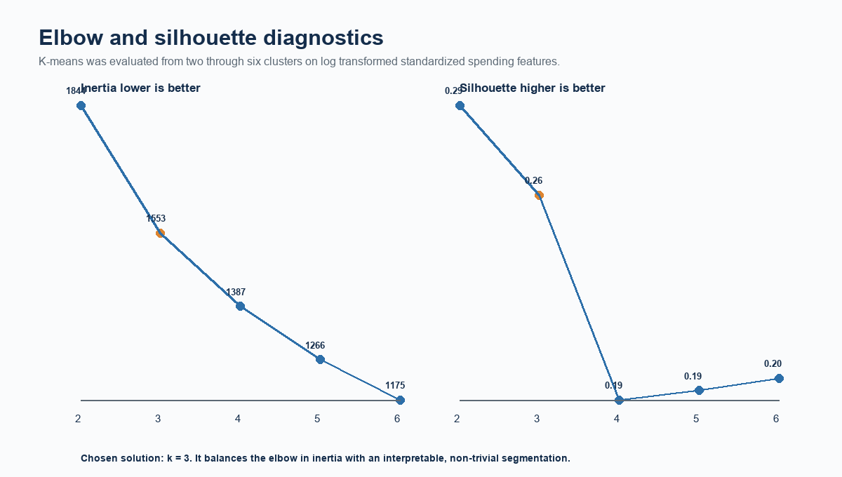
Figure 1. Elbow and silhouette diagnostics for candidate K Means solutions. Source: UCI Wholesale Customers calculations.
The inertia curve decreases as additional clusters are added, as expected. The three-cluster solution was chosen because it marks a practical bend in the curve while remaining easy to interpret and operationalize. The mean silhouette score for k = 3 is 0.26; this indicates moderate separation, which is common in real customer behavior where boundaries overlap. A four- or five-cluster solution may support more granular targeting, but it would also create smaller, less stable groups.

5 Cluster results
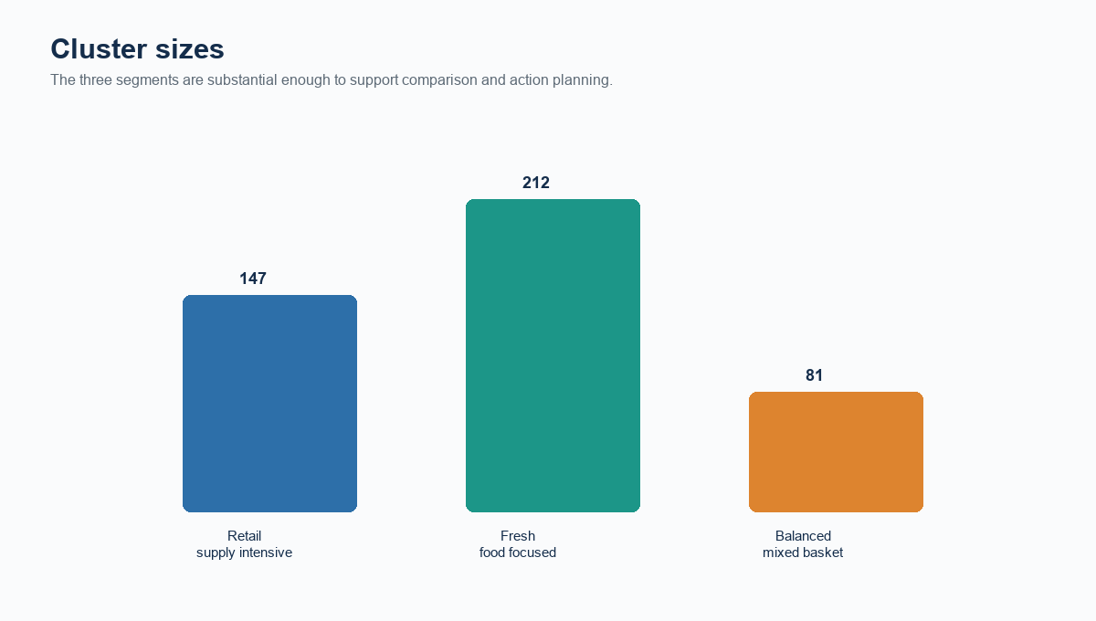
Figure 2. Number of customers assigned to each cluster. Source: UCI Wholesale Customers calculations.
No segment is a trivial singleton. This matters because cluster-level medians and operational recommendations are more credible when they are based on a meaningful number of customers. Cluster sizes should nevertheless be monitored when new customers are scored, because the distribution may shift over time.

5.1 Spending profile comparison
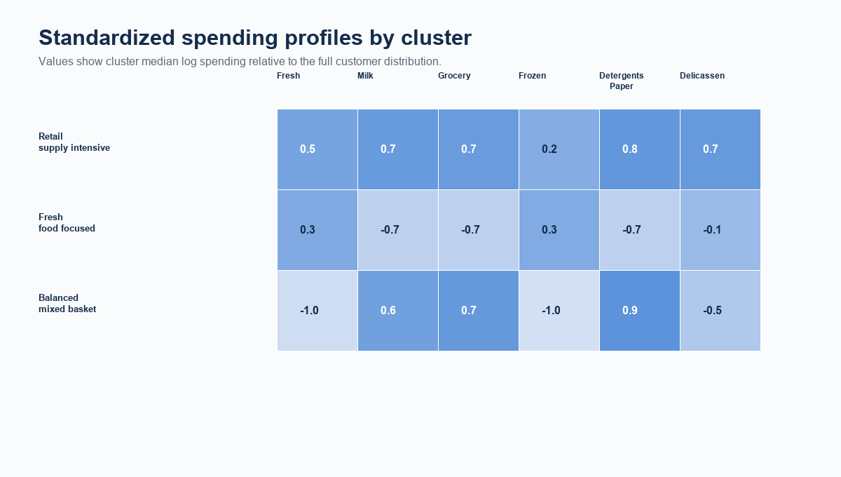
Figure 3. Median standardized spending profiles by cluster. Source: UCI Wholesale Customers calculations.
The heatmap compares median transformed spending against the full dataset scale. Retail supply intensive customers show relatively strong Milk, Grocery, and Detergents Paper purchasing. Fresh food focused customers concentrate more on Fresh and Frozen spending. Balanced mixed basket customers sit closer to the overall center across categories. These labels are descriptive summaries of the observed profile; they are not official customer types supplied by UCI.
Cluster | Fresh | Milk | Grocery | Frozen | Detergents | Delicassen
Retail supply intensive | 12,126 | 7,184 | 9,965 | 2,005 | 3,378 | 2,005
Fresh food focused | 9,635 | 1,598 | 2,151 | 2,151 | 274 | 686
Balanced mixed basket | 1,454 | 6,264 | 10,487 | 388 | 4,196 | 436

5.2 Cluster visualization
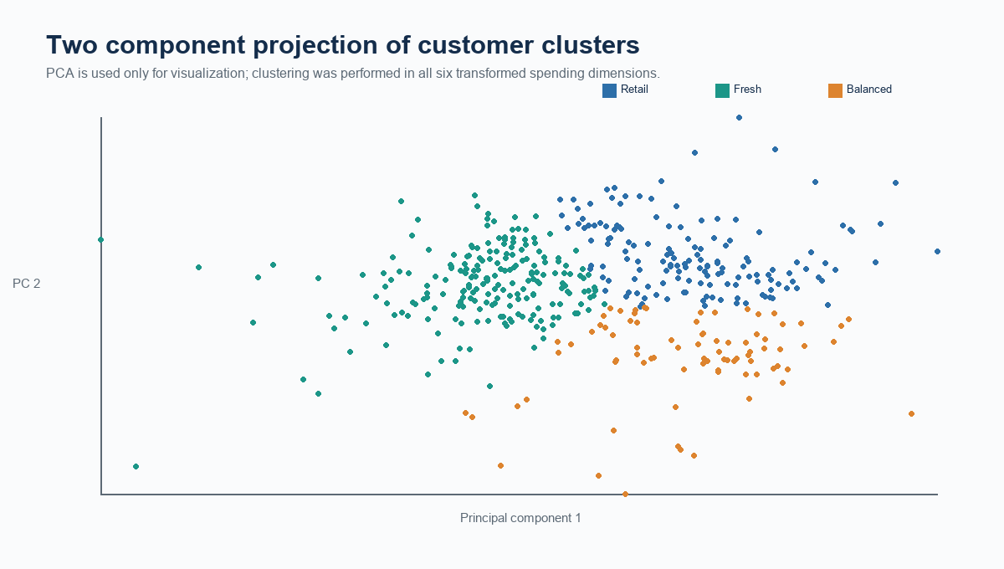
Figure 4. PCA projection of K Means assignments. Source: UCI Wholesale Customers calculations.
Principal component analysis projects the six-dimensional standardized feature space into two dimensions for visualization. The visible overlap is important: clusters are useful summaries of proximity, not perfectly isolated natural classes. Because the K Means model uses all six dimensions, the PCA plot should not be interpreted as the full clustering decision boundary.

6 Segment interpretation and implications
Segment | Characteristic | Potential action
Retail supply intensive | High relative Milk, Grocery, and Detergents Paper demand | Prioritize replenishment reliability, bulk-pack offers, and inventory alerts.
Fresh food focused | Higher relative Fresh and Frozen demand | Promote cold-chain service, freshness communication, and seasonal produce bundles.
Balanced mixed basket | Spending closer to the middle across categories | Use cross-selling tests and personalized recommendations to uncover category expansion opportunities.

These implications are hypotheses for business experimentation, not guaranteed outcomes. A responsible next step is to test promotions or service changes on a subset of each segment and compare response, retention, and margin against a holdout group. Operational decisions should also incorporate customer profitability, delivery cost, and account history, none of which appear in this dataset.

7 Limitations and alternative methods
K Means is sensitive to scaling, initialization, and the number of clusters; this report addresses the first two using transformation, standardization, k means plus plus, repeated initializations, and a fixed random seed. It still favors centroid-shaped groups and can be influenced by unusual observations. Hierarchical clustering, Gaussian mixtures, or density-based methods could be evaluated as sensitivity checks. The source data provides annual spend but lacks time, margin, transaction frequency, and customer lifetime value, so the segmentation should not be mistaken for a complete commercial strategy.

Conclusion
This analysis demonstrates an end-to-end unsupervised learning workflow: identify suitable behavioral variables, preprocess them for distance-based learning, compare candidate cluster counts, assign customers with K Means, visualize the result, and translate profiles into plausible actions. Three clusters provide a clear, defensible starting point. Their value lies in supporting targeted questions and experiments, not in replacing domain expertise or ongoing validation.

8 Reproducibility and code appendix
The following complete starter code uses Scikit learn as required. It can be run after installing pandas, numpy, scikit-learn, matplotlib, and seaborn. The code loads the public UCI CSV, applies the documented preprocessing, evaluates k values, fits the selected model, and visualizes a PCA projection.
import numpy as np
import pandas as pd
import matplotlib.pyplot as plt
import seaborn as sns
from sklearn.preprocessing import StandardScaler
from sklearn.cluster import KMeans
from sklearn.metrics import silhouette_score
from sklearn.decomposition import PCA
url = 'https://archive.ics.uci.edu/ml/machine-learning-databases/00292/Wholesale%20customers%20data.csv'
df = pd.read_csv(url)
features = ['Fresh','Milk','Grocery','Frozen','Detergents_Paper','Delicassen']
X = StandardScaler().fit_transform(np.log1p(df[features]))
results = []
for k in range(2, 7):
km = KMeans(n_clusters=k, init='k-means++', n_init=30, random_state=42)
labels = km.fit_predict(X)
results.append([k, km.inertia_, silhouette_score(X, labels)])
print(pd.DataFrame(results, columns=['k','inertia','silhouette']))
km = KMeans(n_clusters=3, init='k-means++', n_init=30, random_state=42)
df['Cluster'] = km.fit_predict(X)
profile = df.groupby('Cluster')[features].median()
print(profile)
pca = PCA(n_components=2, random_state=42)
plot_df = pd.DataFrame(pca.fit_transform(X), columns=['PC1','PC2'])
plot_df['Cluster'] = df['Cluster'].astype(str)
sns.scatterplot(data=plot_df, x='PC1', y='PC2', hue='Cluster', palette='Set2')
plt.title('Wholesale customer clusters in PCA space')
plt.tight_layout(); plt.show()

Requirement coverage
Assignment requirement | Report section
Public dataset | Section 1
Preprocessing | Section 3
Clustering algorithm and parameter choice | Sections 2 and 4
Figures and visualization | Figures 1 through 4
Cluster characteristics | Section 5
Business implications | Section 6
Code snippets and reproducibility | Sections 2 and 8
Critical limitations | Section 7

