WEEK 2 INTERNSHIP REPORT

Exploratory Data Analysis of Titanic Passenger Outcomes
  - A reproducible analysis of survival patterns, data quality, and passenger characteristics

Report detail | Value
Prepared for | Week 2 Exploratory Data Analysis and Visualization Task
Dataset | Titanic passenger manifest (891 observations, 12 original fields)
Tools | Python, Pandas, Matplotlib, Seaborn
Public source | Data Science Dojo Titanic dataset; derived from the Kaggle Titanic competition data
Date | 29 September 2026

Purpose. This report demonstrates an end-to-end exploratory data analysis workflow: loading and cleaning a public dataset, quantifying data quality, visualizing patterns, testing plausible explanations, and documenting reproducible code. The analysis is descriptive; it does not claim causality.

Executive summary
The Titanic passenger data reveal large and uneven differences in recorded survival. The strongest visible divide is sex: women survived at a much higher rate than men in every passenger class. Passenger class and fare are also associated with survival, while age has a more nuanced relationship. The most important analytical caution is data quality: Cabin is missing for roughly 77% of passengers and Age for about 20%, so conclusions involving those fields require careful qualification.
Question | Evidence based answer
Which passenger groups had the highest survival? | Women and first-class passengers.
Does price/class matter? | Yes. Survival rises from third to first class and across fare quartiles.
Are age effects simple? | No. Children have a relatively high rate, but age is incomplete and interacts with sex and class.
What data issue matters most? | Cabin has pervasive missingness; Age has meaningful missingness and should be handled explicitly.

Contents
1 Dataset and source 2 Analytical methodology 3 Data loading and cleaning 4 Descriptive statistics 5 Univariate, bivariate, and multivariate exploration 6 Data quality and outliers 7 Transformations and aggregations 8 Findings and limitations 9 Reproducibility appendix

1 Dataset and source
The analysis uses the public Titanic passenger dataset published by Data Science Dojo (GitHub repository: datasciencedojo/datasets, file titanic.csv). It is a widely used version of the Kaggle Titanic competition training data and contains 891 passenger records. Each record represents one passenger and includes whether the person survived, demographic attributes, travel class, family relationships, fare, cabin identifier where available, and embarkation port.
Field | Type | Analytical role
Survived | Binary 0/1 | Outcome: recorded survival
Pclass | Ordinal 1-3 | Socioeconomic/travel-class proxy
Sex, Age | Categorical / numeric | Demographic descriptors
SibSp, Parch | Counts | Family-travel indicators
Fare | Continuous | Ticket-price proxy; right-skewed
Cabin, Embarked | Categorical | Location/port context; Cabin is mostly missing

Source citation: Data Science Dojo. “Titanic Dataset.” GitHub, https://raw.githubusercontent.com/datasciencedojo/datasets/master/titanic.csv (accessed 29 September 2026). The original challenge context is Kaggle’s Titanic: Machine Learning from Disaster.

2 Analytical methodology
The workflow proceeded from structure to explanation. First, data types, record count, duplicate rows, descriptive statistics, and missingness were inspected. Second, distributional plots and grouped summaries were created to understand each important feature. Third, cross-tabulations and a numeric correlation matrix were used to examine joint patterns. Finally, derived variables were created to make family composition, age groups, fare scale, and honorific titles easier to interpret.
Rates are computed as the mean of the binary Survived indicator multiplied by 100. For example, a group mean of 0.62 is reported as a 62% survival rate. This is a descriptive comparison, not a causal estimate; passenger class, sex, age, fare, location, and access to lifeboats are intertwined.
import pandas as pd
import matplotlib.pyplot as plt
import seaborn as sns
df = pd.read_csv('titanic.csv')
print(df.shape)
print(df.info())
print(df.describe(include='all'))

3 Data loading and cleaning
The raw CSV contained 891 rows and 12 columns. PassengerId was retained as an identifier but excluded from substantive correlations. No exact duplicate records were found. The target field Survived was verified as binary. Missing values were not silently removed: Age was left missing for analyses that require observed age, Cabin was treated as unavailable rather than interpreted as a cabin category, and the small number of missing Embarked values can be imputed with its modal value only when a complete modeling table is required.
# audit missingness and derive interpretable features
missing_pct = df.isna().mean().mul(100).sort_values(ascending=False)
df['FamilySize'] = df['SibSp'] + df['Parch'] + 1
df['IsAlone'] = (df['FamilySize'] == 1).astype(int)
df['AgeBand'] = pd.cut(df['Age'], [0, 12, 18, 35, 55, 100],
labels=['Child','Teen','Young adult','Adult','Older adult'],
include_lowest=True)
df['FareLog'] = np.log1p(df['Fare'])

4 Descriptive statistics
Variable | Count | Mean | SD | Min | Median | Max
Survived | 891 | 0.38 | 0.49 | 0.0 | 0.0 | 1.0
Pclass | 891 | 2.31 | 0.84 | 1.0 | 3.0 | 3.0
Age | 714 | 29.7 | 14.53 | 0.42 | 28.0 | 80.0
SibSp | 891 | 0.52 | 1.1 | 0.0 | 0.0 | 8.0
Parch | 891 | 0.38 | 0.81 | 0.0 | 0.0 | 6.0
Fare | 891 | 32.2 | 49.69 | 0.0 | 14.45 | 512.33

Overall recorded survival was 38.4% (342 of 891 passengers). The median fare was 14.45, far below the maximum of 512.33, confirming a strongly right-skewed fare distribution. Mean age among the 714 passengers with a recorded age was 29.7 years.

5 Exploratory data analysis

5.1 Bivariate analysis Passenger class and survival
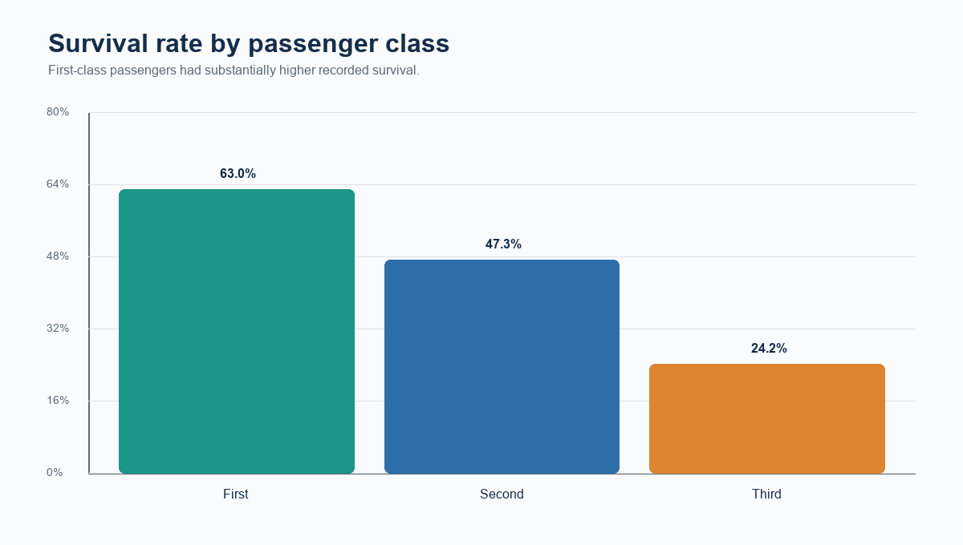
Figure 1. Survival rate by passenger class. Source: Titanic dataset calculations.
First-class survival was 63.0%, compared with 47.3% in second class and 24.2% in third class. Class likely captures several overlapping advantages: physical location on the ship, ticket-holder resources, access to information, and differences in the composition of passengers. The chart alone cannot isolate which mechanism explains the difference.

5.2 Multivariate comparison Sex within class
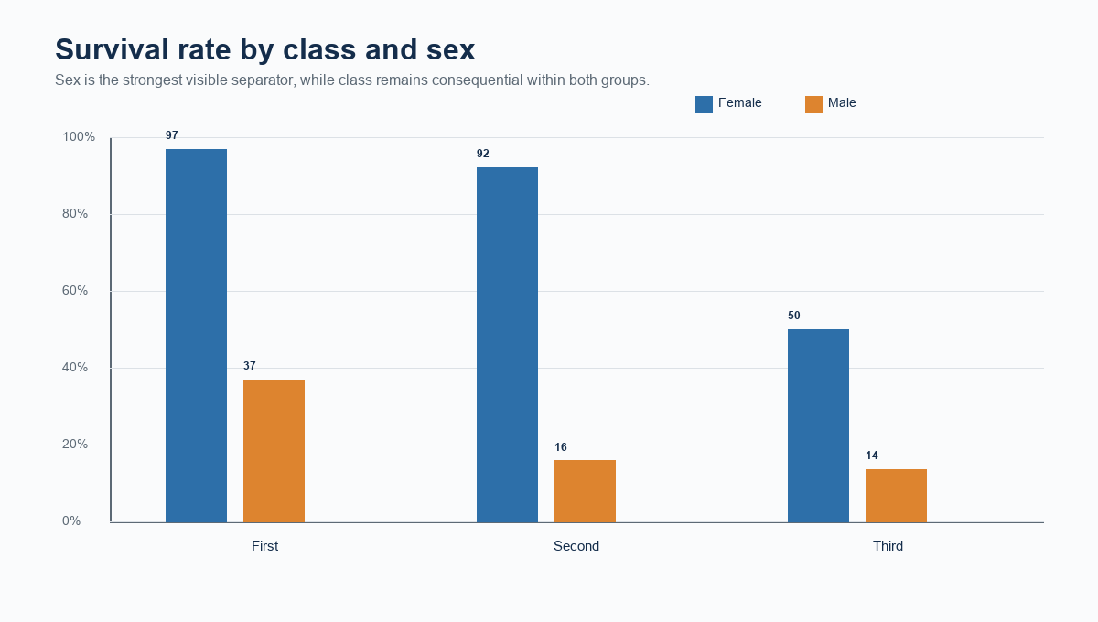
Figure 2. Survival rate by class and sex. Source: Titanic dataset calculations.
Within each class, female passengers had much higher recorded survival than male passengers. The persistence of this pattern across classes suggests that sex is not merely standing in for class composition. At the same time, female survival was not uniform: third-class women had lower rates than women in the higher classes, showing that class still mattered within sex groups.

5.3 Age band patterns
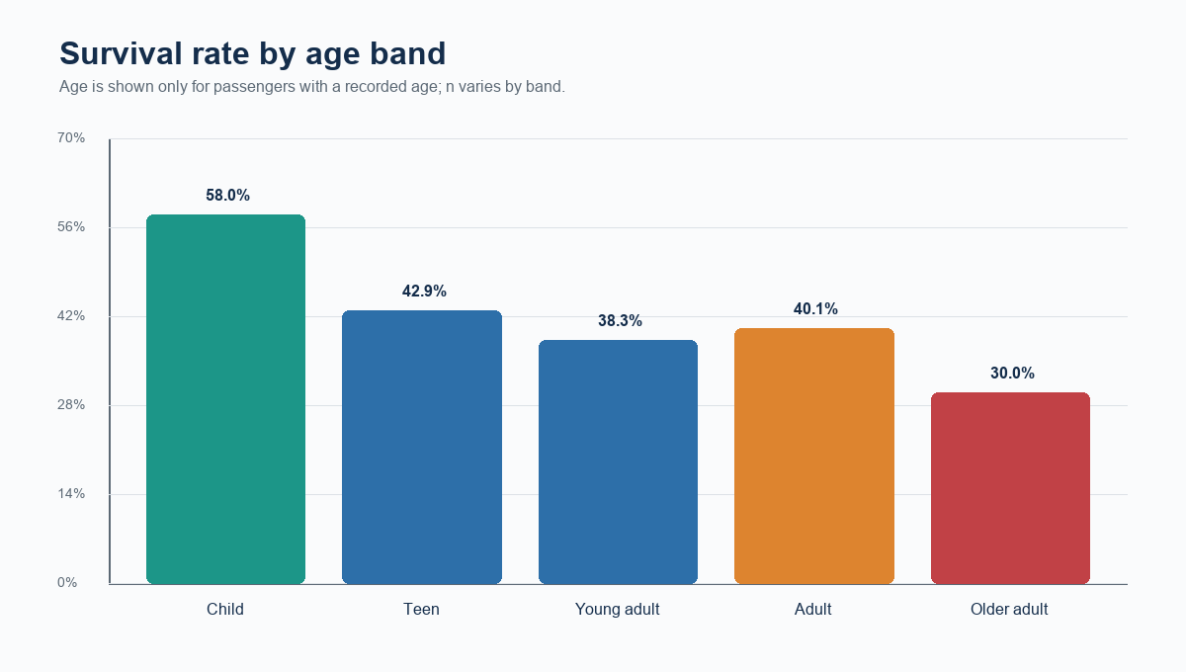
Figure 3. Survival rate by observed age band. Source: Titanic dataset calculations.
Children show a comparatively high survival rate, consistent with historical accounts that children and women were prioritized in evacuation. However, the age chart is conditional on recorded age and should not be generalized to the full manifest without considering the 177 missing Age values. Differences also partly reflect the sex and class mix within each age band.

6 Data quality missing values and outliers
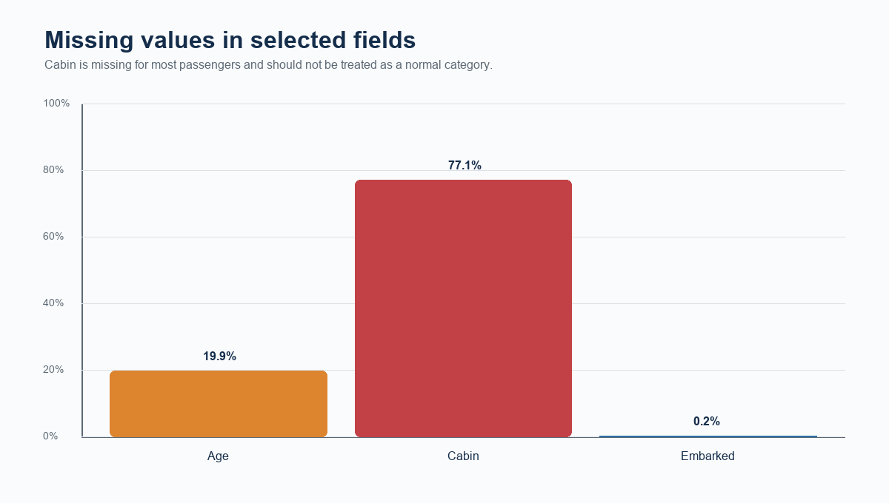
Figure 4. Missingness in selected fields. Source: Titanic dataset calculations.
Cabin is missing for most records, so a simple “unknown cabin” category could encode a meaningful difference in record keeping or travel class rather than a neutral absence. Age is missing for nearly one fifth of passengers. For descriptive charts, the analysis reports observed-age results rather than replacing missing ages with a single value. For a predictive model, median age imputation within sex and passenger class would be a reasonable baseline, with a missingness indicator retained for transparency.

Outliers and distribution shape
Fare has a long right tail: the maximum fare is far greater than the median. Extreme values are plausible rather than necessarily erroneous because tickets may cover groups, premium cabins, or different travel arrangements. The analysis therefore keeps the original fare for transparency and creates FareLog = log(1 + Fare) for scale-sensitive analyses. The log transformation compresses the tail while preserving order and retaining zero fares.

7 Transformations and aggregations
Derived feature | Definition | Reason
FamilySize | SibSp + Parch + 1 | Combines relatives aboard into an interpretable party-size measure
IsAlone | 1 when FamilySize equals 1 | Separates solo travelers from grouped travelers
AgeBand | Five ordered age intervals | Improves readability and avoids overinterpreting individual ages
FareLog | log(1 + Fare) | Reduces right skew for scale-sensitive display/modeling
Title | Honorific extracted from Name | Compact social/demographic signal; rare titles grouped

Aggregations used groupby means for survival rates, pivot tables for the class-by-sex comparison, and quantile bins for fare. Fare quartiles allocate approximately equal numbers of observations per group, which provides a more stable comparison than arbitrary currency intervals in a right-skewed variable.
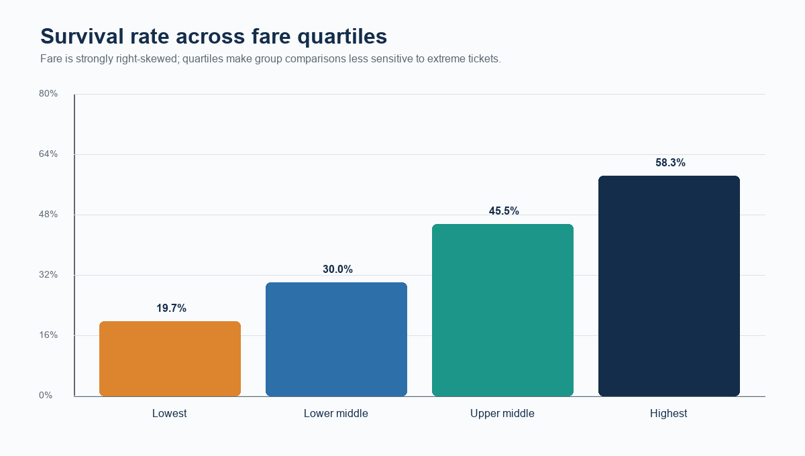
Figure 5. Survival rate by fare quartile. Source: Titanic dataset calculations.
Survival increases across fare quartiles. This mirrors the passenger-class result but does not duplicate it exactly: fare varies within class, and some tickets covered groups. The association should be read as a socioeconomic/travel-context signal, not as evidence that price itself caused survival.

8 Correlations and integrated interpretation
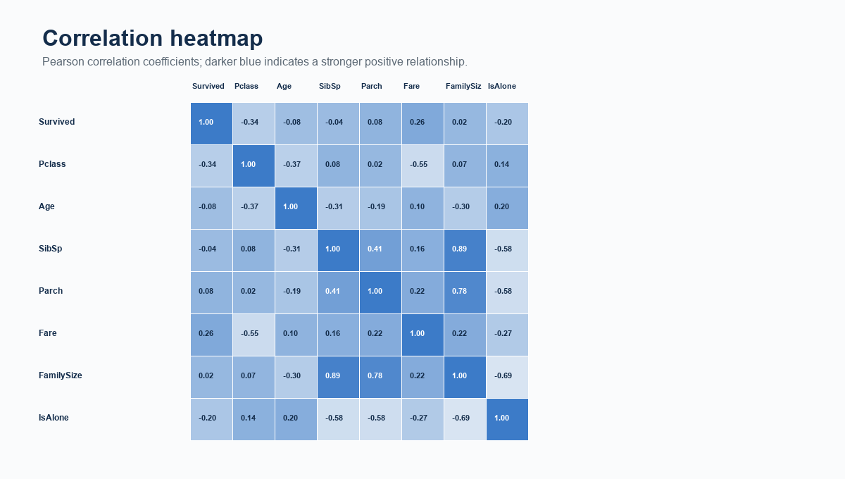
Figure 6. Numeric-feature correlation matrix. Source: Titanic dataset calculations.
The correlation matrix is a compact screening tool, not proof of causal importance. Pclass has a negative correlation with Fare because smaller class numbers denote higher service class. Fare and survival are positively associated, while Pclass and survival are negatively associated for the same coding reason. The modest linear correlation of Age with survival does not rule out meaningful nonlinear age patterns; this is why the age-band plot is included alongside the matrix.

Key findings
Finding | Interpretation and evidence
Sex is the clearest separator | Female survival exceeds male survival in every passenger class (Figure 2).
Class and fare are materially associated | First class and the highest fare quartile have the strongest rates (Figures 1 and 5).
Age has a nonlinear, incomplete-data pattern | Children perform relatively well; missing Age values limit precision (Figures 3 and 4).
Data quality affects conclusions | Cabin is too incomplete for naive category comparisons; age-dependent results use observed cases.
Interactions matter | Class still differentiates outcomes within sex groups, so one-variable summaries are incomplete.

Limitations
This file is a passenger-level historical dataset, not a randomized study. Records may contain measurement gaps, ticket-level fares can represent multiple travelers, and missingness may be informative. The dataset does not include lifeboat access, cabin deck for all passengers, crew behavior, exact location at impact, or a complete account of family ticketing. Thus, observed differences should be described as associations. The 891-row sample is suitable for EDA, but subgroup rates can be unstable when categories are small; tables should report counts before making strong claims about rare titles or small age bands.

Conclusion
The EDA meets the central objective of converting a raw public dataset into evidence-based observations. It shows that survival was strongly patterned by sex and travel context, with class and fare reinforcing the same broad socioeconomic gradient. It also demonstrates why responsible EDA includes negative findings and caveats: missing Cabin and Age values constrain what can be claimed. The next analytical step would be a transparent classification model with train-test validation, preprocessing fitted only on training data, interaction checks, and fairness-aware reporting.

9 Reproducibility and code appendix
The following script is a concise runnable starting point. It uses Pandas for data management, Matplotlib and Seaborn for plots, and the public CSV source cited in Section 1. Run it in a clean environment with Python 3.10+ and install dependencies with: pip install pandas matplotlib seaborn numpy.
import numpy as np
import pandas as pd
import matplotlib.pyplot as plt
import seaborn as sns
url = 'https://raw.githubusercontent.com/datasciencedojo/datasets/master/titanic.csv'
df = pd.read_csv(url)
# inspect and engineer features
print(df.shape)
print(df.isna().mean().mul(100).sort_values(ascending=False))
df['FamilySize'] = df['SibSp'] + df['Parch'] + 1
df['IsAlone'] = (df['FamilySize'] == 1).astype(int)
df['AgeBand'] = pd.cut(df['Age'], [0, 12, 18, 35, 55, 100],
labels=['Child','Teen','Young adult','Adult','Older adult'], include_lowest=True)
df['FareLog'] = np.log1p(df['Fare'])
# annotated class-by-sex survival chart
rates = (df.groupby(['Pclass','Sex'])['Survived'].mean().mul(100).reset_index())
ax = sns.barplot(data=rates, x='Pclass', y='Survived', hue='Sex', palette='Set2')
ax.set(title='Titanic survival rate by class and sex', xlabel='Passenger class', ylabel='Survival rate (%)')
ax.legend(title='Sex')
for container in ax.containers:
ax.bar_label(container, fmt='%.1f%%', padding=3)
plt.tight_layout(); plt.show()
# numeric correlation heatmap
cols = ['Survived','Pclass','Age','SibSp','Parch','Fare','FamilySize','IsAlone']
plt.figure(figsize=(9,6))
sns.heatmap(df[cols].corr(), annot=True, fmt='.2f', cmap='Blues', center=0)
plt.title('Titanic numeric feature correlations')
plt.tight_layout(); plt.show()

Analysis checklist
Requirement | Where addressed
Public dataset and source | Section 1
Initial analysis and descriptive statistics | Sections 3 and 4
Annotated visualizations | Figures 1 through 6
Univariate, bivariate, multivariate EDA | Sections 5 and 8
Missingness and outliers | Section 6
Transformations and aggregations | Section 7
Critical interpretation | Sections 5, 6, and 8
Accurate runnable code | Methodology and appendix

End of report.

