WEEK 1 TASK REPORT
Data Acquisition, Cleaning and Preprocessing
A worked case study on the Titanic passenger dataset using Python
Prepared by: Minuku Chethan Sai
Programme: Data Science Internship - Week 1
Dataset: Titanic - Machine Learning from Disaster (891 records, 12 attributes)
Tools: Python 3, pandas, NumPy, Matplotlib, Seaborn, scikit-learn
Date: September 2026

Table of Contents

Here is the Table of Contents from the document:

- 1. Introduction and Objectives

  - Objectives

- 2. Dataset Selection and Data Collection

  - 2.1 Why the Titanic dataset

  - 2.2 Collection method

  - 2.3 Data dictionary

- 3. Initial Data Exploration

  - 3.1 Structure, types and summary statistics

  - 3.2 Missing-value audit

  - 3.3 Distribution check

- 4. Summary of Data Quality Issues Found

- 5. Handling Missing Values

  - 5.1 Embarked (2 missing values)

  - 5.2 Cabin (77% missing)

  - 5.3 Age (19.9% missing)

- 6. Inconsistencies and Erroneous Entries

  - 6.1 Text standardisation and duplicate checks

  - 6.2 Range and plausibility checks

  - 6.3 Treating zero fares

- 7. Outlier Detection and Treatment

  - 7.1 Detection

  - 7.2 Investigating the extreme fares

  - 7.3 Treatment

- 8. Preprocessing and Feature Engineering

  - 8.1 Feature engineering

  - 8.2 Encoding categorical variables

  - 8.3 Feature scaling

- 9. Validation of the Cleaned Dataset

- 10. Impact of Preprocessing on Subsequent Analyses

  - Effects of imputation

  - Effects of outlier handling

  - Effects of encoding and scaling

  - A simple demonstration

- 11. Challenges Faced and How They Were Overcome

- 12. Reflective Commentary

- 13. Conclusion

- Appendix A: Complete Consolidated Script

- References

1. Introduction and Objectives
Real-world data is rarely analysis-ready. Values are missing, entries are inconsistent, extreme observations distort statistics, and categorical fields are stored in forms that machine-learning algorithms cannot consume directly. Studies of analytical workflows routinely report that data preparation consumes the largest share of a project's effort, and the quality of every downstream result depends on it.
This report documents a complete, reproducible data-preparation pipeline built in Python. It covers how the data was acquired, how its structure and quality were assessed, how missing values, inconsistencies and outliers were handled, how the data was transformed for modelling, and what the consequences of those choices are for later analysis.

Objectives
- Select and acquire a public dataset from a reliable source.
- Explore the dataset to understand its structure, types and quality.
- Detect and treat missing values, erroneous or inconsistent entries, and outliers.
- Apply preprocessing (feature engineering, encoding, scaling) to produce a modelling-ready dataset.
- Justify every decision and discuss its effect on subsequent analyses.

2. Dataset Selection and Data Collection

2.1 Why the Titanic dataset
The Titanic passenger dataset comes from the well-known Kaggle competition "Titanic - Machine Learning from Disaster", derived from historical passenger records. It was chosen because it is widely used and documented, which makes results easy to verify, and because it contains a realistic mixture of data-quality problems in a compact size:
- Missing values of three different kinds - a small number in Embarked, a moderate share in Age, and a majority in Cabin.
- A heavily right-skewed numeric feature (Fare) with genuine extreme values and suspicious zero entries.
- Free-text fields (Name, Ticket) from which useful information can be extracted.
- Categorical variables (Sex, Embarked, Pclass) that must be encoded, and a clear binary target (Survived).

2.2 Collection method
The training file (train.csv, 891 rows) was downloaded programmatically from a public GitHub mirror of the Kaggle dataset and read straight into a pandas DataFrame. Downloading via code rather than manually keeps the workflow reproducible.
import pandas as pd, numpy as np
import matplotlib.pyplot as plt, seaborn as sns
from sklearn.preprocessing import StandardScaler, MinMaxScaler

URL = "https://raw.githubusercontent.com/datasciencedojo/datasets/master/titanic.csv"
df = pd.read_csv(URL) # raw, untouched copy
print(df.shape)
df.head()

Output:
(891, 12)

2.3 Data dictionary
Column | Type (raw) | Meaning
PassengerId | int64 | Unique row identifier
Survived | int64 | Target: 0 = died, 1 = survived
Pclass | int64 | Ticket class: 1 (upper), 2 (middle), 3 (lower)
Name | text | Passenger name including title (e.g. Mr, Mrs, Miss)
Sex | text | male / female
Age | float64 | Age in years (fractional for infants)
SibSp | int64 | Number of siblings / spouses aboard
Parch | int64 | Number of parents / children aboard
Ticket | text | Ticket number (shared by groups travelling together)
Fare | float64 | Passenger fare in pounds
Cabin | text | Cabin number (deck letter + number)
Embarked | text | Port: C = Cherbourg, Q = Queenstown, S = Southampton

3. Initial Data Exploration
Before changing anything, the dataset was profiled to learn its shape, data types, summary statistics, duplicates and the extent of missing data. This baseline is what every later cleaning step is compared against.

3.1 Structure, types and summary statistics
df.info()
df.describe().round(2)
df.duplicated().sum(), df["PassengerId"].duplicated().sum()
df["Sex"].value_counts(), df["Embarked"].value_counts(dropna=False)

Statistic | Age | SibSp | Parch | Fare | Pclass | Survived
count | 714 | 891 | 891 | 891 | 891 | 891
mean | 29.70 | 0.52 | 0.38 | 32.20 | 2.31 | 0.38
std | 14.53 | 1.10 | 0.81 | 49.69 | 0.84 | 0.49
min | 0.42 | 0 | 0 | 0.00 | 1 | 0
median (50%) | 28.00 | 0 | 0 | 14.45 | 3 | 0
max | 80.00 | 8 | 6 | 512.33 | 3 | 1

Key observations from exploration:
- The dataset has 891 rows and 12 columns; there are no fully duplicated rows and no duplicated PassengerId values.
- The target is moderately imbalanced: 549 passengers died (61.6%) and 342 survived (38.4%).
- Sex is clean (577 male, 314 female), Pclass has three valid levels (491 / 216 / 184 for classes 3 / 1 / 2).
- Fare has a mean (32.20) more than double its median (14.45) and a maximum of 512.33 - a strong sign of right skew and extreme values.
- Fare has 15 records equal to exactly 0, and Age has 25 fractional values (7 below one year old) that need a sanity check.
- Ticket has 210 repeated values, indicating groups (families) travelling on shared tickets rather than errors.

3.2 Missing-value audit
missing = df.isnull().sum()
pd.DataFrame({"missing": missing, "percent": (df.isnull().mean()*100).round(2)}) \
.query("missing > 0")

Column | Missing | % missing | Severity
Cabin | 687 | 77.10% | Very high - most values absent
Age | 177 | 19.87% | Moderate - too many to drop
Embarked | 2 | 0.22% | Negligible

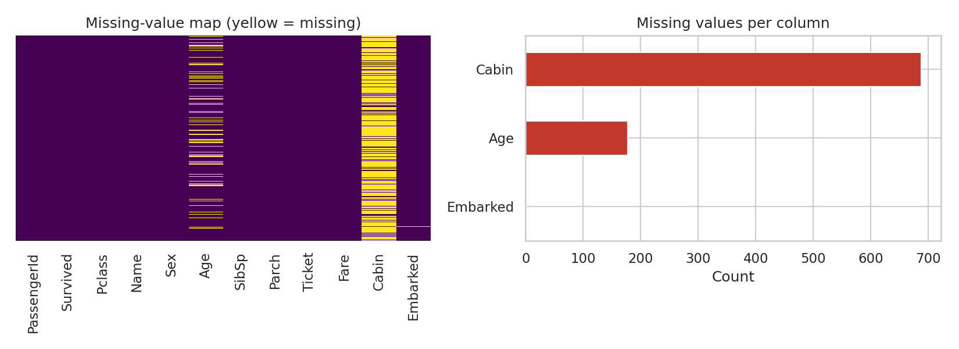
Figure 1: Missing-value map and counts per column

3.3 Distribution check
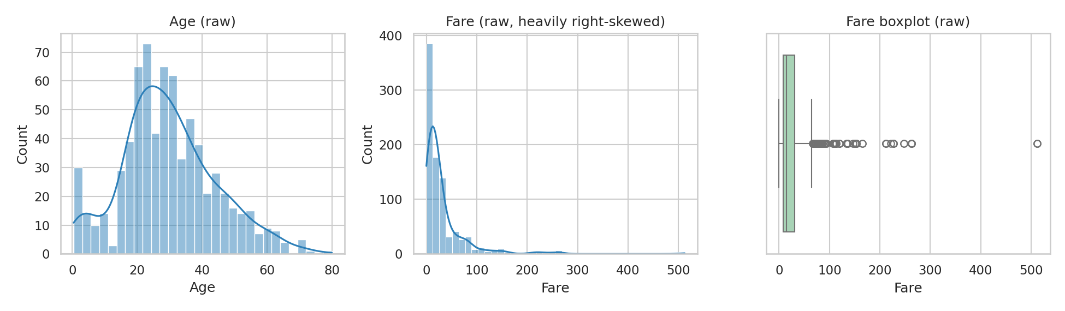
Figure 2: Raw distributions of Age and Fare - Fare is strongly right-skewed with a long upper tail

4. Summary of Data Quality Issues Found
# | Issue | Evidence | Planned treatment
1 | Missing Embarked | 2 rows (0.22%) | Impute with mode after inspection
2 | Missing Age | 177 rows (19.9%) | Group-wise median by Title + missing flag
3 | Missing Cabin | 687 rows (77.1%) | Do not impute; derive HasCabin and Deck
4 | Zero fares | 15 rows with Fare = 0 | Treat as invalid, impute by class median, add flag
5 | Extreme fares | 116 IQR outliers; 20 with |z| > 3; max 512.33 | Winsorise and log-transform; keep original
6 | Inconsistent text/titles | 17 distinct titles in Name | Extract and consolidate to 5 groups
7 | Unusable raw formats | Text categories, skewed scales | Encode and scale

5. Handling Missing Values
The right treatment depends on how much is missing and why. Three columns, three different strategies.

5.1 Embarked (2 missing values)
With only two missing values, dropping rows would be harmless, but it is better to first look at those rows for clues.
df[df["Embarked"].isna()][["PassengerId","Pclass","Fare","Cabin"]]

Output:
PassengerId Pclass Fare Cabin
61 62 1 80.0 B28
829 830 1 80.0 B28

Both records are first-class passengers who paid 80.0 for the same cabin (B28), so they almost certainly travelled together and embarked at the same port. Because Southampton (S) is by far the most common port (644 of 889 known values, 72%), the mode is the sensible fill value.
d = df.copy()
d["Embarked"] = d["Embarked"].fillna(d["Embarked"].mode()[0]) # 'S'

5.2 Cabin (77% missing)
Imputing a cabin number for three quarters of the passengers would mean fabricating most of the column, so the column was not imputed. The pattern of missingness is itself informative: cabin numbers were mainly recorded for wealthier passengers. Two features were derived instead - a binary HasCabin flag and the deck letter, with "U" (unknown) as an explicit category.
d["HasCabin"] = d["Cabin"].notna().astype(int)
d["Deck"] = d["Cabin"].str[0].fillna("U")
d.groupby("HasCabin")["Survived"].mean().round(3)

Output:
HasCabin
0 0.300
1 0.667

Survival is 66.7% for passengers with a recorded cabin versus 30.0% for those without, confirming that the missingness pattern carries signal that would be lost if the column were simply dropped or filled with a constant. The original Cabin column is removed only at the end, once its information has been captured.

5.3 Age (19.9% missing)
Age is an important predictor, and 177 missing values are too many to discard. Filling with a single global median (28) ignores the fact that age varies strongly with social title. To get a more realistic estimate, the passenger's title was extracted from the Name column with a regular expression and rare titles were consolidated:
d["Title"] = d["Name"].str.extract(r",\s*([^\.]+)\.", expand=False).str.strip()

title_map = {"Mlle":"Miss","Ms":"Miss","Mme":"Mrs",
"Lady":"Rare","the Countess":"Rare","Sir":"Rare","Don":"Rare",
"Dona":"Rare","Jonkheer":"Rare","Capt":"Rare","Col":"Rare",
"Major":"Rare","Dr":"Rare","Rev":"Rare"}
d["Title"] = d["Title"].replace(title_map)
d["Title"].value_counts()

Output:
Mr 517
Miss 185
Mrs 126
Master 40
Rare 23

The median age differs sharply by group - Master (boys) 3.5, Miss 21.0, Mr 30.0, Mrs 35.0, Rare 48.5 - which shows why a single global value would be misleading (it would make many boys adults). Ages were imputed with the median of each Title and Pclass combination, with fallbacks to the title median and then the overall median. A binary Age_Missing flag was created first so that the model can still see which ages were estimated.
d["Age_Missing"] = d["Age"].isna().astype(int)

grp_median = d.groupby(["Title","Pclass"])["Age"].transform("median")
d["Age"] = d["Age"].fillna(grp_median)
d["Age"] = d["Age"].fillna(d.groupby("Title")["Age"].transform("median"))
d["Age"] = d["Age"].fillna(d["Age"].median())
d["Age"].isna().sum()

Output:
0

Age statistic | Before | After | Change
Count | 714 | 891 | +177
Mean | 29.70 | 29.14 | -0.56
Median | 28.0 | 26.0 | -2.0
Std. deviation | 14.53 | 13.49 | -1.04

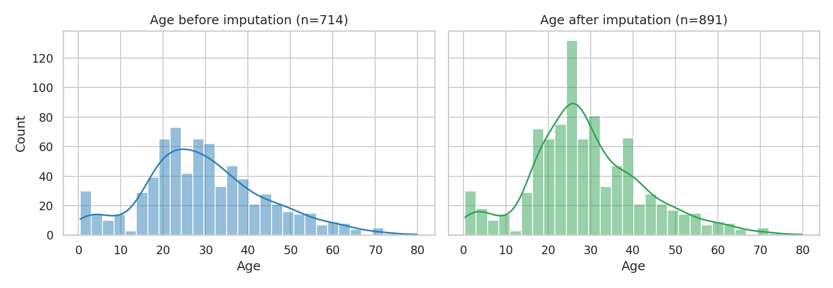
Figure 3: Age distribution before and after group-wise imputation
The overall shape is preserved and the mean moves by only about 0.6 years. The standard deviation shrinks slightly, which is the expected side effect of any median imputation (see Section 10).

6. Inconsistencies and Erroneous Entries

6.1 Text standardisation and duplicate checks
Categorical text was standardised to guard against hidden whitespace or casing differences that would silently split a category in two (for example "male" and "Male "). The raw data was already consistent, but the step is inexpensive insurance and makes the pipeline safe to re-run on future data. Duplicate checks confirmed that the 210 repeated ticket numbers are legitimate group bookings, not duplicate records.
for c in ["Sex", "Embarked"]:
d[c] = d[c].astype("string").str.strip()
d["Sex"] = d["Sex"].str.lower()
d["Embarked"] = d["Embarked"].str.upper()

print(df.duplicated().sum()) # 0 fully duplicated rows
print(df["PassengerId"].duplicated().sum()) # 0 duplicate IDs
print(df["Ticket"].duplicated().sum()) # 210 shared tickets (valid)

Output:
0
0
210

6.2 Range and plausibility checks
- Age: the minimum is 0.42 (an infant of about five months) and the maximum 80. Both are plausible, so no age values were altered.
- Pclass: only the values 1, 2 and 3 occur. Survived: only 0 and 1. Sex: only male and female.
- SibSp (max 8) and Parch (max 6) are large but correspond to real large families that share a ticket.
- Fare = 0: 15 passengers paid nothing. Some may be crew, guests or staff, but for a paid-fare variable these are far more likely recording gaps, and a fare of zero for a first-class ticket (for example passengers 264, 807 and 816) is implausible.

6.3 Treating zero fares
The zeros were treated as invalid values. They were first converted to missing, a flag column was added for transparency, and each was replaced with the median fare of the passenger's class (class medians: 60.29, 14.25 and 8.05 for classes 1, 2 and 3). The class median is preferred over the global median (14.45) because fares differ enormously across classes.
d["Fare_Zero_Flag"] = (d["Fare"] == 0).astype(int) # 15 rows flagged
d.loc[d["Fare"] == 0, "Fare"] = np.nan
d["Fare"] = d["Fare"].fillna(d.groupby("Pclass")["Fare"].transform("median"))

7. Outlier Detection and Treatment

7.1 Detection
Two complementary rules were used. The IQR rule flags values below Q1 - 1.5 x IQR or above Q3 + 1.5 x IQR, and is robust for skewed data. The z-score rule flags values more than three standard deviations from the mean, but is itself distorted by the outliers it looks for, so it is used only as a secondary check.
def iqr_bounds(s):
q1, q3 = s.quantile([.25, .75]); iqr = q3 - q1
return q1 - 1.5*iqr, q3 + 1.5*iqr

for c in ["Age", "Fare", "SibSp", "Parch"]:
lo, hi = iqr_bounds(d[c])
n = ((d[c] < lo) | (d[c] > hi)).sum()
print(f"{c:6s} bounds=({lo:.2f}, {hi:.2f}) outliers={n}")

z = ((d["Fare"] - d["Fare"].mean()) / d["Fare"].std()).abs()
print("Fare |z|>3:", (z > 3).sum())

Output:
Age bounds=(-2.62, 60.38) outliers=22
Fare bounds=(-26.72, 65.63) outliers=116
SibSp bounds=(-1.50, 2.50) outliers=46
Parch bounds=(0.00, 0.00) outliers=213
Fare |z|>3: 20

Feature | IQR bounds | Outliers | Decision
Age | -2.62 to 60.38 | 22 | Keep - elderly passengers are genuine
Fare | -26.72 to 65.63 | 116 | Treat - skew distorts models (winsorise + log)
SibSp | -1.50 to 2.50 | 46 | Keep - real large families
Parch | 0.00 to 0.00 | 213 | Keep - IQR degenerate (75% are zero); rule not meaningful

The Parch result is worth noting: because at least 75% of passengers have Parch = 0, the IQR is zero and every non-zero value is flagged. This is a limitation of the IQR rule on discrete, zero-inflated counts, not evidence of erroneous data, so no treatment was applied.

7.2 Investigating the extreme fares
The three highest fares (all 512.33) belong to passengers on the same ticket, PC 17755 - Lesurer, Cardeza and Ward - and the next highest (263.00) belong to the Fortune family sharing ticket 19950. These are real first-class suite bookings, not typing errors, so deleting them would remove valid information about the wealthiest passengers. A group ticket price also means the recorded fare may reflect the whole booking rather than one person, which motivated a per-person fare feature.

7.3 Treatment
Rather than deleting rows, two transformations were applied and the original Fare was kept:
- Winsorisation (capping): values are clipped to the 1st and 99th percentiles (6.85 and 249.01), limiting the pull of extreme values while keeping every row.
- Log transform (log1p): compresses the long right tail; log1p is used so that a fare of zero would still be defined.
lo, hi = d["Fare"].quantile([.01, .99]) # 6.85, 249.01
d["Fare_Capped"] = d["Fare"].clip(lo, hi)
d["Fare_Log"] = np.log1p(d["Fare"])

d["TicketSize"] = d.groupby("Ticket")["PassengerId"].transform("count")
d["FarePerPerson"] = d["Fare"] / d["TicketSize"]

print(d["Fare"].skew(), d["Fare_Capped"].skew(), d["Fare_Log"].skew())

Output:
4.79 3.11 0.95

Fare version | Skewness | Comment
Original Fare | 4.79 | Severely right-skewed
Winsorised (1-99%) | 3.11 | Improved but still skewed
log1p(Fare) | 0.95 | Close to symmetric - best for linear models

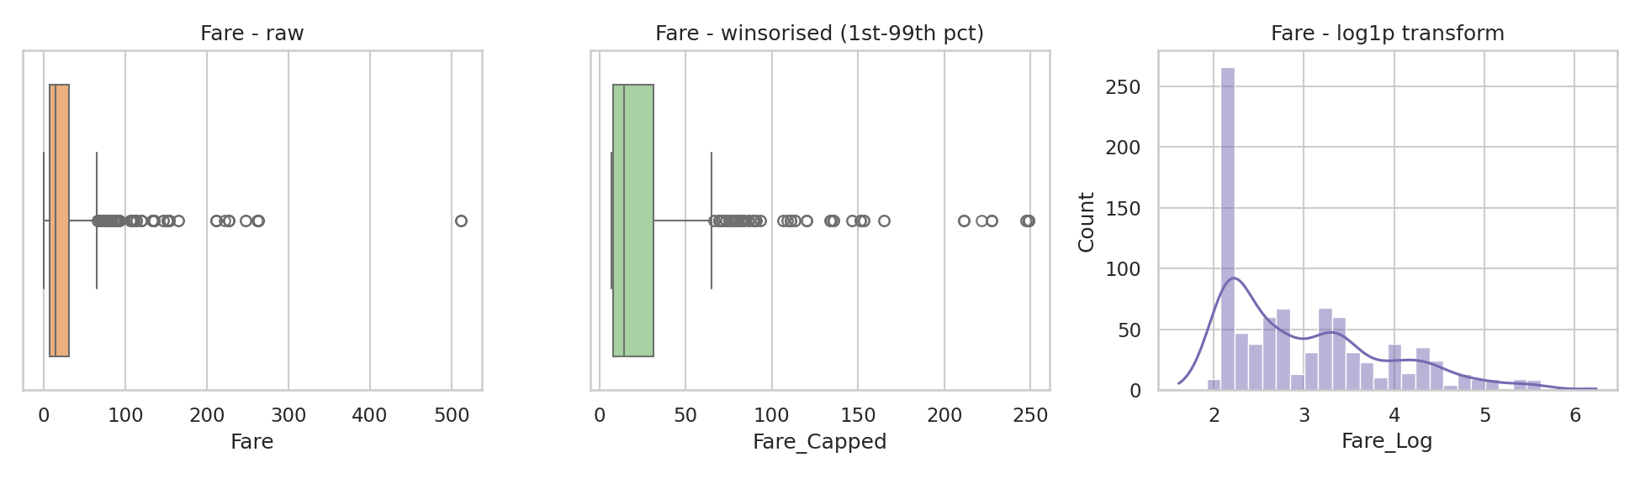
Figure 4: Fare before treatment, after winsorisation, and after log transform

8. Preprocessing and Feature Engineering

8.1 Feature engineering
New features were derived from the existing columns to expose relationships that the raw columns hide.
d["FamilySize"] = d["SibSp"] + d["Parch"] + 1
d["IsAlone"] = (d["FamilySize"] == 1).astype(int)
d["AgeGroup"] = pd.cut(d["Age"], [0,12,18,35,60,120],
labels=["Child","Teen","YoungAdult","Adult","Senior"])
d["AgeGroup"].value_counts()

Feature | Source | Purpose | Note
Title | Name | Social status and age proxy | 5 groups
HasCabin / Deck | Cabin | Capture informative missingness | Deck 'U' = unknown
FamilySize / IsAlone | SibSp, Parch | Group travel effect | IsAlone lowers survival (r = -0.20)
AgeGroup | Age | Non-linear age effect | Child survival 57.5% vs 33.0% young adults
Fare_Log, TicketSize | Fare, Ticket | Reduce skew, group fares | FarePerPerson also kept
Age_Missing, Fare_Zero_Flag | Imputation | Keep track of imputed values | Binary flags

8.2 Encoding categorical variables
Sex is binary and was mapped to 0/1. The nominal variables Embarked, Title and Deck have no natural order, so one-hot encoding was used; integer codes would falsely imply that, for example, port S is greater than port C. Pclass is left numeric because it is genuinely ordinal.
d["Sex_Code"] = d["Sex"].map({"male": 0, "female": 1}).astype(int)
enc = pd.get_dummies(d[["Embarked", "Title", "Deck"]],
prefix=["Emb", "Title", "Deck"], dtype=int)
final = pd.concat([d, enc], axis=1)

8.3 Feature scaling
Age (0-80), log-fare (about 1-6) and family size (1-11) have very different ranges. Scaling matters for distance-based and gradient-based algorithms (KNN, SVM, logistic regression, neural networks) but not for tree models. Age and Fare_Log were standardised (mean 0, standard deviation 1) and FamilySize was min-max scaled to 0-1.
sc, mm = StandardScaler(), MinMaxScaler()
final[["Age_Scaled", "FareLog_Scaled"]] = sc.fit_transform(final[["Age", "Fare_Log"]])
final["FamilySize_MinMax"] = mm.fit_transform(final[["FamilySize"]])

final = final.drop(columns=["Cabin"]) # information kept in HasCabin / Deck
final.to_csv("titanic_cleaned.csv", index=False)

Important caution: in this exploratory report the scalers were fitted on the whole dataset. In a real modelling project the data must first be split into training and test sets and the scalers fitted on the training portion only; otherwise information from the test set leaks into training (data leakage). This is discussed further in Section 11.

9. Validation of the Cleaned Dataset
After processing, the result was checked against the original to confirm that all issues had been resolved and no rows were lost.
print(final.shape)
print(final.isnull().sum().sum())
print(final["Age_Scaled"].mean().round(4), final["Age_Scaled"].std(ddof=0).round(4))

Output:
(891, 44)
0
0.0 1.0

Aspect | Before | After
Rows | 891 | 891 (none deleted)
Columns | 12 | 44 (features added, Cabin removed)
Total missing values | 866 (Age 177, Cabin 687, Embarked 2) | 0
Zero fares | 15 | 0 (imputed and flagged)
Fare skewness | 4.79 | 0.95 (log version)
Text categories | Sex, Embarked, Name, Ticket, Cabin | Numeric and one-hot encoded

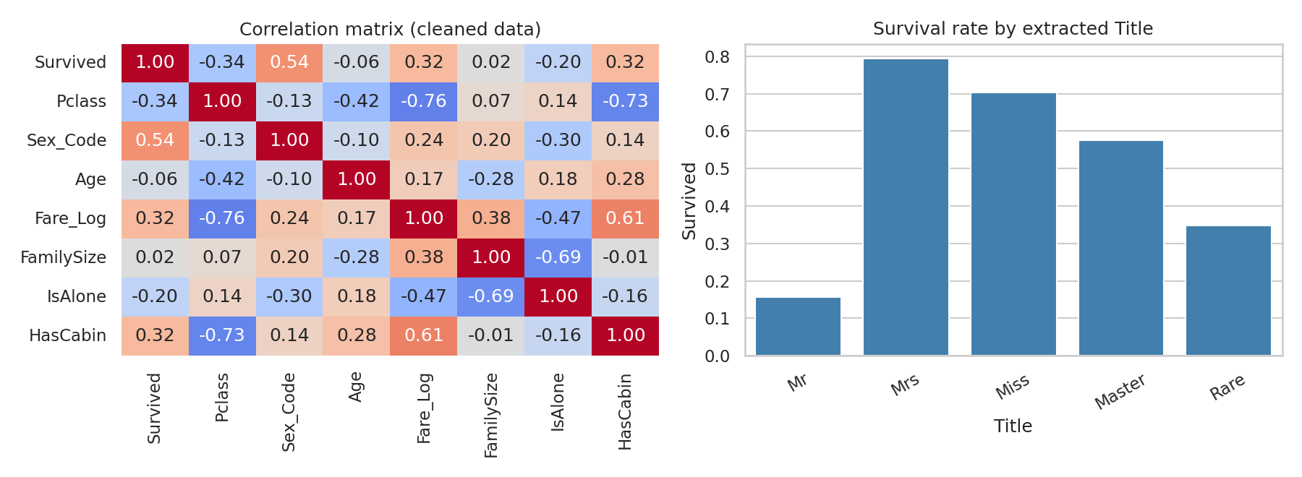
Figure 5: Correlation matrix of the cleaned data and survival rate by extracted Title
The correlations with Survived are sensible and match the historical record: Sex_Code +0.54 (women were prioritised), Pclass -0.34, Fare_Log +0.32, HasCabin +0.32 and IsAlone -0.20. That the engineered features rank alongside the original ones is a useful sign that the preprocessing added real information.
Note: 44 columns are retained so that every step is traceable. Identifier and raw text columns (PassengerId, Name, Ticket) and duplicate representations (for example both Fare and Fare_Log) should be dropped before fitting a model.

10. Impact of Preprocessing on Subsequent Analyses
Every cleaning decision changes the data, and therefore changes the conclusions that can be drawn from it. The main effects are:

Effects of imputation
- Variance shrinks. Median imputation reduced the standard deviation of Age from 14.53 to 13.49, so confidence intervals and significance tests based on Age will look slightly more precise than the evidence justifies.
- Relationships can weaken or be biased if data is not missing completely at random. Age is more often missing for third-class passengers, so the imputation model matters; using Title and Pclass reduces this risk.
- The Age_Missing flag lets models detect that a value was estimated and lets analysts test the sensitivity of results to imputation.

Effects of outlier handling
- Winsorising and log-transforming Fare reduces the leverage of a few very expensive tickets on linear and distance-based models, at the cost of reduced interpretability (coefficients relate to log-fare, not pounds).
- Keeping the original Fare alongside transformed versions means tree-based models and simple descriptive statistics can still use the untouched values.

Effects of encoding and scaling
- One-hot encoding raises dimensionality (12 to 44 columns), which increases the risk of overfitting on a small dataset of 891 rows and introduces perfectly collinear dummies (the dummy-variable trap) that should be handled with drop-first for linear models.
- Scaling is essential for regularised and distance-based models but has no effect on decision trees.

A simple demonstration
To make the impact concrete, the same model (logistic regression with 5-fold cross-validation) was trained on two versions of the data: the naive approach of dropping every row with a missing Age or Embarked value, and the cleaned dataset described in this report.
raw = df.dropna(subset=["Age", "Embarked"]).copy()
raw["Sex"] = raw["Sex"].map({"male": 0, "female": 1})
X_raw = StandardScaler().fit_transform(raw[["Pclass","Sex","Age","SibSp","Parch","Fare"]])
acc_raw = cross_val_score(LogisticRegression(max_iter=1000), X_raw, raw["Survived"], cv=5).mean()

feat = ["Pclass","Sex_Code","Age","SibSp","Parch","Fare_Log",
"FamilySize","IsAlone","HasCabin","Age_Missing"]
X_cl = StandardScaler().fit_transform(final[feat])
acc_cl = cross_val_score(LogisticRegression(max_iter=1000), X_cl, final["Survived"], cv=5).mean()

Approach | Rows used | CV accuracy | Difference
Drop rows with missing values | 712 | 78.65% | baseline
Cleaned and engineered data | 891 | 79.91% | +1.26 points

The cleaned data retains 179 more passengers (20% more data) and gives a modest improvement in accuracy. This is an illustration, not a rigorous benchmark: it uses one algorithm and one split strategy, the scaler was fitted on all rows, and the gain is small enough that it could partly be chance. Its real value is showing that cleaning does not just tidy the data - it changes what a model can learn.

11. Challenges Faced and How They Were Overcome
Challenge | Why it was difficult | Resolution
Very high missingness in Cabin (77%) | Imputation would fabricate most values; dropping loses signal | Extracted HasCabin flag and Deck letter; discovered survival gap of 66.7% vs 30.0%
Choosing an Age imputation method | Global median ignores strong age differences between groups | Extracted Title from Name and imputed by Title x Pclass median, with fallbacks
Telling errors from genuine extremes | Fares of 512 look like typos but are real suite bookings | Traced high fares to shared tickets before deciding; kept rows, transformed values
Zero fares | Could be crew or missing data; ambiguous | Treated as invalid for a paid-fare variable, imputed by class median and flagged
IQR rule failing on Parch | 75% zeros give a zero-width IQR, flagging every non-zero value | Recognised the limitation of the rule on zero-inflated counts; no treatment
Regex title extraction | Rare and foreign titles (Mlle, Jonkheer, the Countess) and inconsistent formats | Tested the pattern on all 891 names and grouped 12 rare titles
Avoiding data leakage | Scaling and imputation statistics computed on all rows | Documented the limitation; recommended sklearn Pipeline with a train/test split for modelling

12. Reflective Commentary
The most important lesson of this exercise is that there is rarely a single correct cleaning decision - each choice trades one risk against another. Dropping the 177 rows with missing Age would have been the quickest option, but it would have discarded 20% of the data and probably biased the sample towards better-documented, higher-class passengers. Imputing preserved the sample but at the price of reduced variance. Neither option is free, which is why the report documents the reasoning and keeps flags that make the choice reversible.
A second lesson concerns domain understanding. The zero fares, the 512 fare and the Cabin missingness could not be resolved by statistics alone; looking at the actual rows (shared tickets, matching cabin numbers, class membership) gave the answers. Automated outlier rules only raise questions - the analyst has to answer them.
Finally, preserving the original columns next to the engineered ones, and encoding every treatment in code, keeps the workflow transparent and reproducible. With more time, the next improvements would be to (1) rebuild the steps inside a scikit-learn Pipeline and ColumnTransformer so fitting happens only on training data, (2) compare imputation strategies such as KNN or iterative imputation against the group-median approach, and (3) test the sensitivity of a model to each cleaning decision.

13. Conclusion
The raw Titanic dataset contained 866 missing values across three columns, 15 implausible zero fares, heavily skewed numeric data, and text fields unsuitable for modelling. Through a documented and reproducible Python pipeline these were resolved without deleting a single record: Embarked was imputed from context, Cabin was converted into informative features, Age was imputed with title- and class-aware medians, zero fares were corrected, extreme fares were transformed rather than removed, and categorical and numeric variables were encoded and scaled. The final dataset has 891 rows, 44 columns and no missing values, and behaves sensibly in a basic model. The main caveats - reduced variance after imputation and the need to fit transformers on training data only - are stated so that later analyses can account for them.

Appendix A: Complete Consolidated Script
The complete pipeline below reproduces every result in this report end to end.
# titanic_cleaning.py - consolidated pipeline (condensed)
import pandas as pd, numpy as np
from sklearn.preprocessing import StandardScaler, MinMaxScaler
df = pd.read_csv("https://raw.githubusercontent.com/datasciencedojo/datasets/master/titanic.csv")
d = df.copy()

# 1. Standardise text
for c in ["Sex", "Embarked"]:
d[c] = d[c].astype("string").str.strip()
d["Sex"] = d["Sex"].str.lower(); d["Embarked"] = d["Embarked"].str.upper()

# 2. Titles
d["Title"] = d["Name"].str.extract(r",\s*([^\.]+)\.", expand=False).str.strip()
title_map = {"Mlle":"Miss","Ms":"Miss","Mme":"Mrs","Lady":"Rare","the Countess":"Rare",
"Sir":"Rare","Don":"Rare","Dona":"Rare","Jonkheer":"Rare","Capt":"Rare","Col":"Rare",
"Major":"Rare","Dr":"Rare","Rev":"Rare"}
d["Title"] = d["Title"].replace(title_map)

# 3. Missing values
d["Embarked"] = d["Embarked"].fillna(d["Embarked"].mode()[0])
d["HasCabin"] = d["Cabin"].notna().astype(int)
d["Deck"] = d["Cabin"].str[0].fillna("U")
d["Age_Missing"] = d["Age"].isna().astype(int)
d["Age"] = d["Age"].fillna(d.groupby(["Title","Pclass"])["Age"].transform("median"))
d["Age"] = d["Age"].fillna(d.groupby("Title")["Age"].transform("median"))
d["Age"] = d["Age"].fillna(d["Age"].median())

# 4. Erroneous fares and outliers
d["Fare_Zero_Flag"] = (d["Fare"] == 0).astype(int)
d.loc[d["Fare"] == 0, "Fare"] = np.nan
d["Fare"] = d["Fare"].fillna(d.groupby("Pclass")["Fare"].transform("median"))
d["TicketSize"] = d.groupby("Ticket")["PassengerId"].transform("count")
d["FarePerPerson"] = d["Fare"] / d["TicketSize"]
lo, hi = d["Fare"].quantile([.01, .99])
d["Fare_Capped"] = d["Fare"].clip(lo, hi)
d["Fare_Log"] = np.log1p(d["Fare"])

# 5. Feature engineering
d["FamilySize"] = d["SibSp"] + d["Parch"] + 1
d["IsAlone"] = (d["FamilySize"] == 1).astype(int)
d["AgeGroup"] = pd.cut(d["Age"], [0,12,18,35,60,120],
labels=["Child","Teen","YoungAdult","Adult","Senior"])

# 6. Encoding and scaling
d["Sex_Code"] = d["Sex"].map({"male": 0, "female": 1}).astype(int)
enc = pd.get_dummies(d[["Embarked","Title","Deck"]], prefix=["Emb","Title","Deck"], dtype=int)
final = pd.concat([d, enc], axis=1)
final[["Age_Scaled","FareLog_Scaled"]] = StandardScaler().fit_transform(final[["Age","Fare_Log"]])
final["FamilySize_MinMax"] = MinMaxScaler().fit_transform(final[["FamilySize"]])
final = final.drop(columns=["Cabin"])

# 7. Validate and save
assert final.isnull().sum().sum() == 0
final.to_csv("titanic_cleaned.csv", index=False)

References
- Kaggle. Titanic - Machine Learning from Disaster (competition dataset). https://www.kaggle.com/c/titanic
- Data Science Dojo. Public dataset repository (Titanic CSV mirror). https://github.com/datasciencedojo/datasets
- pandas development team. pandas documentation. https://pandas.pydata.org/docs/
- scikit-learn developers. Preprocessing data (StandardScaler, MinMaxScaler, Pipeline). https://scikit-learn.org/stable/modules/preprocessing.html
- Tukey, J. W. (1977). Exploratory Data Analysis. Addison-Wesley. (Source of the 1.5 x IQR outlier rule)

