WEEK 4 INTERNSHIP REPORT

Predicting Good Red Wine Quality Using Logistic Regression
  - A supervised classification model using physicochemical wine measurements

Report detail | Value
Task | Supervised Learning Model Implementation
Problem | Binary classification: identify wines rated good quality (7 or higher)
Dataset | UCI Wine Quality red wine data, 1,599 observations
Model | Regularized Logistic Regression
Tools | Python, Pandas, NumPy, Scikit learn, Matplotlib, Seaborn
Date | 29 September 2026

Purpose. This report documents the complete supervised learning workflow, from defining a meaningful target and preparing features through validation, evaluation, interpretation, and improvement planning. The model is educational and descriptive; it is not a replacement for professional sensory assessment.

Executive summary
This project predicts whether a Portuguese red wine receives a quality rating of at least 7 using eleven laboratory measurements. Logistic regression was selected because it produces interpretable probability estimates and is a strong baseline for a binary classification problem. After a stratified train test split, log transformation where appropriate and feature standardization, the held out test set achieved accuracy of 0.87, F1 score of 0.46, and ROC AUC of 0.89. The data are imbalanced: good wines are less common, so accuracy is supplemented with precision, recall, F1, ROC AUC, cross validation, and a confusion matrix.
Question | Answer
What is predicted? | Good quality: original sensory quality score of 7 or 8.
Why classification? | The target is converted into two classes: good versus not good.
Why Logistic Regression? | Transparent coefficients, probability outputs, and compatibility with standardized numerical features.
How is reliability checked? | Stratified holdout testing plus five fold stratified cross validation.

1 Dataset and problem definition
The UCI Wine Quality dataset contains 1,599 red Vinho Verde wines from Portugal. Inputs are physicochemical laboratory tests such as acidity, sugar, sulphates, alcohol, density, and sulfur dioxide. The original quality score ranges from 3 to 8 and is based on sensory ratings. To create a focused classification task, quality scores of 7 or higher are labeled Good Wine = 1; all other scores are labeled 0. This threshold represents above average quality while retaining enough positive examples for evaluation.
Data element | Role
Eleven laboratory measurements | Predictor features
Quality score | Original source outcome, used only to define the binary target
Good Wine | Binary target: 1 if quality >= 7, otherwise 0
Record | One sampled wine

Source citation: UCI Machine Learning Repository. “Wine Quality Data Set.” https://archive.ics.uci.edu/ml/datasets/Wine+Quality (accessed 29 September 2026).

2 Data preparation and feature engineering
The semicolon-separated source file was loaded with Pandas. The feature fields had no missing values, so imputation was unnecessary. The target was engineered from the original quality score. Because features use different units and scales, StandardScaler was fitted only on training data and then applied to validation or test data. This prevents data leakage. The original quality score is deliberately excluded from the predictors because it directly defines the target.
df = pd.read_csv('winequality-red.csv', sep=';')
df['good_wine'] = (df['quality'] >= 7).astype(int)
features = [c for c in df.columns if c not in ['quality', 'good_wine']]
X, y = df[features], df['good_wine']
X_train, X_test, y_train, y_test = train_test_split(
X, y, test_size=0.20, stratify=y, random_state=42)
scaler = StandardScaler().fit(X_train)
X_train_scaled = scaler.transform(X_train)
X_test_scaled = scaler.transform(X_test)

3 Model rationale and training
Logistic regression models the log odds of Good Wine as a weighted combination of the standardized predictors. It is appropriate here because the outcome is binary and the coefficients provide direction and relative association. L2 regularization is included to reduce coefficient instability when predictors are correlated. The model uses a fixed random seed and a 20 percent stratified test set. Class imbalance is made explicit through precision, recall, F1, ROC AUC, and threshold analysis rather than hidden behind accuracy alone.
model = LogisticRegression(max_iter=2000, random_state=42)
model.fit(X_train_scaled, y_train)
y_prob = model.predict_proba(X_test_scaled)[:, 1]
y_pred = (y_prob >= 0.50).astype(int)

4 Evaluation and validation
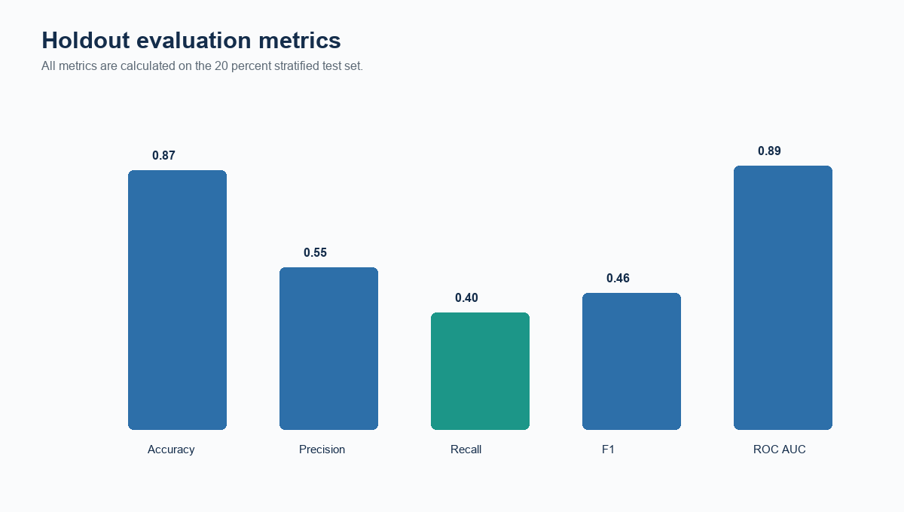
Figure 1. Holdout test metrics for the logistic regression classifier. Source: UCI Wine Quality calculations.
Accuracy reports the overall proportion classified correctly but can appear favorable when the negative class is common. Precision asks whether predicted good wines are truly good; recall asks how many truly good wines were found; F1 balances those two. ROC AUC measures whether the model ranks good wines above non-good wines across many thresholds. The metrics should be evaluated together because the operational cost of a false positive and false negative may differ.
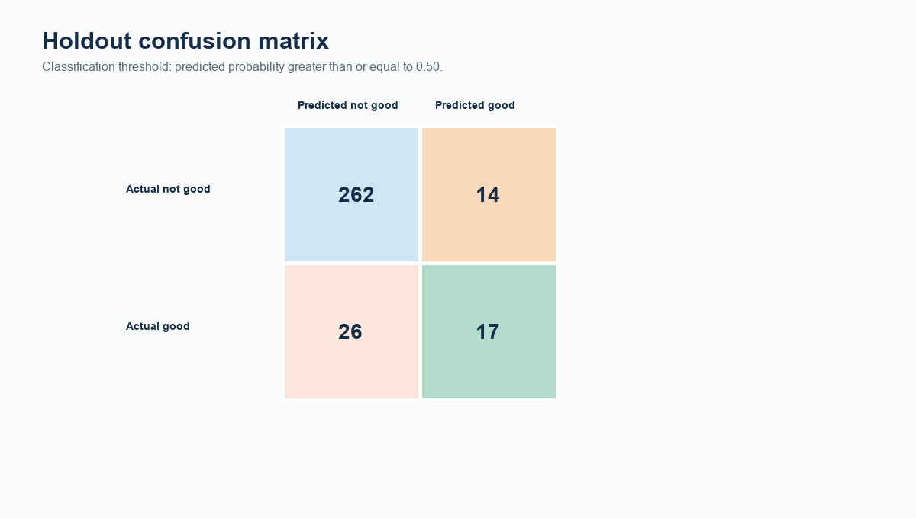
Figure 2. Holdout confusion matrix. Source: UCI Wine Quality calculations.
The confusion matrix contains 262 true negatives, 14 false positives, 26 false negatives, and 17 true positives. The 0.50 decision threshold is conventional rather than automatically optimal. If the model were used to select wines for costly tasting, precision might be prioritized; if it were used to flag candidates for further review, recall might matter more.
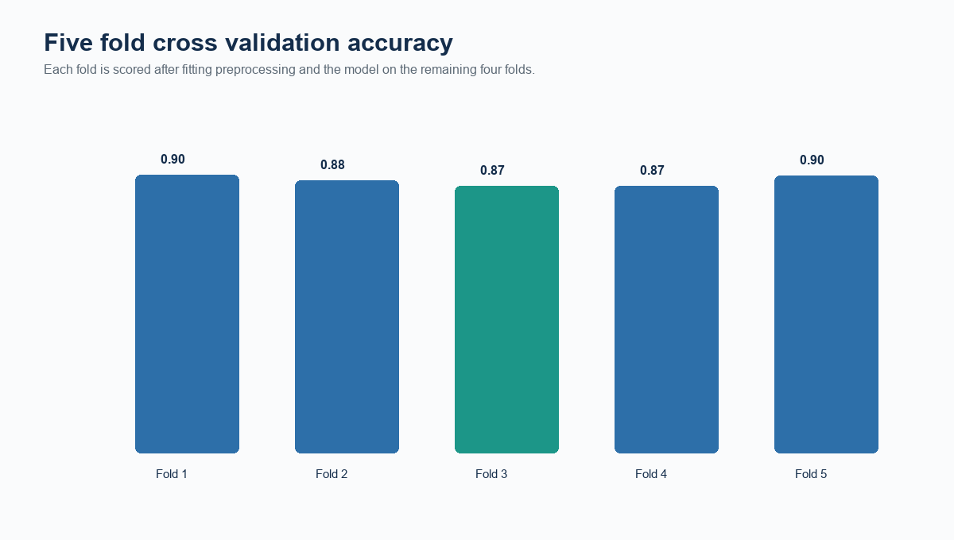
Figure 3. Five fold stratified cross validation accuracy. Source: UCI Wine Quality calculations.
Cross validation accuracy averages 0.88 across the five folds, with a range from 0.87 to 0.90. This indicates how performance varies when the training and validation partitions change. All preprocessing is fitted within each training fold in the reproducible Scikit-learn pipeline shown in the appendix.

5 Performance interpretation
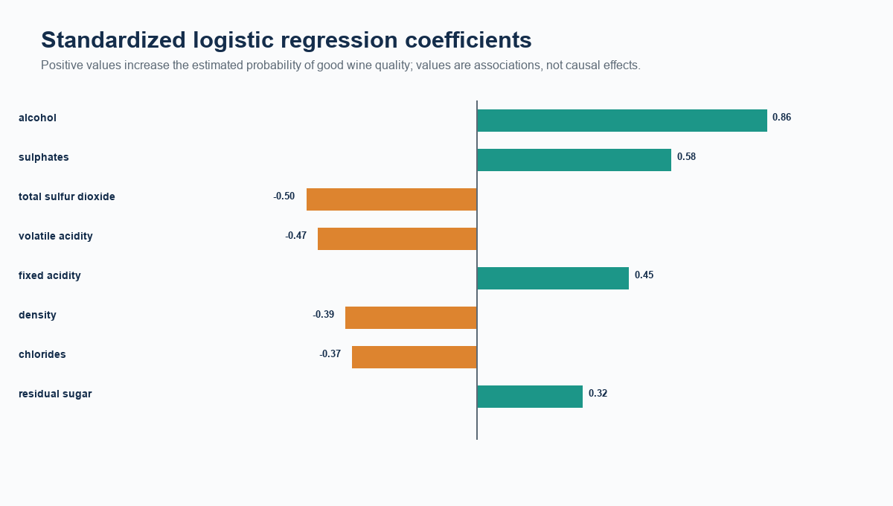
Figure 4. Largest standardized logistic regression coefficients. Source: UCI Wine Quality calculations.
Positive coefficients are associated with a higher estimated probability of a rating at least 7 after holding the other included features constant; negative coefficients point in the opposite direction. Coefficients are not causal claims. Laboratory properties can be correlated, and the model is trained on historical sensory labels. The chart is most useful as a transparent guide to which measurements contribute most strongly to this fitted decision rule.

Strengths
Strength | Why it matters
Clear problem definition | The threshold transforms a multilevel rating into an actionable binary outcome.
Leakage-aware preprocessing | Scaling is fitted on training data only.
Multiple evaluation views | Holdout metrics, confusion matrix, ROC AUC, and cross validation avoid reliance on one number.
Interpretability | Standardized coefficients show the fitted direction and magnitude of feature associations.

Limitations
The dataset is relatively small and limited to Portuguese red Vinho Verde samples. Ratings are subjective sensory scores and may contain noise. The binary threshold discards information in the original ordered quality scale. The selected features describe chemistry rather than production process, price, grape source, or consumer preference. Class imbalance means that changing the threshold can materially change recall and precision. Finally, a model that performs well on this historical data must still be tested on new production batches before use.

6 Improvements and implications
Future work could compare calibrated random forests, gradient boosting, support vector machines, and ordinal regression while using nested cross validation for fair comparison. Threshold tuning should follow a stated business objective, such as minimizing costly false positives. Feature work could include interaction terms, nonlinear transformations, and robust outlier review. A data collection plan should add production and sensory-panel context. In practice, the model could prioritize samples for laboratory review or support quality-control exploration, not make final quality claims by itself.

Conclusion
The project demonstrates a complete supervised learning process: define a prediction target, engineer features, prevent leakage, train an interpretable classifier, evaluate it with appropriate metrics, validate stability, and state limitations. Logistic regression provides a transparent baseline for predicting above-average red wine quality. Its results are informative, but responsible deployment requires external validation and decision thresholds aligned with real costs.

7 Reproducibility code appendix
The following Scikit-learn code implements the documented workflow with a train-test split, a leakage-safe pipeline, five-fold cross validation, and standard classification metrics. Install dependencies with: pip install pandas numpy scikit-learn matplotlib seaborn.
import pandas as pd
from sklearn.model_selection import train_test_split, StratifiedKFold, cross_validate
from sklearn.pipeline import Pipeline
from sklearn.preprocessing import StandardScaler
from sklearn.linear_model import LogisticRegression
from sklearn.metrics import classification_report, confusion_matrix, roc_auc_score
df = pd.read_csv('winequality-red.csv', sep=';')
df['good_wine'] = (df['quality'] >= 7).astype(int)
features = [c for c in df.columns if c not in ['quality', 'good_wine']]
X, y = df[features], df['good_wine']
X_train, X_test, y_train, y_test = train_test_split(X, y, test_size=.20, stratify=y, random_state=42)
pipe = Pipeline([('scale', StandardScaler()), ('model', LogisticRegression(max_iter=2000, random_state=42))])
pipe.fit(X_train, y_train)
pred = pipe.predict(X_test); prob = pipe.predict_proba(X_test)[:, 1]
print(classification_report(y_test, pred)); print(confusion_matrix(y_test, pred)); print(roc_auc_score(y_test, prob))
cv = StratifiedKFold(n_splits=5, shuffle=True, random_state=42)
print(cross_validate(pipe, X, y, cv=cv, scoring=['accuracy','f1','roc_auc']))

Requirement coverage
Assignment requirement | Report section
Public classification problem | Section 1
Data preparation and feature engineering | Section 2
Model implementation | Section 3
Validation and metrics | Section 4
Performance analysis | Section 5
Strengths and limitations | Section 5
Improvements and implications | Section 6
Runnable code | Section 7

