LinkedIn Post — TestForge AI
Caption ready to paste. Attach the two images below (how-to + results screenshot).

LinkedIn caption
Meet TestForge AI — the AI Test Analyst I built end-to-end 🧪

As a QA professional, I know the most tedious part of testing is turning requirements into test cases by hand. So I built TestForge AI — an AI Test Analyst powered by crewAI and Groq's gpt-oss-120b: paste requirements or upload a requirements document, and it writes structured test cases with preconditions, steps, and expected results in seconds. I wrapped it in a Streamlit app where testers review everything in a clean table, mark each case Pass/Fail/Blocked, and export the suite as a Word document. Building it meant owning the full journey — integrating LLMs, debugging environment and token limits, and refining the UI from real usage. The result is a complete tool: requirements file in, export-ready test suite out. If you're looking for someone who pairs QA expertise with hands-on AI and Python development, let's connect. #QA #SoftwareTesting #TestAutomation #AI #Python #CrewAI #GenAI

How-to visual (numbered steps 1–3, upload note between 1 and 2)
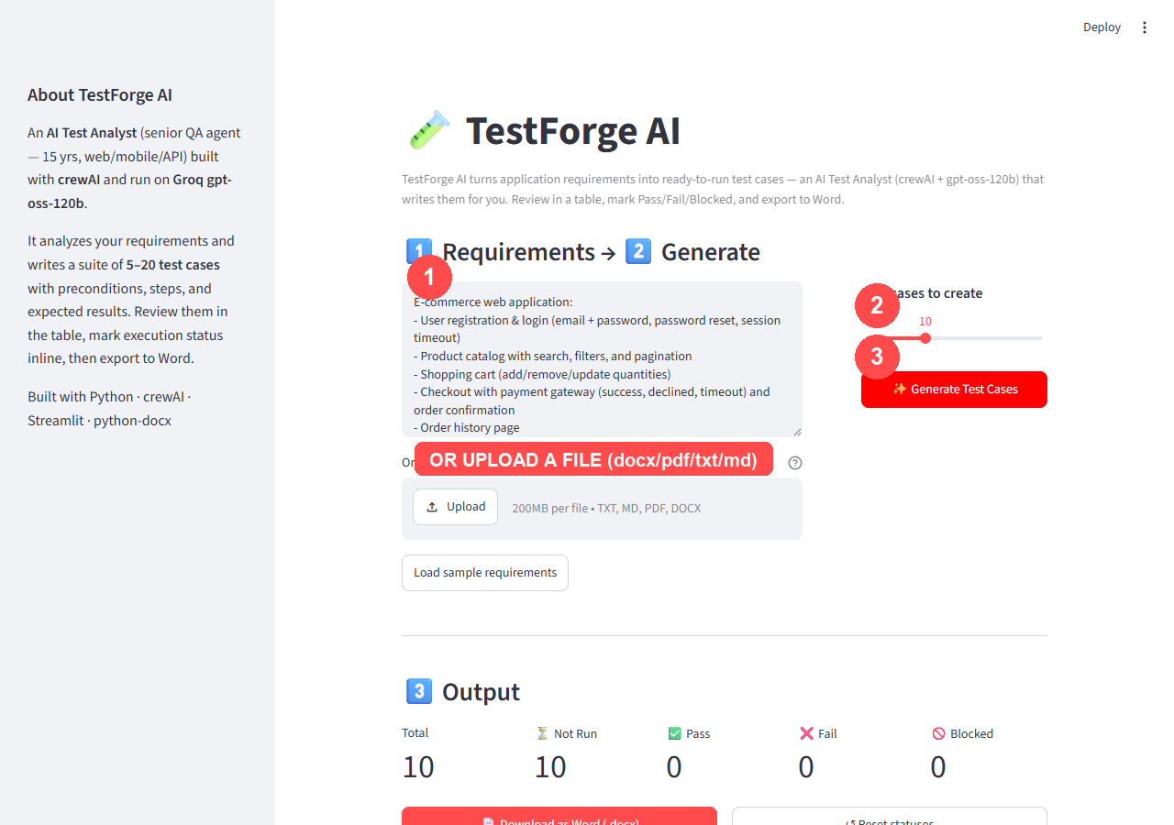

Results visual (step 4: live Pass/Fail tracking)
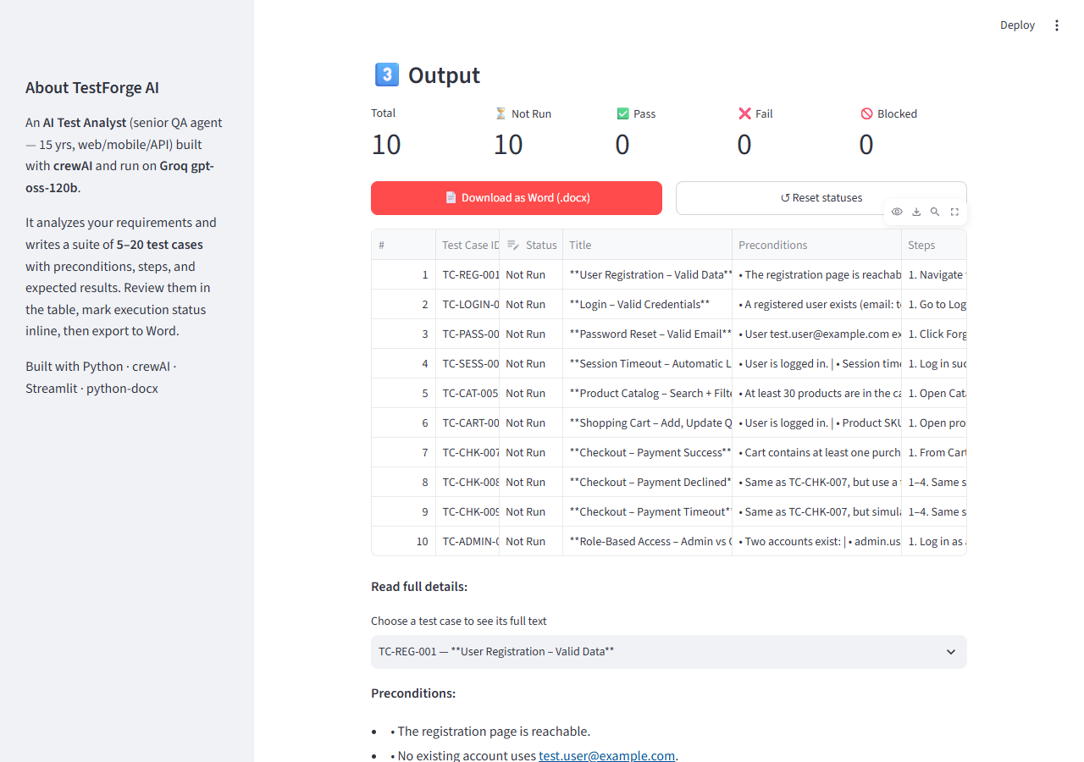

Posting checklist
HOW TO POST:
1. Open LinkedIn and click “Start a post”.
2. Paste the caption text (from the “LinkedIn caption” section below).
3. Attach the two images below — app_home_howto.png and app_result_interactive.png.
4. Preview, then publish (or schedule).

Run the app yourself:
cd Crew.AI
.venv\Scripts\python.exe -m streamlit run app.py
Then paste requirements or upload a file, pick a count, and hit Generate.

