TestForge AI
LinkedIn post — caption, visuals & posting notes

Caption (copy-paste)
Meet TestForge AI — the AI Test Analyst I built end-to-end 🧪
As a QA professional, I know the most tedious part of testing is turning requirements into test cases by hand. So I built TestForge AI — an AI Test Analyst powered by crewAI and Groq’s gpt-oss-120b: paste requirements or upload a requirements document, and it writes structured test cases with preconditions, steps, and expected results in seconds.
I wrapped it in a Streamlit app where testers review everything in a clean table, mark each case Pass/Fail/Blocked, and export the suite as a Word document.
Building it meant owning the full journey — integrating LLMs, debugging environment and token limits, and refining the UI from real usage. The result is a complete tool: requirements file in, export-ready test suite out.
If you’re looking for someone who pairs QA expertise with hands-on AI and Python development, let’s connect.
#QA #SoftwareTesting #TestAutomation #AI #Python #CrewAI #GenAI

Visuals to attach
1. App flow — paste/upload requirements, pick count, generate
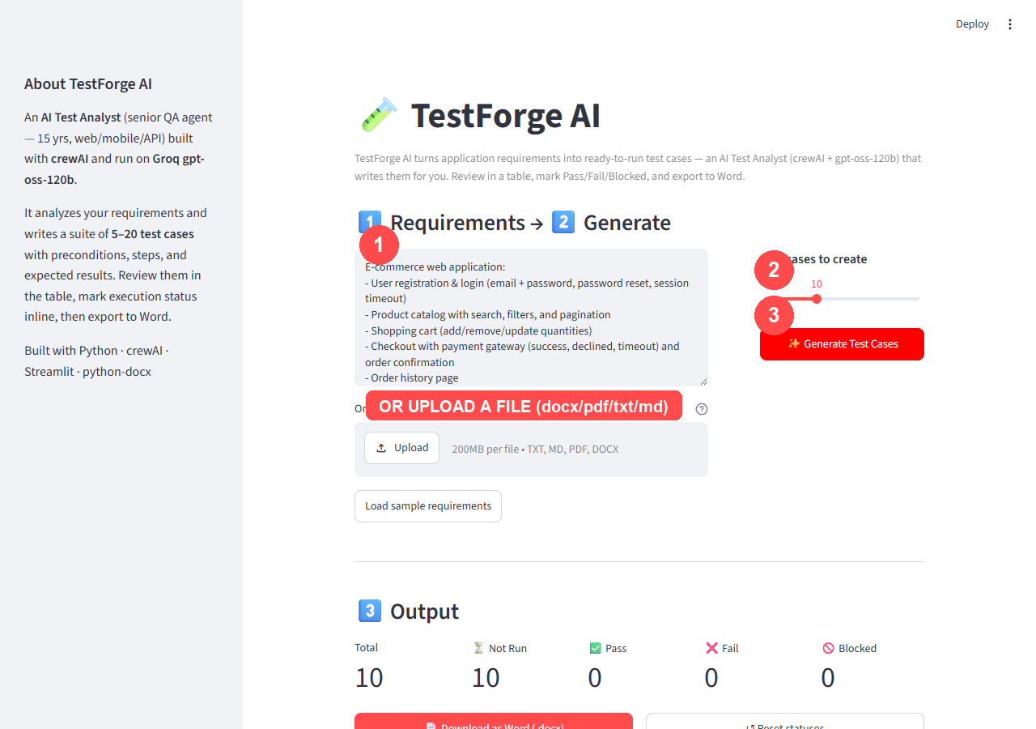
2. Generated suite — table with live Pass/Fail/Blocked status
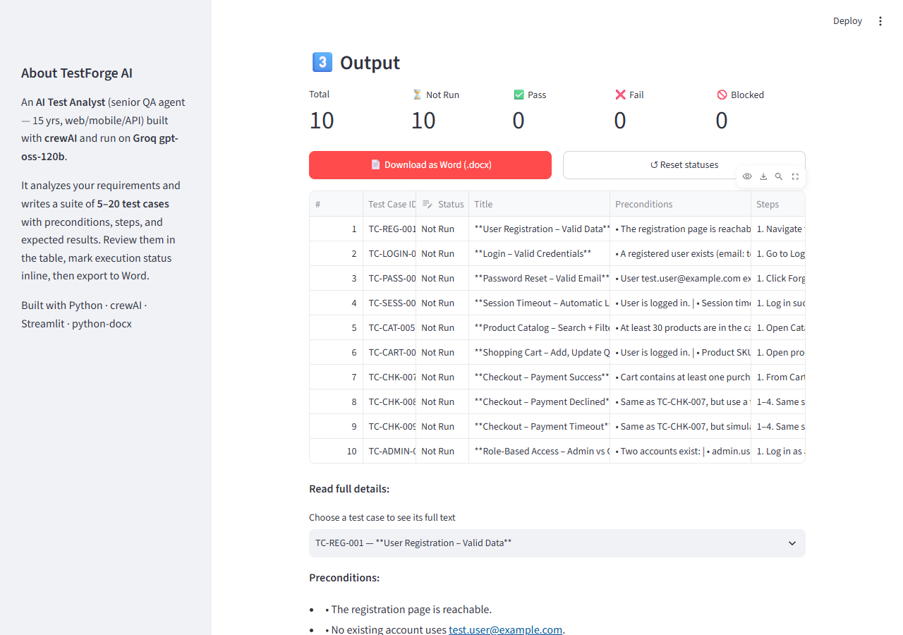
Optional: attach the demo video “TestForge_Demo.mp4” (same folder) for a moving demo.

Posting notes
- Open LinkedIn → “Start a post”.
- Paste the caption (start with the bold heading line, then the paragraphs).
- Attach the two images above (and optionally the demo video).
- Preview, then publish or schedule.

