**Obstacle Avoiding Robot**

**By Chethan**

**4nm19me025@nmamit.in**

**ABSTRACT**

The industry for autonomous vehicles is growing. According to studies nine out of ten traffic accidents are due to the human factor, if the safety can get good enough in autonomous cars they have the potential to save thousands of lives every year. But obstacle detecting autonomous robots can be used in other situations as well, for example where the terrain is inaccessible for humans because of different reasons. In this project, a self-navigating obstacle detecting robot was made. The robot uses ultrasonic sensors to detect obstacles and avoid them. An algorithm of the navigation of the robot was created and implemented to the Arduino. For driving the wheels, two dc motors were used. The robot consists of four wheels, two in the back and two in the front to which the dc motors were attached. This made it possible to implement differential drive which enabled quick and tight turns. The placement of the sensor worked well. Improvements in detection of obstacles could have been made if more sensors had been used. The tests also confirmed that ultrasonic sensors work good for this kind of task.

**CONTENTS**

1. Introduction . . . . . . . . . . . . . . . . . . . . . . . . . . . . . . . . . . . . . . . . . . . 1
2. Methodology. . . . . . . . . . . . . . . . . . . . . . . . . . . . . . . . . . . . . . . . . . . 1- 4
   1. Ultrasonic sensors . . . . . . . . . . . . . . . . . . . . . . . . . . . . . . . 1-2
   2. DC motors . . . . . . . . . . . . . . . . . . . . . . . . . . . . . . . . . . . . 2
   3. Breadboard and jumper wires. . . . . . . . . . . . . . . . . . . . . . 2
   4. Arduino . . . . . . . . . . . . . . . . . . . . . . . . . . . . . . . . . . . . . . . 3
   5. Motor Driver (L293D) & Battery. . . . . . . . . . . . . . . . . . . 3
   6. Algorithm . . . . . . . . . . . . . . . . . . . . . . . . . . . . . . . . . . . . . 3-4
3. Implementation. . . . . . . . . . . . . . . . . . . . . . . . . . . . . . . . . . . . . . . . . 4-5
4. Conclusion . . . . . . . . . . . . . . . . . . . . . . . . . . . . . . . . . . . . . . . . . . . . 5
5. Reference. . . . . . . . . . . . . . . . . . . . . . . . . . . . . . . . . . . . . . . . . . . . . . 6

**INTRODUTION**

An obstacle avoiding robot is an intelligent device, which can automatically sense and overcome obstacles on its path. Obstacle Avoidance is a robotic discipline with the objective of moving vehicles on the basis of the sensorial information. The use of these methods to that of classic methods (path planning) is a natural alternative when the scenario is dynamic with an unpredictable behaviour. In these cases, the surroundings do not remain invariable, and thus the sensory information is used to detect the changes consequently adapting moving. It will automatically scan the surrounding for further path.

**METHODOLOGY**

The obstacle avoiding systems are the most advanced systems which are readily used in the industries in the material handling units. These robots are equipped with different sensors, actuators and controlling unit. The model created for this project has the following units,

* Arduino Uno
* Ultrasonic Sensor (HC-SR04)
* Motor Driver IC (L293D)
* DC Motor with gear System
* Battery Unit
* Breadboard
* Jumper Wires

**Ultrasonic sensors**

When there is a necessity of short-range distance measurement between a moving object and obstacles that may appear around it, ultrasonic sensors are a good alternative. They are cheap but not the most precise. Ultrasonic sensors measure distance by transmitting pulses of ultrasonic sound-waves which propagates through the air and is reflected and received by the sensor when there is an object in front of them. If there is an object in front 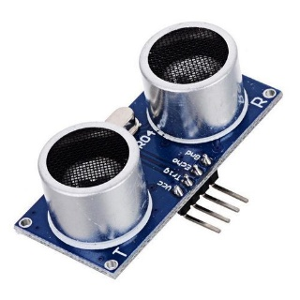of the sensor, the sound-waves reflects and returns to the receiver. One problem with them is that if the object in front of the sensor is tilted relative to the sensor’s transceiver, only such a small amount of the sound-wave will be reflected back to the sensor that the object won’t be detected. This can also cause problems with the measured distance, if the area where the sound-waves hits the object is a little bit tilted the distance may be detected as longer or shorter than it actually is. To calculate the distance between the object on which the sensor is placed and the obstacle, the following equation can be used.

D = $\frac{vt}{2}$

Where, D is the distance,

*t* is the time and *‘v’* is the speed of sound.

It is divided by two because the time is measured from when the signal is transmitted from the sensor to when it is received and in that time the sound-waves have travelled the distance twice, back and forth. What makes the calculations less accurate is the value of the speed of sound. Since the speed of sound depends on temperature it is not ideal to use the same value all the time. What could be made to improve this is using a temperature sensor and constantly update the value of speed.

**DC motors with gear unit**

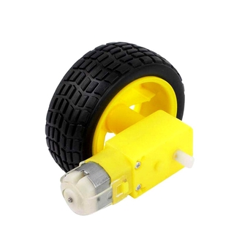DC motors are those class of rotary electrical motors that converts direct current (DC) electrical energy into mechanical energy. The most common types rely on the forces produced by magnetic fields. Nearly all types of DC motors have some internal mechanism, either electromechanical or electronic, to periodically change the direction of current in part of the motor. DC motors were the first form of motor widely used, as they could be powered from existing direct-current lighting power distribution systems. A DC motor's speed can be controlled over a wide range, using either a variable supply voltage or by changing the strength of current in its field windings. The motors used for this project contains a gear system at he front of the motor which reduces the speed of the motor to the required speed with specified gear ratio.

**Breadboard and Jumper Wires**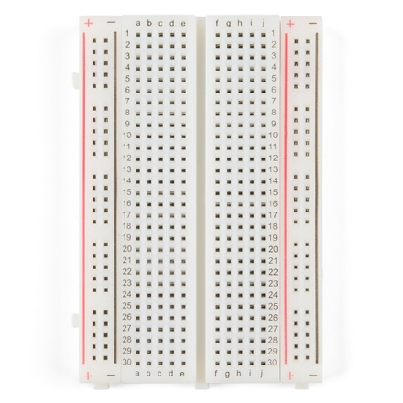

A breadboard is a rectangular plastic board with a bunch of tiny holes in it. These holes let you easily insert electronic components to prototype (meaning to build and test an early version of) an electronic circuit, like this one with a battery, switch, resistor, and an LED (light-emitting diode).

****A jump wire is an electrical wire, or group of them in a cable, with a connector or pin at each end, which is normally used to interconnect the components of a breadboard or other prototype or test circuit, internally or with other equipment or components, without soldering. Individual jump wires are fitted by inserting their "end connectors" into the slots provided in a breadboard, the header connector of a circuit board, or a piece of test equipment.

**Arduino UNO**

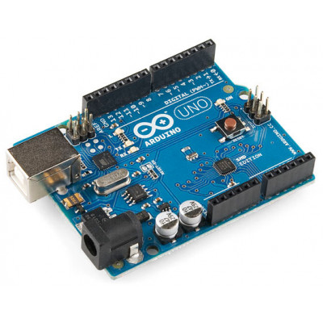The microcontroller used in this project is an Arduino Uno. Arduino is an opensource platform. The Arduino boards are easily programmed on the Arduino Software (IDE). Arduino Uno is based on the microcontroller ATmega328P which has a flash memory of 32 kB. It has 14 digital input/output pins and six of these can be used as PWM outputs. The board can be connected to a computer with a Universal Serial Bus (USB) cable to power it or to an external power supply, the recommended voltage input is 7-12 V. If it is powered with less than 7 V it may become unstable and more than 12 V may cause the voltage regulator to overheat and damage the board.

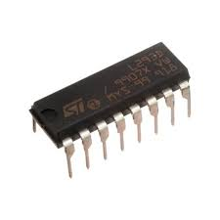**Motor Driver (L293D) & Battery**

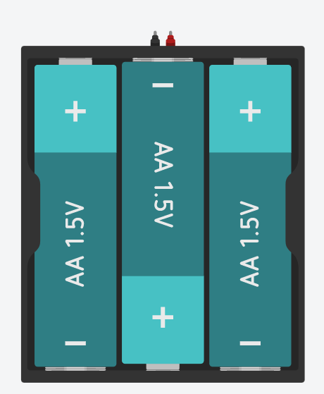The L293D is quadruple high-current half-H drivers. It is designed to provide bidirectional drive currents of up to 600-mA at voltages from 4.5 V to 36 V. Both devices are designed to drive inductive loads such as relays, solenoids, dc and bipolar stepping motors, as well as other high-current/high-voltage loads in positive-supply applications. All inputs are TTL compatible. Each output is a complete totem-pole drive circuit, with a Darlington transistor sink and a pseudo- Darlington source. Drivers are enabled in pairs, with drivers 1 and 2 enabled by 1,2EN and drivers 3 and 4 enabled by 3,4EN. When an enable input is high, the associated drivers are enabled, and their outputs are active and in phase with their inputs. When the enable input is low, those drivers are disabled, and their outputs are off and in the high-impedance state. With the proper data inputs, each pair of drivers forms a full-H (or bridge) reversible drive suitable for solenoid or motor applications.

Battery unit is source of power for the circuit. It consists of a slot for three cells. Each cell of 1.5 volts. It can provide voltage between 4-5 volts.

**Algorithm**

A flowchart was created to describe the algorithm that the robot uses. The flowchart can be seen in figure 1.1. The robot started with driving forward. If it encountered an obstacle in front of its path it checked if there was an obstacle to the right, if not it turned 90° to the right and then continued to drive forward. In the occasion it was an obstacle to the right as well the robot checked to its left and if there was no obstacle there it would turn 90° left and continue forward. In the case where there were obstacles both in front and to both sides the robot would 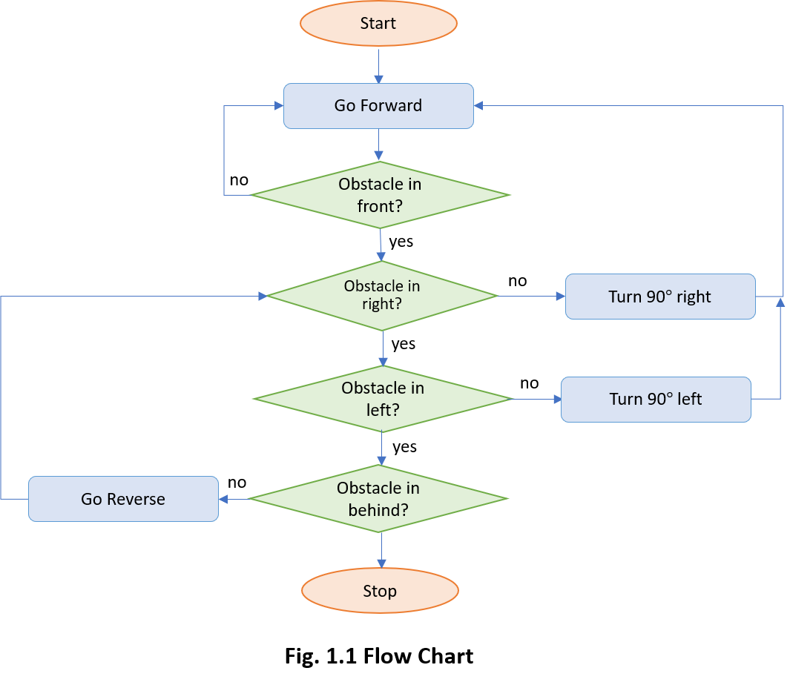check behind and if the way was free there it would reverse and then again check its right and left sides. If a situation occurred where there were obstacles all around the robot the motors would stop and the robot would have to be moved manually.

**IMPLIMENTAION**

The circuit diagram of the robot is shown in fig 2.1. Arduino is the main processing unit of the robot. Out of the 14 available digital I/O pins, 10 pins are used in this project design. The ultrasonic sensor has 3 pins: Vcc, Gnd and Sig. Vcc and Gnd are connected to the +5v and GND pins of the Arduino. Sig (Signal Pin) of front, right, back and left ultrasonic sensors are connected to 10,11,5 and 6th pins of Arduino UNO respectively. Four DC motors are connected to Arduino via 2 L293D motor driver. Each motor driver for two DC motors. L293D is a 16 pin IC. Pins 1 and 9 are the enable pins. These pins are connected to +5V. Pins 13 and 8 are control inputs from microcontroller for left-side motors and pins 7 and 4 are control inputs for right-side motors. Pins 4, 5, 12 and 13 of L293D are ground pins and are connected to Gnd. The 16th pin of L293D is Vcc1. This is connected to +5V. The 8th pins are Vcc2. This is the motor supply voltage. This can be connected anywhere between 4.7V and 36V. In this project, pin 8 if L293D is connected to +5V supply. The enable pins (ENA, ENB) of the L293D IC are connected to 9 and 3 digital pins of Arduino where output pins 9 and 3 are both PWM-enabled. The output pins 3 and 6 of first and second L293D are connected to motor1 and motor4 respectively and pins 11 and 14 of first and second L293D are connected to motor2 and motor3 respectively. The power is supplied to the Arduino by a battery set of 5V.

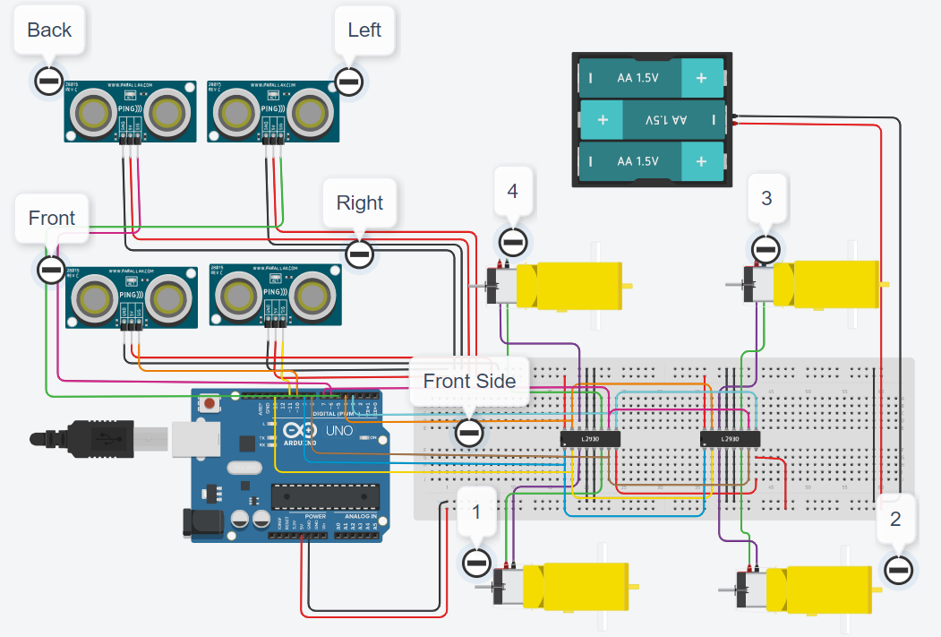

**Fig 2.1 Robot Circuit.**

When the robot is powered on, both the motors of the robot will run normally and the robot moves forward. During this time, the ultrasonic sensor continuously calculates the distance between the robot and the reflective surface. This information is processed by the Arduino. If the distance between the robot and the obstacle is less than 15cm, the Robot turns to right. If the distance towards the right side is less than 15cm, it turns to left side and then same followed for backward. If the condition becomes false, i.e. distance id greater than 15cm then the robot continues to follow the direct which is currently facing. The necessary speed is set for the motors by the Arduino with enable pins of motor driver. The values of the enable pin varies between 0 to 225. When the value of the enable pin is 255, the motors rotates with maximum speed and stops for 0 input and varies linearly between this range.

**CONCLUSION**

Obstacle avoiding robots can be used in almost all mobile robot navigation systems. They can be used for household work like automatic vacuum cleaning. They can also be used in dangerous environments, where human penetration could be fatal.  In conclusion, an obstacle detection circuit was successfully implemented using ultrasonic sensor modules which were placed at the front of the robot to throw sound waves at any obstacle and when a reflection is received, a low output is sent to the Arduino microcontroller which interprets the output and makes the robot to act.

**REFERENCE**

* <https://lastminuteengineers.com/l293d-dc-motor-arduino-tutorial/>
* <https://www.arduino.cc/>
* https://www.tinkercad.com/learn/circuits/learning