

Measurement of Tool Point Temperature

**Department of Mechanical Engineering**

**Metrology and Measurement**

**19ME504**

**Problem based Learning**

|  |  |
| --- | --- |
| Tejas Baliga | 4NM19ME023 |
| Charan | 4NM19ME024 |
| Chethan | 4NM19ME025 |
| Chethan K | 4NM19ME026 |

Instructor: *TR Venugopal*

**Contents**

# Problem Statement…………………………………………………………………

# Introduction and Literature……………………………………………………….

# Methodology………………………………………………………………………..

# Components Used…………………………………………………………………..

# Procedure……………………………………………………………………………

# Results……………………………………………………………………………….

# References…………………………………………………………………………..

# 

**Problem Statement**

**Measurement of Tool Point Temperature during Machining**: -

The temperature developed in the tool can be measured in different ways. We are using thermocouple to measure the temperature because it is inexpensive and has good reproducibility.

**Introduction and Literature**

It is known that during the transformation of a work piece into chips energy transformations occur at the cutting zone, it releases significant quantities of heat. The temperature developed is an important factor which has a dominant influence on the mechanism of transformation of the work piece machined layer into a chip. Also, it has an effect on the phenomenon that

occurs in the process of cutting tool wear (abrasive, adhesive, diffusive). The development of temperature influences the magnitude of the cutting force components it also causes residual stresses in various parts of the work piece. Therefore, in the machining process it is important accurately to know the magnitude of the temperature that occurs in the cutting zone. The temperature developed in the tool can be measured in different ways. The chip, tool and work piece help to remove this heat from the cutting zones. Figure 1 schematically shows this dissipation of heat. The increase in temperature at cutting point of the tool is mainly due to secondary shear zone, but primary shear zone also contribute towards the temperature rise of the cutting tool and indirectly affects the temperature distribution on the tool rake face

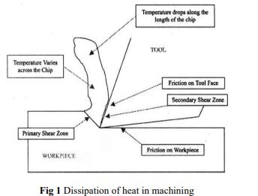

**Sources of Heat Generation during Machining**

During machining heat is generated at the cutting point from three sources. Those sources and causes of development of cutting temperature are:

**Primary shear zone** (1) where the major part of the energy is converted into heat

**Secondary deformation zone** (2) at the chip – tool interface where further heat is generated due to rubbing or shear

**At the flanks** (3) due to rubbing between the tool and the finished surfaces.

**Effect of High Cutting Temperature**

The effects of the high cutting temperature, particularly when it is high, are mostly detrimental to both the tool and the job. The major portion of the heat is taken away by the chips. So attempts should be made such that the chips takeaway more and more of heat leaving a small amount of heat to harm the tool and the work piece. The possible detrimental effects of the high cutting temperature on cutting edge are rapid tool wear, which reduces tool life. Plastic deformation of cutting edges if the tool materials is not enough hard and strong Thermal flaking and fracturing of cutting edges due to thermal shocks Built up edge formation The possible detrimental effects of cutting temperature on the machined work piece are Dimensional inaccuracy of the job due to thermal distortion and expansion-contraction during and after machining Surface damage by oxidation, rapid corrosion, burning etc. Induction of tensile residual stresses and micro cracks at the surface and sub surfaces.

**Thermocouple Method**

The principle of temperature measurement by a thermocouple is that when two different metals come in contact, if these parts, called the hot and the cold junctions, are maintained at two different temperatures, an electromotive force (emf) is produced across these two junctions. The emf generated is a function of the materials used for the thermocouple as well as the temperatures of the junctions. In machining applications, a thermoelectric emf is generated between the tool and the work piece. For this study, the tool temperature was measured using a K-type thermocouple.

**Methodology**

In this experiment we are setting up a temporary arrangement for measuring temperature at the tool tip during turning operation in the center lathe. Temperature measuring device consists of an assembly of K type thermocouple and Arduino. The tool being used in the experiment is a high carbon steel tip with cast iron shank. A hole of diameter 4mm is drilled on the shank of the tool and a probe of the thermocouple is inserted in the hole such that it is close to the tool tip. The negative and positive end of the thermocouple is connected to the corresponding terminals of the temperature sensing module. In this arrangement the temperature at the tip of the tool will develop an emf in the thermocouple which will be displayed in the software. The tool is fixed on the tool post and the work piece is fixed on the four jaw chuck. The reading is taken for different machining conditions by varying the cutting parameters like cutting feed and cutting speed.

**Components used**

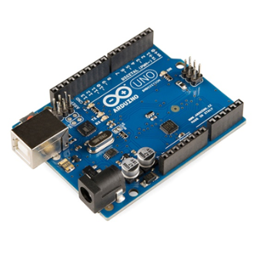**Arduino (Microcontroller)**

The Arduino board designs use a variety of microprocessors and controllers. The boards are equipped with sets of digital and analog input/output (I/O) pins that may be interfaced to various expansion boards or breadboards (for prototyping) and other circuits. The boards feature serial communications interfaces, including Universal Serial Bus (USB) on some models, which are also used for loading programs. The microcontrollers can be programmed using the C and C++ programming languages

**K-Type Thermocouple with MAX6755 module:**

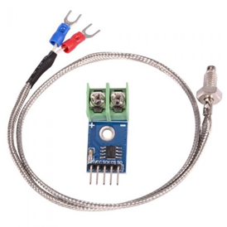

K-Type Thermocouple Sensor with MAX6675 Module measure 1024°C Temperature sensor makes use of the Maxim MAX6675 K-Thermocouple to digital converter IC to provide a microcontroller compatible digital serial interface

(SPI compatible) for giving an accurate temperature compensated measurement of the supplied K-Type thermocouple sensor. It has a 12-bit resolution providing temperature readings from 0°C to 1024°C (max temperature of the supplied sensor is 450°C) with a resolution of 0.25°C. Screw terminals allow for connection to the thermocouples spade connectors and a 5-pin standard 0.1″ header provides an interface to a microcontroller such as an Arduino development board.

**Cutting Tool (HSS Tool)**

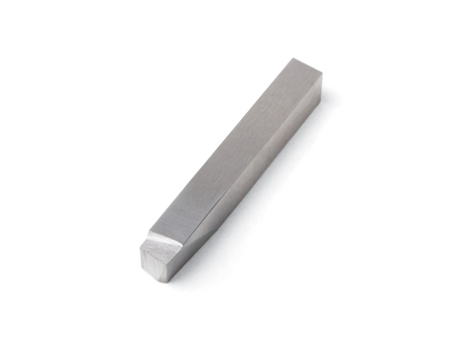**Category**: 1/4" Square Cutting Tools – Individual

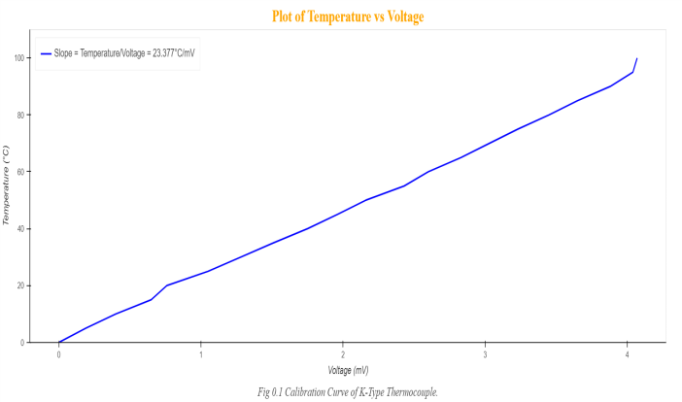High-speed steel is a subset of tool steels, commonly used as cutting tool material. It is often used in power-saw blades and drill bits. It is superior to the older high-carbon, steel tools used extensively through the 1940s in that it can withstand higher

temperatures without losing its temper (hardness. High-speed steels (HSS) are used in the foreseeable future for many applications such as drilling, reaming, tapping and dieing, forming, broaching and milling due to the ease with which they can be shaped in both the soft and hardened state.

**Procedure**

**Tool Drilling Process**

The HSS tool is drilled using the EDM machine (Electrical Discharge Machine).

A T-slot is made, where the end of the thermocouple is be inserted. The drill is made at distance of 1.5mm from the tool tip. We have used T-slot considering the size of the thermocouple end and the tool piece, a 4mm blind hole was considered for the experiment but the material was prone to failure due to structural changes, hence risking the safety.

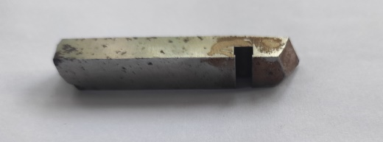

**Thermocouple Calibration**

The Thermocouple fixed to the temperature

sensor which is ideally calibrated, is now calibrated to the accurate temperature,

by keeping it in cold and boiling water bath at constant atmospheric pressure. The obtained voltage to the respective temperature is plotted and hence the sensor is calibrated to actual condition.

Fig: Temperature vs mv plot

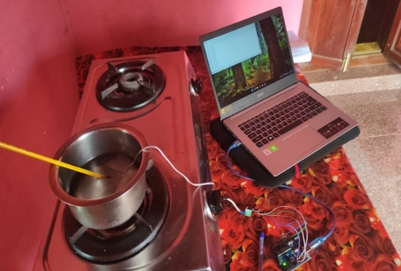

Fig: Calibration of thermocouple in ice water

**Experimental Data**

|  |  |
| --- | --- |
| Temperature(°C) | Voltage(mV) |
| 0 | 0 |
| 5 | 0.19 |
| 10 | 0.4 |
| 15 | 0.65 |
| 20 | 0.76 |
| 25 | 1.05 |
| 30 | 1.28 |
| 35 | 1.51 |
| 40 | 1.75 |
| 45 | 1.96 |
| 50 | 2.16 |
| 55 | 2.43 |
| 60 | 2.6 |
| 65 | 2.83 |
| 70 | 3.03 |
| 75 | 3.23 |
| 80 | 3.45 |
| 85 | 3.65 |
| 90 | 3.88 |
| 95 | 4.04 |
| 100 | 4.07 |

**Experimental setup**

The Thermocouple which is calibrated is fixed on to the T-slot which was drilled with help of EDM, is now placed on to the tool post. The work piece is also fixed to the jaw chuck, necessary set up is done, which is connecting the K-type thermocouple and Max6755 module to the Arduino which is then connected to a computer with the software for accessing the data input.

The temperature data received during the experiment is fed to Microsoft Visual code, which plots the data into a graph with help of Python code.

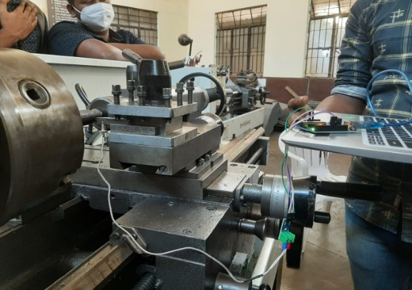

Fig: Experimental set-up

Theexperiment is conducted for different RPM and depth of cut, the necessary plots are obtained and a conclusion is drawn.

**Results**

The experiment is conducted for various parameters:

**Temperature vs Time:**

1. The tool temperature is tested for 450 RPM with depth of cut of 1.4mm and feed of 11mm/min

|  |  |  |  |
| --- | --- | --- | --- |
| temperature(°C) | time | temperature(°C) | time |
| 35.25 | 00:00 | 48.5 | 01:51 |
| 34.5 | 00:05 | 49 | 01:55 |
| 34.5 | 00:09 | 49.5 | 01:59 |
| 34.5 | 00:13 | 50.5 | 02:03 |
| 35 | 00:17 | 50.25 | 02:08 |
| 34.25 | 00:21 | 51.5 | 02:12 |
| 34.25 | 00:25 | 52 | 02:16 |
| 34.75 | 00:29 | 52.25 | 02:20 |
| 35.25 | 00:33 | 52.5 | 02:24 |
| 35.75 | 00:37 | 52.5 | 02:28 |
| 36.5 | 00:41 | 53.75 | 02:32 |
| 37.25 | 00:45 | 54 | 02:36 |
| 37.75 | 00:50 | 54 | 02:40 |
| 38 | 00:54 | 54 | 02:45 |
| 39.75 | 00:58 | 55.25 | 02:49 |
| 40.25 | 01:02 | 56 | 02:53 |
| 41 | 01:06 | 56.25 | 02:57 |
| 41.75 | 01:10 | 56.25 | 03:01 |
| 41.75 | 01:14 | 56.25 | 03:05 |
| 42.75 | 01:18 | 57 | 03:09 |
| 43.75 | 01:22 | 57.25 | 03:13 |
| 44.75 | 01:26 | 57.75 | 03:17 |
| 45 | 01:31 | 57.5 | 03:22 |
| 45.75 | 01:35 | 58.5 | 03:26 |
| 46.25 | 01:39 | 58.75 | 03:30 |
| 47 | 01:43 | 59.5 | 03:34 |
| 47.5 | 01:47 |  |  |

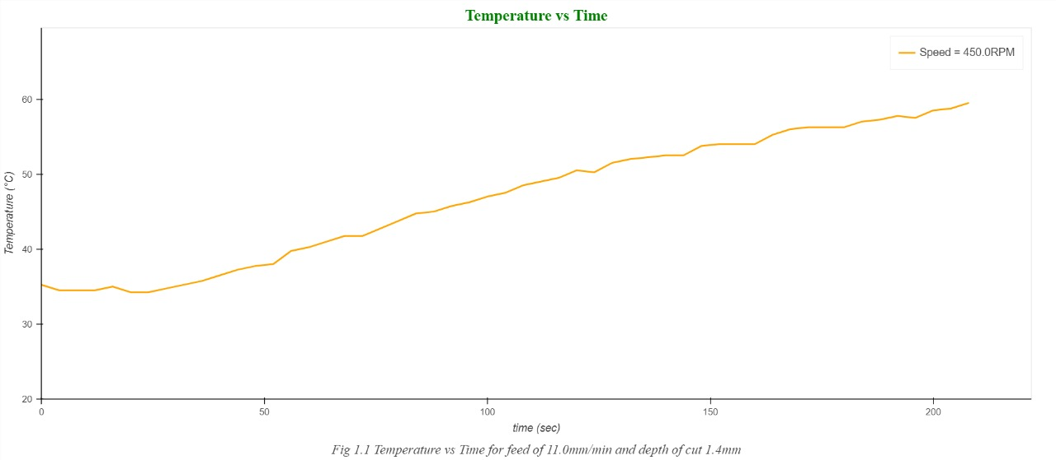

1. The tool temperature is tested for 450 and 710 RPM

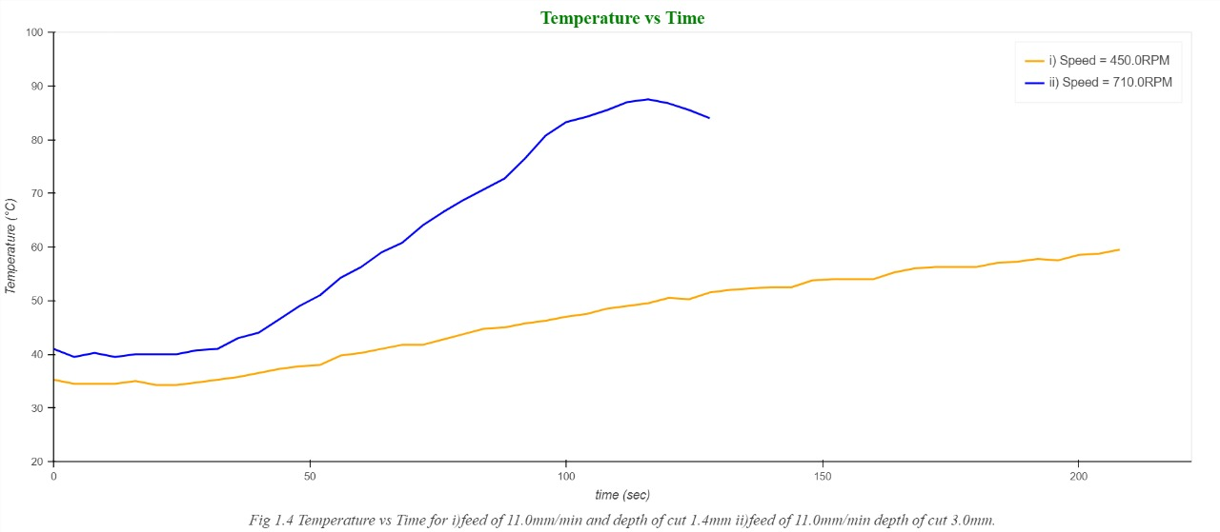

1. The tool temperature is tested for 710 RPM with feed of 25mm/min and depth of cut of 3mm

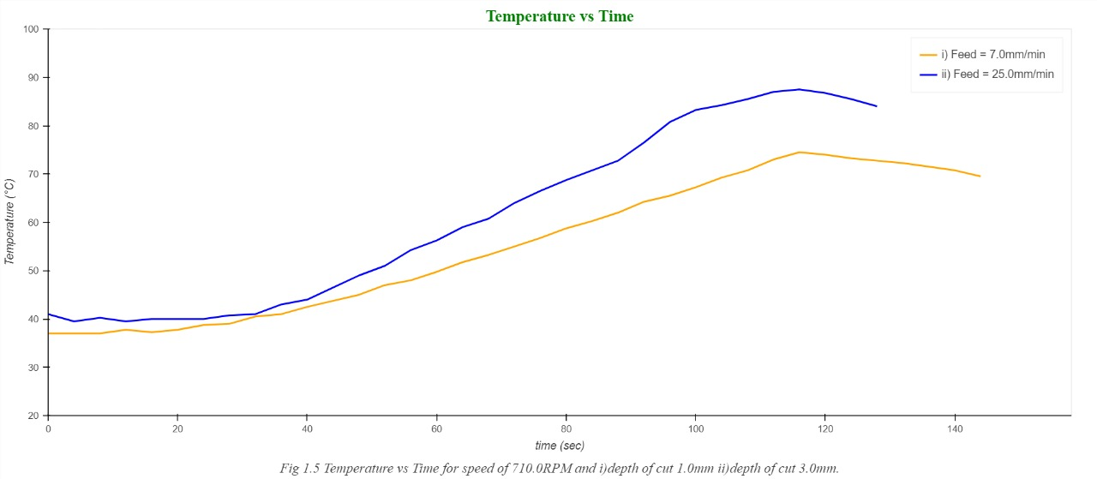

1. The tool temperature is tested for 710 RPM for feed rate of 7mm/min and 25mm/min

|  |  |  |  |
| --- | --- | --- | --- |
| temperature(°C) | time | temperature(°C) | time |
| 41 | 00:00 | 60.75 | 01:10 |
| 39.5 | 00:04 | 64 | 01:14 |
| 40.25 | 00:08 | 66.5 | 01:18 |
| 39.5 | 00:12 | 68.75 | 01:22 |
| 40 | 00:16 | 70.75 | 01:26 |
| 40 | 00:21 | 72.75 | 01:30 |
| 40 | 00:25 | 76.5 | 01:34 |
| 40.75 | 00:29 | 80.75 | 01:39 |
| 41 | 00:33 | 83.25 | 01:43 |
| 43 | 00:37 | 84.25 | 01:47 |
| 44 | 00:41 | 85.5 | 01:51 |
| 46.5 | 00:45 | 87 | 01:55 |
| 49 | 00:49 | 87.5 | 01:59 |
| 51 | 00:53 | 86.75 | 02:03 |
| 54.25 | 00:57 | 85.5 | 02:07 |
| 56.25 | 01:02 | 84 | 02:11 |
| 59 | 01:06 |  |  |

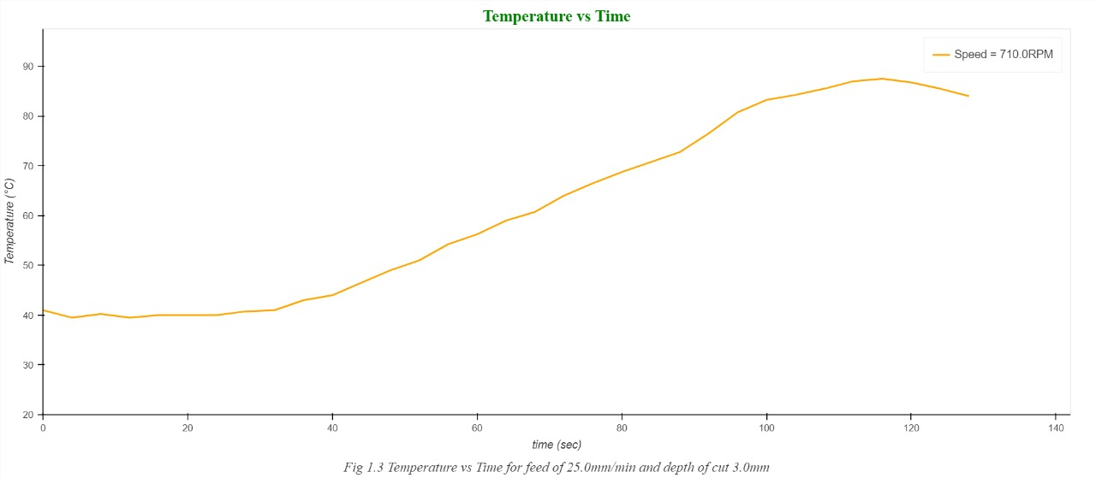

Hence the temperature is obtained for different parameters, the experiment was conducted successfully. Chip-tool interface temperature is closely connected to cutting speed with increase of cutting speed, friction increases; this induces an increase in temperature in the cutting zone. With the increase in feed rate, section of chip increases and consequently friction increases this involves the increase in temperatures.

**References**

[1]. L. B. Abhang, M. Hameedullah,'Chip-Tool Interface Temperature Prediction Model for Turning Process', International Journal of Engineering Science and Technology, 2(4), 2010, 382-393.

[2]. Sushil D. Ghodam, 'Temperature Measurement of A Cutting Tool in Turning Process By Using Tool Work Thermocouple’, International Journal of Research in Engineering and Technology, 3(4), 2014, 831-835.

[3]. Ajay Goyal, Rajesh Sharma, Shailendra Kumar, Suresh Dhiman. 'A Study of Experimental Temperature Measuring Techniques used in Metal Cutting', Jordan Journal of Mechanical and Industrial Engineering, 8(2), 2014, 82-93