VISVESVARAYA TECHNOLOGICAL UNIVERSITY
“JnanaSangama”, Belgaum -590014, Karnataka.

LAB REPORT
on
Artificial Intelligence (23CS5PCAIN)
Submitted by
Chethana C (1BM23CS077)
in partial fulfillment for the award of the degree of
BACHELOR OF ENGINEERING
in
COMPUTER SCIENCE AND ENGINEERING

B.M.S. COLLEGE OF ENGINEERING
(Autonomous Institution under VTU)
BENGALURU-560019
Sep-2024 to Jan-2025

B.M.S. College of Engineering,
Bull Temple Road, Bangalore 560019
(Affiliated To Visvesvaraya Technological University, Belgaum)
Department of Computer Science and Engineering

CERTIFICATE
This is to certify that the Lab work entitled “Artificial Intelligence (23CS5PCAIN)” carried out by Chethana C (1BM23CS077), who is bonafide student of B.M.S. College of Engineering. It is in partial fulfillment for the award of Bachelor of Engineering in Computer Science and Engineering of the Visvesvaraya Technological University, Belgaum. The Lab report has been approved as it satisfies the academic requirements in respect of an Artificial Intelligence (23CS5PCAIN) work prescribed for the said degree.

Lab faculty Incharge Name  Assistant Professor  Department of CSE, BMSCE | Dr. Kavitha Sooda  Professor & HOD  Department of CSE, BMSCE

Index
Sl.  No. | Date | Experiment Title | Page No.
1 | 21-8-2025 | Implement Tic –Tac –Toe Game  Implement vacuum cleaner agent | 4-8
2 | 11-9-2025 | Implement 8 puzzle problems using Depth First Search (DFS)  Implement Iterative deepening search algorithm | 9-14
3 | 9-10-2025 | Implement A* search algorithm | 15-17
4 | 9-10-2025 | Implement Hill Climbing search algorithm to solve N-Queens problem | 18-20
5 | 9-10-2025 | Simulated Annealing to Solve 8-Queens problem | 21-24
6 | 16-10-2025 | Create a knowledge base using propositional logic and show that the given query entails the knowledge base or not. | 25-29
7 | 2-12-2024 | Implement unification in first order logic
8 | 6-11-2025 | Create a knowledge base consisting of first order logic statements and prove the given query using forward reasoning. | 30-32
9 | 12-11-2025 | Create a knowledge base consisting of first order logic statements and prove the given query using Resolution | 33-35
10 | 30-10-2025 | Implement Alpha-Beta Pruning. | 36-38

Github Link:
https://github.com/Chethana-0711/AI-LAB
Program 1
Implement Tic –Tac –Toe Game
Implement vacuum cleaner agent

Algorithm:
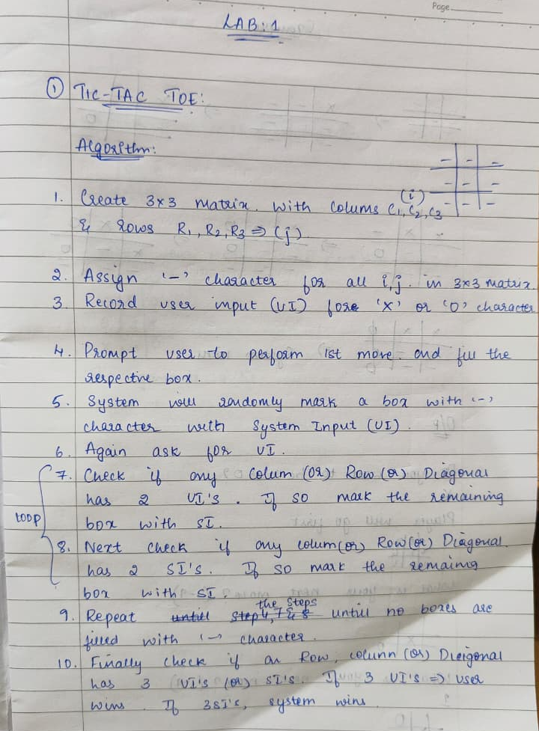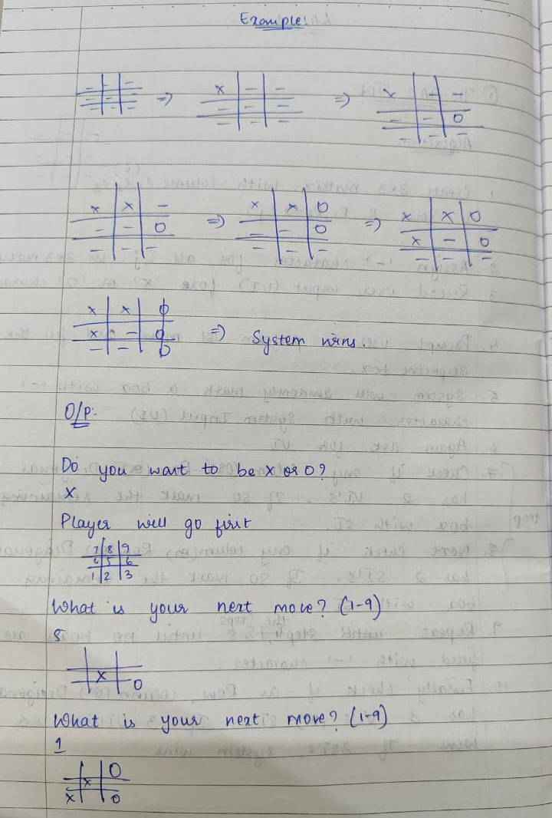
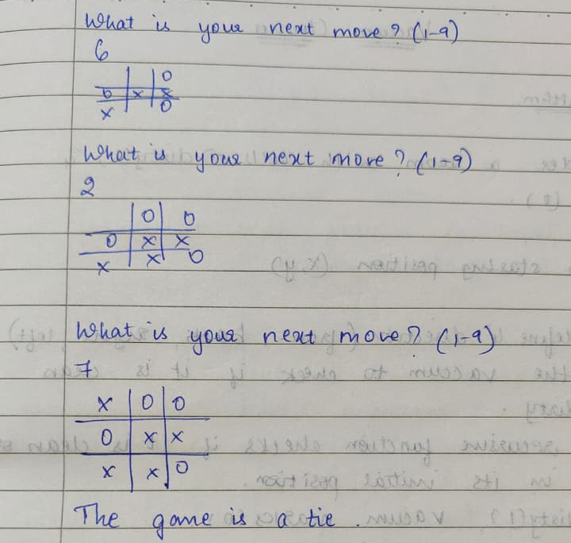

Code:
import math

def print_board(board):
print("\n")
for r in range(3):
row = " | ".join(board[r])
print(" " + row)
if r < 2:
print("---+---+---")
print("\n")

def check_winner(board):

for i in range(3):
if board[i][0] == board[i][1] == board[i][2] != ' ':
return board[i][0]
if board[0][i] == board[1][i] == board[2][i] != ' ':
return board[0][i]
if board[0][0] == board[1][1] == board[2][2] != ' ':
return board[0][0]
if board[0][2] == board[1][1] == board[2][0] != ' ':
return board[0][2]
return None

def is_full(board):
return all(board[r][c] != ' ' for r in range(3) for c in range(3))

def minimax(board, depth, alpha, beta, maximizing, ai, human):
winner = check_winner(board)
if winner == ai:
return 1
elif winner == human:
return -1
elif is_full(board):
return 0

if maximizing:
max_eval = -math.inf
for r in range(3):
for c in range(3):
if board[r][c] == ' ':
board[r][c] = ai
eval = minimax(board, depth + 1, alpha, beta, False, ai, human)
board[r][c] = ' '
max_eval = max(max_eval, eval)
alpha = max(alpha, eval)
if beta <= alpha:
return max_eval
return max_eval
else:
min_eval = math.inf
for r in range(3):
for c in range(3):
if board[r][c] == ' ':
board[r][c] = human
eval = minimax(board, depth + 1, alpha, beta, True, ai, human)
board[r][c] = ' '
min_eval = min(min_eval, eval)
beta = min(beta, eval)
if beta <= alpha:
return min_eval
return min_eval

def best_move(board, ai, human):
best_val = -math.inf
move = (-1, -1)
for r in range(3):
for c in range(3):
if board[r][c] == ' ':
board[r][c] = ai
move_val = minimax(board, 0, -math.inf, math.inf, False, ai, human)
board[r][c] = ' '
if move_val > best_val:
best_val = move_val
move = (r, c)
return move

def play_game():
board = [[' ' for _ in range(3)] for _ in range(3)]

print("Welcome to Tic-Tac-Toe (You vs AI)")
user = input("Choose your symbol (X/O): ").upper()
while user not in ['X', 'O']:
user = input("Invalid choice! Choose X or O: ").upper()

ai = 'O' if user == 'X' else 'X'
turn = 'X'

print_board(board)

while True:
if turn == user:
print("Your turn!")
try:
row, col = map(int, input("Enter row and column (1-3 1-3): ").split())
if row not in [1,2,3] or col not in [1,2,3]:
print("Invalid input! Please use 1-3 for both row and column.")
continue
if board[row-1][col-1] != ' ':
print("That spot is already taken!")
continue
board[row-1][col-1] = user
except ValueError:
print("Enter two numbers separated by space (e.g., 2 3).")
continue
else:
print("AI is thinking...")
r, c = best_move(board, ai, user)
board[r][c] = ai
print(f"AI plays: row {r+1}, column {c+1}")

print_board(board)

w = check_winner(board)
if w:
if w == user:
print(" You win!")
else:
print("AI wins!")
break
if is_full(board):
print("It's a draw!")
break

turn = 'O' if turn == 'X' else 'X'

if __name__ == "__main__":
play_game()

Output:
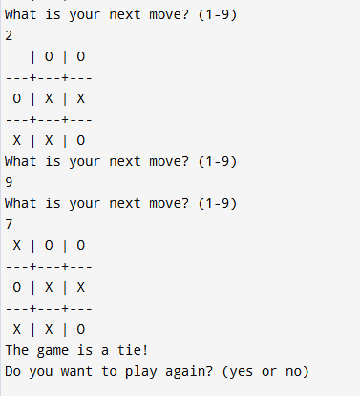

Program 2
Implement 8 puzzle problems using Depth First

Search (DFS)
Implement Iterative deepening search algorithm

Algorithm:
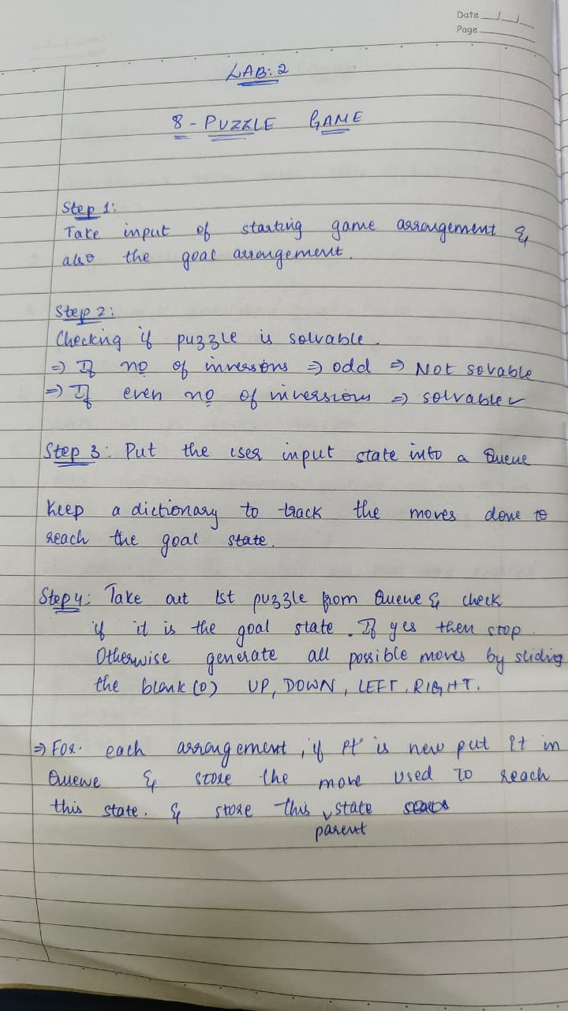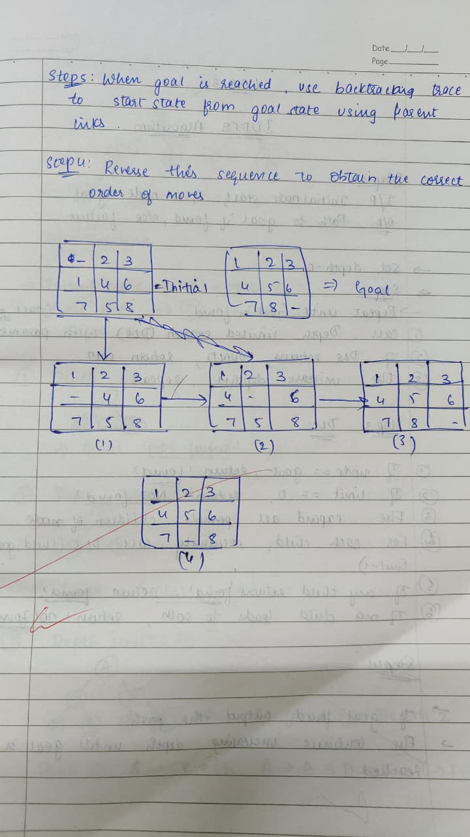
Code:
from copy import deepcopy

goal_state = [[1, 2, 3],
[4, 5, 6],
[7, 8, 0]]

def misplaced_tiles(state, goal=goal_state):
count = 0
for i in range(3):
for j in range(3):
if state[i][j] != 0 and state[i][j] != goal[i][j]:
count += 1
return count

def manhattan_distance(state, goal=goal_state):
distance = 0
pos = {}

for i in range(3):
for j in range(3):
pos[goal[i][j]] = (i, j)

for i in range(3):
for j in range(3):
val = state[i][j]
if val != 0:
x, y = pos[val]
distance += abs(i - x) + abs(j - y)
return distance

def find_blank(state):
for i in range(3):
for j in range(3):
if state[i][j] == 0:
return i, j

def get_neighbors(state):
neighbors = []
x, y = find_blank(state)
directions = [(0,1),(0,-1),(1,0),(-1,0)]
for dx, dy in directions:
nx, ny = x+dx, y+dy
if 0 <= nx < 3 and 0 <= ny < 3:
new_state = deepcopy(state)
new_state[x][y], new_state[nx][ny] = new_state[nx][ny], new_state[x][y]
neighbors.append(new_state)
return neighbors

def print_state(state):
for row in state:
print(row)
print()

def DLS(state, goal, limit, path, visited):
if state == goal:
return True, path

if limit == 0:
return False, None

for neighbor in get_neighbors(state):
tup = tuple(map(tuple, neighbor))
if tup not in visited:
visited.add(tup)
found, result = DLS(neighbor, goal, limit-1, path + [neighbor], visited)
if found:
return True, result
return False, None

def IDDFS(start, goal):
depth = 0
while True:
visited = {tuple(map(tuple, start))}
found, path = DLS(start, goal, depth, [start], visited)
if found:
return path, depth
depth += 1

if __name__ == "__main__":
initial_state = [[1, 2, 3],
[4, 6, 0],
[7, 5, 8]]

print("Initial State:")
print_state(initial_state)

print("Goal State:")
print_state(goal_state)

print("Misplaced Tiles Heuristic (h1):", misplaced_tiles(initial_state))
print("Manhattan Distance Heuristic (h2):", manhattan_distance(initial_state))

path, depth = IDDFS(initial_state, goal_state)

print("\nSolution found at depth:", depth)
print("Solution Path:")

step = 0
for state in path:
print("Step", step)
print_state(state)
step += 1

Output:
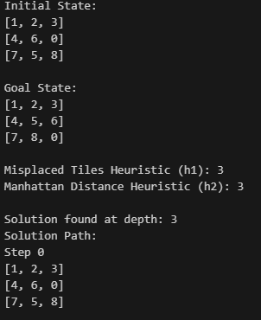 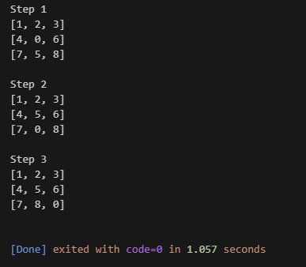

IDDFS SEARCH:
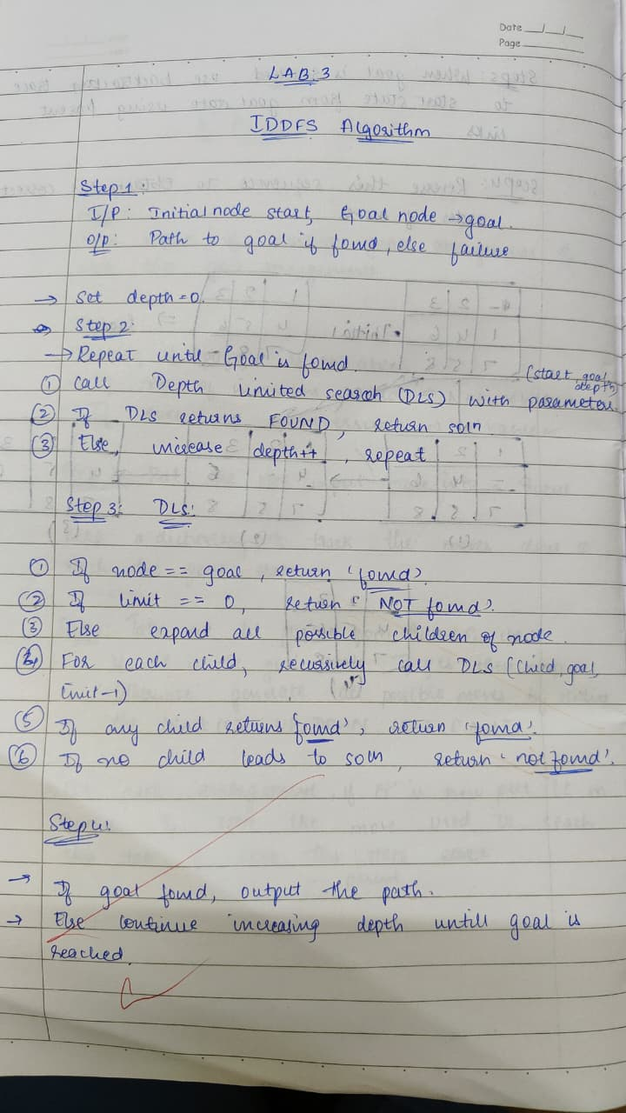 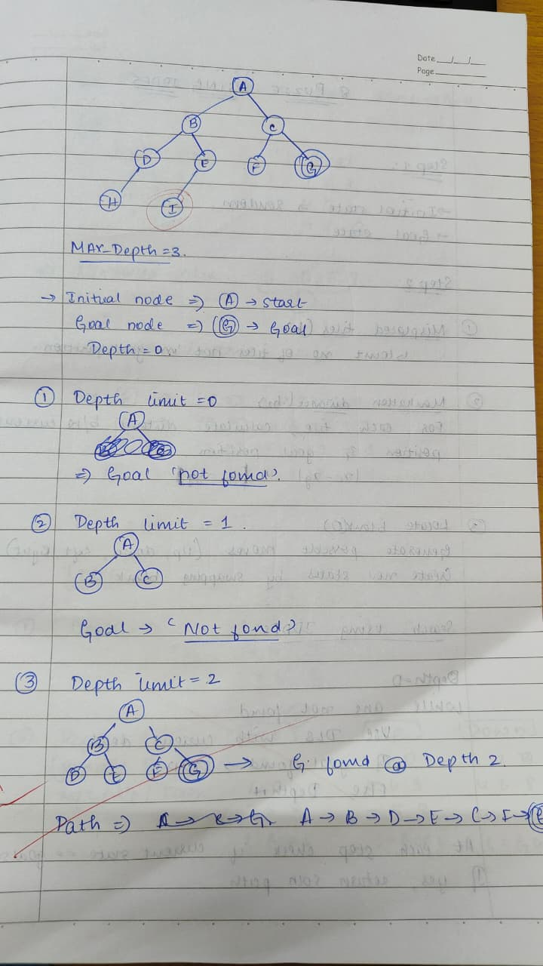

Code:
graph = {
'A': ['B', 'C'],
'B': ['D', 'E'],
'C': ['F', 'G'],
'D': ['H'],
'E': ['I'],
'F': [],
'G': [],
'H': [],
'I': []
}

def DLS(node, goal, limit, visited, path):
visited.append(node)

if node == goal:
return True, path + [node]

if limit <= 0:
return False, None

for neighbor in graph.get(node, []):
found, result = DLS(neighbor, goal, limit-1, visited, path + [node])
if found:
return True, result

return False, None

def IDDFS(start, goal, max_depth):
for depth in range(max_depth + 1):
visited = []
print(f"\nDepth Limit = {depth}")
found, path = DLS(start, goal, depth, visited, [])
print("Visited :", " - ".join(visited))
if found:
return path, depth
return None, -1

if __name__ == "__main__":
start_node = 'A'
goal_node = 'G'
max_depth = 3

path, depth = IDDFS(start_node, goal_node, max_depth)

if path:
print("\nGoal found at depth:", depth)
print("Solution Path:", " -> ".join(path))
else:

print("\ngoal not found within depth limit.")

Output:
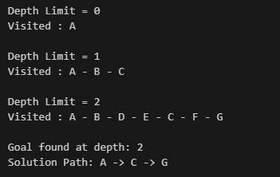
Program 3
Implement A* search algorithm

Algorithm:

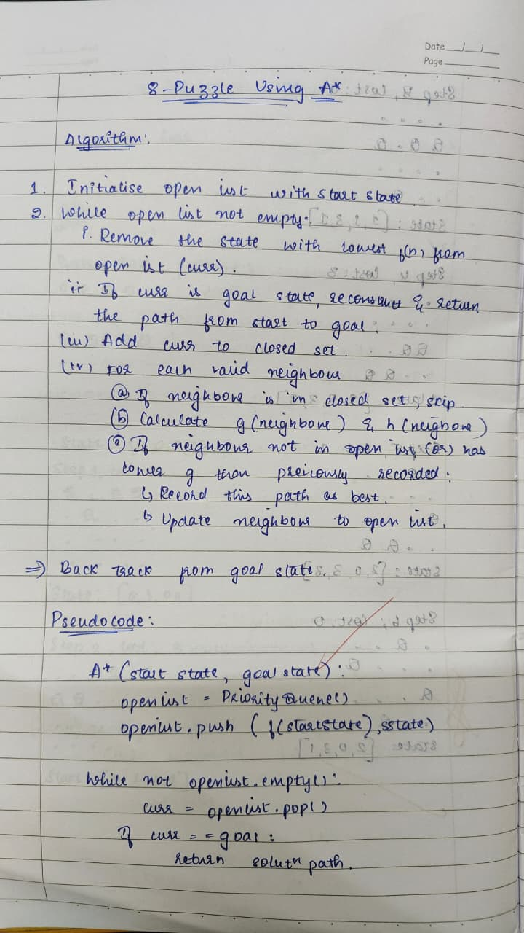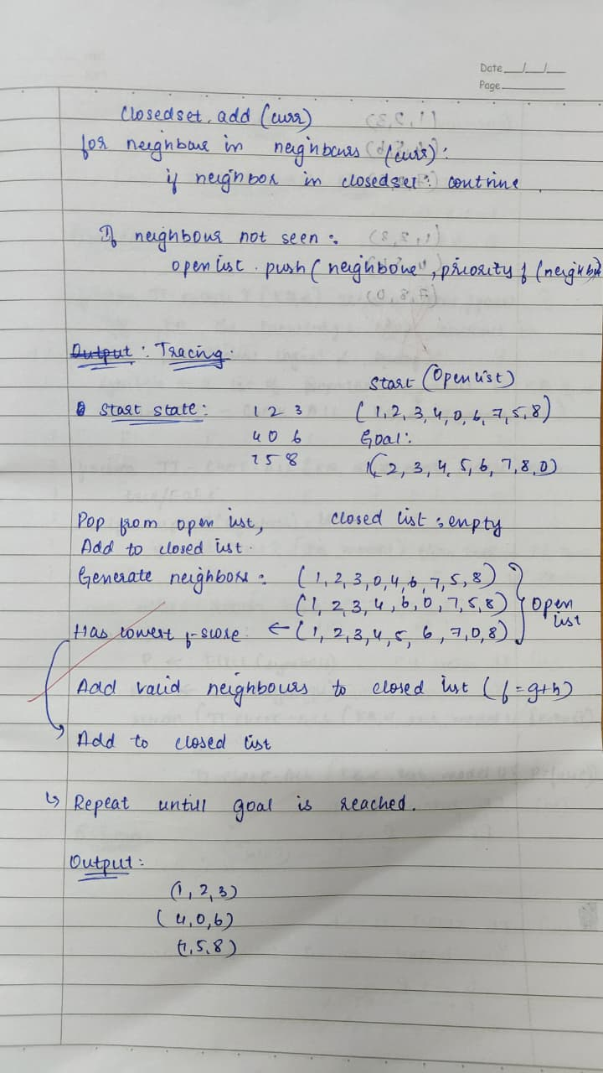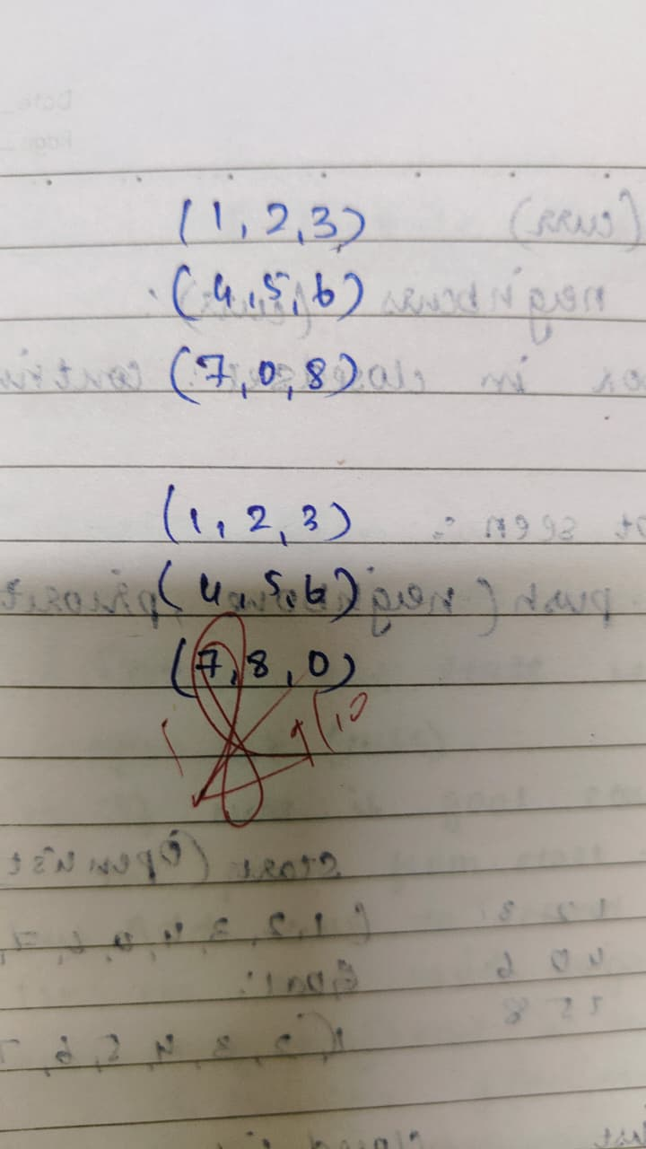

Code:
import heapq

def astar(start, goal):
def h(state):
d = 0
for i,v in enumerate(state):
if v == 0: continue
gi = goal.index(v)
d += abs(gi//3 - i//3) + abs(gi%3 - i%3)
return d

def neighbors(state):
s = list(state)
i = s.index(0)
r, c = divmod(i, 3)
moves = []
if r > 0: moves.append(i-3)
if r < 2: moves.append(i+3)
if c > 0: moves.append(i-1)
if c < 2: moves.append(i+1)
res = []
for m in moves:
t = s[:]
t[i], t[m] = t[m], t[i]
res.append(tuple(t))
return res

pq = []
heapq.heappush(pq, (h(start), 0, start, []))
seen = set()

while pq:
f, g, state, path = heapq.heappop(pq)
if state in seen:
continue
if state == goal:
return path + [state]
seen.add(state)
for nxt in neighbors(state):
if nxt not in seen:
heapq.heappush(pq, (g+1+h(nxt), g+1, nxt, path+[state]))

start = (1,2,3,4,0,5,6,7,8)
goal = (1,2,3,4,5,6,7,8,0)
solution = astar(start, goal)
for s in solution:
print(s)

Output:
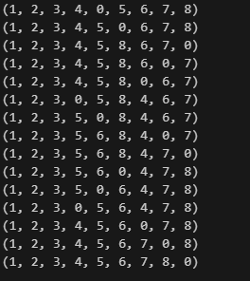

Program 4
Implement Hill Climbing search algorithm to solve N-Queens problem

Algorithm:
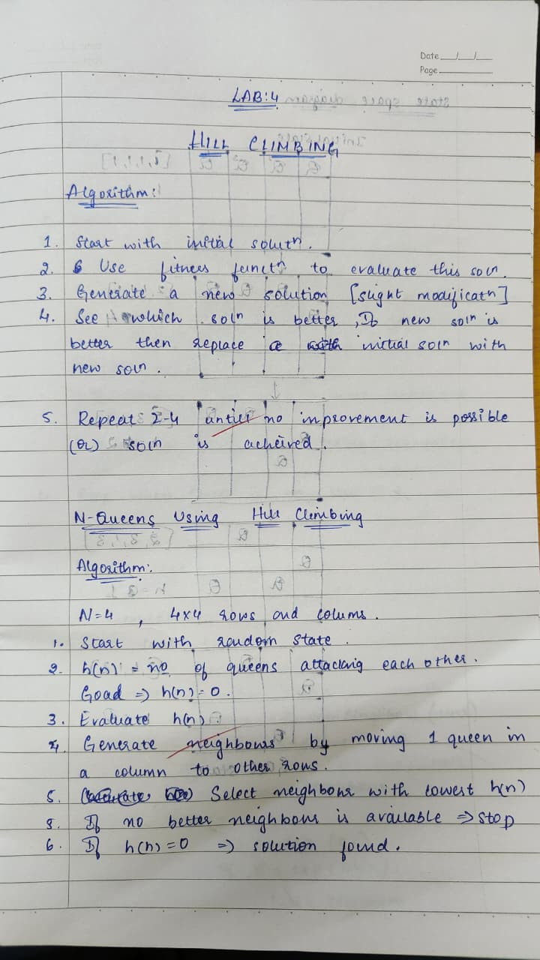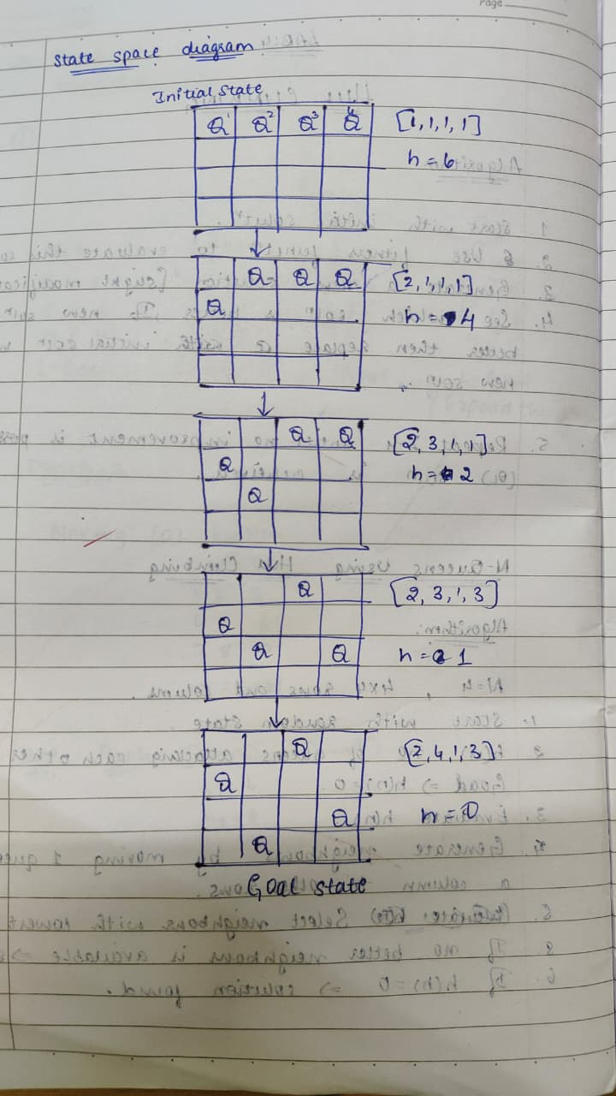
Code:
def print_board(state):
N = len(state)
for r in range(N):
row = ""
for c in range(N):
if state[c] == r:
row += "Q "
else:
row += ". "
print(row)
print()

def compute_conflicts(state):
N = len(state)
conflicts = 0
for i in range(N):
for j in range(i + 1, N):
if state[i] == state[j] or abs(state[i] - state[j]) == abs(i - j):
conflicts += 1
return conflicts

def get_neighbors(state):
N = len(state)
neighbors = []
for col in range(N):
for row in range(N):
if state[col] != row:
neighbor = state.copy()
neighbor[col] = row
neighbors.append(neighbor)
return neighbors

def hill_climbing(initial_state):
current = initial_state
steps = 0
print("Step", steps, "(Initial State):")
print_board(current)
while True:
neighbors = get_neighbors(current)
current_conflicts = compute_conflicts(current)
best_neighbor = current
best_conflicts = current_conflicts

for neighbor in neighbors:
neighbor_conflicts = compute_conflicts(neighbor)
if neighbor_conflicts < best_conflicts:
best_neighbor = neighbor
best_conflicts = neighbor_conflicts

if best_conflicts >= current_conflicts:
# Local minimum reached
break

current = best_neighbor
steps += 1
print(f"Step {steps}:")
print_board(current)

if best_conflicts == 0:
print("Goal reached in", steps, "steps!")
return

if compute_conflicts(current) == 0:
print("Goal reached in", steps, "steps!")
else:
print("Stuck in local minimum. No solution found from this initial state.")

if __name__ == "__main__":
N = 4
print("Enter the initial queen positions (row number 0-3) for each column (space separated):")
user_input = input()
initial_state = list(map(int, user_input.strip().split()))
if len(initial_state) != N or not all(0 <= x < N for x in initial_state):
print("Invalid input! Enter exactly 4 numbers between 0 and 3.")
else:
hill_climbing(initial_state)

output:
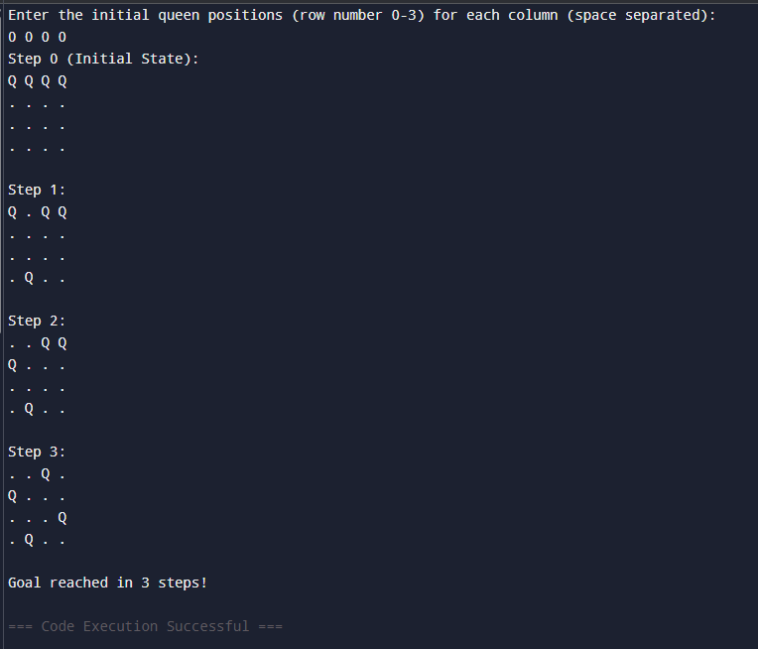

Program 5
Simulated Annealing to Solve 8-Queens problem

Algorithm:
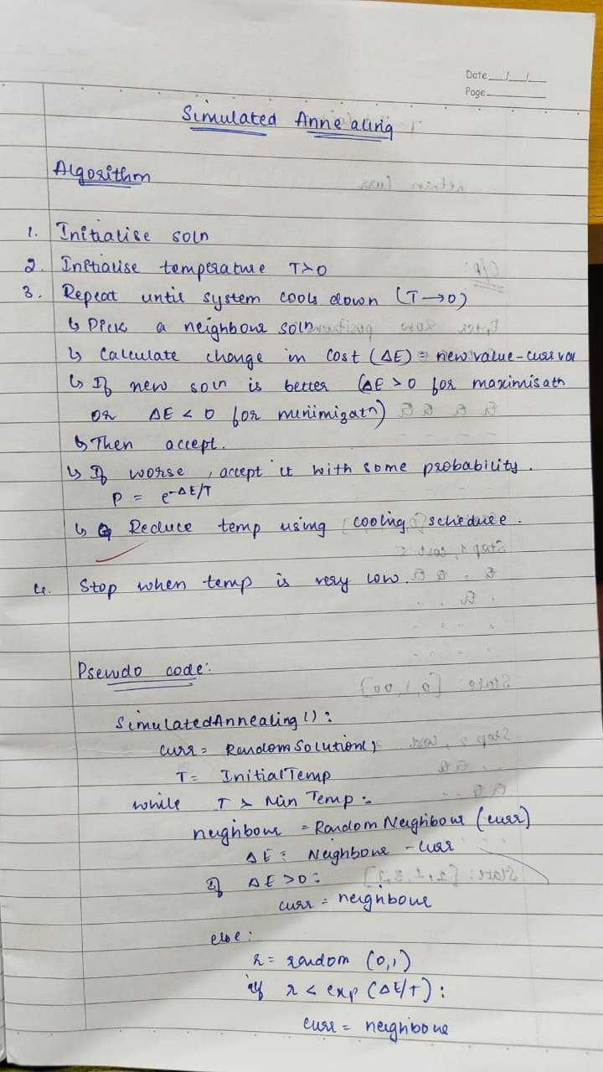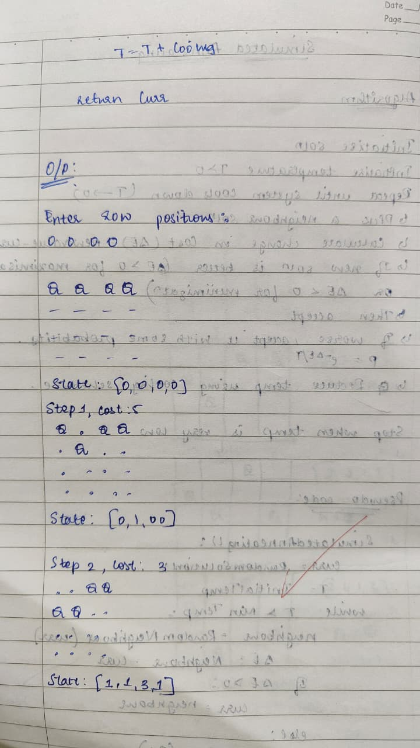
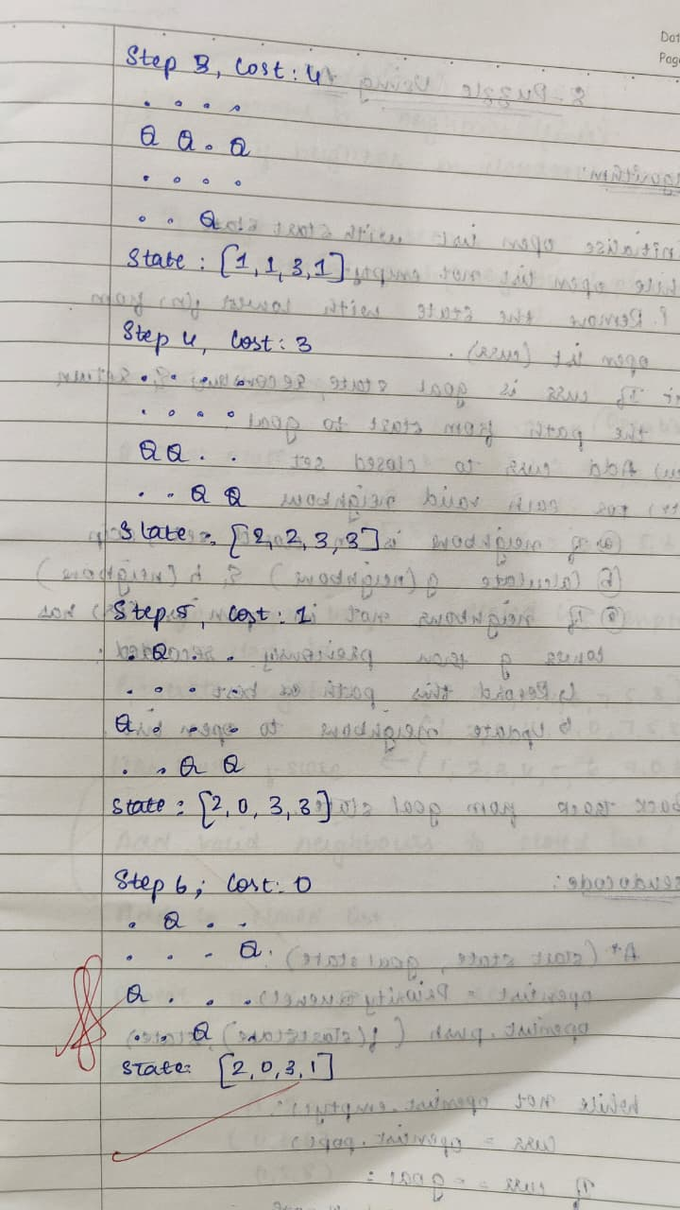

Code:
import random
import math

def print_board(state):
n = len(state)
for row in range(n):
line = ""
for col in range(n):
if state[col] == row:
line += "Q "
else:
line += ". "
print(line)
print("State:", state)
print("-" * (2 * n))

def attacking_pairs(state):
count = 0
n = len(state)
for i in range(n):
for j in range(i + 1, n):
if state[i] == state[j] or abs(state[i] - state[j]) == abs(i - j):
count += 1
return count

def random_neighbor(state):
n = len(state)
neighbor = state[:]
col = random.randint(0, n - 1)
rows = list(range(n))
rows.remove(state[col])
neighbor[col] = random.choice(rows)
return neighbor

def simulated_annealing(initial_state):
current = initial_state[:]
current_cost = attacking_pairs(current)
steps = 0
T = 1.0
T_min = 1e-5
alpha = 0.99

print("Initial board:")
print_board(current)

while T > T_min and current_cost > 0:
neighbor = random_neighbor(current)
neighbor_cost = attacking_pairs(neighbor)
delta = neighbor_cost - current_cost

if delta < 0 or random.uniform(0, 1) < math.exp(-delta / T):
if neighbor_cost < current_cost:
steps += 1
print(f"Step {steps}, Cost: {neighbor_cost}")
print_board(neighbor)
current = neighbor
current_cost = neighbor_cost

T *= alpha

print("Final board:")
print_board(current)
print(f"Total steps with improved cost: {steps}")

if __name__ == "__main__":
N = 4
print(f"Enter the row positions for the queens in columns 0 to {N-1} (0-indexed, e.g., 1 3 0 2):")
user_input = input().strip()
try:
initial_state = list(map(int, user_input.split()))
if len(initial_state) != N or not all(0 <= x < N for x in initial_state):
raise ValueError
except Exception:
print("Invalid input. Please enter 4 integers between 0 and 3 separated by spaces.")
exit(1)

simulated_annealing(initial_state)

output:
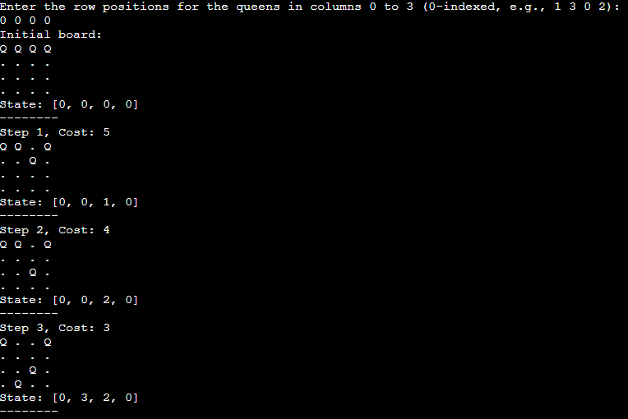
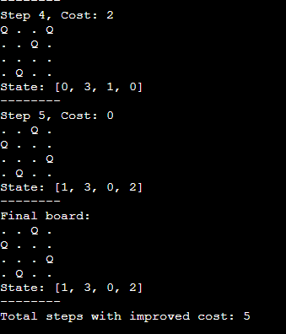
Program 6
Create a knowledge base using propositional logic and show that the given query entails the knowledge base or not.

Algorithm:
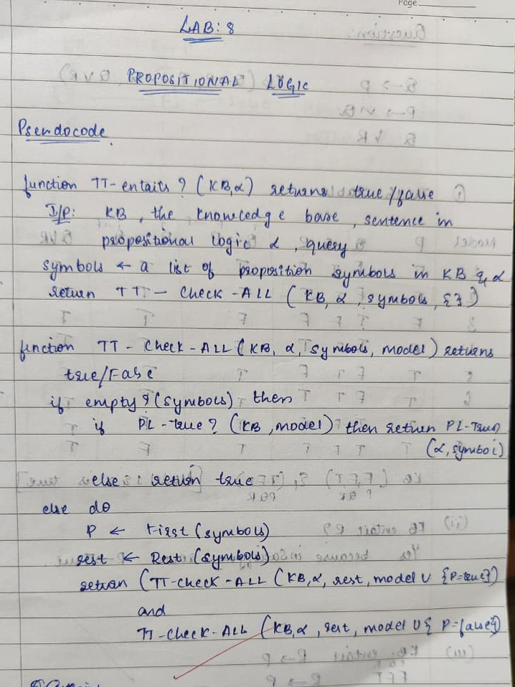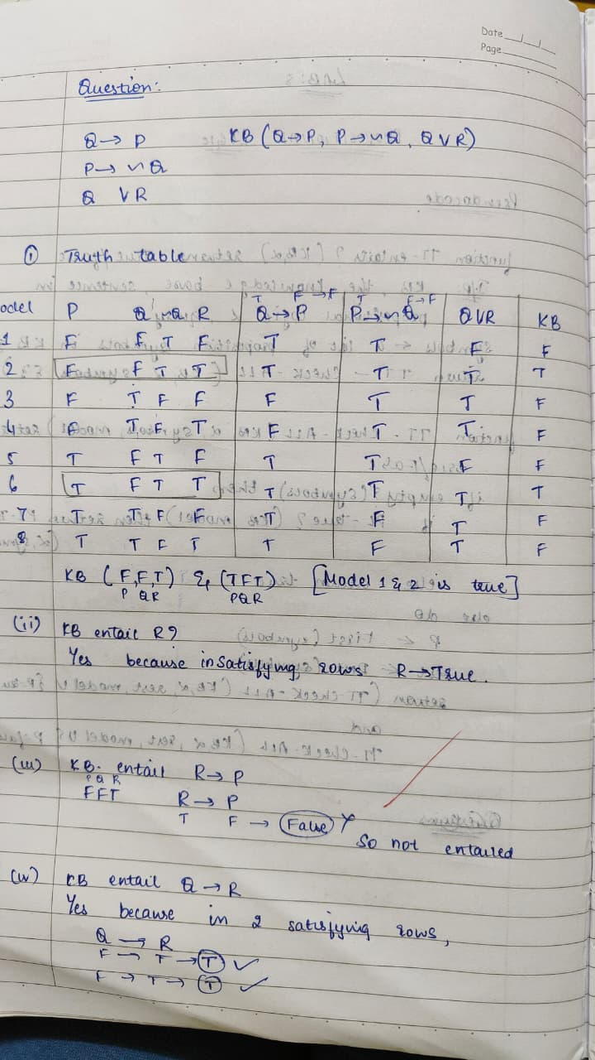
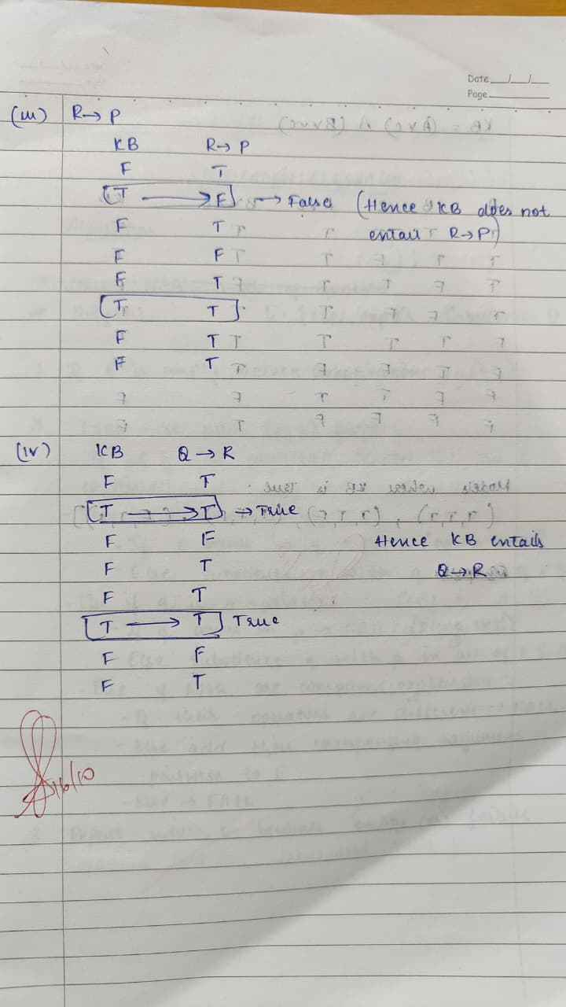

Code:
import itertools

values = [True, False]

def implies(a, b):
return (not a) or b

def KB(P, Q, R):
return implies(Q, P) and implies(P, not Q) and (Q or R)

def query_R(P, Q, R):
return R

def query_R_implies_P(P, Q, R):
return implies(R, P)

def query_Q_implies_R(P, Q, R):
return implies(Q, R)

print(f"{'P':^3} {'Q':^3} {'R':^3} {'Q→P':^5} {'P→¬Q':^6} {'Q∨R':^5} {'KB':^4} {'R':^3} {'R→P':^6} {'Q→R':^6}")
print("-" * 60)

kb_models = []
for P, Q, R in itertools.product(values, repeat=3):
q1 = implies(Q, P)
q2 = implies(P, not Q)
q3 = Q or R
kb_true = q1 and q2 and q3
r_val = R
r_imp_p = implies(R, P)
q_imp_r = implies(Q, R)

print(f"{P!s:^3} {Q!s:^3} {R!s:^3} {q1!s:^5} {q2!s:^6} {q3!s:^5} {kb_true!s:^4} {r_val!s:^3} {r_imp_p!s:^6} {q_imp_r!s:^6}")

if kb_true:
kb_models.append((P, Q, R))
def entails(query):
for (P, Q, R) in kb_models:
if not query(P, Q, R):
return False
return True

print("\nModels where KB is True:", kb_models)
print("\nEntailment Results:")
print("Does KB entail R? ->", entails(query_R))
print("Does KB entail (R → P)? ->", entails(query_R_implies_P))
print("Does KB entail (Q → R)? ->", entails(query_Q_implies_R))

output:
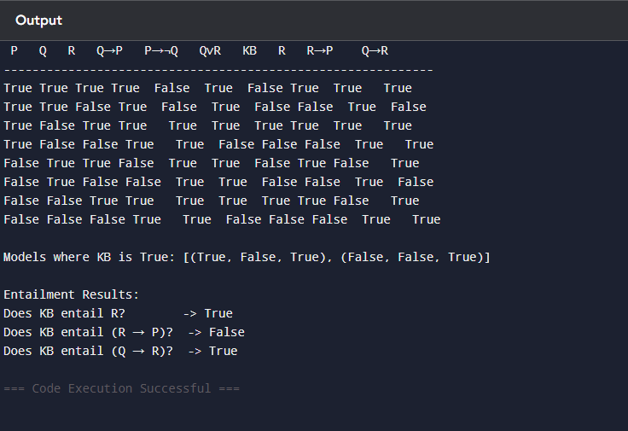

code:
import itertools

values = [True, False]

def implies(a, b):
return (not a) or b

def KB(A, B, C):
return (A or C) and (B or (not C))
print(f"{'A':^3} {'B':^3} {'C':^3} {'A∨C':^5} {'B∨¬C':^6} {'KB':^4}")
print("-" * 40)

kb_models = []

for A, B, C in itertools.product(values, repeat=3):
a_or_c = A or C
b_or_not_c = B or (not C)
kb_true = a_or_c and b_or_not_c

print(f"{A!s:^3} {B!s:^3} {C!s:^3} {a_or_c!s:^5} {b_or_not_c!s:^6} {kb_true!s:^4}")

if kb_true:
kb_models.append((A, B, C))

def entails(query):
for (A, B, C) in kb_models:
if not query(A, B, C):
return False
return True

def query_A(A, B, C): return A
def query_B(A, B, C): return B
def query_C(A, B, C): return C
def query_A_implies_B(A, B, C): return implies(A, B)
def query_C_implies_B(A, B, C): return implies(C, B)

print("\nmodels where KB is True:", kb_models)
print("\noutput")
print("Does KB entail A?->", entails(query_A))
print("Does KB entail B?->", entails(query_B))
print("Does KB entail C?->", entails(query_C))
print("Does KB entail (A → B)? ->", entails(query_A_implies_B))
print("Does KB entail (C → B)? >", entails(query_C_implies_B))

output:
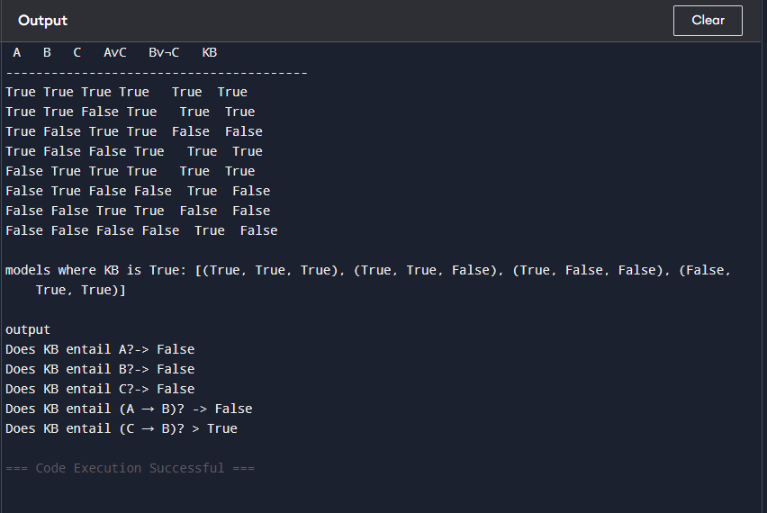

Program 8
Create a knowledge base consisting of first order logic statements and prove the given query using forward reasoning.

Algorithm:
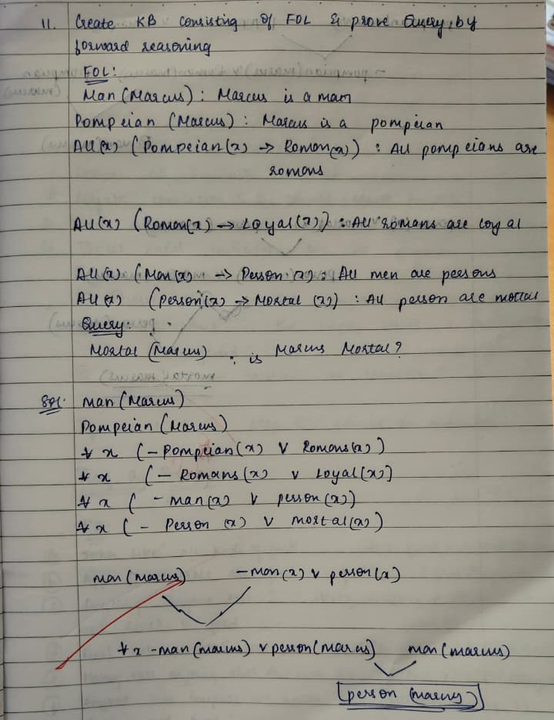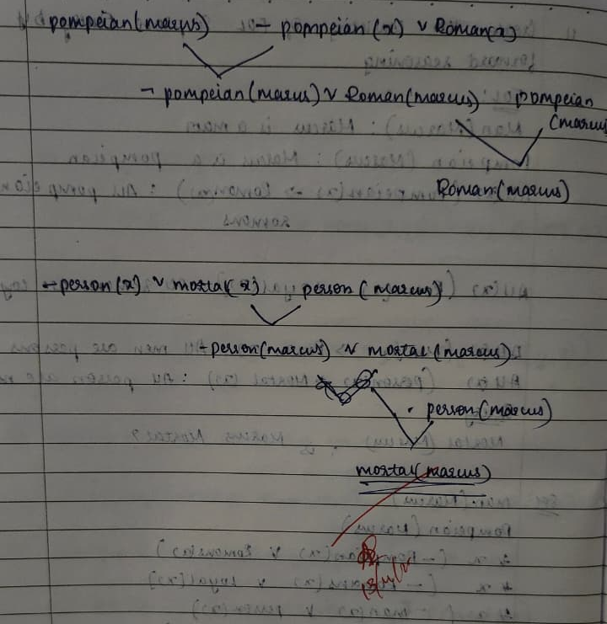

Code:
facts = {
"Man(Marcus)",
"Pompeian(Marcus)"
}

rules = [
("Pompeian(x) -> Roman(x)"),
("Roman(x) -> Loyal(x)"),
("Man(x) -> Person(x)"),
("Person(x) -> Mortal(x)")
]

def substitute(statement, var, const):
return statement.replace(f"({var})", f"({const})").replace(f"{var},", f"{const},").replace(f",{var}", f",{const}")

def forward_chain(facts, rules):
step = 1
new_fact_added = True
while new_fact_added:
new_fact_added = False
print(f"\n--- Step {step} ---")
print("Current Facts:", ", ".join(sorted(facts)))
for rule in rules:
premise, conclusion = rule.split("->")
premise = premise.strip()
conclusion = conclusion.strip()
var = 'x'
for fact in list(facts):
if premise.startswith(fact.split("(")[0]):
const = fact[fact.find("(")+1:fact.find(")")]
new_fact = substitute(conclusion, var, const)
if new_fact not in facts:
print(f"Applied Rule: {rule}")
print(f"Matched Fact: {fact}")
print(f"Inferred: {new_fact}")
print("---------------------------------")
facts.add(new_fact)
new_fact_added = True
step += 1
return facts

print("=== Forward Reasoning Process ===")
derived_facts = forward_chain(facts.copy(), rules)

query = "Mortal(Marcus)"
print("\n=== Final Result ===")
if query in derived_facts:
print(f" Query '{query}' is PROVED TRUE.")
else:
print(f" Query '{query}' cannot be proved from the Knowledge Base.")

output:
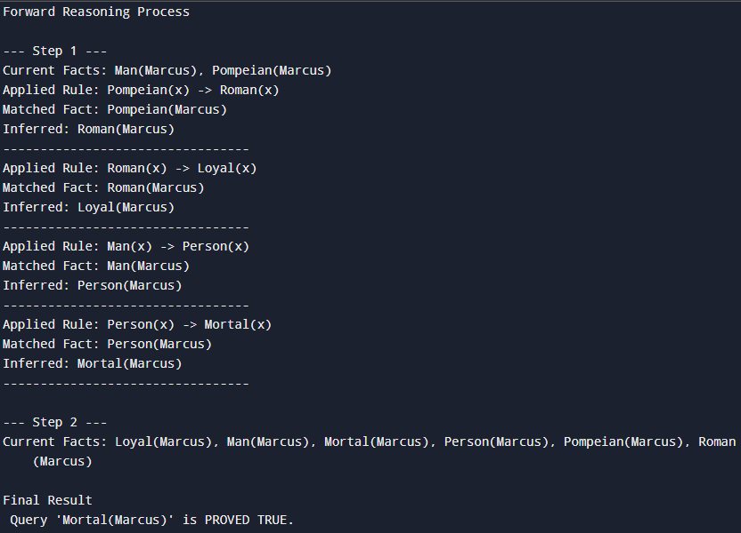

Program 9
Create a knowledge base consisting of first order logic statements and prove the given query using Resolution

Algorithm:
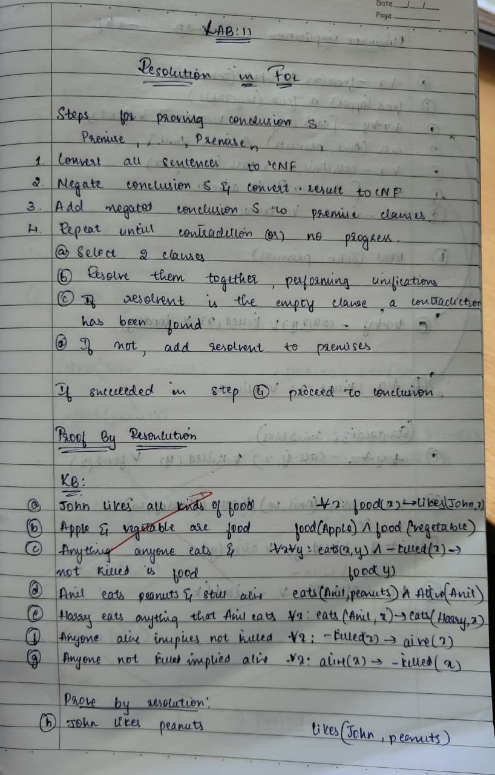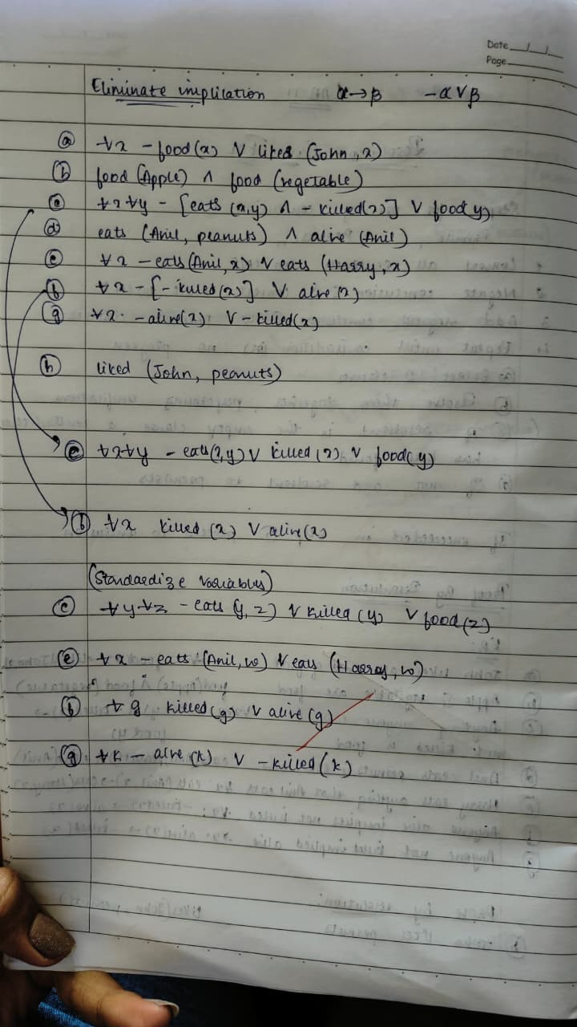

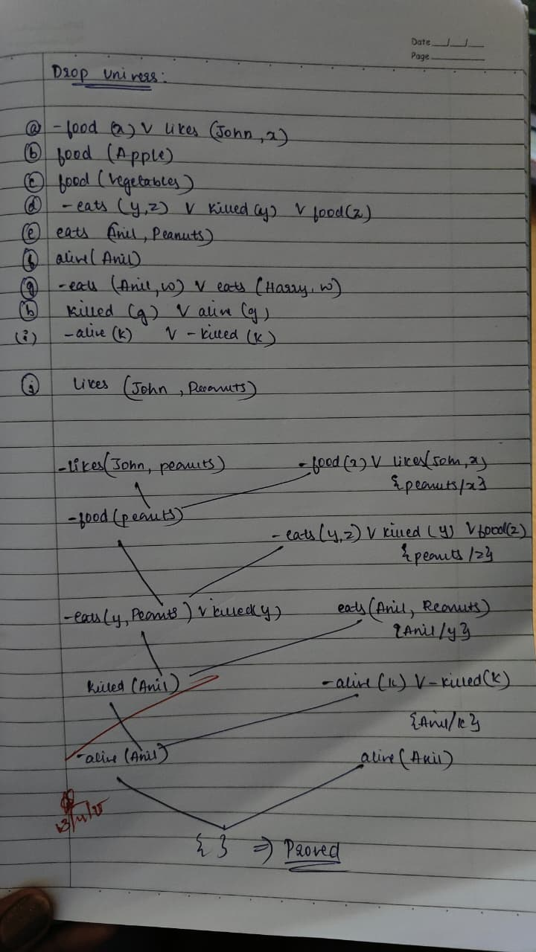

Program 10
Implement Alpha-Beta Pruning.

Algorithm:
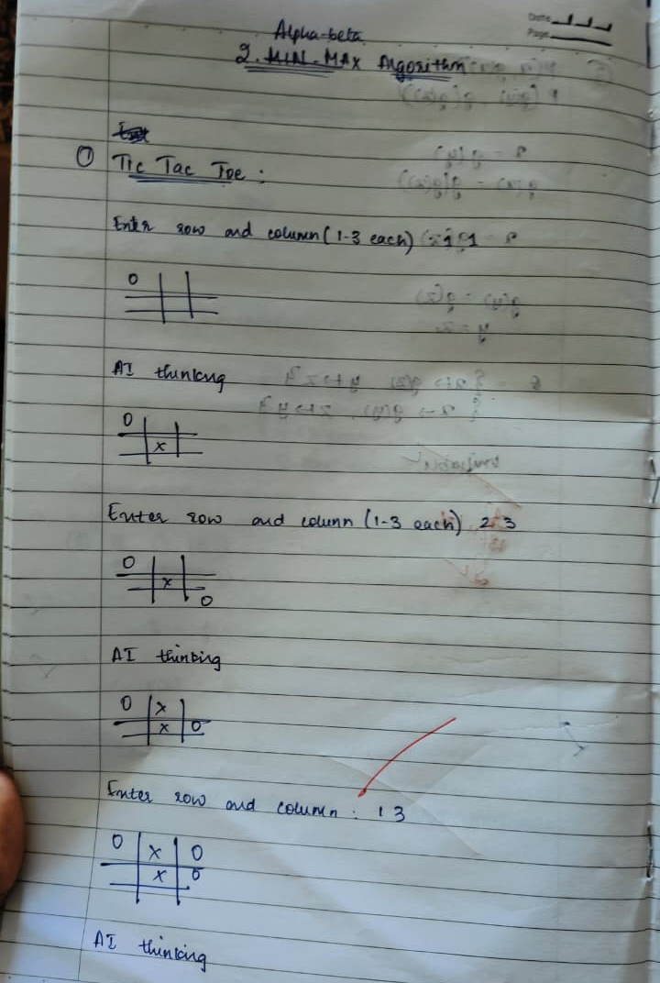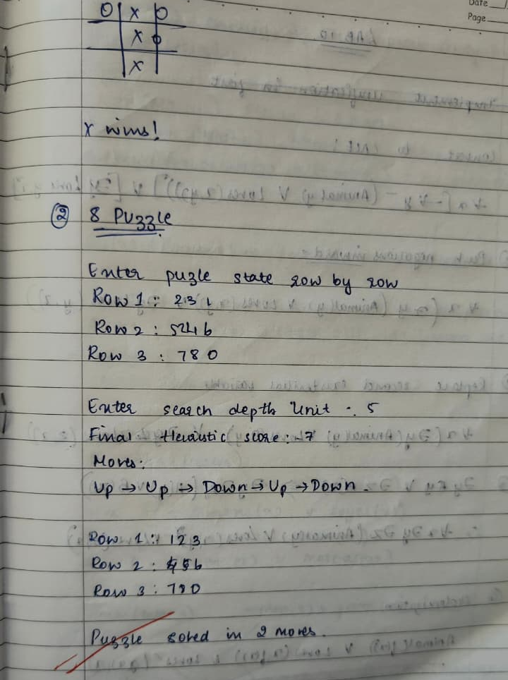

Output:
