B.M.S. COLLEGE OF ENGINEERING BENGALURU
Autonomous Institute, Affiliated to VTU



Lab Record

Computer Networks – 23CS5PCCON

Submitted in partial fulfillment for the 5th Semester Laboratory

Bachelor of Engineering
in
Computer Science and Engineering

Submitted by:

Chethana C

(1BM23CS077)

Department of Computer Science and Engineering
B.M.S. College of Engineering
Bull Temple Road, Basavanagudi, Bangalore 560 019
August 2025-December 2025

B.M.S. College of EngineerinG
DEPARTMENT OF COMPUTER SCIENCE AND ENGINEERING



CERTIFICATE

This is to certify that the Computer Networks (23CS5PCCON) laboratory has been carried out by Chethana C (1BM23CS077) during the 5th Semester August 2025-December 2025

Signature of the Faculty Incharge:

Spoorthi D M
Assistant Professor

Department of Computer Science and Engineering
B.M.S. College of Engineering, Bangalore

Table of Contents

PART - A
Serial No. | Name of Expirement
1. | Create a topology and simulate sending a simple PDU from source to destination using hub and switch as connecting devices and demonstrate ping message.
2. | Configure DHCP within a LAN and outside LAN.
3. | Configure Web Server, DNS within a LAN.
4. | Configure IP address to routers in packet tracer. Explore the following messages: ping responses, destination unreachable, request timed out, reply.
5. | Configure default route, static route to the Router.
6. | Configure RIP routing Protocol in Routers.
7. | Configure OSPF routing protocol.
8. | To construct a VLAN and make the PC’s communicate among a VLAN.
9. | To construct a WLAN and make the nodes communicate wirelessly.
10. | Demonstrate the TTL/ Life of a Packet.
11. | To understand the operation of TELNET by accessing the router in server room from a PC in IT office.
12. | To construct simple LAN and understand the concept and operation of Address Resolution Protocol (ARP).

PART – B
Serial No. | Name of Expirement
1. | Write a program for congestion control using Leaky bucket algorithm.
2. | Using TCP/IP sockets, write a client-server program to make client sending the file name and the server to send back the contents of the requested file if present.
3. | Using UDP sockets, write a client-server program to make client sending the file name and the server to send back the contents of the requested file if present.
4. | Write a program for error detecting code using CRC-CCITT (16-bits).

PART - A
Program 1: Create a topology and simulate sending a simple PDU from source to destination using hub and switch as connecting devices and demonstrate ping message.
Network diagram:
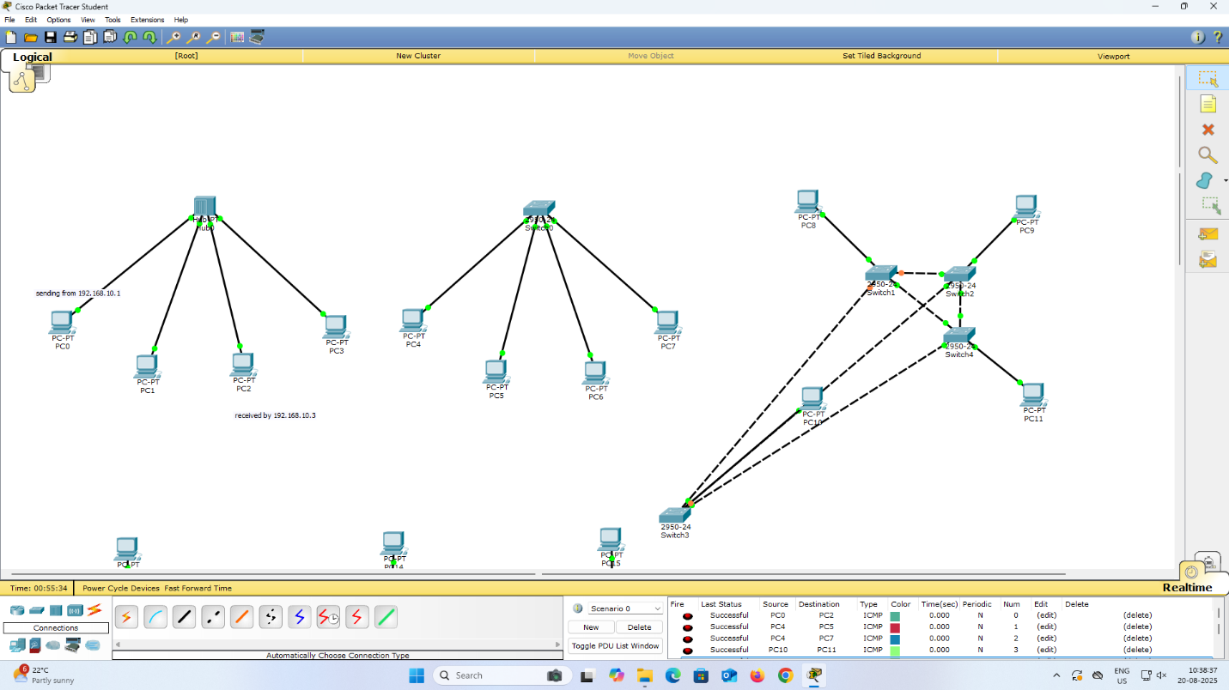
Program 2: Configure DHCP within a LAN and outside LAN.
Network diagram:
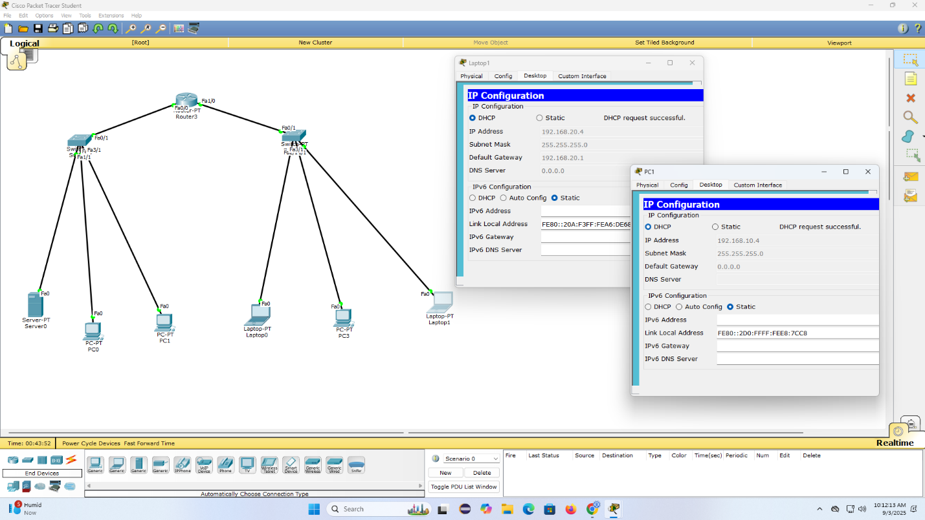
Program 3: Configure Web Server, DNS within a LAN.
Network diagram:
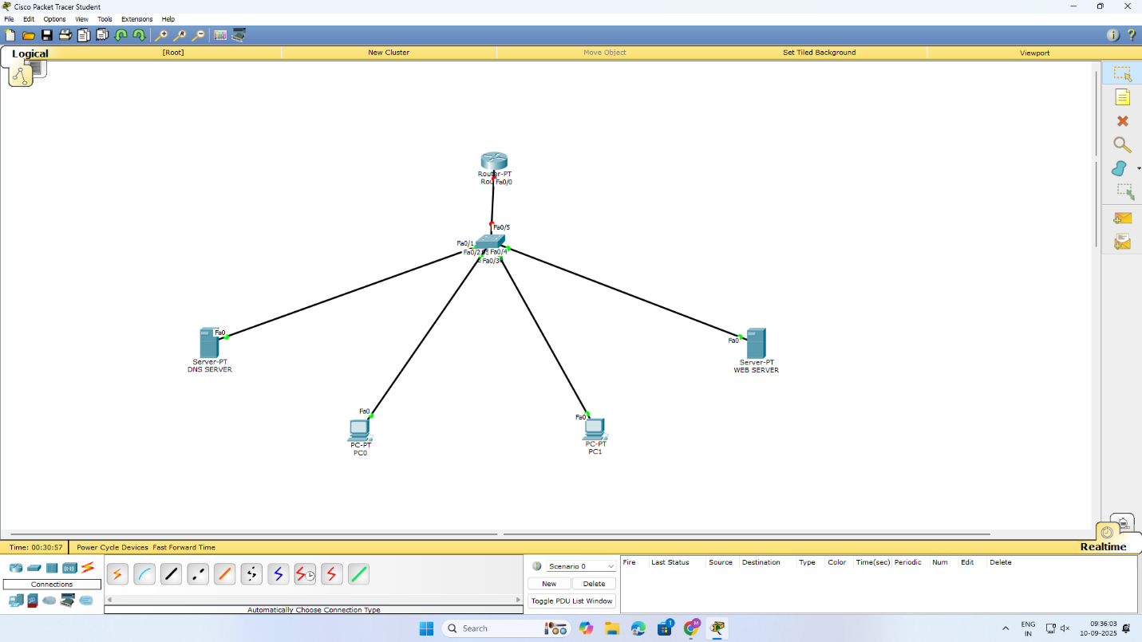
Program 4: Configure IP address to routers in packet tracer. Explore the following messages: ping responses, destination unreachable, request timed out, reply.
Network diagram:
Configuration:

Program 5: Configure default route, static route to the Router.
Network diagram:
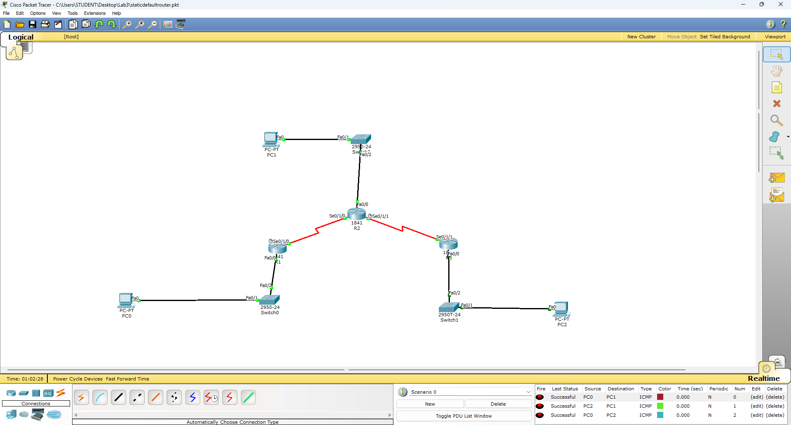
Program 6: Configure RIP routing Protocol in Routers.
Network diagram:
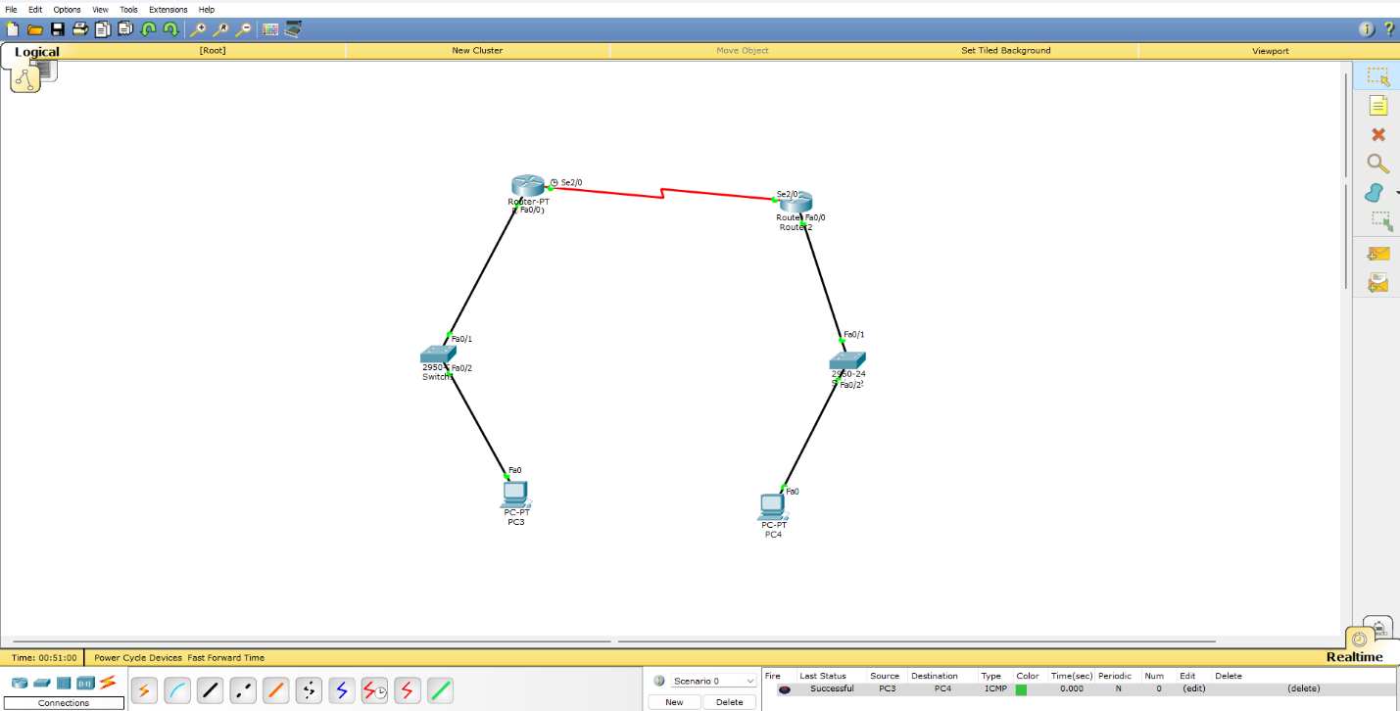

Program 7: Configure OSPF routing protocol.
Network diagram:
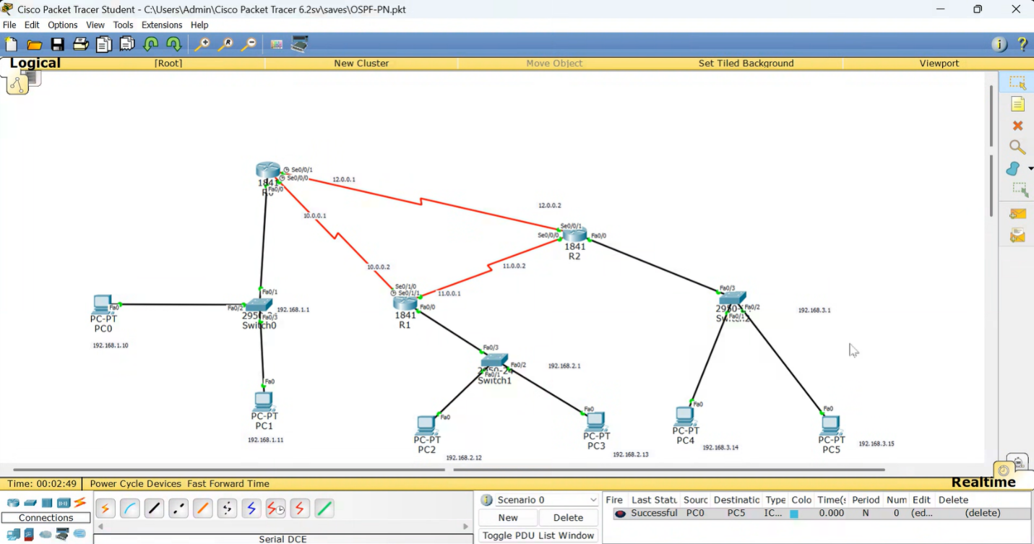
Program 8: To construct a VLAN and make the PC’s communicate among a VLAN.
Network diagram:
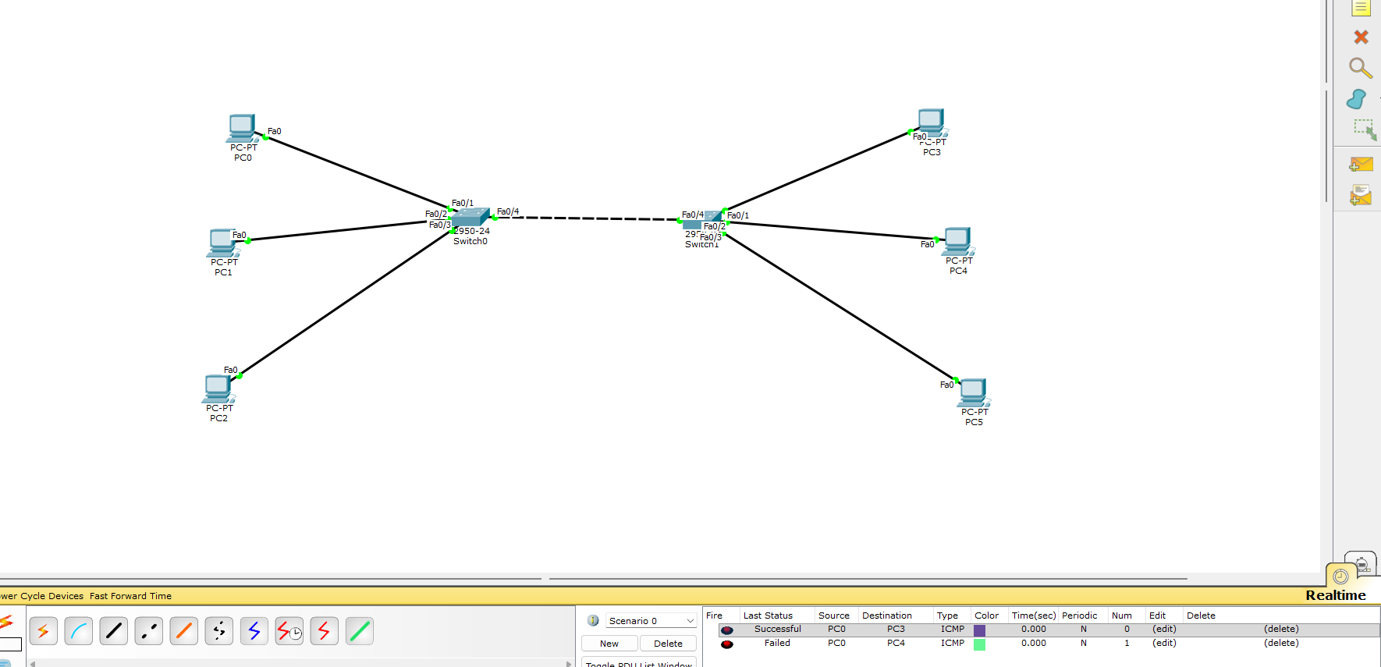

Program 9: To construct a WLAN and make the nodes communicate wirelessly.
Network diagram:
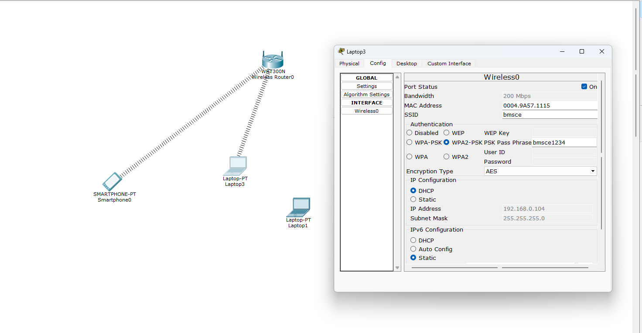
Program 10: Demonstrate the TTL/ Life of a Packet.
Network diagram:
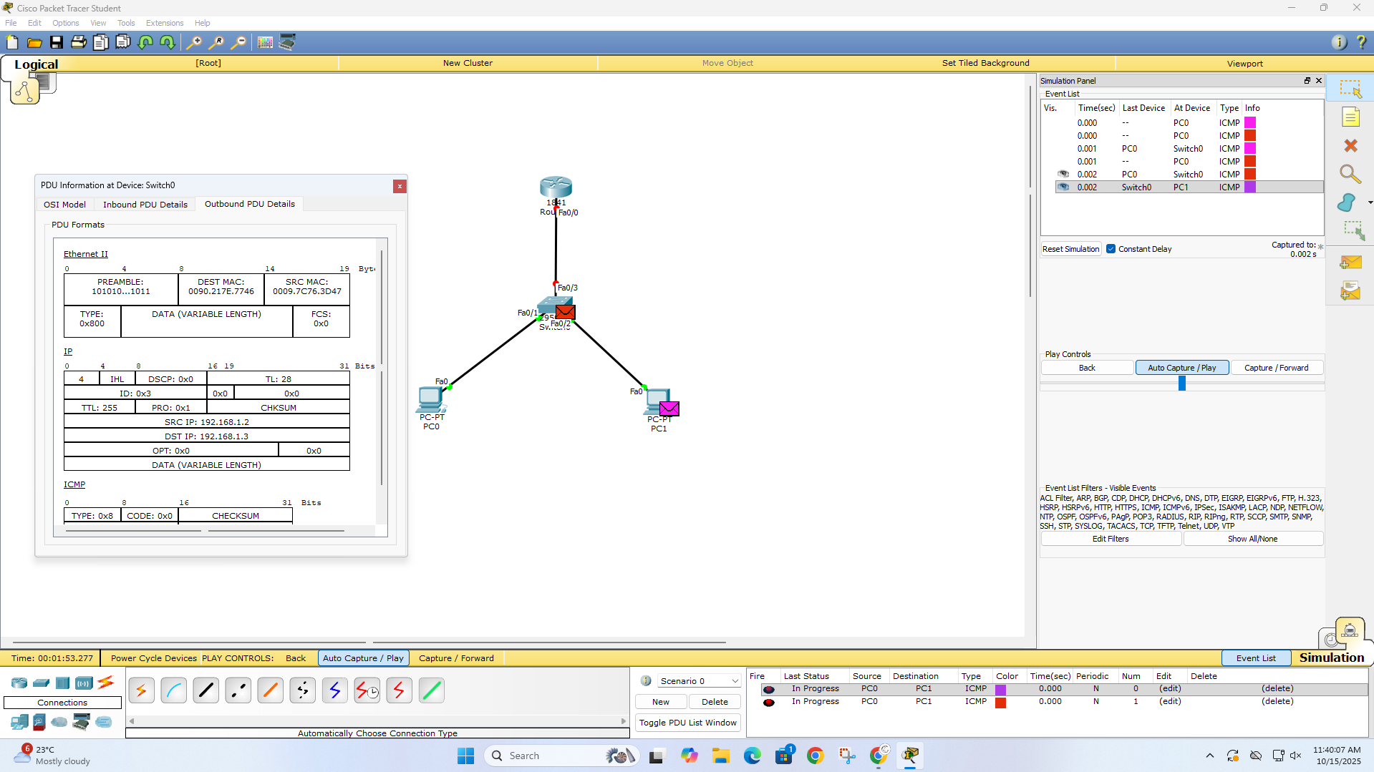

Program 11: To understand the operation of TELNET by accessing the router in server room from a PC in IT office.
Network diagram:
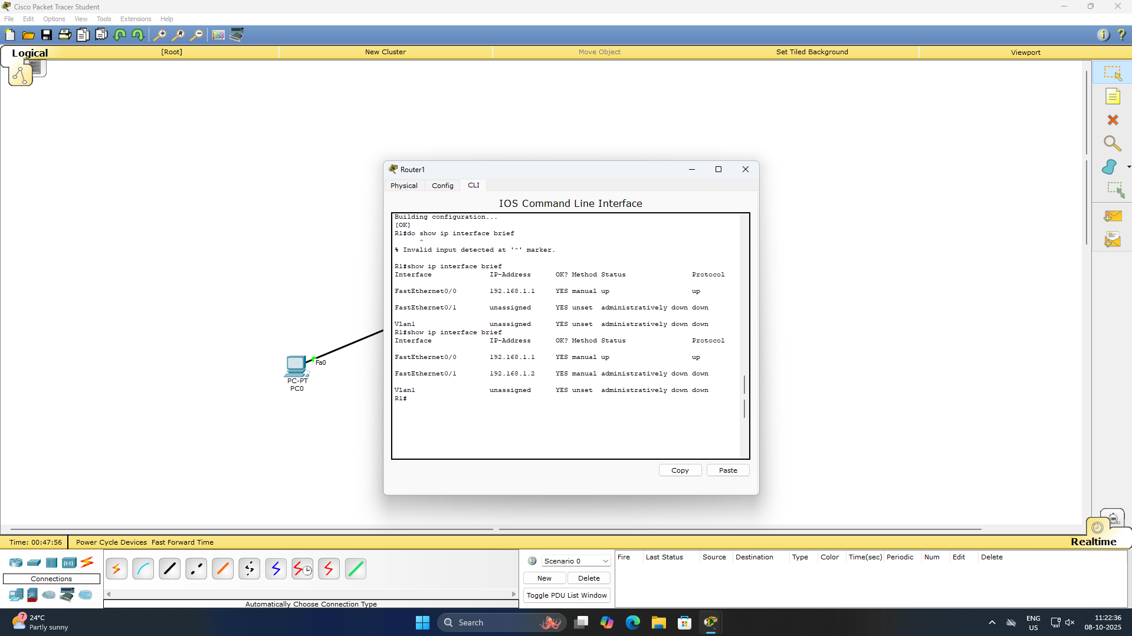

Program 12: To construct simple LAN and understand the concept and operation of Address Resolution Protocol (ARP).
Network diagram:
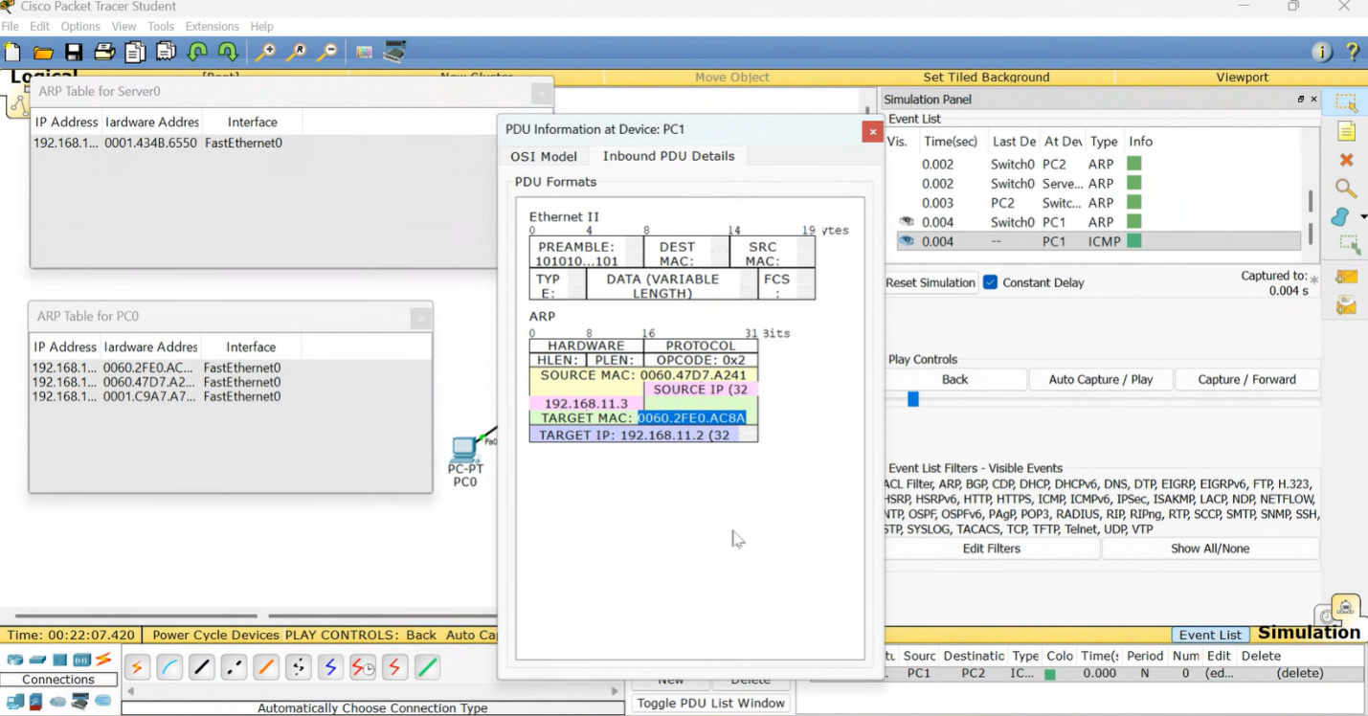

PART - B
Program 1: Write a program for congestion control using Leaky bucket algorithm.
Code:
#include <stdio.h>

int main() {
printf("Chethana.C (1BM23CS077)\n");
printf("Leaky Bucket Congestion Control Simulator\n\n");

int n;
int capacity;
int output_rate;

printf("Enter number of time units (n): ");
if (scanf("%d", &n) != 1 || n <= 0) {
printf("Invalid number of time units.\n");
return 1;
}

printf("Enter bucket capacity (max packets): ");
if (scanf("%d", &capacity) != 1 || capacity <= 0) {
printf("Invalid bucket capacity.\n");
return 1;
}

printf("Enter output (leak) rate per time unit: ");
if (scanf("%d", &output_rate) != 1 || output_rate < 0) {
printf("Invalid output rate.\n");
return 1;
}

int arrivals[n];
printf("Enter %d integers: number of arriving packets at each time unit (space separated):\n", n);
for (int i = 0; i < n; ++i) {
if (scanf("%d", &arrivals[i]) != 1 || arrivals[i] < 0) {
printf("Invalid arrival value at index %d.\n", i);
return 1;
}
}

int bucket = 0;
int dropped_total = 0;
int sent_total = 0;

printf("\nTime\tArrived\tBucketBefore\tSent\tDropped\tBucketAfter\n");
printf("----\t-------\t------------\t----\t-------\t-----------\n");

for (int t = 0; t < n; ++t) {
int arrived = arrivals[t];
int before = bucket;

int space_left = capacity - bucket;
int accepted = (arrived <= space_left) ? arrived : space_left;
int dropped = arrived - accepted;
bucket += accepted;
dropped_total += dropped;

int sent = (bucket <= output_rate) ? bucket : output_rate;
bucket -= sent;
sent_total += sent;

printf("%2d\t%6d\t%12d\t%4d\t%7d\t%11d\n",
t+1, arrived, before, sent, dropped, bucket);
}

printf("\nSummary:\n");
printf("Total packets sent: %d\n", sent_total);
printf("Total packets dropped: %d\n", dropped_total);
printf("Packets remaining in bucket: %d\n", bucket);

return 0;
}

Output:
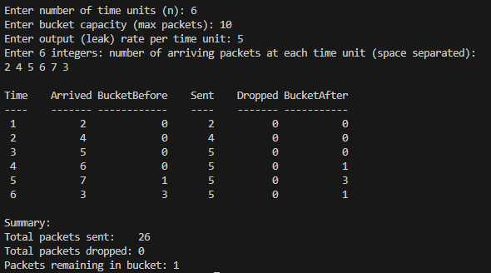

Program 2: Using TCP/IP sockets, write a client-server program to make client sending the file name and the server to send back the contents of the requested file if present.
Code:
SERVER SIDE:
#define _CRT_SECURE_NO_WARNINGS
#include <stdio.h>
#include <stdlib.h>
#include <stdint.h>
#include <string.h>
#include <inttypes.h>
#include <winsock2.h>
#include <ws2tcpip.h>

#pragma comment(lib, "ws2_32.lib")

#define BACKLOG 5
#define CHUNK 4096

int send_all(SOCKET s, const void *buf, size_t len) {
size_t sent = 0;
const char *p = (const char*)buf;
while (sent < len) {
int n = send(s, p + sent, (int)(len - sent), 0);
if (n == SOCKET_ERROR) return -1;
sent += n;
}
return 0;
}

int recv_all(SOCKET s, void *buf, size_t len) {
size_t recvd = 0;
char *p = (char*)buf;
while (recvd < len) {
int n = recv(s, p + recvd, (int)(len - recvd), 0);
if (n == 0 || n == SOCKET_ERROR) return -1;
recvd += n;
}
return 0;
}

uint64_t htonll(uint64_t v) {
uint32_t hi = htonl((uint32_t)(v >> 32));
uint32_t lo = htonl((uint32_t)(v & 0xFFFFFFFFULL));
return (((uint64_t)lo) << 32) | hi;
}
uint64_t ntohll(uint64_t v) { return htonll(v); }

int handle_client(SOCKET client) {
uint32_t name_len_n;
if (recv_all(client, &name_len_n, sizeof(name_len_n)) < 0) return -1;
uint32_t name_len = ntohl(name_len_n);
if (name_len == 0 || name_len > 64*1024) return -1;

char *filename = (char*)malloc(name_len + 1);
if (!filename) return -1;
if (recv_all(client, filename, name_len) < 0) { free(filename); return -1; }
filename[name_len] = '\0';

FILE *f = fopen(filename, "rb");
if (!f) {
uint8_t status = 0;
send_all(client, &status, 1);
char errmsg[512];
snprintf(errmsg, sizeof(errmsg), "File '%s' not found or cannot be opened.", filename);
uint32_t elen_n = htonl((uint32_t)strlen(errmsg));
send_all(client, &elen_n, sizeof(elen_n));
send_all(client, errmsg, strlen(errmsg));
free(filename);
return 0;
}

if (fseek(f, 0, SEEK_END) != 0) { fclose(f); free(filename); return -1; }
long long fsize_ll = _ftelli64(f);
fseek(f, 0, SEEK_SET);
if (fsize_ll < 0) { fclose(f); free(filename); return -1; }
uint64_t fsize = (uint64_t)fsize_ll;

uint8_t status = 1;
if (send_all(client, &status, 1) < 0) { fclose(f); free(filename); return -1; }

uint64_t fsize_n = htonll(fsize);
if (send_all(client, &fsize_n, sizeof(fsize_n)) < 0) { fclose(f); free(filename); return -1; }

char buf[CHUNK];
size_t r;
while ((r = fread(buf, 1, sizeof(buf), f)) > 0) {
if (send_all(client, buf, r) < 0) { fclose(f); free(filename); return -1; }
}

fclose(f);
free(filename);
return 0;
}

int main(int argc, char *argv[]) {
printf("Chethana.C (1BM23CS077)\n");

if (argc != 2) {
fprintf(stderr, "Usage: %s <port>\n", argv[0]);
return 1;
}
int port = atoi(argv[1]);

WSADATA wsa;
if (WSAStartup(MAKEWORD(2,2), &wsa) != 0) {
fprintf(stderr, "WSAStartup failed\n");
return 1;
}

SOCKET srv = socket(AF_INET, SOCK_STREAM, IPPROTO_TCP);
if (srv == INVALID_SOCKET) { fprintf(stderr, "socket failed\n"); WSACleanup(); return 1; }

char yes = 1;
setsockopt(srv, SOL_SOCKET, SO_REUSEADDR, &yes, sizeof(yes));

struct sockaddr_in sa;
sa.sin_family = AF_INET;
sa.sin_port = htons((unsigned short)port);
sa.sin_addr.s_addr = INADDR_ANY;

if (bind(srv, (struct sockaddr*)&sa, sizeof(sa)) == SOCKET_ERROR) {
fprintf(stderr, "bind failed\n");
closesocket(srv); WSACleanup(); return 1;
}
if (listen(srv, BACKLOG) == SOCKET_ERROR) {
fprintf(stderr, "listen failed\n");
closesocket(srv); WSACleanup(); return 1;
}

printf("Server listening on port %d. Put files in this folder to serve.\n", port);

for (;;) {
struct sockaddr_in cli;
int clin = sizeof(cli);
SOCKET client = accept(srv, (struct sockaddr*)&cli, &clin);
if (client == INVALID_SOCKET) {
fprintf(stderr, "accept failed\n");
continue;
}
char ipbuf[INET_ADDRSTRLEN];
inet_ntop(AF_INET, &cli.sin_addr, ipbuf, sizeof(ipbuf));
printf("Client connected: %s:%d\n", ipbuf, ntohs(cli.sin_port));

handle_client(client);

closesocket(client);
printf("Client connection closed.\n");
}

closesocket(srv);
WSACleanup();
return 0;
}

CLIENT SIDE:
#define _CRT_SECURE_NO_WARNINGS
#include <stdio.h>
#include <stdlib.h>
#include <stdint.h>
#include <string.h>
#include <inttypes.h>
#include <winsock2.h>
#include <ws2tcpip.h>

#pragma comment(lib, "ws2_32.lib")

#define CHUNK 4096

int send_all(SOCKET s, const void *buf, size_t len) {
size_t sent = 0;
const char *p = (const char*)buf;
while (sent < len) {
int n = send(s, p + sent, (int)(len - sent), 0);
if (n == SOCKET_ERROR) return -1;
sent += n;
}
return 0;
}

int recv_all(SOCKET s, void *buf, size_t len) {
size_t recvd = 0;
char *p = (char*)buf;
while (recvd < len) {
int n = recv(s, p + recvd, (int)(len - recvd), 0);
if (n == 0 || n == SOCKET_ERROR) return -1;
recvd += n;
}
return 0;
}

uint64_t htonll(uint64_t v) {
uint32_t hi = htonl((uint32_t)(v >> 32));
uint32_t lo = htonl((uint32_t)(v & 0xFFFFFFFFULL));
return (((uint64_t)lo) << 32) | hi;
}
uint64_t ntohll(uint64_t v) { return htonll(v); }

int main(int argc, char *argv[]) {
printf("Chethana.C (1BM23CS077)\n");

if (argc < 4) {
fprintf(stderr, "Usage: %s <server-ip> <port> <filename>\n", argv[0]);
return 1;
}

const char *server_ip = argv[1];
int port = atoi(argv[2]);
const char *filename = argv[3];
size_t name_len = strlen(filename);
if (name_len == 0) { fprintf(stderr, "Empty filename\n"); return 1; }

WSADATA wsa;
if (WSAStartup(MAKEWORD(2,2), &wsa) != 0) { fprintf(stderr, "WSAStartup failed\n"); return 1; }

SOCKET sock = socket(AF_INET, SOCK_STREAM, IPPROTO_TCP);
if (sock == INVALID_SOCKET) { fprintf(stderr, "socket failed\n"); WSACleanup(); return 1; }

struct sockaddr_in srv;
srv.sin_family = AF_INET;
srv.sin_port = htons((unsigned short)port);
if (inet_pton(AF_INET, server_ip, &srv.sin_addr) != 1) { fprintf(stderr, "inet_pton failed\n"); closesocket(sock); WSACleanup(); return 1; }

if (connect(sock, (struct sockaddr*)&srv, sizeof(srv)) == SOCKET_ERROR) { fprintf(stderr, "connect failed\n"); closesocket(sock); WSACleanup(); return 1; }

uint32_t name_len_n = htonl((uint32_t)name_len);
if (send_all(sock, &name_len_n, sizeof(name_len_n)) < 0) { fprintf(stderr, "send failed\n"); closesocket(sock); WSACleanup(); return 1; }
if (send_all(sock, filename, name_len) < 0) { fprintf(stderr, "send failed\n"); closesocket(sock); WSACleanup(); return 1; }

uint8_t status;
if (recv_all(sock, &status, 1) < 0) { fprintf(stderr, "recv failed\n"); closesocket(sock); WSACleanup(); return 1; }

if (status == 0) {
uint32_t elen_n;
if (recv_all(sock, &elen_n, sizeof(elen_n)) < 0) { fprintf(stderr, "recv failed\n"); closesocket(sock); WSACleanup(); return 1; }
uint32_t elen = ntohl(elen_n);
char *errmsg = (char*)malloc(elen + 1);
if (!errmsg) { closesocket(sock); WSACleanup(); return 1; }
if (recv_all(sock, errmsg, elen) < 0) { free(errmsg); closesocket(sock); WSACleanup(); return 1; }
errmsg[elen] = '\0';
fprintf(stderr, "Server error: %s\n", errmsg);
free(errmsg);
} else if (status == 1) {
uint64_t fsize_n;
if (recv_all(sock, &fsize_n, sizeof(fsize_n)) < 0) { fprintf(stderr, "recv failed\n"); closesocket(sock); WSACleanup(); return 1; }
uint64_t fsize = ntohll(fsize_n);
printf("Receiving file '%s' (%llu bytes)...\n", filename, (unsigned long long)fsize);

char outname[1100];
snprintf(outname, sizeof(outname), "recv_%s", filename);
FILE *out = fopen(outname, "wb");
if (!out) { fprintf(stderr, "fopen failed\n"); closesocket(sock); WSACleanup(); return 1; }

uint64_t remaining = fsize;
char buf[CHUNK];
while (remaining > 0) {
int toread = (int)((remaining > CHUNK) ? CHUNK : (size_t)remaining);
if (recv_all(sock, buf, toread) < 0) { fprintf(stderr, "recv failed\n"); fclose(out); closesocket(sock); WSACleanup(); return 1; }
fwrite(buf, 1, toread, out);
remaining -= toread;
}
fclose(out);
printf("File received and saved as: %s\n", outname);
} else {
fprintf(stderr, "Unknown status from server: %d\n", status);
}

closesocket(sock);
WSACleanup();
return 0;
}

Output:
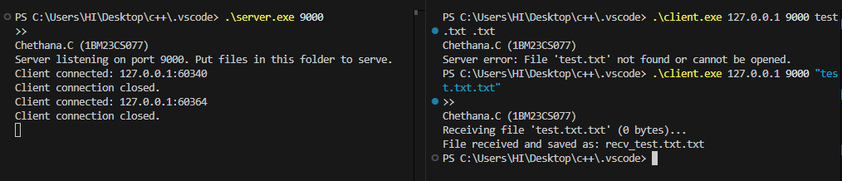

Program 3: Using UDP sockets, write a client-server program to make client sending the file name and the server to send back the contents of the requested file if present.
Code:
CLIENT SIDE:

#define _CRT_SECURE_NO_WARNINGS
#include <stdio.h>
#include <stdlib.h>
#include <stdint.h>
#include <string.h>
#include <winsock2.h>
#include <ws2tcpip.h>

#pragma comment(lib,"ws2_32.lib")

#define CHUNK 1024
#define TIMEOUT_MS 5000

int main(int argc, char *argv[]) {
printf("Chethana.C (1BM23CS077)\n");
if (argc < 4) {
fprintf(stderr, "Usage: %s <server-ip> <port> <filename>\n", argv[0]);
return 1;
}
const char *server_ip = argv[1];
int port = atoi(argv[2]);
const char *filename = argv[3];

WSADATA wsa;
if (WSAStartup(MAKEWORD(2,2), &wsa) != 0) { fprintf(stderr, "WSAStartup failed\n"); return 1; }

SOCKET s = socket(AF_INET, SOCK_DGRAM, IPPROTO_UDP);
if (s == INVALID_SOCKET) { fprintf(stderr, "socket failed\n"); WSACleanup(); return 1; }

struct sockaddr_in srv;
srv.sin_family = AF_INET;
srv.sin_port = htons((unsigned short)port);
if (inet_pton(AF_INET, server_ip, &srv.sin_addr) != 1) { fprintf(stderr, "inet_pton failed\n"); closesocket(s); WSACleanup(); return 1; }

int sent = sendto(s, filename, (int)strlen(filename), 0, (struct sockaddr*)&srv, sizeof(srv));
if (sent == SOCKET_ERROR) { fprintf(stderr, "sendto failed\n"); closesocket(s); WSACleanup(); return 1; }

char outname[1100];
snprintf(outname, sizeof(outname), "recv_%s", filename);
FILE *out = fopen(outname, "wb");
if (!out) { perror("fopen"); closesocket(s); WSACleanup(); return 1; }

struct timeval tv;
tv.tv_sec = TIMEOUT_MS / 1000;
tv.tv_usec = (TIMEOUT_MS % 1000) * 1000;
setsockopt(s, SOL_SOCKET, SO_RCVTIMEO, (const char*)&tv, sizeof(tv));

uint32_t expected_seq = 0;
int finished = 0;
while (!finished) {
char pkt[5 + CHUNK];
struct sockaddr_in from;
int fromlen = sizeof(from);
int r = recvfrom(s, pkt, sizeof(pkt), 0, (struct sockaddr*)&from, &fromlen);
if (r == SOCKET_ERROR) {
int err = WSAGetLastError();
if (err == WSAETIMEDOUT) {
fprintf(stderr, "Timed out waiting for server response\n");
} else {
fprintf(stderr, "recvfrom error: %d\n", err);
}
break;
}
if (r < 5) continue;

uint32_t seq_n;
memcpy(&seq_n, pkt, 4);
uint32_t seq = ntohl(seq_n);
uint8_t last = (uint8_t)pkt[4];
int payload_len = r - 5;

if (seq == 0xFFFFFFFFu) {

pkt[5 + payload_len] = '\0';
fprintf(stderr, "Server error: %.*s\n", payload_len, pkt + 5);
break;
}

if (seq == expected_seq) {
if (payload_len > 0) fwrite(pkt + 5, 1, payload_len, out);

uint32_t ack_n = htonl(seq);
sendto(s, (const char*)&ack_n, 4, 0, (struct sockaddr*)&from, fromlen);
expected_seq++;
if (last) {
printf("Received final packet seq %u; total bytes written in recv_%s\n", seq, filename);
finished = 1;
break;
}
} else {

uint32_t ack_n = htonl((expected_seq == 0) ? 0xFFFFFFFFu : expected_seq - 1);
sendto(s, (const char*)&ack_n, 4, 0, (struct sockaddr*)&from, fromlen);
}
}

fclose(out);
closesocket(s);
WSACleanup();
return 0;
}
SERVER SIDE:
#define _CRT_SECURE_NO_WARNINGS
#include <stdio.h>
#include <stdlib.h>
#include <stdint.h>
#include <string.h>
#include <winsock2.h>
#include <ws2tcpip.h>

#pragma comment(lib,"ws2_32.lib")

#define CHUNK 1024
#define MAX_FILENAME 1024
#define RETRANS_MAX 8
#define ACK_TIMEOUT_MS 1000

int send_packet_and_wait_ack(SOCKET s, struct sockaddr_in *cli, socklen_t clin, uint32_t seq,
uint8_t last, const char *data, int data_len) {

uint32_t seq_n = htonl(seq);
char packet[5 + CHUNK];
memcpy(packet, &seq_n, 4);
packet[4] = (char)last;
if (data_len > 0) memcpy(packet + 5, data, data_len);
int pkt_len = 5 + data_len;

int attempts = 0;
while (attempts < RETRANS_MAX) {
// send
int sent = sendto(s, packet, pkt_len, 0, (struct sockaddr*)cli, clin);
if (sent == SOCKET_ERROR) return -1;

fd_set readfds;
FD_ZERO(&readfds);
FD_SET(s, &readfds);
struct timeval tv;
tv.tv_sec = ACK_TIMEOUT_MS / 1000;
tv.tv_usec = (ACK_TIMEOUT_MS % 1000) * 1000;

int rv = select(0, &readfds, NULL, NULL, &tv);
if (rv > 0 && FD_ISSET(s, &readfds)) {

char ackbuf[4];
struct sockaddr_in from;
int fromlen = sizeof(from);
int r = recvfrom(s, ackbuf, 4, 0, (struct sockaddr*)&from, &fromlen);
if (r == 4) {
uint32_t ack_n;
memcpy(&ack_n, ackbuf, 4);
uint32_t ack = ntohl(ack_n);
if (ack == seq) return 0; // success

}
}

attempts++;
}
return -2;
}

int main(int argc, char *argv[]) {
printf("Chethana.C (1BM23CS077)\n");
if (argc != 2) {
fprintf(stderr, "Usage: %s <port>\n", argv[0]);
return 1;
}
int port = atoi(argv[1]);

WSADATA wsa;
if (WSAStartup(MAKEWORD(2,2), &wsa) != 0) {
fprintf(stderr, "WSAStartup failed\n");
return 1;
}

SOCKET s = socket(AF_INET, SOCK_DGRAM, IPPROTO_UDP);
if (s == INVALID_SOCKET) { fprintf(stderr, "socket failed\n"); WSACleanup(); return 1; }

struct sockaddr_in sa;
sa.sin_family = AF_INET;
sa.sin_port = htons((unsigned short)port);
sa.sin_addr.s_addr = INADDR_ANY;

if (bind(s, (struct sockaddr*)&sa, sizeof(sa)) == SOCKET_ERROR) {
fprintf(stderr, "bind failed\n"); closesocket(s); WSACleanup(); return 1;
}

printf("UDP server listening on port %d\n", port);

for (;;) {
char buf[1500];
struct sockaddr_in cli;
int clin = sizeof(cli);

int r = recvfrom(s, buf, sizeof(buf)-1, 0, (struct sockaddr*)&cli, &clin);
if (r <= 0) continue;
buf[r] = '\0';
printf("Request from %s:%d -> filename: '%s'\n", inet_ntoa(cli.sin_addr), ntohs(cli.sin_port), buf);

FILE *f = fopen(buf, "rb");
if (!f) {

uint32_t errseq_n = htonl(0xFFFFFFFFu);
char errmsg[512];
snprintf(errmsg, sizeof(errmsg), "NOTFOUND");
char pkt[4 + 1 + 512];
memcpy(pkt, &errseq_n, 4);
pkt[4] = 0; // last flag ignored
int pktlen = 5 + (int)strlen(errmsg);
memcpy(pkt + 5, errmsg, strlen(errmsg));
sendto(s, pkt, pktlen, 0, (struct sockaddr*)&cli, clin);
printf("File '%s' not found -> sent NOTFOUND\n", buf);
continue;
}

fseek(f, 0, SEEK_END);
long long fsize_ll = _ftelli64(f);
fseek(f, 0, SEEK_SET);
uint64_t fsize = (fsize_ll < 0) ? 0 : (uint64_t)fsize_ll;
printf("Sending file size: %llu bytes\n", (unsigned long long)fsize);

uint32_t seq = 0;
char chunk[CHUNK];
size_t got;
while ((got = fread(chunk, 1, CHUNK, f)) > 0) {
uint8_t last = (feof(f) ? 1 : 0);
int res = send_packet_and_wait_ack(s, &cli, clin, seq, last, chunk, (int)got);
if (res == 0) {
// sent & acked
seq++;
} else if (res == -2) {
fprintf(stderr, "Failed to get ACK for seq %u after retries; aborting transfer\n", seq);
break;
} else {
fprintf(stderr, "Socket error while sending seq %u\n", seq);
break;
}
}
fclose(f);
printf("Finished transfer (or aborted). Last seq sent: %u\n", seq ? seq-1 : 0);
}

closesocket(s);
WSACleanup();
return 0;
}

Output:
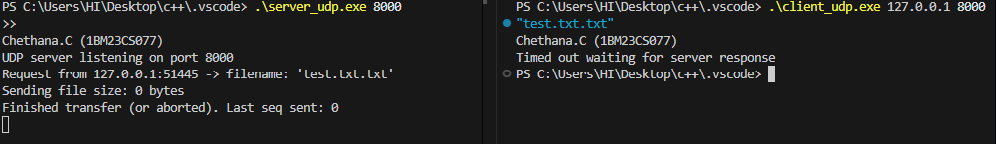

Program 4: Write a program for error detecting code using CRC-CCITT (16-bits).
Code:
#include <stdio.h>
#include <stdint.h>
#include <string.h>

#define POLY 0x1021
#define INIT_CRC 0xFFFF

uint16_t compute_crc(uint8_t *data, int len) {
uint16_t crc = INIT_CRC;

for (int i = 0; i < len; i++) {
crc ^= (uint16_t)data[i] << 8;

for (int b = 0; b < 8; b++) {
if (crc & 0x8000)
crc = (crc << 1) ^ POLY;
else
crc <<= 1;
}
}
return crc & 0xFFFF;
}

int main() {
printf("Chethana.C (1BM23CS077)\n");

char msg[256];
printf("Enter message: ");
scanf("%s", msg);

int len = strlen(msg);
uint16_t crc = compute_crc((uint8_t *)msg, len);

printf("\nOriginal Message: %s", msg);
printf("\nCRC-16 (CCITT) : %04X\n", crc);

printf("\n--- Receiver Side CRC Check ---\n");
char received[300];
printf("Enter received message: ");
scanf("%s", received);

uint16_t recv_crc = compute_crc((uint8_t *)received, strlen(received));

if (recv_crc == 0)
printf("NO ERROR: CRC Verified Successfully.\n");
else
printf("ERROR DETECTED: CRC Mismatch. (Syndrome = %04X)\n", recv_crc);

return 0;
}

Output:
