1. Create employee database.

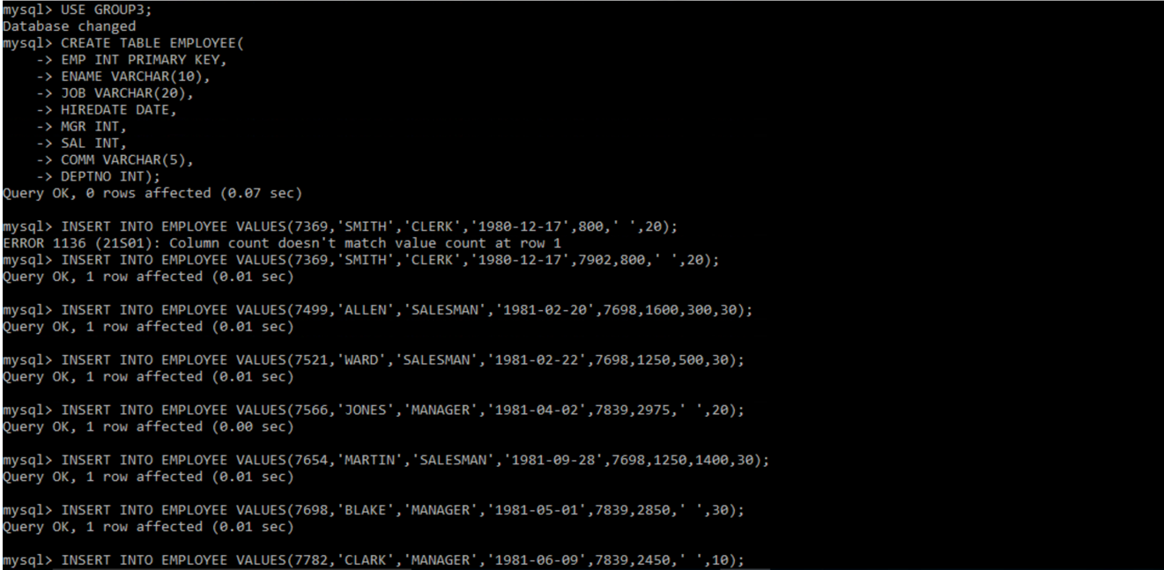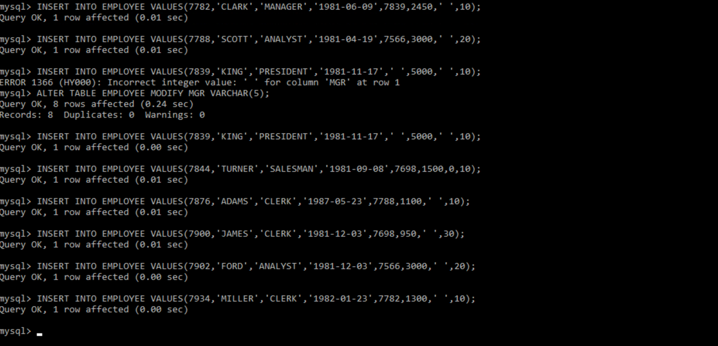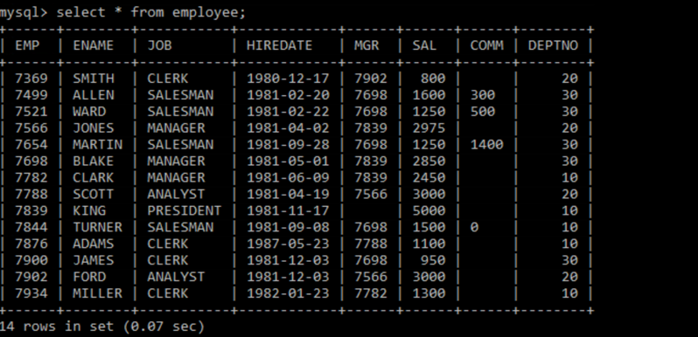

2.Select the employees in dept 30

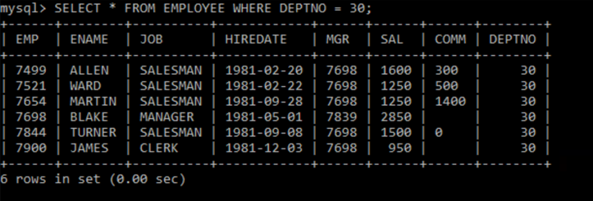

3.List names, numbers and departments of all clerks

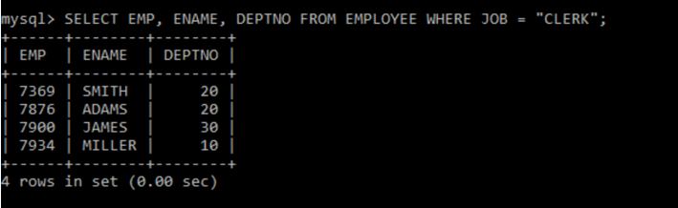

4.Find the department numbers and names of employees of all departments with deptno greater then 30.

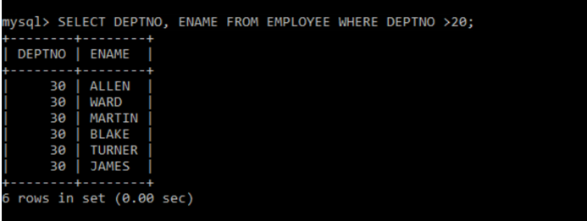

5.Find employees whose commission is greater than their salary.

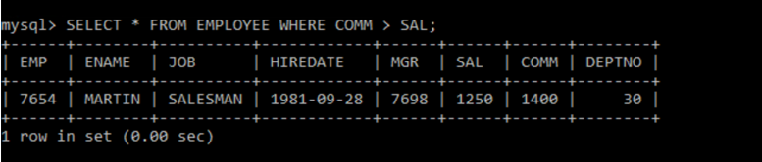

6.Find employees whose commission is greater than 60% of their salary.

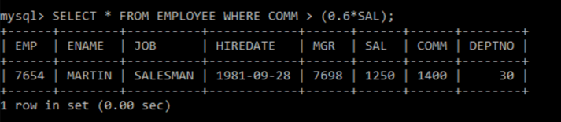

7.List name, job and salary of all the employees in dept 20 who earn more than 2000.

8.Find all salesman in dept 30 whose salary is greater than 1500.

9.Find all employees whose designation is either manager or president.

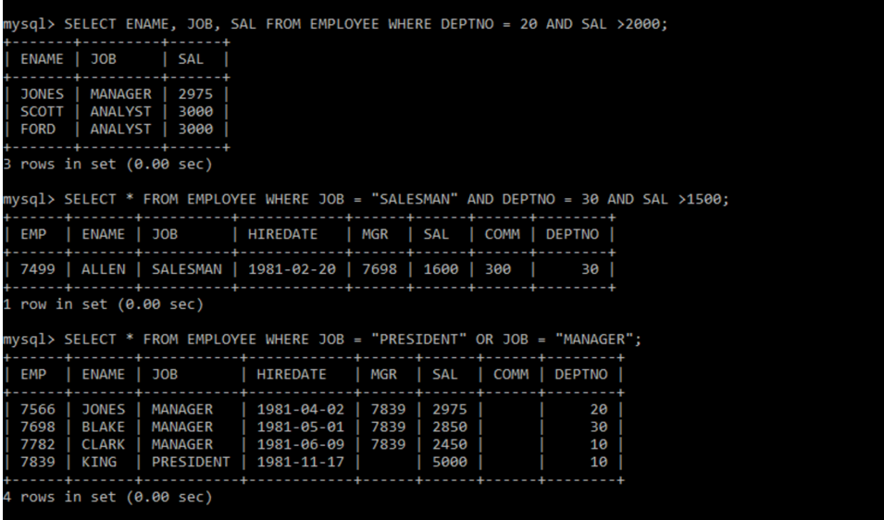

10.Find all the managers who are not in dept 30.



11.Find all the details of managers and clerks in department 10.

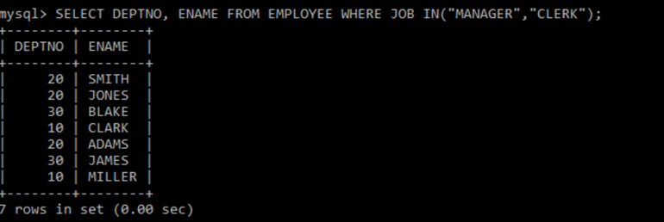

12.Find all the details of Managers(in any dept) and clerks in dept 20.

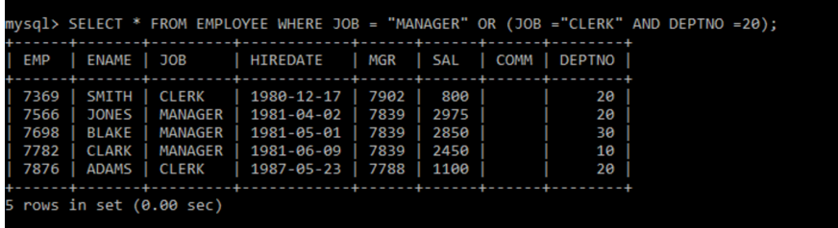

13.Find the details of all the managers in dept 10 and all the clerks in dept 20 and all the employees who are neither manager nor clerks but whose salary is more than or equal to 1200/-

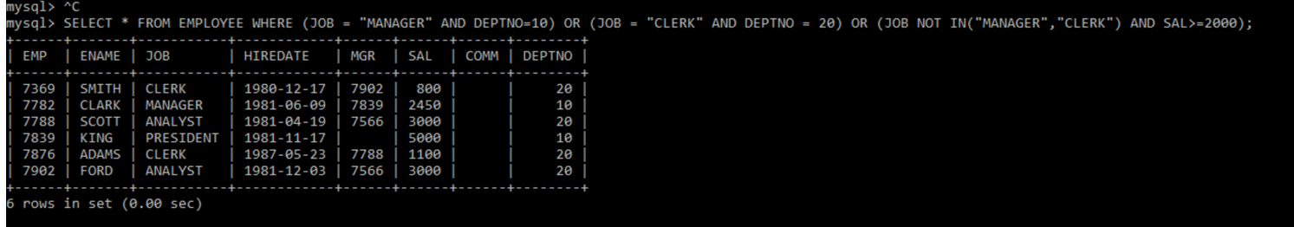

14.Find the names of anyone in dept 20, who’s neither manager nor clerk.

15.Find the names of employees who earn between 1200 and 1400/-.

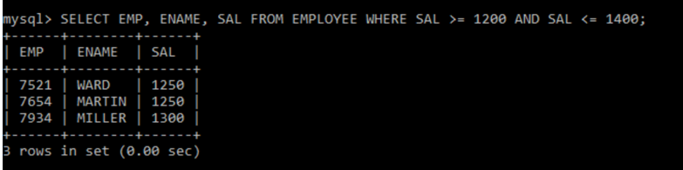

16.Find the employees who are clerks, analysts and salesmen.

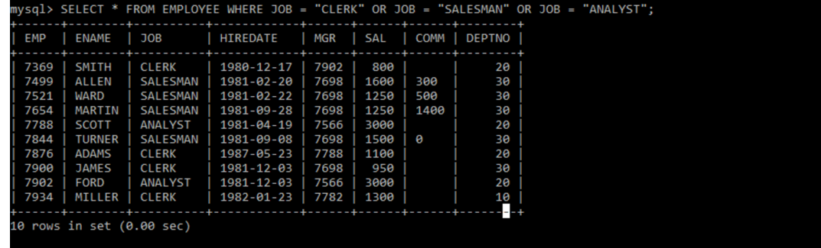

17.Find the employees who are not clerks, analysts and salesmen.

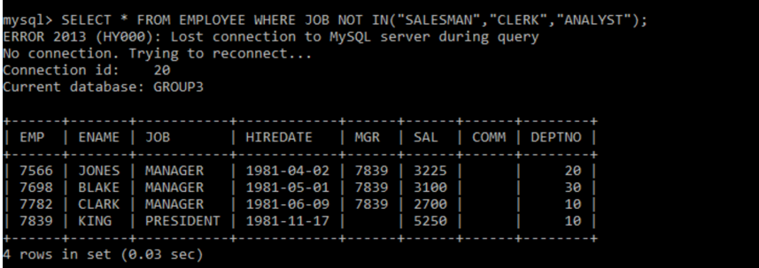

18. Find the employees who do not receive commission.

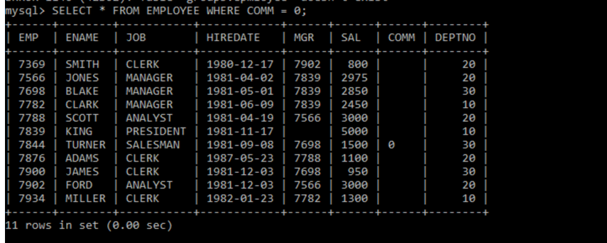

19. Find the different jobs of employees who receive commission.

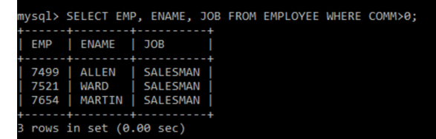

20. Find the employees who doesn’t receive commission or whose commission is less than 100.

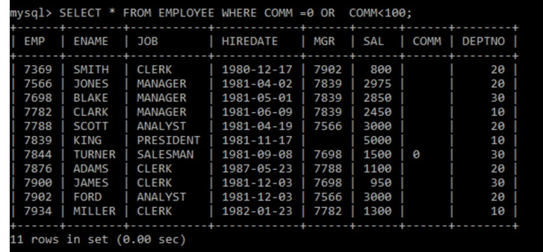

21. If all employees not receiving commission entitles a bonus of Rs 250, show the new earnings of all the employees.

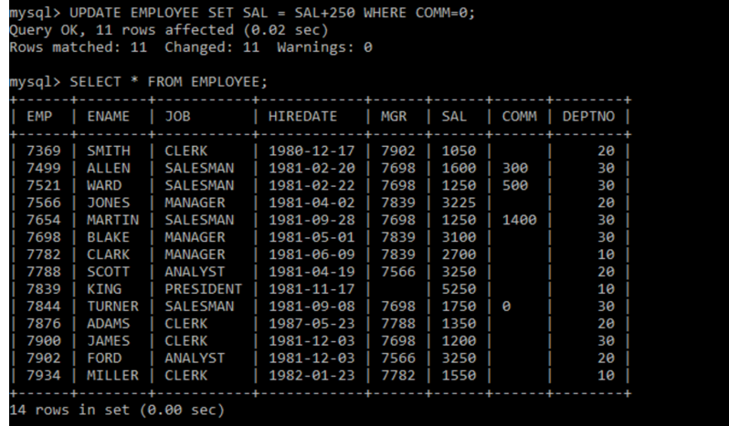

22. Find all the employees whose total earnings is greater than 2000/.

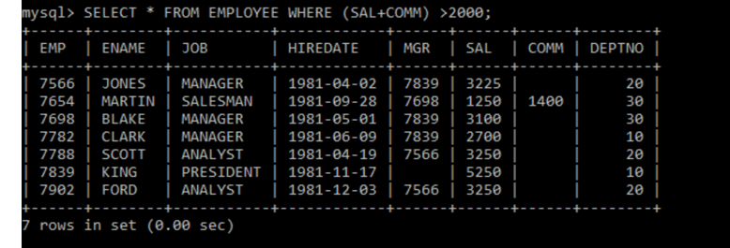

23. Find all the employees whose name begins or ends with M.

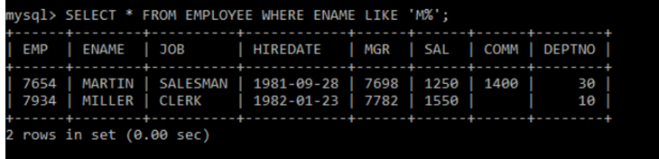

24. Find all the employees whose name contain letter m in any case.

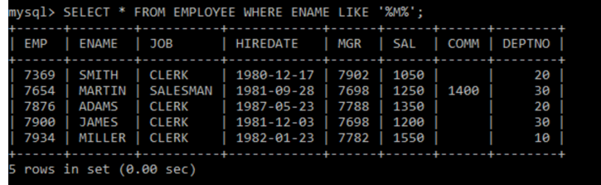

25. Find all the employees whose names are upto 15 characters and has letter R in 3rd place.

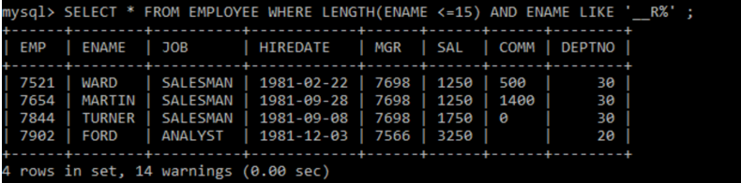

26. Find all the employees who were hired in the month february of any year.

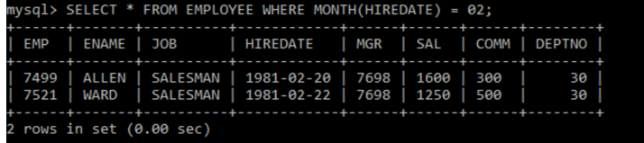

27. Find all the employees who were hired in the last day of month.

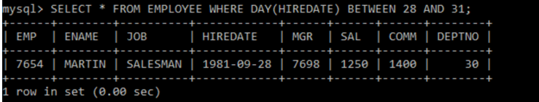

28. Find all the employees who were hired more than two years ago.

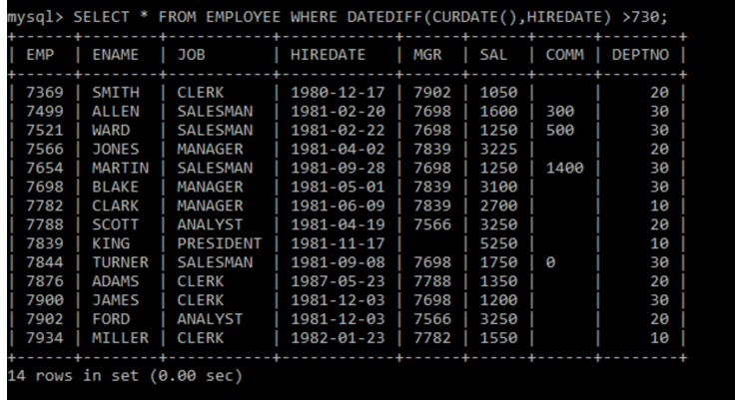

29. Find the managers hired in the year 2003.

