**Observations and Setup**

**-Simply must copy and paste the original script from R markdown/R script file to Knime R-Source and R-Table nodes.**

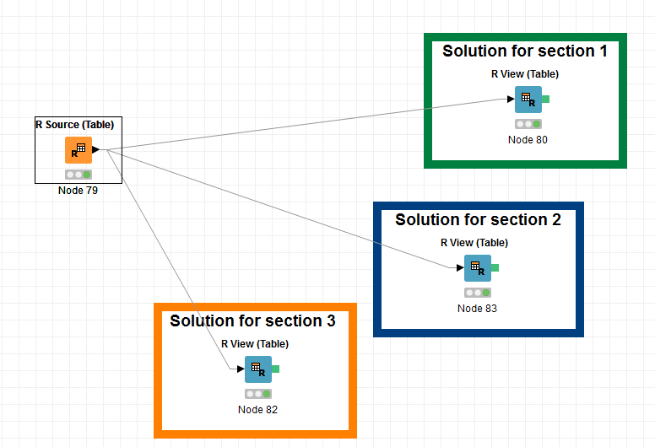

**Additional:**

-It is always better to install the ‘tidyverse’ package into Knime. May be more according to the requirements.

Additional line to R script:

*install.packages(“tidyverse”)*

*etc.*

-Need to add to avoid the output to be 'tbl_df', but a data.frame that knime.out accept as a proper format, no matter what the input file type is(sas/csv/xlxs).

*variablename<- as.data.frame.data.frame(inputdata)*

(NOTE: ONLY IF…)

-If the data table include fields with date type and are to be used in the analysis. The R script must be changed, by simply adding 2 lines.

Reason: *When exported to Knime the date column is automatically converted to Unix timestamp. This field must be converted from Unix timestamp into human readable data. Then can be converted into date class and convert to a character.*

From:

transactional_daily$CENSUSDATE <- as.Date(transactional_daily$CENSUSDATE)

To:

transactional_daily $CENSUSDATE <- as.POSIXct(transactional_daily $CENSUSDATE, origin="1970-01-01", tz="GMT")

transactional_daily $CENSUSDATE <- as.character(as.Date(transactional_daily $CENSUSDATE, "%d-%b-%Y"))

**Code in Original is similar to what is in Knime**

*Code in Knime*

##-----------------------------------------------------------------------------------





