**Report** (R output -> Knime output)

R studio version: 1.1.456 (Note: need to install packages to meet requirements)

R scripting 3.5.1

***-R markdown code is converted to R script***

Ran the code below in R console:

>install.packages(knitr)

>library(knitr)

>purl(“C:/………/filename.Rmd”)

***-Knime had to have the scripting R extension(Mainly used R Source(Table) & R View(table))***

-To get the data table

--Used R Source(Table) node -> Configure(from the drop-down menu) -> Copy & paste from the original script

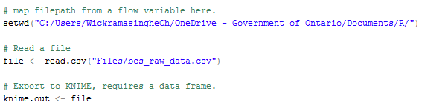

*QUICKLINKS*

* Solution for section1
* Solution for section2
* Solution for section3

# SOLUTION FOR SECTION 1

--Then connected to a R View(Table) node-> Configure (from the drop-down menu) -> Copy & paste from the original script (Scatter Plot)(Note:line11 is added later)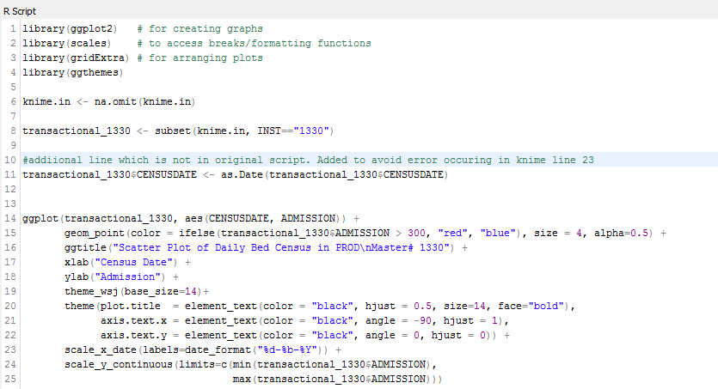

Which gives,

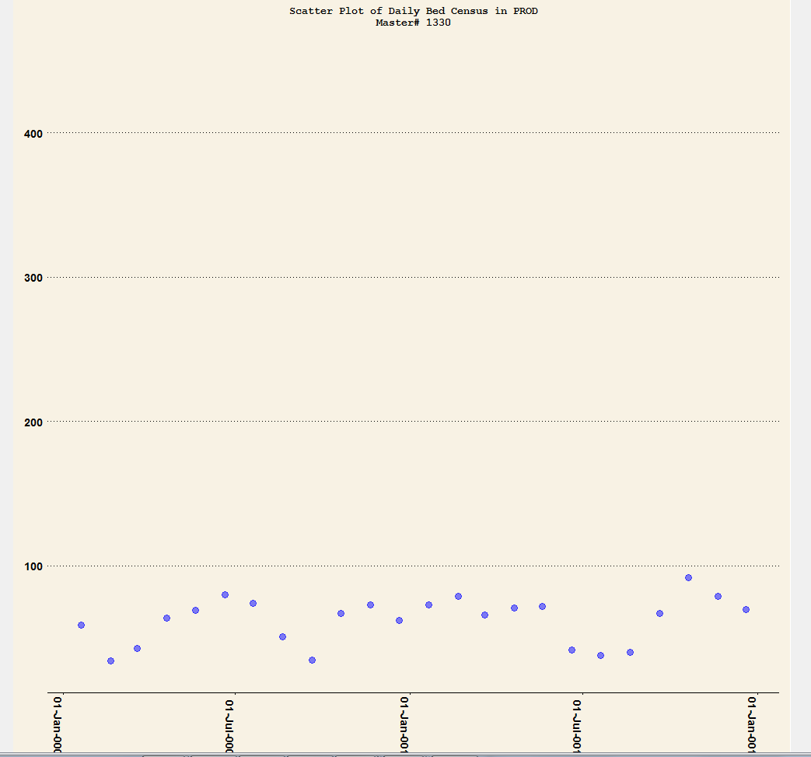

But I modified to the code as such,

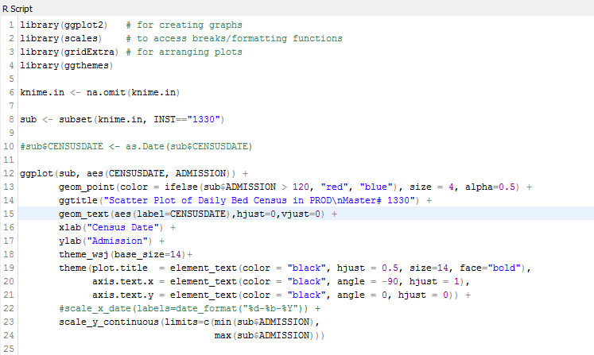

Which gives,

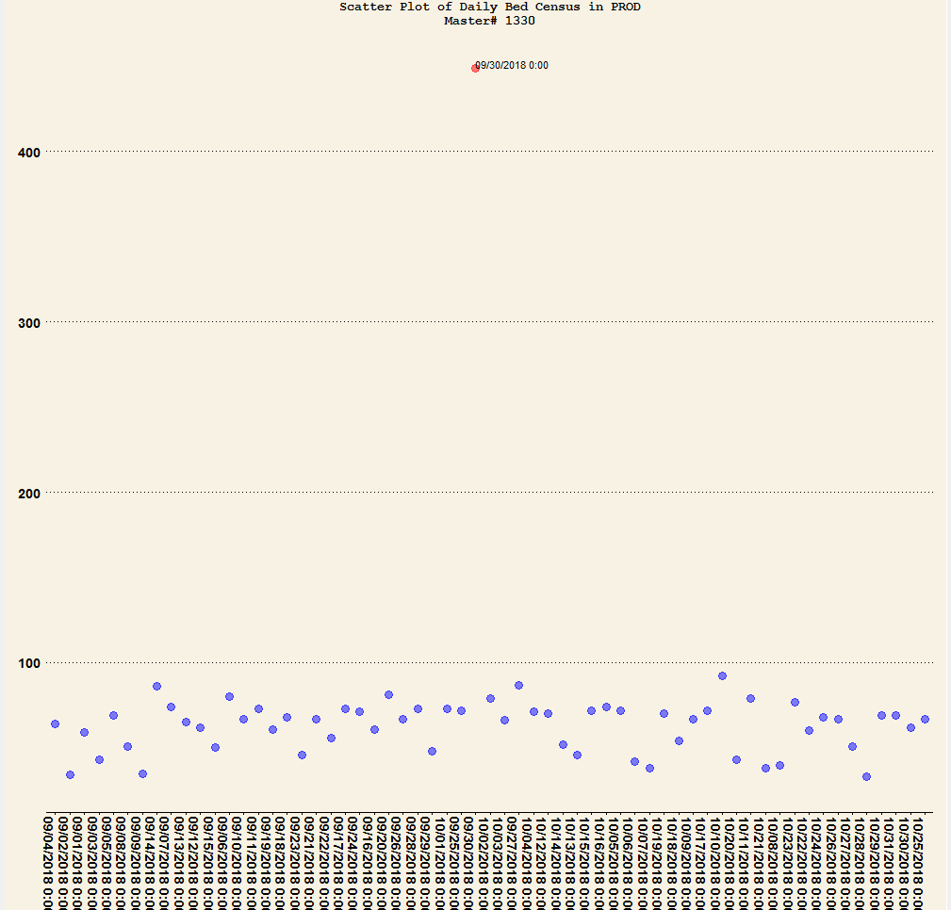

# SOLUTION FOR SECTION 2

For Box Plot

Connected to another R View(Table) node-> Configure(from the drop-down menu) -> Copy & paste from the original script

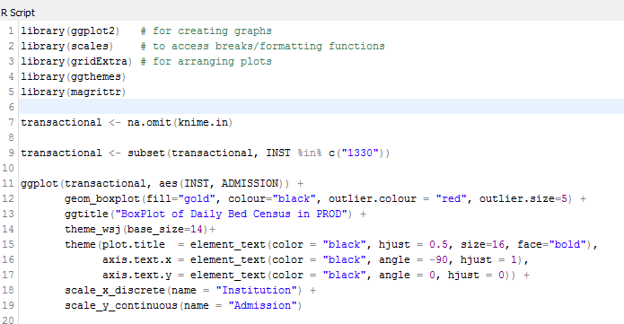

Gives the following output,

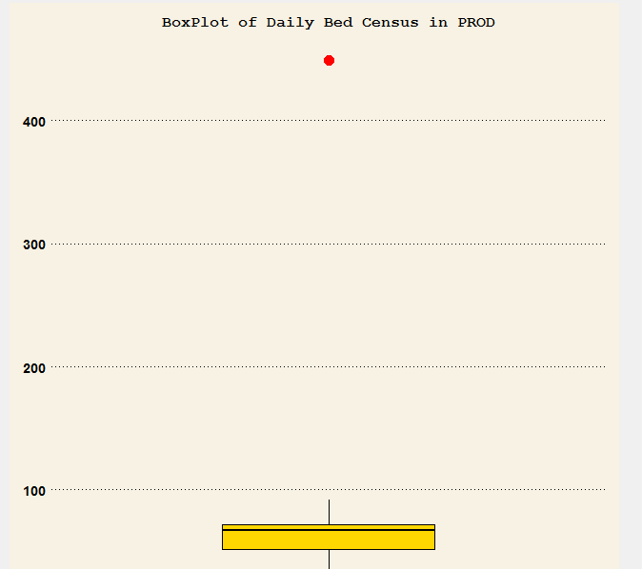

This is the simplest model,

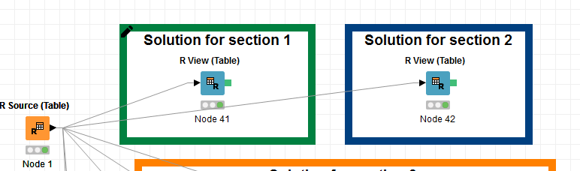

# SOLUTION FOR SECTION 3

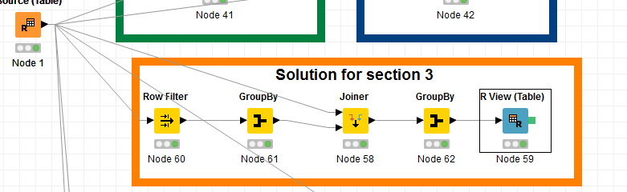

**(Note: Had to use more nodes because Knime doesn’t recognize the R (even after inserting the install.packages(‘dplyr’) at the top)‘dplyr’ package which is used in the script to perform filtration)**

For Box Plot

Connected to another R View(Table) node-> Configure (from the drop-down menu) -> Copy & paste from the original script

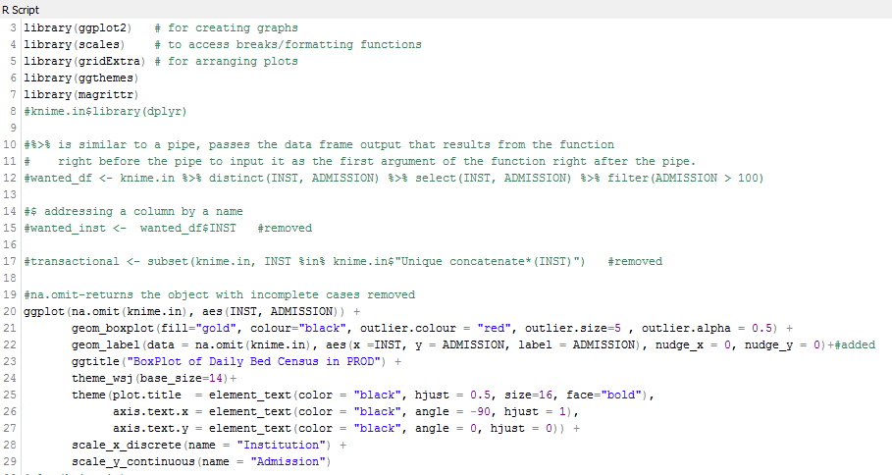

This gives this graph:

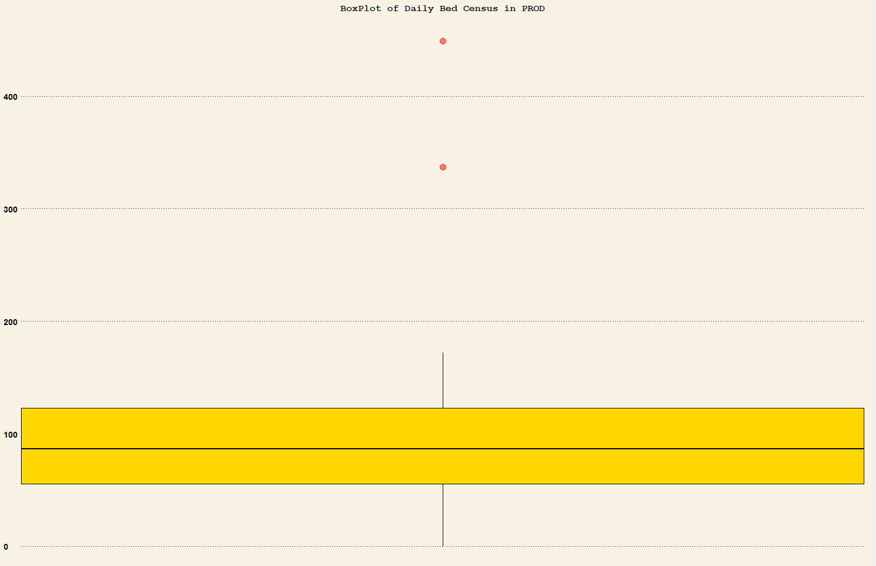

How the outliers were created in each script (According to the Script)

Section1: Just given > a number

Section 2: outlier function in ggplot package

Section 3: outlier function in ggplot package

I found this which can be use to create Cook’s Distance charts in R: (note: not in Knime: Still trying to find a way)

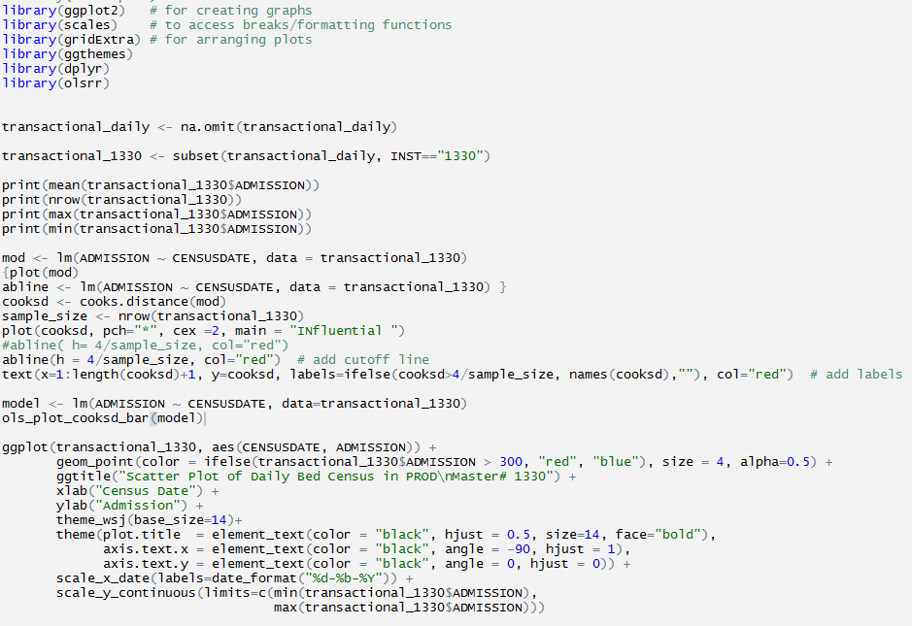

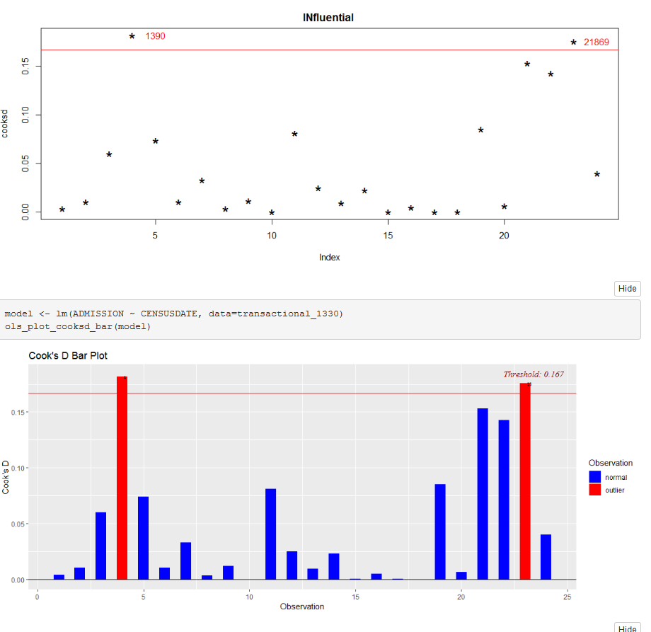

If line 20 added to the View Source node configuration:

