**Lab 3**

**Fourier series, Fourier transform and Bode Plots in MATLAB**

**EECS3451**

**Name: Chethana Wickramasinghe**

**Student Number: 214866511**

**Professor: Peter Lian**

**11th of March 2021**

**1. Introduction:**

Using MATLAB to answer questions provided. Questions leads to plot periodic signals with Fourier series representation, obtain and plot the output response signal with a periodic input signal and o learn and create plots for the frequency response of a system (i.e. Bode plot) in MATALB. This report is mainly answering the provided questions using MATLAB. Results will demonstrate the use of MATLAB properly in analysing signals and systems.

**2. Equipment:** MATLAB

**3. Results and discussion:**

# 1. Periodic signals with Fourier series representation

## Laboratory Exercise 1

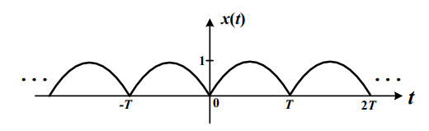Consider the following periodic signal x(t), which is a full-wave rectified sine-wave as shown in figure.

1. Determine the Fourier coefficients of x(t)

$x\left(t\right)=\left|\sin\left(ωot\right)\right| , ωo= π/T$

$a0=\frac{1}{To}\int_{0}^{T}{\sin\left(ωot\right)dt}$

**4. Conclusion: state what you learn from this lab, lab objectives you achieved, and any difficulties you met.**

Learned how to plot CT signals, DT signals, rectangular pulse functions, Unit step functions, sign functions, sinusoidal functions, exponential functions in MATLAB using pre defined functions such as real(), imag(), etc.

All the questions were answered using MATLAB and was able to get a better understanding of signals and systems by observing the generated plots.

Had a hard time to find how to plot a rectangular pulse function. In addition, had to review formulas related to circuits and waveforms.