**Lab 4**

**Analog (continuous-time) filters: design and analysis systems**

**EECS3451**

**Name: Chethana Wickramasinghe**

**Student Number: 214866511**

**Professor: Peter Lian**

**18th of March 2021**

**1. Introduction:**

Using MATLAB to design analog filters such as Butterworth, Chebyshev (Type I and II), and Elliptic filters and to learn how to apply filter to real-world problem. This report is mainly answering the provided questions using MATLAB. Results will demonstrate the use of MATLAB properly in analysing and designing Analog filters.

**2. Equipment:** MATLAB

**3. Results and discussion:**

The answers to provided question are as follows,

# Laboratory Exercise 1

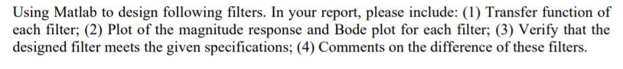

## Q1

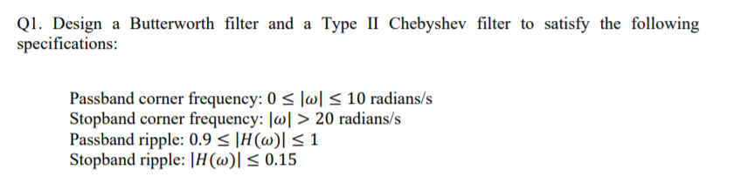

**Butterworth filter**

Wp =10;

Ws =20;

Pb = 0.9; %Passband

Sb = 0.15; %Stopband

Rp = -20*log10(Pb);

Rs = -20*log10(Sb);

[N,Wc]= buttord(Wp,Ws,Rp,Rs, 's')

[num,den]=butter(N,Wc,'s')

Ht=tf(num,den)

[H,w]=freqs(num,den);

% plot magnitude response

plot(w, abs(H));

xline(Wp,'--k',sprintf('Wp=%0.2f', Wp))

xline(Ws,'--k',sprintf('Ws=%0.2f', Ws))

yline(Pb,'--k',sprintf('delta_p=%0.2f', Pb))

yline(Sb,'--k',sprintf('delta_s=%0.2f', Sb))

xlabel('Frequency-w');

ylabel('Magnitude (dB)');

title('Magnitude Repsonse (dB)');

1. Transfer function =
2. Magnitude response plot

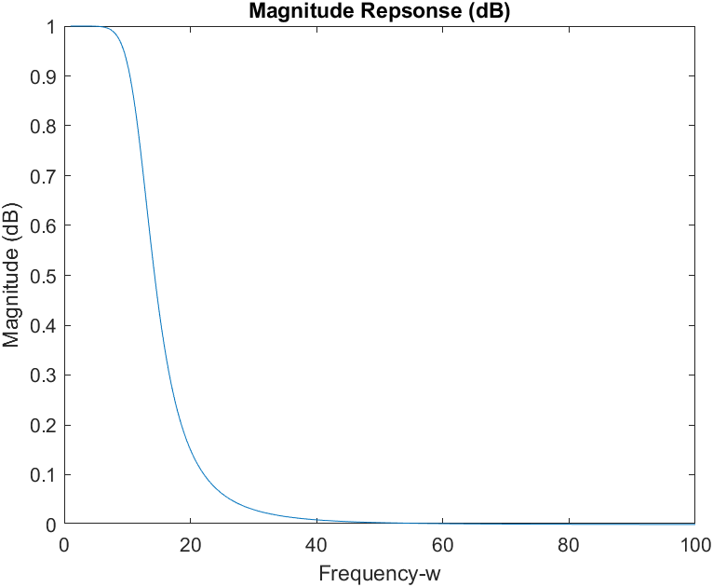

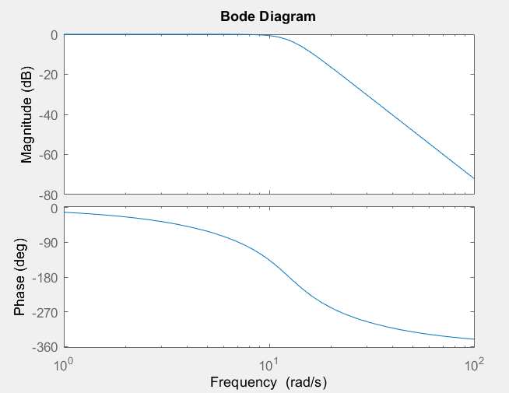Bode plot

1. 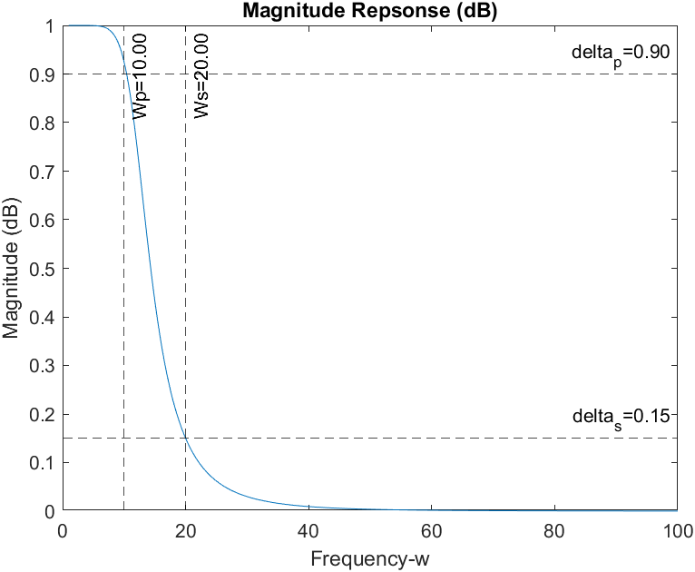Verify

**Type II Chebyshev Filter**

Wp =10;

Ws =20;

Pb = 0.9; %Passband

Sb = 0.15; %Stopband

Rp = -20*log10(Pb);

Rs = -20*log10(Sb);

[N,Wn]= cheb2ord(Wp,Ws,Rp,Rs, 's')

[num,den]=cheby2(N,Rs,Wn,'s')

Ht=tf(num,den)

[H,w]=freqs(num,den);

% plot magnitude response

plot(w, abs(H));

xline(Wp,'--k',sprintf('Wp=%0.2f', Wp))

xline(Ws,'--k',sprintf('Ws=%0.2f', Ws))

yline(Pb,'--k',sprintf('delta_p=%0.2f', Pb))

yline(Sb,'--k',sprintf('delta_s=%0.2f', Sb))

xlabel('Frequency-w');

ylabel('Magnitude (dB)');

title('Magnitude Repsonse (dB)');

% Bode plot

bode(Ht);

1. Transfer function =
2. Magnitude response plot

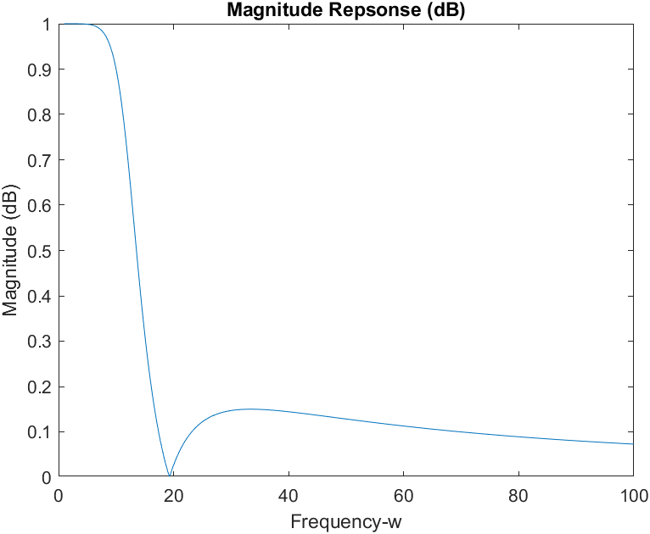

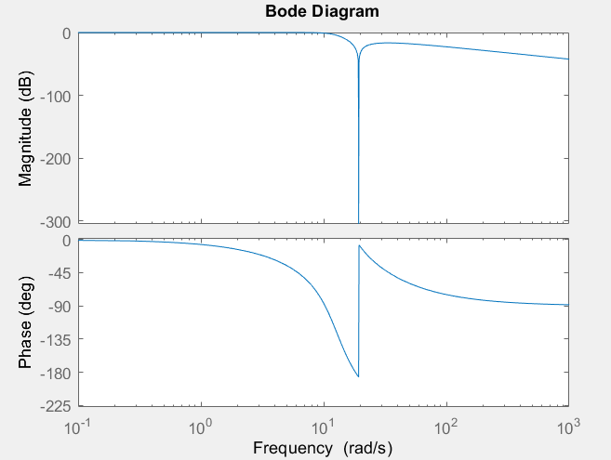Bode plot

1. Verify

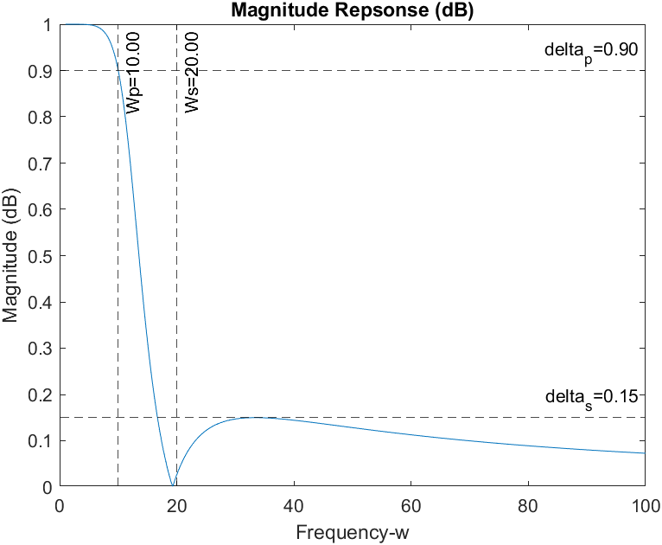

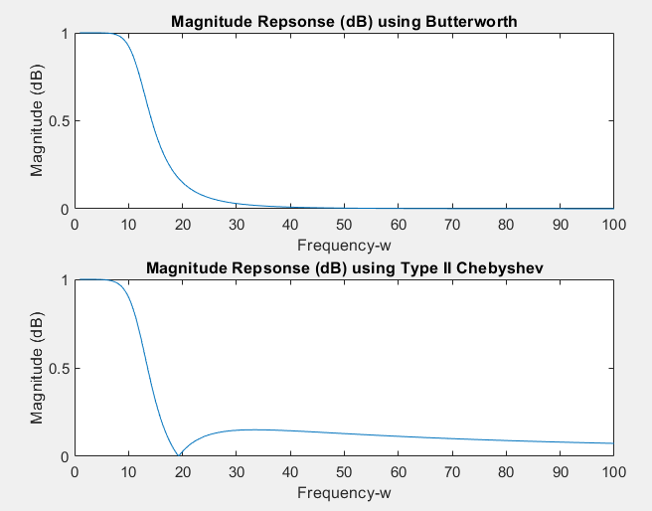Difference between Butterworth and Type II Chebyshev Filters

Butterworth filter is flat during pass band and stop band, while in Type II Chebyshev it is flat during pass band but has ripples during stop band.

Transition band of Butterworth filter is larger than Type II Chebyshev.

## Q2

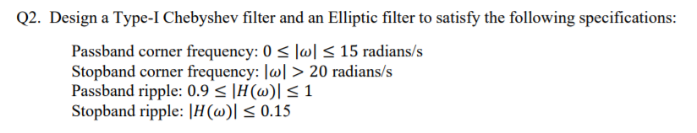

**Type I Chebyshev filter**

Wp =15;

Ws =20;

Pb = 0.9; %Passband

Sb = 0.15; %Stopband

Rp = -20*log10(Pb);

Rs = -20*log10(Sb);

[N,Wn]= cheb1ord(Wp,Ws,Rp,Rs, 's');

[num,den]=cheby1(N,Rp,Wn,'s');

Ht=tf(num,den)

[H,w]=freqs(num,den);

% plot magnitude response

plot(w, abs(H));

xlabel('Frequency-w');

ylabel('Magnitude (dB)');

title('Magnitude Repsonse (dB)');

xline(Wp,'--k',sprintf('Wp=%0.2f', Wp))

xline(Ws,'--k',sprintf('Ws=%0.2f', Ws))

yline(Pb,'--k',sprintf('delta_p=%0.2f', Pb))

yline(Sb,'--k',sprintf('delta_s=%0.2f', Sb))

% Bode plot

bode(Ht);

1. Transfer function =
2. Magnitude response plot

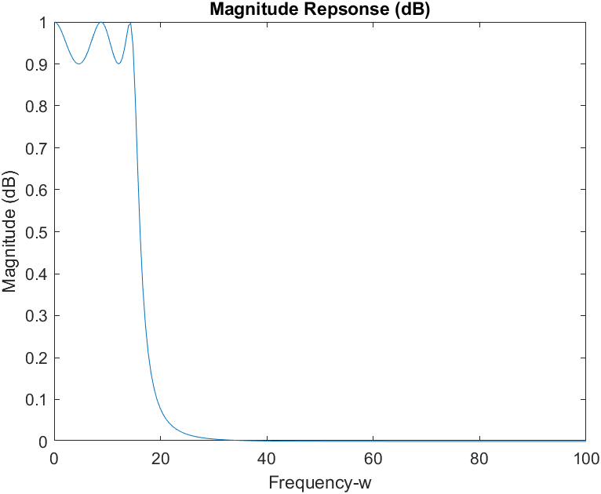

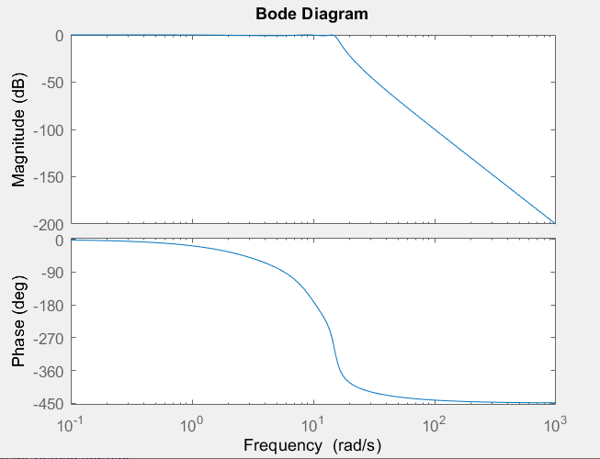 Bode plot

1. Verify

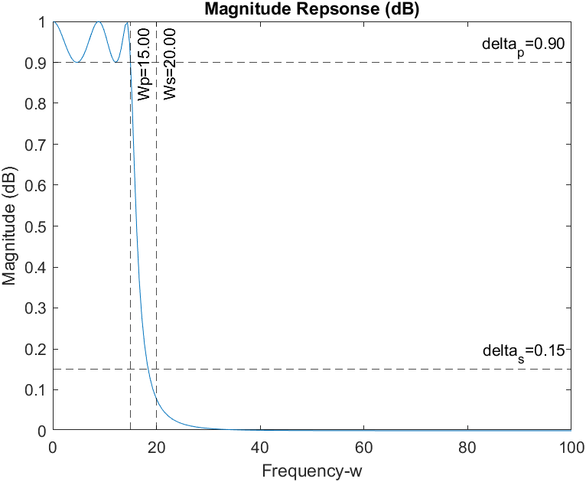

**Elliptic Filter**

Wp =10;

Ws =20;

Pb = 0.9; %Passband

Sb = 0.15; %Stopband

Rp = -20*log10(Pb);

Rs = -20*log10(Sb);

[N,Wn]= cheb2ord(Wp,Ws,Rp,Rs, 's')

[num,den]=cheby2(N,Rs,Wn,'s')

Ht=tf(num,den)

[H,w]=freqs(num,den);

% plot magnitude response

plot(w, abs(H));

xline(Wp,'--k',sprintf('Wp=%0.2f', Wp))

xline(Ws,'--k',sprintf('Ws=%0.2f', Ws))

yline(Pb,'--k',sprintf('delta_p=%0.2f', Pb))

yline(Sb,'--k',sprintf('delta_s=%0.2f', Sb))

xlabel('Frequency-w');

ylabel('Magnitude (dB)');

title('Magnitude Repsonse (dB)');

% Bode plot

bode(Ht);

1. Transfer function =
2. Magnitude response plot

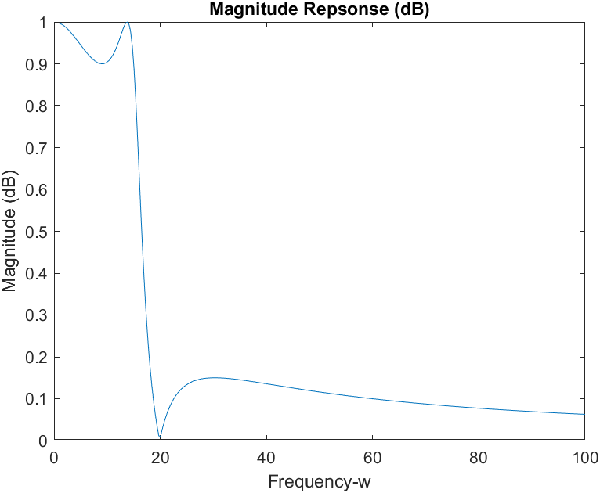

Bode plot

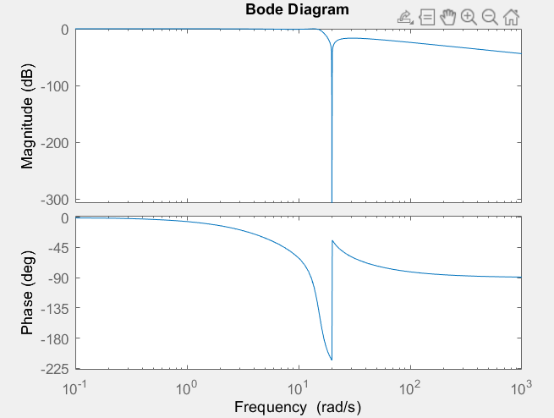

1. 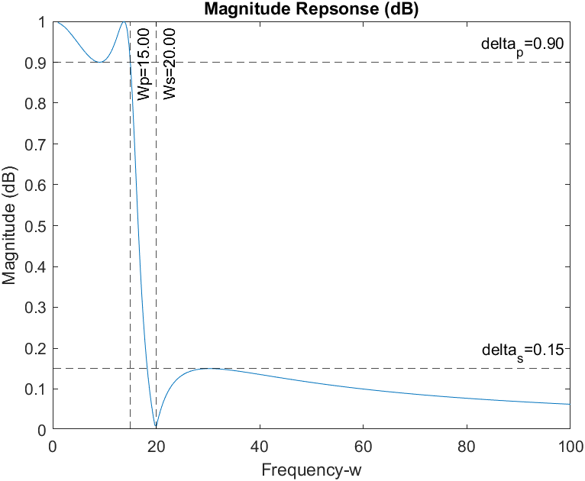Verify

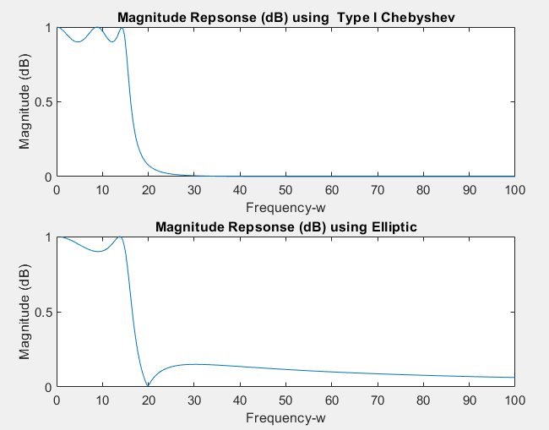Difference between Type I Chebyshev Filters and Elliptic Filter

Type I Chebyshev filter is flat during stop band and pass band ripples, while in Elliptic it has ripples in both pass band and stop band.

Transition band of Type I Chebyshev filter is larger than Elliptic.

# Laboratory Exercise 2

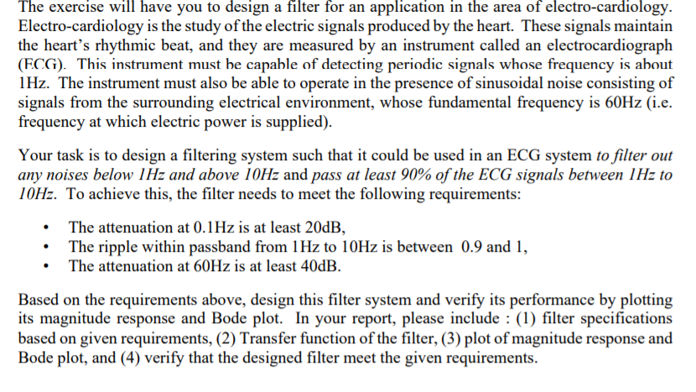

This Exercise is done using Elliptic and Butterworth filters

% 1) Using Elliptic filter

% high pass filter specifications

**wp=1; ws=0.1; Rp=-20*log(0.9); Rs=20;**

[N,Hwn] = ellipord(wp,ws,Rp,Rs,'s') ;

[num4,den4] = ellip(N,Rp,Rs,Hwn,'high','s') ;

H4 = tf(num4,den4);

[H,w]=freqs(num4,den4);

plot(w, abs(H));

xlabel('Frequency-w');

ylabel('Magnitude (dB)');

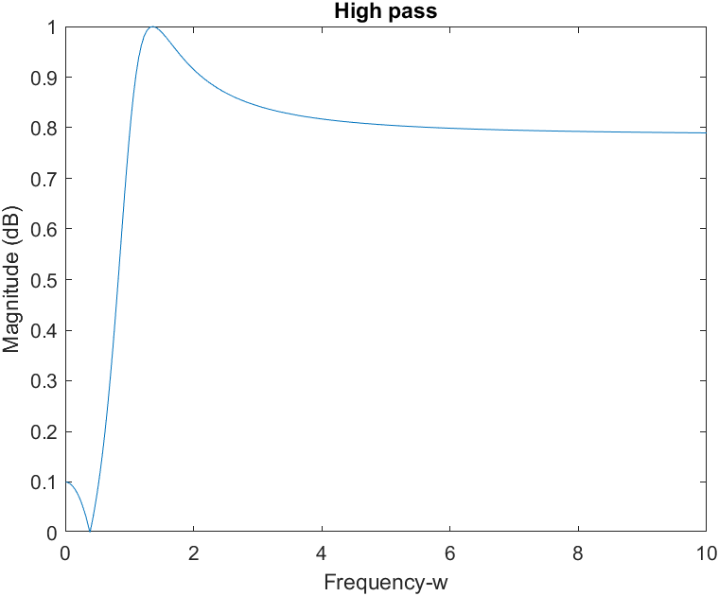title('High pass');

bode(H4);

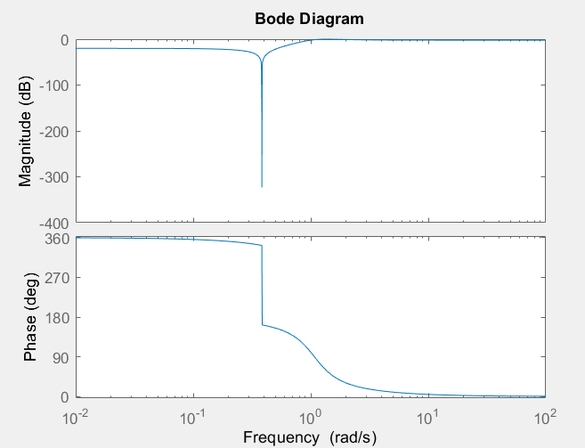

% low pass filter specifications

**wp=10; ws=60; Rp=-20*log(0.9); Rs=40;**

[N,Lwn] = ellipord(wp,ws,Rp,Rs,'s') ;

[num4,den4] = ellip(N,Rp,Rs,Lwn,'s') ;

H4 = tf(num4,den4);

[H,w]=freqs(num4,den4);

plot(w, abs(H));

xlabel('Frequency-w');

ylabel('Magnitude (dB)');

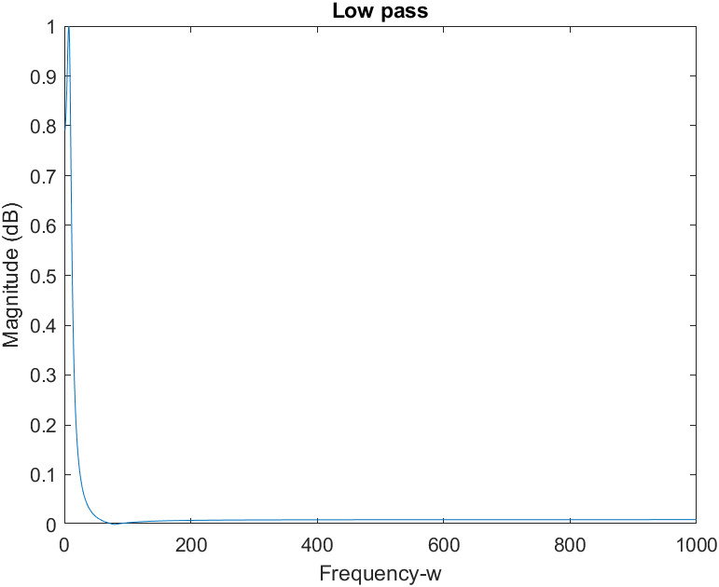title('Low pass');

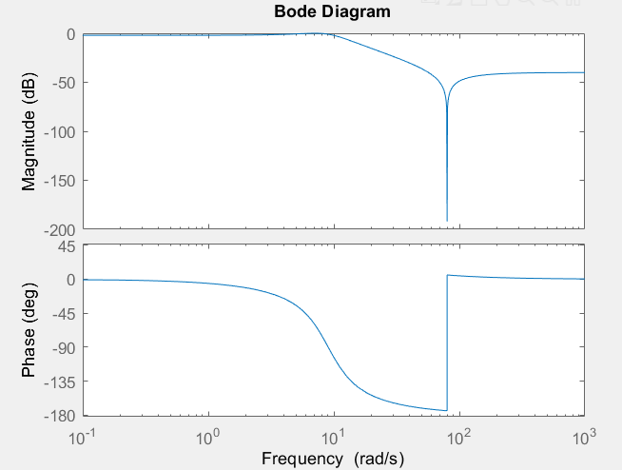bode(H4)

% Band pass filter specifications

[num,den] = ellip(**N,Rp,Rs,[Hwn Lwn],**'s') ;

H = tf(num,den);

[PH,w]=freqs(num,den);

plot(w, abs(PH));

xlabel('Frequency-w');

ylabel('Magnitude (dB)');

title('Band pass');

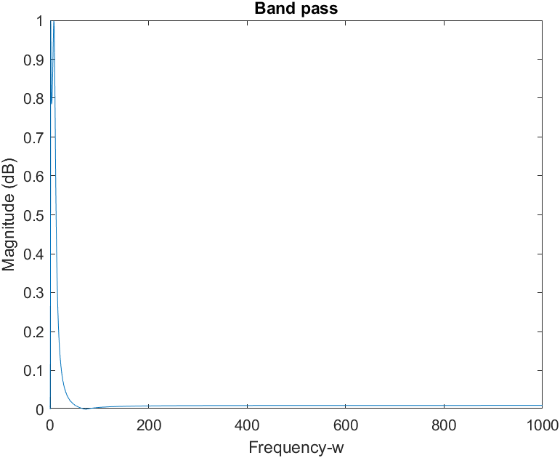% Verification

xline(1,'--k','Wp1=1')

xline(10,'--k','Wp2=10')

xline(0.1,'--k','Ws1=0.1')

xline(60,'--k','Ws2=60')

yline(0.9,'--k','Pb=0.9')

yline(0.1,'--k','Sb1=0.1')

yline(0.01,'--k','Sb2=0.01')

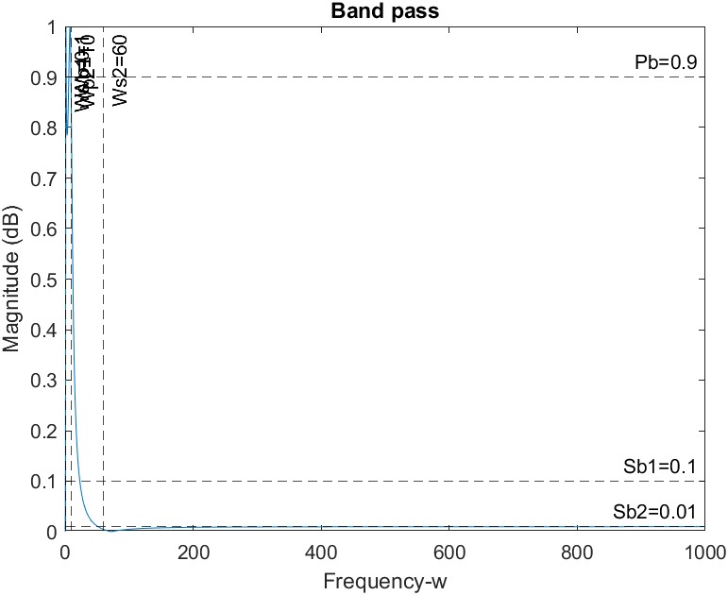

**closeup of a small range**

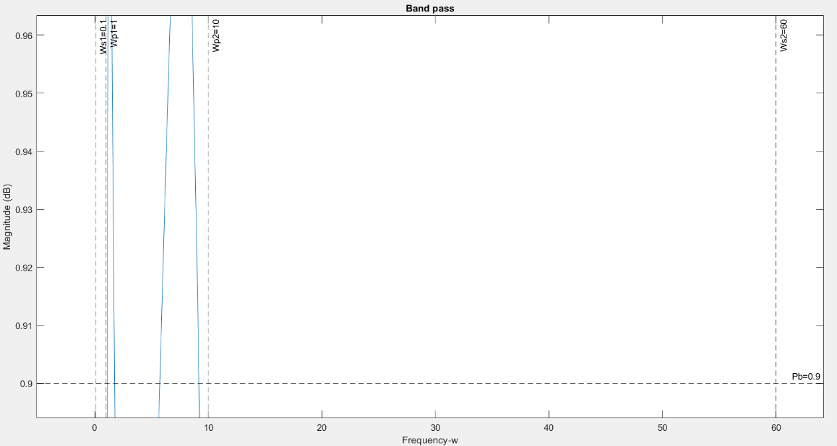

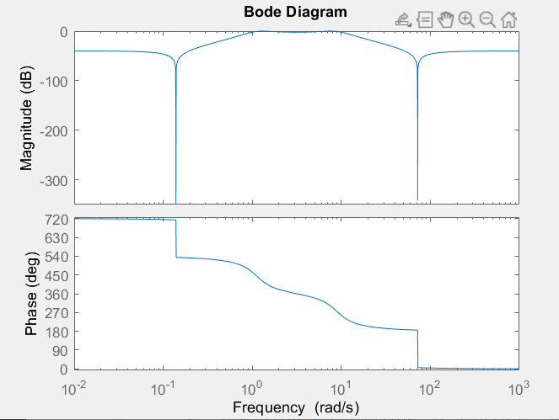bode(H)

% 2) Using Butterworth filter

% high pass filter specifications

**wp=1; ws=0.1; Rp=-20*log(0.9); Rs=20;**

[N, Hwc] = buttord(wp,ws,Rp,Rs,'s');

[num1,den1] = butter(N,Hwc,'high','s');

H4 = tf(num1,den1);

[H,w]=freqs(num1,den1);

plot(w, abs(H));

xlabel('Frequency-w');

ylabel('Magnitude (dB)');

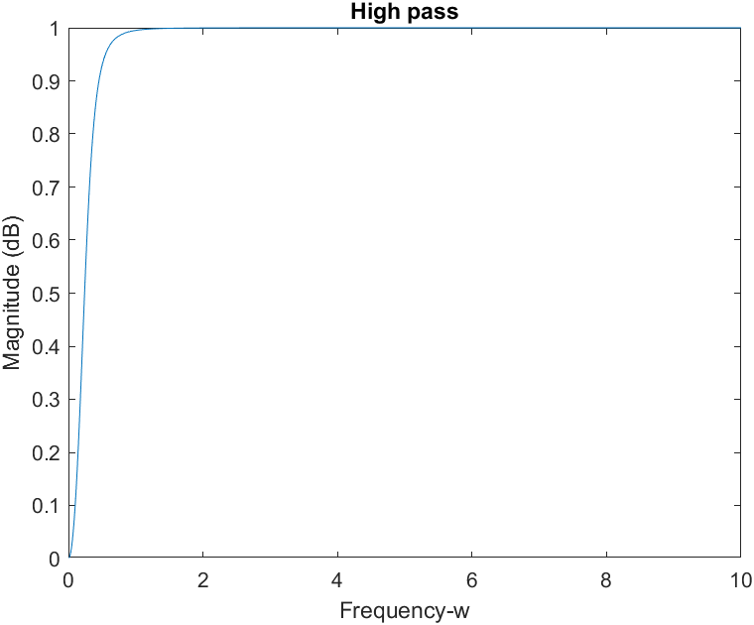title('High pass');

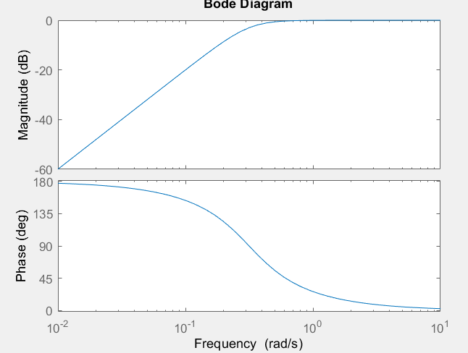bode(H4)

% low pass filter specifications

**wp=10; ws=60; Rp=-20*log(0.9); Rs=40;**

[N, Lwc] = buttord(wp,ws,Rp,Rs,'s');

[num1,den1] = butter(N,Lwc,'s');

H4 = tf(num1,den1);

[H,w]=freqs(num1,den1);

plot(w, abs(H));

xlabel('Frequency-w');

ylabel('Magnitude (dB)');

title('Low pass');

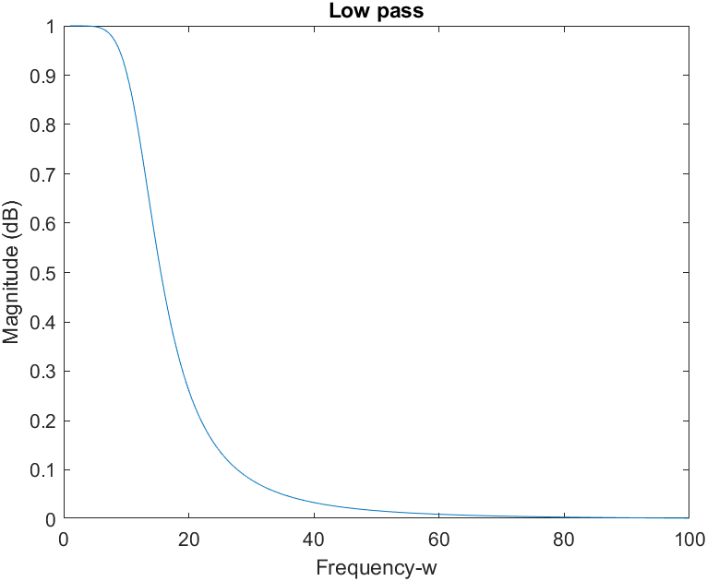

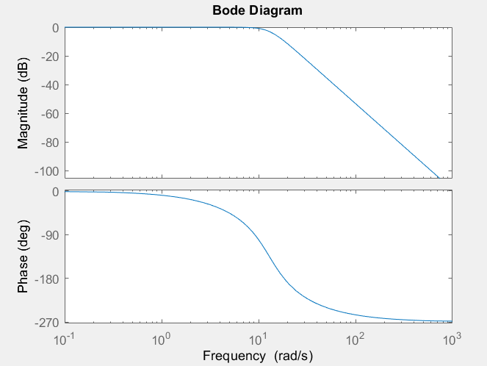bode(H4)

% Band pass filter specifications

[num,den] = butter(**N,[Hwc Lwc],**'s') ;

H = tf(num,den);

[PH,w]=freqs(num,den);

plot(w, abs(PH));

xlabel('Frequency-w');

ylabel('Magnitude (dB)');

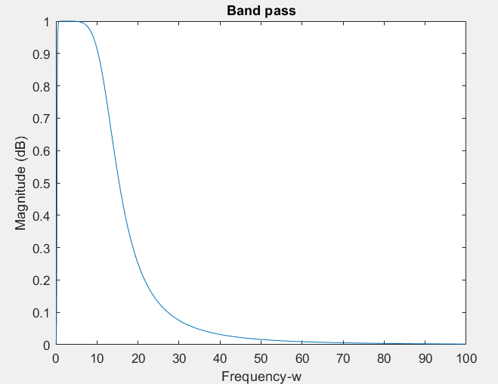title('Band pass');

% Verifications

xline(1,'--k','Wp1=1')

xline(10,'--k','Wp2=10')

xline(0.1,'--k','Ws1=0.1')

xline(60,'--k','Ws2=60')

yline(0.9,'--k','Pb=0.9')

yline(0.1,'--k','Sb1=0.1')

yline(0.01,'--k','Sb2=0.01')

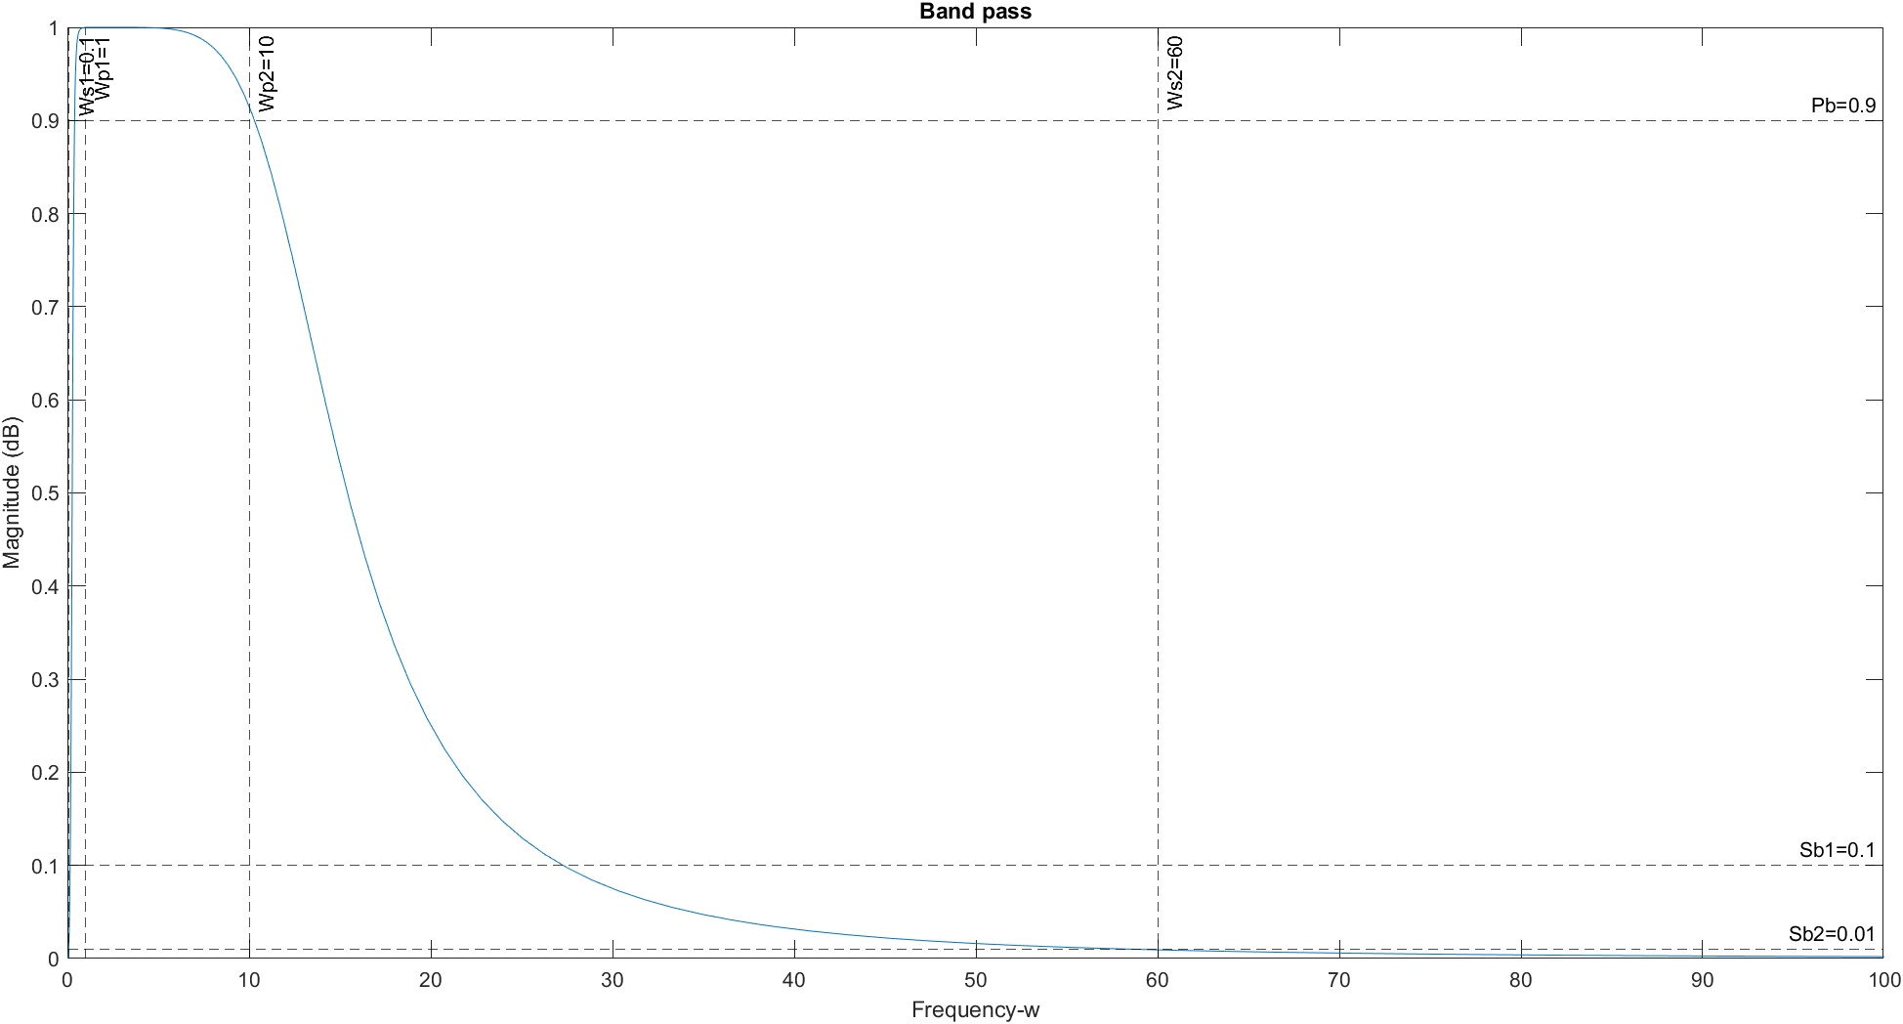

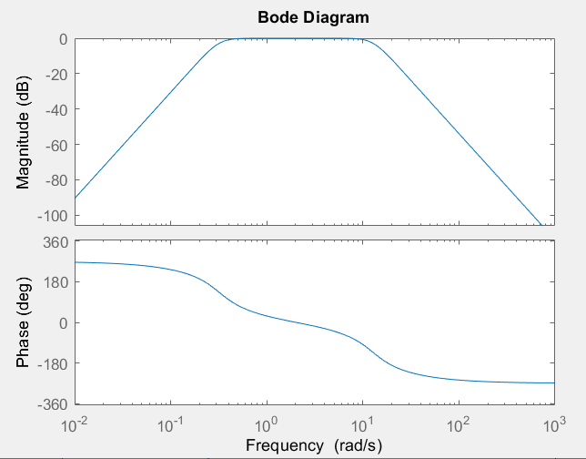bode(H)

**4. Conclusion: state what you learn from this lab, lab objectives you achieved, and any difficulties you met.**

Learned how to use Butterworth, Chebyshev (Type I and II), and Elliptic filters in MATLAB to design analog filters and how to build a filter that could be used in an ECG system.

All the questions were answered using MATLAB and was able to get a better understanding of high pass, low pass and band pass filters.

Building a band pass filter for an EGC system was challenging, but turns out its not that hard to make one.