**Lab 6**

**Discrete Fourier Transform**

**EECS3451**

**Name: Chethana Wickramasinghe**

**Student Number: 214866511**

**Professor: Peter Lian**

**8th of April 2021**

**1. Introduction:**

Using MATLAB to answer questions provided. Questions leads to verifying the properties of DFT, using the convolution to calculate the output of the LTI DT system, and using DFT and IDFT to find the output of an LTI DT system. This report is mainly answering the provided questions using MATLAB. Results will demonstrate the use of MATLAB properly in analysing Amplitude modulation and Time-domain response.

**2. Equipment:** MATLAB

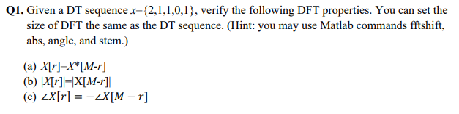**3. Results and discussion:**

x(k) = {2,1,1,0,1} , 0 ≤ k ≤ 4

N= 5 , N<M

X(r) = $\sum_{k=0}^{4}{x\left(k\right)e^{-\frac{j2πkr}{N}}}$

**4. Conclusion: state what you learn from this lab, lab objectives you achieved, and any difficulties you met.**

Learned how to use “dsolve” function in MATLAB to investigate time-domain response of the provided LTIC systems and how the factor “k” (modulation index) effect the output signal.

All the questions were answered using MATLAB and was able to get a better understanding of signal construction and Time-domain response of LTIC systems by observing the generated plots.

Had to spent time to review on how to build KCL equations, took some time to find out how to use “dsolve” function to generate response plots and also understand the role of modulation index.