# 🚀 BGSIT – CodeFest Machine Learning Challenge 2025

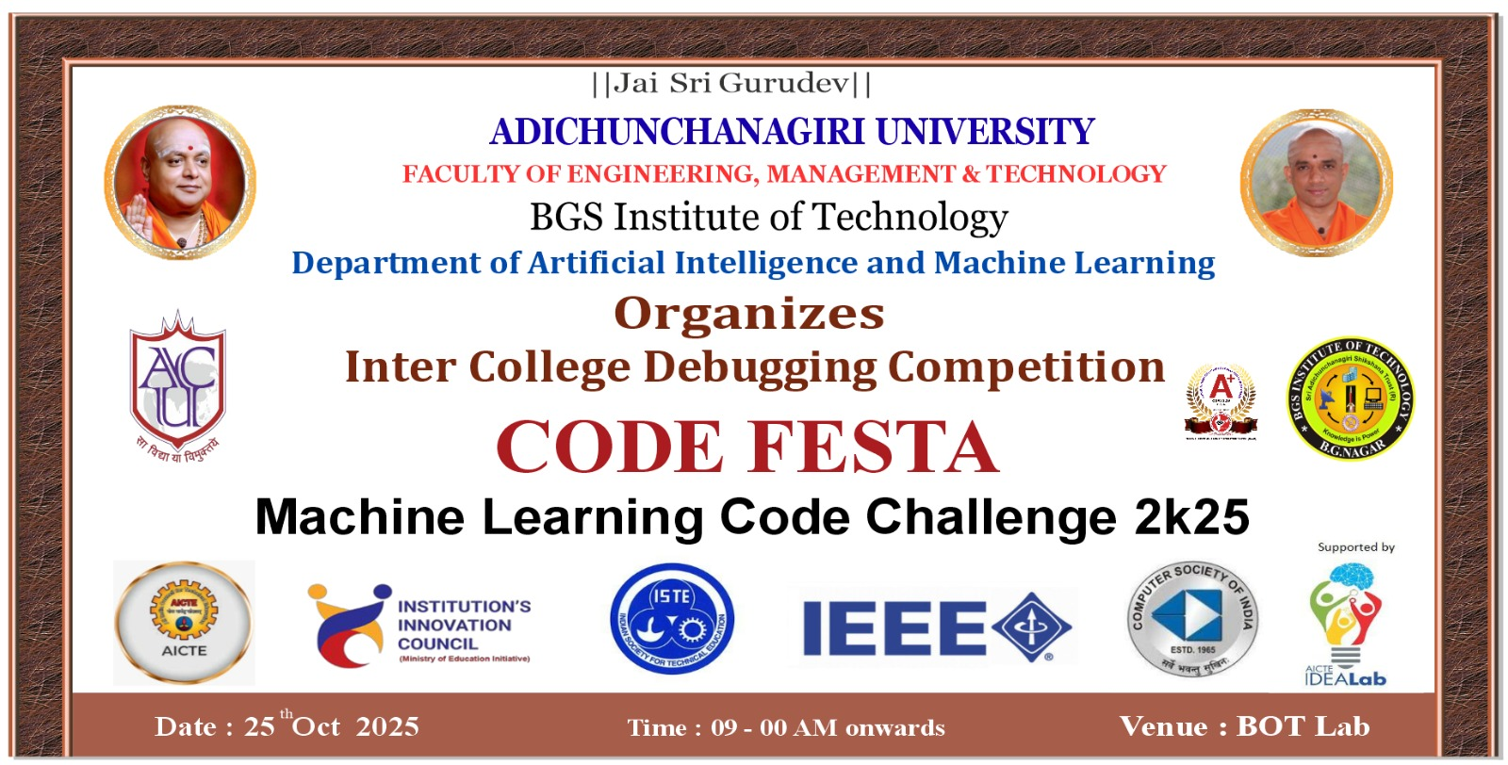

Event Banner

Welcome to the **BGSIT CodeFest Machine Learning Challenge 2025**! This is an exciting 4-hour individual/team competition designed to test your data science and machine learning skills under time constraints.

## 🎯 Problem Statement

You are provided with a dataset and a target variable. Your task is to build a machine learning model that can accurately predict the specified target within the stipulated **4-hour event duration**.

This competition simulates a real-world data science project workflow, testing your ability to analyze, preprocess, model, and justify your decisions under time constraints.

## ⏰ Event Schedule

* **Event Duration**: 9:00 AM - 4:00 PM
* **Participant Working Time**: 4 hours total
  + **Session 1**: 10:00 AM - 1:00 PM (3 hours)
  + **Lunch Break**: 1:00 PM - 2:00 PM
  + **Session 2**: 2:00 PM - 3:00 PM (1 hours)
* **Evaluation Time**: 3:00 PM - 4:00 PM (1 hour)
* **Teams**: 45 teams from East West, Navkis, MIT, AIT, Chikmagaluru, PESITM

## 🛠️ Prerequisites

Before participating in the hackathon, ensure you have the following setup:

### 💻 Hardware Requirements

* **Laptop** with adequate processing power and memory

### 🖥️ Software Requirements

#### Essential Tools

1. **WSL (Windows Subsystem for Linux)**
   * Preferably **Ubuntu 22.04 LTS**
   * 📺 [Setup Tutorial Videos on YouTube](https://www.youtube.com/results?search_query=wsl+ubuntu+installation)
2. **Git**
   * Must be installed and configured
   * **CRITICAL**: You MUST know how to **FORK and CLONE** repositories
   * 📺 [Setup Tutorial Videos on YouTube](https://www.youtube.com/results?search_query=install+git+in+wsl+and+set+up)
3. **Python** (Latest stable version recommended)
   * Python 3.8+ required
4. **Jupyter Notebook**
   * For interactive development and presentation

#### Package Managers (Choose one)

* **Anaconda** (Recommended for beginners)
* **Virtual Environment (venv)**
* **uv env package manager**

### 📚 Required Knowledge

Participants should have prior knowledge of: - **Git basics**: clone, commit, push, pull - **Git Fork and Clone workflow** ⚠️ **MANDATORY** - Python programming fundamentals - Basic data science concepts - Jupyter Notebook usage

### 🆓 Allowed Resources

✅ **You CAN use:**

- **ChatGPT/LLMs/AI assistants** for coding help

- **Any open-source Python libraries**

- **Any publicly available machine learning models**

- **Online documentation and tutorials**

❌ **You CANNOT use:**

- Pre-trained models on the specific dataset

- External datasets other than provided - Plagiarized code

## � Dataset Information

* A dataset will be provided at the **start of the event** (in CSV format)
* It will consist of:
  + **Training data** (with target variable)
  + **Test data** (without target variable)
* The dataset will contain a mix of:
  + Numerical features
  + Categorical features
  + Possibly missing values

## 👥 Team Format

* **Individual** or **Team participation** (max 3 members per team)
* At the end of 3 hours, teams must submit their complete project files + predictions

## ✅ Expectations from Participants

Each submission must include:

### 1. 🔍 Exploratory Data Analysis (EDA)

* Clean, structured, and insightful analysis
* Identification of patterns, distributions, outliers, correlations
* Clear visualizations (plots, charts, heatmaps, etc.)

### 2. 🧹 Data Preprocessing

* Handling missing values
* Feature engineering if required
* Encoding categorical variables
* Normalization/standardization if applicable

### 3. 🤖 Model Building

* Choice of ML model(s) should be **justified**
* You may use multiple models but must explain why you chose the final one
* Hyperparameter tuning is encouraged but must be explained clearly

### 4. 📈 Predictions

* Final predictions for the test dataset must be submitted as a .csv file

### 5. 📝 Documentation & Approach

* Clearly document your approach, reasoning, and steps taken
* Justify why your approach is effective for this problem

## 📦 Deliverables

Participants must submit the following before the deadline:

1. **Jupyter Notebook / Python Script**
   * Well-documented, clean, and reproducible
2. **Prediction File (CSV)**
   * File containing predictions for the given test dataset
3. **Brief Report** (1–2 pages or final notebook section)
   * Summary of EDA insights
   * Justification for chosen model
   * Explanation of approach

## ⚖️ Evaluation Criteria

Submissions will be evaluated on:

|  |  |  |
| --- | --- | --- |
| Criteria | Weight | Description |
| **Model Performance** | 40% | Accuracy / **RMSE** / F1-score (depending on problem type) |
| **EDA & Insights** | 20% | Quality of data exploration, depth of insights and clarity of visualizations |
| **Approach & Justification** | 20% | Clarity in explaining steps, justification of preprocessing and model choice |
| **Clean Code & Presentation** | 20% | Code readability, comments, structure, and professionalism of submission |

## 📋 Rules

1. Participants must use **Python** (Jupyter Notebook, Colab, or IDE)
2. You are allowed to use public Python libraries (pandas, numpy, matplotlib, seaborn, scikit-learn, xgboost, lightgbm, etc.)
3. **No pre-trained models** or external datasets allowed (other than the one provided)
4. Any attempt at **plagiarism** or rule-breaking will lead to **disqualification**
5. All submissions must be made **before the 4-hour deadline**. Late submissions will **not be accepted**

## 🏆 Awards & Recognition

* **Top teams** will be awarded certificates & prizes
* **Winning projects** may be showcased on BGSIT platforms as model AIML case studies

## ⏱️ Pro Tip for Participants

**Time is short—plan your workflow:** - **~1 hour**: EDA + preprocessing - **~2 hours**: Modeling + tuning  
- **~1 hour**: Predictions + polishing your report

## 📁 Project Structure Template

BGSIT_Hackathon/  
├── Notebooks/  
│ ├── 01-exploratory_data_analysis.ipynb  
│ ├── 02-model_development.ipynb  
│ └── 03-dummy_for_testing.ipynb  
├── README.md  
├── data/  
│ ├── processed/  
│ │ └── bgsit_processed.csv  
│ └── raw/  
│ └── bgsit_raw_data.csv  
├── extras/  
│ ├── banner.jpg  
│ └── docs.docx  
├── model_artifacts/  
│ └── model.pkl  
├── submissions/  
│ └── teamid-teamname.csv  
└── test/

## 📋 Directory Guidelines

### 📓 Notebooks/

This folder contains Jupyter notebooks for your data science workflow:

- **01-exploratory_data_analysis.ipynb**: Initial data exploration, visualization, and insights

- **02-model_development.ipynb**: Model building, training, and evaluation

- **03-dummy_for_testing.ipynb**: Testing and validation scripts

**Important**: Follow the numerical naming convention for proper workflow organization.

### 📊 data/

Contains all dataset files: - **raw/**: Original, unmodified datasets - bgsit_raw_data.csv: The provided raw dataset - **processed/**: Cleaned and preprocessed data files - bgsit_processed.csv: Your processed dataset ready for modeling

### 🏗️ model_artifacts/

Store your trained models and related files: - model.pkl: Your final trained model (pickle format) - Additional model files, scalers, encoders, etc.

### 📤 submissions/

Final submission files: - **teamid-teamname.csv**: Your prediction file for evaluation - Format: Replace teamid with your assigned team ID and teamname with your team name

### 📁 extras/

Additional documentation and supplementary files: - banner.jpg: Event banner image - docs.docx: Project documentation, methodology, insights - Any additional supporting files

### 🧪 test/

Testing scripts and validation code (optional)

## 🚀 Getting Started

### Step 1: Setup Your Environment

1. **Fork this repository** to your GitHub account
2. **Clone your forked repository** to your local environment

* git clone https://github.com/Chethanpatel/BGSIT_Hackathon.git  
  cd BGSIT_Hackathon

### Step 2: Environment Setup

1. **Create a virtual environment** (recommended)

* # Using venv  
  python -m venv hackathon_env  
  source hackathon_env/bin/activate # On Windows: hackathon_env\Scripts\activate  
    
  # OR using conda  
  conda create -n hackathon_env python=3.9  
  conda activate hackathon_env

1. **Install required dependencies**

* pip install pandas numpy matplotlib seaborn scikit-learn jupyter  
  # Add other libraries as needed: xgboost, lightgbm, plotly, etc.

### Step 3: Start Working

1. **Launch Jupyter Notebook**

* jupyter notebook

1. **Follow the notebook sequence**: Start with 01-exploratory_data_analysis.ipynb
2. **Maintain the folder structure** throughout your project
3. **Document your work** in the notebooks with clear markdown explanations

## 📝 Submission Requirements

* ✅ Ensure your final model is saved in model_artifacts/model.pkl
* ✅ Submit predictions in submissions/teamid-teamname.csv
* ✅ Complete all three notebooks with proper documentation
* ✅ Include a brief methodology summary in extras/docs.docx
* ✅ All code should be reproducible and well-commented

## ⚠️ Important Notes

* **DO NOT** modify the basic folder structure
* Keep file naming conventions consistent
* Ensure your code is reproducible
* Comment your code thoroughly
* Include data preprocessing steps in the processed folder
* **Time management is crucial** - stick to the recommended timeline
* **Test your code** before final submission
* **Save frequently** to avoid losing work

## 🛠️ Recommended Python Libraries

### Essential Libraries

import pandas as pd  
import numpy as np  
import matplotlib.pyplot as plt  
import seaborn as sns  
from sklearn.model_selection import train_test_split  
from sklearn.preprocessing import StandardScaler, LabelEncoder  
from sklearn.metrics import accuracy_score, classification_report

### Advanced Libraries (Optional)

import xgboost as xgb  
import lightgbm as lgb  
import plotly.express as px  
from sklearn.ensemble import RandomForestClassifier  
from sklearn.linear_model import LogisticRegression

## 🆘 Troubleshooting & Support

### Common Issues

1. **Git Fork/Clone Problems**: Ensure you have proper Git credentials set up
2. **Environment Issues**: Make sure Python and required libraries are properly installed
3. **Jupyter Not Starting**: Check if Jupyter is installed in the correct environment
4. **Import Errors**: Verify all required libraries are installed

### Getting Help

* Use **ChatGPT/LLMs** for coding assistance
* Refer to **library documentation**
* Check **Stack Overflow** for common errors
* Ask **organizing team** for clarification on rules

## 🏆 Good luck with the BGSIT CodeFest Machine Learning Challenge 2025! 🎯

**Remember**: This is not just about winning - it’s about learning, applying your skills, and having fun with data science!

For any questions or clarifications, please contact the organizing team.

*Last Updated: October 24, 2025*