VISVESVARAYA TECHNOLOGICAL UNIVERSITY BELAGAVI

A Mini Project Report on

“RECIPE MANAGEMENT SYSTEM”
Submitted in the partial fulfillment for the requirements for the conferment of degree of
BACHELOR OF ENGINEERING
In

ARTIFICIAL INTELLIGENCE & MACHINE LEARNING
By
Mr. Aditya P Karchi USN: 1BY23AI010

Mr. Chethan S L USN: 1BY23AI037

Under the guidance of
Dr. ARCHANA BHAT
Assistant Professor

Department of AI & ML, BMSIT&M.

DEPARTMENT OF ARTIFICIAL INTELLIGENCE & MACHINE LEARNING
B.M.S. INSTITUTE OF TECHNOLOGY & MANAGEMENT
Yelahanka, BENGALURU-560064 2024-2025

ABSTRACT

Any modern business that lacks a digital presence misses out on the incredible reach and efficiency that a website provides. In today's digital age, people rely on online searches to discover products and services before making a purchase.

Recognizing this dependency, we develop a Recipe Management System that allows users to access, organize, and share recipes seamlessly online.

Instead of relying on traditional paper records or scattered Excel files, which make collaboration difficult and introduce duplication errors, our system provides a structured digital platform for recipe storage, categorization, and retrieval.

This solution enhances efficiency, accuracy, and accessibility, eliminating the manual hassle of updating multiple records across different systems.

Through automation, user-friendly interfaces, instant information retrieval, and cost-effective management, our system ensures a smarter, more streamlined way to handle recipes compared to outdated methods.

CONTENTS

Chapters Page no
Chapter 1: Introduction 06
1.1 Overview of the project 06
Chapter 2: Literature Survey 08
Chapter 3: Software Requirements Specification 09
  - Hardware requirements 09
  - Software requirements 09
Chapter 4: Design 10
  - Schema Diagram 10
  - Entity-Relationship Diagram 11
Chapter 5: Implementation 12
5.1 Implementation with Screen shot 12
Chapter 6: Conclusion & Future Enhancement 16
  - Conclusion 16
  - Future Enhancement 17
Chapter 7: References 18

Chapter 1

Introduction

We all understand the importance of efficient management. No matter how advanced a system is, without proper organization, it can lead to inefficiencies and frustration. Keeping things structured and accessible is the key to productivity.
Recognizing this, we propose a Recipe Management System designed to simplify the process of storing, accessing, and sharing recipes. A well-organized recipe collection saves time, eliminates confusion, and ensures that users can retrieve their favorite recipes whenever needed. Whether it's meal planning, nutritional tracking, or experimenting with new cuisines, a structured system is essential.
This system focuses on three core aspects: storage, categorization, and accessibility—each playing a vital role in streamlining the culinary experience. By prioritizing efficiency and ease of use, we aim to make cooking more enjoyable and hassle-free for everyone.

1.1 Overview Of The Project

The Recipe Management System is designed for individuals and businesses looking to streamline the process of organizing and accessing recipes. Before developing this system, we conducted thorough research to identify common challenges faced in traditional recipe management.
We carefully analyzed how to build a robust digital platform that ensures seamless recipe storage, retrieval, and categorization, while also incorporating user-specific privileges for different types of access.
Cooking is an essential part of daily life, and a well-organized recipe collection saves time, reduces errors, and enhances the culinary experience. Users can create and store recipes, manage ingredient lists, and even track nutritional values through this system.
The Recipe Management System provides comprehensive functionality, including recipe registration, ingredient tracking, categorization, sharing features, nutritional information, and more. It eliminates the limitations of manual record-keeping by offering a user-friendly digital interface.
The admin of the system oversees overall management, ensuring smooth operations and effective communication between contributors and users. A structured system like this helps maintain consistency, improve accessibility, and enhance collaboration in cooking-related activities.
This digital solution simplifies recipe management through intuitive design and automated features, making it more efficient than traditional methods. The system also ensures data security and accessibility, guaranteeing users a hassle-free experience while handling recipes.

Chapter 2

Literature Survey

We have collected and studied the successful gym management strategies, location and their nearby places.
The following research papers were referred as a part of Literature survey:

Title | Authors | Year of publication | Methodology
Exploring Large Language Models for Personalized Recipe Generation and Weight-Loss Management | ACM Transactions on Computing for Healthcare | 2025 | Investigates the role of AI-driven language models in creating personalized meal plans and managing dietary preferences.
Decision-Support Platform for Industrial Recipe Management | Springer, CIMPS | 2017 | Discusses an integrated platform for optimizing industrial food production by enhancing recipe formulation and ingredient selection.
SmartRecepies: Towards Cooking and Food Shopping Integration via Mobile Recipes Recommender System | ACM, iiWAS | 2020 | Explores a mobile application that seamlessly connects recipe recommendations with grocery shopping for a smarter cooking experience.
RecipeLog: Recipe Authoring App for Accurate Food Recording | ACM, MM | 2021 | Presents a digital recipe management tool that assists users in logging meals with precise ingredient details for tracking purposes.

Chapter 3

Software And Hardware Requirements Specification

Hardware requirements
The hardware components which are used in gym management system are:
    - Windows OS: Windows 7 or higher
    - Ram: 2GB or higher
    - Hard Disk: 100GB or above

3.2 Software requirements

The software components which are used in recipe management system are:

- Operating System:- Windows/Linux/Mac
- Programming Language:- PHP
- User Interface:- HTML,CSS
- Database:- MYSQL
- Server Development :- XAMPP
- Browser:- Google chrome

Chapter 4

Design

4.1 Schema Diagram

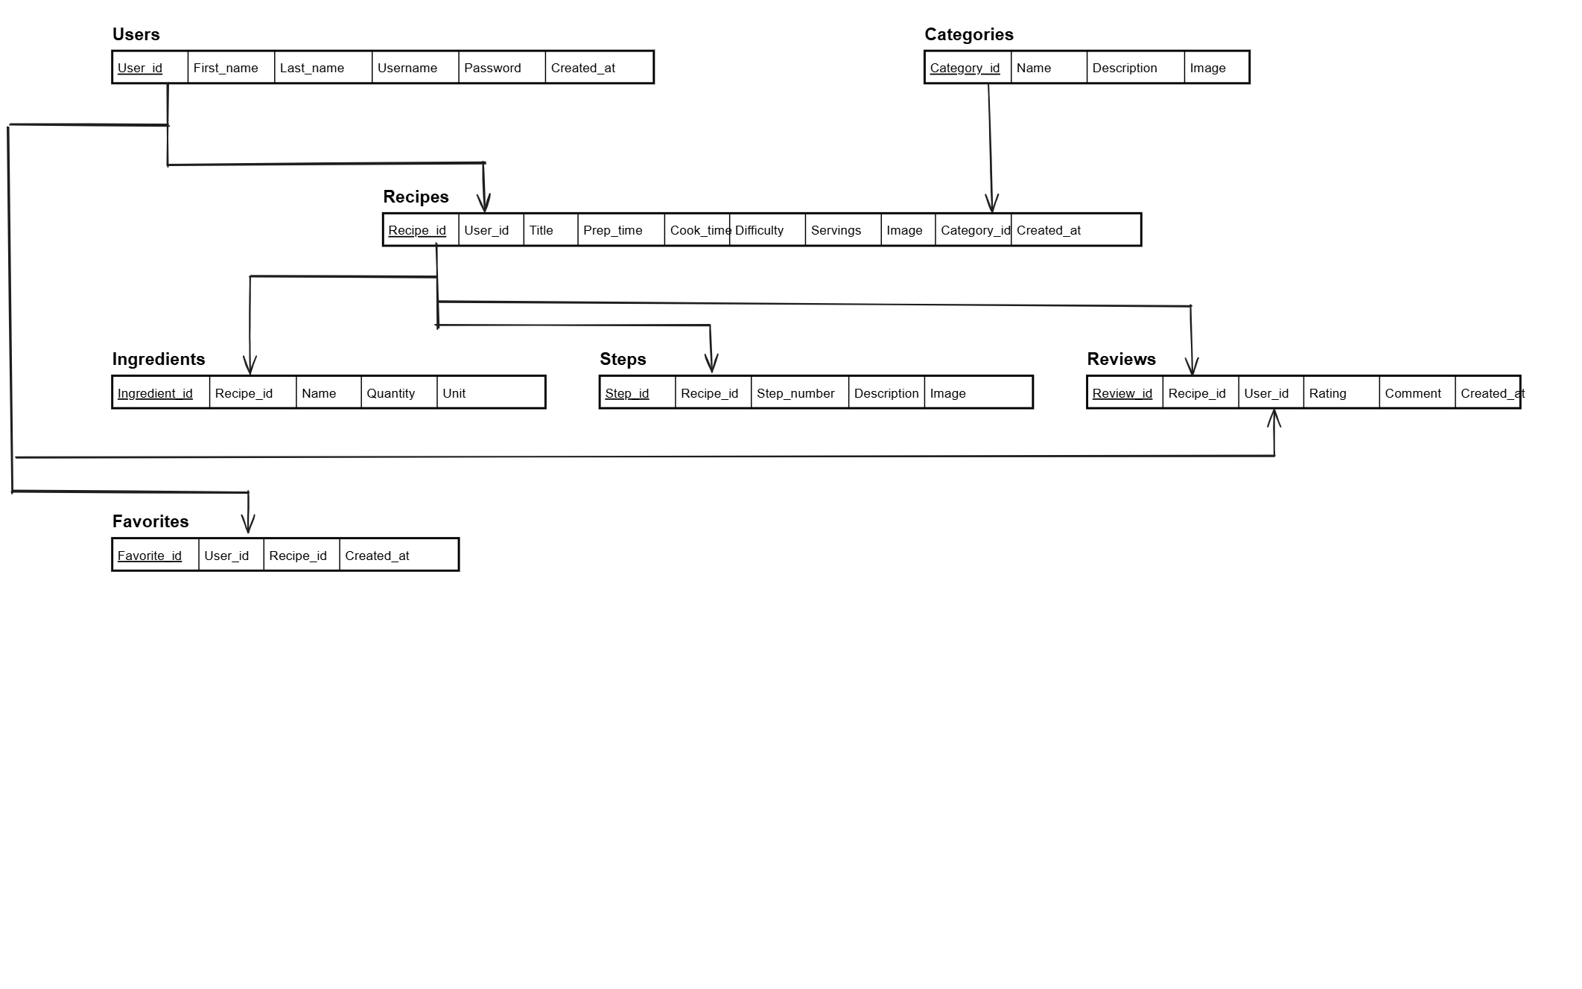

  - ER Diagram

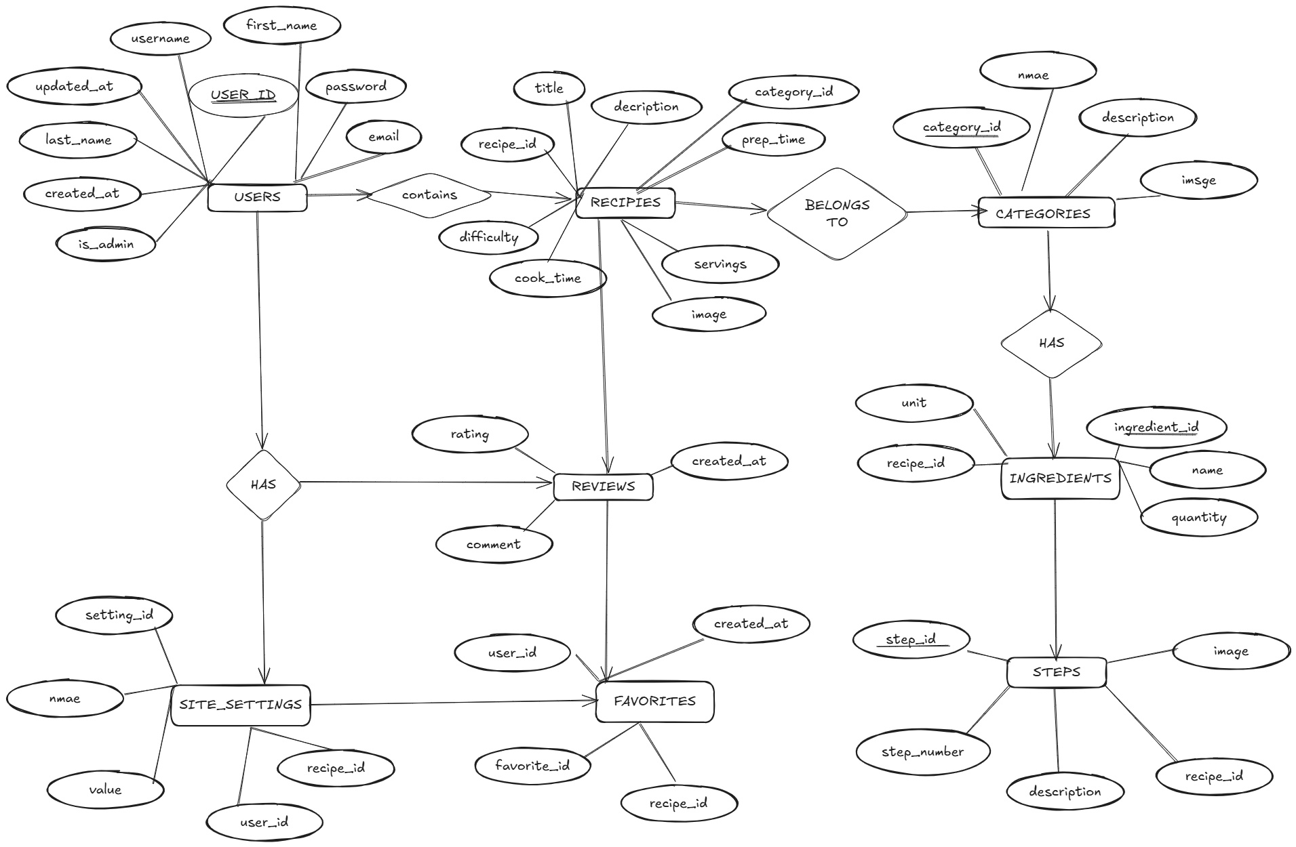

Chapter 5

Implementation Snapshots
The following are few snapshots of different views of the recipe Management System.

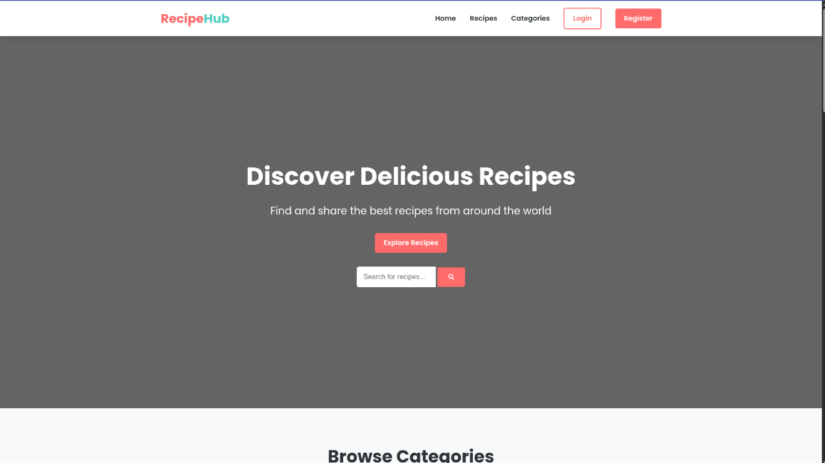

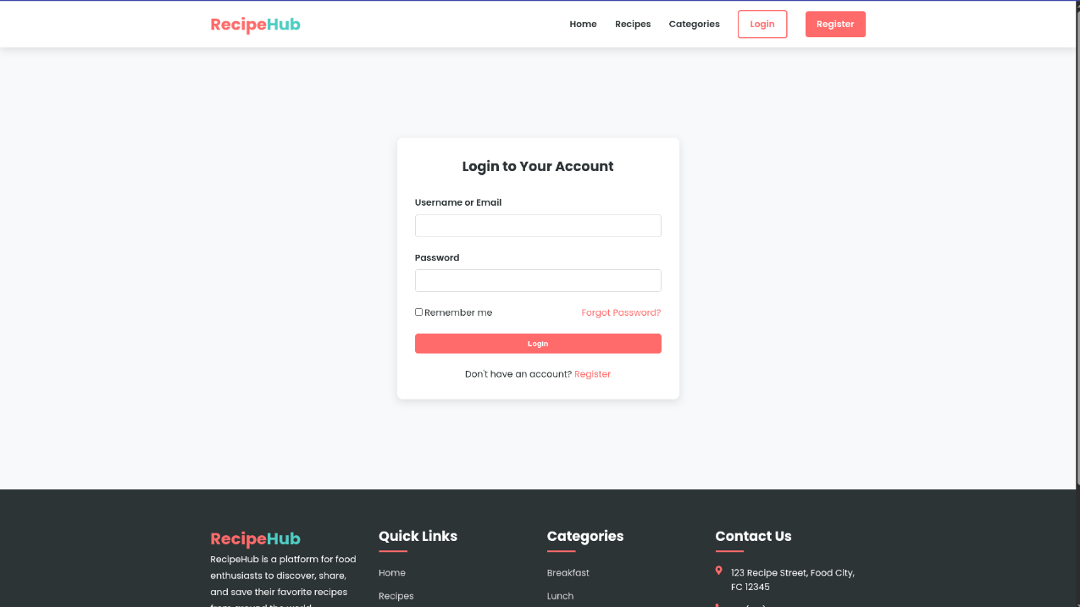

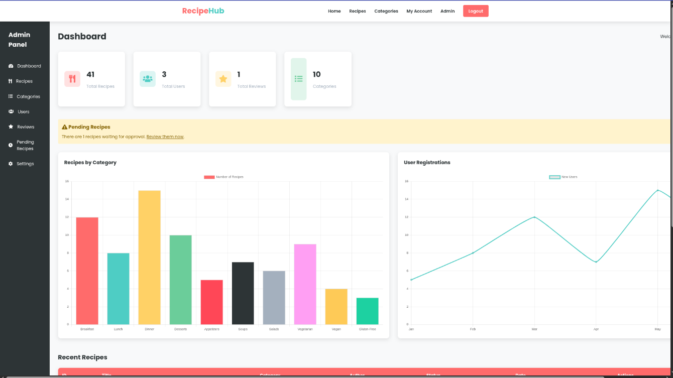

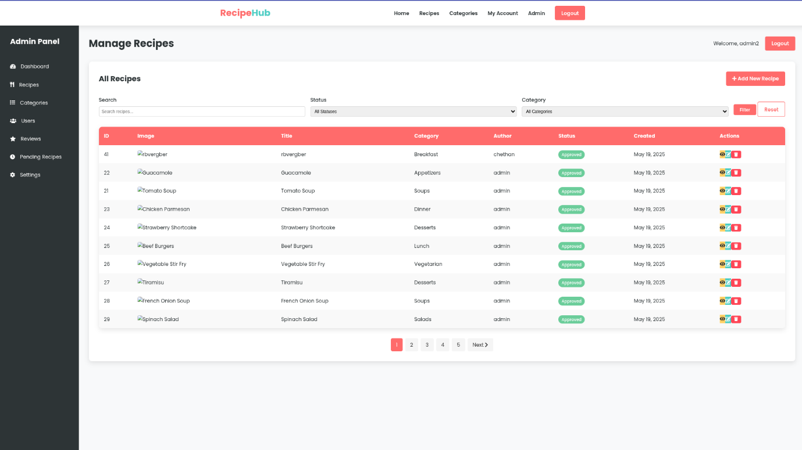

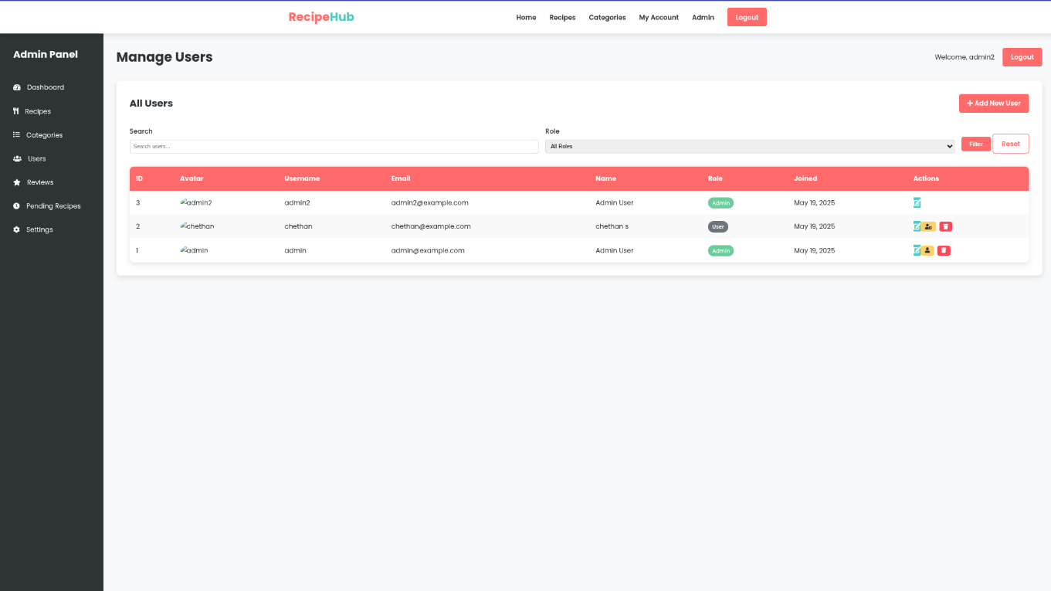

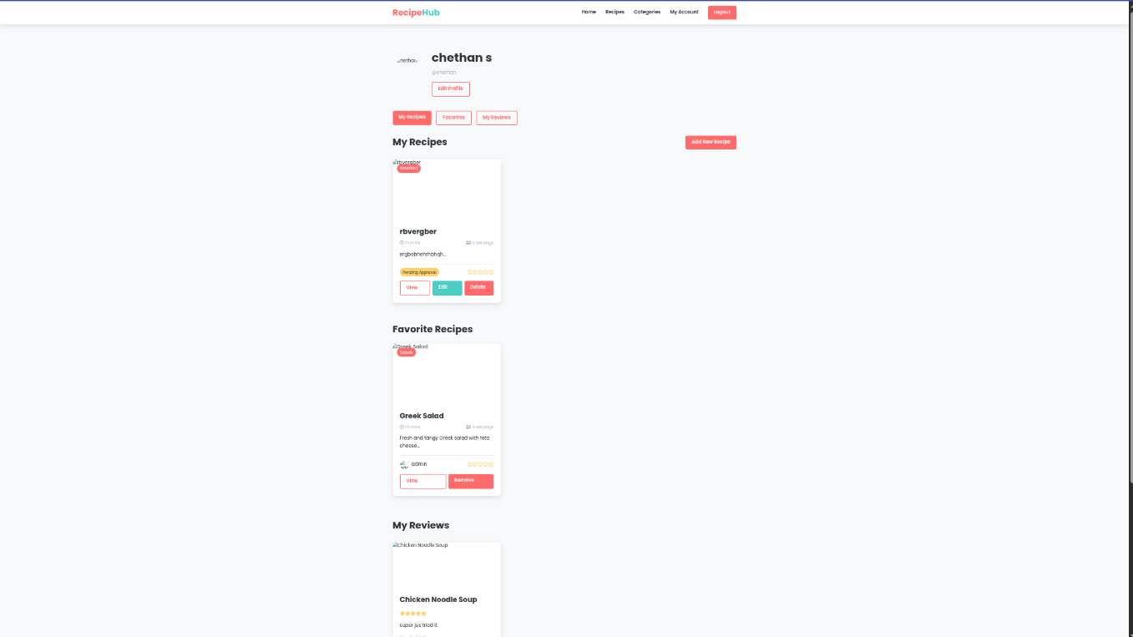

Chapter 6

Conclusion and Future Enhancement

6.1 Conclusion

The Recipe Management System has been successfully designed and developed to meet essential requirements identified during the analysis phase. The system is highly user-friendly, ensuring efficient validation at both the form and field levels.
Traditional methods of recipe storage and management suffered from numerous inefficiencies, such as manual record-keeping and difficulty in retrieval. This modern system has been developed to address those challenges and streamline the experience.
The Recipe Management System functions effectively as a digital recipe organizer. It is robust, preventing errors and crashes due to user input mistakes. The system is scalable and can support extensive recipe databases, offering limitless storage capacity.
It maintains comprehensive information, including recipe details, ingredients, nutritional facts, and even cooking instructions. Users can edit or delete entries as needed, ensuring flexibility.
This project stands as a significant achievement in software development, from initial conception through planning and execution, providing a structured, efficient, and innovative approach to recipe management.

6.2 Future Enhancement

The Recipe Management System has been developed efficiently within a short period, ensuring smooth execution. However, there is still room for improvement, and several enhancements can be integrated to make the system even more versatile and user-friendly.
Here are some potential upgrades:
- Improved User Interface: The application can be designed with a more visually appealing layout, making navigation smoother and enhancing user experience.

- Mobile Application Development: A dedicated mobile app for Android and iOS can be created, allowing users to access and manage recipes conveniently on their devices.

- Advanced Database Management: Optimization of data storage and retrieval methods can further enhance performance and ease of access for administrators.

- Enhanced Security Measures: Strengthening security protocols will help protect sensitive user data, ensuring a safer platform.

- Additional Features for Flexibility: Functionalities like AI-powered recipe recommendations, ingredient substitution suggestions, and meal planning tools can be incorporated to enrich the system’s capabilities.
.

Chapter 7

References

BOOKS
[1] "Exploring Large Language Models for Personalized Recipe Generation and Weight-Loss Management" Authors: ACM Transactions on Computing for Healthcare Publisher: ACM (2025)
[2] "Decision-Support Platform for Industrial Recipe Management" Authors: Springer, CIMPS Publisher: Springer (2017)
[3] "SmartRecepies: Towards Cooking and Food Shopping Integration via Mobile Recipes Recommender System" Authors: ACM, iiWAS Publisher: ACM (2020)
[4] "RecipeLog: Recipe Authoring App for Accurate Food Recording" Authors: ACM, MM Publisher: ACM (2021)
[5] "Recipe-oriented Food Logging for Nutritional Management" Authors: ACM, MM Publisher: ACM (2022)

SITES
[1] https://dl.acm.org/doi/10.1145/3712709
[2] https://link.springer.com/chapter/10.1007/978-3-319-69341-5_18
[3] https://dl.acm.org/doi/10.1145/3428757.3429096
[4] https://dl.acm.org/doi/10.1145/3474085.3478563
[5] https://dl.acm.org/doi/10.1145/3503161.3549203

