REPORT

*On*

*Analysis of Rural Health Care Infrastructure in Different States of India*

**Rural Health Care System in India**

PHC is the primary contact point between the town community and the therapeutic officer. The PHCs were conceived to supply co-ordinates corrective and preventive wellbeing care to the provincial populace with accentuation on preventive and promotive angles of wellbeing care. The PHCs are set up and kept up by the State governments beneath the Least Needs Program (MNP)/ Fundamental Least Administrations (BMS) Programme. As per least prerequisite, a PHC is to be kept an eye on by a therapeutic officer bolstered by 14 paramedical and other staff. Beneath NRHM, there's an arrangement for two extra staff medical caretakers at PHCs on contract premise. It acts as a referral unit for 6 Sub Centres and has 4-6 beds for patients. The exercises of PHC include corrective, preventive, promotive and family welfare services.

At the national level, there were 24855 PHCs working (i.e 16613 PHCs and 8242 HWC-PHCs) in provincial ranges as on 31st March 2019. There's an upgrade of 8242 of PHCs as HWC-PHCs. The noteworthy number of transformations of PHCs into HWC-PHCs have been observed within the States of Andhra Pradesh (1145), Uttar Pradesh (946), Odisha (827), Gujarat (772), Tamil Nadu (716) and Telangana (636). Critical increments within the number of PHCs have been seen within the States of Karnataka (446), Gujarat (406), Rajasthan (369), Assam (336), Jammu & Kashmir (288) and Chhattisgarh (275). Percentage of PHCs working in Government buildings has increased significantly from 69% in 2005 to 94.5% in 2019. For allopathic Specialists at PHCs, there's a shortage of 7.6% of the full necessity for existing foundations as compared to labour in position.

**There are certain constraints that work impede the rural healthcare sector:**

**Infrastructure:** The rural healthcare system in India lacks proper infrastructure. In the current scenario health care centres in rural areas are under-financed and hence they have to use low quality equipment, have a low supply of medicines and also lack qualified and dedicated human resources. Even a few things like underdeveloped roads, railway systems, poor power supply makes it difficult to set up proper healthcare facilities.

**Doctor:** Doctors need nurses for a smooth working, but these hospitals lack in catering their patients because of an improper ratio of doctors and nurses. The hospitals lack more than 3,000 doctors. Even, the patients in rural India are not treated well on time because of lack of doctors.

**Affordability:** Healthcare services are becoming costly with the advancement in technology; therefore, it becomes difficult for everyone to bear the charges. There are various things like diagnostic facilities or any other charges which further increase the cost.

**Lack of Medical Stores:** Unavailability of medicines is common in rural areas. There is an irregular supply of medicines. Even there is no consistency in the prices charged by various shops for the medicines also, the percentage id discount varies too.

**Lack of Awareness:** Awareness is something that people lack in India, even about healthcare. There is a need to educate people about the importance of proper sanitization, health, hygiene and various policies etc. proper health seeking behaviour must be inculcated in them.

**Objective of the Study**

The objective of the research is to:

1.To study state wise distribution of various factors affecting PHCs.

2.To study the relationship of various infrastructure factors.

3.To analyze variation of rural health infrastructure across states of India.

**Research Methodology**

For this, we have taken the data from the site data.gov.in.  The research methodology we took a data of various factors that affect the infrastructural aspects of public healthcare units in rural areas of India.

The data set is as follows:

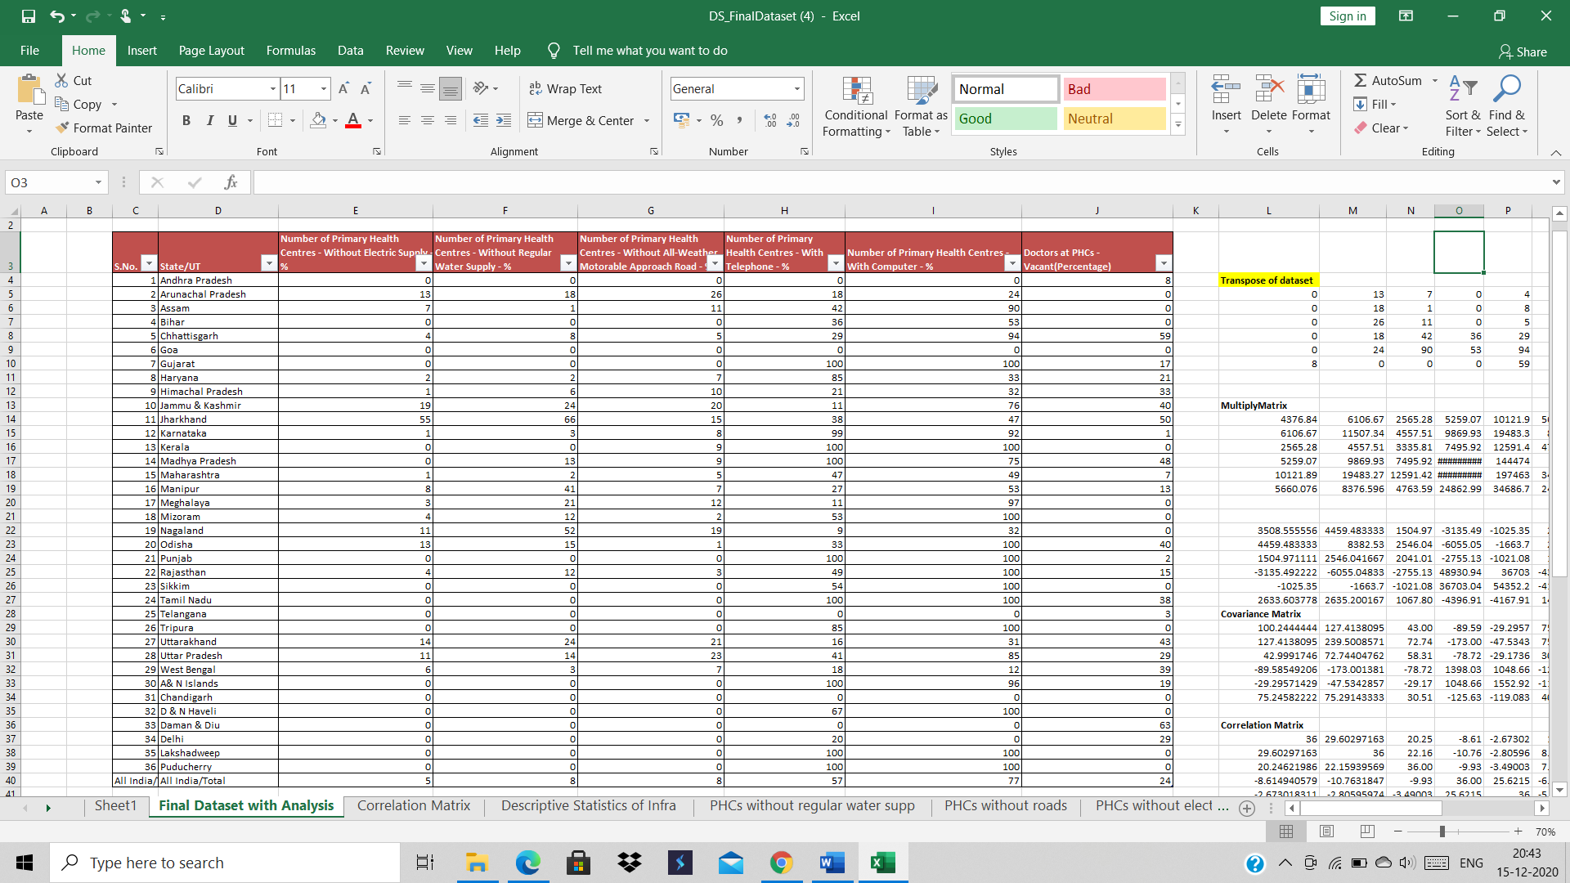

**Findings and Interpretation**

1. **Descriptive Analysis**



Descriptive analysis was done for the six factors i.e. electricity supply, water supply. Approachability, telephone facility, computer facility and availability of doctors.

In this we found mean, standard error, median, mode, standard deviation, sampl variance, kurtosis, skewness, range, minimum, maximum, sum, count, largest, smallest, confidence level relating to these factors.

1. **Correlation matrix**

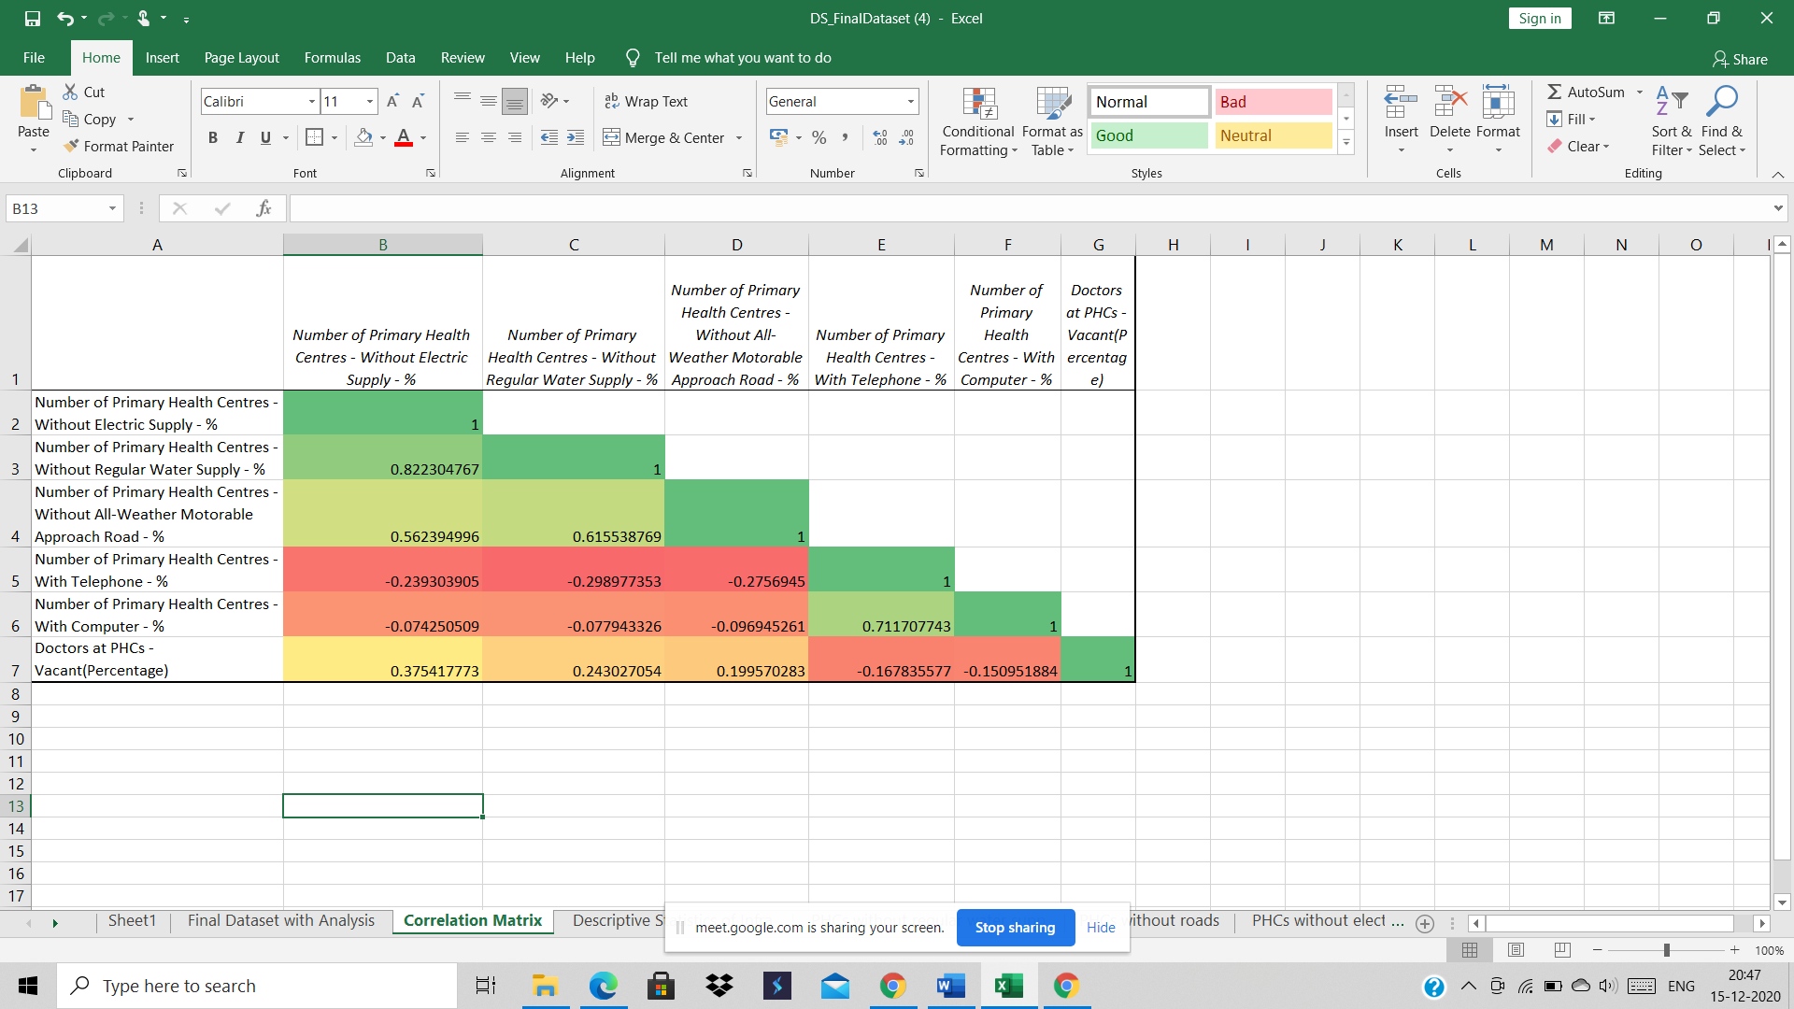

Correlation Matrix: it is a network giving relationship between all sets of information sets. It is concerned with collection and translation of quantitative information.

In this there are two types of relation; Positive means direct relation between variables and negative means inverse relationship.

* PHCs without Electric supply has a positive relation with factors like PHCs without water, approachability and availability of doctors and negative relationship with telephone and computer facility.
* PHCs without water has direct relationship with PHCs without approachability and availability of doctors and inverse relationship with availability of telephone and computers.
* PHCs without Motor approachability has positive relation only with the availability of doctors and negative with telephone and computers.
* Telephone services has direct relationship with telephone and computer availability and inverse relationship with availability of doctors.
* Computer facility is inversely related to availability of doctors.

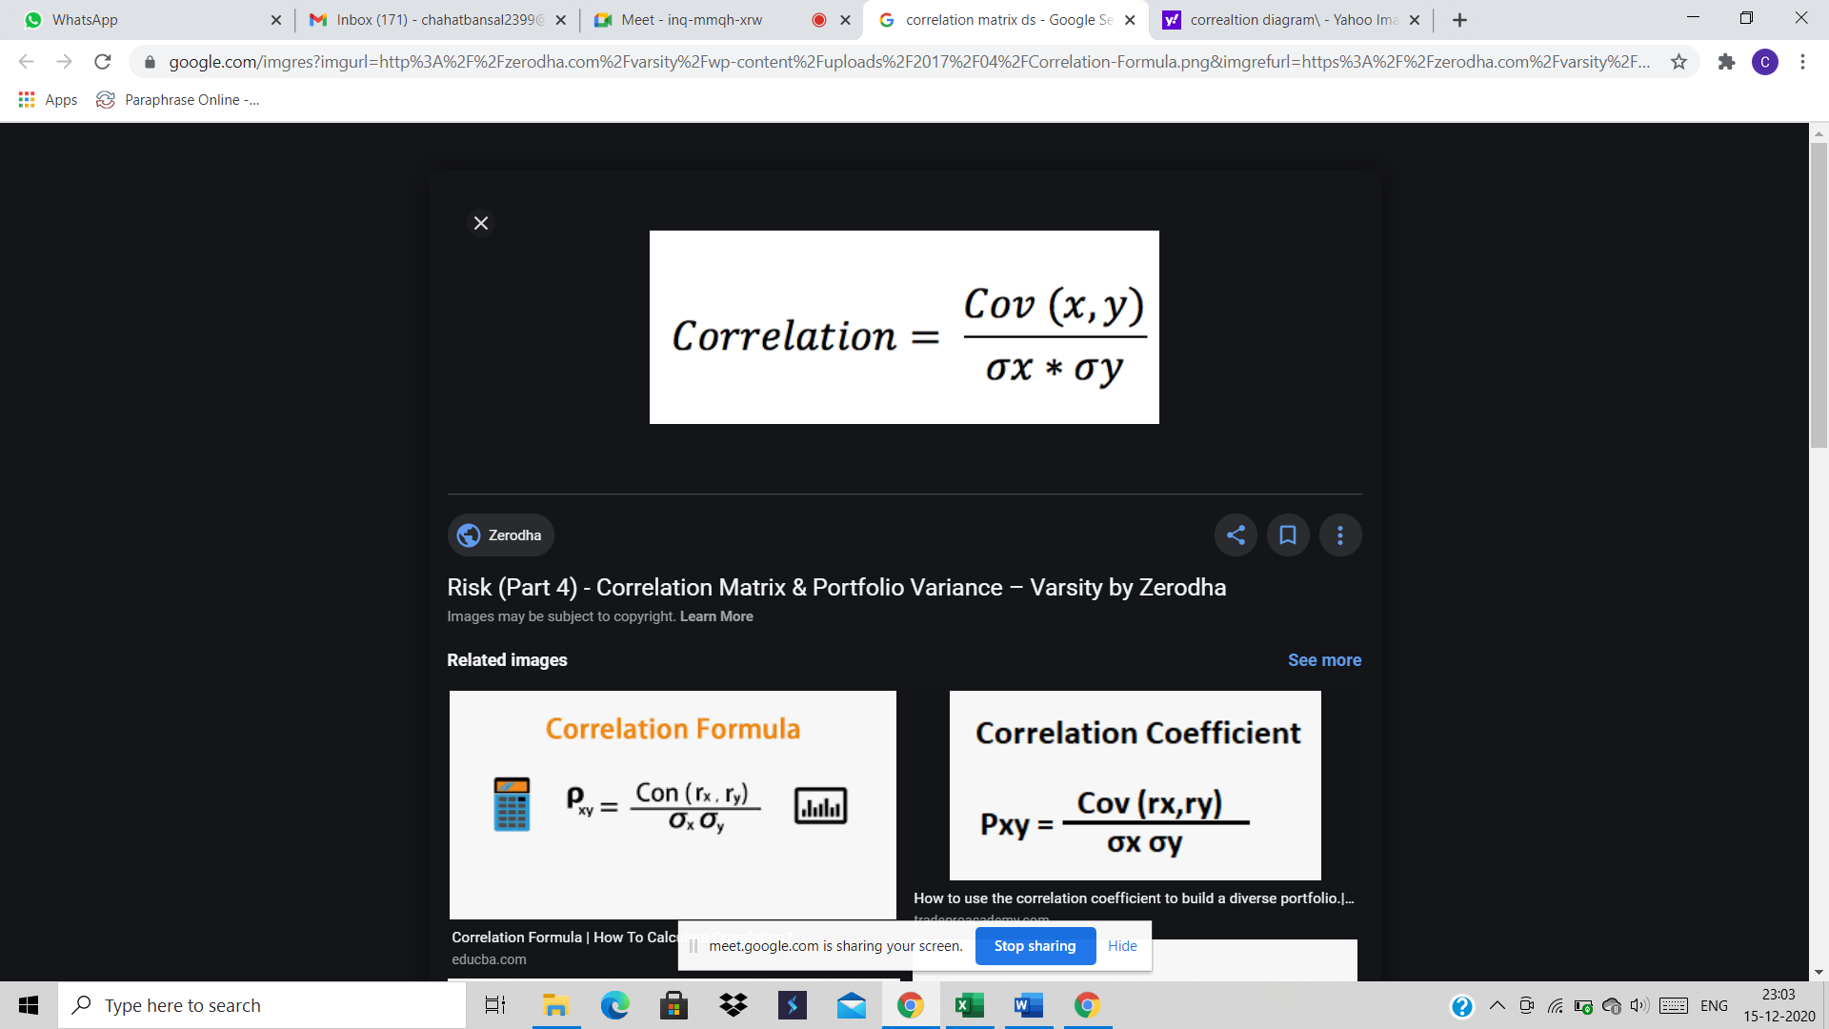

1. **Pivot Table**

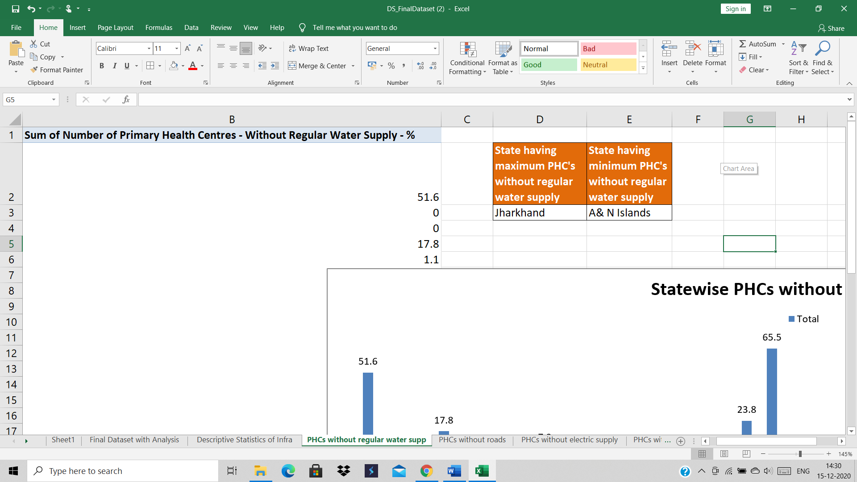

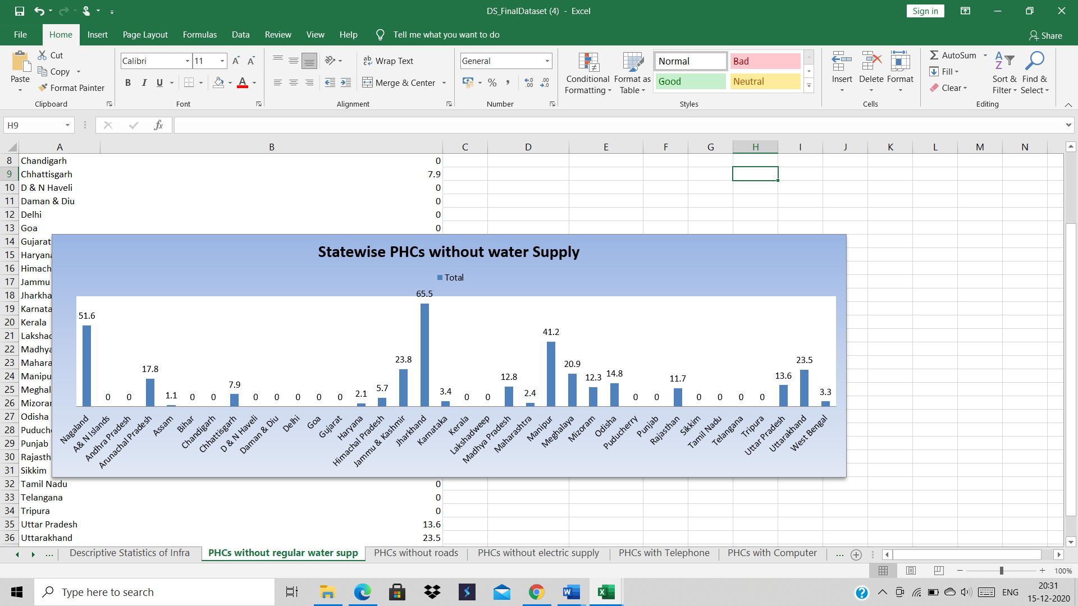

According to the data and the graph it is clear that JHARKHAND has the maximum number of PHC’s that do not have regular water supply and A&N ISLAND has the minimum number of PHC’s that do not have regular water supply.

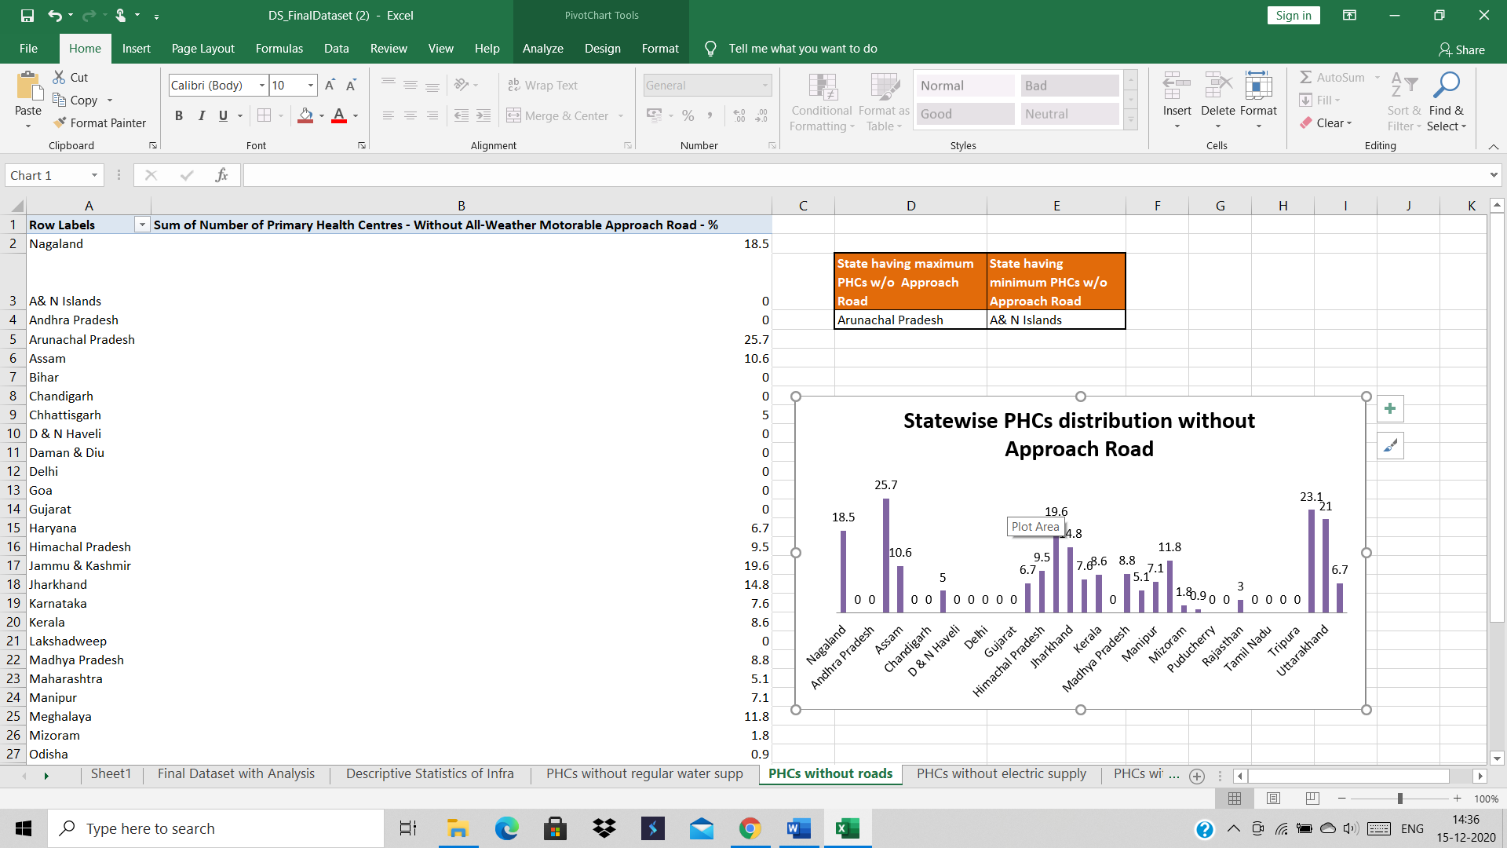

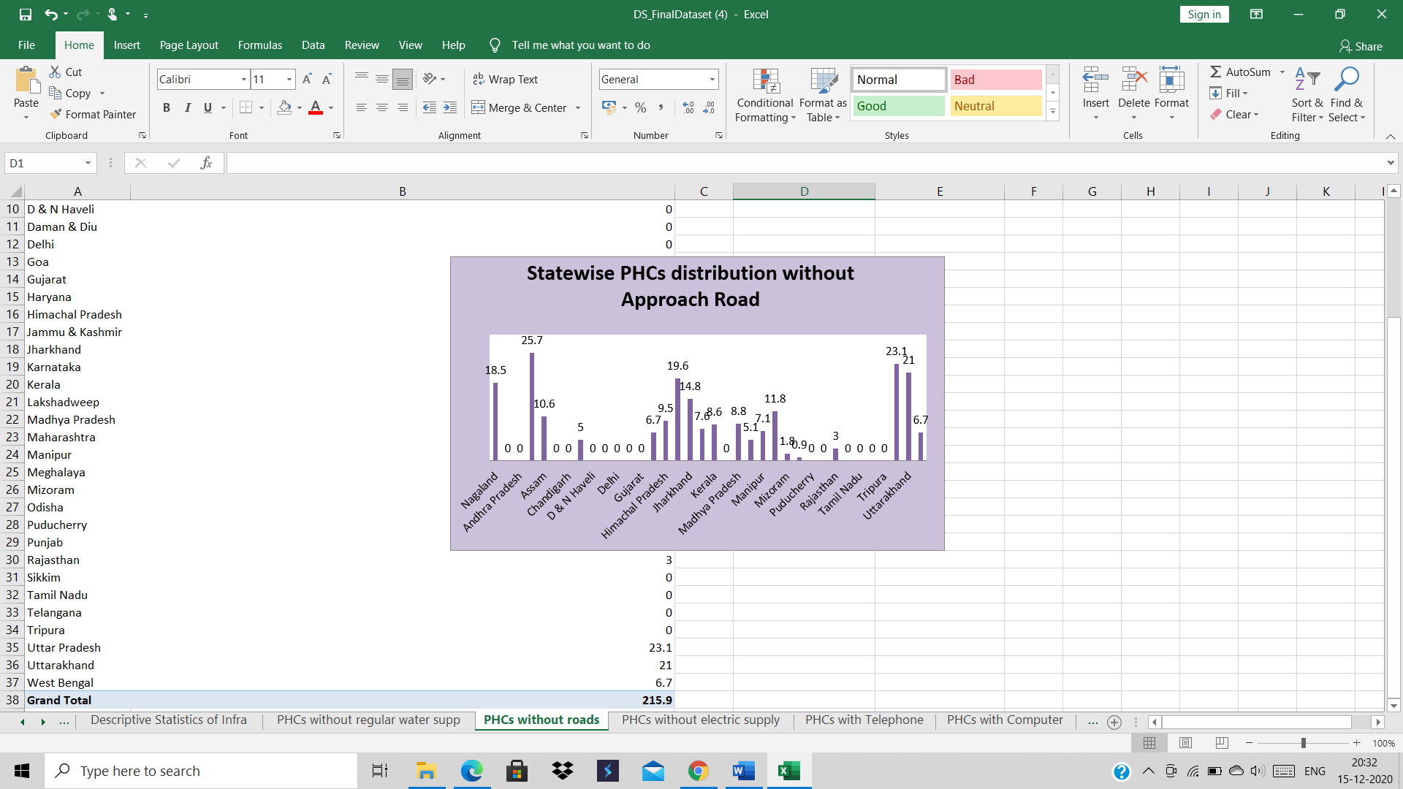  
  
According to the data and the graph it is clear that ARUNACHAL PRADESH has the maximum number of PHC’s that do not have a proper approach road and A&N ISLAND has the minimum number of PHC’s that do not have proper approach road.





According to the data and the graph it is clear that JHARKHAND has the maximum number of PHC’s that do not have regular electricity supply and A&N ISLAND has the minimum number of PHC’s that do not have regular electricity supply.

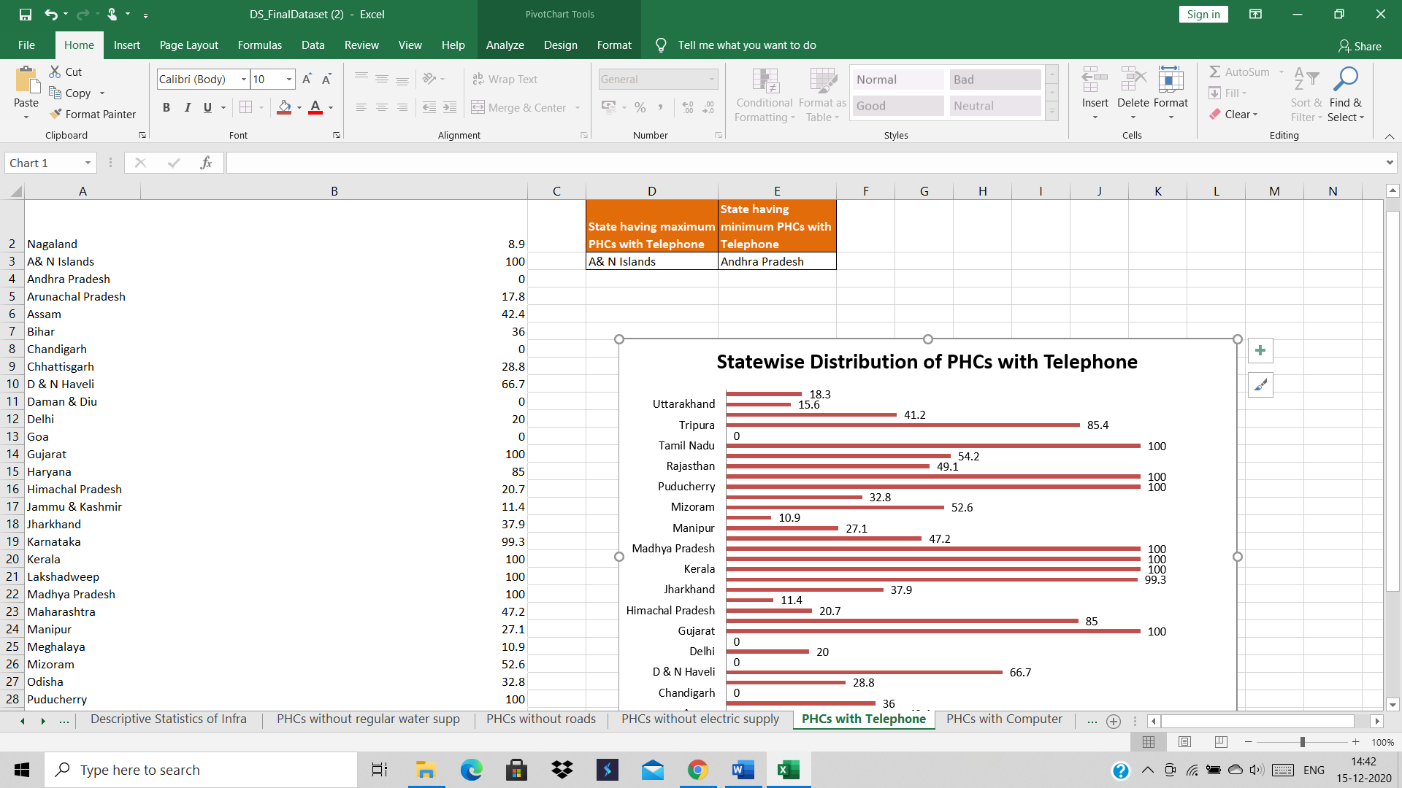

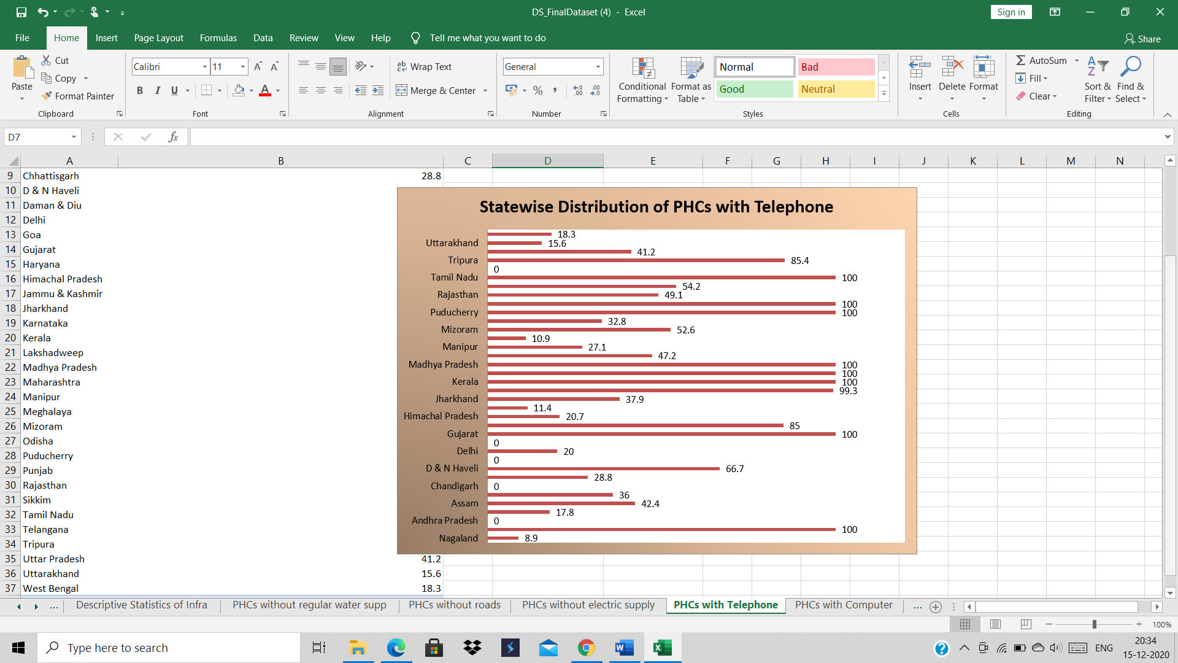

According to the data and the graph it is clear that A&N ISLAND has the maximum number of PHC’s that have telephone and ANDHRA PRADESH has the minimum number of PHC’s that have telephone.

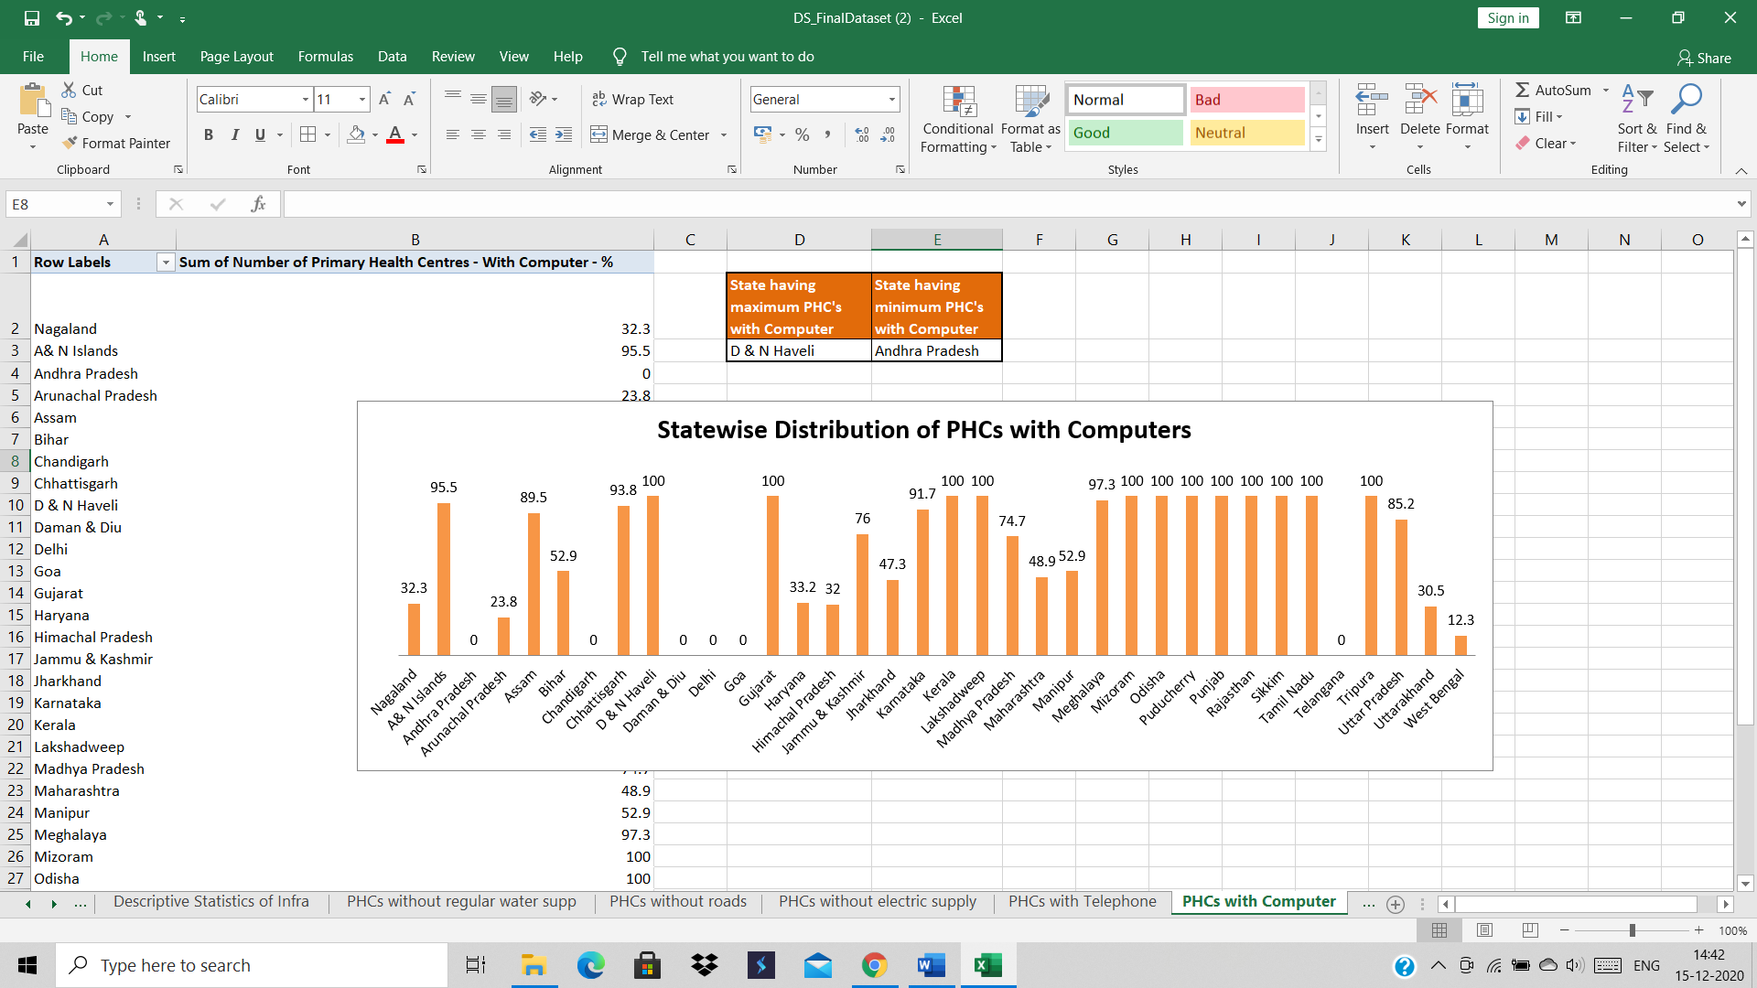

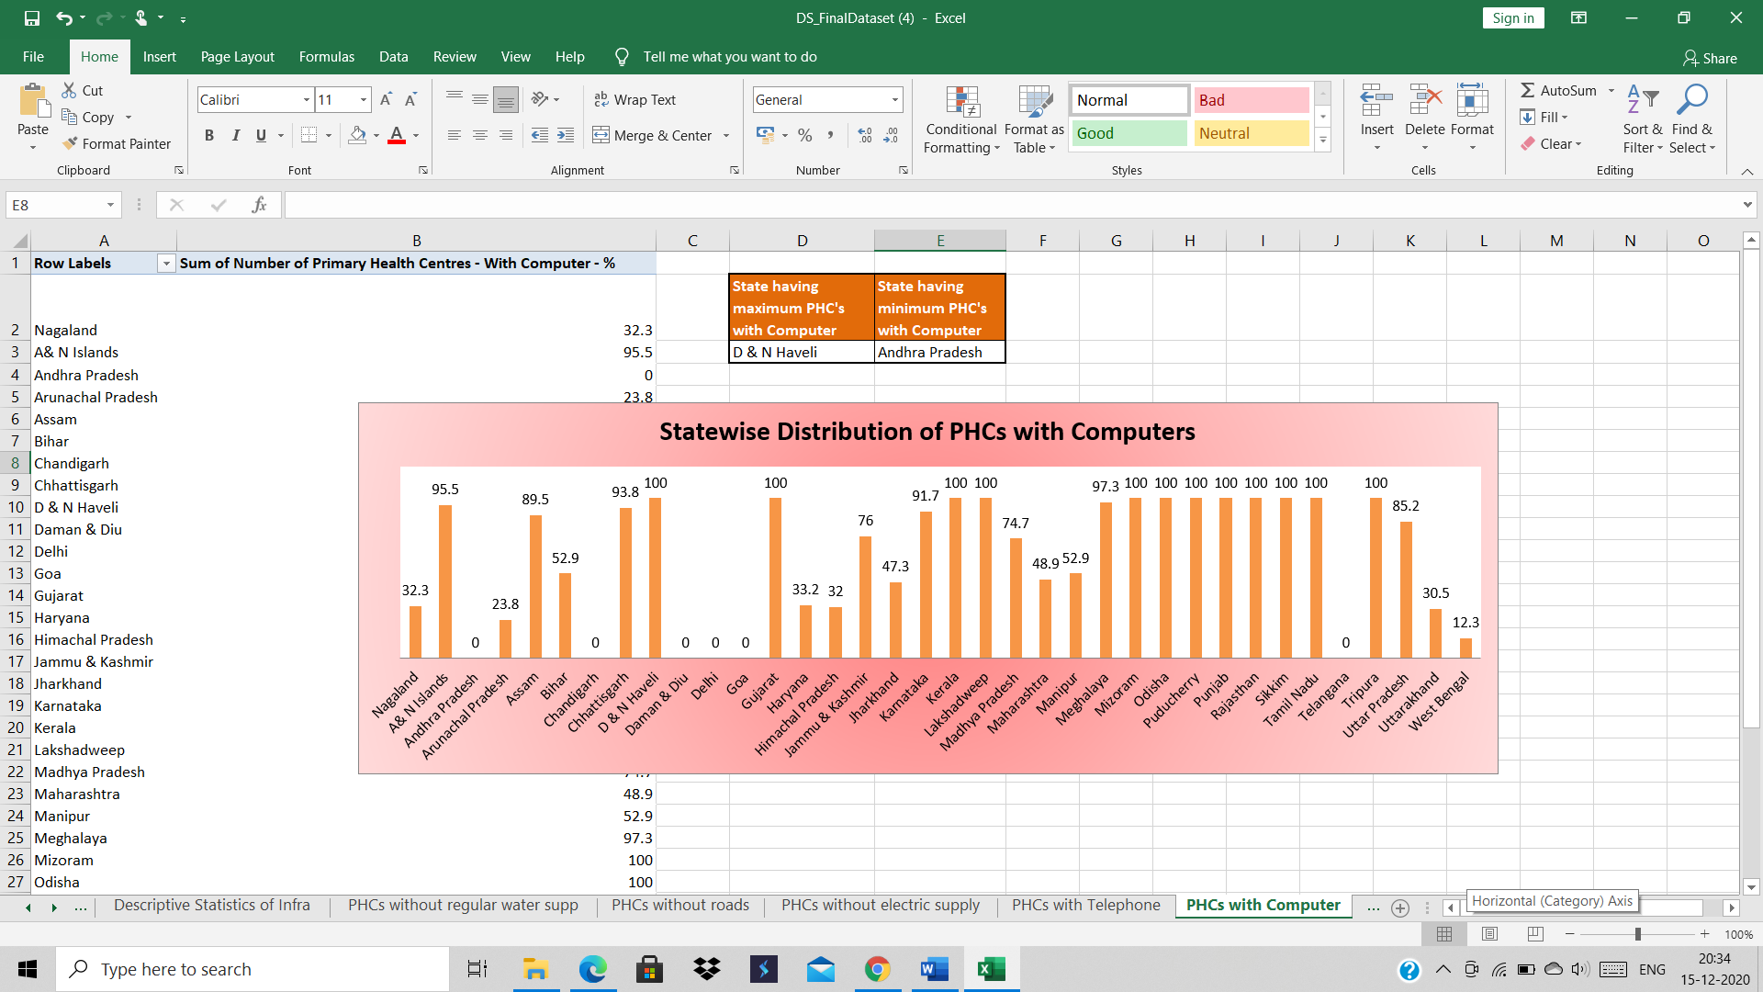

According to the data and the graph it is clear that A&N ISLAND has the maximum number of PHC’s that have telephone and D&N HAVELI has the minimum number of PHC’s that have telephone.

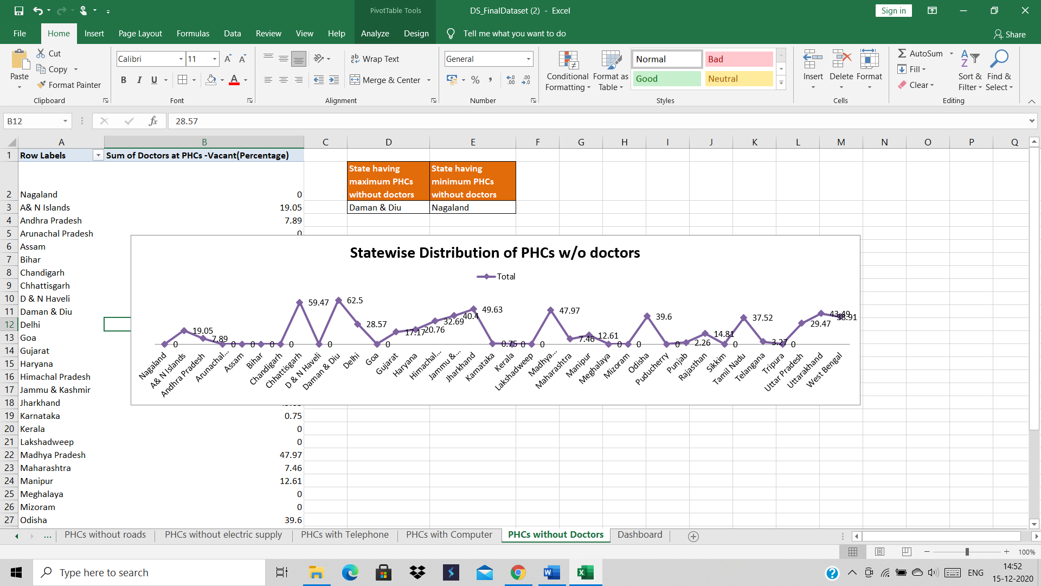

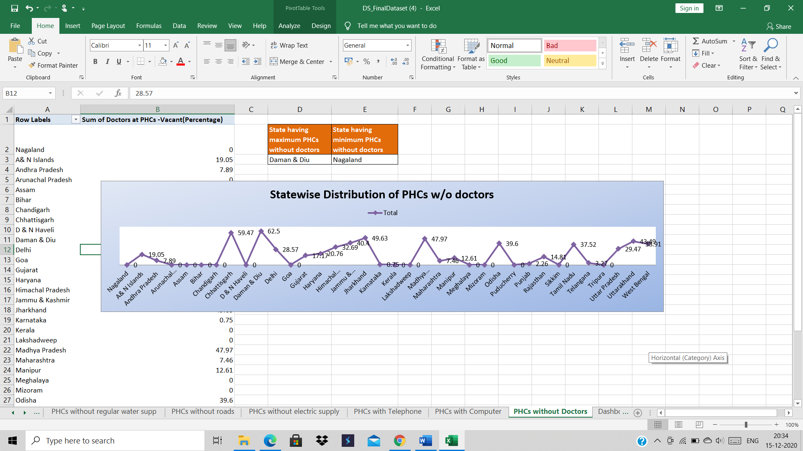

According to the data and the graph it is clear that DAMAN &N DIU has the maximum number of PHC’s without doctors and NAGALAND has the minimum number of PHC’s that do not have doctors.

1. **ANOVA**

**ANOVA** determines whether the groups created by the levels of the independent variable are statistically different by calculating whether the means of the treatment levels are different from the overall mean of the dependent variable.

P-value is the probability that the null hypothesis – that both (or all) populations are the same – is true. In other words, a lower p-value reflects a value that is more significantly different across populations. Biomarkers with significant differences between sample populations have p-values ≤ 0.05.



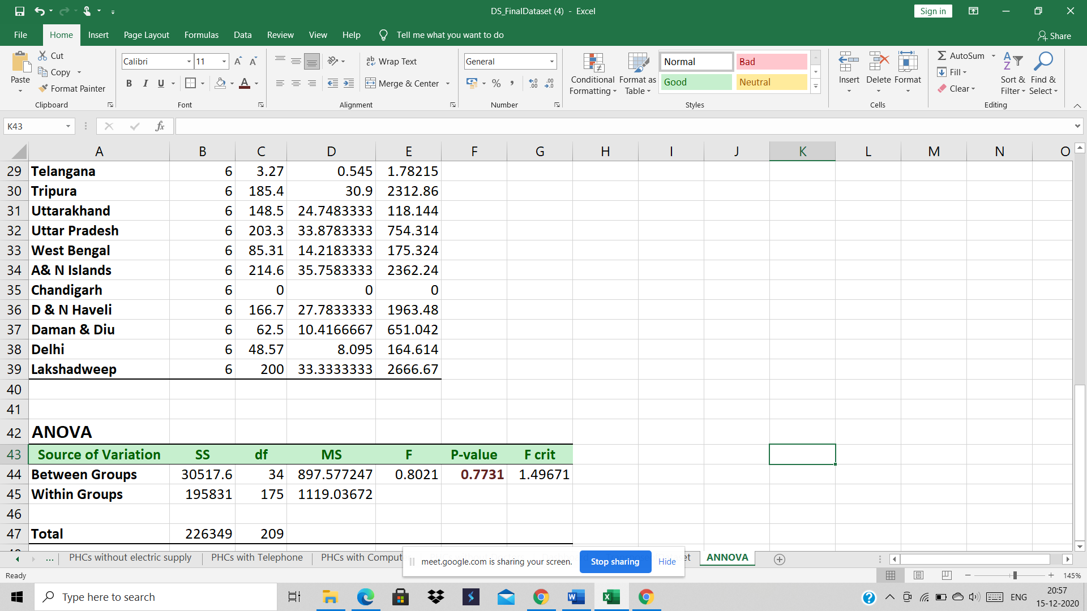

Null hypothesis: Infrastructure of PHCs in rural India of all the states is same.

Alternate Hypothesis: Infrastructure of PHCs varying across all the states of India.

P-value: In our research the p-value is more than 0.05, therefore null hypothesis will be accepted.

**References**

* <https://www.vikaspedia.in/health/health-directory/rural-health-care-system-in-india>
* <https://towardsdatascience.com/let-us-understand-the-correlation-matrix-and-covariance-matrix-d42e6b643c22>
* <https://towardsdatascience.com/statistical-tests-when-to-use-which-704557554740>
* <https://raybiotech.com/learning-center/t-test-anova/#:~:text=The%20t%2Dtest%20is%20a,statistically%20different%20from%20each%20other>.