Server Performance Monitoring – Data Engineering & Analytics Case Study
Submitted by: Chetna Radke
Role: Data Analyst Case Study
Tools & Technologies: Python (Pandas), Power BI, Excel, ETL process

1. Business Problem Overview
XYZ Corporation operates multiple virtual servers supporting critical applications. However, the organization lacks a centralized system to monitor server performance metrics such as CPU utilization, disk I/O, and downtime. The objective of this case study is to design an end-to-end data pipeline that ingests raw server data, performs data cleaning and transformation, models the data using a star schema, and delivers actionable insights through an interactive Power BI dashboard.

2. Solution Summary
An end-to-end data engineering and analytics solution was implemented using Python for data ingestion and transformation, followed by dimensional modeling and visualization in Power BI. The solution consolidates raw performance logs, enriches them with server metadata, and presents actionable insights through an interactive dashboard aligned with operational needs.

3. Architecture & Data Flow
The overall architecture follows a modular and scalable design:
Raw Excel Files → Python-based ETL using Pandas → Cleaned & Transformed Parquet Dataset → Power BI Semantic Model (Star Schema) → Interactive Power BI Dashboard
This approach ensures separation of concerns, reusability of transformed data, and optimal performance for analytical workloads.

Data modelling
Star schema

Python based
ETL
Data Source
(Raw excel file)

4. Data Sources
• Server_Metadata: Contains server configuration details, operating system type, cluster information, and administrator contact details.
• Server_Performance_Station1 & Station2: Performance logs capturing CPU utilization, disk I/O, downtime hours, and related metrics collected from multiple monitoring stations.
The datasets intentionally include missing values to simulate real-world data quality challenges.

5. Data Ingestion & ETL Process
Python and the Pandas library were used to implement the ETL process. Key steps included:
• Reading multiple Excel sheets and consolidating performance logs
• Removing non-analytical and configuration-specific columns
• Handling missing performance metrics using median-based imputation
• Enriching performance data with server metadata
• Standardizing column names for analytics and reporting
• Persisting the curated dataset in Parquet format for efficient downstream consumption
The ETL pipeline ensures data consistency, reliability, and readiness for analytical modeling.

6. Data Cleaning Strategy
A structured data cleaning strategy was applied to improve data quality:
• Records with missing Server IDs were removed to maintain referential integrity
• Irrelevant configuration-related fields were excluded from analysis
• Missing numerical metrics were imputed using median values to reduce skew
• Column naming conventions were standardized to align with Power BI best practices

7. Data Modeling – Star Schema Design
To support efficient analytics and intuitive reporting, a star schema data model was designed.
Fact Table:
• FactServerPerformance – Contains measurable metrics such as CPU utilization, disk I/O, downtime hours, and log date.
Dimension Tables:
• DimServer – Server attributes including OS type, cluster, and administrator details.
• DimDate – Calendar attributes including date, month, quarter, and year.
This dimensional model enables fast aggregations, simplified DAX calculations, and consistent filtering across visuals.
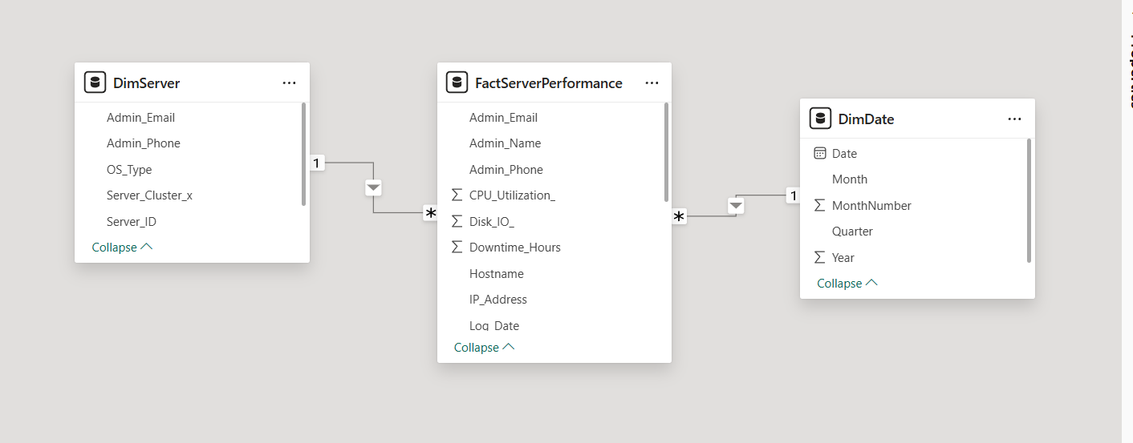

8. Power BI Dashboard Design
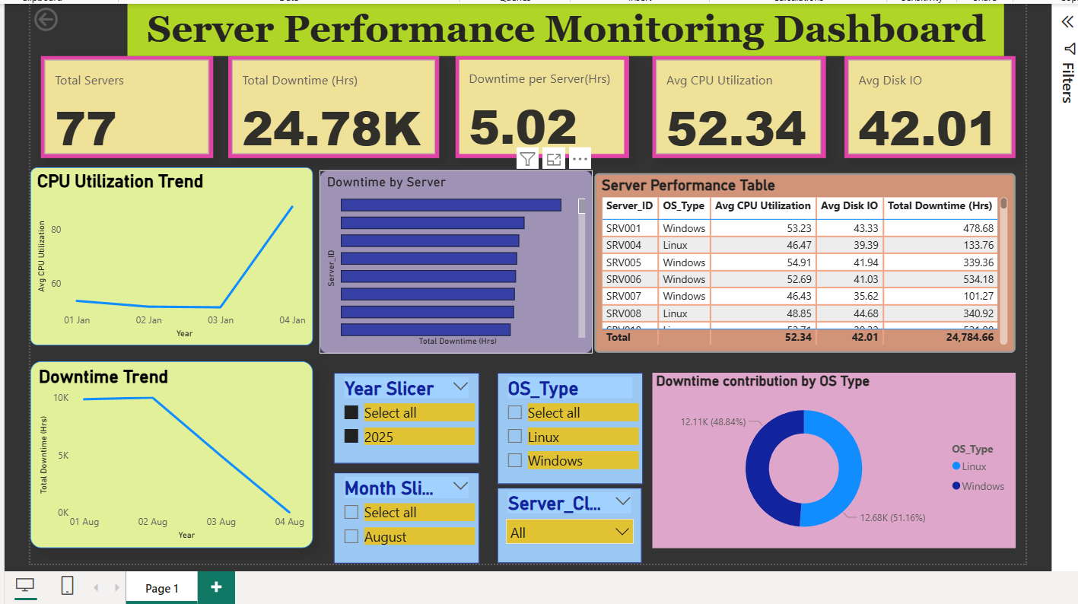
An interactive Power BI dashboard was developed on top of the star schema model. The dashboard provides both high-level KPIs and detailed operational views.
Key dashboard components include:
• KPI cards for total servers, total downtime, average CPU utilization, and average disk I/O
• Trend analysis using line charts for CPU utilization and downtime over time
• Server-level downtime analysis to identify high-impact servers
• Distribution analysis of downtime by operating system
• Interactive slicers for year, month, OS type, and server cluster
All visuals are fully interactive and driven by dimension-based filters.

9. Key Business Insights
The dashboard enables several actionable insights:
• A small subset of servers contributes disproportionately to overall downtime
• Performance trends vary across time periods, highlighting potential seasonal patterns
• Downtime contribution differs by operating system, indicating platform-level considerations
• Cluster-based filtering helps prioritize infrastructure optimization efforts

10. Assumptions
• Downtime metrics are measured in hours
• Server metadata remains relatively static during the analysis period
• Median imputation is appropriate for handling missing performance values

11. Scalability & Future Enhancements
The solution is designed with scalability in mind. In a production environment, the pipeline can be extended using cloud-native services such as Azure Data Factory for orchestration, Azure Data Lake for storage, and Azure Synapse for large-scale processing.
Future enhancements may include real-time streaming ingestion, anomaly detection, and automated alerting for proactive monitoring.
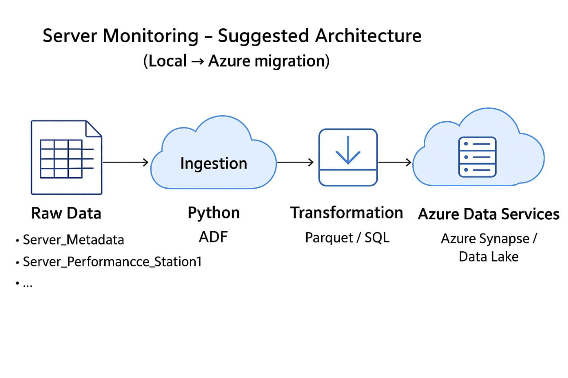

12. Conclusion
This case study demonstrates the implementation of a robust, end-to-end data engineering and analytics solution. By combining Python-based ETL, dimensional modeling, and Power BI visualization, the solution delivers meaningful insights into server performance and operational stability, aligned with server performance focus on data-driven decision support.

