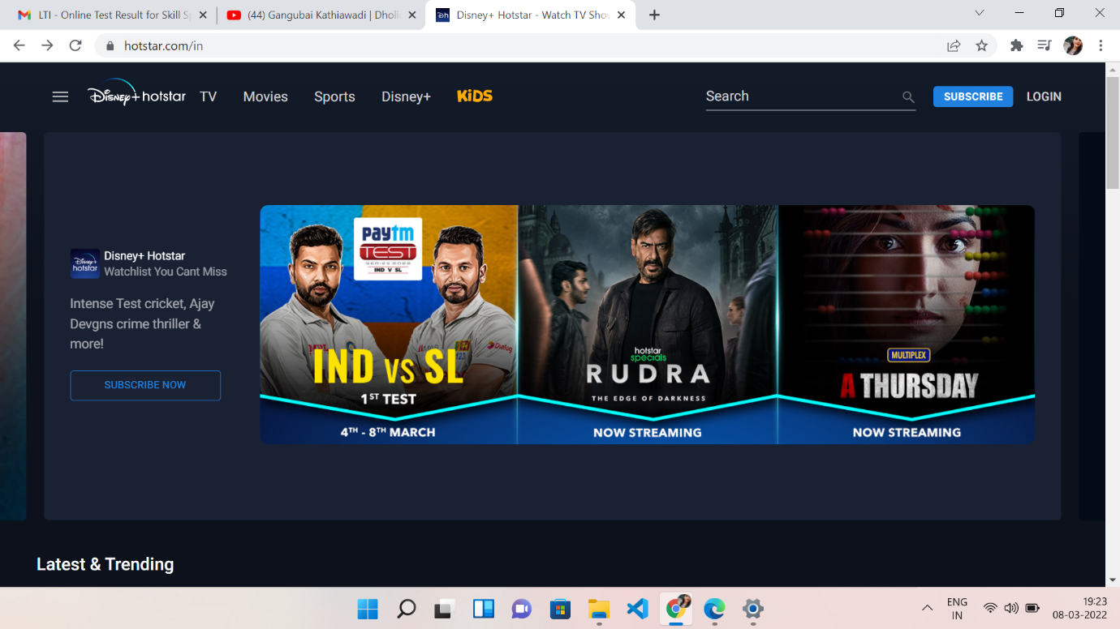

**Project Name: Disney +Hotstar**

**Chetna Rajesh Chaudhari**

**Edureka Presents**

**Hotstar** (also known as **Disney+ Hotstar**) is an Indian brand of subscription video on-demand over-the-top streaming service owned by Novi Digital Entertainment of Star India and operated by Disney Media and Entertainment Distribution, both divisions of The Walt Disney Company.

**Goals:**

1. Login page
2. Subscription page
3. Payment page
4. Streaming page
5. Login and logout page

**History:**

The brand was first introduced as Hotstar, for a streaming service carrying content from Star India's local networks, including films, television series, live sports, and original programming, as well as featuring content licensed from third-parties such as HBO and Showtime among others. Amid the significant growth of mobile broadband in India, Hotstar quickly became the dominant streaming service in the country.

**Technologies used in Aha Front-End:**

1. Html
2. Css
3. Bootstrap
4. React

**Dynamic:**

1. JavaScript
2. Ci/cd with AWS
3. Login and Logout (oauth and jwt)

**Database:**

1. Mongo dB
2. Json Data

**Code compilers:**

1. Visual studio code
2. Git bash
3. Git hub
4. Node js