LOAD BALANCER
USING
NGINX
AND
APACHE WEB SERVER

By
PRASAD R. YAMNURWAR
BT16CSE096

What is Load Balancing?

- It refers to efficiently distributing incoming network traffic across a group of backend servers, also known as a server farm or server pool.
- It acts as the “traffic cop” sitting in front of your servers and routing client requests across all servers capable of fulfilling those requests in a manner that maximizes speed and capacity utilization and ensures that no one server is overworked, which could degrade performance.
- If a single server goes down, the load balancer redirects traffic to the remaining online servers. When a new server is added to the server group, the load balancer automatically starts to send requests to it.

Why Load Balancing?

- Modern high-traffic websites must serve hundreds of thousands, if not millions, of concurrent requests from users or clients and return the correct text, images, video, or application data, all in a fast and reliable manner. To cost-effectively scale to meet these high volumes, modern computing best practice generally requires adding more servers.

What does it do?

- Distributes client requests or network load efficiently across multiple servers
- Ensures high availability and reliability by sending requests only to servers that are online.
- Provides the flexibility to add or subtract servers as demand dictates.

What is NGINX?
- It is a web server which can also be used as a reverse proxy, load balancer, mail proxy and HTTP cache.
- Nginx is free and open-source software.

What is Apache Web Server?

- It is a free and open-source cross-platform web server.
- It is developed and maintained by an open community of developers under the auspices of the Apache Software Foundation.
- Apache supports a variety of features, many implemented as compiled modules which extend the core functionality.
- supporting server-side programming languages such as Perl, Python, Tcl and PHP.

The process of load balancing-
- Three computers are chosen. One of them serves as load balancer while the other two are web servers.
- Apache is installed in the two web servers using system call
: ‘sudo-apt get install Apache2’
- Open the file /var/www/html/index.html and edit the HTML page as desired.
- The Apache server is started using system call : ‘sudo systemctl start Apache2’.
- Open the web browser and browse for “localhost/”. The desired index.html page should be visible.
- Nginx, which is used as load balancer, is installed in the load balancer by the system call ‘sudo-apt get install nginx’
- Open etc/nginx/sites-available/default.config and add the following code:
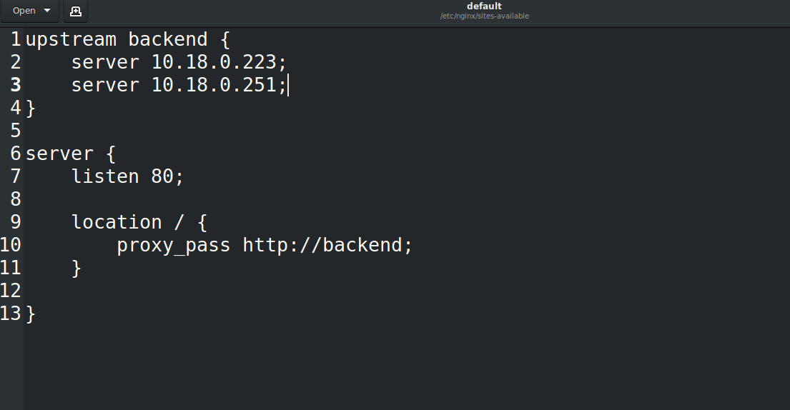
The code takes the IP addresses of the two web servers.
- Start the nginx using system call: ‘sudo systemctl start nginx’

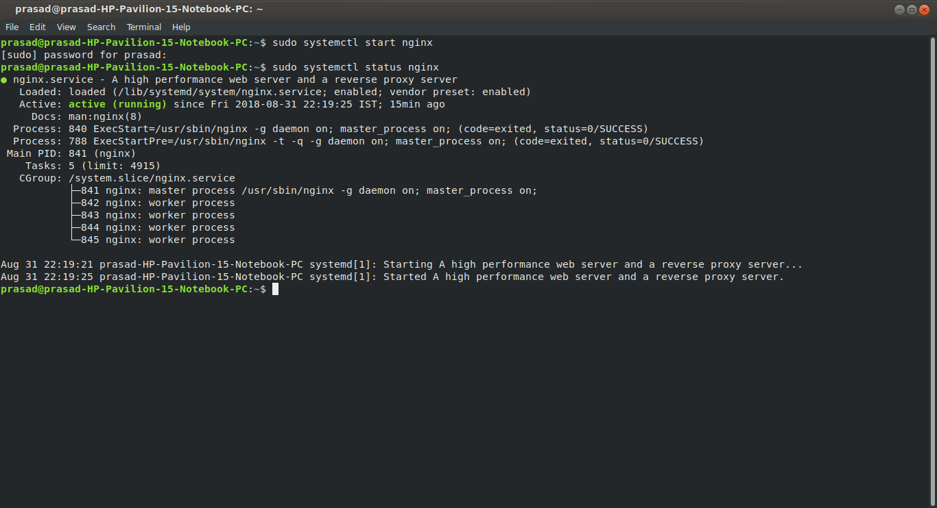
- Make sure the Apache server is actively running in the web servers using system call: ‘sudo systemctl status Apache2’

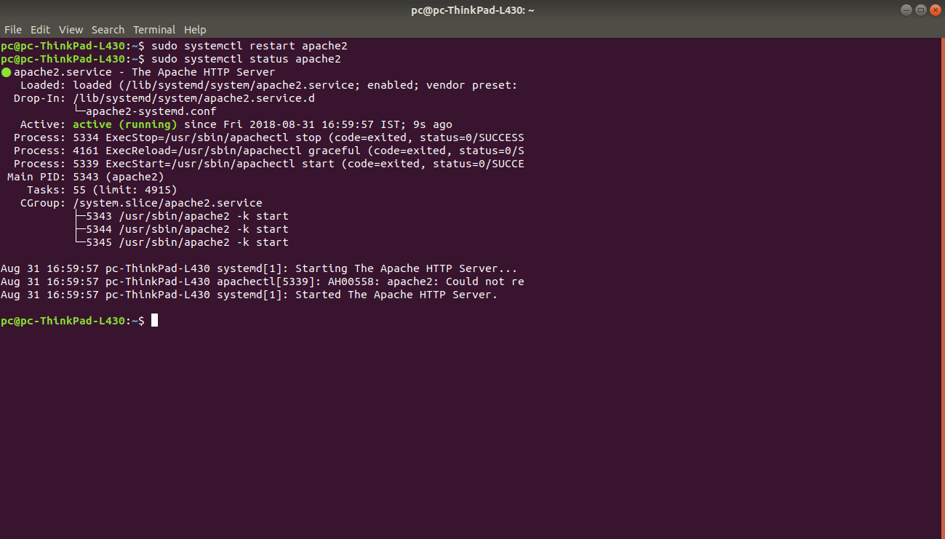
- Now if we enter the IP address of the load balancer computer in the web browser of any other device, the web pages of either web servers should be visible.
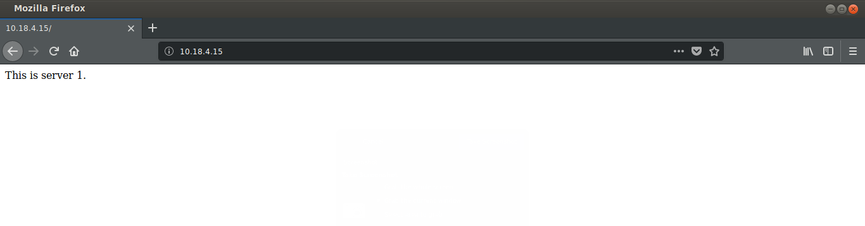
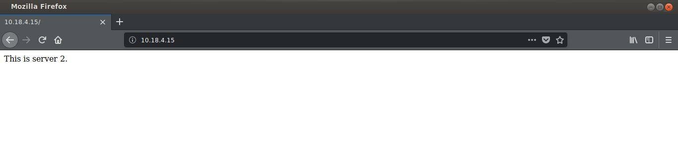
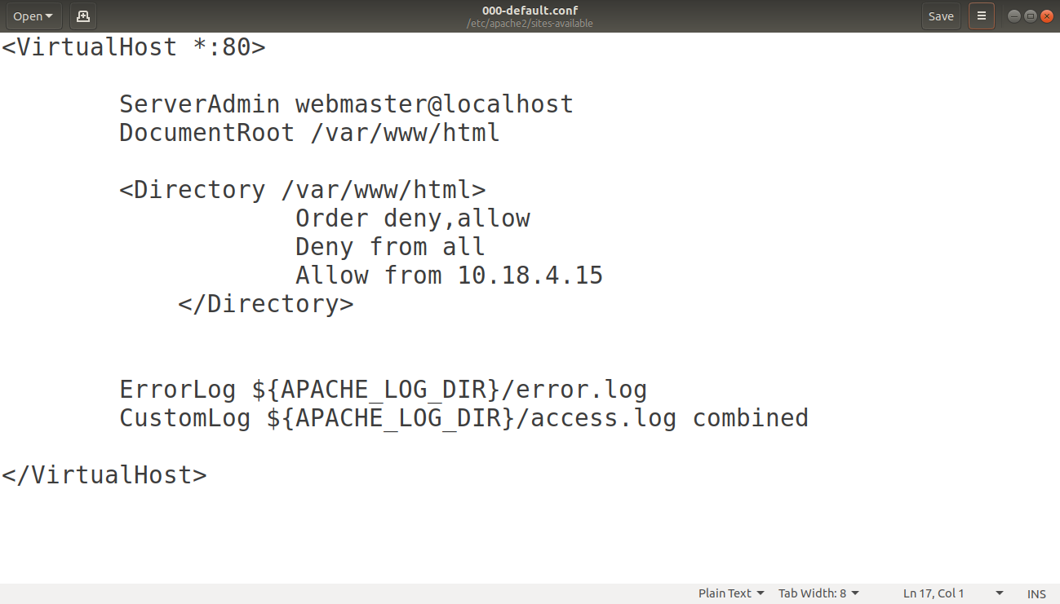
The web servers can be made secure(i.e. allowing only the load balancer to access that web server), by making the following changes in the file

This code allows access to the web server from only one load balancer.

THANK YOU!

