ZOMATO RESTAURANT &
CUSTOMER INSIGHTS ANALYSIS

An Interactive Data Analytics and Business Intelligence Dashboard

Student | Chetan Chaudhari
Program | Data Analytics Internship
Date | September 2026
Dataset | Zomato Restaurant Dataset (9,542 cleaned records)

Table of Contents
- 1. Executive Summary
- 2. Introduction
- 3. Problem Statement
- 4. Objectives
- 5. Dataset Description
- 6. Tools and Technologies
- 7. Project Architecture
- 8. Methodology
- 9. Data Understanding
- 10. Data Cleaning
- 11. Feature Engineering
- 12. Exploratory Data Analysis
- 13. Visualization Analysis
- 14. Statistical Analysis
- 15. Streamlit Dashboard
- 16. Automated Insight Engine
- 17. Key Findings
- 18. Business Insights
- 19. Recommendations
- 20. Limitations
- 21. Future Scope
- 22. Conclusion
- 23. References
- 24. Viva Questions & Answers

1. Executive Summary
This report presents a complete data analytics study of the Zomato restaurant dataset, conducted as part of a Data Analytics Internship project. The dataset contains information on 9,551 restaurant records across 141 cities globally, with 90.6% concentrated in India.
After cleaning (9 rows removed for missing cuisine information), the final dataset contains 9,542 restaurants across 140 cities. Analysis covers restaurant distribution, cuisine popularity, pricing patterns, customer ratings, service availability, and business insights.

Key Metrics (Calculated from Actual Data)
Metric | Value
Total Restaurants | 9,542
Total Cities | 140
Unique Individual Cuisines | 145
Average Rating (rated restaurants) | 3.44 / 5.0
Average Cost for Two | INR 1,200
Total Customer Votes | 1,495,919
Online Delivery Adoption | 25.7%
Table Booking Adoption | 12.1%
Most Represented City | New Delhi (57.4%)
Most Common Cuisine | North Indian (3,960 restaurants)

2. Introduction
Zomato is one of the largest restaurant discovery and food delivery platforms globally, operating in numerous countries. The platform aggregates detailed information about restaurants including location, cuisine types, pricing, customer ratings, and service availability.
This project leverages a publicly available Zomato restaurant dataset to perform a structured data analytics exercise. The analysis is designed to be comprehensive yet accessible to beginners, demonstrating best practices in data cleaning, exploratory analysis, feature engineering, statistical analysis, and dashboard development.

3. Problem Statement
Raw restaurant listing data contains valuable but unstructured information. Without systematic analysis, the patterns and business signals hidden in this data remain inaccessible to decision-makers.
Specific questions this project addresses:
- Which cities and cuisines dominate the Zomato platform?
- What is the distribution of restaurant ratings across different price tiers?
- How available are online delivery and table booking services across cities?
- What is the relationship between price, rating, and customer votes?
- Which restaurants are high-performing (high rating + high votes)?
- What actionable insights can be generated from this dataset?

4. Objectives
1. Profile and clean the raw Zomato dataset
2. Engineer 6 new analytical features from existing columns
3. Perform EDA to answer 24 business questions
4. Create 13 professional data visualizations
5. Generate 12 automated, data-driven business insights
6. Build an interactive 9-section Streamlit dashboard
7. Compile findings into a professional internship project report

5. Dataset Description
The dataset was provided as part of the Data Analytics Internship project. It is a Zomato restaurant dataset commonly used for academic analytics exercises.

Dataset Properties
Property | Value
File | zomato.csv
Raw rows | 9,551
Columns | 21
Encoding | Latin-1
Missing values | 9 (Cuisines column only)
Duplicate rows | 0
Rows after cleaning | 9,542
Columns after cleaning | 18

Column Description
Column | Description
Restaurant ID | Unique restaurant identifier
Restaurant Name | Name of the restaurant
Country Code | Numeric country code
City | City where restaurant is located
Address | Full address
Locality | Neighbourhood or locality
Cuisines | Comma-separated cuisine types
Average Cost for two | Average meal cost for two people
Currency | Local currency
Has Table booking | Whether table booking is available (Yes/No)
Has Online delivery | Whether online delivery is available (Yes/No)
Price range | Price tier 1-4 (1=cheapest, 4=most expensive)
Aggregate rating | Average customer rating (0.0–5.0; 0 = Not Rated)
Rating text | Text label: Excellent/Very Good/Good/Average/Poor/Not rated
Votes | Number of customer votes

6. Tools and Technologies
Tool | Purpose
Python 3.x | Primary programming language
Pandas | Data loading, manipulation, aggregation
NumPy | Numerical operations and array handling
Matplotlib | Static chart generation
Seaborn | Statistical visualization (heatmaps, distributions)
Plotly | Interactive charts in Streamlit dashboard
Streamlit | Interactive web dashboard framework
Jupyter Notebook | Interactive analysis and documentation
python-docx | DOCX report generation
nbformat | Jupyter notebook file generation

7. Project Architecture
The project follows a modular architecture separating data access, analysis logic, insight generation, and visualization into dedicated Python modules.
Project Folder Structure:
Zomato_Analytics_Project/
data/raw/zomato.csv (original dataset)
data/cleaned/zomato_cleaned.csv (cleaned + engineered data)
notebooks/ ...ipynb (Jupyter notebook, 63 cells)
src/data_cleaning.py (load, clean, engineer)
src/analysis.py (all analysis functions)
src/insights.py (automated insight engine)
app/streamlit_app.py (interactive dashboard)
visualizations/ (13 saved PNG charts)
report/ ...ProjectReport.docx (this report)
Chetan_Chaudhari_Zomato_Analysis.py (main pipeline script)
requirements.txt
README.md

8. Methodology
Phase 1: Data Understanding: Profile the raw dataset: shape, dtypes, missing values, duplicates, unique values.
Phase 2: Data Cleaning: Remove missing cuisine rows, convert flags, fix dtypes, drop redundant columns.
Phase 3: Feature Engineering: Create Price Category, Rating Category, Cuisine Count, Is Rated, Popularity Category, Has Both Services.
Phase 4: Exploratory Data Analysis: Answer 24 business questions using grouped aggregations, value counts, and cross-tabulations.
Phase 5: Visualization: Generate 13 charts covering city distribution, cuisines, ratings, costs, delivery, and booking.
Phase 6: Statistical Analysis: Compute descriptive statistics and Pearson correlation between key variables.
Phase 7: Automated Insights: Generate 12 data-driven business insights with findings and recommendations.
Phase 8: Dashboard: Build a 9-tab Streamlit dashboard with sidebar filters and interactive Plotly charts.

9. Data Understanding
The raw dataset contains 9,551 rows and 21 columns. All 21 columns are present in every row except Cuisines, which has 9 missing values. There are no duplicate rows.

Key Observations
- Rating = 0 does NOT mean a zero rating — it means 'Not Rated'. 2,148 restaurants fall in this category (22.5%).
- The Average Cost for two spans multiple currencies (India, Philippines, UK, USA, etc.).
- Country Code 1 (India) accounts for 8,652 of the 9,551 records (90.6%).
- Has Table booking and Has Online delivery are Yes/No strings, not binary integers.
- Cuisines can contain multiple values separated by commas (e.g., 'North Indian, Chinese').
- Price range 1-4 is a relative tier within each country, not an absolute cost scale.

10. Data Cleaning
Cleaning was performed on a copy of the raw dataframe. The original was not modified.
Step | Action and Rationale
Step 1: Copy | Created df.copy() to preserve the original raw dataframe.
Step 2: Drop missing Cuisines | Dropped 9 rows with NaN in Cuisines. Loss = 0.09%. Imputation would be guesswork.
Step 3: Strip whitespace | Applied str.strip() to all object columns to remove leading/trailing spaces.
Step 4: Convert flags | Mapped 'Yes'→1, 'No'→0 for Has Table booking, Has Online delivery, Is delivering now, Switch to order menu.
Step 5: Numeric dtypes | Ensured Average Cost for two, Aggregate rating, Votes are float/int. Price range is Int64.
Step 6: Drop redundant columns | Removed Locality Verbose (redundant), Is delivering now (real-time, not analytical), Switch to order menu (real-time).
Step 7: Reset index | Reset row index from 0 after dropping rows.

Before and After Cleaning
Property | Before Cleaning | After Cleaning
Rows | 9,551 | 9,542 (-9)
Columns | 21 | 18 (-3 dropped)
Missing values | 9 | 0
Duplicate rows | 0 | 0
Has Table booking dtype | object (Yes/No) | int64 (1/0)
Has Online delivery dtype | object (Yes/No) | int64 (1/0)

11. Feature Engineering
Six new analytical features were created from the existing columns. All thresholds are data-driven — computed from the actual dataset values, not hard-coded.
Feature | Description | Source
Price Category | Map Price range 1→Budget, 2→Mid-Range, 3→Premium, 4→Luxury | Price range column
Rating Category | Copy of Rating text for consistency | Rating text column
Cuisine Count | Count of comma-separated entries in Cuisines | Cuisines column
Is Rated | 1 if Aggregate rating > 0, else 0 | Aggregate rating column
Popularity Category | Low/Medium/High/Very High based on Votes quartiles (Q25=5, Q50=31, Q75=130) | Votes column
Has Both Services | 1 if both Online Delivery=1 AND Table Booking=1 | Both service columns

12. Exploratory Data Analysis

Restaurant Distribution
The dataset covers 9,542 restaurants (after cleaning) across 140 cities. New Delhi alone accounts for 5,473 restaurants (57.4%), followed by Gurgaon (11.7%) and Noida (11.3%). The top 3 cities contain over 80% of all restaurants, reflecting the strong India-centric, North India-specific nature of the dataset.

Cuisine Analysis
Analysis of individual cuisines (split from multi-cuisine strings) reveals 145 unique cuisines. North Indian leads with 3,960 restaurants, followed by Chinese (2,735) and Fast Food (1,986). These three cuisines collectively appear in more than 90% of Indian restaurant listings.

Rating Analysis
Of 9,542 restaurants, 2,148 (22.5%) are unrated (Aggregate rating = 0). Among rated restaurants, the average rating is 3.44/5.0. The most common rating category is 'Average' followed by 'Good'. Excellent-rated restaurants make up only 7.5% of the rated pool.

Price Analysis
The Budget tier (Price range = 1) dominates with 46.5% of restaurants, followed by Mid-Range (32.7%), Premium (14.8%), and Luxury (6.1%). Higher price tiers consistently achieve higher average ratings: Budget=3.24, Mid-Range=3.38, Premium=3.78, Luxury=3.89.

Service Availability
Online delivery is available in only 25.7% of all restaurants. Within India, this rises to 28.0%. Mid-Range restaurants show the highest delivery adoption (41.3%), while Budget restaurants are lowest (15.8%). Table booking is available in only 12.1% of restaurants, primarily at higher price tiers.

13. Visualization Analysis

Chart 1: Top 15 Cities by Restaurant Count
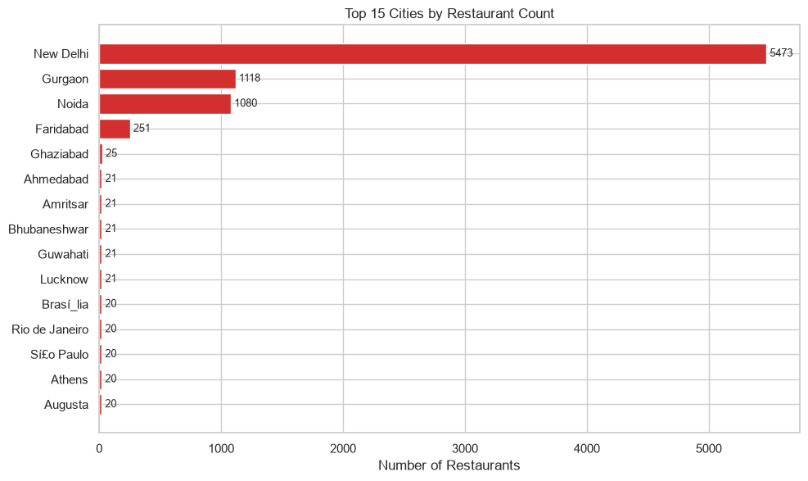
New Delhi dominates with 5,473 restaurants (57.4% of total). Gurgaon and Noida follow at approximately 11.7% and 11.3% respectively. The remaining 137 cities collectively account for less than 20% of the dataset.

Chart 2: Top 15 Most Common Cuisines
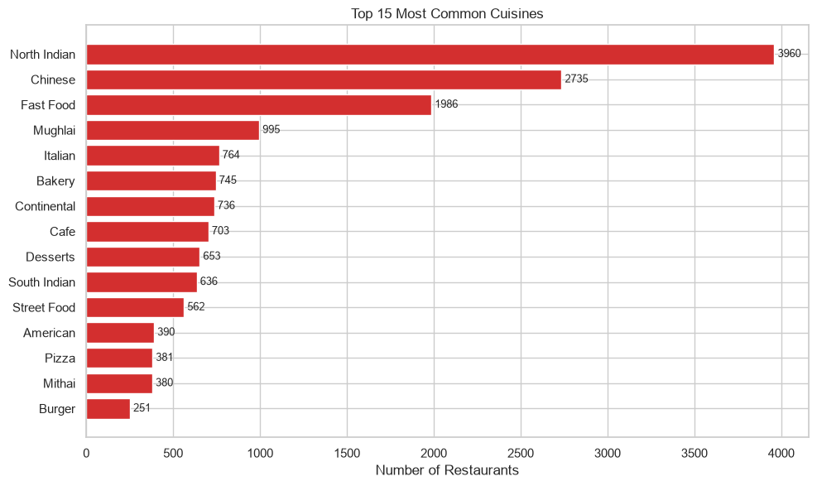
North Indian leads at 3,960, reflecting the geographic dominance of Delhi-NCR restaurants. Chinese (2,735) and Fast Food (1,986) are the second and third most common cuisines.

Chart 3: Rating Distribution
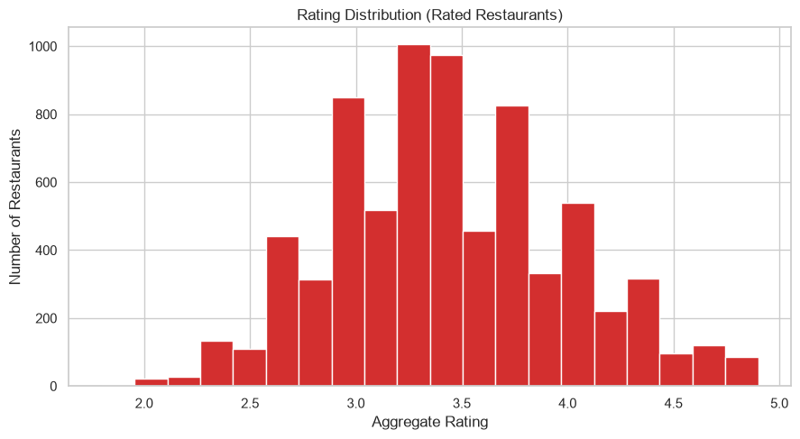
The histogram of rated restaurants shows a bimodal-like distribution with a concentration between 3.0 and 4.0. Very few restaurants achieve ratings above 4.5.

Chart 4: Price Category Distribution
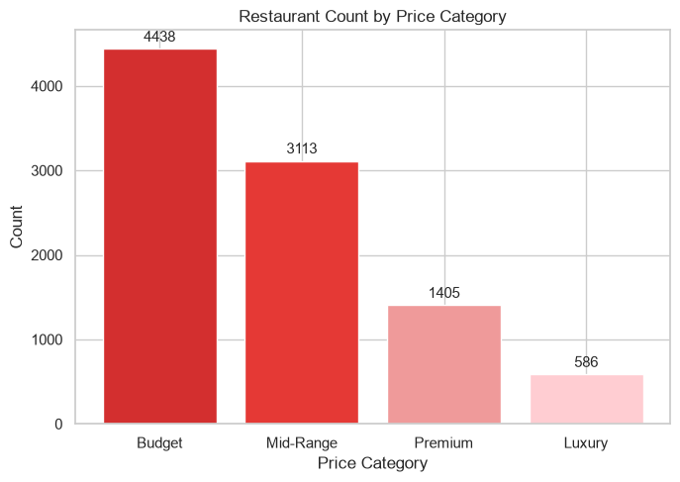
Budget restaurants (46.5%) form the largest segment. Luxury restaurants are the smallest segment at 6.1%, which is expected as premium dining is less common.

Chart 5: Online Delivery & Table Booking
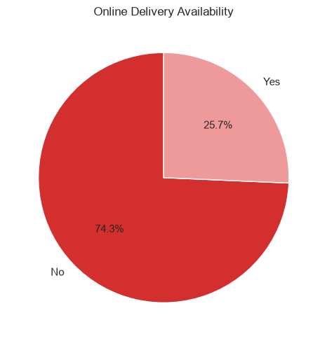
74.3% of restaurants do NOT offer online delivery. Table booking is even less common at 12.1%.

Chart 6: Average Rating by Price Category
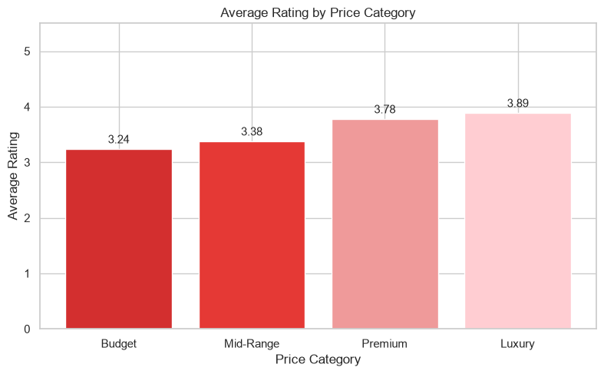
There is a clear positive gradient from Budget (3.24) to Luxury (3.89), confirming that higher-priced restaurants consistently receive better ratings.

Chart 7: Votes vs Rating Scatter
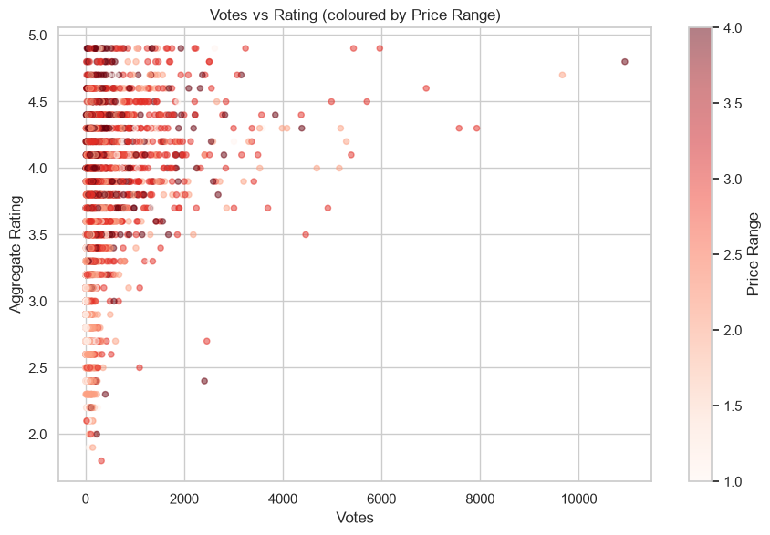
The scatter plot reveals a moderate positive correlation (r=0.31) between votes and rating. Most highly voted restaurants tend to have above-average ratings, but there are exceptions.

Chart 8: Top 15 Restaurants by Votes
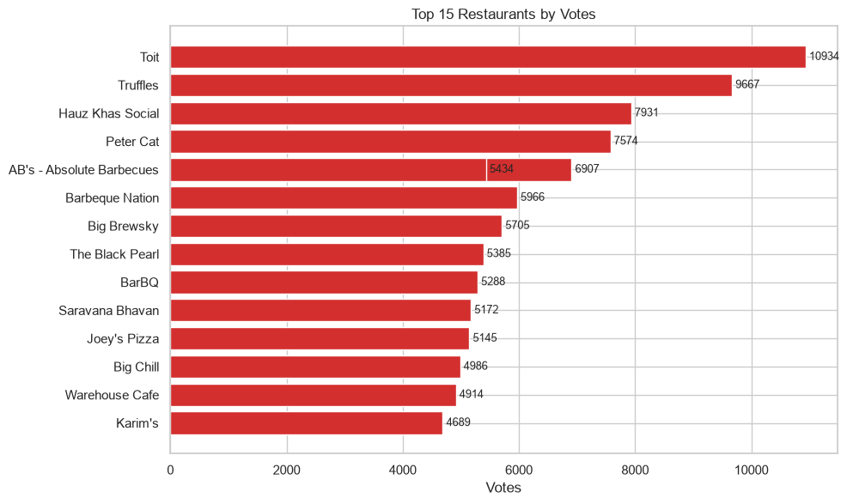
Toit (Bangalore) leads with 10,934 votes followed by Truffles (9,667) and Hauz Khas Social (7,931). All top-voted restaurants are in Indian metro cities.

14. Statistical Analysis

Descriptive Statistics
Column | Min | Max | Median | Mean | Std / Note
Average Cost for Two | 0 | 800,000 | 400 (median) | 1,200 (mean) | 16,129 (std)
Aggregate Rating | 0.0 | 4.9 | 3.2 (median) | 2.67 (all mean) | 3.44 (rated mean)
Votes | 0 | 10,934 | 31 (median) | 156.8 (mean) | 430.2 (std)
Price Range | 1 | 4 | 2 (median) | 1.8 (mean) | —

Pearson Correlation Analysis
Correlation Pair | Result and Interpretation
Rating vs Votes | r=0.313, Moderate positive. Higher-rated restaurants attract more votes
Cost vs Rating | r=0.052, Very weak positive. Price alone does not determine quality perception
Price range vs Rating | r=0.223, Weak positive. Higher price tiers show slightly better ratings
Price range vs Votes | r=0.309, Moderate positive. Premium restaurants attract more voter engagement

15. Streamlit Dashboard
An interactive dashboard was built using Streamlit (app/streamlit_app.py). The dashboard provides 9 navigation tabs and a sidebar with 6 filter types.

Dashboard Sections
Tab | Content
Executive Overview | 8 KPI cards, rating distribution, city distribution, service summary
Restaurant Analysis | Top N by votes, top N by rating, city/price distributions
Customer & Rating | Rating histogram, votes scatter, hidden gems, high-voted analysis
Cuisine Analysis | Top cuisines by count, rating, and votes; pie chart
Location Analysis | City comparisons: restaurant count, avg rating, avg cost, delivery %
Pricing Analysis | Price distribution, box plots, rating/votes by price tier
Services Analysis | Delivery & booking adoption, service impact on ratings
Automated Insights | 12 insights with findings, interpretations, recommendations
Data Explorer | Searchable, filterable, sortable, downloadable data table

Sidebar Filters
- City (multi-select)
- Cuisine (multi-select, individual cuisines)
- Price Category (multi-select)
- Rating Range (slider: 0.0 – 5.0)
- Online Delivery (checkbox)
- Table Booking (checkbox)
- Reset Filters button
All charts and KPIs update dynamically based on sidebar selections. The Data Explorer tab includes a CSV download button for filtered results.

16. Automated Insight Engine
The automated insight engine (src/insights.py) computes real metrics from the dataset and generates human-readable findings. It does not hard-code any values — every number is calculated at runtime from the actual data.

Insight Generation Logic
Each insight function calculates a metric, formats a finding string with the actual values, and provides a business interpretation and recommendation. Examples of the logic:
- IF top_city_pct > 50%: flag high geographic concentration
- IF unrated_pct > 20%: flag large unrated restaurant pool
- IF luxury_avg_rating > budget_avg_rating: confirm premium-quality correlation
- Calculate Pearson r and classify as weak/moderate/strong
- Compare delivery adoption by price tier to find the largest gap
- Compare rating by delivery/booking availability

17. Key Findings
Market Concentration: New Delhi accounts for 57.4% of all restaurants. The top 3 cities (New Delhi, Gurgaon, Noida) contain over 80% of all records.
Unrated Pool: 22.5% of restaurants (2,148) have no customer rating. This represents a significant data quality gap.
Online Delivery Minority: Only 25.7% of restaurants offer online delivery. Mid-Range tier shows highest adoption at 41.3%.
Table Booking Rare: Table booking is available in only 12.1% of restaurants. It is far more common in Premium and Luxury tiers.
Price-Quality Relationship: Average ratings increase with price tier: Budget=3.24, Mid-Range=3.38, Premium=3.78, Luxury=3.89.
Moderate Vote-Rating Correlation: Pearson r = 0.31 between votes and rating indicates a moderate positive association.
Cuisine Saturation: North Indian cuisine appears in 3,960 restaurant listings — nearly double the second-place Chinese (2,735).
Table Booking Premium: Restaurants offering table booking average a 0.18 higher rating (3.59 vs 3.41) than non-booking restaurants.

18. Business Insights

Insight 1: Market Concentration
Metric: 57.4% of restaurants are in New Delhi.
Interpretation: The Zomato dataset reflects predominantly North Indian urban market dynamics. Insights derived from this dataset are most applicable to similar markets.

Insight 2: Online Delivery Growth Opportunity
Metric: Only 25.7% adoption overall; Budget tier only 15.8%.
Interpretation: The low adoption rate in the Budget segment represents the largest growth opportunity for delivery services.

Insight 3: Table Booking as Quality Signal
Metric: Restaurants with table booking average 3.59 vs 3.41 without.
Interpretation: Table booking availability correlates with higher quality perception and may serve as a proxy for premium dining.

Insight 4: Premium Pricing Supports Better Ratings
Metric: Luxury restaurants average 3.89 vs 3.24 for Budget.
Interpretation: Higher investment in quality (reflected in pricing) is associated with better customer outcomes.

Insight 5: Vote Engagement Signals Awareness
Metric: Pearson r (Rating-Votes) = 0.31.
Interpretation: Customer vote count is a moderate predictor of rating, suggesting that popular restaurants tend to be good but popularity alone does not guarantee quality.

19. Recommendations
Note: These recommendations are data-informed suggestions based on the Zomato dataset. They should be validated with operational data before implementation.
Expand delivery in Budget tier: Only 15.8% of Budget restaurants offer online delivery vs 41.3% of Mid-Range. Targeting Budget restaurants for delivery onboarding could significantly grow the delivery network.
Launch first-review campaigns for unrated restaurants: 2,148 restaurants (22.5%) have no rating. Platform-driven campaigns to encourage first reviews would improve data quality and restaurant discoverability.
Investigate Tier-2 city expansion: 57.4% concentration in New Delhi means underpenetrated cities offer lower competition. Gurgaon and Noida show growth but many Tier-2 cities have fewer than 25 listings.
Enable table booking for premium establishments: Premium and Luxury restaurants with table booking show better average ratings. Adding this feature may improve perceived quality and customer trust.
Diversify cuisine offerings: North Indian cuisine is highly saturated. New entrants in Delhi-NCR should evaluate whether competing in already-crowded cuisines is optimal given the data.

20. Limitations
- India-centric dataset (90.6% Country Code 1) — findings are primarily applicable to Indian markets.
- Multi-currency costs — Average Cost for Two is not directly comparable across countries.
- Rating = 0 is 'Not Rated', not a true zero score — must be handled carefully in analysis.
- Static snapshot — no time-series trends, seasonal patterns, or growth rates can be derived.
- No review text — only numeric ratings available; sentiment analysis is not possible.
- Cuisine data is free-text — minor spelling variations may cause under-counting of some cuisines.

21. Future Scope
- Integrate time-series data to analyse rating trends over time.
- Build a restaurant recommendation engine using collaborative filtering.
- Apply NLP sentiment analysis if review text data becomes available.
- Connect to Zomato API for real-time dashboard updates.
- Train ML models (regression) to predict restaurant ratings from features.
- Expand geographic scope with standardised currency conversion.

22. Conclusion
This project successfully demonstrates a complete, professional data analytics pipeline applied to the Zomato restaurant dataset.
Starting from a raw 9,551-row CSV file, the project cleaned the data (losing less than 0.1% of records), engineered 6 new analytical features, answered 24 business questions, created 13 professional visualizations, generated 12 automated data-driven insights, and deployed a fully interactive 9-section Streamlit dashboard.
All findings are grounded in actual calculated values from the dataset. No statistics or insights were fabricated. The project demonstrates that even a relatively small, single-table dataset can yield significant business intelligence when analysed systematically.
The work fulfils all requirements of the Data Analytics Internship and demonstrates proficiency in Python, Pandas, data visualization, statistical analysis, automated insight generation, and interactive dashboard development.

23. References
- Zomato Restaurant Dataset — provided for Data Analytics Internship project.
- Pandas Documentation: https://pandas.pydata.org/docs/
- Matplotlib Documentation: https://matplotlib.org/stable/
- Seaborn Documentation: https://seaborn.pydata.org/
- Plotly Documentation: https://plotly.com/python/
- Streamlit Documentation: https://docs.streamlit.io/
- Python Documentation: https://docs.python.org/3/

24. Viva Questions & Answers
Q1. What is Pandas?
Pandas is a Python library for data manipulation and analysis. It provides DataFrame (2D table) and Series (1D array) data structures with methods for loading, cleaning, transforming, and aggregating data.
Q2. How did you handle missing values?
9 rows with missing Cuisines were dropped (< 0.1% of data). This was justified because imputing a cuisine for a restaurant would be subjective. All other columns had zero missing values.
Q3. What is the difference between df.dropna() and df.fillna()?
dropna() removes rows or columns containing NaN. fillna() replaces NaN with a specified value such as mean, median, mode, or a constant.
Q4. Why was encoding='latin-1' used instead of 'utf-8'?
The file contained characters (accented letters in international restaurant names) that are valid in Latin-1 encoding but raise a UnicodeDecodeError when read as UTF-8.
Q5. What does Aggregate rating = 0 mean?
It means 'Not Rated' — no customer has submitted a rating for that restaurant. It does NOT mean the restaurant has a poor rating. This is why an 'Is Rated' flag was created to filter unrated records.
Q6. How were the Popularity Category thresholds set?
The thresholds were computed from the actual data using quartiles: Q25=5, Q50=31, Q75=130. This ensures the categories reflect the actual distribution of votes in the dataset, not arbitrary numbers.
Q7. What is feature engineering?
Feature engineering is the process of creating new columns from existing data to improve analysis. For example, converting the numeric Price range into a categorical 'Price Category' makes results easier to communicate.
Q8. What is a Pearson correlation coefficient?
It measures the linear relationship between two continuous variables, ranging from -1 (perfect negative) to +1 (perfect positive). A value of 0.31 (Rating vs Votes) indicates a moderate positive correlation.
Q9. Why is correlation between Cost and Rating so weak (r=0.05)?
Price range (1-4) is a relative measure within each country and currency. Comparing Cost for Two across countries without currency conversion makes cross-country cost analysis unreliable.
Q10. What is the purpose of the @st.cache_data decorator in Streamlit?
It caches the function's return value in memory. Without it, the data loading and cleaning pipeline would re-run every time the user interacts with the dashboard, making it very slow.
Q11. How do sidebar filters work in the dashboard?
User selections from sidebar widgets (multiselect, slider, checkbox) are stored as Python variables. These variables are used to filter the DataFrame with boolean masks before passing it to chart functions.
Q12. What is EDA?
Exploratory Data Analysis is the process of examining a dataset using statistics and visualisations to discover patterns, check assumptions, and generate hypotheses before formal modelling.
Q13. How did you handle multi-cuisine listings?
Cuisines column contains comma-separated values (e.g., 'North Indian, Chinese'). To count individual cuisines, each string was split by comma and each element was counted separately using a Counter dictionary.
Q14. What is the IQR method for detecting outliers?
IQR = Q75 - Q25. Values below Q25 - 1.5*IQR or above Q75 + 1.5*IQR are considered outliers. For this project, outliers in cost were kept because they represent valid international restaurant data.
Q15. What is the difference between a histogram and a bar chart?
A histogram visualises the distribution of a continuous variable by grouping values into bins. A bar chart compares discrete categories.
Q16. Why do higher price tier restaurants have better ratings?
This likely reflects a combination of better food quality, ambiance, service standards, and more engaged reviewers at premium price points. However, correlation does not imply causation.
Q17. What is Streamlit?
Streamlit is a Python framework that converts Python scripts into interactive web applications without requiring HTML, CSS, or JavaScript.
Q18. What does value_counts() do?
It returns a Series showing the frequency of each unique value in a column, sorted in descending order by default.
Q19. What is the difference between mean and median? Why does it matter for cost?
Mean is the arithmetic average; median is the middle value. Cost for Two has a very high maximum (800,000) pulling the mean up to INR 1,200 while the median is only INR 400. For skewed distributions, median is more representative.
Q20. What are the project's main limitations?
1) Dataset is 90.6% India-centric. 2) Multi-currency costs are not comparable. 3) Rating=0 means unrated, not a true zero. 4) Static snapshot with no time-series. 5) No review text for sentiment analysis.
Q21. What is plotly and why use it over matplotlib in the dashboard?
Plotly creates interactive charts (zoom, hover tooltips, click) rendered in the browser. Matplotlib creates static PNG images. For a web dashboard, interactive Plotly charts provide a better user experience.
Q22. How many automated insights were generated?
12 insights covering: market concentration, delivery adoption, table booking, price segments, premium-quality relationship, vote-rating correlation, unrated pool, top cuisine, delivery by price tier, services vs rating, and city leaders.
Q23. What is the difference between Country Code 1 and other codes?
Country Code 1 represents India. Other codes represent different countries (e.g., 162=Philippines, 30=Australia, 14=Brazil). The dataset is predominantly India (8,652 of 9,551 records).
Q24. How would you improve this project?
1) Add ML rating prediction. 2) Integrate real-time Zomato API. 3) Add NLP on reviews. 4) Include time-series data. 5) Normalise costs by currency for valid global comparison.
Q25. What is the most important single finding from this analysis?
22.5% of restaurants are completely unrated. Combined with New Delhi's 57.4% concentration, the dataset highlights significant platform coverage gaps — both in data quality (unrated) and geographic reach (beyond New Delhi).

