Group 09
Au Tsz Kin, Cheung Kei Yau, Lau Ming Yin, Lee Yin Lam Elaine

COMP2432 Operating Systems

Smart Parking Management System (SPMS) Project Report
Abstract— The Smart Parking Management System (SPMS), which makes use of operating system scheduling algorithms, aims to transform the traditional parking management system. This project addresses the increasing challenges of resource management and parking space distribution in the past 10 years. A priority-based scheduling mechanism included in the system optimizes booking management, ensuring that high-priority events and reservations are given priority over regular parking requests. The system includes booking, scheduling timetable, printing schedule, as well as generating summary reports. System call functions, fork() and pipe() are used to enable inter-process communication, which enhances the program’s responsiveness and makes it easier to manage concurrent booking requests. The report allows staff to compare different schedules and determine which of the three parking spaces would be most useful. By simulating real-world scenarios, SPMS demonstrates the possibility for enhanced reservation process and boost PolyU's income from member rentals of these spaces in parking services.

INTRODUCTION
The Hong Kong Polytechnic University (PolyU), an educational institution, faces an issue with their parking management system, which was developed 10 years ago, while the varied student body, faculty and staff need convenient access to on-campus parking facilities. The existing parking management system has become outdated and inflexible, resulting in the limited number of parking spaces on campus being underutilized. The present system is essential to be improved to better serve its members and allocate resources effectively, as there are only 10 parking spaces that can meet the demands of an expanding community.

Apart from parking, PolyU offers necessary amenities in pairs to improve user experience – such as batteries with cables, lockers with umbrellas, and inflation services with valet parking. However, the current reservation system is not equipped to handle these paired essentials alongside parking. The entire request is denied if any portion of the request is unavailable, leaving users dissatisfied and underutilizing the system.

The objective of the system is to implement a more flexible scheduling and rescheduling system that can handle individual bookings as well as offering alternative options when certain items are unavailable. The updated system aims to maximize booking efficiency, user experience, and parking spot rental income by integrating scheduling algorithms learned in the field of operating systems into a real-world scenario.

Scope/Related work
The objective of scheduling algorithms is to optimize resource usage, minimize turnaround time, and maximize throughput by allocating CPU time to different processes. Inter-process communication via system calls fork() and pipe().
This project implements a multi-process booking and scheduling system using pipes for inter-process communication (IPC) and fork to create child processes. The system is designed to handle various types of bookings, such as parking, reservations, events, and booking essentials, while ensuring proper scheduling and resource allocation. The core of the system revolves around the Booking and forPri structures. The Booking structure stores details about each booking, such as the type, member name, date, time, duration, and requested facilities. The forPri structure is used for scheduling purposes and includes fields like booking type, day, start time, duration, facilities, and a unique booking ID. These structures allow the system to manage and prioritize bookings effectively.
The project uses a timetable array to track the availability of resources, such as parking slots and facilities, across multiple days and hours. Functions like checkavailability and updatetimetable ensure that no two bookings overlap in the same timeslot. The checkavaADDON function handles edge cases, such as bookings that span multiple days. The system supports two well-known scheduling algorithms: First-Come First-Served (FCFS) and priority-based scheduling, and an optimized scheduling algorithm designed by us. FCFS processes bookings in the order they are received, while the priority-based algorithm accepts bookings by their type before scheduling.
In addition, the parent process communicates with child processes using pipes. Each child process is responsible for managing the bookings of a specific member. The parent sends scheduling commands (e.g., fcfs, prio or opti) and booking IDs to the child processes, which process these commands, update their local accept/reject lists, and send responses back to the parent. Functions like displayaccept and displayreject retrieve and display the accepted and rejected bookings for each member by communicating with the child processes. The parent sends the commands, and the child processes respond with the booking IDs of the accepted or rejected bookings.
The project also includes a batch processing feature, allowing bookings to be loaded from a “.dat” file using the addBatch function. This function parses the file, extracts booking details, and adds them to the system. Static arrays are used for storing bookings, timetables, and buffers, simplifying memory management but requiring careful handling to avoid exceeding predefined limits. Proper resource cleanup is implemented using close() for pipes and waitpid() for child processes.

CONCEPT
The project mainly focuses on the scheduling algorithms that have been commonly used in modern operating systems. The performance report, performed by inputting the command printBookings –[fcfs/prio/opti/ALL], provides an overview of the number of bookings that are received, distributed, and ultimately rejected based on the algorithm used.

First-Come-First-Served (FCFS)
The FCFS algorithm serves processes in their arrival order, i.e. the earliest process will be assigned the resource first. In our system in which this algorithm is implemented, the bookings made earliest will be considered first; hence they will be assigned the desired slots.

If a long-running request arrives first, all subsequent requests must wait until the long one completes. The phenomenon is known as Convoy Effect. Its non-preemptive feature led to a single long process being blocked by numerous processes, causing shorter tasks to remain idle in the queue.

Priority Scheduling (Prio)
The bookings will be considered in the following decreasing order of priority rank: events, reservations, parkings and essentials. Bookings with higher priority rank will be considered the most important. For instance, “events” have the highest priority, they can replace an occupied time slot made with “reservations.”

The limit for this algorithm is starvation, where low-priority tasks may never get executed if there are any higher priority requests that repeatedly coming. A higher priority request may occasionally wait for a lower priority request to release an essential. This is known as priority inversion. Conflict over resources and delays may result from this circumstance. For example, if there is only no battery left, and a member is using a battery for 3 hours, while there is another booking event for 1 hour requesting battery and cable, it is impossible to accept the event booking as no battery is available.

Both well-known algorithms suffer from notable drawbacks which impact the system performance negatively. The following section will discuss our own optimized scheduling algorithm considering the problem.

OUR OWN SCHEDULING ALGORITHM
Our optimized algorithm, executed by the command opti, follows similar idea of priority scheduling but with different considerations. Priority is given based on the order of (i) smaller facility count (facility_count) and (ii) shorter duration time.

The idea is to obtain a higher hit rate for the booking requests. Therefore, we consider smaller facility counting for higher priority, then shorter durations as second. In this case, more essentials can be freed for other requests in a quicker time. We decided to use the smaller facility count as the most significant factor because of the consideration of any possible requests with a shorter duration yet higher facility needed. This will cause a bottleneck situation in which several more requests will be rejected only due to this single request.

SOFTWARE STRUCTURE OF OUR SYSTEM
Our project is divided into four modules, namely the input, scheduling, output and analyzer modules.

For the input module, an infinite while-loop is used for standard input, which will only stop if the user input endProgram. Users are allowed to add details of a booking to the schedule, including booking type, name, date, time, duration, and/or essentials, etc. Another way to add bookings is to import batch files, which contain details of the booking requests.

For the scheduling module, timetables for all bookings will be generated according to different scheduling algorithms by staff’s choice, including FCFS, priority, and optimized scheduling algorithm.

For the output module, a booking schedule for available parking slots, plus related additional facilities will be printed. This includes a list of accepted and rejected booking requests.

For the analyzer module, a summary report will be generated based on the results done by different scheduling algorithms. The results will be compared to discover which scheduling algorithm has made the best use of the parking resources, showing detailed information about total requests, as well as allocation percentages of facilities.

The following figure shows the system structure:

Input module
Output module
Analyzer module
Scheduling module

1. Sorting
Valid requests will be passed on to the corresponding sorting functions as shown below:

First-Come-First-Served sort (fcfssort)
This sorting function organizes the booking requests based on the booking ID in ascending order, which means that the bookings are processed in the order they were added. Bubble sort is implemented to compare adjacent requests and swap their order when needed.

Priority sort (priosort)
This sorting function organizes the booking requests based on the booking type and the booking ID. The priority rank is of the following from highest to lowest: (i) events, (ii) reservations, (iii) parkings, and (iv) essentials. A combined priority value is calculated (type*1000 + bookingid) and compared against each other using bubble sort.

Optimized sort (optisort)
This sorting function organizes the booking requests based on the facility count, duration and booking ID. Bookings with fewer facilities, then shorter durations are prioritized to maximize the hit rate for requests. A combined priority value (facility_count*1000 + duration*100 + bookingid) is compared against each other using bubble sort.

Time sort (timesort)
This algorithm is used to prepare the forPri list and sort the booking requests in ascending order of date and time, using bubble sort to swap adjacent bookings. It is important for all three algorithms to have their outputs printed in ascending order.
2. Check availability of time slot
The function, checkavaADDON, checks if a specific time slot is available during the given date, time and facility type. The request will be passed on to the accept list, which is sorted by time. After processing all booking requests in the execution, those not accepted will be considered “rejected.”
After the user prints the output using the printBookings() function and requests another booking afterwards, the original child will be killed, and another child will be created by parent to maintain consistency. The process is done by createchild().
3. Summary Report
The summary report, performed by printBookings -ALL, will be saved to SPMS_Report_G09.txt, and the file will appear in the Apollo server.

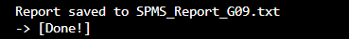
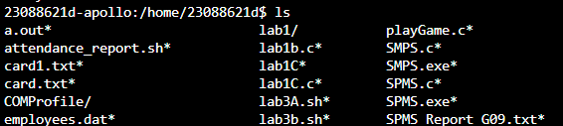

4. User interaction
The input function processes user commands that allow to add booking requests, such as addParking, addReservation, addEvent and bookEssentials. Users are allowed to view current accepted and declined bookings through executing the printBookings command, as well as the usage percentage of each facility.

ASSUMPTIONS/ TESTING CASES

Assumptions
According to the requirements, the following assumptions are made for the system:
- Inputs are assumed to be all correct, i.e. no typos made by users, for example, “cabal” instead of “cable”. Users will be prompted to input their request again if not.
- The components available in SPMS include:
  - five members – member_A, member_B, member_C, member_D and member_E.
  - three lockers
  - three umbrellas
  - three batteries
  - three cables
  - three valet parkings
  - three inflation services
Where for valet parking and inflation service facilities, the commands are “valetpark” and “inflationservice” respectively.
- Each time slot represents one hour, resulting in a total of 24 time slots per day.
- There are only 3 parking spaces.
- The booking priority in priosort will be in the following decreasing order:
(i) Events;
(ii) Reservations;
(iii) Parking requests;
(iv) Essentials.
- Booking duration will be rounded up to nearest integer, for example, when the user input is 2.5, 3 hours of time slot will be assigned.
- Requests from batch file does not need to follow the format of input command. Such includes the member field does not require hyphen (-) and semi-colon (;).

Testing Cases
We have two ways to test the system’s correctness as the user can import a batch file and/or directly type the request.

The dataset in test_data_G09.dat contains 277 requests with different natures. It is assumed that all requests in the file are all correct. The large sample size allows us to check both accept and reject cases and performances of the three scheduling algorithms.

To ensure the correctness of rejected cases and compare the results of the three modes, it is impossible to check by only typing inputs in the command line since it is challenging to create a large dataset with this method. We test by having the batch file and use input together, to check if both input modules work normally and display the result correctly. The testing results are discussed in the next section.

For user input testing, we test to have 4 bookings with same type and essential, starting at the same date and time but ending differently, so that the number of essential facilities would not exceed and one of the bookings is rejected. Here is our testing input and its results:
-------------------------------------------------------------------------
bookEssentials -member_A 2025-05-09 10:00 3.0 locker;
addParking -member_A 2025-05-09 10:00 3.0 locker umbrella;
addReservation -member_A 2025-05-09 10:00 3.0 locker umbrella;
addEvent -member_A 2025-05-09 10:00 3.0 locker umbrella;
--------------------------------------------

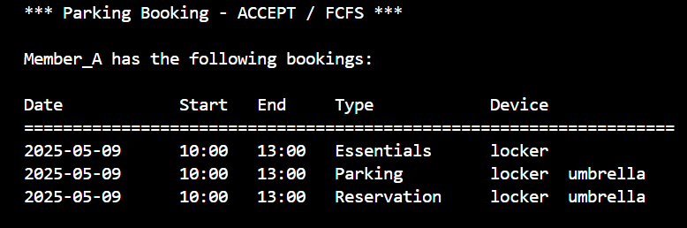
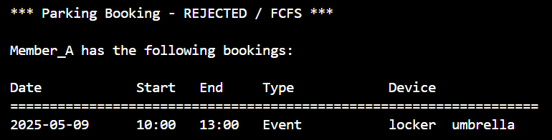

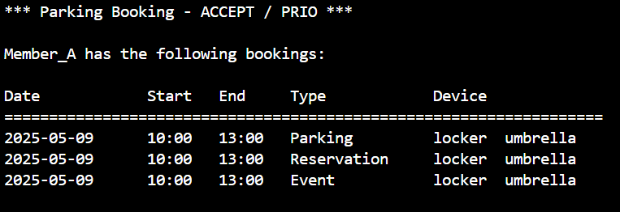
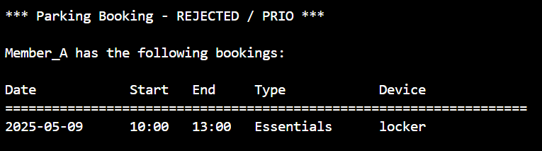

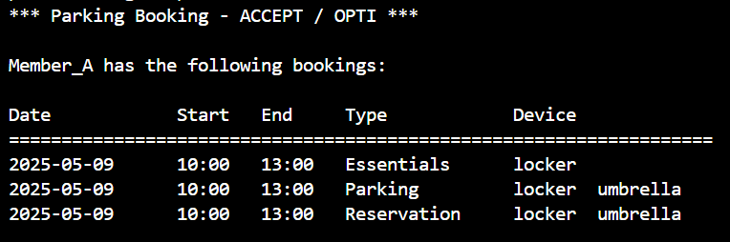
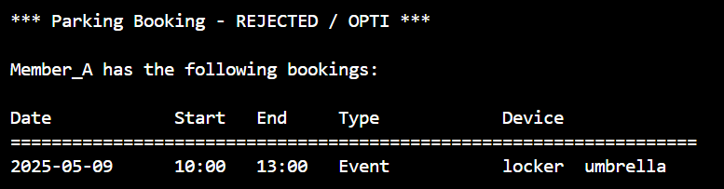

Another input test is to have 4 bookings starting at the same date and time but ends differently, also having 2 booking types and 2 sets of number of essentials, so that the optimized algorithm is tested, and we expected the second request is rejected. Here is our testing input and its results:
-------------------------------------------------------------------------
addParking -member_A 2025-05-20 14:00 1.0 battery cable locker;
addParking -member_A 2025-05-20 14:00 2.0 battery cable locker;
addReservation -member_A 2025-05-20 14:00 3.0 battery cable;
addReservation -member_A 2025-05-20 14:00 1.0 battery cable;
--------------------------------------------

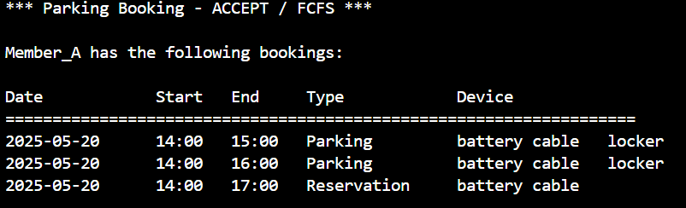
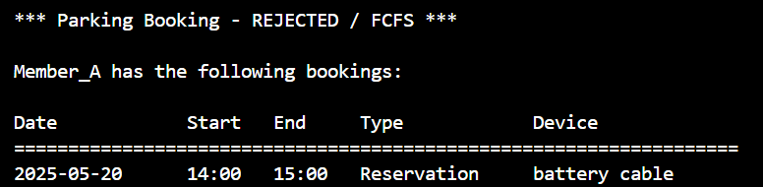

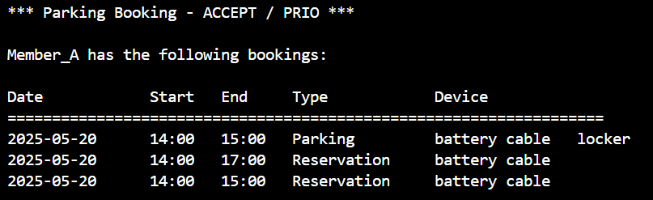
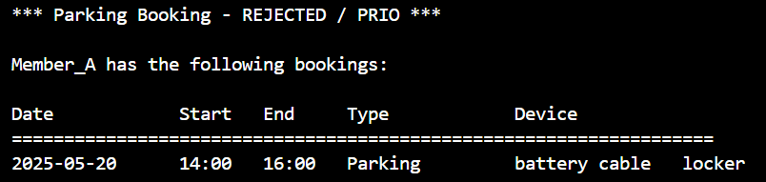

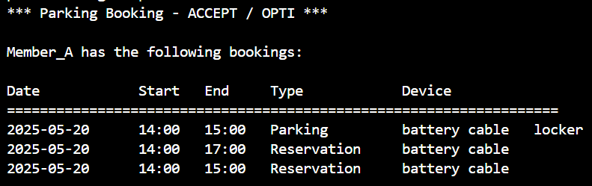
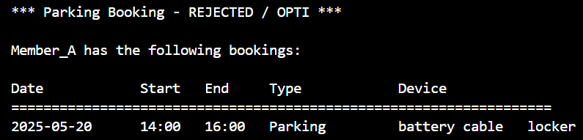

To check the correctness of the optimized algorithm, we have 6 bookings starting at the same date and 5 of them start at the same time but end differently. Also have 2 booking types so that bookings for the longest duration are rejected. Here is the input and its results:

-------------------------------------------------------------------------
addEvent -member_A 2025-05-09 14:00 5.0 locker umbrella;
bookEssentials -member_A 2025-05-09 14:00 3.0 locker;
addEvent -member_A 2025-05-09 14:00 2.0 locker umbrella;
addEvent -member_A 2025-05-09 14:00 1.0 locker umbrella;
bookEssentials -member_A 2025-05-09 14:00 1.0 locker;
bookEssentials -member_A 2025-05-09 15:00 2.0 locker;
--------------------------------------------

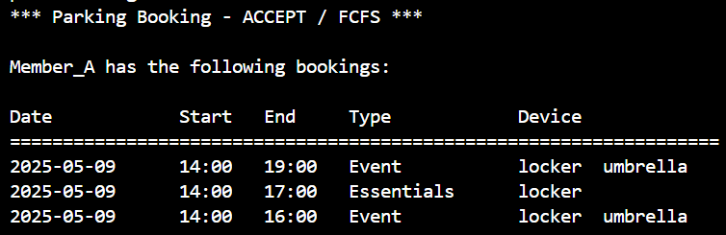
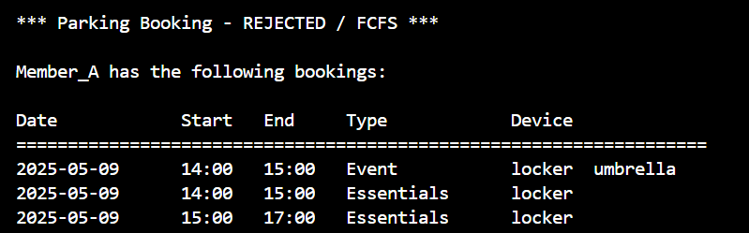

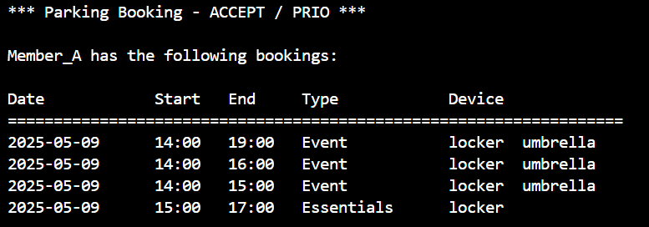
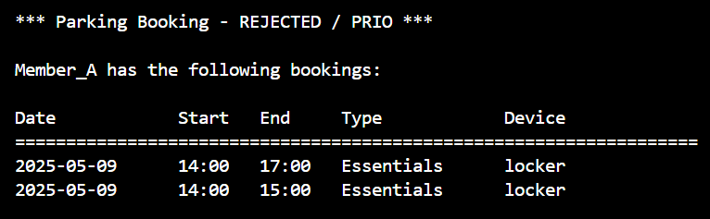

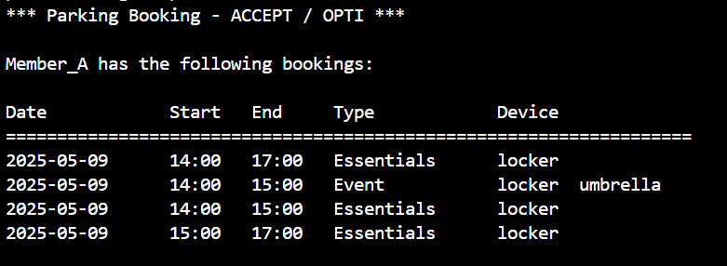
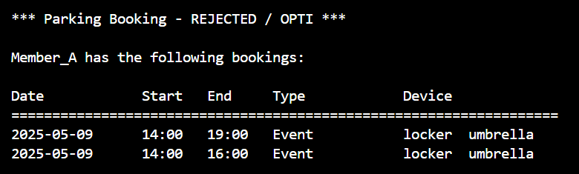

PERFORMANCE ANALYSIS
The dataset that we used for performance analysis is the data in file test_data_G09.dat, where it contains 56 events, 60 reservations, 79 parking and 82 essentials. The number of essentials request is as follows:
  - 57 lockers
  - 57 umbrellas
  - 155 batteries
  - 95 cables
  - 55 valet parkings
  - 55 inflation services

FCFS
The algorithm ranks the last. FCFS does not consider the duration or number of essentials remaining but only considers the arrival time of the requests. In our dataset, many members request for battery only, while other types of requests may have the essentials equipped with others, resulting in a very low utilization of cables and thus requests with battery and cables are rejected.

Priority
The algorithm performed equally to the optimized algorithm with an assigned rate of 60.29%. Its standard deviation between different facilities is about 1.992. It is observed that numerous essentials bookings are rejected and mostly event bookings are assigned. This implies members may get no chance to request essentials due to its low priority rank.

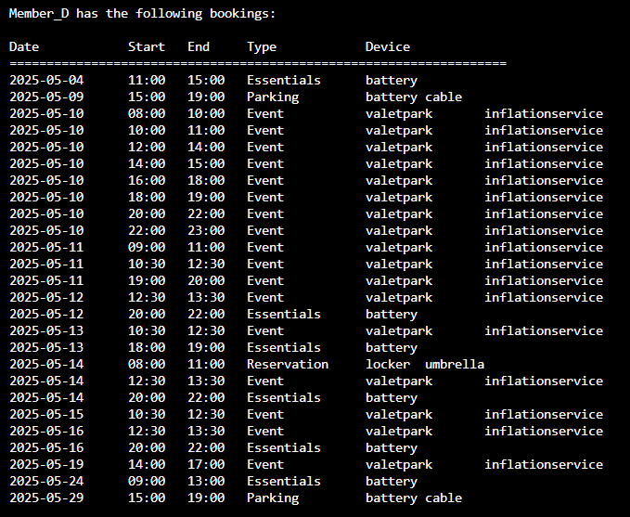
Screenshot of accept bookings in priority scheduling.

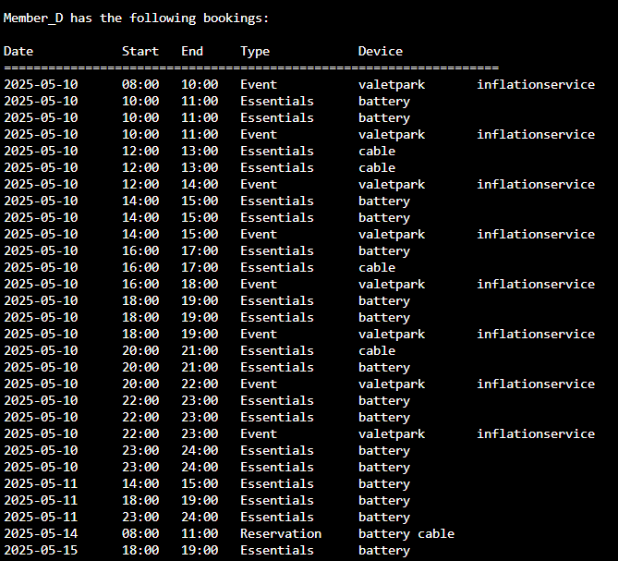
Screenshot of reject bookings in priority scheduling.

Optimized
The optimized algorithm achieved a tie in performance with the priority algorithm. The standard deviation of the utilization between different facilities is 1.85, which is less than that of the priority algorithm. This means that it can achieve a more evenly usage of facilities. The weak point of this algorithm is the tiebreaking of both criteria. If there are same number of facilities count and same duration, the algorithm accepts requests in the first-come-first-served basis.

PROGRAM SET UP AND EXECUTION
The operating system-related library <unistd.h>, is supplied for process management like fork(), pipe(), getpid() for creating inter-process communication, low-level I/O such as read(), write() and close(), and sleep functionality sleep(). It is specific to Unix-like operating systems.

<stdlib.h> provides various functions for memory management like memory allocation, process control, and conversion, including malloc(), free(), as well as for conversion of strings to numbers like atoi().

<string.h> is used for manipulating string variables and inputs, for instance, strcmp() compares user input with pre-defined values, strcpy() is used to copy required data into arrays, while strtok() is used to split the input string into different variables.

<stdbool.h> can be used to perform boolean operations. It defines the boolean data type in C, so that various lists and arrays can function properly with boolean values available. It is used in childcreated and acceptlist.

To compile the project, please ensure that the gcc or cc compiler is configured to support the C99 standard. Start the program by typing ./SPMS and a welcome message will be shown on the screen. If you wish to import a batch file for one or more requests, please upload the file as a plain text document to apollo in the same directory. To end the program, type endProgram in the terminal. For proper execution, it is recommended to restart the program if there are any errors in the commands input. A text file (.txt) will be saved to your working directory if you input the command printBookings -ALL for a summary report on the performance of different algorithms.

RESULTS DISCUSSION
It is observed that both prio and opti performed equally better than fcfs in terms of accept rate, but opti has a more evenly distributed usage of facilities.

The testing cases given can achieve the expected results, and the program is able to handle the input commands and generate the output and analyze files as required.

Conclusion

In a nutshell, our program for the smart parking scheduling system is effective. Our code can fully meet the project requirements and is adequately stable to handle the tasks of input parsing, scheduling, output generation, and analysis exporting.

