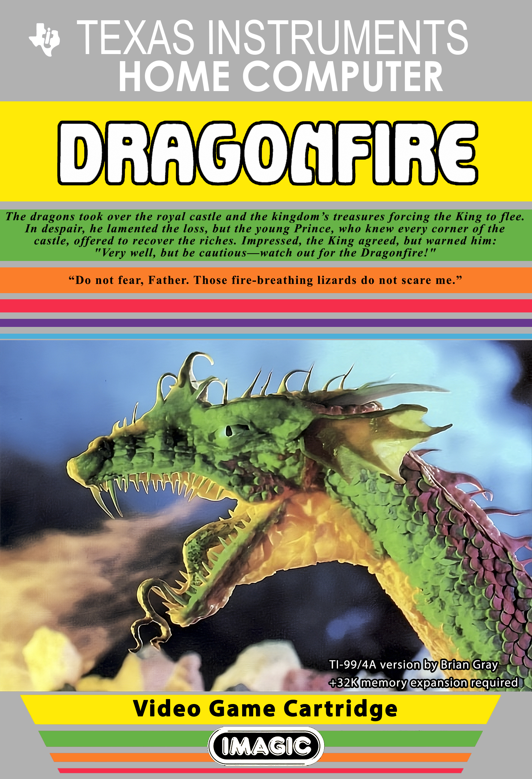
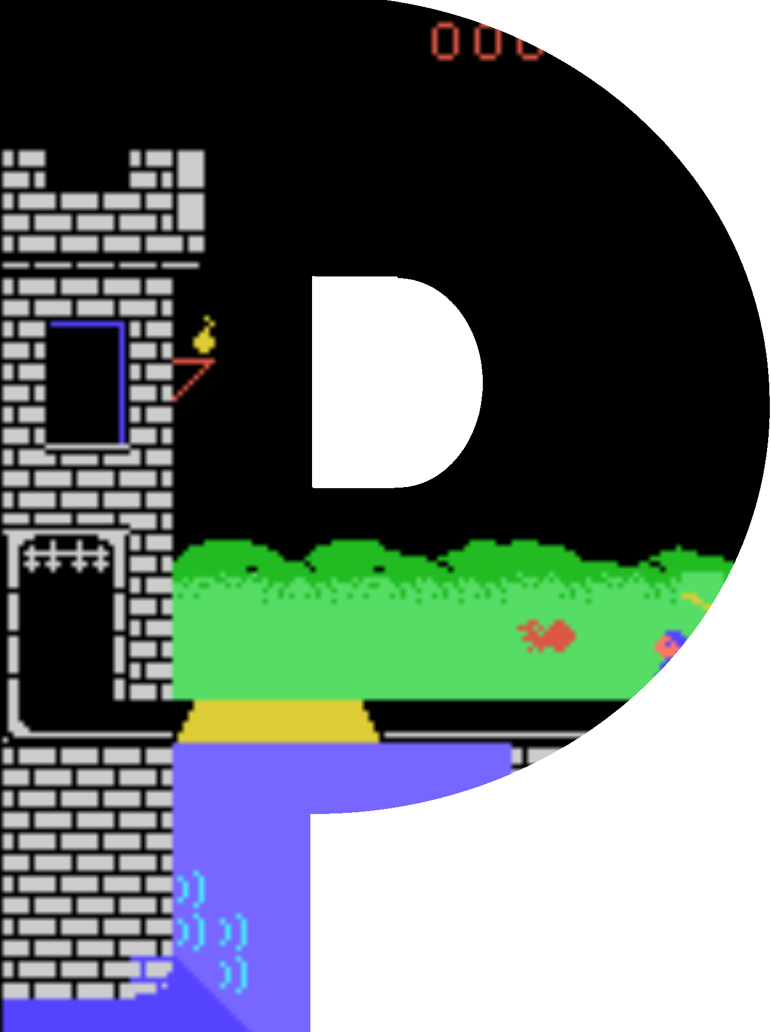

rince Pip and the Dragons.

Dragons have driven the Royal Court from the castle! Without his vast treasures, the king cannot raise an army to defeat the scaly, fire-breathing invaders. His kingdom is ruled by lizards. Yet the young Prince Pip knows the castle’s many bridges and storerooms better than anyone throughout the kingdom. He plots to loot the dragons of their plunder and regain the palace. “Brave boy,” trembles his father, the king, as the prince leaves for the ramparts. “Please I beg for the sake of those who love you. Beware the dreaded dragonfire!”

Game Objective

Guide Prince Pip across the castle bridges and into the royal storerooms. Avoid all dragonfire, trolls, archers and pitfalls along the way.

Collect storeroom treasures and head for the exit once you have obtained them all. The next level will begin on a new bridge with greater obstacles.
Game Setup

Insert the Dragonfire game cartridge into the loading bay of the TI99/4A home computer and power on the system. Press any key to move beyond the TI99/4A startup screen.

The cartridge menu should appear on screen. If the menu does not appear, power off the computer and then restart after waiting several seconds.

The cartridge menu will have two options.
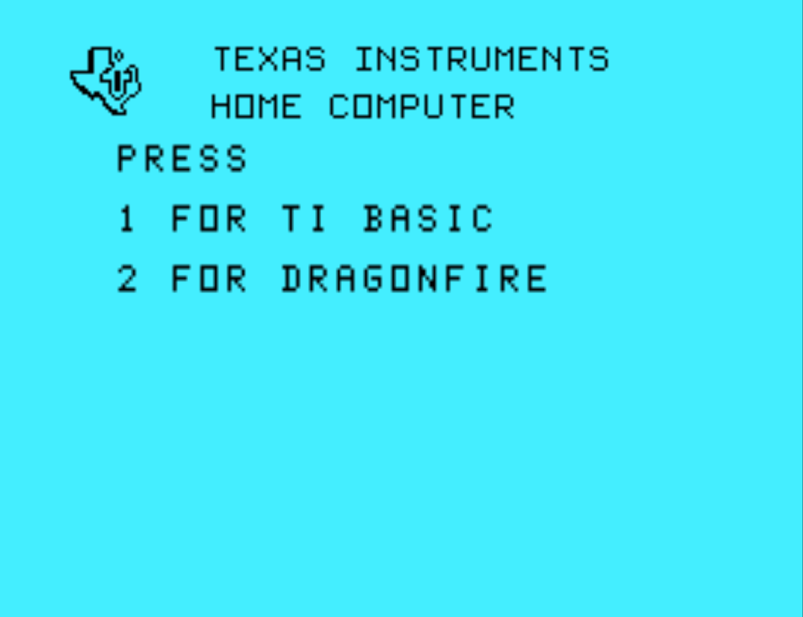
Press the ‘2’ key to select the Dragonfire game. The title screen with in-cartridge game instructions will appear.

The game’s description and instructions will automatically scroll through the lower black text box. To advance the instruction text, press the space bar.

Instruction display will repeat upon completion. To to begin the game, press the ‘Q’ key at any time. The title screen will clear and the game play screen will appear.
Game Play

Guide Prince Pip over the castle bridges and into the treasure storerooms located within the castle towers to collect the kingdom’s stolen treasures.

Dash, duck and jump to avoid all dragon fireballs, archer arrows, trolls and pitfalls. Collect all treasures from the dragon’s lair to advance to the next level.

Game Items

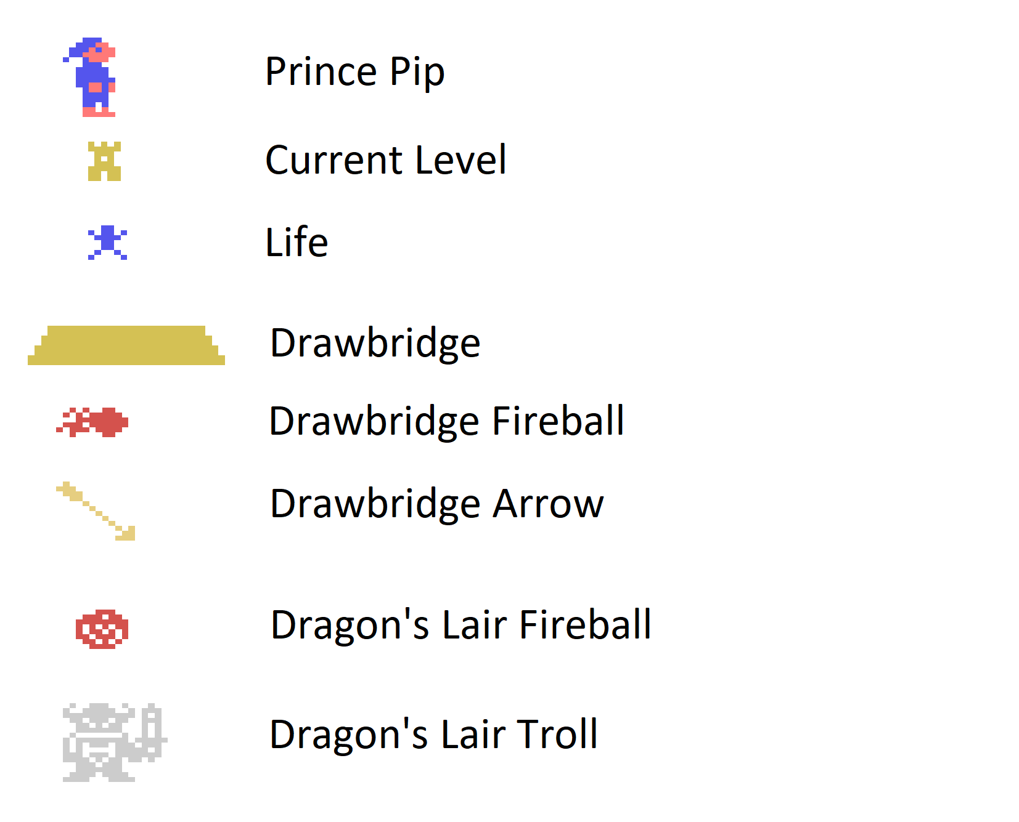
Levels

Each level consists of two distinct screens - a drawbridge screen and a dragon’s lair screen. Completion of each screen in succession is required to advance to the next level.

Drawbridge Screen

Avoid the dragon’s fireballs and archer’s arrows as you guide Pip to the tower entrance. Mind the drawbridge gap along the way or you will fall into the castle’s moat.

Dragon’s Lair Screen

Avoid the dragon’s fireballs as you collect the treasures strewn about the room’s floor. Once all treasures are collected, the door at the top of the screen will open and allow Pip to advance to the next level.

As Pip advances in the game, the game will become progressively more difficult with more and faster fireballs, an arrow and troll.
Scoring

Points are scored by collecting treasures found in the dragon’s lair (screen 2). Collect a treasure by positioning Prince Pip over the item on screen. A tone will sound, the treasure will disappear while your score increases.

Item Points

Bonus points are scored when the current screen is completed within the allotted time. The quicker the screen is completed, the more bonus points are awarded upon completion of the screen

Play Mechanics

Use the TI99/4A compatible joystick controllers to move Prince Pip on the play screen.

Screen 1: Drawbridge

Pushing the joystick left will move Pip towards the left tower entrance. Pushing the joystick right moves Pip towards the right tower entrance. Pushing down on the joystick causes Pip to duck.

The joystick button will cause Pip to jump. Pushing the joystick left or right and pressing the joystick button at the same time, causes Pip to jump in the direction of the joystick (left or right).

Screen 2: Dragon’s Lair

Pushing joystick in any direction moves Pip in that direction. There is no duck or jump for Screen 2.

The troll can be defeated by attacking on his unarmed side. A bonus of 1000 points is awarded for defeating the troll.

Credits

Original game produced by IMAGIC, (1982)

Game design by Bob Smith, (1982)

TI99/4A Dragonfire port by Brian Gray, (2025)

Special thanks to Ciro Barile and www.ti99iuc.it

Thanks to AtariAge and the TI99/4a Community

Software is distributed free of charge




