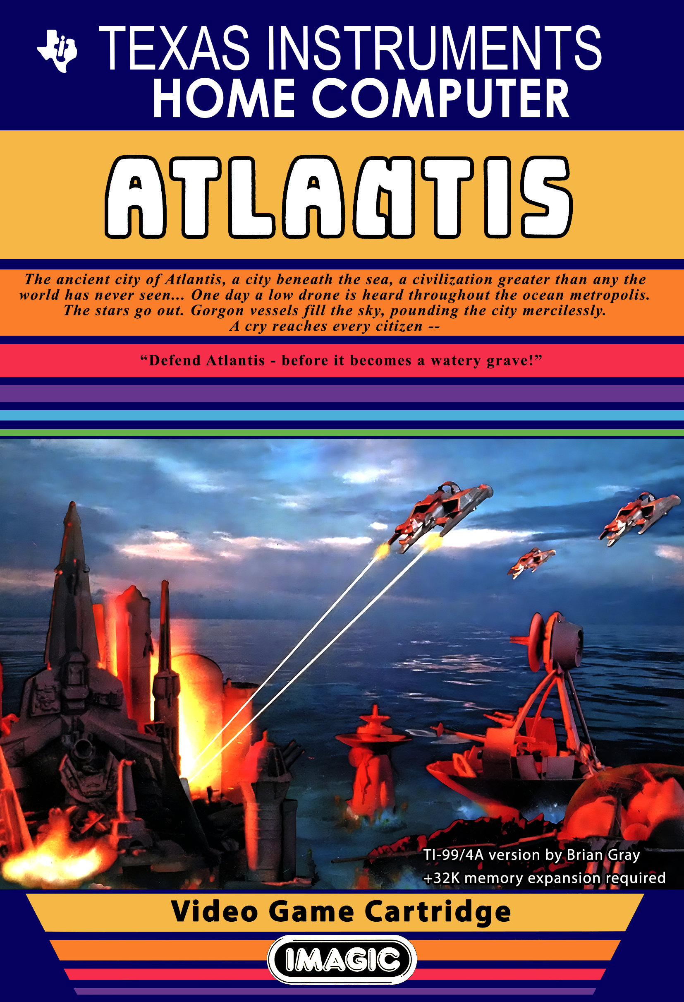
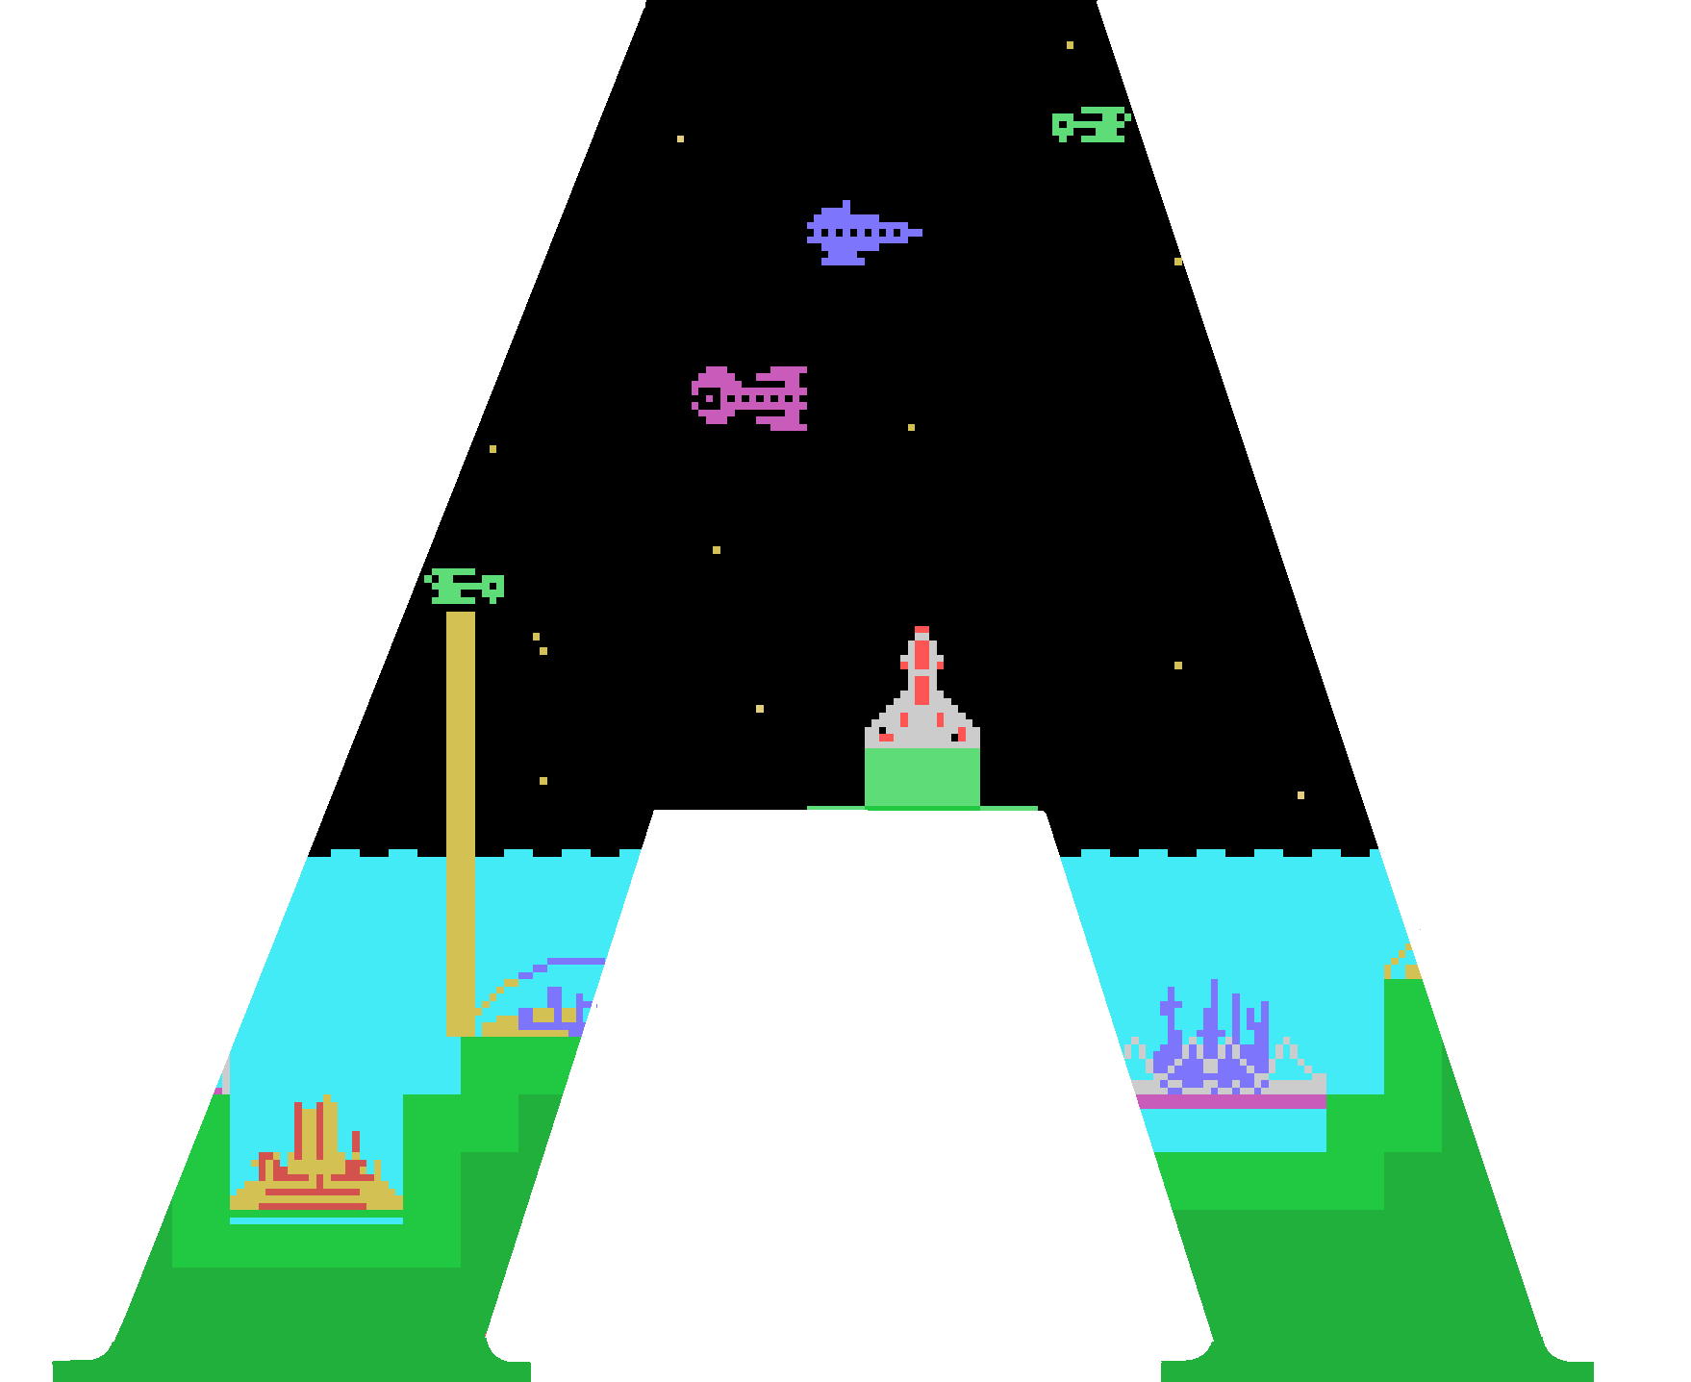

tlantis and the Gorgon Fleet.

Atlantis, the fabled city of antiquity, lies in peaceful waters. The major districts of the city – the Aqua Plain, the Domed Palaces and the Bridged Bazaar – murmur with activity while the vital generators whirl. Three defense posts guard the skies over the metropolis.

Game Objective
Defend Atlantis! Blast Gorgon vessels before they come close enough to demolish Atlantis with the Deathray. Survive each attack wave to replace parts of the city the Gorgons have hit.
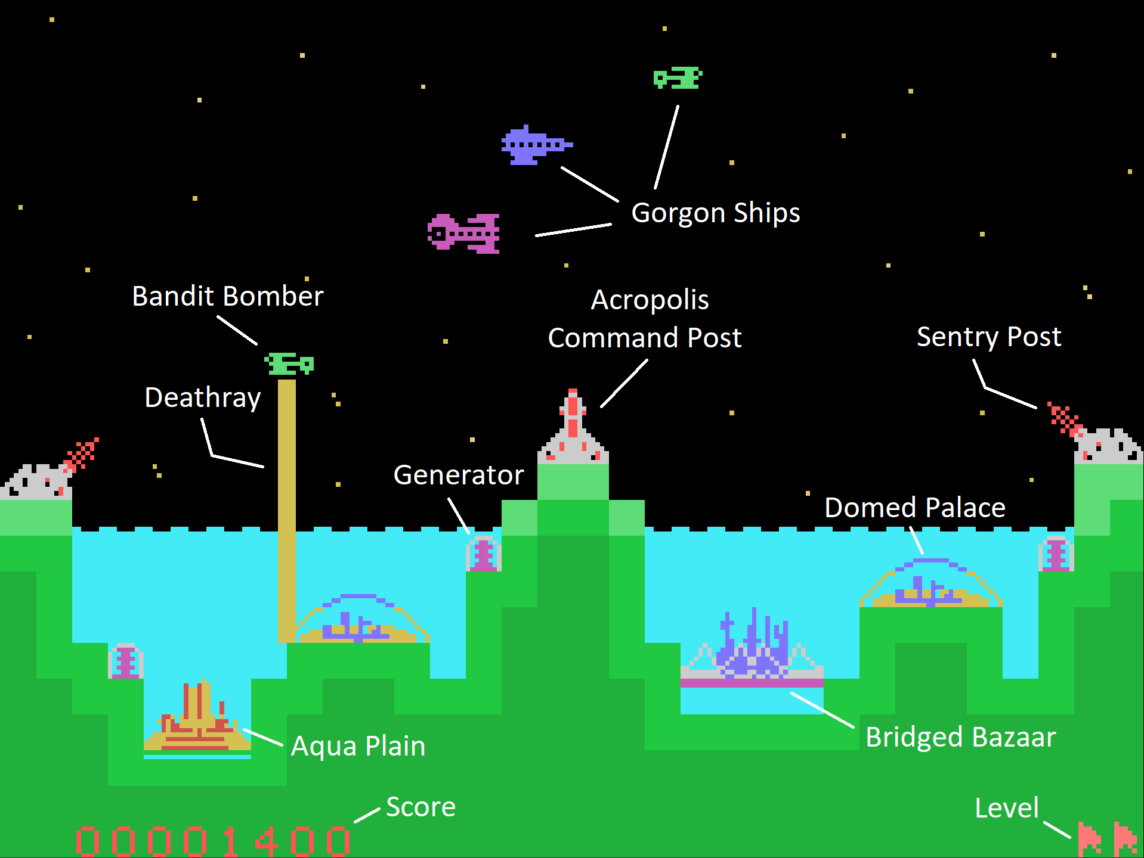
Game ends when all ten of Atlantis’ installations have been leveled and none is left in reserve.
Game Setup

Insert the Atlantis game cartridge into the loading bay of the TI99/4A home computer and power on the system. Press any key to move beyond the TI99/4A startup screen.

The cartridge menu should appear on screen. If the menu does not appear, power off the computer and then restart after waiting several seconds.

The cartridge menu will have three options.

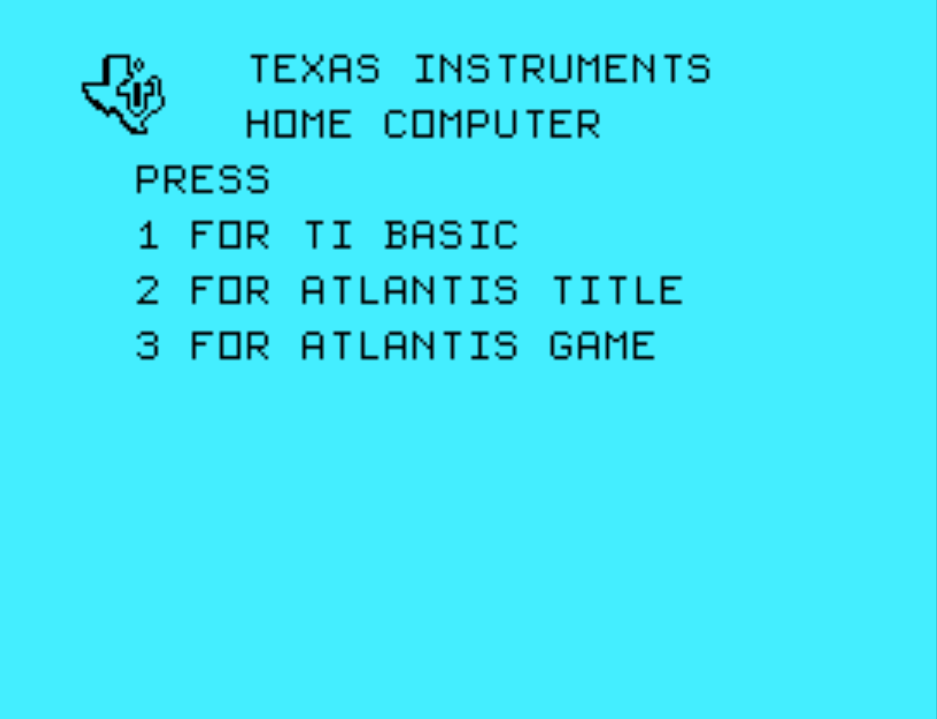
Press the ‘2’ key to select the Atlantis Title Screen with in-cartridge game instructions and title music.

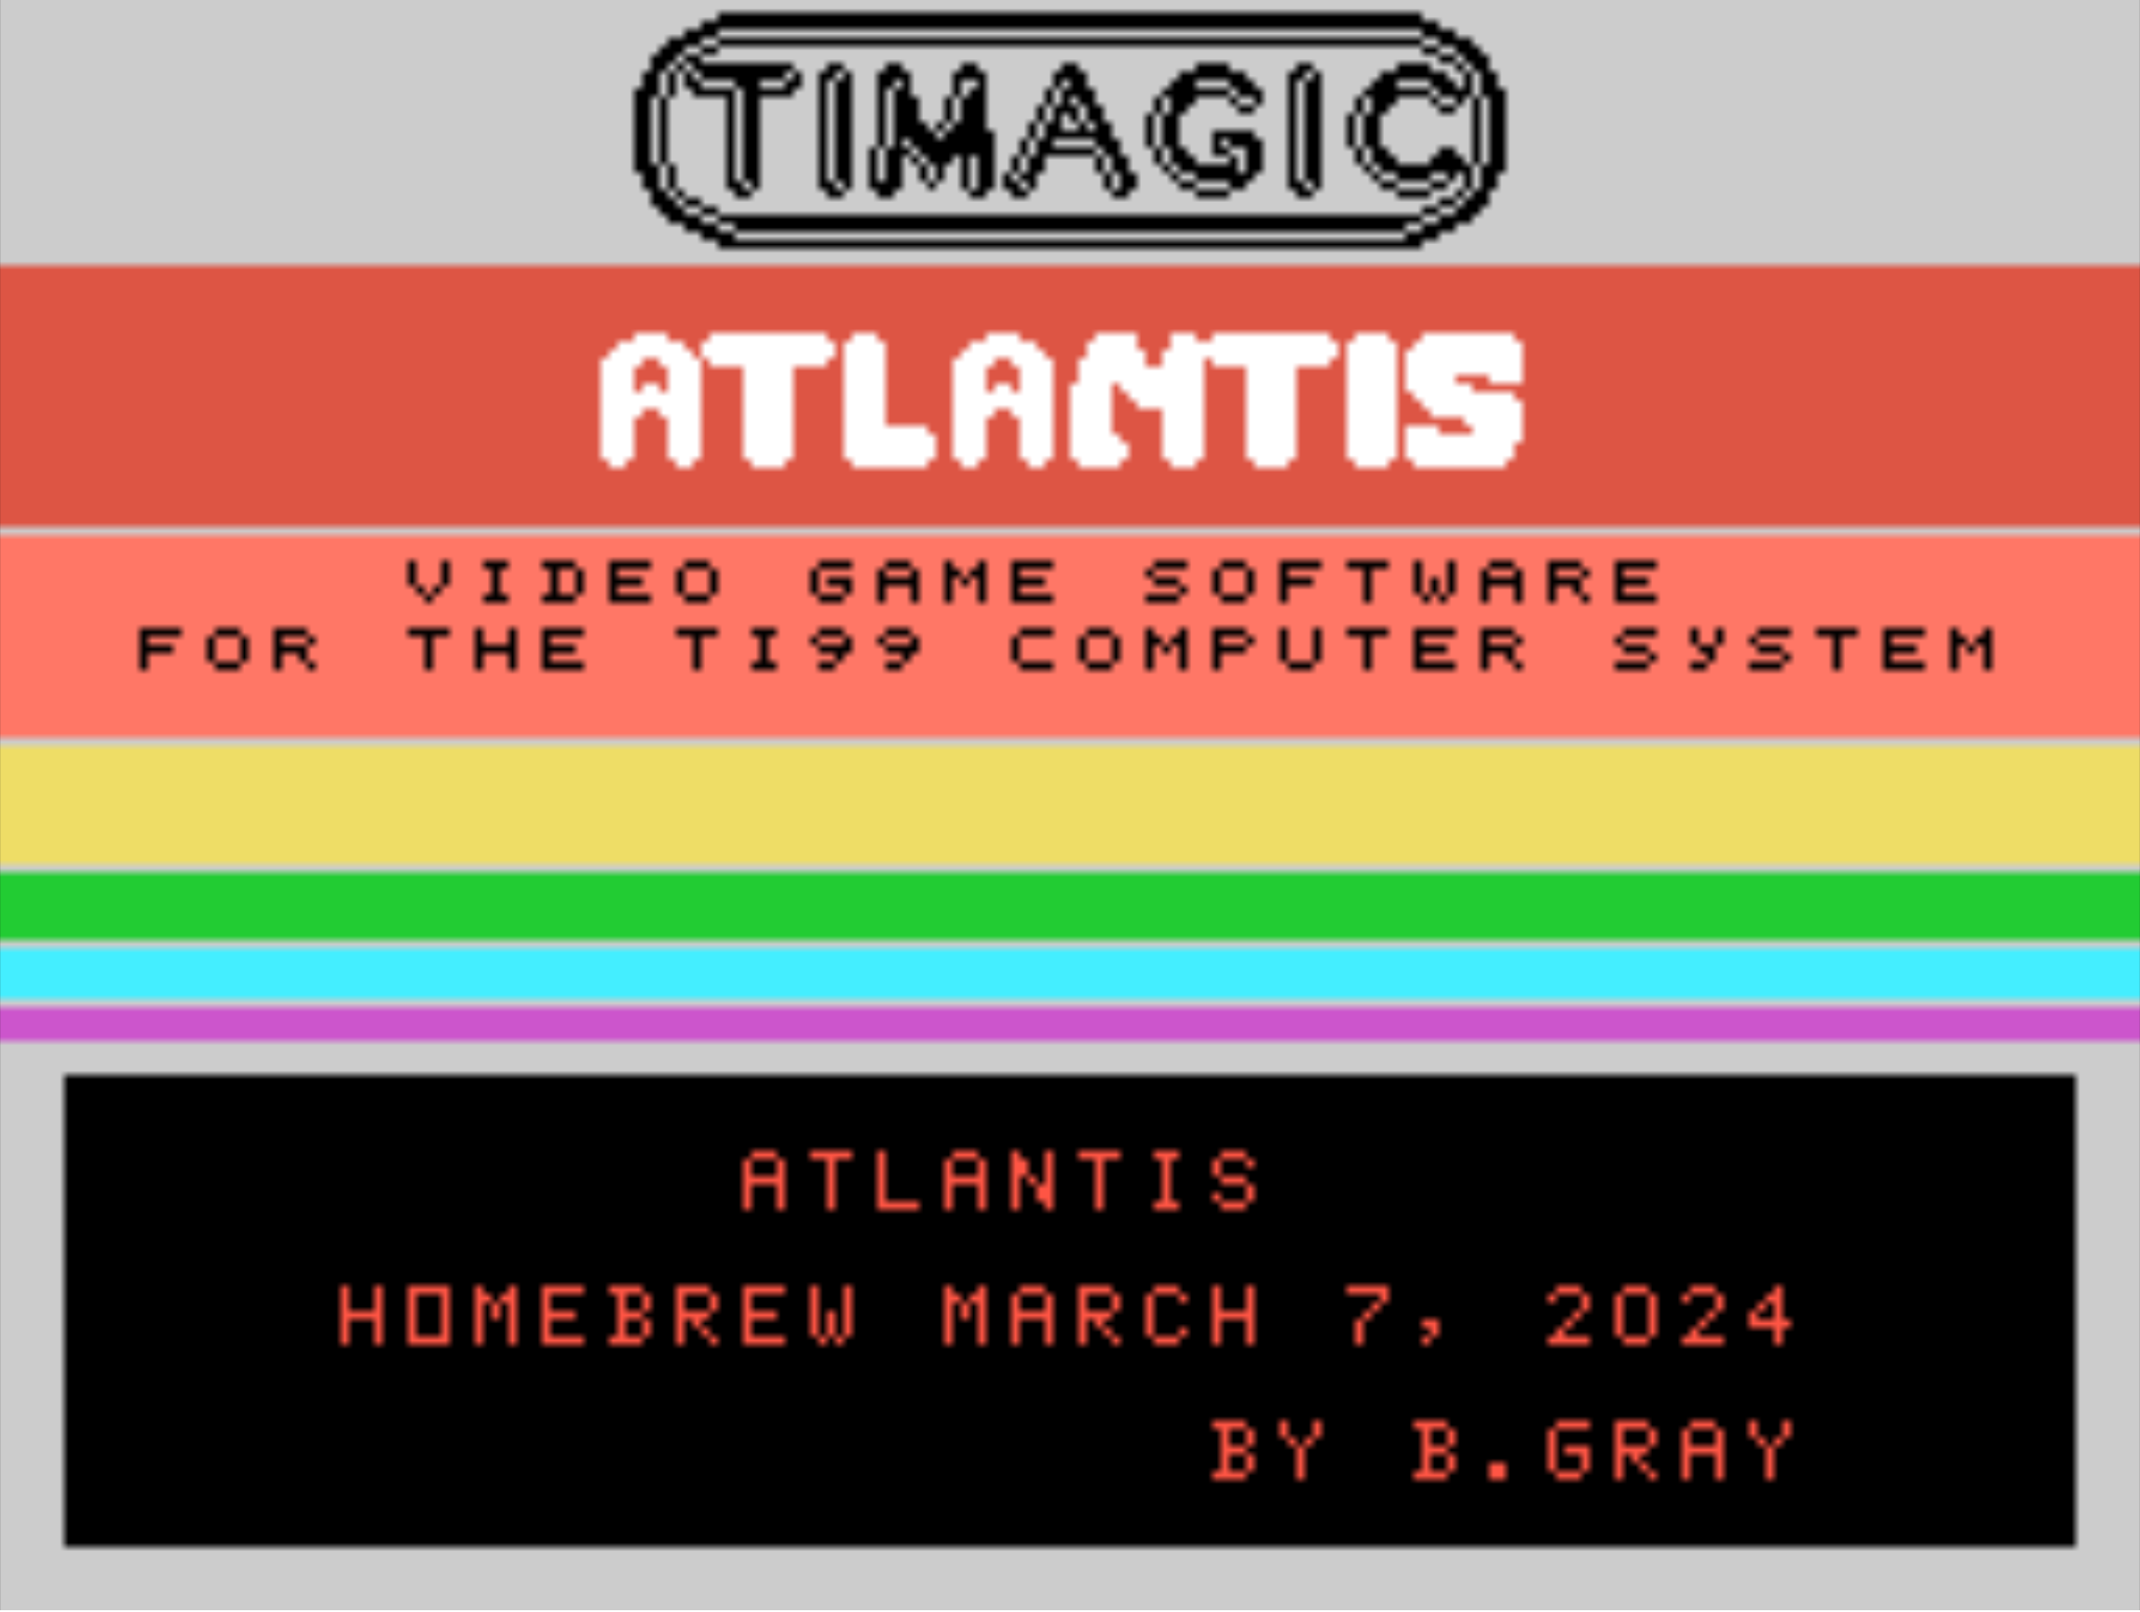
Game description and instructions will automatically scroll through the lower black text box. To advance the instruction text, press the space bar.

Instruction display will repeat upon completion. To return to the cartridge menu, press the ‘Q’ key at any time. Once the cartridge menu has appeared, press the ‘3’ key to start the game.
Game Play

Gorgon ships enter into range from the upper atmosphere. Circling clockwise or counter clockwise and spiraling down until they are within range of the city.

Ships stay in assigned attack lanes to avoid collisions. There are five attack lanes that the ships occupy while descending towards Atlantis. Only one ship can occupy an attack lane at any given time.

Ships can only fire the Deathray from the closest attack lane. Ships are in range of Atlantis’ plasma canons from any lane.

Destroy Gorgon ships by firing one of three plasma cannons located at the city’s defense posts. Generators deliver enough power to fire twice in succession but must cool before firing again.

Defend the city against all attacking Gorgon ships. Bonus points are awarded and assets are rebuilt after each attack wave. The game ends when all city assets have been destroyed.
Scoring

You score each time you vaporize a Gorgon vessel. You must hit the ship directly to score.

Points

Gorgon Cruiser 10 x Lane

Gorgon Scout 20 x Lane

Bandit Bomber 50 x Lane

- Ships in attack lanes closer to the city generate more points than those in lanes that are further away.

- Bandit Bombers destroy other ships when they explode. Points are accumulated for each additional ship destroyed.

- Bonus points are rewarded for each city asset remaining intact at the completion of each attack wave. The bonus for each asset is 10 x Current Level for a max of 100 points per asset.
Play Mechanics

Use the TI99/4A compatible joystick controllers to fire any of the three plasma canons located throughout the city.

To fire the main, center canon, simply press joystick #1 fire button.

Firing the left cannon is achieved by pressing joystick #1 left and pressing the fire button.

The right cannon fires when joystick #1 is moved right and the fire button is pressed.

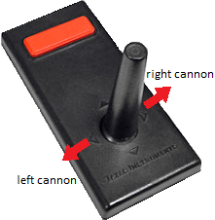

Plasma cannons will no longer fire if they are destroyed by the Gorgon Deathray.
Credits

Original game produced by IMAGIC, (1983)

Game design by Dennis Koble, (1983)

TI99/4A Atlantis port by Brian Gray, (2024)

Title music by J.S. Bach

Manual cover and cartridge label by Ciro Barile

Special thanks to www.ti99iuc.it

Thanks to AtariAge and the TI99/4a Community

Software is distributed free of charge



