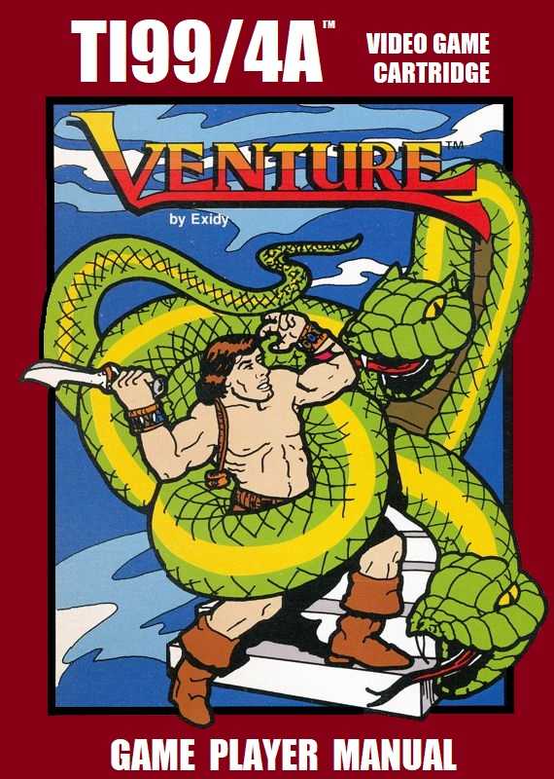
GAME DESCRIPTION

Winky™ has climbed deep inside a dungeon laden with incredible treasures, but guarded by terrible monsters. Equipped with only bow and arrows, he seeks the treasures as the monsters close in. Guide him through the dungeon rooms...but don’t stop to count your treasure until you’re through!

Getting ready to play


Make sure the TI99/4A home computer is plugged in and connected to its monitor or television set (Image 1).

Insert the Venture™ game cartridge (Image 2) into the computer’s cartridge port and power on the computer system.

Image 1

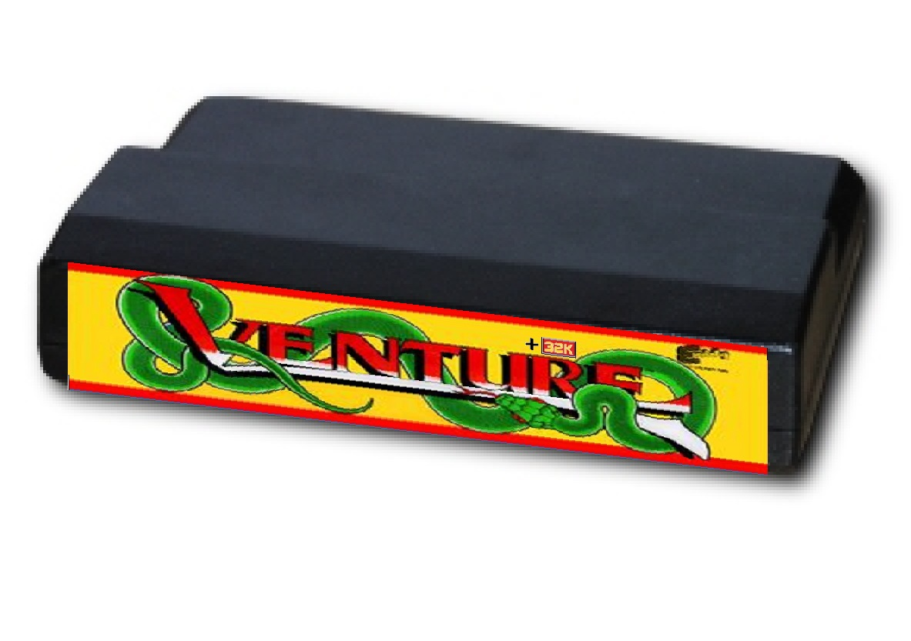
The cartridge menu should appear on screen (Image 3). If the menu does not appear, power off the computer and
Image 2 restart after waiting several seconds. If the software continues to fail to start, immediately return the game to the retail outlet where it was purchased.

The cartridge menu will have two options. Select option 2 to start the Venture™ software.

Image 3

The Venture™ game title screen (image 4) will appear on the computer’s display screen. The title screen offers 4 selections, START, INSTRUCTIONS, OPTIONS and EXIT.
Image 4
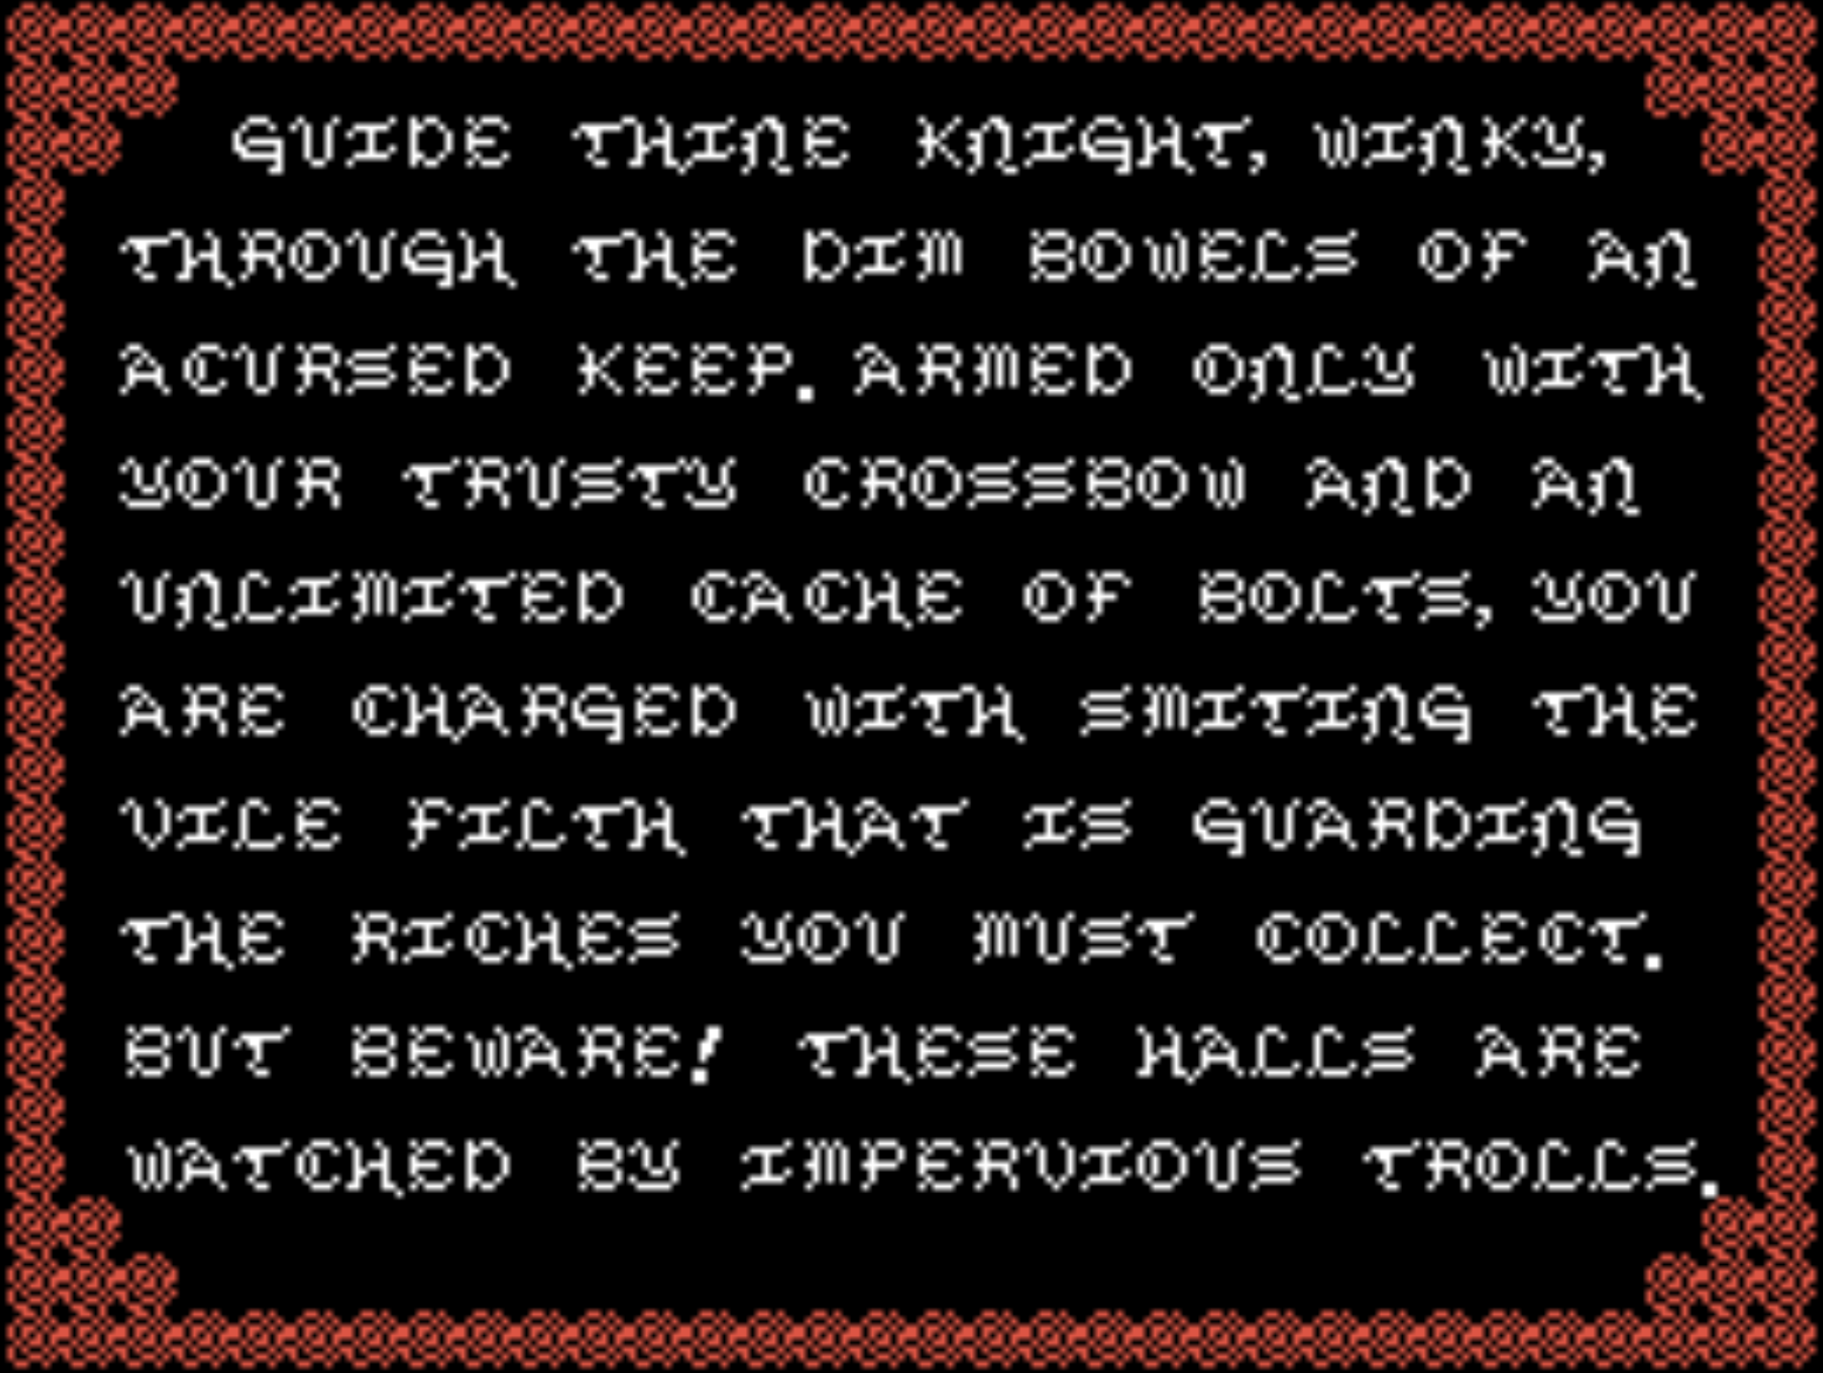
The START option begins a new Venture™ game. The
INSTRUCTIONS option will display the in-game in-structions screen (Image 5).
The OPTIONS choice will bring up the game options screen (Image 6). The EXIT option will exit from Venture™. Image 5

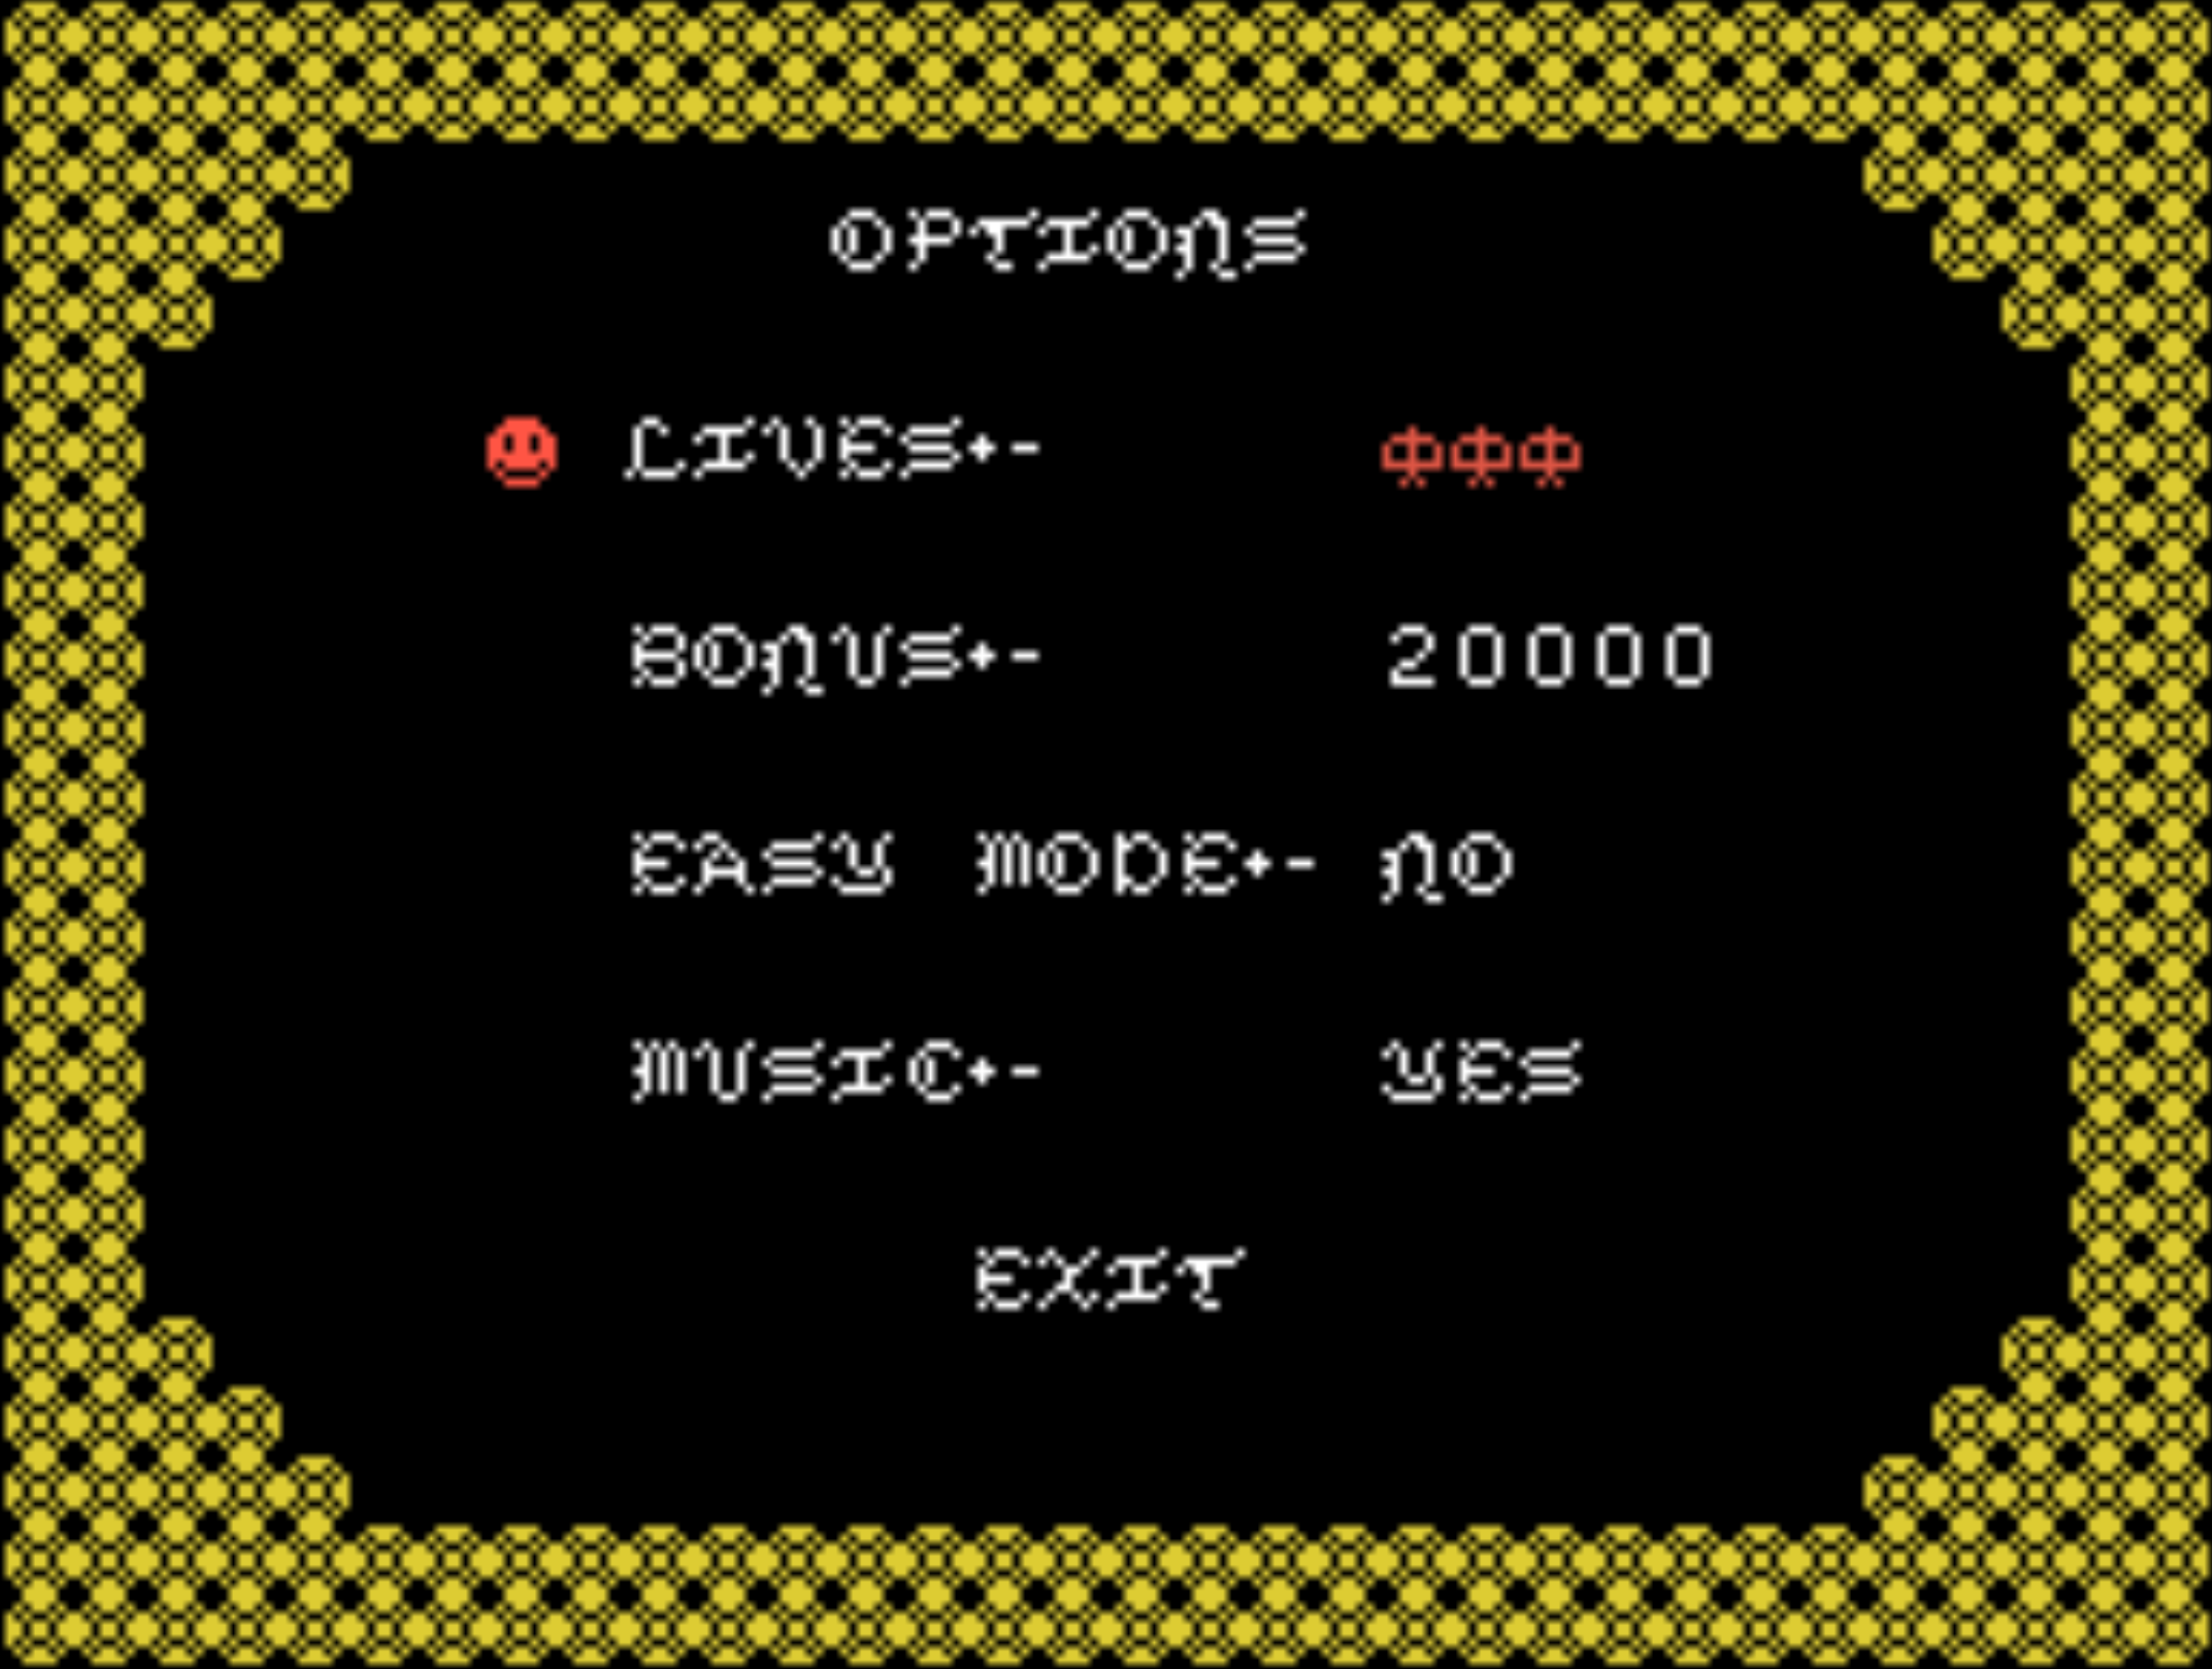
Image 6
Game Options

The options menu has 4 settings that can be adjusted to the player’s preference. To select a desired setting, press the SPACE BAR to toggle the Winky™ Icon to the desired setting. Use the PLUS and MINUS (+ and -) keys to adjust the settings to desired level.

The LIVES setting, allows the player to start the game with additional lives for Winky™ (the default is 3 with a maximum of 6). The number of lives can be reduced below three, but this is not recommended.

The BONUS setting allows the player to adjust how many points are needed to gain an extra life. The default value is 20000 points but it can be reduced to a minimum of 10000 and a maximum of 50000. The user is also able to set the value to NONE, which will award no BONUS lives during game play.

The MUSIC option allows the player to turn off the game’s music. EXIT returns the player to the title screen.
The EASY MODE setting allows the player to toggle between normal game play and game play that is less challenging. When EASY MODE is turned on, there are fewer wandering trolls and no limit on how long Winky™ can remain in a room.

Game Mechanics

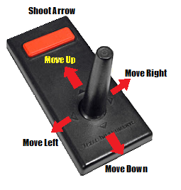
Use the TI99/4A compatible joystick controllers (Image 7) to guide Winky™ through the various game levels and rooms.

Move the joystick in the
direction of Winky’s desired movement. Use the controller’s Fire Button to fire arrows when Winky™ is in a dungeon room. Image 7

It is important to have the ALPHA LOCK key in the up position during game play. The Z key will pause the game.

Game Play

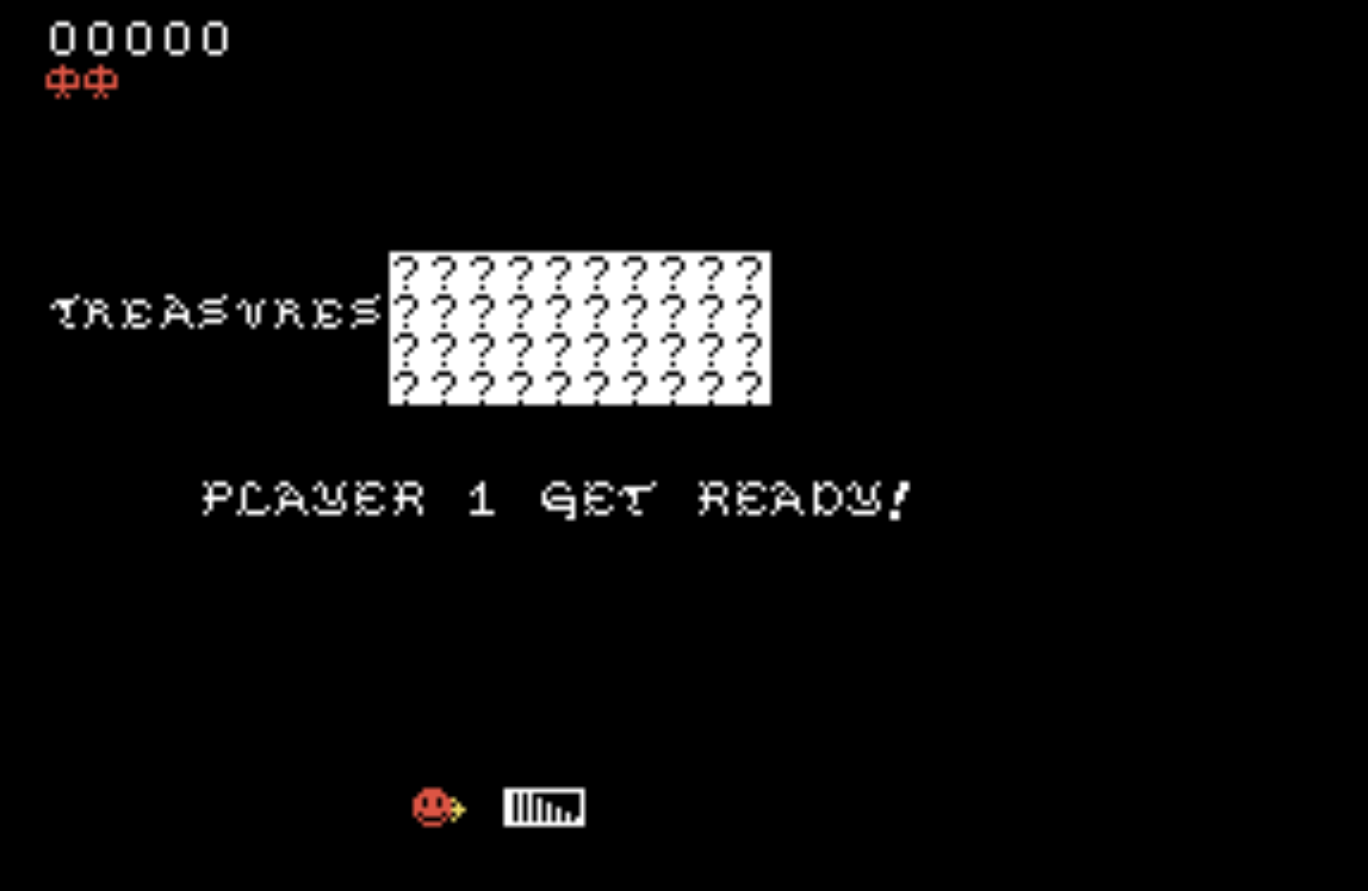
The game starts with Winky™ collecting his trusty bow and descending the dungeon’s staircase to face the perils below and collect the treasures he covets (Image 8).

Winky™ emerges from the staircase into a great hall fraught Image 8
with danger. The dungeon is infested with deadly,
invulnerable cave trolls, who would like nothing
more than to make a meal of our hero (Image 9).
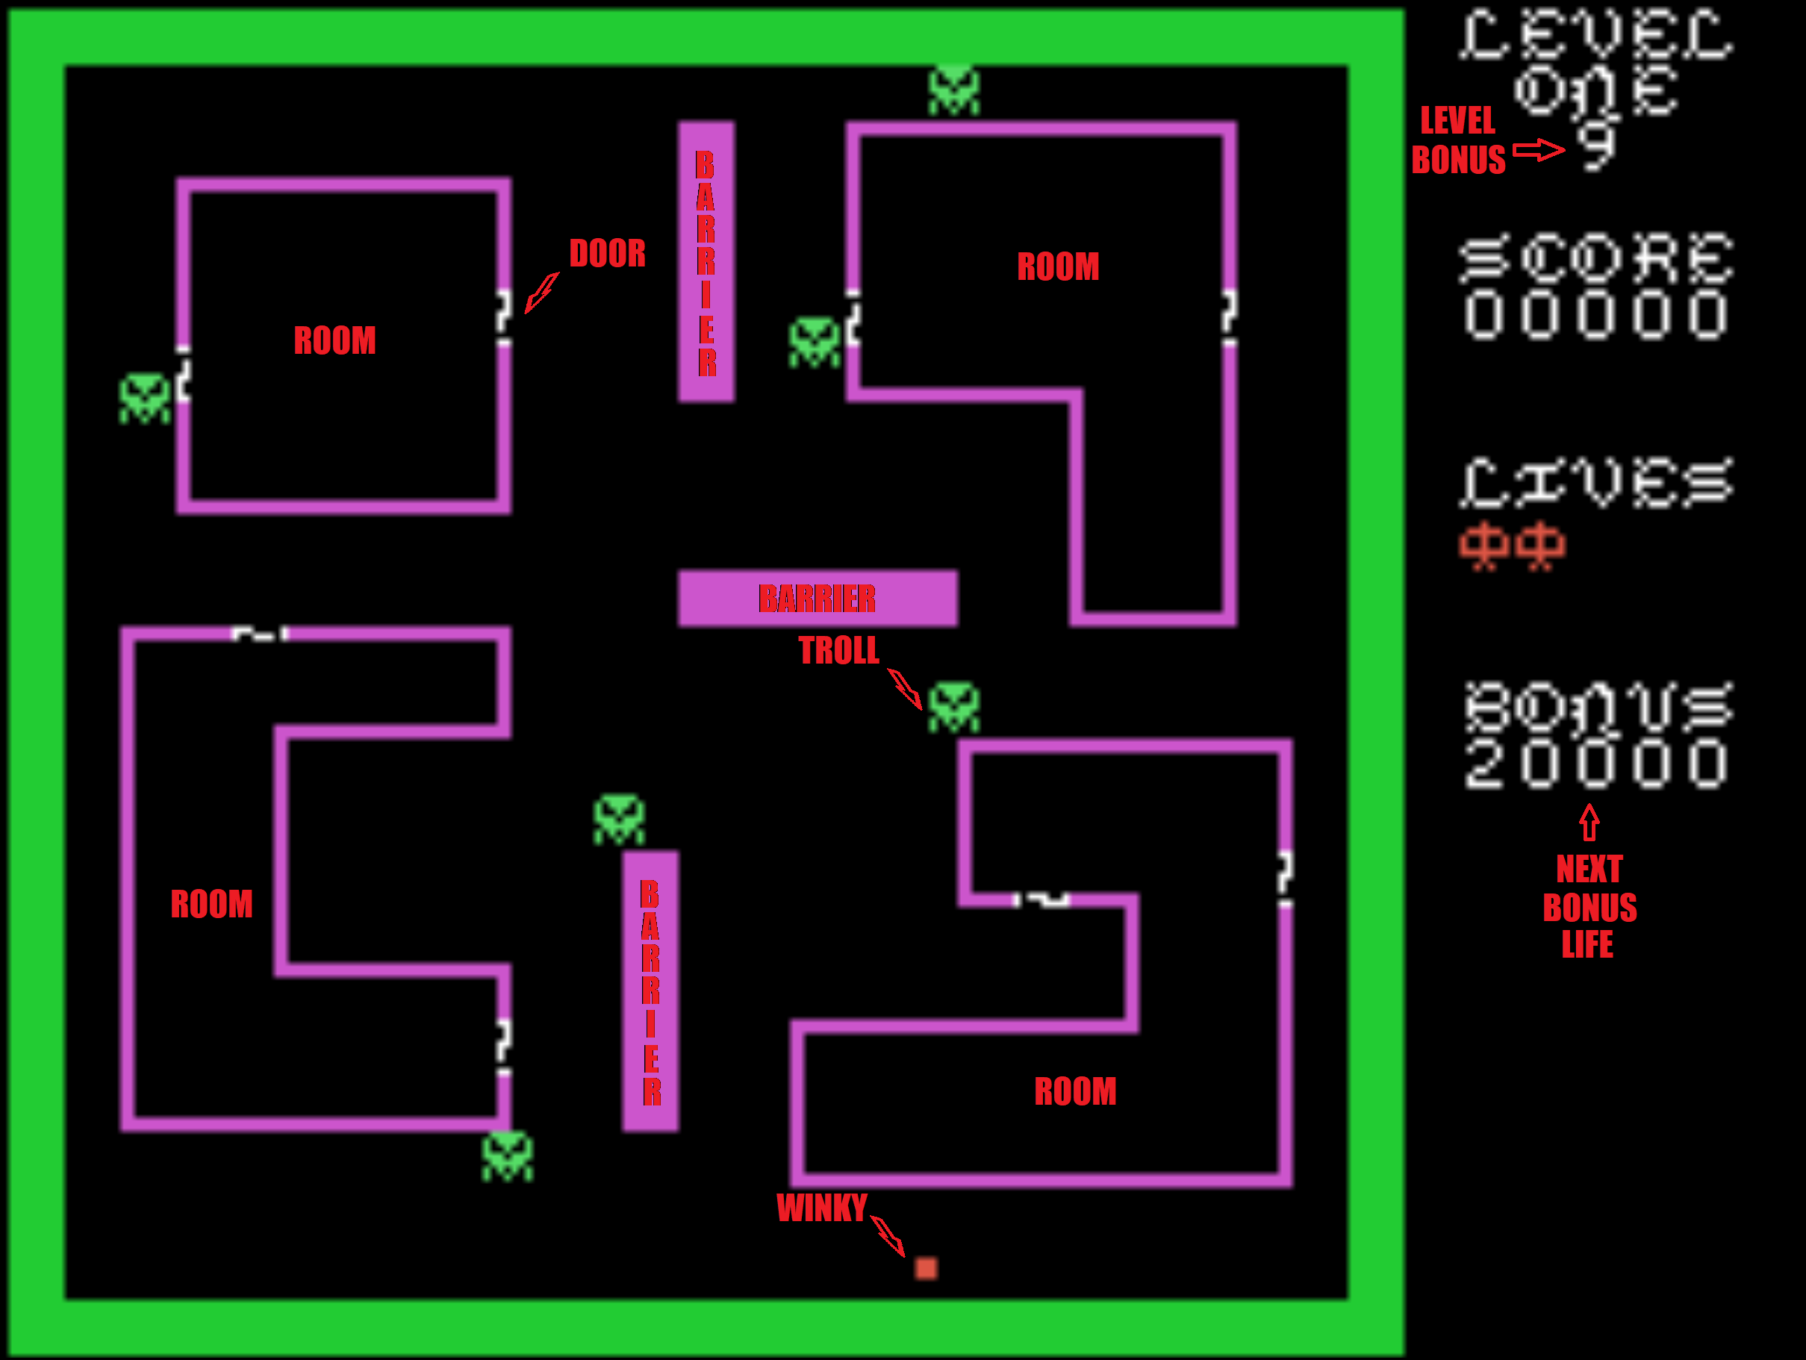
Image 9
Winky™ must avoid the trolls and make way to each of the hall’s rooms. Winky™ is not able to fight the cave trolls so they must be avoided.

Each level and room has a status display that shows the lives remaining, current score and score the next bonus life will be awarded.

The display shows the Level Bonus Counter. This timer is used to determine the level bonus points awarded upon completion of the level. The higher this number is, the more points are awarded.

To complete a level, Winky™ must enter each room, collect the treasure and exit without being killed by the horrors residing within. Winky™ is armed with a bow and unlimited arrows.
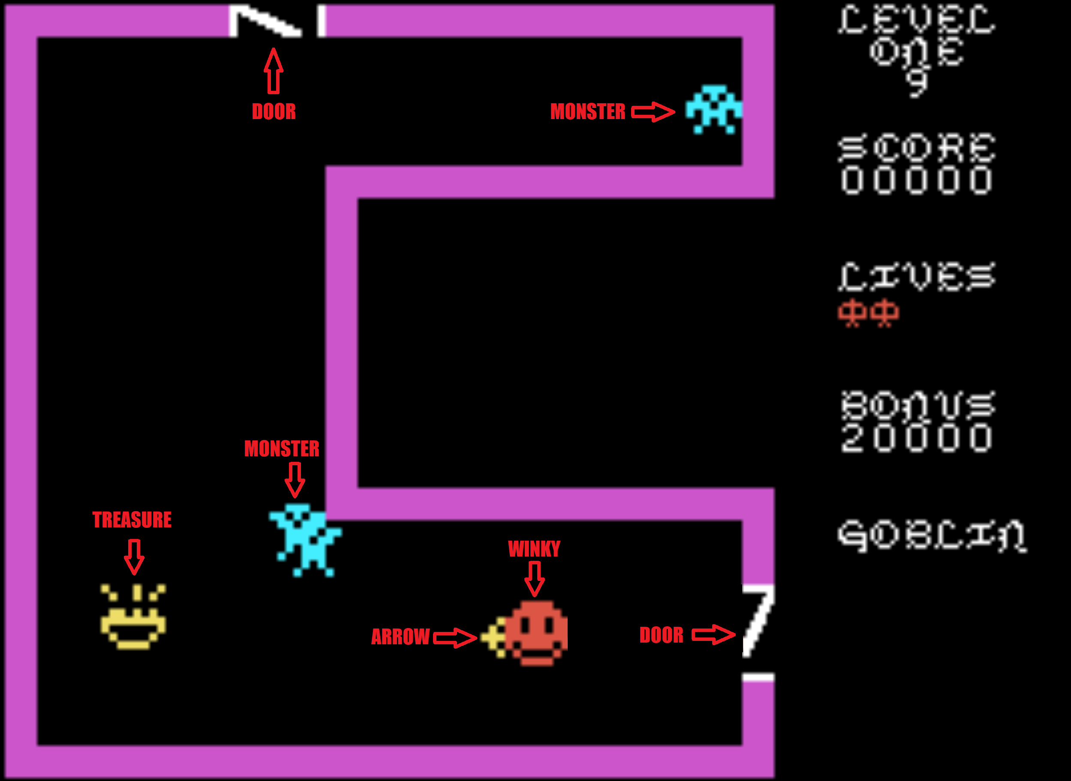
Image 10
Winky™ must avoid the blood thirsty monsters or kill them with his bow and arrows. Should Winky™ exit a room without collecting the treasure, monsters will respawn themselves when Winky™ returns to the room.

Monsters that have been shot but are in the process of dying, can still kill Winky™. Avoid dying monsters and try not to let them block your path (be careful where you kill them).

Winky™ must collect each room’s treasure to advance to the next level. Winky™ cannot return to rooms where the treasure was already collected.

Should Winky™ linger in a room for too long, a wandering cave troll will give chase and kill him if caught. This troll cannot be killed, so flee for your life should he appear.

Special Rooms

There are a number of rooms throughout the game that are a little different than most of the other rooms.
In these rooms, monsters might not appear until after the treasure is collected or additional monsters might show up.

In one room, monsters are held safe, behind barriers, until a certain amount of time has passed and the barriers are lowered.

For one note worthy room, there are no monsters. This room contains deadly moving walls (Image 11) that will kill Winky™ should he come in contact with them.

Winky™ is unable to use his bow in this room and a cave troll will come knocking should Winky™ take too long to traverse these obstacles.
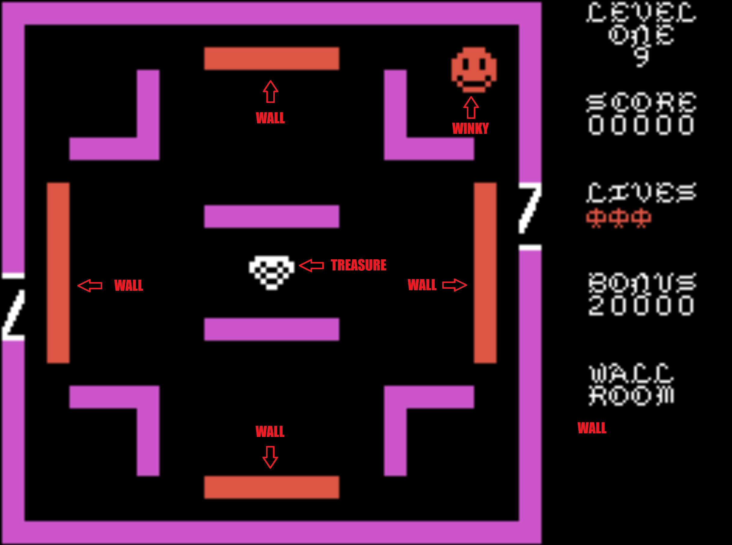
Image 11
Level Completion

Once treasures have been collected for all rooms of the current level, the level is considered “completed” and the level completion screen will appear (Image 12).

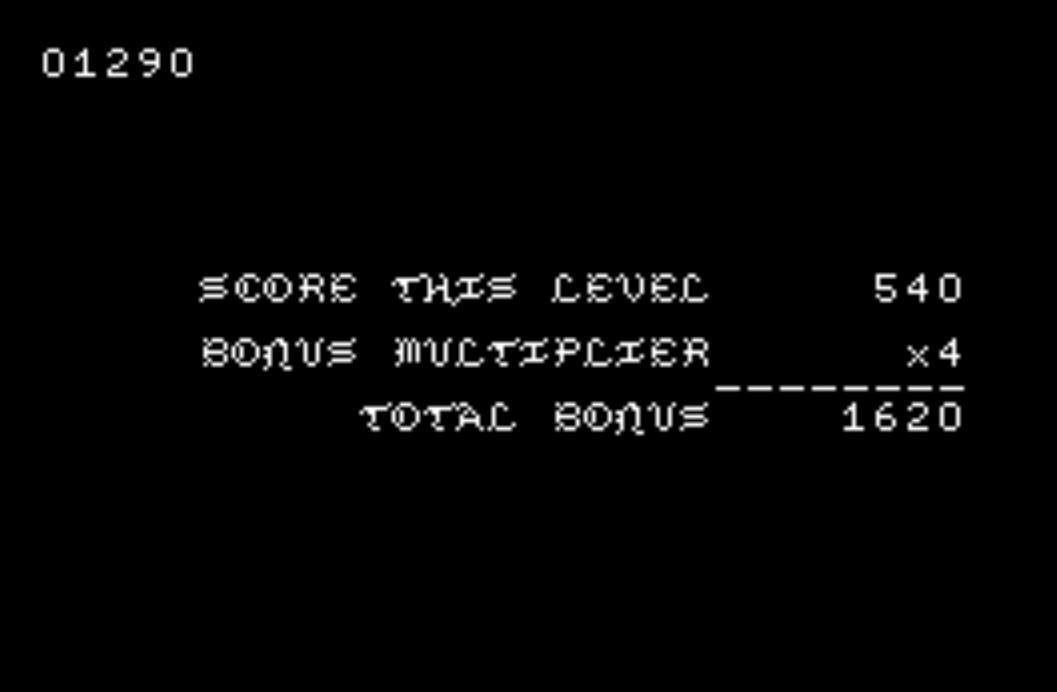
Image 12

Level bonus points are awarded at this time. The points are calculated from the points awarded for monster kills multiplied by the level BONUS MULTIPLIER, which is based on how quickly the level was completed. This multiplier can be from 9 to 0.
After the bonus is awarded, Winky™ returns to the level start screen, where he will begin the next dungeon level.

This screen (Image 13) will show all treasures that have been successfully collected. When all 40 unique treasures have been collected, Winky™ retires, the game ends and the credit screen is shown.

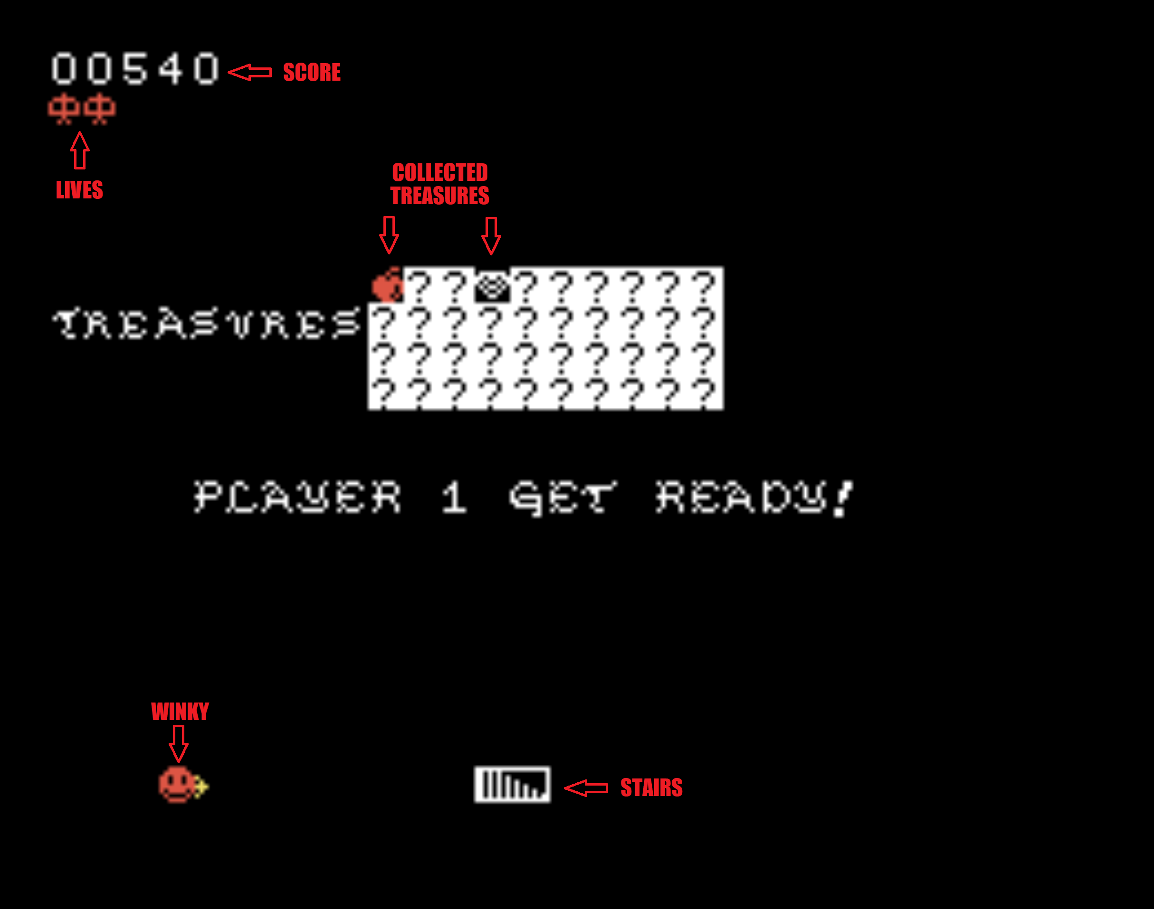
Image 13

Credits

Original game by Howell Ivy, Exidy (1981)

TI99/4A Venture port by Brian Gray, (2025)

Thanks to Stefan Bach, Harry Wilhelm, M. Brent

Thanks to Sometimes99er for the Venture™ font

Thanks to AtariAge and the TI99/4a Community

Thanks to Ciro Barile TI99IUC TI99 IUC | Homepage

TY ArcadeShopper Store - arcadeshopper.com LLC

Thanks to TIGameShelf TI-99/4A Game Shelf




