**Report on CSCI3280 Assignment 1**

**Basic Requirements**

Since some conditions are not specified in the assignment specification, I have done some adjustments beyond the basic requirements. There are several remarks on running ascii.cpp:

1. Invalid inputs  
   The execute command should follow the format:  
   ascii <s|p> <input.bmp> <size1,size2> <output.txt>  
   where first two inputs are mandatory, others are optional. Only the first letter of the first input will be collected. If the first input is not s|p, an error message “Task undefined!” will be printed out. If the first input is s but the fourth input is missed, and error message “Cannot find the output file!” will be printed.
2. Rescaling  
   ascii.cpp is only be able to contract the input image but not enlarge it. Therefore, the valid range of input <size1, size2> are:  
   0 < size1 <= original width  
   0 <= size2 <= original height  
   For all invalid inputs out of the range, a message “The input size is invalid!” will be printed and the program will be **continued** **with the original image size.**(Since the specification did not mentioned the enlargement of the image, ascii.cpp cannot enlarge image by either width or height. The enlargement feature is added in enhancement part.)

**Enhancement part**

The complied program of ascii_enhance.cpp should be execute in the following syntax:

ascii_enhance <s|p|i|c|b> <input.bmp> <size1,size2> <output.txt|bmp|html>

The first input identifies the task of the program as following:

|  |  |
| --- | --- |
| argv[1] | Task |
| s | Generate a greyscale ascii art of input image and print it in command prompt. Only first two inputs are mandatory. |
| p | Generate a greyscale ascii art of input image and save it as a text file. A txt output file is preferred. All inputs are mandatory. |
| i | Generate a greyscale ascii art of input image and save it as an image file. A bmp output file is preferred. All inputs are mandatory. |

|  |  |
| --- | --- |
| c | Generate a coloured ascii art of input image and save it as a webpage. A html output file is preferred. All inputs are mandatory. |
| b | Generate a blurred version (pixel art) of input image. A bmp output file is preferred. All inputs are mandatory. |

There are several features are added in ascii_enhance.cpp:

1. Rescaling the image (Contraction and enlargement)  
   ascii_enhance.cpp is able to contract and enlarge the input image to the target size. Both rescaling use the block rounding algorithm. The image can contract to the nearest block size.   
   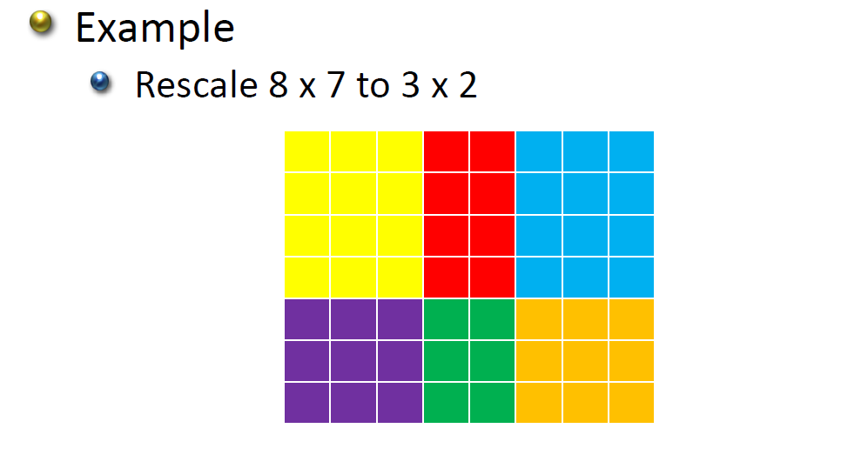  
   The enlargement is just do the reversion of the above block mapping.

|  |  |  |  |  |  |  |  |  |  |  |  |  |  |  |  |  |  |  |  |  |  |  |  |
| --- | --- | --- | --- | --- | --- | --- | --- | --- | --- | --- | --- | --- | --- | --- | --- | --- | --- | --- | --- | --- | --- | --- | --- |
|  |  |  |  |  |  |  |  |  |  |  |  |  |  |  |  |  |  |  |  |  |  |  |  |
|  |  |  |  |  |  |  |  |  |  |  |  |  |  |  |  |  |  |  |  |  |  |  |  |
|  |  |  |  |  |  |  |  |  |  |  |  |  |  |  |  |  |  |  |  |  |  |  |  |
|  |  |  |  |  |  |  |  |  |  |  |  |  |  |  |  |  |  |  |  |  |  |  |  |
|  |  |  |  |  |  |  |  |  |  |  |  |  |  |  |  |  |  |  |  |  |  |  |  |
|  |  |  |  |  |  |  |  |  |  |  |  |  |  |  |  |  |  |  |  |  |  |  |  |
|  |  |  |  |  |  |  |  |  |  |  |  |  |  |  |  |  |  |  |  |  |  |  |  |
|  |  |  |  |  |  |  |  |  |  |  |  |  |  |  |  |  |  |  |  |  |  |  |  |
|  |  |  |  |  |  |  |  |  |  |  |  |  |  |  |  |  |  |  |  |  |  |  |  |
|  |  |  |  |  |  |  |  |  |  |  |  |  |  |  |  |  |  |  |  |  |  |  |  |
|  |  |  |  |  |  |  |  |  |  |  |  |  |  |  |  |  |  |  |  |  |  |  |  |
|  |  |  |  |  |  |  |  |  |  |  |  |  |  |  |  |  |  |  |  |  |  |  |  |
|  |  |  |  |  |  |  |  |  |  |  |  |  |  |  |  |  |  |  |  |  |  |  |  |
|  |  |  |  |  |  |  |  |  |  |  |  |  |  |  |  |  |  |  |  |  |  |  |  |

(Rescale 3 x 2 to 8 x 7: the shaded region share the rgb value of the block which has boarder with same colour)

source code:  
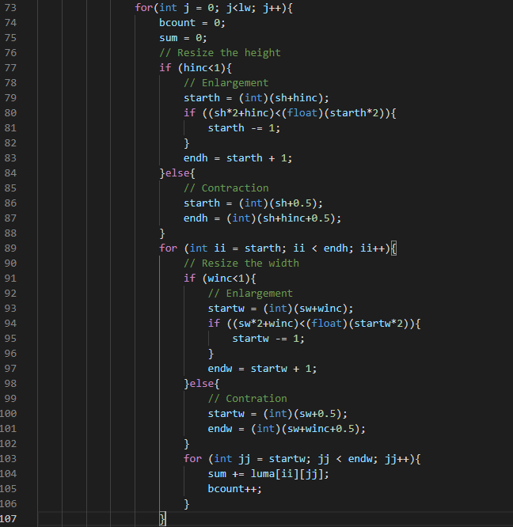

(Please read the source code directly for details.)

Sample run:  
ascii_enhance p mario.bmp 200,0 output1.txt  
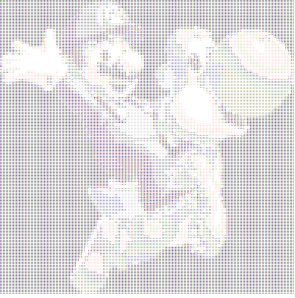

ascii_enhance p mario.bmp 200,50 output2.txt  
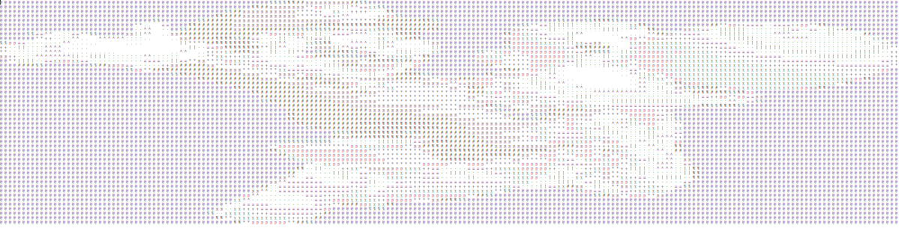

(The original image size is 100,100)

1. 16 colour depth of greyscale  
   8 more shades are added to represent more details of greyscale ascii art.  
   source code:  
   
2. Save ascii art as image  
   Use the images of shades to replace the shades text. The output image is 8 colour depth of greyscale (same as ascii.bmp). Collage the shades images to generate the output image.  
   source code:  
   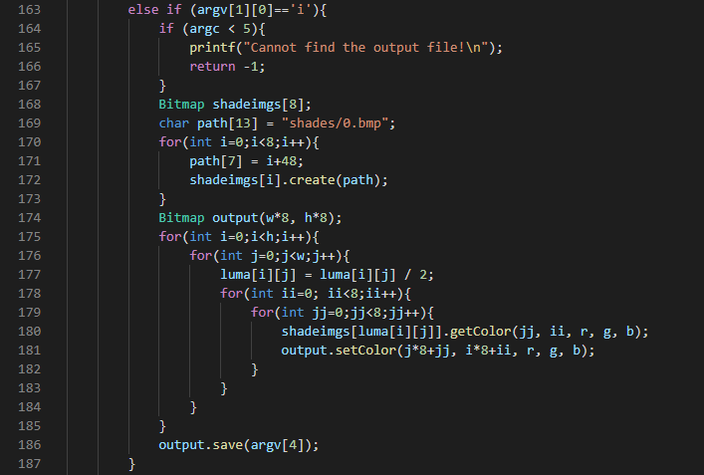  
   sample run:  
   ascii_enhance i mario.bmp 100,0 output3.bmpA picture containing text, window, white, standing

   Description automatically generated
3. Generate a coloured ascii art as HTML  
   Use the colour value mean to map the shades and use corresponding to colour code to describe the character in HTML document.  
   source code:  
   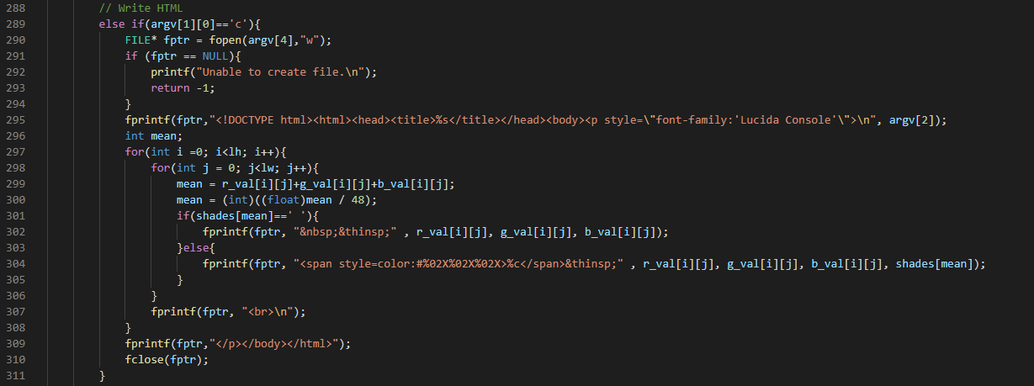  
   sample run:  
   ascii_enhance c mario.bmp 100,0 output4.html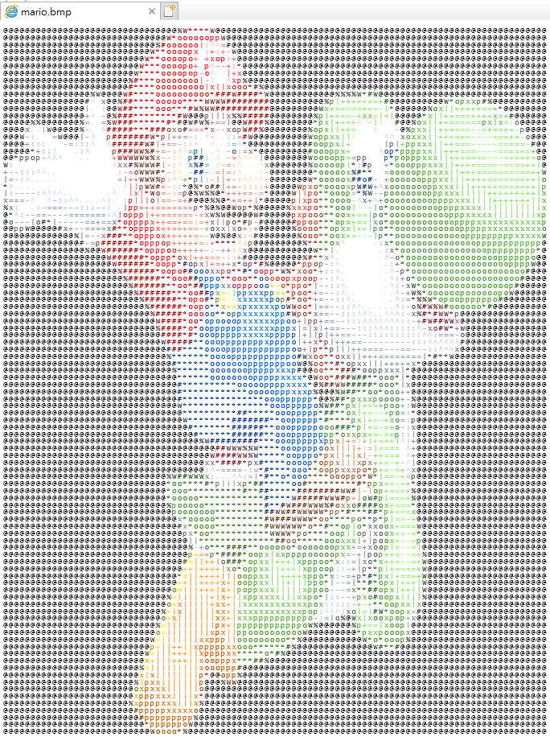
4. Generate a blurred image (pixel art)  
   Generate a blurred image form the input image. The input <size1,size2> are the dimension of blurred blocks. All pixels in the blurred blocks share the same rgb values The actual pixel of output image is same as the original image.  
   source code: 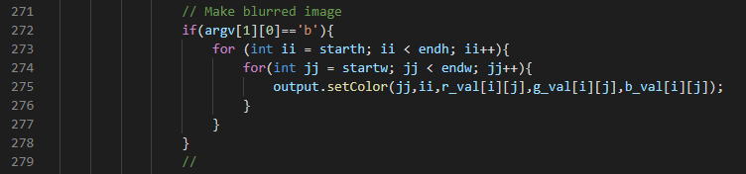  
   sample run:  
   ascii_enhance b micky.bmp 20,0 output5.bmpA picture containing square

   Description automatically generated

Remarks:

The submission includes the following files

* ascii.cpp
* bmp.cpp
* bmp.h
* ascii_enhance.cpp
* shades
  + require when execute ascii_enhance.cpp
* report.pdf
* sample
  + contains output1-5 mentioned in this report
  + mario.bmp
  + micky.bmp