COMP2090SEF Group Project EECS S&T HKMU
COMP8090SEF/S209W Individual Project
Requirement on academic honesty (COMP2090SEF):
- Each group must make the following declaration on the cover page ofthe report
HongKong Metropolitan University
COMP2090SEF
Data Structures, Algorithms And Problem Solving
Course Project Report Group 62
Submission date:2026/4/16
We declare that:
  - all members of the group have read and checked that all parts of the project (including proposal, code programs, and reports), irrespective of whether they are contributed by individual member or all members as a group, here submitted is original except for source material explicitly acknowledged;
  - the project, in parts or in whole, has not been submitted for more than one purpose without declaration; (iii) we are aware of the University's policy and regulations on honesty in academic work and understand the possible consequence when breaching such policy and regulations;
  - we confirm that we have declared in the report about the usage of AI and other generative models, including but not limited to ChatGPT, LLaMA, Gemini, Mistral, and Stable Diffusion, and complied with the instructions provided by HKMU; and
  - we are aware that all members of the group should be held responsible and liable to disciplinary actions, irrespective of whether he/she has signed the declaration and whether he/she has contributed, directly or indirectly, to the problematic contents.
We confirm that we have read through and understood the project requirements. We understand that failure to comply with the project requirements will result in score deduction.
NAME | SID
Laiyutao | 13996440
Longenze | 14018180
Zhangwancen | 14002864
- The group must acknowledge ALL external resources or code from others referenced. We will only mark the parts that are original, not the parts from others.
- All members are liable to the plagiarism incidence, even if a free-rider.

Core Functions
This project is a food donation management system named FoodBridge, built with Flask and Flask-SQLAlchemy. Its core functions are:
User Management: Supports registration, login, and role-based access control (donor/receiver). Donors can publish surplus food listings, while receivers can claim available food.
Food Listing Management: Donors can create food listings with details such as title, description, location, and expiry time. The system automatically calculates expiry time based on user input.
Claim & Pickup Workflow: Receivers can claim available food listings; after successful claim, the system notifies the donor via email/SMS. Both donors and receivers can confirm the completion of food pickup.
Dashboard: Role-specific dashboards display relevant data (donors see their published listings, receivers see their claimed food).
Data Persistence: Uses SQLite database to store user information, food listings, and workflow statuses.

Techniques Summary
The project leverages the following key techniques:
Flask Web Framework: A lightweight Python web framework for routing, request handling, template rendering, and session management.
Flask-SQLAlchemy: An ORM extension for Flask that abstracts database operations, enabling model definition and CRUD (Create, Read, Update, and Delete) operations without writing raw SQL.
Flask-Login: Manages user authentication, session maintenance, and access control for protected routes.
Object-Oriented Programming (OOP): Encapsulates business logic into models and service classes, using design patterns such as Factory, Singleton, and Strategy.
Notification Service Layer: Separates notification logic from route handlers, supporting multiple notification channels (email, SMS) via polymorphic design.
Declaration of External Resources
To facilitate robust development, security, and maintainability, this project relies on a selection of open-source Python packages and web frameworks. All dependencies are formally documented and managed within the application’s requirements.txt environment file.
The external resources utilized include:
- Flask (v3.0.0): Served as the primary web application framework[1]. It was utilized to handle backend HTTP routing, request/response parsing, and the overall modelview-controller (MVC) architectural flow.
- Flask-SQLAlchemy (v3.1.1): Implemented as the Object-Relational Mapper (ORM)[2]. This package enabled the program to interact with the SQLite database using Python object-oriented constructs. It was critical for facilitating our SingleTable Inheritance design pattern.
- Flask-Login (v0.6.3): Used for managing persistent user sessions, authentication, and access contro [3]l. It provided security decorators to ensure the correct separation of privileges between the "Donor" and "Receiver" dashboard views.
- Werkzeug (v3.0.1): A comprehensive WSGI web application utility library [4]. Specific cryptographic functions from this package
(generate_password_hash and check_password_hash) were integrated into our User class encapsulation methods to securely encrypt user credentials within the database.
- Jinja2 Engine: Integrated directly via Flask, this templating engine was used to dynamically inject back-end Python logic—such as object properties, database query results, and live expiration timestamps—into the front-end HTML structures[5].
- Bootstrap / System UI Utilities: External CSS design paradigms were referenced to rapidly build a responsive and modernized frontend interface
(e.g., utilizing utility classes for tables, buttons, and alert flashes) without relying purely on out-of-the-box browser default styling[6].

Usage of OOP Concepts1. Encapsulation
Encapsulation is used to hide internal implementation details and expose only necessary interfaces [7].
Model Encapsulation: The User class encapsulates user data and password security. It uses private attributes and public methods like set_password() and check_password(), preventing direct access to sensitive data .
Business Logic Encapsulation: The FoodListing class encapsulates state management logic. Methods like claim and complete_pickup() handle state transitions, keeping route code clean
[7].

Inheritance & Polymorphism
Inheritance: The FoodListing base class is extended by subclasses which inherit common attributes while implementing type-specific behaviors [8].
Polymorphism: Each subclass implements display_info() differently, allowing the system to show type-specific information .
Strategy Pattern Polymorphism: Notification classes implement a common interface, showing polymorphic behavior [8].

Factory Pattern
The FoodFactory class centralizes object creation and decouples it from route logic, making the system easy to extend .
4. Singleton & Service Layer
The NotificationManager uses the singleton pattern to manage all notification services uniformly [8].
(Please refer to Appendix A for the UML Class Diagram and Appendix B for detailed applications)
Self-reflection (Potential Weaknesses & Future Improvements)

Potential Weaknesses
Limited Scalability: The app uses SQLite, which cannot support high-concurrency production environments or large-scale data growth effectively.
Insufficient Input Validation: There are no comprehensive checks for user inputs (e.g., food expiry dates, location formats), which may cause invalid data or security risks like XSS/SQL injection.
Poor User Experience: The app lacks pagination for food listings, frontend styling, and confirmation prompts for critical actions (e.g., claiming food), which reduces usability.

Future Improvements
Technical Optimization: Replace SQLite with PostgreSQL to improve scalability; add input validation and security protections against common web vulnerabilities.
Function Enhancement: Add food search/filter (by location/type), auto-archiving for expired listings, and user-specific notification preferences.
UX Upgrade: Implement pagination for food listings, add frontend styling for better visual appeal, and include confirmation modals for key operations (e.g., claiming/completing food pickup).
OOP Refinement: Refactor core logic with dependency injection for better maintainability; add an AdminUser subclass to expand role-based permission management. (see Appendix D) References
- Pallets, "Flask Documentation (3.0.x)," Pallets Projects. [Online].
Available: https://flask.palletsprojects.com/. [Accessed: Apr. 10, 2026].
- Pallets, "Flask-SQLAlchemy Documentation (3.1.x)," Pallets Projects. [Online]. Available: https://flask-sqlalchemy.palletsprojects.com/. [Accessed: Apr. 10, 2026].
- M. Kennedy et al., "Flask-Login Documentation (0.6.x)," Read the Docs. [Online]. Available: https://flask-login.readthedocs.io/. [Accessed: Apr. 10, 2026].
- Pallets, "Werkzeug Documentation (3.0.x)," Pallets Projects. [Online].
Available: https://werkzeug.palletsprojects.com/. [Accessed: Apr. 10, 2026].
- Pallets, "Jinja Documentation," Pallets Projects. [Online].
Available: https://jinja.palletsprojects.com/. [Accessed: Apr. 10, 2026].
- Bootstrap Team, "Bootstrap: The most popular HTML, CSS, and JS library in the world," Bootstrap. [Online]. Available: https://getbootstrap.com/. [Accessed: Apr. 10, 2026].
- M. T. Goodrich, R. Tamassia, and M. H. Goldwasser, Data Structures and Algorithms in Python, Hoboken, NJ, USA: Wiley, 2013, pp. 412–438.
- T. H. Cormen, C. E. Leiserson, R. L. Rivest, and C. Stein, Introduction to Algorithms, 3rd ed. Cambridge, MA, USA: MIT Press, 2009, pp. 197–200.
link to github: https://github.com/function03937-dev/-

Appendix A UML Class Diagram
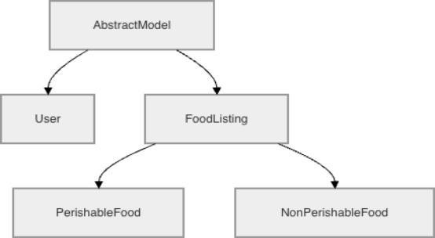
Appendix B Application of Core OOP Concepts
OOP Concept | Application in  Codebase | Explanation / Benefit
Abstraction | AbstractModelclass  (models.py) | Hides internal ORM implementation details and enforces a standard API template across the codebase. Compels all inheriting entities to define a customizeddisplay_info()representation.
Encapsulation | Userclass properties (models.py) | Protects sensitive data variables. The___password_hash is highly restricted. Properties like @username.setter bind business logic directly to data assignment (e.g., rejecting usernames under 3 characters).
Inheritance | Single-Table  Inheritance  (models.py) | PerishableFoodandNonPerishableFoodshare the common attributes of an overarchingFoodListingtemplate, drastically reducing code duplication while sharing the same underlying SQLite table structure.
Polymorphism | display_info()and  Magic Methods | Subclasses react differently to the same method call.  APerishableFoodprints a completely different UI format than aNonPerishableFood. Magic methods like___lt__allow lists of custom food objects to be seamlessly sorted by the Python engine.
Appendix C Entity-Relationship Diagram
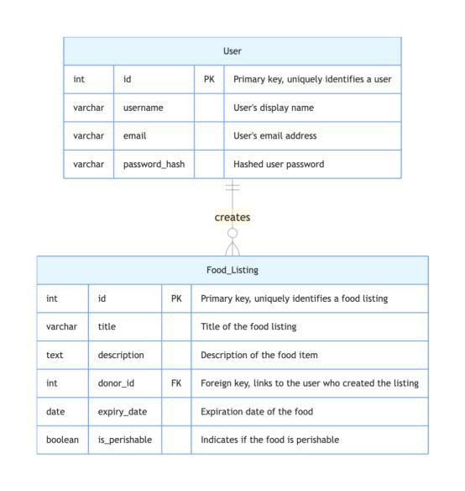
Appendix D Summary of Weaknesses and Proposed Improvements
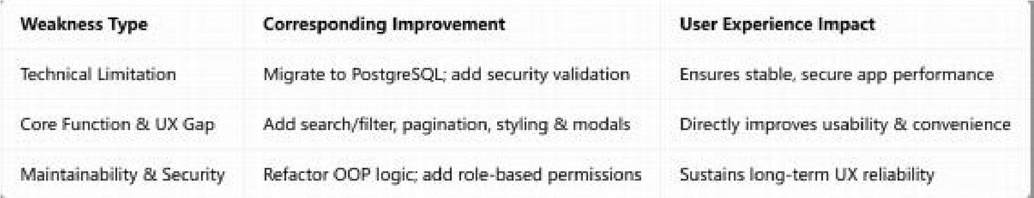
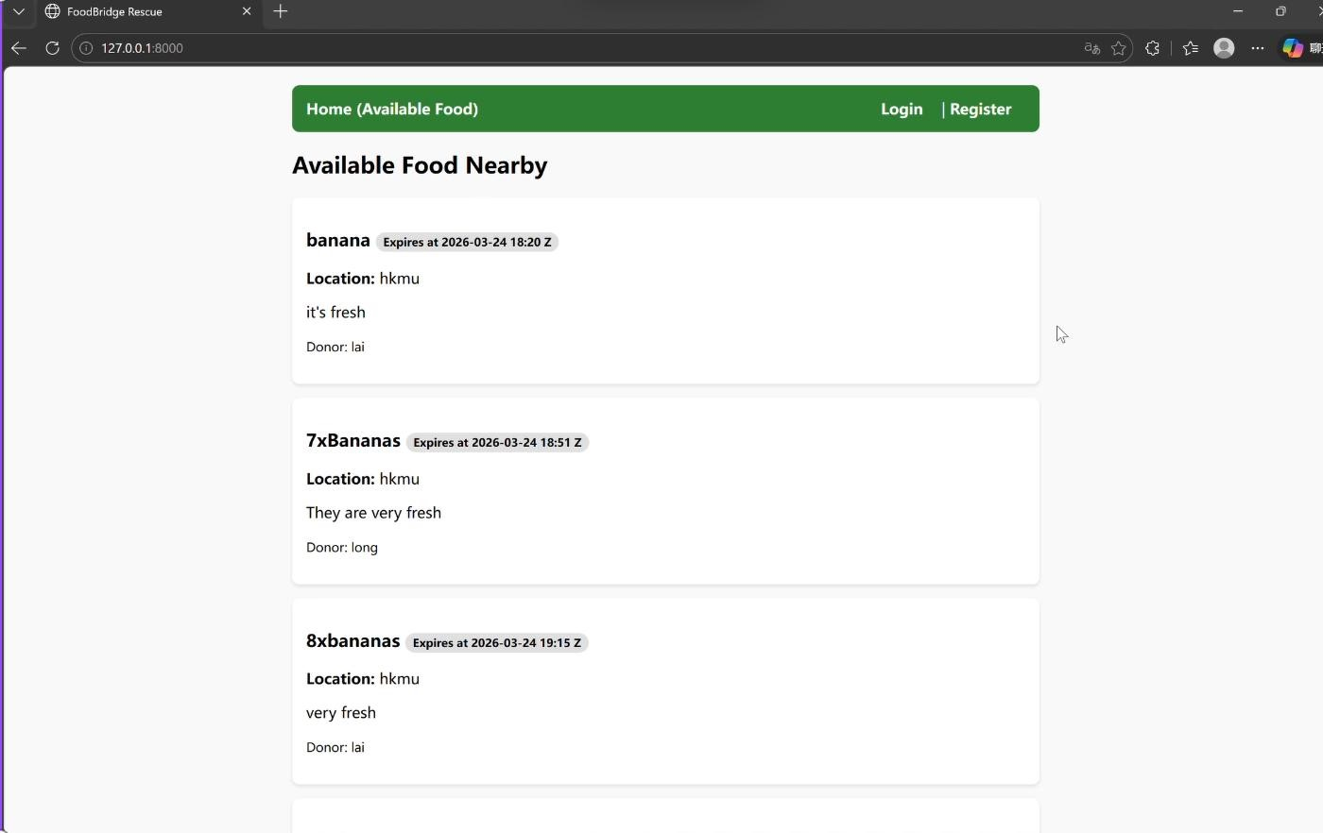
Appendix E Project Demonstration with Test Cases

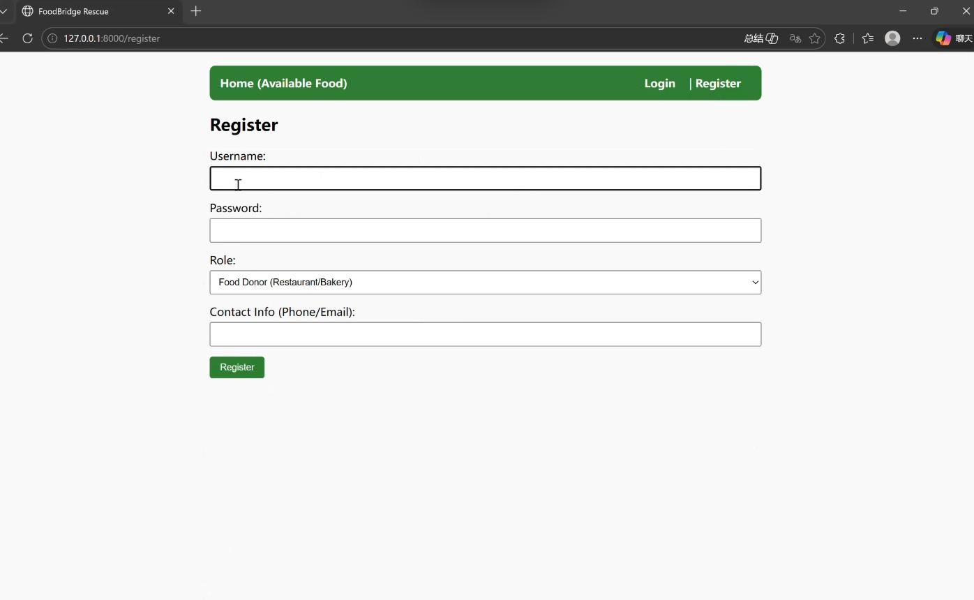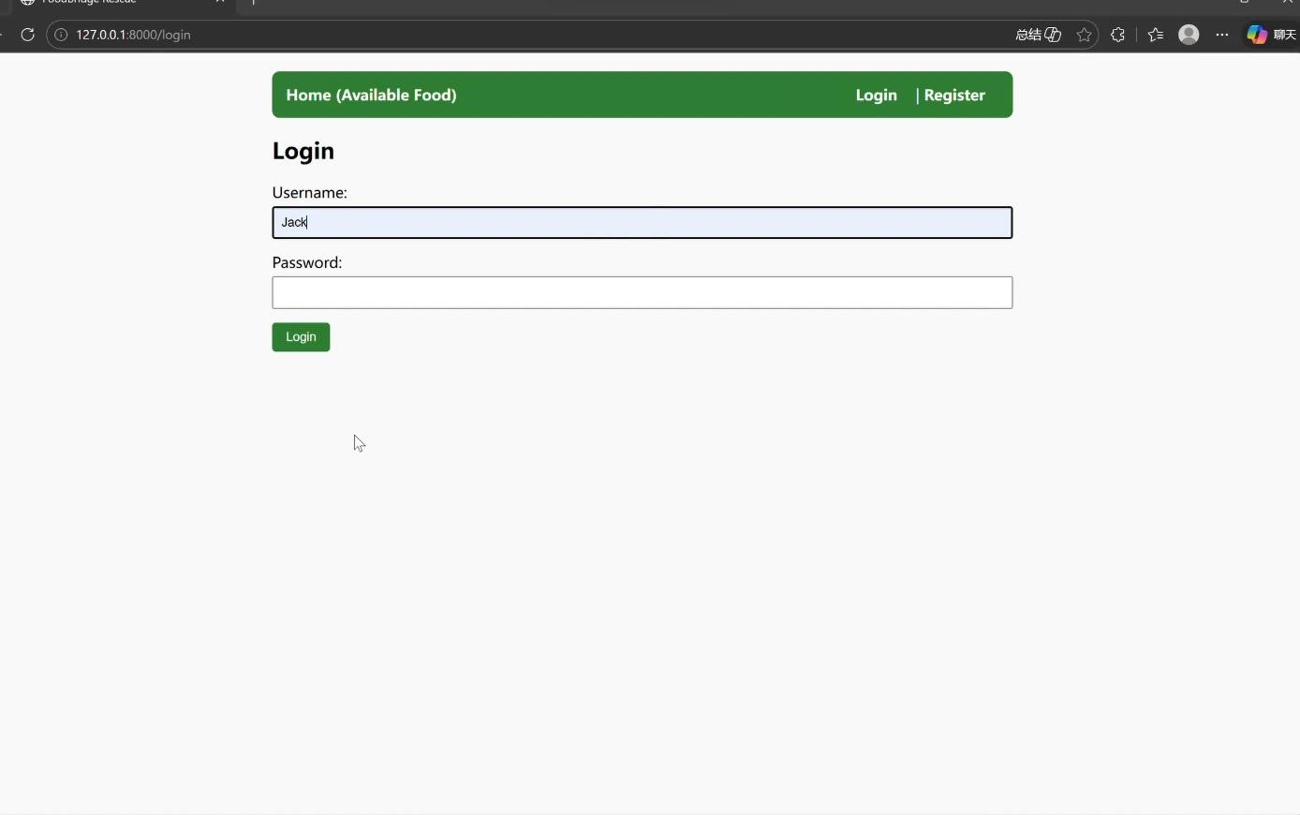
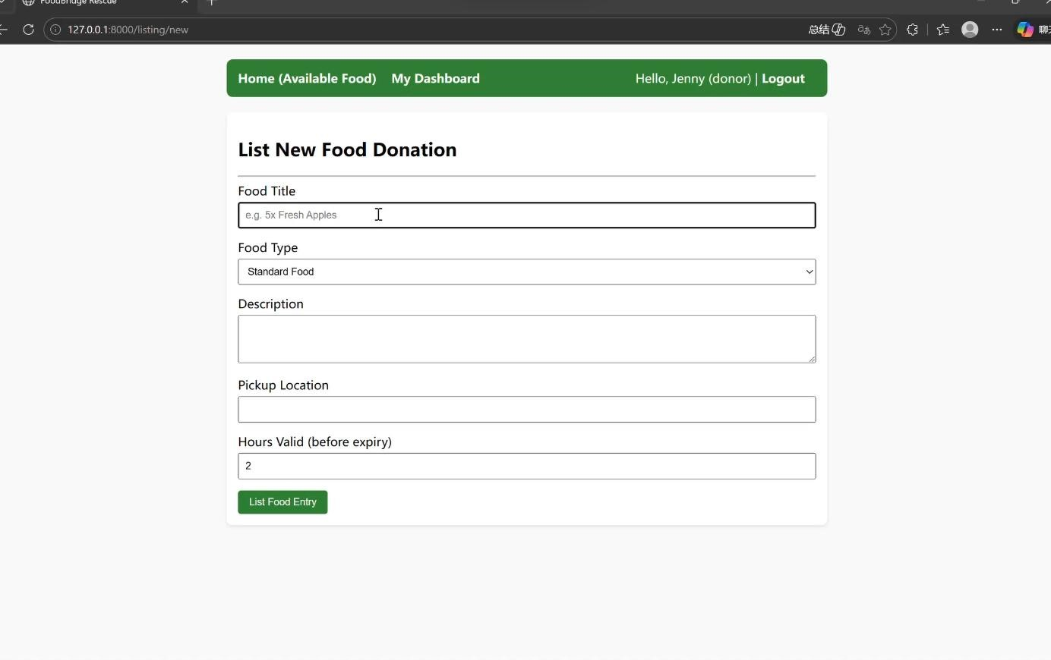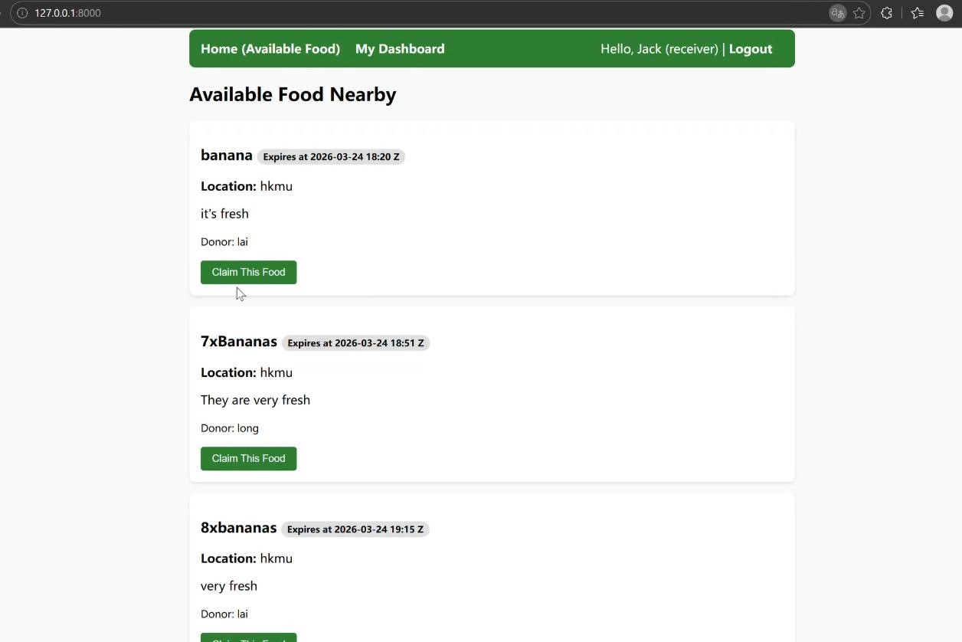
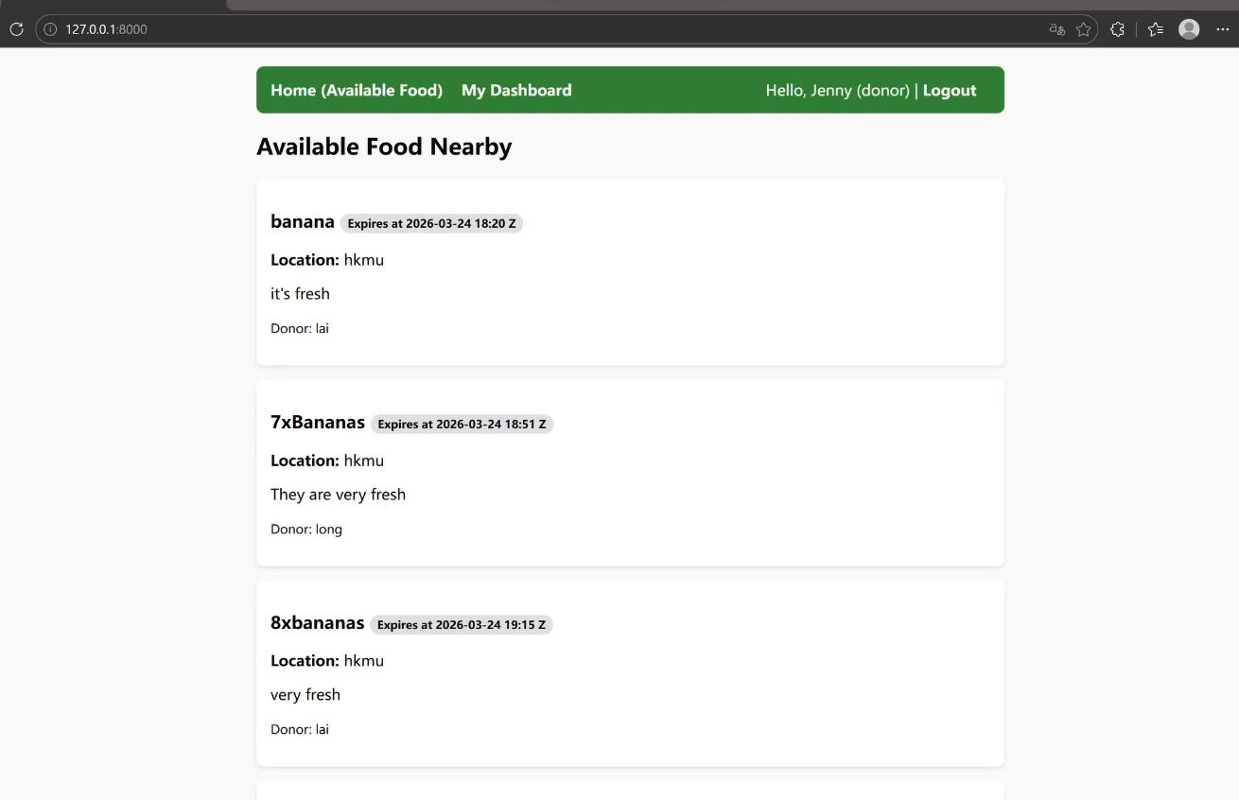

Appendix F
Contributor | Detailed Contribution | Percentage
Lai Yutao | Designed project architecture; implemented Flask routing, user authentication, and database models; completed core OOP design (encapsulation, inheritance, polymorphism). | 33.3%
Long Enze | Developed food listing & claim workflow; implemented factory/singleton/strategy patterns; built notification service layer; tested system functions. | 33.3%
Zhang Wancen | Wrote full project report; organized academic declaration & references; designed UML diagrams; summarized weaknesses & future improvements; finalized document formatting. | 33.4%

