**Statistical Inference**  
*Francois Chevallier*

**Overview:**

In this study, we are going to analyse the exponential distribution and compare it to the Central Limit Theorem.

The Central Limit Theorem (or CLT) states that the sampling distribution of the mean of any independent random variable will be (nearly) normal.

Through this analysis, we will simulate the exponential distribution in R with the following parameters:

* n
* lambda

**Study:**

We set up the parameter:

library(ggplot2)

set.seed(123)

lambda <- 0.2

n <- 40

simulationNumber <- 1000

expdistrib <- matrix(data=rexp(n*simulationNumber, lambda), nrow=simulationNumber)

expdistribMeans <- data.frame(means=apply(expdistrib, 1, mean))

Let’s represent the exponential distribution:

qplot(expdistribMeans$means, geom="histogram")

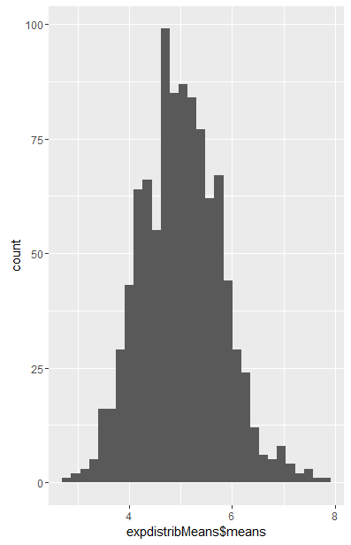

The theoretical mean value is:

mu <- 1/lambda

Mu

5  
  
The mean found is:

themean <- mean(expdistribMeans$means)

themean

5.011911

The theoretical standard deviation is:

sd <- mu/sqrt(n)

sd

0.7905694

The practical standard deviation is:

sdX <- sd(expdistribMeans$means)

sdX

0.7802751

The variance is:

variance <- sd^2

variance

0.625

The practical variance is:

varX <- var(expdistribMeans$means)

varX

0.6088292

As the figures can tell, the CLT seems to be true for n=1000.  
  
We could finally represent the normal and exponential distribution on the same plot:

g = expdistribMeans$means

m=5

std=0.625

hist(g, density=20, breaks=20, prob=TRUE,

+ xlab="means", ylim=c(0, 1),

+ main="normal curve over histogram")

curve(dnorm(x, mean=m, sd=std),

+ col="darkblue", lwd=2, add=TRUE, yaxt="n")

