**Effect of vitamin C on Guinea Pigs toothgrowth**

*Francois Chevallier*

**Purpose:**

The purpose of this study is to determine if vitamin C could have an significant impact on the toothgrowth on population of Guinea Pigs.

First of all, we are going to proceed to some basic exploration of the data.

The dataset ToothGrowth included in R is composed of 3 variables:

* len (tooth length in mm)
* supp (OJ or VC)
* dose (0.5, 1, 2)

Moreover the ToothGrowth dataset gathers records for 60 Guinea Pigs.

Let’s visualise the tooth lengths for each supp depending on the different dose tested:

library(ggplot2)

library(diplyr)

library(broom)

library(wesanderson)

library(grid)

data=ToothGrowth

## ggplot(data, aes(as.factor(dose), len)) + geom_boxplot(aes(fill = as.factor(dose)))+ facet_grid(.~supp)+ xlab('Dose')+ ylab('Length')+ ggtitle('Length by supp and dose')+ scale_fill_manual(values = wes_palette("GrandBudapest"))+ theme(legend.position = "none")

## 

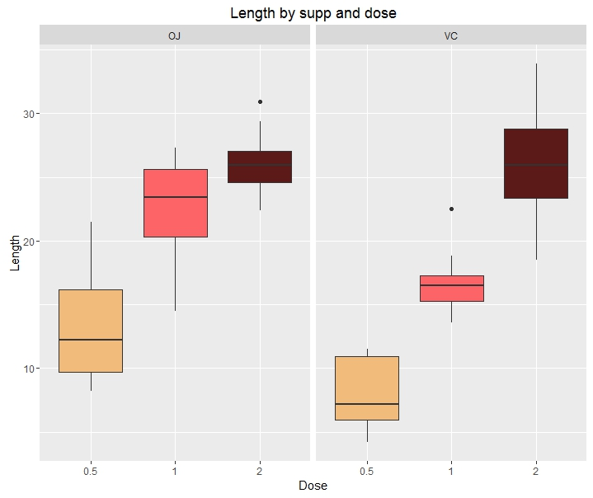

It seems that in average, pigs that have received OJ instead of VC have longer teeths.

**Testing:**

As our population is small (30 *2) we’ll consider a T-distribution for our tests. Note that we’ll assume that the data is normally distributed and all the pigs were independently dispatched between groups.

T-test 1 will verify if there is a statistically significant difference between the two kinds of supp.

Our null hypothesis will be that there is no difference.

Tsupp <- t.test(len ~supp, data, var.equal = FALSE)

tidy(Tsupp)

estimate estimate1 estimate2 statistic p.value parameter conf.low conf.high method alternative

1 3.7 20.66333 16.96333 1.915268 0.06063451 55.30943 -0.1710156 7.571016 Welch Two Sample t-test two.sided

With a p-value superior to 0.5, the null hypothesis couldn’t be rejected, so no difference could be denoted.

T-test 2 will verify if there is a statistically significant difference between the three kinds of dose.

We’ll proceed by paired analysis:

* 1mg/0.5mg
* 2mg/1mg
* 2mg/0.5mg

Our null hypothesis will be that there is no difference.

Tdose<-t.test(data$len[data$dose == 1],

+ data$len[data$dose == 0.5]) %>%

+ tidy%>%

+ mutate(

+

+ null_hypothesis='µ1mg - µ0.5mg = 0'

+ ) %>%

+ select (9, 1:8)

Tdose<-t.test(data$len[data$dose == 2],

+ data$len[data$dose == 1]) %>%

+ tidy%>%

+ mutate(

+

+ null_hypothesis='µ2mg - µ1mg = 0'

+ ) %>%

+ bind_rows(Tdose, .)

Tdose<-t.test(data$len[data$dose == 2],

+ data$len[data$dose == 0.5]) %>%

+ tidy%>%

+ mutate(

+

+ null_hypothesis='µ2mg - µ0.5mg = 0'

+ ) %>%

+ bind_rows(Tdose, .)

print.data.frame (Tdose)

1 Welch Two Sample t-test 9.130 19.735 10.605 6.476648 1.268301e-07 37.98641 6.276219 11.983781 <NA> <NA>

2 Welch Two Sample t-test 6.365 26.100 19.735 4.900484 1.906430e-05 37.10109 3.733519 8.996481 two.sided µ2mg - µ1mg = 0

3 Welch Two Sample t-test 15.495 26.100 10.605 11.799046 4.397525e-14 36.88259 12.833833 18.156167 two.sided µ2mg - µ0.5mg = 0

This time the small p values enable us to reject the null hypothesis.

In a nutshell, the different T-tests enable to conclude that contrary to the type of supp, the dose can have an impact on the tooth growth.