Objective:
The goal of this assignment is to create a simple e-commerce website using HTML5, CSS3, and JavaScript. The website will include basic functionalities such as login, registration, a product list, a shopping cart, and the generation of an invoice. Additionally, the project will involve storing user information in localStorage, manipulating arrays and objects, and implementing functions that show:
1. Frequency of users based on gender and age group.
2. A summary of all invoices.

Assignment Requirements
You are encouraged to choose one of the IA#2 projects submitted (by any of your group members) as the topic going forward for the group project. Save all project folders ie. HTML, CSS, JS, Assets in a single folder using the format ie. company name + day/time of lab class, eg Porcche Mon9am.

User Authentication (LocalStorage)

Registration Page:

create a registration form where users can enter their first name, last name, date of birth, gender, phone number, email, tax registration number (trn), and password, etc.

Validate the form to ensure:

all fields are filled (HTML validation).

passwords should be at least 8 characters long.

visitor must be over 18 years old to register. Calculate using JavaScript.

trn is unique; must be of length and in the format (000-000-000). **trn is used instead of a username with login.
    - store registration information (ie. first name, last name, date of birth, gender, phone number, email, tax registration number (trn), password, date of registration, cart{}, invoices[]) as a JavaScript object. Each registration record must be appended to localStorage key called RegistrationData using JavaScript (as an array of objects.)
Include the following buttons:
    - Register (used to stored registration form data)
    - Cancel (used to clear data from the registration form)

  - Login Page:
    - create a login form where visitors can enter their trn and password provided at registration.
    - validate this login data by checking the currently entered trn and password against data associated with the localStorage key called, RegistrationData.
    - a visitor is given three (3) attempts to enter a correct trn and password. If login is successful, redirect the user to the product catalog. Otherwise, redirect the user to an error/account locked page.
Include the following:
    - Login button (validate user login information)
    - Cancel button (used to clear data from the Login form)
    - Reset Password hyperlink (used to allow the user to change their password that is associated with the localStorage key called, RegistrationData by matching their trn.

- Product Catalogue:
  - Product List (Using Arrays & Objects)
    - Create an array of product objects in JavaScript. Each product should have:
`name`
`price`
`description`
`image`
  - An updated product list must be kept on localStorage, as AllProducts.
  - Display the product list dynamically on the website.
  - Each product should have an “Add to Cart” button.
  - Add to Cart:
    - Shopping Cart (localStorage and Objects)
      - When a user clicks the “Add to Cart” button, add the selected product to the user’s shopping cart.
      - Shopping cart must include,{ product details} along with the {taxes, discounts, subtotal and current total cost}.
- Cart Page:
  - Create a shopping cart page that lists the items in the cart (name, price, quantity, sub-total, discount, tax, and total, etc).
  - Allow users to remove items from the cart and update quantities.
  - Calculate and display the total price of the items in the cart.
Include:
  - Clear All button (remove all items from shopping cart)
  - Check Out button (redirects to Checkout Page)
  - Close button (close the shopping cart view)

- Checkout Page:
Checkout
  - Show a summary of the shopping cart with the total cost.
  - Allow the user to enter their shipping details (e.g., name, address, amount being paid).
  - When the user confirms the checkout, generate an invoice.
Include:
  - Confirm button (confirms the checkout)
  - Cancel button (go back to the cart)

- Invoice Generation:
  - After checkout, generate an invoice with the following details:
`Name of company`
`Date of invoice`
`Shipping information` (from checkout)
`Invoice number` (unique)
‘trn’
`Purchased items` (name, quantity, price, discount)
`Taxes`
`Subtotal`
`Total cost`
  - Append this invoice to the user’s array of invoices (array of objects). Also store the invoice to localStorage with the key called AllInvoices (as an array of objects) to access later.
After generating the invoice
  - Optionally, display a message indicating that the invoice has been “sent” to the user’s email.

- Additional Functionality:
  - ShowUserFrequency() – Show’s user requency based on Gender and Age Group:
    - show how many registered users fall under specific gender categories (e.g. Male, Female, Other)
    - show how many registered users fall under different age groups (e.g., 18-25, 26-35, 36-50, 50+).
    - Display this data on a dashboard or a separate page.
  - ShowInvoices() - displays all invoices and allow the visitor to search for any of the invoices (using trn) stored in AllInvoices from localStorage using console.log().
  - GetUserInvoices() – displays all the invoices for a user based on trn stored in the localStorage key called, RegisterData.

Notice
JavaScript can change the body of a container tag like <div></div> or <span></span> by using the innerHTML property like: document.getElementById(id).innerHTML = <string> where string can be any set of HTML tags and content you want to see in that container and your container must have an id attribute for JavaScript to identify and change it. Also note that a small pixelated JPEG or PNG image can be stretched horizontally to any size without losing its consistency in HTML5 using img’s width attribute as can be seen below.
<img src=”./thinbar.jpg” width=”20px”/> | <img src=”./thinbar.jpg” width=”100px”/>

With this knowledge, you are to create a function called ShowUserFrequency() which will display two frequency bar charts based on age group, and gender . Your first chart is to show a frequency chart on gender (how many females to males are in the system). Your second chart is to show the frequency chart age-group (e.g., 18-25, 26-35, 36-50, 50+).

Technical Requirements
- Frontend (HTML5 & CSS3):
  - HTML5: Structure your website using semantic HTML elements (e.g., forms, divs, sections, etc.).
  - CSS3: Style your website using CSS for layout, buttons, forms, and product grid, etc. Only 40% or less of your code is allowed to be from a CSS Framework, eg Bootstrap. The remaining 60% must be vanilla css code.
  - Design for at least two (2) different screens eg. mobile and desktop (eg Media Query, FlexBox, Grid, etc).
  - Materials UI, and Google Fonts are allowed.
- JavaScript:
Use JavaScript to manage:
  - User authentication (registration and login).
  - Product listing (arrays and objects).
  - Shopping cart functionality (localStorage).
  - Invoice generation and data storage in localStorage.
  - Functions to analyze user frequency and display all invoices.
  - Manipulate HTML and CSS features.
  - Events and Event Handlers
- LocalStorage:
  - Store and retrieve user data, cart items, and invoices using localStorage.
  - Use JSON methods (`JSON.stringify()` and `JSON.parse()`) to handle arrays and objects in localStorage.
--------------

Assignment Steps
1. Create Basic Pages:
- `product.html` (Product List)
- `register.html` (User Registration)
- `index.html` (User Login)
- `cart.html` (Shopping Cart)
- `checkout.html` (Checkout)
- `invoice.html` (Invoice)
- `dashboard.html` (User Frequency & Invoice List)

2. Design Layout:
- Use CSS to style the website and make it responsive.

3. Implement JavaScript:
- Create arrays and objects to store product and user data.
- Use localStorage for persistent data (cart, invoices, and user data, etc).
- Write functions for login, registration, adding to cart, invoice generation, and displaying
user statistics.

4. Test Functionality:
- Test user registration and login.
- Test the shopping cart, checkout, and invoice generation.
- Test the functions that display user statistics and all invoices.
---------

Submission Guidelines:
- Submit your project files (ie HTML, CSS, JavaScript, Assets) in a ZIP folder on Moodle no later than Thursday, November 21st, 2024 at 11:59PM. Folder name format company name + ”day time of class eg. Porcche Mon9am
- Ensure that the project works correctly in Chrome browser.
- Ensure that your code is commented with each group member’s details, describing user
defined js functionalities.
- Include a **README** file with instructions on how to run the project; login credentials,
all group members details, all frameworks and tools used, etc.
- You must include the question number and the question instructions as comments above
the js code. See Fig. 1 below
Fig. 1 - Example on how to comment your JS code:
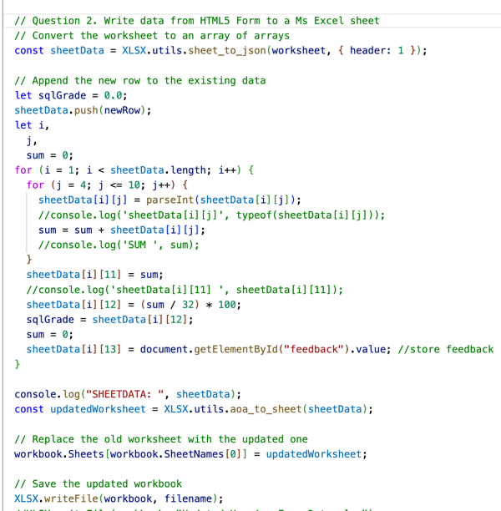

---------

Grading Criteria:
- Wireframes/Mockups, SiteMap due in Week of November 4th, 2024. Submitted via
Moodle and presented (by 1 member of the group on behalf of the group) during
tutorial/lab session. Wireframes can be done using any tool of your choice. 10 marks
- Clear and user-friendly design (HTML5/CSS3) based on wireframes presented in week
of Nov. 4th. 10 marks
- Successfully using frameworks and tools to enhance design and functionality. [5 marks]
- Code readability and structure, including comments. 5 marks
- Each student must be present for an online presentation and interview in the week the
assignment is due. Failure to part-take in the interview with your tutor will result in a
zero (0) grade.
- Your group details must be on the class group project team tracker (excel sheet).

Rubric
