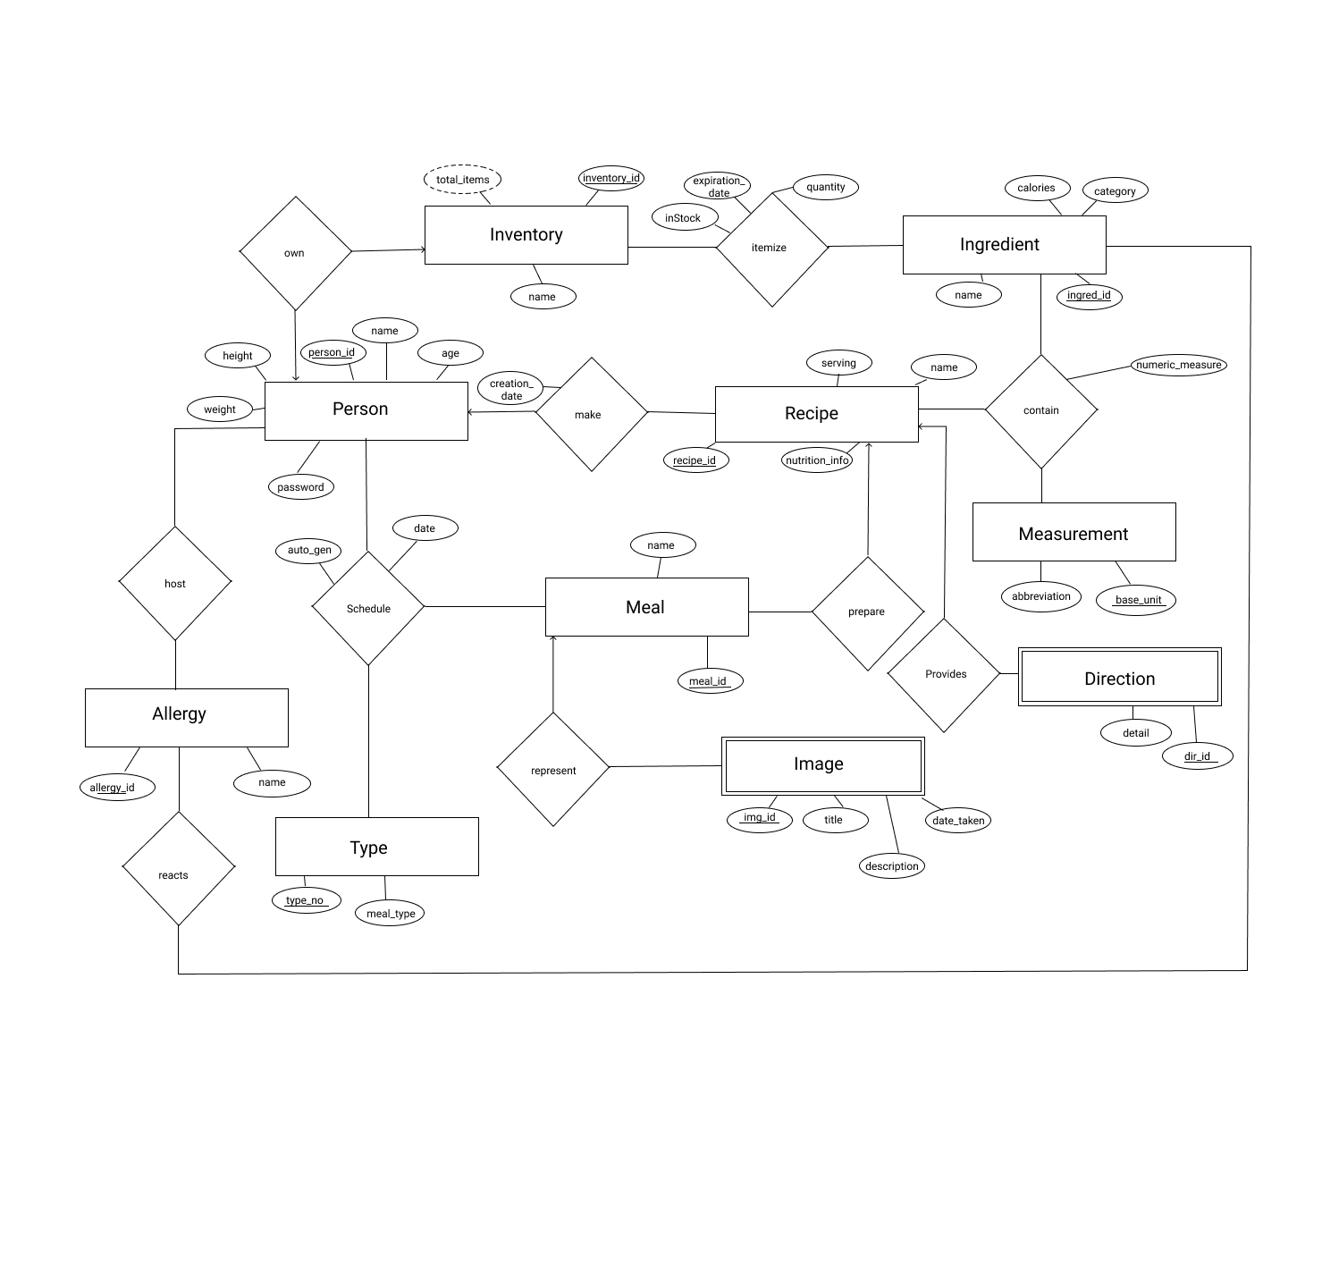

**Tables before normalization**

**Strong-Entities**

Person( person_id , name, age, height, weight )

Recipe( recipe_id , name, calories, nutrition_info )

Inventory( inventory_id )

Ingredient(ingred_id , name, category , calories )

Measurement(base_unit , abbreviation )

Meal ( meal_id , name, serving , calories)

Allergy ( allergy_id , name)

Type( type_no , meal_type )

**Weak-Entities**

Direction(recipe_id , dir_id , step, detail )

Image ( meal_id , img_id , title , description )

**Relationships**

own( person_id , inventory_id )

itemize( inventory_id , ingred_id , quantity, inStock , expiration_date)

make( person_id , recipe_id , creation_date )

contains( recipe_id , ingred_id, base_unit , numeric_measure)

host( person_id , allergy_id )

schedule( person_id , meal_id , type_no, date, auto_gen)

prepare( recipe_id , meal_id )

provides(recipe_id , dir_id)

represent(meal_id , img_id, date_taken)

reacts(allergy_id , ingred_id , food_category )

**Functional Dependencies**

|  |  |
| --- | --- |
| Table Name | Functional Dependency |
| Person | person_id 🡪 name, age, height, weight |
| Recipe | recipe_id 🡪 name, calories, nutrition_info |
| Inventory | inventory_id 🡪 total_items |
| Ingredient | ingred_id 🡪 name, category, calories |
| Measurement | base_unit 🡪 abbreviation |
| Meal | meal_id 🡪 name, serving, calories |
| Allergy | allergy 🡪 name |
| Direction | recipe_id , dir_id 🡪 step, detail |
| Image | meal_id , img_id 🡪 title , description , date_taken |
| Own | person_id 🡪 inventory_id |
| Itemize | inventory_id, ingred_id 🡪 quantity, inStock, expiration_date |
| Make | person_id , recipe_id 🡪 creation_date |
| Contains | recipe_id , ingred_id , base_unit 🡪 numeric_measure |
| Host | person_id , allergy_id 🡪 person_id , allergy |
| Schedule | person_id, meal_id , type_no 🡪 auto_gen , date |
| Prepare | meal_id , recipe_id 🡪 meal_id , recipe_id |
| Reacts | allergy_id , ingred_id 🡪 allergy_id , ingred_id |

**Normalized Tables**

Recipe( recipe_id , name, serving, calories, nutrition_no)

Nutrition (nutrition_no , calories , total_fat , sugar , sodium , protein , saturated_fat )

**Data Dictionary**