CAMPUS ENERGY
OPTIMIZATION ANALYZER
Exploratory Data Analytics and Anomaly Detection
for Campus Building Power Demand
PROJECT REPORT
IBM SkillsBuild
Data Analytics with AI
October 2026

Abstract
This project analyzes historical electrical power data from multiple buildings on an academic campus using Python-based exploratory data analytics. The objective is to understand building-level demand, identify high-demand periods, detect statistically unusual demand hours, examine relationships between building power patterns, and create an action-priority ranking for energy optimization. The study uses the I-BLEND campus-scale energy dataset and focuses on data cleaning, descriptive statistics, time-based aggregation, anomaly detection, correlation analysis and visualization. The results indicate that the Academic building has the highest average available power demand, while the typical campus demand profile reaches its highest average level around 6:00 AM. Academic and Mess buildings are major contributors during high-demand periods.

1. Introduction
Campus electricity demand is distributed across buildings with different purposes, schedules and operating patterns. Academic spaces, hostels, libraries, dining facilities and support buildings can therefore contribute differently to demand. Data analytics can convert large volumes of meter readings into understandable patterns that support energy-management decisions.
The project follows the flow Data → Information → Insights → Decision → Action. It emphasizes historical analysis and anomaly detection rather than prediction.

2. Problem Statement
Campus energy managers may have large volumes of meter data but still need clear answers to practical questions: which buildings have higher average demand, when demand is highest, which periods are unusually high, which buildings contribute during those periods, and where optimization efforts could be prioritized.

3. Objectives
- Structure and clean multi-building electrical power data.
- Compare average power demand across campus buildings.
- Identify the typical peak hour in the campus demand profile.
- Detect unusually high hourly demand using the IQR method.
- Measure building contributions during high-demand periods.
- Examine relationships between building power patterns using correlation analysis.
- Create an analytical action-priority ranking.
- Convert findings into practical recommendations.

4. Dataset
The project uses I-BLEND, a campus-scale commercial and residential buildings electrical energy dataset from an academic institute campus in India. The source paper describes 52 months of electrical energy data at one-minute sampling, with supplementary occupancy, calendar, building and weather resources. The present project uses the combined energy file.
Item | Project value
Records analyzed | 2,310,568
Power columns | 9 building/meter columns
Sampling in source | 1-minute electrical measurements
Main fields | Timestamp + building power readings
Source | Figshare / I-BLEND
License | CC BY 4.0

Buildings analyzed: Academic, Boys Main, Boys Backup, Facilities, Girls Main, Girls Backup, Lecture, Library and Mess.

5. Tools and Technologies
- Python 3.x
- Pandas
- NumPy
- Matplotlib
- VS Code

6. Methodology
The workflow converts Unix timestamps into readable date-time values, uses time as the series index, checks missing values and data-quality issues, performs descriptive and time-based analysis, detects statistical high-demand anomalies, examines building relationships and creates an action-priority score.
Stage | What was done
Structure | Converted Unix timestamps and set time index
Cleaning | Checked missing values, duplicates and negative readings
EDA | Compared building averages and descriptive statistics
Time analysis | Aggregated available readings by hour
Anomaly detection | Applied IQR to hourly available campus demand
Relationships | Calculated building-to-building Pearson correlations
Decision support | Created normalized 50:50 priority score

7. Data Cleaning
Short missing gaps were interpolated using time-based interpolation with a limit of 60 observations. Longer gaps were retained rather than filled blindly. There were 0 duplicate timestamps and 0 negative power readings.
Building | Missing before | Missing after
Academic | 41,041 | 37,819
Boys Main | 639,024 | 585,629
Boys Backup | 622,525 | 574,338
Facilities | 261,665 | 242,906
Girls Main | 657,515 | 648,713
Girls Backup | 9,823 | 5,190
Lecture | 41,259 | 37,820
Library | 596,931 | 592,137
Mess | 297,479 | 289,897

8. Exploratory Data Analysis

8.1 Average Power by Building
Academic has the highest average available power reading at approximately 27.79 kW, followed by Mess at 22.20 kW and Boys Main at 17.46 kW.
Building | Average power (kW)
Academic | 27.79
Mess | 22.20
Boys Main | 17.46
Boys Backup | 13.95
Facilities | 10.48
Library | 9.08
Girls Main | 7.31
Girls Backup | 6.88
Lecture | 0.64

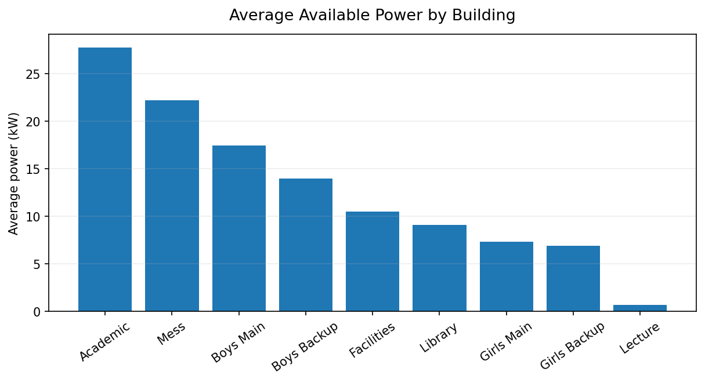
Figure 1. Average available power by building.

8.2 Hourly Demand Pattern
The highest average campus demand occurs at 6:00 AM, approximately 111.93 kW. This is the average sum of available building readings; missing meter readings mean it should not be interpreted as a complete measured campus total.
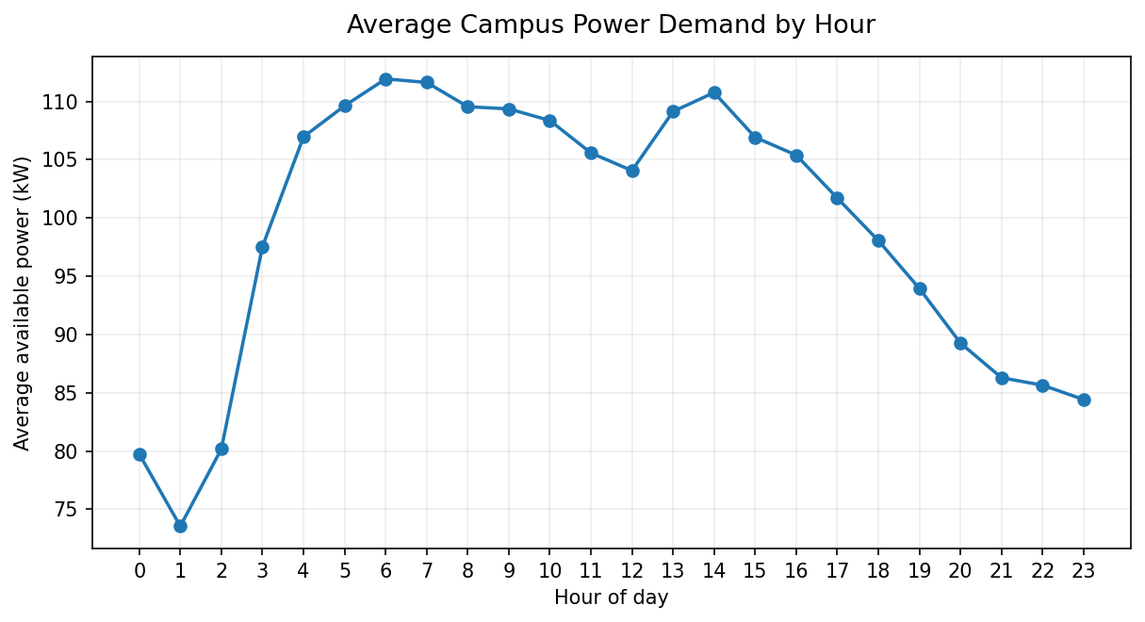
Figure 2. Average campus power demand by hour.

8.3 Peak-Hour Contribution
At 6:00 AM, Academic contributes approximately 39.67 kW, followed by Mess at 24.28 kW and Boys Main at 13.75 kW.

9. Anomaly Detection
The IQR method was applied to hourly available campus demand. The calculated upper threshold was approximately 190.48 kW, with 971 hourly observations identified above this threshold. These are statistical high-demand anomalies and do not automatically represent equipment faults.
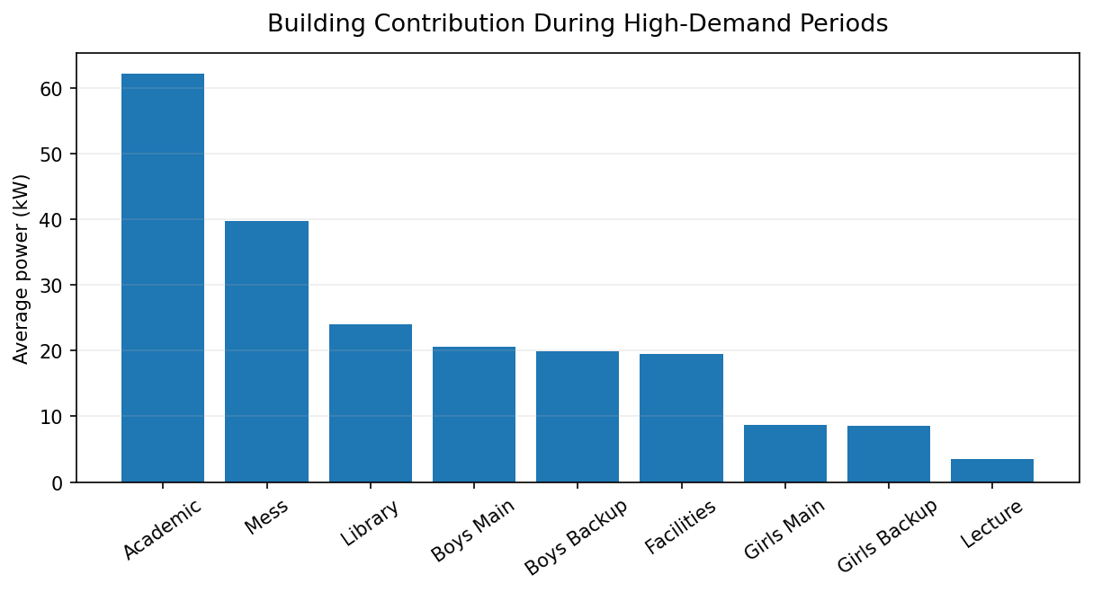
Figure 3. Building contribution during high-demand periods.

10. Correlation Analysis
Pearson correlation was calculated between building power readings. Higher positive values indicate stronger linear association; correlation does not establish causation.
Pair | Correlation
Boys Backup – Girls Backup | 0.84
Academic – Lecture | 0.69
Academic – Library | 0.69
Boys Main – Girls Main | 0.69
Academic – Mess | 0.50
Boys Main – Lecture | -0.08

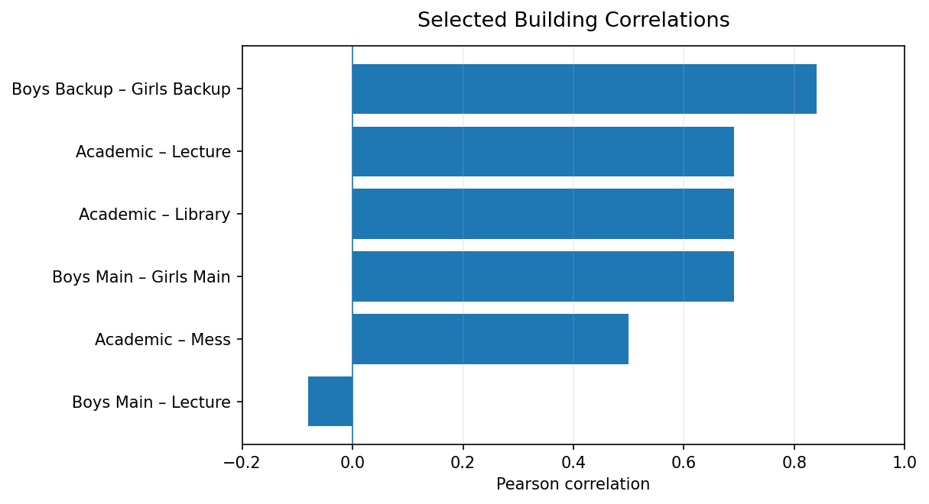
Figure 4. Selected building correlations.

11. Action Priority Ranking
The project combines normalized average power and normalized anomaly-period contribution with equal 50:50 weighting. This is a project-defined decision-support score, not a value supplied by the dataset.
Building | Avg kW | Anomaly kW | Score | Priority
Academic | 27.79 | 62.16 | 100.00 | High
Mess | 22.20 | 39.78 | 71.93 | High
Boys Main | 17.46 | 20.65 | 48.02 | Medium
Boys Backup | 13.95 | 19.88 | 41.09 | Medium
Library | 9.08 | 24.00 | 35.63 | Low
Facilities | 10.48 | 19.50 | 34.54 | Low
Girls Main | 7.31 | 8.67 | 20.14 | Low
Girls Backup | 6.88 | 8.57 | 19.28 | Low
Lecture | 0.64 | 3.55 | 4.01 | Low

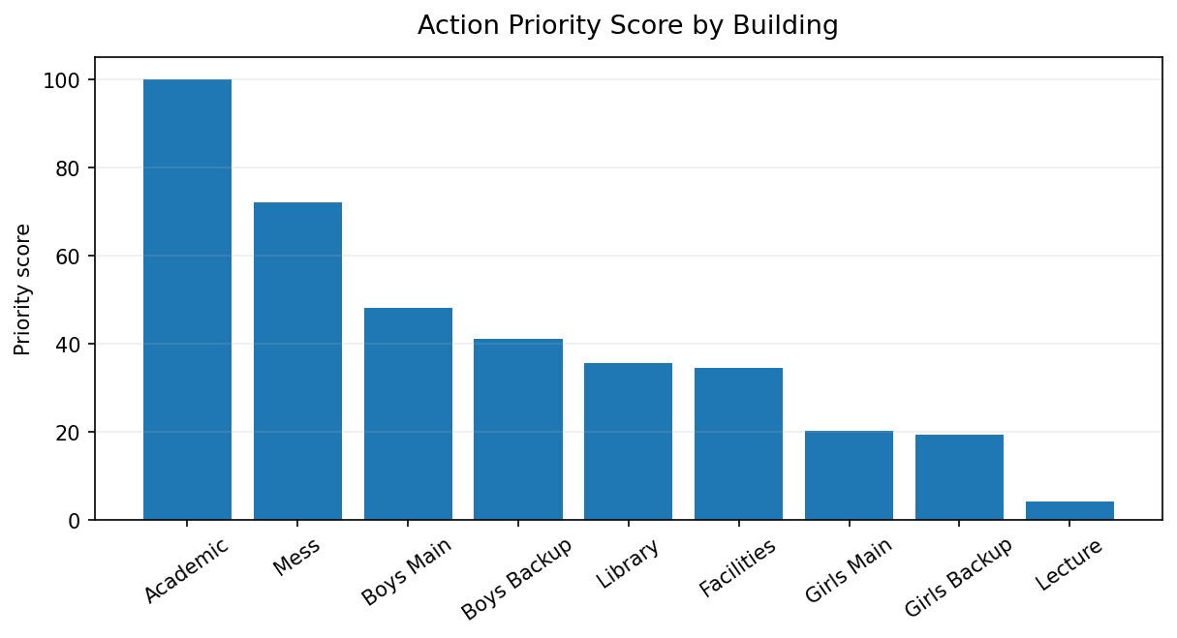
Figure 5. Analytical action-priority ranking.

12. Key Findings
- Academic has the highest average available power demand (27.79 kW).
- Mess is the second-highest average-demand building (22.20 kW).
- The highest average hourly campus demand occurs around 6:00 AM (111.93 kW).
- Academic and Mess are the largest contributors during identified high-demand periods.
- Boys Backup and Girls Backup have a strong positive correlation of 0.84.
- The priority score places Academic and Mess in the High category.

13. Recommendations
- Investigate operating conditions and equipment schedules in the Academic building during high-demand periods.
- Review energy use in the Mess around repeated high-demand periods.
- Check repeated anomalies before treating them as operational faults.
- Use building-level monitoring to focus energy-efficiency assessments.
- Combine energy data with occupancy, weather and academic-calendar information.
- Validate the operational cause before applying targeted energy-saving measures.

14. Limitations
- Some meters contain substantial missing data, so campus-level sums use available readings.
- Short gaps were interpolated but long gaps were retained.
- IQR anomalies are statistical flags, not fault diagnoses.
- The priority score is a project-defined ranking, not a formal energy audit.
- Occupancy, weather and academic-calendar data were not included in the current analysis.

15. Future Scope
- Integrate occupancy data.
- Add local weather variables.
- Compare working, non-working and high-activity periods using the academic calendar.
- Develop demand-forecasting models.
- Explore machine-learning-based anomaly detection.
- Build an interactive Power BI dashboard.

16. Conclusion
The Campus Energy Optimization Analyzer demonstrates how a large time-series energy dataset can be transformed into decision-oriented information. The analysis covers cleaning, descriptive statistics, time-based aggregation, anomaly detection, correlation analysis and action prioritization. Academic and Mess emerge as important areas for further investigation, while the results also show that demand varies across buildings and times of day.

17. Dataset Attribution and Reference
Rashid, H., Singh, P., & Singh, A. (2019). Data Descriptor: I-BLEND, a campus-scale commercial and residential buildings electrical energy dataset. Scientific Data, 6, 190015. DOI: 10.1038/sdata.2019.15.
Dataset collection DOI: 10.6084/m9.figshare.c.3893581.v1. The original dataset is distributed under the Creative Commons Attribution 4.0 International (CC BY 4.0) license. The original authors and source should be credited when the dataset or derived analysis is reused.
— End of Report —

