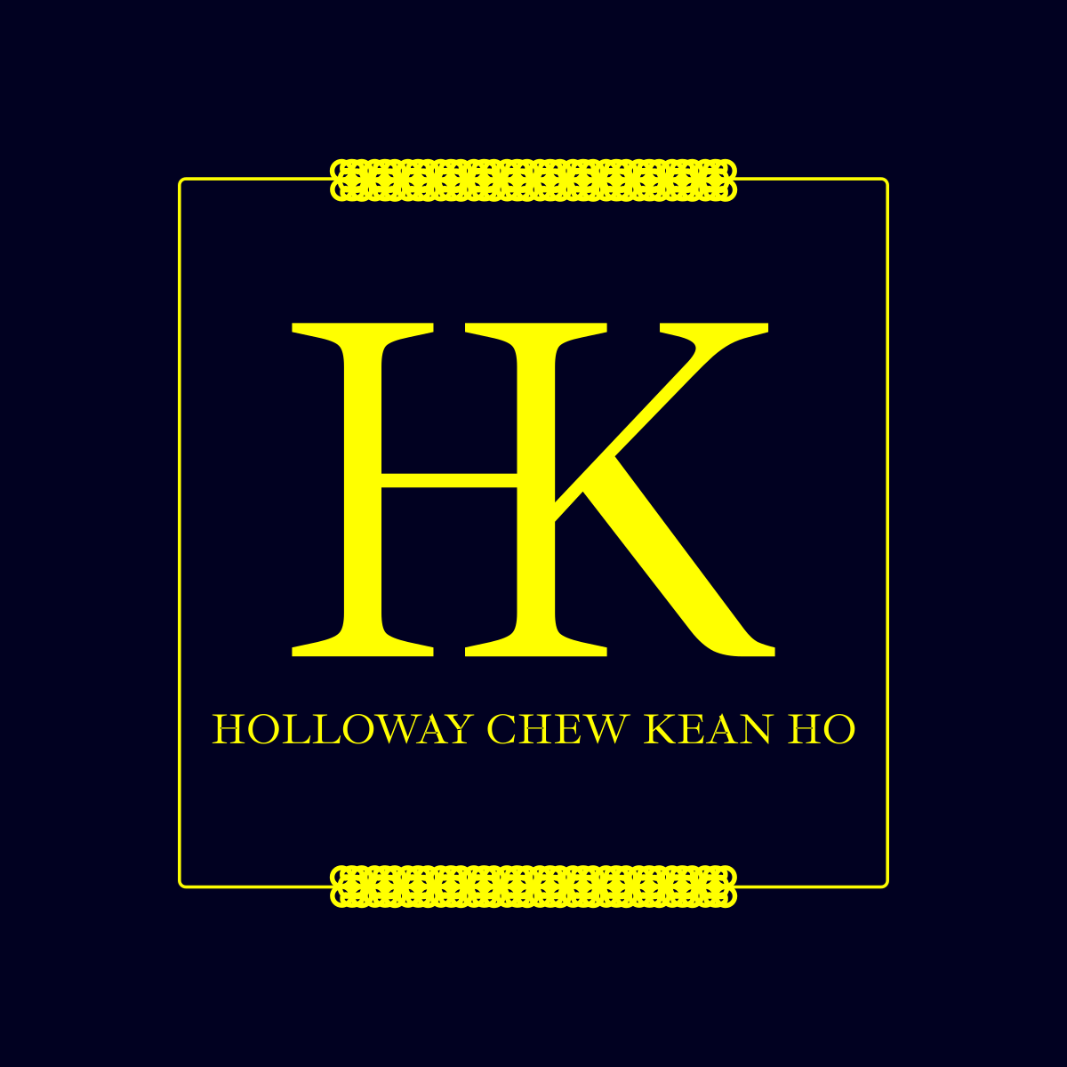

(Holloway) Chew, Kean Ho’s

Proprietary License 1.0
Covering all terms and conditions for this license

ID:
chewkeanho-proprietary-1.0

Version:
v1.0.0

By:
(Holloway) Chew, Kean Ho
legal@hollowaykeanho.com

For:
Legal Entities Procuring Product subjected to this License

Effective from:
Friday 19 April 2024

Available at:
https://doi.org/10.5281/zenodo.13767361
This Agreement is made on the date and time stipulated by any of the action specified in Section 2 of this License:
BETWEEN
- (Holloway) Chew, Kean Ho (Business Reg. No: 202403160286) of Seri Kembangan, Malaysia (hereinafter refers as “HOLLOWAY”)
AND
- YOU, where you’re a legally liable entity of whatsoever description including but not limited to an individual, a group of individuals, a sole proprietorship, a partnership, a body corporate, governmental bodies and agencies, or otherwise of any kind established under the laws, rules and/or regulations for the time being in force and which may come into force authorized to use one or more (Holloway) Chew, Kean Ho’s Products subjected to these Terms and Conditions herein (hereinafter referred as “CLIENT”)

(CLIENT shall be collectively referred to as “Receiving Parties”)
(HOLLOWAY, and the Receiving Parties shall be collectively referred to as “Parties”)

WHEREAS:
- The Receiving Parties are desirous of appointing HOLLOWAY for one or more Products (as defined in this License). At the request of the Receiving Parties, HOLLOWAY agrees to provide the service of the Product to the Receiving Parties upon the terms and subject to the conditions set out in this License.

NOTE THE PARTIES ARE AGREED as follows:

Definitions

Words importing the singular number includes the plural number and vice versa.

Words importing the masculine gender including feminine.
Account | Means an identifiable and manageable context data container offering one or more Services such as but not limited to Payment report, License Grant, PII references, and Services for You identified as being You to interact with Us directly and indirectly via Our User Interfaces.
Authentication Credentials | Means any confidential and uniquely identifiable information which is a part of PII with access authorization capability such as but not limited to username, email addresses, phone numbers, passwords, 2-factor authentication token and its generator.
Crypto,  Cryptography,  Cryptographic,  Cryptograpically | Means the use of one or more cryptographic algorithms such as but not limited to AES-256, ChaCha20-Poly1305, HMAC, Argon-2i, CAMELLIA, and SHASUM to mutate or seal a given data for achieving one or more, single or combination purposes such as but not limited to confidentiality, integrity, authenticity, availability, and non-repudiation.
Content | Means a literary or artistic property (such as but not limited to a book, title, writing, artwork, images, movie, website, software, or musical composition) that is capable of being printed, copied, sold, licensed, distributed, transformed to another medium, translated, recorded or performed or otherwise use (or not use) and to give it to another by will; and is governed by Copyrights laws of Yours and Ours country of operations and country of residences.
Fair Use | Means the Copyright Acts’ Fair Use governing laws definitions of Yours and Ours country of operations and country of residences.
License | Means the terms and conditions designated in this document agreed by both You and Us.
Grant | Means the specific right permitted and granted by Us with specific details such as but not limited to the type of ability, its effective periods, its limitations and scopes, and Payment details strictly in written document.
Notice | Means all official bill statements, receipts, notices, requests, notice of demands, writ of summons, all other legal processes and/or other communications/documents.
Payment | Means a monetary transactional financial payable amount through any facilitated Payment Method.
Payment Method | Means one or more facilitated official financial monetary exchange channels such as, but not limited to: (i) bank transfer; (2) e-wallet transfer; (3) credit card charging transfer; (4) cash transfer.
PDPA | Means Yours and Ours country of operations’ and country of residences’ personal data protection laws such as but not limited to Malaysia’s Personal Data Protection Act 2010.
PII | Means any personal identifiable information that can distinguish or trace back to an individual's identity, either alone or when combined with other personal or identifiable information that is linked or linkable to a specific individual, such as but not limited to biodata, behavioral data, biometric data, and health data that are protected by PDPA.
Procure | Means the action of obtaining a Product either though the means of Purchase or provided freely by Us.
Purchase | Means the action of obtaining a Product via the means of performing one or more Payment.
Product | Means a purchasable tangible or intangible serviceable goods (not to be confused with Service) such as but not limited to physical products (example: software, computing devices, and clothing) and packaged services (example: data processing services, content creation services, and repair services) offered by Us.
Sensitive Data | Means information that is protected against unwarranted disclosure such as but no limited to PII, Authentication Credentials, or financial data.
Service | Means the required customer services offered by Us in order to deliver a procured Product such as but not limited to logistics, concierge, and etc.
User Interface | Means the end-user interactive facilities designed for You to communicate with the Product and/or Service such as but not limited to web application; web app; mobile app; books; manuals; smart devices; and Our Web Portal.
Web Portal | Means any browse-able Content platforms accessible under the domain name hollowaykeanho.com alongside with all its paths (e.g. www.hollowaykeanho.com/about) and subdomains (e.g. legal.hollowaykeanho.com) of any kinds; or any approved third party domains with verifiable back-linking directly from hollowaykeanho.com.
You, Your | Means the Receiving Parties.
We, Us, Our | Means HOLLOWAY and any of its subsidiaries, affiliates, or successors.

(The following blank spaces in this page is intentionally left empty for the page organization purpose.)

License Assignment, Ratification, and Tenure

This License shall be ratified by You, be effective, and be in-force until terminated according to these Terms and Conditions starting from the explicitly specified actions such as but not limited to:

fulfilling checkbox in web form submission from any of Our supported User Interfaces; OR

procuring the Product from any source be it directly from Ours or a third-party Entity regardless of Ours’ authorizations; OR

using any part of the Content from the Procured Product by any means regardless of any of Our License Grant status with You; OR

actively or passively reading, analyzing, or reverse engineering the Product; OR

performing Payment upon any Product procurement; OR

delivering formal written Notice referencing to this License signed by You to Us; OR

agreement upon any other Product or Service level Terms and Conditions extended from this License specified therein.

You are not permitted to assign or novate any or parts of their rights and obligations under the License to any party without Ours’ written approval.

We may assign or novate all or parts of the License to any third party by written notice without prior consent from You and You shall agree to make all subsequent payments (if applicable) and commitment to Us as instructed in such further notice.

License Suspension & Termination

You may at any time terminate the License by the following actions:

deleted your Account with Us and purged by removing all the Procured Product in possession from Your ecosystem with the absolute intention to refrain from using the Product and move on.

We reserves the right to cancel, withdraw, terminate, or suspend the License for any reason whatsoever at its sole discretion by the way of a written notice to You and You agree that We shall not be liable for such cancellation, withdrawal, termination, and suspension.

Our Rights

We reserves the right to make any alteration or suspending of the License which shall affect any parts of Products without prior notice to You and We shall not be liable for any loss or inconvenience to You resulting therefrom.

We reserves the right at its absolute discretion to vary, add, or otherwise amend any part of the Terms of Conditions of the License such that:

You may or may not be given written notice of such amendments; OR

Your continued use of Products after the effective date of the variation, changes, or amendments to the Terms and Conditions of the License and the same shall constitute an unconditional acceptance of such variation, changes or amendments by You.

In order to protect You and Us from transactions and identity fraud, We reserves the right, at its absolute discretion, not to communicate through any suspicious channels or to ship goods to certain addresses.

We reserves the right to refuse any permission to use the Products to any individual or company for any reason, and may do so without Notice.

We reserves the right to review Your conducts and Contents on compliance with all applicable Terms and Conditions detailed in this License from the usage of the Products.

In lieu with Clause 4.5, where any violation is found, we reserve the right to perform any countermeasures, with or without prior Notice, with or without permission from You, such as but not limited to:

deleting the subjected Contents belonging to You from our Products with or without Notice; AND

ceasing, suspending, and deleting Your Account and its access to our Products definitely or indefinitely; AND

cooperating with local enforcement for any Rules of Laws breaches committed by You.

Your Rights & Responsibilities

You SHALL:

In the absent of any License Grant provisioned by Us to You, You SHALL NOT AND WILL NOT utilize the Products in any means such as but not limited download, read, preview, analyze, reverse engineer, and attack the licensing mechanism until the said License Grant herein is obtained from Us.

agree and ratify that the use of Our Products SHALL NOT be contributed to destruction in any form, any kind, or any consequences such as but not limited to weaponizing the Product both in the Internet and in the physical interactions with the society anywhere in the world with or without malicious intent resulting in death of any living or any property damage or harm to oneself of You, Yours and others.

agree and ratify that the use of Our Product SHALL BE BOUNDED WITHIN the Granted License’s specification such as but not limited to its use authorities, time-frame, and deployment scope ONLY; AND

Contact Us for License Grant’s amendment or extension request in the case of any unspecified justification and uncertainties; AND

provide accurate and complete PII to Us and inform Us immediately of any changes to Your’ PII including electronics and physical addresses and/or employment or business; AND

only use the Products for its specified purposes; AND

complies to all Notices and the instructions within provided by Us; AND

be responsible for all equipment and assets necessary to use the Procured Products and for the security and integrity of all information data transmitted, disclosed, and/or obtained via the use of Ours’ Products; AND

agrees, consents, allows and has no objections to Us in extracting PII or any other data required to be used as evidence in court when necessary; AND

be responsible for all usage and charges for the Procured Products, including to payment and service charges and any related charges related to Us pursuant to this License in a timely manner; AND

be responsible for protecting any Authentication Credentials such as but not limited to username, passwords, 2-factor authentication token and its generator at all times and not releasing to other entities such as third-party or any person; AND

notify Us immediately for any unauthorized usage and/or access to Your PII and Authentication Credentials and all its activities; AND

notify Us immediately for any compromised Authentication Credentials; AND

comply with all applicable laws of Yours’ and Ours’ country of operations and residences related to the use of the Procured Products; AND

take responsible steps to prevent fraudulent, improper, or illegal use of the Procured Products; AND

cease to utilize the Products as may be required by Us; AND

indemnify and shall keep Us indemnified from any loss, damage, liability or expense arising from any claims from libel, privacy and/or copyright infringement, patent, breach of confidence, or breach of any law or regulations whatsoever arising from data transmitted, received or stored via the Products or part thereof and for all claims arising from Your unauthorized use or exploitation of the Products; AND

If You are below 18 years old, that You shall require Your parent or legal guardian’s permission to use any Ours’ Products; AND

Comply with the terms and conditions of this License.

You SHALL NOT:

bypass, remove, deactivate, impair, descramble, decipher, compile, disassemble, or reverse engineer any part or forms of the Ours’ Products; AND

Use, display, mirror or frame any individual elements or whole User Interfaces and its contents, Our name, any of Our trademarks, logos, or other proprietary information without Our written consent; AND

Attempt to probe, scan, breach, or test any vulnerability including security or authentication measures of Our systems or network communications without explicit written approval; AND

Attempt to interfere with Us and Our customers from proper use and actions such as sending malware, ransomware, overloading, flooding, spamming, or mailbombing; AND

Collect and/or store any Sensitive Data from any Our assets without written approval; AND

Impersonate or misrepresent any person or entity including Us; AND

Create, recreate, distribute, or advertise index of any significant portion of the Products without Ours’ written approval.

Risks and Warranty

In the absent of any License Grant provisioned by Us, the Product shall be "AS IS" BASIS, WITHOUT WARRANTIES OR CONDITIONS OF ANY KIND, either express or implied, including, without limitation, any warranties or conditions of MERCHANTABILITY, or FITNESS FOR A PARTICULAR PURPOSE. You’re solely responsible for all the risks associated with your prohibited use.

In the presence of one or more License Grant provisioned by Us, the Product’s warranties and risks coverage shall only comply to the terms and conditions specified in the provisioned License Grant.

We shall not be liable to You or anyone else for any direct, indirect, special, exemplary, and consequential types of losses, injury, damages or whatsoever including but not limited to lost of use, data, revenue or profits, in actions of contract, negligence or other actions arising out or in connection with the use of Products.

We shall not be responsible or liable to any link redirecting to any third party’s Content which is clicked/activated by You from any User Interfaces provided by Us.

We shall not be liable, and You agree to indemnify Us against all claims, losses, liabilities, proceedings, demands, costs, and expenses, including legal fees which may result or which We may sustain in connection with or arising from the Products used by You.

Without prejudice to the forgoing, in the event of a court or tribunal holds Us liable for any breach or default by Us, You agree that the amount damages payable by Us to You shall not at any time exceed the sum of USD300.00 notwithstanding any order, decree, or judgment obtained by You.

Without limiting the generality of any provision in this License, We shall not be liable for any failure to perform its obligations herein caused by an act of God; insurrection or civil disorder; military operations; act of terrorism; emergency; acts or omission of Government or any competent authority; labor trouble or industrial disputes of any kind; fire; lightning destruction; subsidence; explosion; floods; acts of omission of persons or bodies; or any other form of force majeure for whom We has no control over or any cause outside Our reasonable control.

The Products and Services may occasionally be affected by interference caused by objects beyond Our control such as radio interference, room temperature fluctuation, power disruptions, and weather conditions. In the event of such interference, We shall not hold liable for any inability to use or access the affected Products.

License Grants

You acknowledge to contact Us made available in the last section of this License directly for Procuring any of Your desired License Grant from Us.

We can provision one or more License Grant in written format under a single Procurement by You either by the mean of chargeable Payment of 0 (free) or a specified amount of Payment at Ours’ sole discretion.

You agree and ratify to provide Us the required information such as but not limited to basic PII governed by PDPA from both Ours and Yours country of operations or residences for creating Your Account managing Your Procurement and use such as but not limited to Payment, License Grant, the list of requested rights, the number of use, the deployment scope, and the required timeline of use.

Under this License, we provide the following procurable itemized rights that serves Your desired intent of using the Product:

Personal Use Right – authorizing the ability to use the Product for non-commercial deployment; AND

Commercial Use Right – authorizing the ability to use the Product for commercial deployment involving monetary gains in any kind and forms; AND

Representation Right – authorizing the ability to review and market the Product as Our associated marketing affiliation, representing or on behalf of Us outside the Fair Use defined by copyright laws of Yours and Ours country of operations and country of residences; AND

Editing, Update, and Remastering Right – authorizing the ability to edit, update, and enhance the existing Product; AND

Derivative, and Remix Right – authorizing the ability to create a new derivative version of the Product through any means not limited to references or remixes; AND

Patent Right – authorizing the ability to use Our patented intellectual properties of all or parts of the Product; AND

Distribution Right – authorizing the ability to perform logistical delivery of the Product to one or more third-party entity; AND

Redistribution Right – authorizing the ability to retail and to resell the Product to one or more third-party entity; AND

Miscellaneous Right – authorizing the ability not covered under the common rights of the License Grant usually discovered along the deployment timeline that are rectifiable by Us.

Delivery and Acceptance

We shall provision a Cryptographically signed, offline readable and deployable, written License Grant document usually in the common an deployable formats such as but not limited to PDF with ASC certificate that can are transmittable via various online networks and channels upon Your successful Procurement of License Grant.

We shall deliver Your procured License Grant via online transfer such as but not limited to:

make it available on Our Web Portal for directly download; OR

send by email transaction; OR

send by instant messaging such as but not limited to Google Messages, Signal Messenger, Telegram Messenger, or Whatsapp Messenger.

Your License Grant shall be in effect as specified therein.

Payment Terms

Payment can be done through Our specified and available Payment Methods offered via Our supported User Interfaces such as but not limited to Web Portal.

Contact and Support

We are reachable via the following channels:

Email: hello@hollowaykeanho.com

