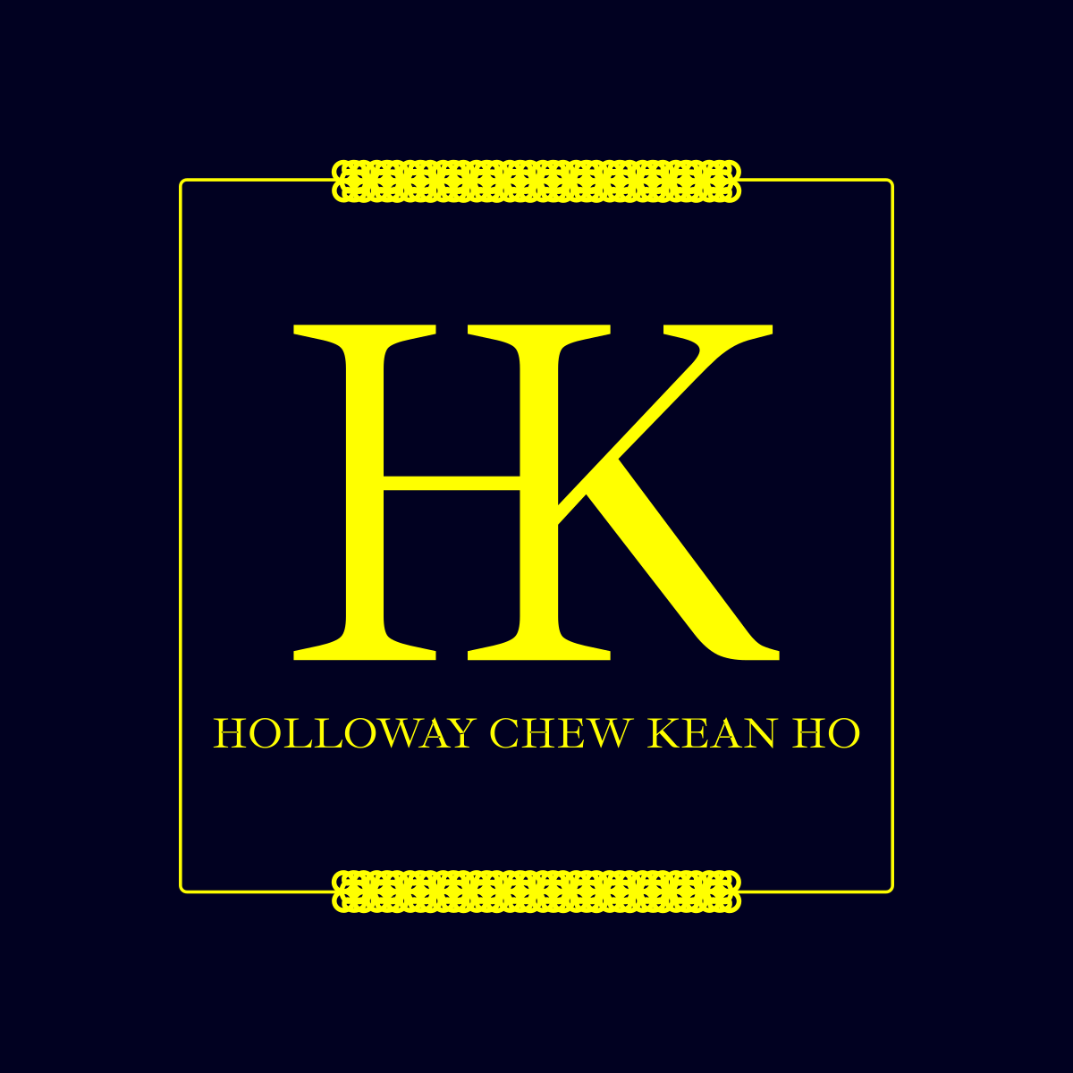

(Holloway) Chew, Kean Ho’s

BSD 3 Clauses License
Covering all terms and conditions for this license

ID:
chewkeanho-bsd-3

Version:
v1.0.0

By:
(Holloway) Chew, Kean Ho
legal@hollowaykeanho.com

For:
Legal Entities Procuring Product subjected to this License

Effective from:
Friday 19 April 2024

Available at:
https://zenodo.org/doi/10.5281/zenodo.13777226

This Agreement is made on the date and time whichever earliest either stipulated or by the first execution of any of the stipulated action specified herein the “Covenant Assignment, Ratification, and Tenure” section of this Covenant:
BETWEEN
- (Holloway) Chew, Kean Ho (Business Reg. No: 202403160286) of Seri Kembangan, Malaysia (hereinafter refers as “HOLLOWAY”)
AND
- YOU, where you’re a legally liable entity of whatsoever description including but not limited to an individual, a group of individuals, a sole proprietorship, a partnership, a body corporate, governmental bodies and agencies, or otherwise of any kind established under the laws, rules and/or regulations for the time being in force and which may come into force authorized to use one or more (Holloway) Chew, Kean Ho’s Products subjected to these terms and conditions herein (hereinafter referred as “CLIENT”)

(CLIENT shall be collectively referred to as “Receiving Parties”)
(HOLLOWAY shall be collectively referred to as “Provisioning Parties”)
(the Provisioning Parties and the Receiving Parties shall be collectively referred to as “Parties”)

WHEREAS:
- The Receiving Parties are desirous of appointing the Provisioning Parties for one or more Products (as defined in this Covenant). At the request of the Receiving Parties, the Provisioning Parties agrees to provide the values and services of the Product to the Receiving Parties upon the terms and subject to the conditions set out in this legal document.

NOTE THE PARTIES ARE AGREED as follows:

Definitions

Words importing the singular number includes the plural number and vice versa.

Words importing the masculine gender including feminine.

Unless otherwise specified, all capitalized terms shall have the meaning set forth in this Covenant. All other terms not defined herein shall have the meaning as may generally be accepted by industrial based on context used herein.

Author,  Creator | Means the entities involving directly and indirectly towards the Content creation, modification, actualization, and realization such as but not limited to Us, the publishers, the inventors, the writers, the designers, the editors, the curator, and etc.
Content | Means a literary, an appreciative value, or an artistic property (such as but not limited to a book, title, writing, artwork, images, movie, website, software, or musical composition) be it in its tangible and/or intangible physical form that is capable of being produced, reproduced, manufactured, printed, copied, sold, licensed, distributed, transformed to another medium, translated, recorded or performed or otherwise use (or not use) and to give it to another by will; and is governed by Copyrights, Manufacutring laws, intellectual properties laws, and other applicable governing laws of Yours and Ours country of operations and country of residences.
Covenant | Means the terms and conditions designated in this legally binding document which can be but not limited to a contract, license, agreement, terms and conditions, terms of use, or privacy policy agreed by You and Us.
Grant | Means the specific and exclusive terms and conditions permitted and granted by Us such as but not limited to use rights, the type of ability, its effective periods, its limitations and scopes, its conditions of use, its prohibitions, terms overrides, terms amendments, and Payment details; that are delivered to You strictly in written format.
License | Means the terms and conditions designated in this legally binding document agreed by both You and Us.
Notice | Means all official bill statements, receipts, notices, requests, notice of demands, writ of summons, all other legal processes and/or other communications/documents.
Payment | Means a monetary transactional financial payable amount through any facilitated Payment Method.
Payment Method | Means one or more facilitated official financial monetary exchange channels such as, but not limited to: (i) bank transfer; (2) e-wallet transfer; (3) credit card charging transfer; (4) cash transfer.
Procure | Means the action of obtaining a Product either though the means of Purchase or provided freely by Us.
Produced Form | Means the subject is in its produced form or state such as but not limited to a meal, drinkable water, software binary form, and cloths, yielded from its production process using its source or raw material from such as but not limited to raw vegetables, untreated water, software source codes, and balls of threads.
Product | Means a procurable tangible or intangible serviceable goods (not to be confused with Service) such as but not limited to physical products (example: software, source codes, compiled software binaries & libraries, computing devices, graphic materials, Computer Aided Design files, architecture artifacts, and clothing) and packaged services (example: data processing services, content creation services, and repair services) offered by Us.
Purchase | Means the action of obtaining a Product via the means of performing one or more Payment.
Raw Form | Means the subject is in its source or raw material form or state such as but not limited to raw vegetables, untreated water, software source codes, and ball of threads that is meant for its production process to yield its produced form such as but not limited to a meal, drinkable water, compiled software binary form, and a cloth.
Service | Means the required customer services offered by Us in order to deliver a procured Product such as but not limited to logistics, concierge, and etc.
User Interface | Means the end-user interactive facilities designed for You to communicate with the Product and/or Service such as but not limited to web application; web app; mobile app; books; manuals; smart devices; and Our Web Portal.
You, Yours | Means the Receiving Parties.
Web Portal | Means any browse-able Content platforms accessible under the domain name hollowaykeanho.com alongside with all its paths (e.g. www.hollowaykeanho.com/about) and subdomains (e.g. legal.hollowaykeanho.com) of any kinds; or any approved third party domains with verifiable back-linking directly from hollowaykeanho.com.
We, Us, Our | Means the Provisioning Parties and any of their subsidiaries, affiliates, or successors.

(The following blank spaces in this page is intentionally left empty for the page organization purpose.)

Covenant Assignment, Ratification, and Tenure

This Covenant shall be ratified by You, be effective, and be in-force until terminated according to these terms and conditions starting on the date and time whichever earliest from one or more the explicitly specified actions herein such as but not limited to:

fulfilling checkbox in web form submission from any of Our supported User Interfaces; OR

procuring the Product from any source with or without Ours’ authorizations be it directly from Us or from a third-party entity regardless of its affiliation with Us; OR

using any part of the Content from the Procured Product by any means regardless of any of Our Covenant Grant approval status with You; OR

actively or passively reading, analyzing, or reverse engineering the Product with or without Ours’ written authorizations; OR

performing Payment upon the Product procurement; OR

delivering formal written Notice referencing to this Covenant signed by You to Us; OR

agreement upon any other Product or Service level external terms and conditions extended from this Covenant specified therein.

You are not permitted to assign or novate any or parts of the rights and obligations under the Covenant to any party without Ours’ written approval.

We may assign or novate all or parts of the Covenant to any third party by written Notice without prior consent from You and You shall agree to make all subsequent payments (if applicable) and commitment to Us as instructed in such further Notice.

(The following blank spaces in this page is intentionally left empty for the page organization purpose.)

BSD 3 Clauses License

Upon redistribution and use of the Product in its Raw Forms and Produced Forms, with or without modification, You are permitted to do as such provided that the following conditions are met:

redistributions of the Product’s Raw Forms must retain the existing copyright Notice, this list of conditions and the following disclaimer; AND

redistributions of the Product’s Produced Forms must reproduce the existing copyright Notice, this list of conditions and the following disclaimer in the documentation and/or other materials provided with the distribution; AND

neither the name of any Creator may be used to endorse or promote products derived from this Product without specific prior written permission.

This Product is provided by the Creators “as is” and any express or implied warranties, including, but not limited to, the implied warranties of merchantability and fitness for a particular purpose are disclaimed.

In no event shall the Creators be liable for any direct, indirect, incidental, special, exemplary, or consequential damages (including, but not limited to, procurement of substitute goods or services; loss of use, data, or profits; or business interruption) however caused and on any theory of liability, whether in contract, strict liability, or tort (including negligence or otherwise) arising in any way out of the use of this Product, even if advised of the possibility of such damage.

(The following blank spaces in this page is intentionally left empty for the page organization purpose.)

Contact and Support

We are reachable via the following channels:

Email: hello@hollowaykeanho.com

(The following blank spaces in this page is intentionally left empty for the page organization purpose.)

