Training Data: 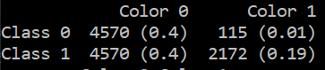
Test Data: 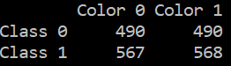
Accuracies for Test Data | MNIST – Class 0 Color 1 | MNIST – Color 1 | Fashion MNIST – Class 0 Color 1 | Fashion MNIST - Color 1
Method 1: Standard SGD | 0.9959183673469387 | 0.99810964083175 | 0.978 | 0.988
Method 2: Re-weight Probability | 0.9918367346938776 | 0.996219281663516 | 0.978 | 0.989
Method 3: Discard till balanced | 0.9918367346938776 | 0.996219281663516 | 0.992 | 0.995

Training Data: 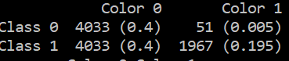
Test Data:
Accuracies for Test Data | MNIST – Class 0 Color 1 | MNIST – Color 1 | Fashion MNIST – Class 0 Color 1 | Fashion MNIST - Color 1
Method 1: Standard SGD | 0.9918367346938776 | 0.996219281663516 | 0.946 | 0.973
Method 2: Re-weight Probability | 0.9918367346938776 | 0.99621928166351 | 0.938 | 0.969
Method 3: Discard till balanced | 0.9959183673469387 | 0.998109640831758 | 0.924 | 0.962

