User Manual For

ContractCreate web service

How to use.

The aim of this manual is to provide help in understanding business entities in our XML request in order to make easily manipulation with it.

To achieve this it is provided screens from our business process “New Business” with all mandatory information for CreateContract web service and screens with XML Request flow. Each business entity from GT screens is shown in XML Request flow screens and described bellow. Each field has explanation for possible values.

Explanation of CreateContract web service based on “New Business” business process.

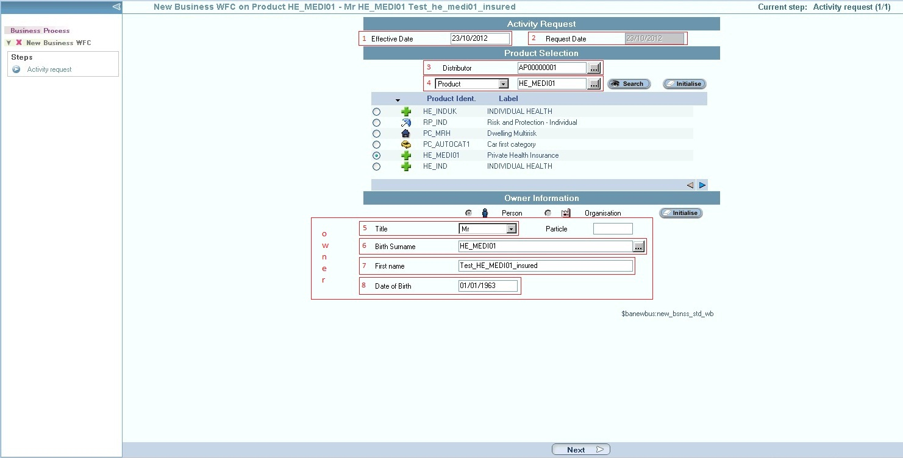

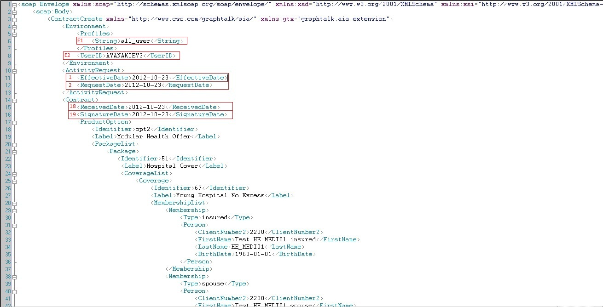

E1 - This tag must contain GT AIA profile. It is advised to be used all_user.

E2 – It is the Username that must belong in the E1 profile. It means it should be an username registered in GT. Alternative values for this tag – KKARAGIO, TZVELEVA, MTODOROV.

1, 2 – The dates on which the contract will be created.

Note: In the XML flow date format is YYYY-MM-DD

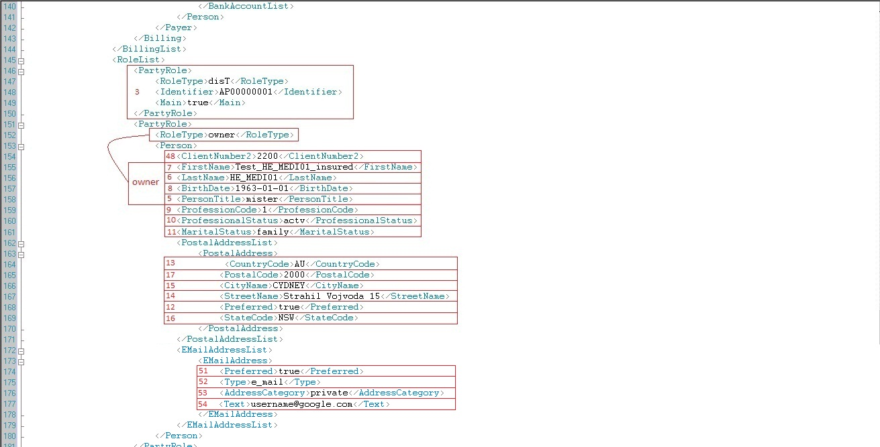

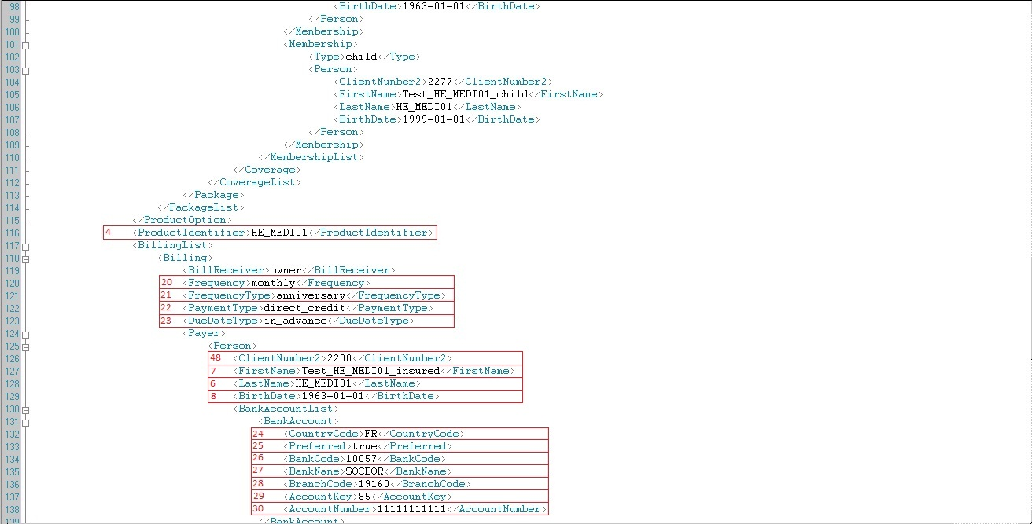

3 – This tag contain information for Distributor

<PartyRole>disT</PartyRole> - With this tag we tell that this Party will contain information for Distributor.

It is necessury to be found in xml flow, so please do not remove!

<Identifier>AP00000001</Identifier> - This is Distributor identifier( please note this is an identifier of an object existing in GT, so it is highly recommended to use it or ask for another valid identifier)

<Main>true</Main> - True if the person plays this role as a primary role (not a co_distributor, etc.).

4 – Product Identifier – this will be the product used during demonstration. During building your request flow please be sure it is into it.

|  |
| --- |
| Title Code Val. |
| *miss* |
| *mister* |
| *mrs* |

5 – Person Title - possible values:

Note: Corresponding tag should contain code value from table that belonging to him!

6 – Owner/Insured Last Name

7 – Owner/Insured First Name

8 – Owner/Insured Birth Date - Note: In the XML flow date format is YYYY-MM-DD

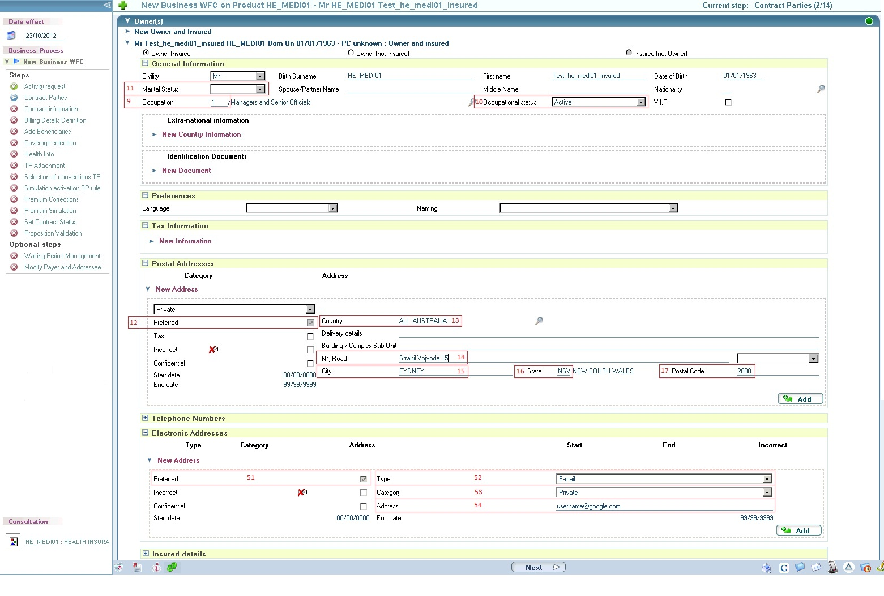

|  |  |
| --- | --- |
| Proffesion Code | Proffesion Label |
| 1 | Managers and Senior Officials |

9 – Owner/Insured Proffesion Code :

Valid Values:

|  |  |
| --- | --- |
| Proffesional Status Code | Proffesional Status Label |
| active | Active |
| non_active | Non active |

10 – Owner/Insured Proffesional Status :

Valid Values:

|  |  |
| --- | --- |
| Marital Status Code | Marital Status Label |
| divorcet | Single Parent |
| married | Family |
| partner | Couples |
| single | Single |

11 – Owner/Insured Marital Status :

Valid Values:

12 – Owner/Insured Postal Address Preferred: This tag can contain 2 values - true or false respectively for Preferred and No Preferred.

13 - Owner/Insured Postal Address Country: Contain International country code.

14 - Owner/Insured Postal Address Street Name

15 - Owner/Insured Postal Address City Name

16- Owner/Insured Postal Address State Code:

17 - Owner/Insured Postal Address Postal Code:

Note: Postal Address City Name, State Code and Postal Code must be one from the table below

|  |  |  |  |
| --- | --- | --- | --- |
| Postal Code | Postal City Name | Postal Address State Code | Postal Address State Label |
| 0800 | DARWIN | NT | NORTHERN TERRITORY |
| 2000 | CYDNEY | NSW | NEW SOUTH WALES |
| 2600 | CANBERRA | ACT | AUSTRALIAN CAPITAL TERRITORY |
| 3000 | MELBOURNE | VIC | VICTORIA |
| 4000 | BRISBANE | QLD | QUEENSLAND |
| 5000 | ADELAIDE | SA | SOUTH AUSTRALIA |
| 6000 | PERTH | WA | WESTERN AUSTRALIA |
| 7000 | HOBART | TAS | TASMANIA |

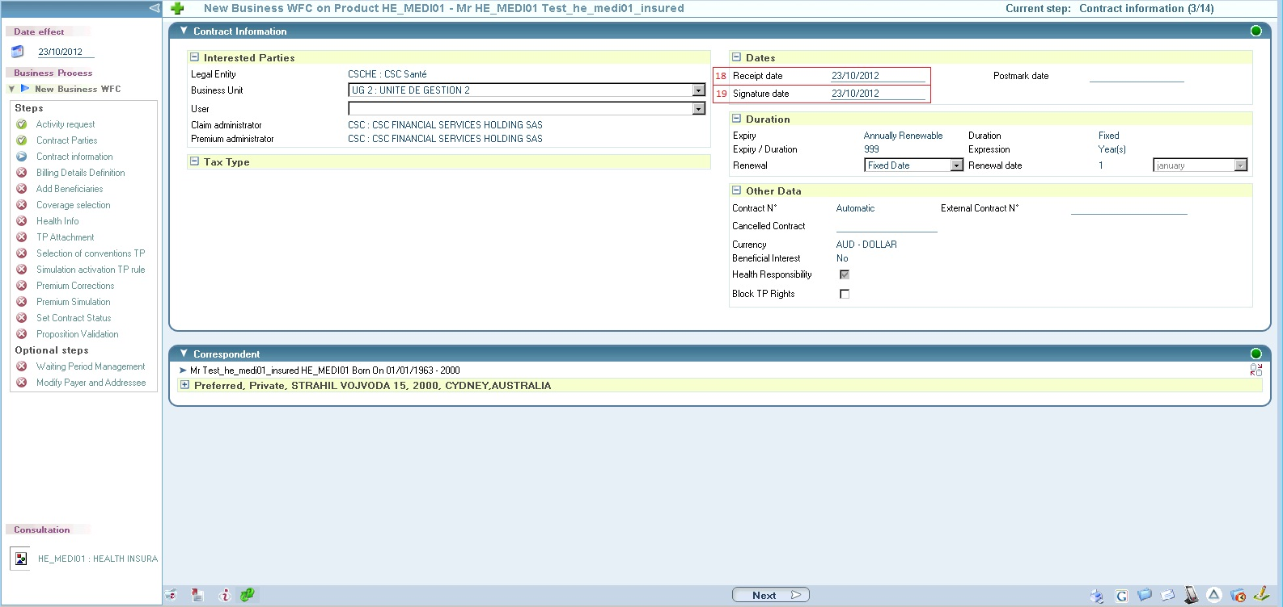

18 – Receipt Date

19 – Signature Date

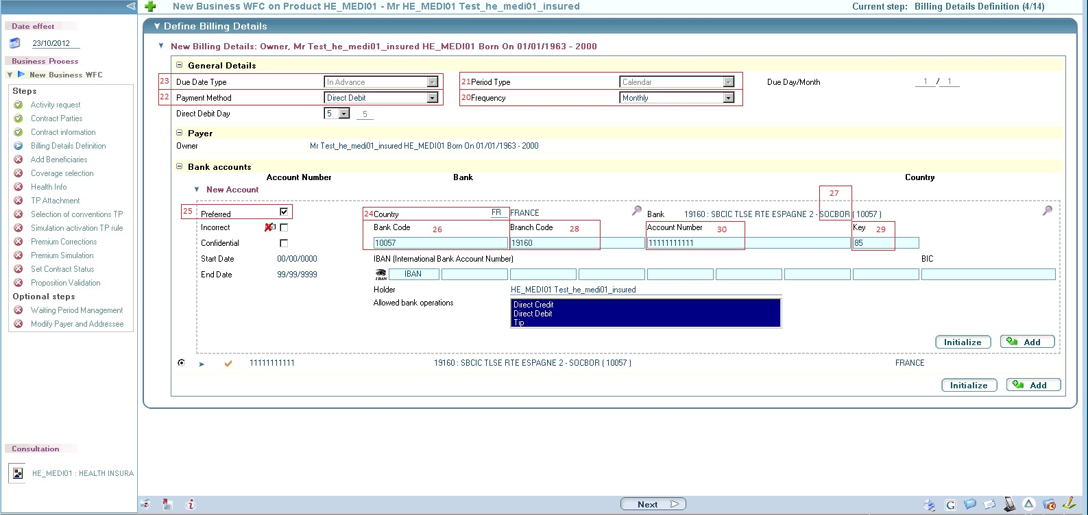

|  |  |
| --- | --- |
| Frequency Code | Frequency Label |
| annual | Annual |
| monthly | Monthly |
| quaterly | Quarterly |
| semi_annual | Semi-Annual |

20 – Frequency:

21-Frequency Type - anniversary

22 – Payment Type:

|  |  |
| --- | --- |
| Payment Type Code | Payment Type Label |
| direct_credit | Direct Debit |
| check_deposit | Cheque |

23 – Due Date Type – in_advance – it is set by parameterization. You are advised to use this exact value.

It has to be used a Bank that is parameterized in GT. Currently we do not have parameterized Australian bank so tests were done with French banks.

24 – Bank Account Country Code – Contain International Country Code of the Bank.

25 – Bank Account Preferred - This tag can contain 2 values true or false respectively for Preferred and No Preferred.

26 – Bank Code

27 – Bank Name

28 – Branch Code

29 – Account Key - calculable

30 – Account Number

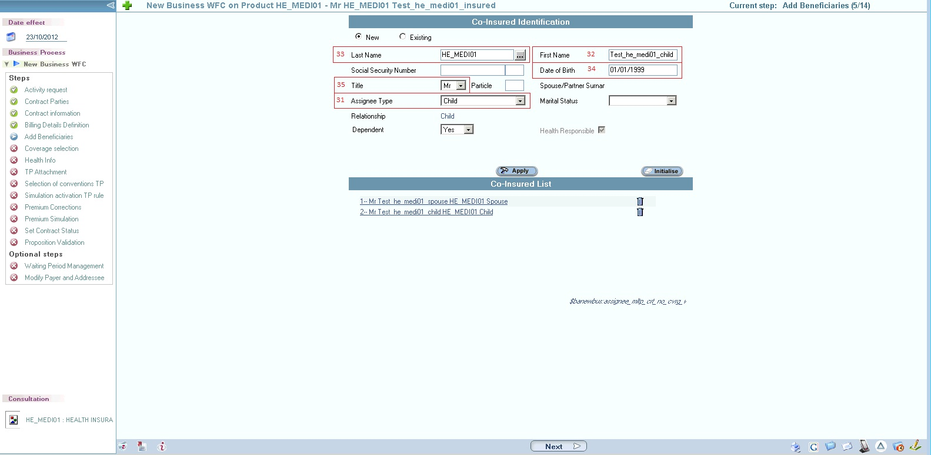

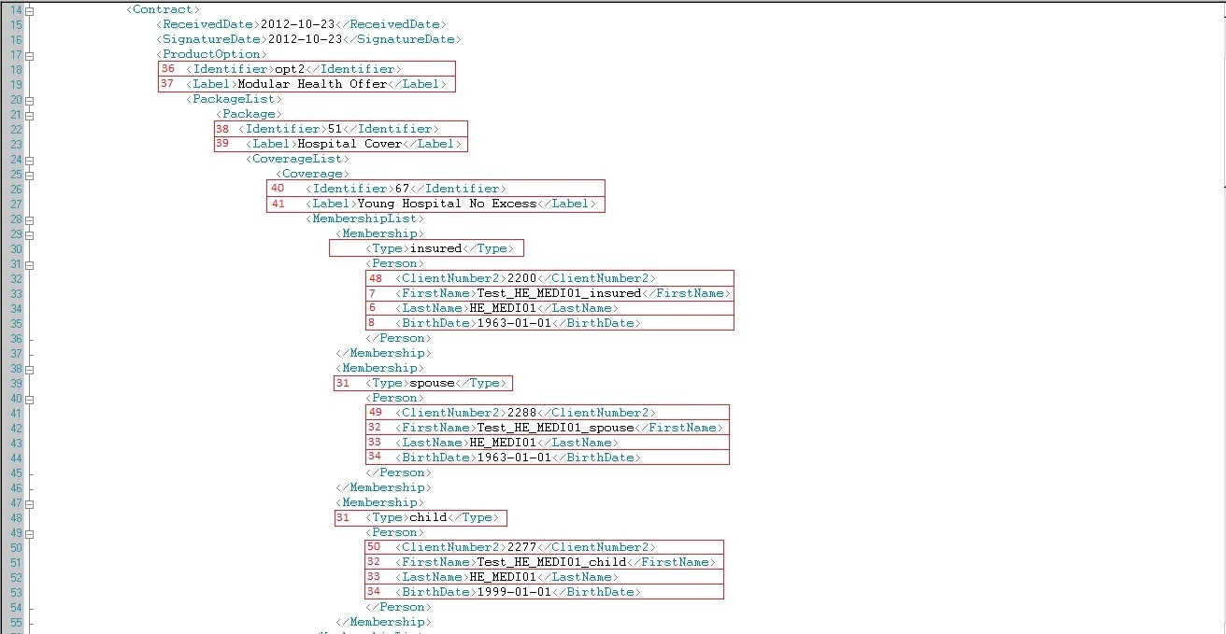

31 – Membership Type – This tag contain a type of the relation between insured and beneficiary, possible values:

|  |  |
| --- | --- |
| Membership Type Code | Membership Type Label |
| assignee | Assignee |
| child | Child |
| insured | Insured |
| partner | Partner |
| spouse | Spouse |

32 – First Name of the beneficiary  
33 – Last Name of the beneficiary

34 – Birth Date of the beneficiary

35 – Title of the beneficiary

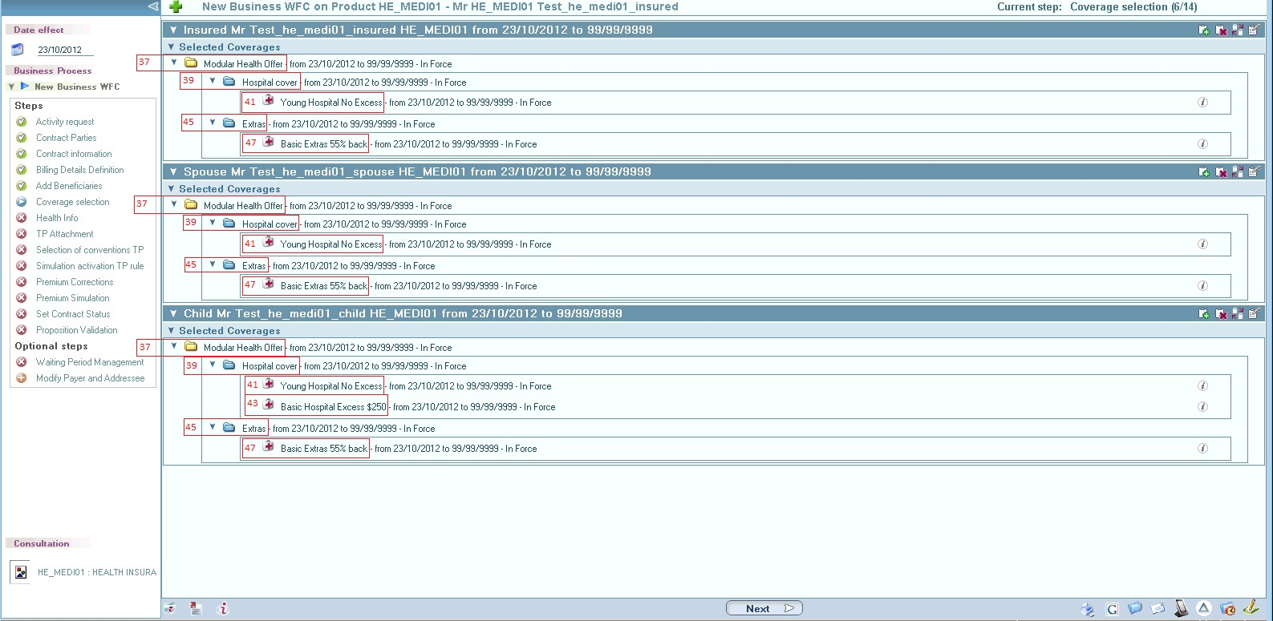

36 – Option identifier – contain identifier of the chosen option  
37 – Option Label  
38 – Package Identifier

39 – Package Label

40 – Coverage Identifier

41 – Coverage Label

42 - Coverage Identifier

43 - Coverage Label

44 - Package Identifier

45 - Package Label

46 - Coverage Identifier

47 - Coverage Label

**Note: All Options, Packages and Coverages can be seen in the table below!**

**Note: All beneficiaries must have at least the same coverages as insured. They could have additional.**

In the XML flow we have an example for this. Insured and Spouse have identical coverages and the child have one more.

**Note: We can select only one Option!**

|  |  |
| --- | --- |
| Option | |
| Identifier | Label |
| opt2 | Modular Health Offer |

|  |  |
| --- | --- |
| Package | |
| Identifier | Label |
| 51 | Hospital cover |

|  |  |
| --- | --- |
| Coverages | |
| Identifier | Label |
| 67 | Young Hospital No Excess |
| 52 | Basic Hospital Excess $250 |
| 68 | Basic Hospital Excess $500 |
| 53 | Mid Hospital No Excess |
| 69 | Mid Hospital Excess $250 |
| 70 | Mid Hospital Excess $500 |
| 54 | Top Hospital No Excess |
| 71 | Top Hospital $250 |
| 72 | Top Hospital $500 |

|  |  |
| --- | --- |
| Package | |
| Identifier | Label |
| 39 | Extras |

|  |  |
| --- | --- |
| Coverages | |
| Identifier | Label |
| 73 | Basic Extras 55% back |
| 74 | Basic Extras 70% back |
| 40 | Top Extras 55% back |
| 41 | Top Extras 70% back |
| 42 | Top Extras 85% back |

|  |  |
| --- | --- |
| Option | |
| Identifier | Label |
| opt3 | Ultra Health Cover |

|  |  |
| --- | --- |
| Coverage | |
| Identifier | Label |
| 63 | Ultra Health Cover |

48, 49, 50 – Contain Persons Client Number

**Note: In case we want to create a new person (a person not existing in our GT database) we must use tag <ClientNumber2>. Value is random string9, but the same each time you are trying to refer that exact person in your request flow.**

We must describe the required information for the new person in RoleList that information is:

**For Insured:**

Client Number - <ClientNumber2>

First Name - <FirstName>

Last Name - <LastName>

Birth Date - <BirthDate>

Peron Title - <PersonTitle>

Profession Code - <ProfesionCode>

Professional Status - <ProfessionalStatus>

For Beneficiaries:

Client Number - <ClientNumber2>

First Name - <FirstName>

Last Name - <LastName>

Birth Date - <BirthDate>

Peron Title - <PersonTitle>

**In case we want to use already created person we must use tag <ClientNumber> and set his number. It has to be valid Client number from GT database.**

Under all coverages in the flow we must describe in <MembershipList> all persons that want to have this coverage and set his/him <MembershipType>.  
All this persons from <MembershipList>, should be described in <RoleList>.

51 – EmailAddress Preferred - This tag can contain 2 values true or false respectively for Preferred and No Preferred.

52 – EmailAddress Type – This is a type of the Electronic Address in our case this is Email

53 – EmailAddress Address Category – values that can contain:

|  |  |
| --- | --- |
| Address Category Code | Address Category Label |
| private | Private |
| professional | Professional |

54 – EmailAddress Address – Email address username@domain

XML Request Flow:

<soap:Envelope xmlns:soap="http://schemas.xmlsoap.org/soap/envelope/" xmlns:xsd="http://www.w3.org/2001/XMLSchema" xmlns:xsi="http://www.w3.org/2001/XMLSchema-instance">  
 <soap:Body>  
 <ContractCreate xmlns="http://www.csc.com/graphtalk/aia/" xmlns:gtx="graphtalk.aia.extension">  
 <Environment>  
 <Profiles>  
 <String>all_user</String>  
 </Profiles>  
 <UserID>AYANAKIEV3</UserID>  
 </Environment>  
 <ActivityRequest>  
 <EffectiveDate>2012-10-24</EffectiveDate>  
 <RequestDate>2012-10-24</RequestDate>  
 </ActivityRequest>  
 <Contract>  
 <ReceivedDate>2012-10-24</ReceivedDate>  
 <SignatureDate>2012-10-24</SignatureDate>  
 <ProductOption>  
 <Identifier>opt2</Identifier>  
 <Label>Modular Health Offer</Label>  
 <PackageList>  
 <Package>  
 <Identifier>51</Identifier>  
 <Label>Hospital Cover</Label>  
 <CoverageList>  
 <Coverage>  
 <Identifier>67</Identifier>  
 <Label>Young Hospital No Excess</Label>  
 <MembershipList>  
 <Membership>  
 <Type>insured</Type>  
 <Person>  
 <ClientNumber2>2201</ClientNumber2>  
 <FirstName>Test_HE_MEDI01_insured1</FirstName>  
 <LastName>HE_MEDI01</LastName>  
 <BirthDate>1963-01-01</BirthDate>  
 </Person>  
 </Membership>  
 <Membership>  
 <Type>spouse</Type>  
 <Person>  
 <ClientNumber2>2281</ClientNumber2>  
 <FirstName>Test_HE_MEDI01_spouse1</FirstName>  
 <LastName>HE_MEDI01</LastName>  
 <BirthDate>1963-01-01</BirthDate>  
 </Person>  
 </Membership>  
 <Membership>  
 <Type>child</Type>  
 <Person>  
 <ClientNumber2>2271</ClientNumber2>  
 <FirstName>Test_HE_MEDI01_child1</FirstName>  
 <LastName>HE_MEDI01</LastName>  
 <BirthDate>1999-01-01</BirthDate>  
 </Person>  
 </Membership>  
 </MembershipList>  
 </Coverage>  
 <Coverage>  
 <Identifier>52</Identifier>  
 <Label>Basic Hospital Excess $250</Label>  
 <MembershipList>  
 <Membership>  
 <Type>child</Type>  
 <Person>  
 <ClientNumber2>2271</ClientNumber2>  
 <FirstName>Test_HE_MEDI01_child1</FirstName>  
 <LastName>HE_MEDI01</LastName>  
 <BirthDate>1999-01-01</BirthDate>  
 </Person>  
 </Membership>  
 </MembershipList>  
 </Coverage>  
 </CoverageList>  
 </Package>  
 <Package>  
 <Identifier>39</Identifier>  
 <Label>Extras</Label>  
 <CoverageList>  
 <Coverage>  
 <Identifier>73</Identifier>  
 <Label>Basic Extras 55% back</Label>  
 <MembershipList>  
 <Membership>  
 <Type>insured</Type>  
 <Person>  
 <ClientNumber2>2201</ClientNumber2>  
 <FirstName>Test_HE_MEDI01_insured1</FirstName>  
 <LastName>HE_MEDI01</LastName>  
 <BirthDate>1963-01-01</BirthDate>  
 </Person>  
 </Membership>  
 <Membership>  
 <Type>spouse</Type>  
 <Person>  
 <ClientNumber2>2281</ClientNumber2>  
 <FirstName>Test_HE_MEDI01_spouse1</FirstName>  
 <LastName>HE_MEDI01</LastName>  
 <BirthDate>1963-01-01</BirthDate>  
 </Person>  
 </Membership>  
 <Membership>  
 <Type>child</Type>  
 <Person>  
 <ClientNumber2>2271</ClientNumber2>  
 <FirstName>Test_HE_MEDI01_child1</FirstName>  
 <LastName>HE_MEDI01</LastName>  
 <BirthDate>1999-01-01</BirthDate>  
 </Person>  
 </Membership>  
 </MembershipList>  
 </Coverage>  
 </CoverageList>  
 </Package>  
 </PackageList>  
 </ProductOption>  
 <ProductIdentifier>HE_MEDI01</ProductIdentifier>  
 <BillingList>  
 <Billing>  
 <BillReceiver>owner</BillReceiver>  
 <Frequency>monthly</Frequency>  
 <FrequencyType>anniversary</FrequencyType>  
 <PaymentType>direct_credit</PaymentType>  
 <DueDateType>in_advance</DueDateType>  
 <Payer>  
 <Person>  
 <ClientNumber2>2201</ClientNumber2>  
 <FirstName>Test_HE_MEDI01_insured1</FirstName>  
 <LastName>HE_MEDI01</LastName>  
 <BirthDate>1963-01-01</BirthDate>  
 <BankAccountList>  
 <BankAccount>  
 <CountryCode>FR</CountryCode>  
 <Preferred>true</Preferred>  
 <BankCode>10057</BankCode>  
 <BankName>SOCBOR</BankName>  
 <BranchCode>19160</BranchCode>  
 <AccountKey>85</AccountKey>  
 <AccountNumber>11111111111</AccountNumber>  
 </BankAccount>  
 </BankAccountList>  
 </Person>  
 </Payer>  
 </Billing>  
 </BillingList>  
 <RoleList>  
 <PartyRole>  
 <RoleType>disT</RoleType>  
 <Identifier>AP00000001</Identifier>  
 <Main>true</Main>  
 </PartyRole>  
 <PartyRole>  
 <RoleType>owner</RoleType>  
 <Person>  
 <ClientNumber2>2201</ClientNumber2>  
 <FirstName>Test_HE_MEDI01_insured1</FirstName>  
 <LastName>HE_MEDI01</LastName>  
 <BirthDate>1963-01-01</BirthDate>  
 <PersonTitle>mister</PersonTitle>  
 <ProfessionCode>1</ProfessionCode>  
 <ProfessionalStatus>actv</ProfessionalStatus>  
 <MaritalStatus>family</MaritalStatus>  
 <PostalAddressList>  
 <PostalAddress>  
 <CountryCode>AU</CountryCode>  
 <PostalCode>2000</PostalCode>  
 <CityName>CYDNEY</CityName>  
 <StreetName>Strahil Vojvoda 15</StreetName>  
 <Preferred>true</Preferred>  
 <StateCode>NSW</StateCode>  
 </PostalAddress>  
 </PostalAddressList>  
 <EMailAddressList>  
 <EMailAddress>  
 <Preferred>true</Preferred>  
 <Type>e_mail</Type>  
 <AddressCategory>private</AddressCategory>  
 <Text>username@google.com</Text>  
 </EMailAddress>  
 </EMailAddressList>  
 </Person>  
 </PartyRole>  
 <PartyRole>  
 <Person>  
 <ClientNumber2>2281</ClientNumber2>  
 <FirstName>Test_HE_MEDI01_spouse1</FirstName>  
 <LastName>HE_MEDI01</LastName>  
 <BirthDate>1995-01-01</BirthDate>  
 <PersonTitle>mister</PersonTitle>  
 </Person>  
 </PartyRole>  
 <PartyRole>  
 <Person>  
 <ClientNumber2>2271</ClientNumber2>  
 <FirstName>Test_HE_MEDI01_child1</FirstName>  
 <LastName>HE_MEDI01</LastName>  
 <BirthDate>1999-01-01</BirthDate>  
 <PersonTitle>mister</PersonTitle>  
 </Person>  
 </PartyRole>  
 </RoleList>  
 </Contract>  
 </ContractCreate>  
 </soap:Body>  
</soap:Envelope>

XML Response:

<?xml version="1.0" encoding="utf-8"?>

<soap:Envelope xmlns:soap="http://schemas.xmlsoap.org/soap/envelope/" xmlns:xsd="http://www.w3.org/2001/XMLSchema" xmlns:xsi="http://www.w3.org/2001/XMLSchema-instance">

<soap:Body>

<ContractCreateResponse xmlns="http://www.csc.com/graphtalk/aia/">

<Contract>

<BillingList>

<Billing/>

</BillingList>

<Number>HINC0000454</Number>

<ProductLabel>Private Health Insurance</ProductLabel>

<Status>in_force</Status>

</Contract>

<ReturnStatus>

<Code>WM_SUCCESS</Code>

<ErrorList>

<Error>

<Code>prsn_nmbr</Code>

<Level>audi</Level>

<Message>Mr Test_HE_MEDI01_insured1 HE_MEDI01 No. is PRSN0002856.</Message>

<Source>prsnorg:cp_prsn_org</Source>

</Error>

<Error>

<Code>contract_nmbr</Code>

<Level>audi</Level>

<Message>Contract No. is HINC0000454</Message>

<Source>header:cp_contract9qDH</Source>

</Error>

</ErrorList>

</ReturnStatus>

</ContractCreateResponse>

</soap:Body>

</soap:Envelope>

Description

<Number>HINC0000454</Number> - Number of created contract

<ProductLabel>Private Health Insurance</ProductLabel> - Product Label of the created contract

<Message>Mr Test_HE_MEDI01_insured1 HE_MEDI01 No. is PRSN0002856.</Message> - Title, First Name, Last Name and Identifier of the Created Person (Owner/Insured) in case we use a new person.

Once the person is created in GT database he/she receive automatic client number.

In example above PRSN0002856 is client number for this person.

From now on if we want to refer this person we have to use this client number in tag <ClientNumber> instead<Client Number2>.

<Message>Contract No. is HINC0000454</Message> - Number of created contract