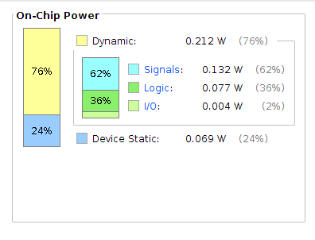
POWER

ESQUEMATICO

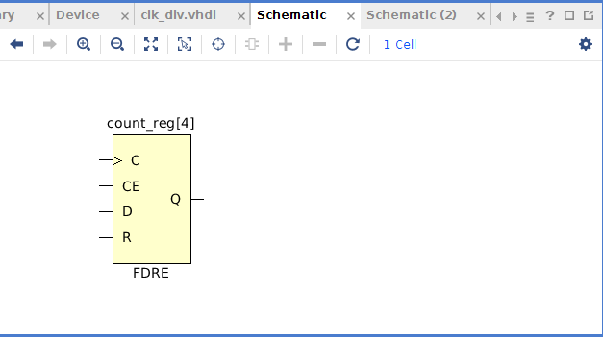

Simulaçao
clk: leading edge = 0
trailing edge = 1
period = 0.1ns
sim time = 20873701950 ps

