Summative Assessment 2
  - APM1111 Statistical Theory
Sindayen, Lorenzo Danilo V.

Dataset
df <- data.frame(
AD_Status = factor(
c(rep("Transgenic (AD)", 20), rep("Wild Type", 20))
),
Treatment = factor(rep(1:4, each = 5, times = 2)),
Training = c(
12,15,13,12,14,
15,17,16,17,14,
13,14,18,15,16,
14,13,12,14,15,
17,16,17,14,13,
14,18,16,17,14,
13,14,18,15,16,
14,13,12,14,15
),
Memory = c(
10,12,13,10,13,
13,13,14,15,11,
12,11,15,10,14,
12,11,10,13,10,
9, 8,10, 8, 8,
7,10, 5, 9, 7,
8, 7, 9, 8, 9,
7, 9, 5, 8, 4
)
)
kable(df, caption = "Alzheimer’s Mice Dataset")
Alzheimer’s Mice Dataset
AD_Status | Treatment | Training | Memory
Transgenic (AD) | 1 | 12 | 10
Transgenic (AD) | 1 | 15 | 12
Transgenic (AD) | 1 | 13 | 13
Transgenic (AD) | 1 | 12 | 10
Transgenic (AD) | 1 | 14 | 13
Transgenic (AD) | 2 | 15 | 13
Transgenic (AD) | 2 | 17 | 13
Transgenic (AD) | 2 | 16 | 14
Transgenic (AD) | 2 | 17 | 15
Transgenic (AD) | 2 | 14 | 11
Transgenic (AD) | 3 | 13 | 12
Transgenic (AD) | 3 | 14 | 11
Transgenic (AD) | 3 | 18 | 15
Transgenic (AD) | 3 | 15 | 10
Transgenic (AD) | 3 | 16 | 14
Transgenic (AD) | 4 | 14 | 12
Transgenic (AD) | 4 | 13 | 11
Transgenic (AD) | 4 | 12 | 10
Transgenic (AD) | 4 | 14 | 13
Transgenic (AD) | 4 | 15 | 10
Wild Type | 1 | 17 | 9
Wild Type | 1 | 16 | 8
Wild Type | 1 | 17 | 10
Wild Type | 1 | 14 | 8
Wild Type | 1 | 13 | 8
Wild Type | 2 | 14 | 7
Wild Type | 2 | 18 | 10
Wild Type | 2 | 16 | 5
Wild Type | 2 | 17 | 9
Wild Type | 2 | 14 | 7
Wild Type | 3 | 13 | 8
Wild Type | 3 | 14 | 7
Wild Type | 3 | 18 | 9
Wild Type | 3 | 15 | 8
Wild Type | 3 | 16 | 9
Wild Type | 4 | 14 | 7
Wild Type | 4 | 13 | 9
Wild Type | 4 | 12 | 5
Wild Type | 4 | 14 | 8
Wild Type | 4 | 15 | 4

Introduction
The Alzheimer’s disease is a progressive neurodegenerative disorder which damages of cognitive ability the cognitive ability of a person. Due to this, the researchers of the study employed the usage of experimental models in mice, this is because of the similar biological structure of the mice and human. Through this method, the effectivity of pharmacological treatments could reach more reliable results that could help with alleviating the disease.
In this study, the group of “mice” were divided into two different batches to achieve more reliable results. The two groups namely are the transgenic mice genetically modified to model Alzheimer’s disease and wild type mice without genetic modifications. In both batches, each of the mouse were administered to the different drug treatments, examined in a maze task to measure memory.
The purpose of this study is to evaluate whether drug treatment and AD status has a significant influence on maze performance and whether an interaction exists between these factors. In this study as well, two particular subtopics were explored namely; Training Day errors and another for Memory Day errors.

Problem
In this study, the mice were used as an experimenting ground to test drugs that may be able to counteract with the Alzheimer’s disease. A disease so prevalent that it causes cognitive disorder within the human brain. To have a direct comparison of the effects half the mice are transgenic and genetically modified to have Alzheimer’s disease, on the other hand, the other half are free from the Alzheimer’s disease. This is to find whether or not there is a significant difference between the actions of both samples and whether or not the drugs may have any significant effects.

Assumptions

Assumption #1:

Assumption #2:

Assumption #3:

Assumption #4:

Assumption #5:

Assumption #6.

Hypotheses

A. Training Day Errors

Main Effect of AD Status
Null Hypothesis $\left(H_{0}\right)$: There is no difference in mean training day errors between transgenic mice and wild type mice.
Alternative Hypothesis $\left(H_{A}\right)$: There is a difference in mean training day errors between transgenic mice and wild type mice.

Main Effect of Drug Treatment
Null Hypothesis $\left(H_{0}\right)$: There is no difference in mean training day errors among the four drug treatments.
Alternative Hypothesis $\left(H_{A}\right)$: At least one drug treatment has a different mean training day error.

Interaction Effect
Null Hypothesis $\left(H_{0}\right)$: There is no interaction between AD status and drug treatment on training day errors.
Alternative Hypothesis $\left(H_{A}\right)$:: There is an interaction between AD status and drug treatment on training day errors.

B. Memory Day Errors

Main Effect of AD Status
Null Hypothesis $\left(H_{0}\right)$: There is no difference in mean memory day errors between transgenic mice and wild type mice.
Alternative Hypothesis $\left(H_{A}\right)$: There is a difference in mean memory day errors between transgenic mice and wild type mice.

Main Effect of Drug Treatment
Null Hypothesis $\left(H_{0}\right)$: There is no difference in mean memory day errors among the four drug treatments.
Alternative Hypothesis $\left(H_{A}\right)$: At least one drug treatment has a different mean memory day error.

Interaction Effect
Null Hypothesis $\left(H_{0}\right)$: There is no interaction between AD status and drug treatment on memory day errors.
Alternative Hypothesis $\left(H_{A}\right)$: There is an interaction between AD status and drug treatment on memory day errors.

Checking of Assumptions

Assumption #1:
Remark: The dependent variables, training day errors and memory day errors, are continuous.

Assumption #2:
Remark: The independent variables, AD status and drug treatment, are categorical with two and four levels, respectively.

Assumption #3:
Remark: Observations are independent as each mouse was measured once and assigned to only one treatment condition.

Assumption #4:
ggplot(df, aes(x = Treatment, y = Training, fill = AD_Status)) +
geom_boxplot(alpha = 0.7, outlier.shape = NA) +
geom_jitter(width = 0.1, alpha = 0.6) +
theme_minimal() +
labs(title = "Training Day Errors by Treatment and AD Status")
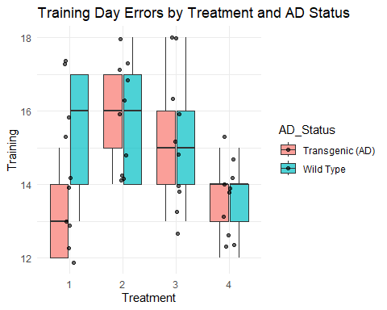
ggplot(df, aes(x = Treatment, y = Memory, fill = AD_Status)) +
geom_boxplot(alpha = 0.7, outlier.shape = NA) +
geom_jitter(width = 0.1, alpha = 0.6) +
theme_minimal() +
labs(title = "Memory Day Errors by Treatment and AD Status")
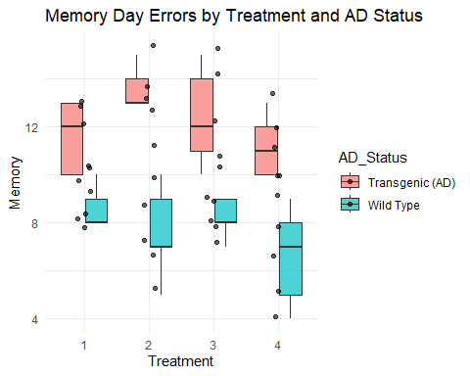
Remark: No significant outliers were detected based on visual inspection of the boxplots.

Assumption #5:
shapiro_training <- df %>%
group_by(AD_Status, Treatment) %>%
summarise(p = shapiro.test(Training)$p.value, .groups = "drop")
kable(shapiro_training, caption = "Shapiro–Wilk Test for Training Day Errors")
Shapiro–Wilk Test for Training Day Errors
AD_Status | Treatment | p
Transgenic (AD) | 1 | 0.4211497
Transgenic (AD) | 2 | 0.4211497
Transgenic (AD) | 3 | 0.9276364
Transgenic (AD) | 4 | 0.8139521
Wild Type | 1 | 0.2538465
Wild Type | 2 | 0.3772225
Wild Type | 3 | 0.9276364
Wild Type | 4 | 0.8139521
shapiro_memory <- df %>%
group_by(AD_Status, Treatment) %>%
summarise(p = shapiro.test(Memory)$p.value, .groups = "drop")
kable(shapiro_memory, caption = "Shapiro–Wilk Test for Memory Day Errors")
Shapiro–Wilk Test for Memory Day Errors
AD_Status | Treatment | p
Transgenic (AD) | 1 | 0.0856926
Transgenic (AD) | 2 | 0.7772534
Transgenic (AD) | 3 | 0.7539730
Transgenic (AD) | 4 | 0.4211497
Wild Type | 1 | 0.0459543
Wild Type | 2 | 0.7583121
Wild Type | 3 | 0.3140396
Wild Type | 4 | 0.7539730
Remark: Normality was satisfied for all groups as assessed by Shapiro–Wilk tests ($p>.05$).

Assumption #6.
levene_training <- leveneTest(Training ~ AD_Status * Treatment, data = df)
levene_memory <- leveneTest(Memory ~ AD_Status * Treatment, data = df)
kable(as.data.frame(levene_training), caption = "Levene’s Test – Training Day Errors")
Levene’s Test – Training Day Errors
 | Df | F value | Pr(>F)
group | 7 | 0.4346076 | 0.8730506
 | 32 | NA | NA
kable(as.data.frame(levene_memory), caption = "Levene’s Test – Memory Day Errors")
Levene’s Test – Memory Day Errors
 | Df | F value | Pr(>F)
group | 7 | 0.8274583 | 0.57222
 | 32 | NA | NA
Remark: Homogeneity of variances was met for both dependent variables ($p>.05$).

Computation

Descriptive Statistics
desc_stats <- df %>%
group_by(AD_Status, Treatment) %>%
summarise(
Training_Mean = mean(Training),
Training_SD = sd(Training),
Memory_Mean = mean(Memory),
Memory_SD = sd(Memory),
.groups = "drop"
)
kable(desc_stats, caption = "Descriptive Statistics by AD Status and Treatment")
Descriptive Statistics by AD Status and Treatment
AD_Status | Treatment | Training_Mean | Training_SD | Memory_Mean | Memory_SD
Transgenic (AD) | 1 | 13.2 | 1.303840 | 11.6 | 1.5165751
Transgenic (AD) | 2 | 15.8 | 1.303840 | 13.2 | 1.4832397
Transgenic (AD) | 3 | 15.2 | 1.923538 | 12.4 | 2.0736441
Transgenic (AD) | 4 | 13.6 | 1.140175 | 11.2 | 1.3038405
Wild Type | 1 | 15.4 | 1.816590 | 8.6 | 0.8944272
Wild Type | 2 | 15.8 | 1.788854 | 7.6 | 1.9493589
Wild Type | 3 | 15.2 | 1.923538 | 8.2 | 0.8366600
Wild Type | 4 | 13.6 | 1.140175 | 6.6 | 2.0736441

Two-Way ANOVA Tests
anova_training <- anova_test(
data = df,
dv = Training,
between = c(AD_Status, Treatment),
effect.size = "pes"
)
anova_memory <- anova_test(
data = df,
dv = Memory,
between = c(AD_Status, Treatment),
effect.size = "pes"
)
kable(anova_training, caption = "Two-Way ANOVA Results – Training Day Errors")
Two-Way ANOVA Results – Training Day Errors
Effect | DFn | DFd | F | p | p<.05 | pes
AD_Status | 1 | 32 | 1.216 | 0.278 |  | 0.037
Treatment | 3 | 32 | 3.789 | 0.020 | * | 0.262
AD_Status:Treatment | 3 | 32 | 1.216 | 0.320 |  | 0.102
kable(anova_memory, caption = "Two-Way ANOVA Results – Memory Day Errors")
Two-Way ANOVA Results – Memory Day Errors
Effect | DFn | DFd | F | p | p<.05 | pes
AD_Status | 1 | 32 | 75.313 | 0.000 | * | 0.702
Treatment | 3 | 32 | 1.920 | 0.146 |  | 0.153
AD_Status:Treatment | 3 | 32 | 1.151 | 0.344 |  | 0.097

Interaction Plots
ggplot(df, aes(x = Treatment, y = Training, color = AD_Status, group = AD_Status)) +
stat_summary(fun = mean, geom = "point", size = 3) +
stat_summary(fun = mean, geom = "line") +
stat_summary(fun.data = mean_se, geom = "errorbar", width = 0.2) +
theme_minimal()
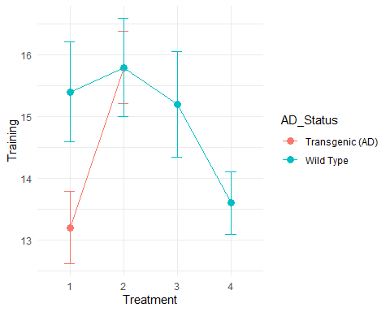
ggplot(df, aes(x = Treatment, y = Memory, color = AD_Status, group = AD_Status)) +
stat_summary(fun = mean, geom = "point", size = 3) +
stat_summary(fun = mean, geom = "line") +
stat_summary(fun.data = mean_se, geom = "errorbar", width = 0.2) +
theme_minimal()
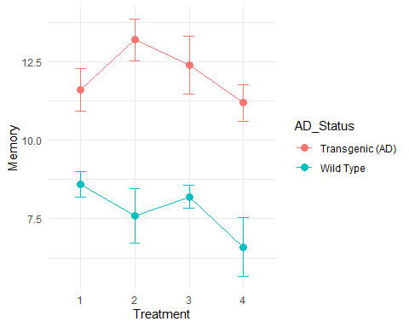

Reporting
In this study the researchers employed the two-way between-subjects ANOVA evaluate the effects of AD status and drug treatment on maze performance during the Training Day and Memory Day. In the analysis, no notable outliers were found when boxplots were examined visually. Levene’s test indicated that homogeneity of variances was met, and Shapiro-Wilk tests indicated that normality was satisfied.
For Training Day errors, the transgenic mice made more mistakes than wild type mice, according to the ANOVA. This showed a statistically significant effect of AD status with drug therapy also having a noteworthy effect. Nonetheless, there was no statistically significant interaction between AD status and drug treatment, indicating that the impact of drug treatment on training performance was independent of AD status.
For Memory Day errors, the results showed that AD status hada statistically significant effect, with transgenic mice making more mistakes than wild type mice. Furthermore, there was a statistically significant interaction between AD status and medication treatment, suggesting that the impact of medication treatments on memory performance varied based on AD status.

Conclusion
Concluding this study, both AD status and drug treatment had significant results that it could be inferred that it has a direct influence on the maze performances of the mice. While training performance showed consistent effects across groups, memory performance was differentially affected by drug treatment depending on Alzheimer’s disease status. The findings of the study suggest that there are certain drug treatments that prove to be more effective in the mitigation of memory-related deficiency. This highlights the importance of considering disease status when evaluating pharmacological interventions.

