CPAN 144 – Lab 2

SUBMISSION - Submit the following as part of your lab report:

1. Screenshots showing the header and main content components displayed on the page with the correct props.

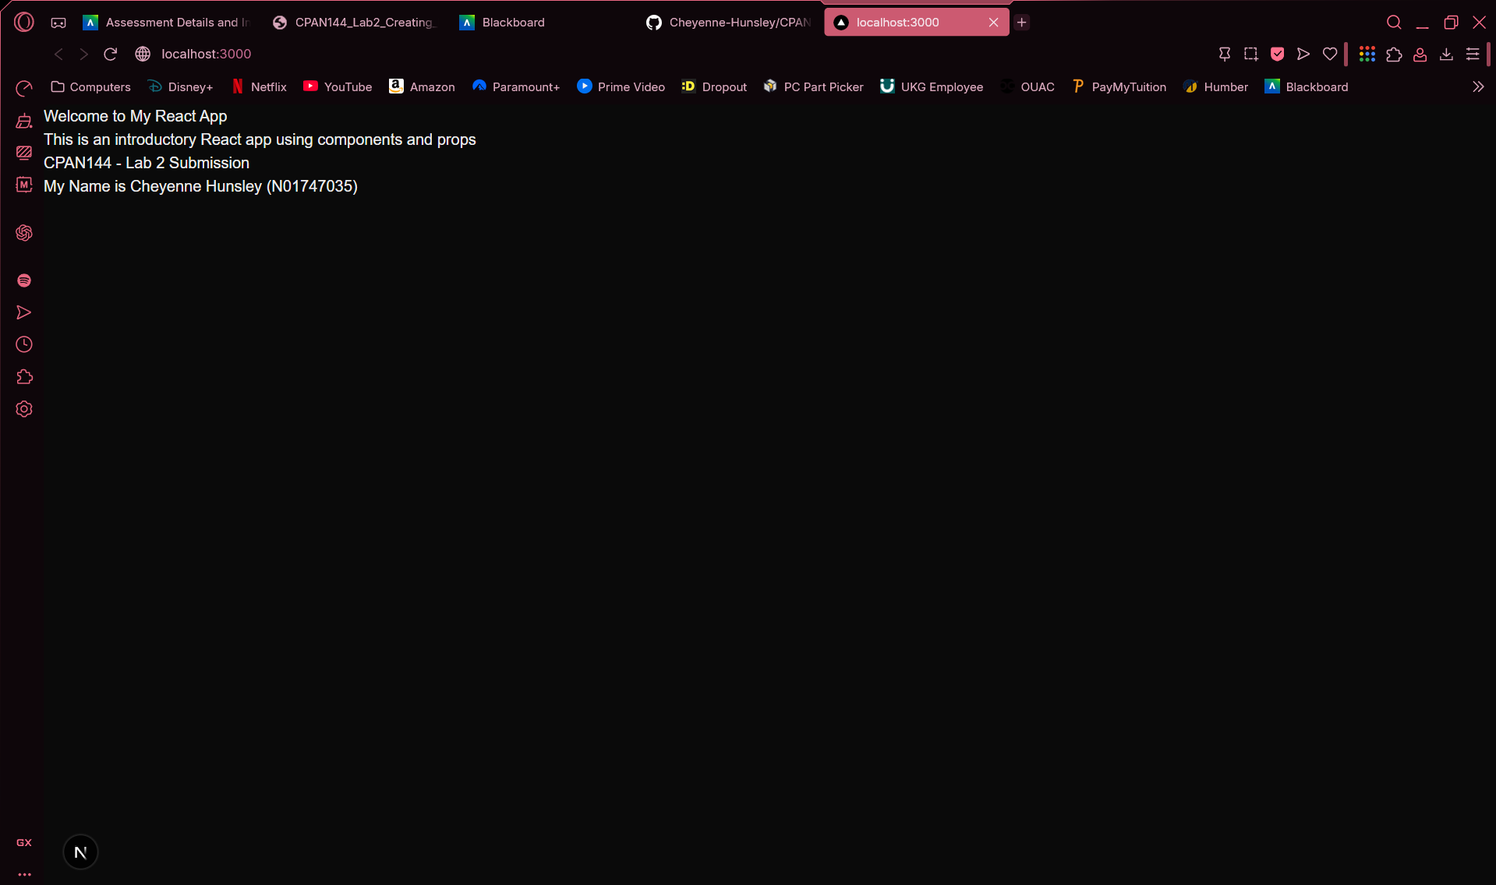

1. A screen shot of your project structure in VSCode showing the components folder and files within it.

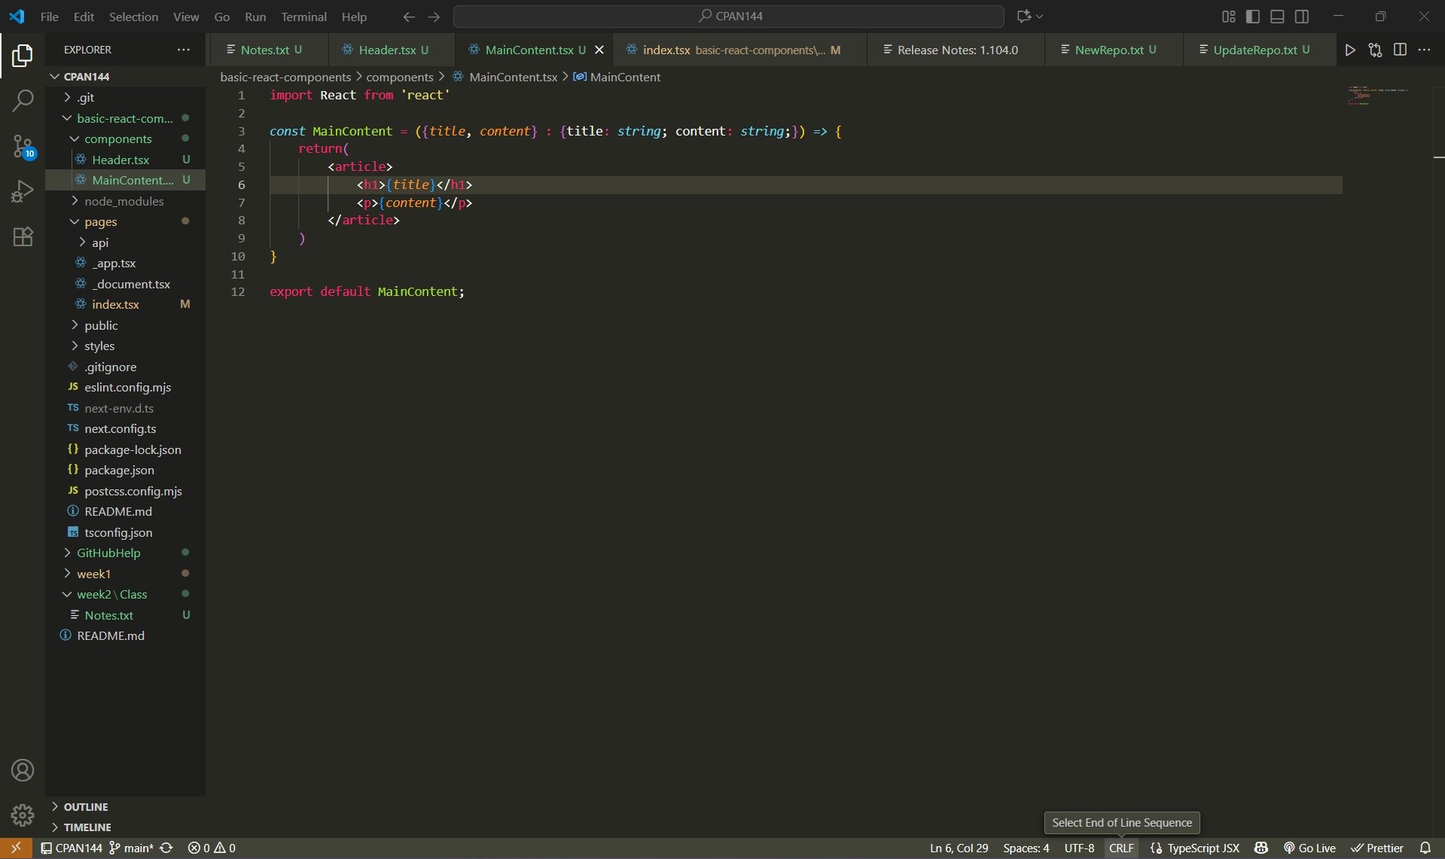

RUBRIC (10 POINTS TOTAL)

* Project Setup and Structure (2 points): Correctly set up Next.js project and organized folder structure.
* Header Component(2 points): Header component displays correctly with JSX.
* MainContent Component(3points): MainContent component accepts and displays props correctly.
* Integration and Testing(2points): Components integratedanddisplayedonindex.js.
* Submission(1point): Provided all required screen shots as outlined in the submission instructions.