CPAN144 – Lab 3

*SUBMISSION -* Submit the following screenshots as part of your lab report:

1. The Code in VSCode.

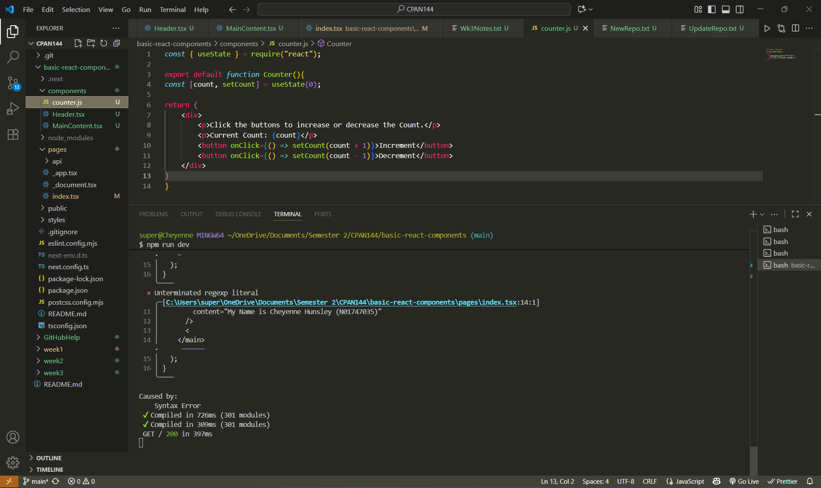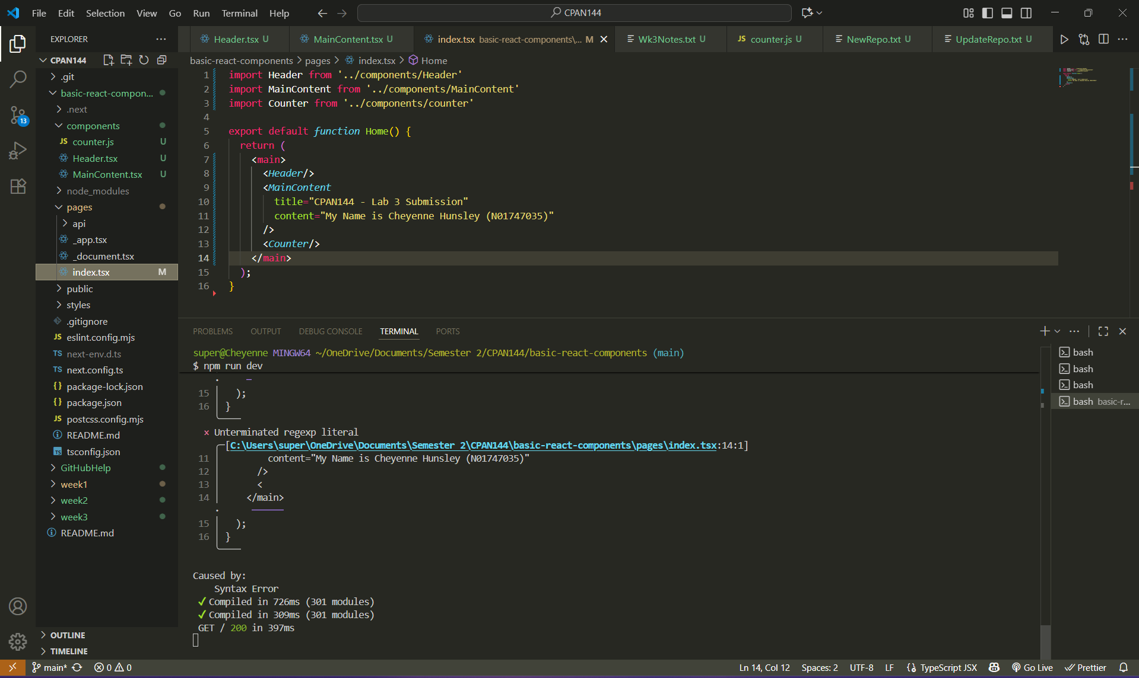

1. Screenshot showing the initial count at 0.

1. Screenshot showing the count after incrementing.

1. Screenshot showing the count after decrementing. (I did it twice just so it didn’t look the same as the screenshot from initial count).

