Lab 4

*STEP-BY-STEP INSTRUCTIONS*

2. IMPLEMENT BUTTON CLICK EVENT:  
Create a button that toggles the visibility of a specific component or text when clicked.  
The button should display 'Show' when the component is hidden and 'Hide' when the  
component is visible.

3. HANDLING FORM SUBMISSION:  
Implement a form with an input field and a submit button. When submitted, prevent the  
default form submission behavior, validate the input, and display a message indicating  
success or failure. Show a validation message if the input is empty or invalid.

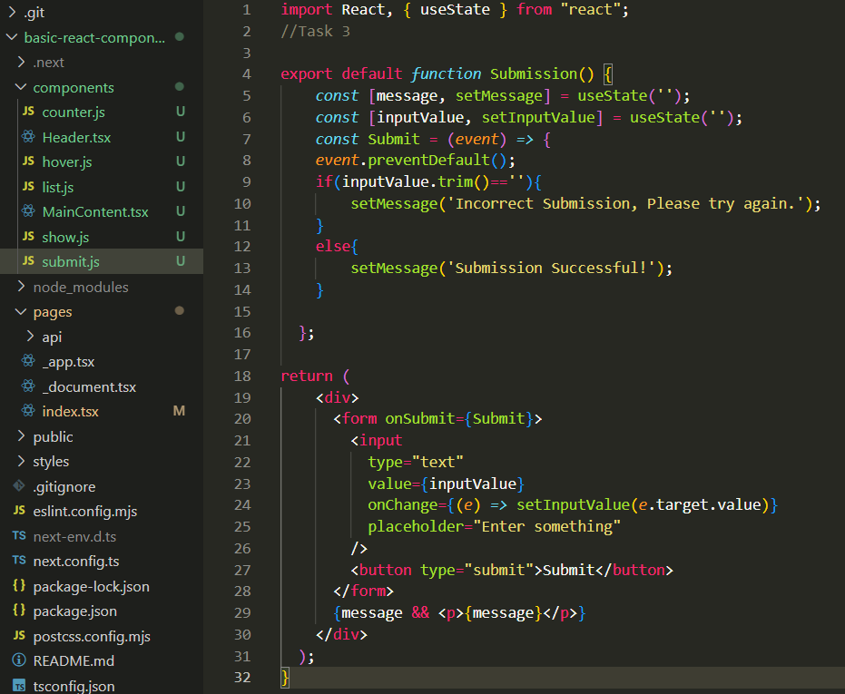

4. CONDITIONAL RENDERING BASED ON STATE:  
Render a list of items conditionally based on a selected filter (e.g., active or inactive  
items). Include two buttons ('Show Active' and 'Show Inactive') to toggle between the  
two lists.

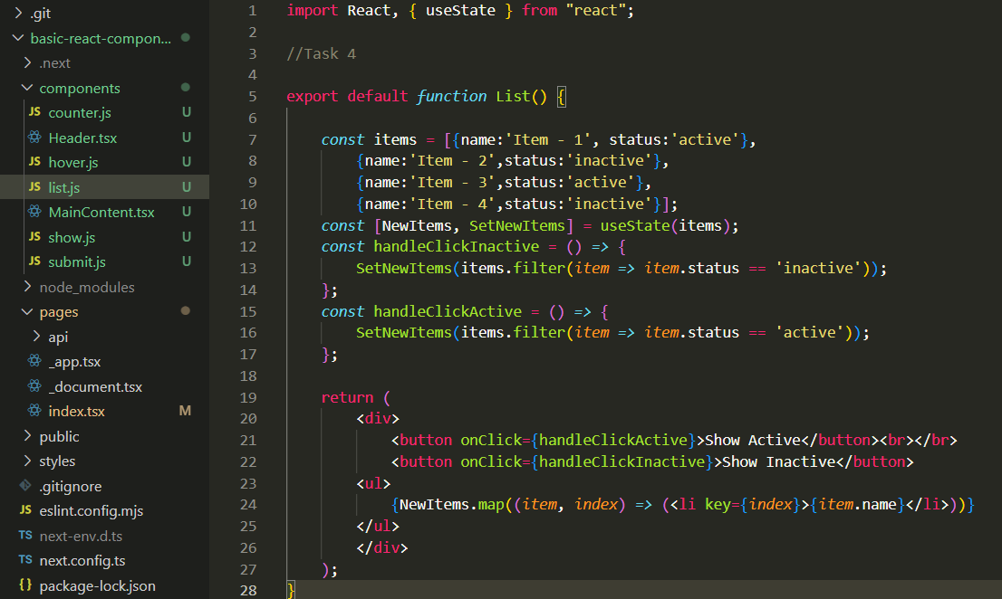

5. ADDING A HOVER INTERACTION:  
Create a simple hover interaction on a component, changing its style when hovered over.

*SUBMISSION* - Submit the following screenshots as part of your lab report:

1. Screenshots showing the button toggling component visibility.

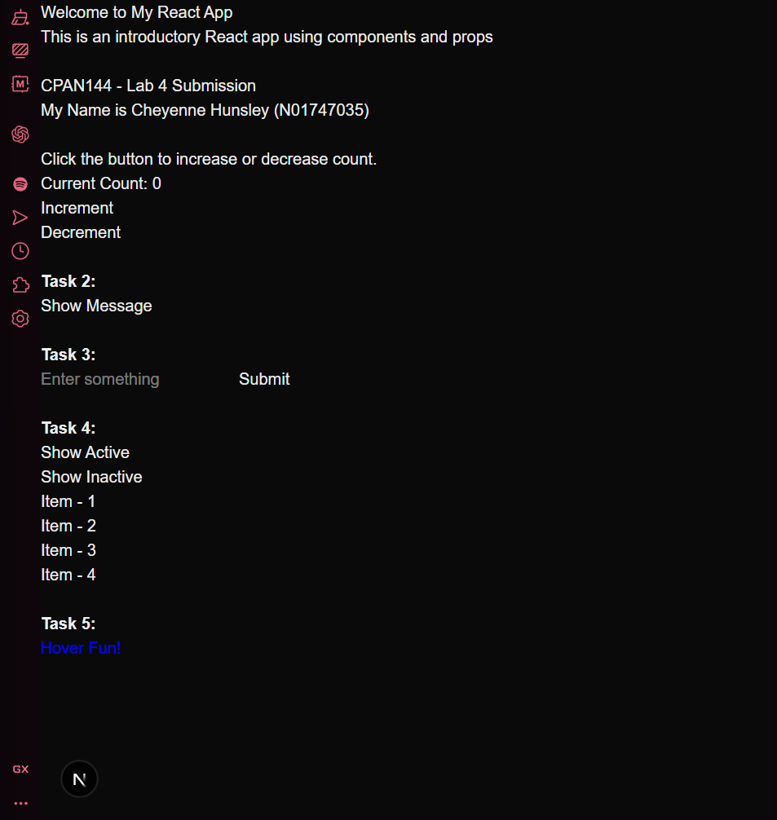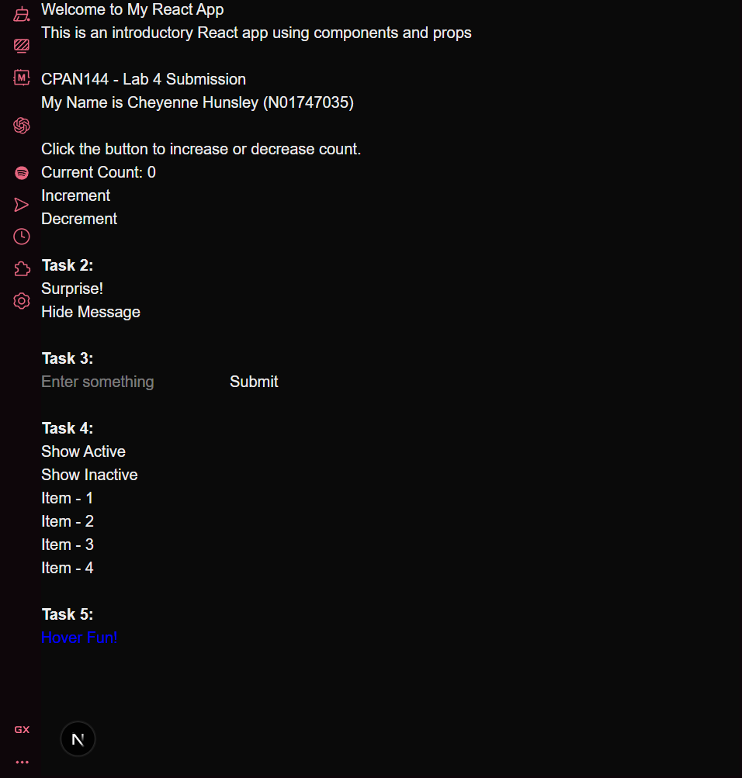

1. Screenshots of form submission with both success and validation error messages.

1. Screenshots of the list display based on the selected filter.

1. Screenshots of the component with a hover effect.

