**Fox Hunt**

**Launch Date**



# Cheyenne Pace

Confidential Disclaimer_________________________________________________________________

**Overview of the Game:**

The overview should be concise and impactful

* Adventure, retro-platform game
* Super Mario and unity assets
* Telling the users how to play
* 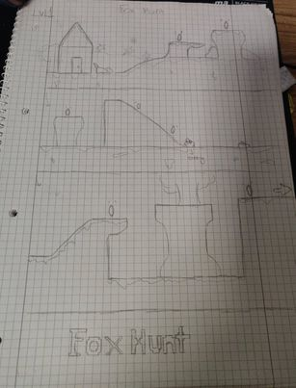

## Unique Selling Points

* Freshness and replay ability
* Waiting time is responsive
* Uniformity
* Game loop
* surprise

## Game loop

The player has the ability to control the fox by pressing the arrow keys or the awsd keys on the keyboard. The player can also press the space bar to jump. If the player dies, he has the chance to respawn 3 times, after he loses the game. The player can always restart the game and re-try to win. The player will win after two levels.

## Scope

Here’s just a few important questions to answer in this section. Be elaborative!

* The time depends on the player. It should take around 5 mins maximum to complete
* 2 levels
* 3-5 mins
* The objectives are that the player controls the fox to find the surprise. The player should follow and collect the coins where possible. The player should avoid the enemies or else a life would be deducted. After the deduction of 3 lives the player dies and has to start from the beginning.
* There is 1 playable character. There are no customizations or upgrades

## Art Style & Assets

Include a description of your art style and supplement with art concepts or inspirational concepts.

Describe your style for the environment, characters, UI, etc. You can also link to a different area/scene it lives in.

## Player Profiles Stories

* Describe the ideal player profile or multiple profiles
* E.g. Sam loves to play narrative-driven games like Edith Finch….
* E.g. Alex is a completionist and likes to spend hours in a game purchasing or earning all the upgrades...
* How might these players play your game differently
* Walk the reader through your game loop and describe what your different player profiles focus on.

## Milestone Schedule

* Your Milestone Schedule should include the milestone #, milestone description, and date of delivery.
* The big milestones for your game include 1) Design 2) Look and feel 3) First Playable, 4) Final Game

## State Machine Diagram

* A UML Design that shows different game states and transitions.