+91 9033737504
sonigautamkumar@outlook.com
 |  | https://www.linkedin.com/in/gautamkumar-soni-830126229/
GAUTTAMKUMAR SONI  Senior QA Analyst with nearly 11 years of experience in software quality assurance, test automation, and process improvement, seeking a challenging role to leverage expertise in functional testing. Adept at driving end-to-end testing, mentoring QA teams, implementing QA best practices, and ensuring high-quality software delivery that aligns with business objectives.  Certifications  - Foundation Level – ISTQB  - Advanced Level – ISTQB  Core Competencies  Manual Testing  API Testing (Postman tool)  Test Automation (Selenium)  Requirement Analysis  Agile Methodologies  Team Building and Leadership  Defect Tracking and Management |  | Profile Summary  - Established and enforced Standard Test Processes & Deliverables (including defect management (TestRail) and quality metric reporting) within the gated process to streamline testing including automation and manual testing efforts.  - Performed various types of testing like Functionality Testing, System Testing, Database Testing, Automation Testing, Integration Testing, Smoke/Sanity Testing, User Acceptance Testing, Regression Testing, Performance Testing, Adhoc Exploratory Testing.  - Excels in leading cross-functional teams to deliver high-quality applications, with specialized experience in mobile app testing.  - Proven track record of integrating industry best practices and methodologies into testing processes, enhancing defect detection and resolution efficiency; experienced in managing end-to-end project lifecycles across Agile environments.  - Demonstrated strong strategic acumen in establishing comprehensive Quality Assurance programs, including criteria for system reviews, software metrics, benchmarking, productivity analysis, risk management, and cost evaluation to drive informed decision-making for developers and business stakeholders.  - Excelled in formulating and executing software testing plans by defining resource needs, scheduling assumptions, and scope, while effectively coordinating test strategies across multiple teams, test organizations, and facilities.  - An effective leader with proven skills in leading & motivating teams during the project phase; holds expertise in managing & supporting the teams.  Education  - Master of Computer Applications (MCA) | Gujarat Technological University, Gujarat | 2013 | CGPA: 7.5  - Bachelor of Computer Applications (BCA) | Veer Narmad South Gujarat University, Gujarat | 2010 | Percentage: 64%  - Higher Secondary Certificate (HSC) | Sarvajanik High School, Dungri, Gujarat | 2007 | Percentage: 60%






Career Timeline 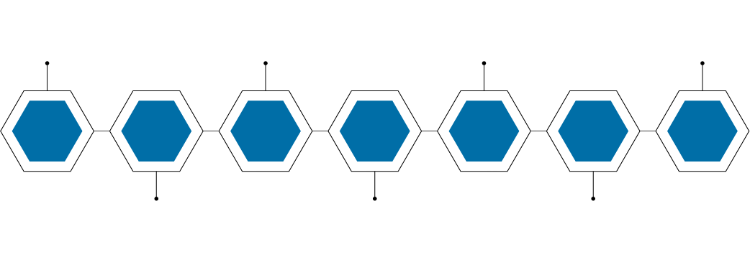
Since Oct’23
Mar’21-Sep’23

Oct’09-Feb’10
Jan’18-Oct’19

Mar’15-Dec’17
Jun’20-Mar’21
Work Experience

Oct 2023-Sep 2025: IHCS Technologies (Qualifacts) as QA II

Key Responsibilities:
- Executing end-to-end quality assurance activities across web and enterprise applications, ensuring alignment with business and technical requirements.
- Developing and maintaining manual test data for functional, regression, and sanity testing.
- Collaborating with developers, business analysts, product owners and project managers to identify, document, and resolve defects, enhancing application quality.
- Participating in requirement analysis, test planning, and test strategy development, ensuring comprehensive test coverage.
- Utilizing QA tools and frameworks to track defects, generate test reports, and monitor quality metrics.
- Supporting process improvements and adherence to QA best practices, contributing to enhanced team productivity and reduced defect leakage.
- Engaging in cross-functional communication to ensure timely delivery of high-quality releases.

Mar 2021- Sep 2023: Ambab Infotech Pvt. Ltd., Mumbai, Maharashtra as Senior QA Analyst
E-Commerce Domain (Magento-based e-Com Web Application)

Key Responsibilities:
- Analyzed requirements and application workflow to design effective test strategies and detailed test plans.
- Executed test scenarios and cases, generated comprehensive test reports to validate quality standards.
- Monitored, documented, and tracked defects, ensured timely resolution in collaboration with developers.
- Applied Requirement Traceability Matrix (RTM) methodology to review test cases and maximize coverage.
- Facilitated team meetings, delegated tasks, and ensured efficient execution of project deliverables.
- Designed and implemented a robust test automation framework, reduced manual effort and improved efficiency.
- Led the transition from manual to automated testing, enhanced test coverage and productivity.
- Enforced QA protocols, SOPs, and compliance standards to mitigate business risks.
- Defined and tracked Testing Team KPIs; managed onshore/offshore testing resources for timely delivery.
- Steered testing operations including estimation criteria, prioritization, and review of test reports/artifacts.
- Directed the Regression Team for on-time completion of each regression cycle.
- Utilized Target Process Management Tool for test case design, execution, and tracking.
- Conducted defect triage/status meetings with BAs, developers, and project managers to align resolution plans.
- Established QA policies, continuous improvement practices, and quality assurance best practices.
- Actively participated in cross-functional discussions, provided insights for release readiness and stakeholder updates.

Jun 2020-Mar 2021: Indimedi Solutions Pvt. Ltd., Gujarat as Senior QA Analyst
ERP – Domain (Odoo-based ERP System)

Key Responsibilities:
- Analyzed client requirements and application workflows to design effective test strategies and plans and ensure full coverage.
- Reviewed test scenarios and cases using RTM methodology, delivered comprehensive test reports.
- Tracked and resolved defects in close collaboration with developers and ensured timely fixes.
- Managed and guided team members, delegated tasks for smooth and efficient project execution.
- Partnered with cross-functional teams to identify and resolve critical defects, ensured high-quality deliverables.

Oct 2019-Feb 2020: DevDigital, Vadodara, Gujarat as Software QA

Key Responsibilities:
- Analyzed requirements and application workflow to design and execute effective test cases.
- Delivered detailed test reports to ensure transparency and traceability of test execution.
- Tracked, documented, and resolved defects in collaboration with Development Teams.
- Built strong cross-functional collaboration to drive seamless project execution and high-quality deliverables.

Jan 2018-Oct 2019: 1Rivet, Valsad, Gujarat as Software QA

Mar 2015-Dec 2017: Smarte Inc., Navi Mumbai, Maharashtra as Software QC

Achievements  - Received the “Hyper Helper Award” (June 2024) for exceptional collaboration and support.  - Earned client appreciation for delivering the e-commerce project (https://www.spaces.in/) with defect-free deployment for public use.  - Recognized for strong multi-tasking abilities and consistently delivering high-performance outcomes across organizations. | Personal Details  Date of Birth: 2nd October 1988  Languages Known: English, Gujarati and Hindi  Address: 102, D.B. Complex, Link Road, Dungri (R.S.), Valsad – 396375, Gujarat, India

