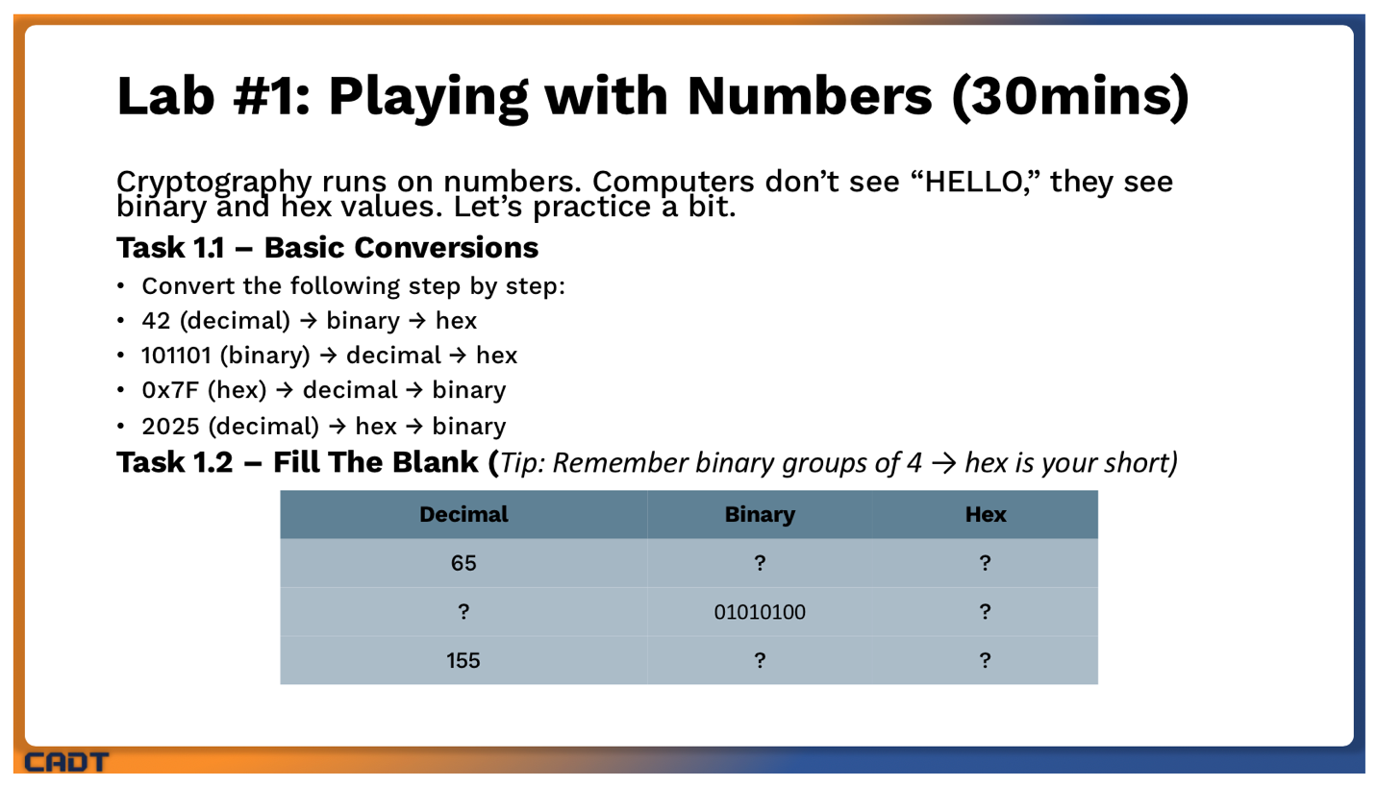

- Task 1.1 Basic Conversion
Convert the following step by step
42 | 10010 | 12
101101 | 45 | 2D
0x7F | 127 | 01111111
2025 | 7E9 | 011111101001

- Task 1.2 Fill The Blank
Decimal | Binary | Hex
65 | 01000001 | 41
84 | 01010100 | 54
155 | 10011011 | 9B

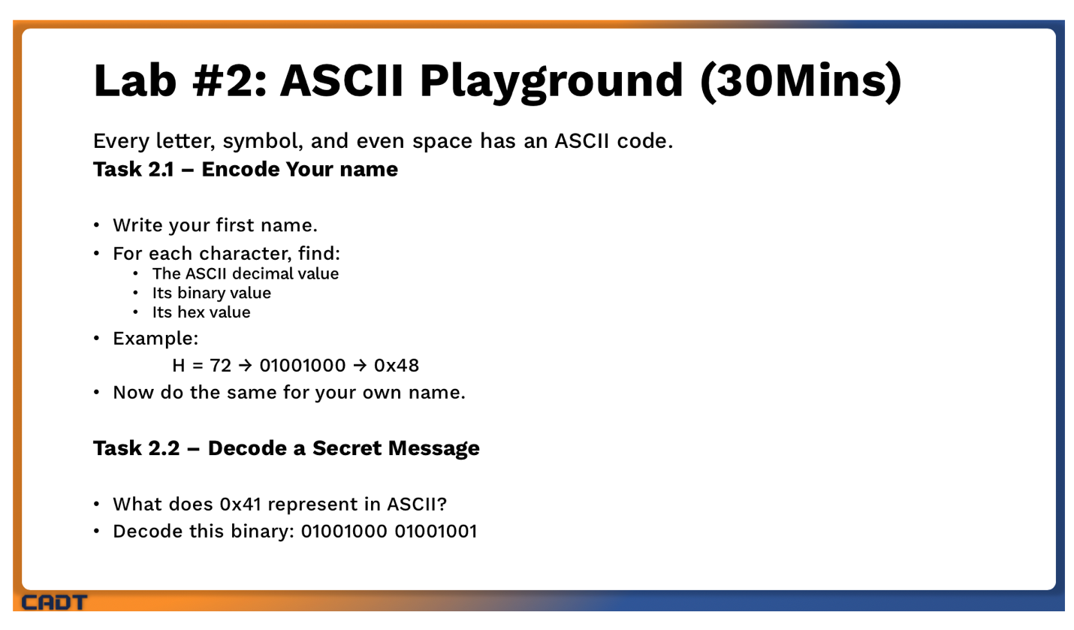
- Task 2.1 Encode (Hean Chhanun)
Decimal | Binary | Hex
72 | 01001000 | 48
101 | 01100101 | 65
97 | 01100001 | 61
110 | 01101110 | 6E
32 | 00100000 | 20
67 | 00100011 | 43
104 | 01101000 | 68
104 | 01101000 | 68
97 | 01100001 | 61
110 | 01101110 | 6E
117 | 01110101 | 75
110 | 01101110 | 6E

- Task 2.2 Decode a Secret Message
- 0x41 = 29
- 01001000 = 8 + 64 = 72 = H
- 01001001 = 1 + 8 + 64 = 73 = I

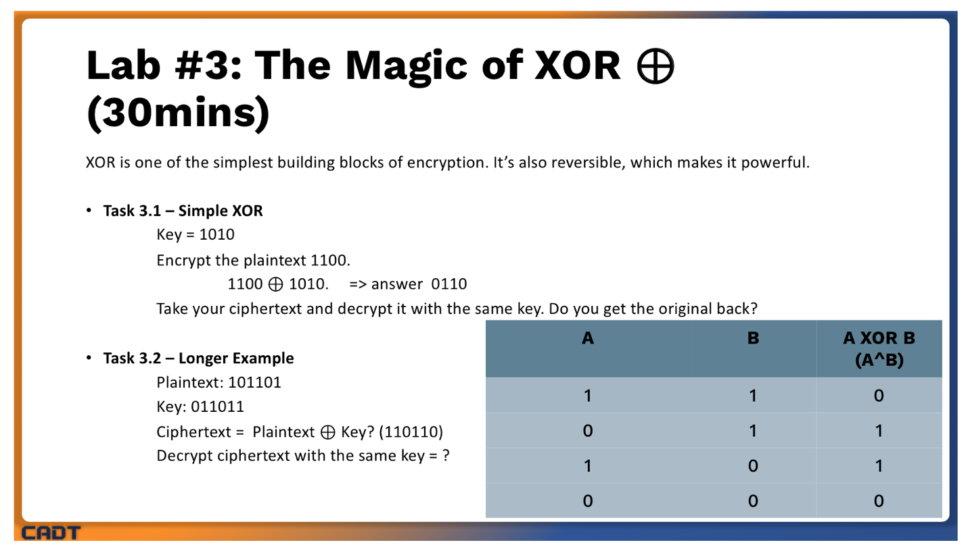

- Task 3.1 Simple XOR
A | B | XOR
1 | 1 | 0
0 | 1 | 1
1 | 0 | 1
0 | 0 | 0

- Task 3.2 Longer Example
A | B | XOR
1 | 0 | 1
0 | 1 | 1
1 | 1 | 0
1 | 0 | 1
0 | 1 | 1
1 | 1 | 0

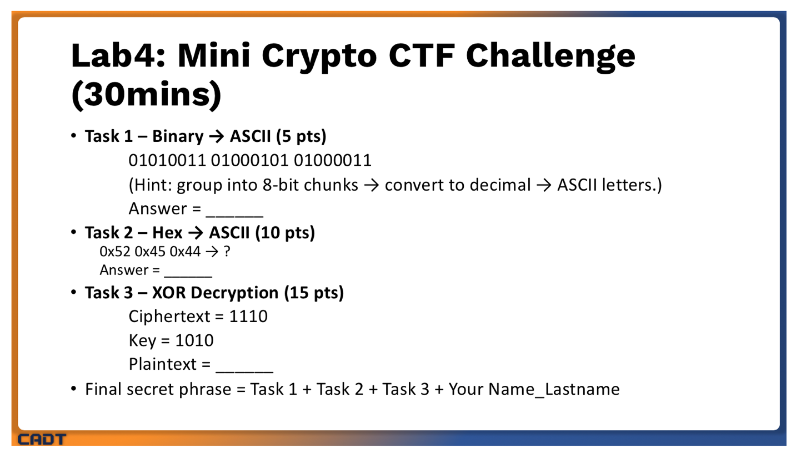

- Task 1 Binary
- 01010011 = 83
- 01000101 = 69
- 01000011 = 67
Answer = SEC

- Task 2 Hex
- 0x52 = R
- 0x45 = E
- 0x44 = D
Answer = RED
- Task XOR Decryption
A | B | XOR
1 | 1 | 0
1 | 0 | 1
1 | 1 | 0
0 | 0 | 0

Final secret phrase = SECRED0100CHHANUN_HEAN

