Lab Week2

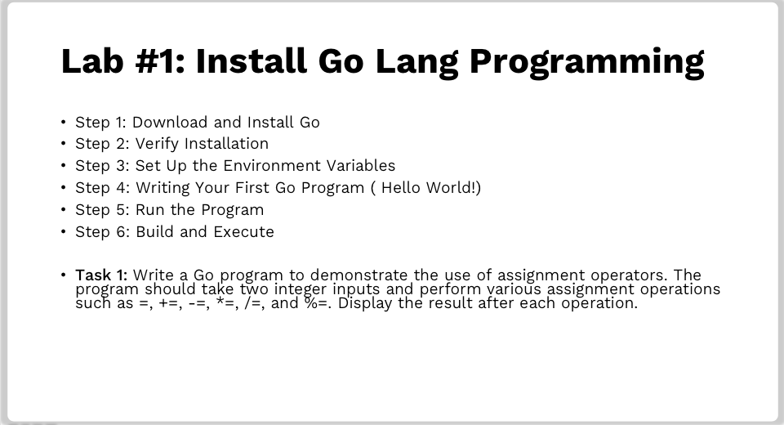

- Install Go Lang Programming
  - Step 1 : Dowload and install go
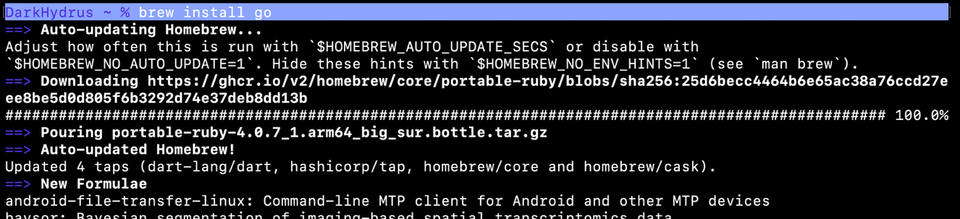
  - Step 2 : Verify Installation
  - Step 3 : Set up Environment
  - Step 4 : Write Go Program
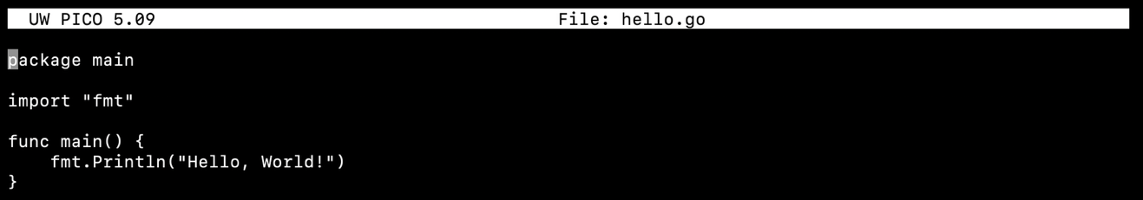

  - Step 5 : Run

  - Step 6 : Build and Execute
  - Task 1
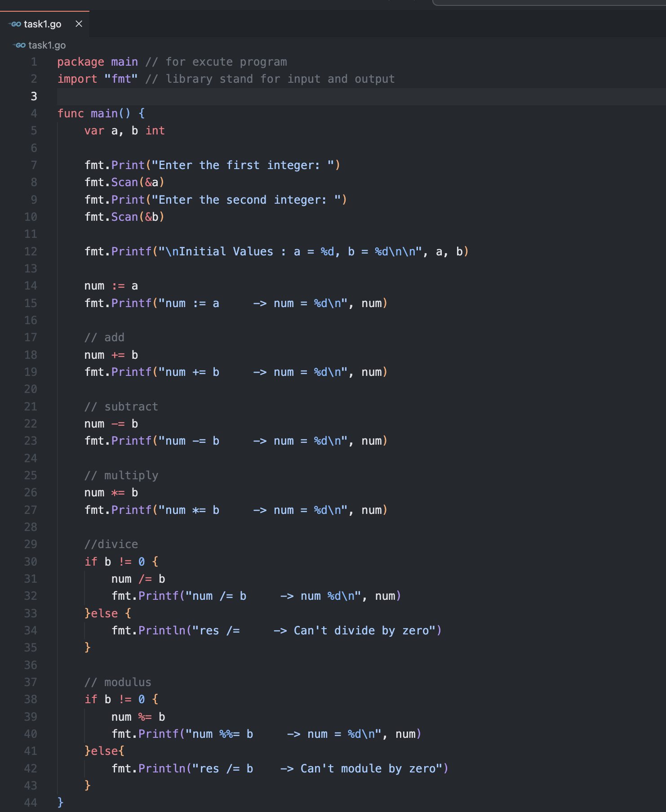

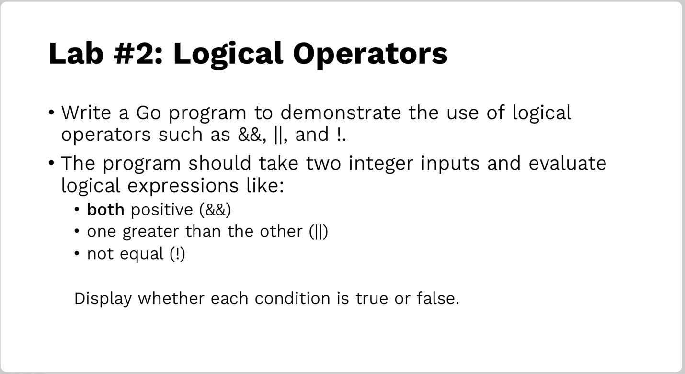
- Logical Operators

