AI-BASED FOOD PACKAGING MATERIAL RECOMMENDATION SYSTEM
23CS71C – MINI PROJECT

A PROJECT REPORT

Submitted by

Aarabhi Shen S A | 2303957610422001
Chharlatha UN | 2303957610422009
Pooja M | 2303957610422033

in partial fulfillment for the award of the degree of
BACHELOR OF ENGINEERING

in

COMPUTER SCIENCE AND ENGINEERING


NATIONAL ENGINEERING COLLEGE
(An Autonomous Institution affiliated to Anna University, Chennai) K.R.NAGAR, KOVILPATTI – 628503
ANNA UNIVERSITY : CHENNAI 600 025
OCTOBER 2026

NATIONAL ENGINEERING COLLEGE

(An Autonomous Institution affiliated to Anna University, Chennai) K.R.NAGAR, KOVILPATTI – 628503

BONAFIDE CERTIFICATE
Certified that this project report “AI-BASED FOOD PACKAGING MATERIAL RECOMMENDATION SYSTEM” is the bonafide work of Aarabhi shen S A (2312001), Chharlatha UN (2312009), Pooja M(2312033) who carried out the project work under my supervision.

SIGNATURE SIGNATURE
Dr. V. GOMATHI, M.Tech., Ph.D., Mrs.S.G.Janani Ratthna, M.E.,
HEAD OF THE DEPARTMENT SUPERVISOR
Department of Computer Science and Assistant Professor
Engineering Department of Computer Science and
National Engineering College Engineering
K.R.Nagar, Kovilpatti – 628503 National Engineering College K.R.Nagar, Kovilpatti – 628503

Submitted to the 23CS71C – MINI PROJECT Viva-Voce examination held at National Engineering College, K.R.Nagar, Kovilpatti on .

INTERNAL EXAMINER CO-EXAMINER

ACKNOWLEDGEMENT

First and foremost, we would like to thank God Almighty for showering His blessings throughout our lives. He has been the tower of our strength at every step of our work. We take this privilege to express our heartfelt thanks to our parents for their valuable support, encouragement, and efforts towards the successful completion of this project work.
We would like to express our deep sense of gratitude and respectful regards to our Director Dr. S. Shanmugavel, B.Sc., D.M.I.T., Ph.D., for giving us an opportunity to do this work.
We would like to express our sincere gratitude to our highly respected Principal, Dr. K. Kalidasa Murugavel, M.E., Ph.D., for providing unwavering support for our endeavor.
We would like to send our sincere gratitude to our esteemed Department Head, Dr. V. Gomathi, M.Tech., Ph.D., Department of Computer Science and Engineering, for her unwavering support and provision of several facilities during the project.
We would like to take this opportunity to acknowledge our generous Project Guide, Ms. S.G. Janani Ratthna, M.E., Assistant Professor, Department of Computer Science and Engineering, for her insightful advice, helpful recommendations and technical support throughout the project.
We would like to express our sincere gratitude to Mrs.D.Thamarai Selvi, M.E., Ph.D., Assistant Professor (Sr.Grade), Department of Computer Science and Engineering, our course instructor, for his valuable guidance, encouragement, and support throughout the project.
We extend our sincere gratitude to Dr. R. Rajakumari, M.E., Ph.D., Associate Professor, Department of Computer Science and Engineering, our course coordinator, who have provided invaluable assistance throughout the entire project.
We would also like to thank our tutors, class incharge, faculty members, non teaching staff and friends for their valuable advice, recommendations and collaboration during our project work

ABSTRACT

The selection of suitable packaging for perishable food products often relies on supplier recommendations, prior experience, or predefined lookup tables that associate food categories with packaging materials. Such approaches do not adequately determine the barrier performance required to preserve food quality and achieve the desired shelf life, and may overlook missing data and the need for transparent, evidence-based recommendations. This paper presents PackWise, an evidence-driven inverse-design decision-support system developed using FastAPI, Pydantic, PostgreSQL, and a React/TypeScript frontend. Given the food commodity, storage conditions, and target shelf life, the system infers missing food properties from verified evidence while explicitly representing uncertainty. It calculates the required oxygen, carbon dioxide, and water-vapour transmission rates using respiration, modified-atmosphere, moisture-transfer, and predictive-microbiology models. Candidate packaging materials are classified as FEASIBLE, INFEASIBLE, or UNKNOWN using interval-aware hard constraints. A pluggable search engine evaluates multiple objectives while preserving uncertainty intervals and identifies the exact Pareto front, accompanied by constraint-level explanations and counterfactual thresholds. Furthermore, a feedback module compares observed trial results with model predictions and records potential model updates for expert review. The system follows an evidence-preserving approach in which unsupported properties are not fabricated, enabling transparent, traceable, and scientifically grounded packaging recommendations.
Keywords: Food packaging, inverse design, Pareto optimization, modified atmosphere packaging, uncertainty, explainability, decision support.

 | TABLE OF CONTENTS
NO. | TITLE | PAGE NO
1. | INTRODUCTION | 1
1.1 | GENERAL | 1
1.2 | NOVELTY AND PRIOR-ART ANALYSIS | 2
1.3 | IP CONSIDERATIONS AND SUGGESTED CLAIM FOCUS | 7
1.4 | LITERATURE SURVEY | 9
1.5 | ADDITIONAL FEATURES | 12
2. | OBJECTIVE | 14
2.1 | TECHNICAL DOMAIN | 14
2.2 | EXISTING INDUSTRIAL PROBLEM | 14
2.2.1 | Existing Solutions | 15
2.2.2 | Products, Patents and Publications | 16
2.2.3 | Objectives of the Proposed System | 17

- DESCRIPTION 18
  - SYSTEM ARCHITECTURE DIAGRAM 18
  - DATA AND EVIDENCE MODULE 19
  - REQUEST AND INTERFACE MODULE 20
  - INFERENCE, PHYSICS AND OPTIMIZATION MODULE 21
- METHODOLOGY 22
  - METHODOLOGY FLOW CHART 22
  - OVERVIEW OF SYSTEM WORKFLOW 24
  - EVIDENCE ACQUISITION, VERIFICATION AND 26
DATABASE SETUP
  - REQUEST VALIDATION AND PROPERTY INFERENCE 26
  - PHYSICS-BASED REQUIREMENT CALCULATION 26
  - HARD-CONSTRAINT FEASIBILITY FILTERING 28
  - OBJECTIVES AND PARETO FRONT CONSTRUCTION 29
  - INVERSE-DESIGN SEARCH ENGINES 30
  - EXPLAINABILITY AND COUNTERFACTUAL 30
ANALYSIS
  - FEEDBACK AND MODEL-UPDATE FOUNDATION 31
  - AI-SURROGATE PREPARATION LAYER AND 31
PRECOMPUTED STATES
  - FRONTEND RECOMMENDATION INTERFACE 31
- TESTING AND RESULTS 32
  - SYSTEM TESTING AND RESULT 32
  - POSSIBLE FUTURE ENHANCEMENTS 47
- INTERPRETATION AND RESULTS 48
  - PackWise PROJECT FLOW 48
  - FOLDER STRUCTURE 49
  - DATABASE DESIGN (ER DIAGRAM) 49
  - USER INTERFACE SCREENS 51
- CONCLUSION AND SUMMARY 56
  - CONCLUSION 56

7.2 | SUMMARY | 56
APPENDIX 1 | PROJECT SUBMISSION CONTENT | 57
APPENDIX 2 | EVIDENCE SOURCES AND DATA PROFILING | 58
APPENDIX 3 | PROCESSED DATASET SUMMARY | 60
APPENDIX 4 | CONFIGURATION PARAMETERS | 61
 | REFERENCES | 62

 | LIST OF TABLES
TABLE NO. | TITLE | PAGE NO.
1.1 | Reference Points Reviewed and the Gap Addressed | 3
1.2 | Traditional Packaging Selection versus the Proposed System | 7
2.1 | Limitations of Existing Approaches | 15
3.1 | Technology Stack | 19
3.2 | REST API Endpoints | 20
4.1 | Epistemic Result States of the Physics Engine | 27
4.2 | Hard-Constraint Comparison Semantics | 28
4.3 | Optimisation Objectives | 29
5.1 | Milestone Verification Results | 32
5.2 | Functional and Safety Test Cases | 32
6.1 | Main Database Tables | 50
A2.1 | Evidence Sources Used by the System | 58
A3.1 | Processed Datasets and Validation Result | 60
A4.1 | Main Configurable Parameters | 61

LIST OF FIGURES

FIG. NO. | TITLE | PAGE NO.
1.1 | Patent Mapping Table – Key Documents Identified (Part 1) | 5
1.2 | Patent Mapping Table – Key Documents Identified (Part 2) | 6
1.3 | Patent Mapping Table – Key Documents Identified (Part 3) | 6
1.4 | Patent Mapping Table – Key Documents Identified (Part 4) | 6
3.1 | System Architecture Diagram of the PackWise | 18
4.1 | Methodology Flow Chart of the PackWise | 22
4.2 | Use Case Diagram of the Proposed System | 23
4.3 | System Workflow for the PackWise | 24
5.1 | Full Regression Test Run of the Backend Test Suite | 34

  - Recommendation API Response with Candidate 43
Counts and Pareto Front
  - Feedback API Response 44
  - PackWise Project Flow 48
  - Entity Relationship (ER) Diagram of the Evidence and 50
Feedback Database
  - Packaging Request Form – Product Context 51
  - Packaging Request Form – Food Properties and 52
Geometry
  - Recommendation Dashboard 52
  - Property Inference and Scientific Requirements 53
  - Pareto Candidate Cards 53
  - No Feasible Recommendation Established 54
  - API Documentation (/docs) 54
  - Explainability and Counterfactual Output 55

6.11 | PostgreSQL Evidence and Feedback Tables | 50
A2.1 | Indian Commodity Coverage Figure from Data Profiling | 59
A2.2 | Packaging Material Barrier Properties Figure from Data Profiling | 59

LIST OF SYMBOLS, ABBREVIATIONS AND NOMENCLATURE

ABBREVIATION EXPANSION

API Application Programming Interface

aw Water Activity

CO₂TR Carbon Dioxide Transmission Rate

CORS Cross-Origin Resource Sharing

EMAP Equilibrium Modified Atmosphere Packaging

ER Entity Relationship

FSSAI Food Safety and Standards Authority of India

GAB Guggenheim–Anderson–de Boer (Sorption Model)

HTTP Hypertext Transfer Protocol

ICAR Indian Council of Agricultural Research

IFCT Indian Food Composition Tables

JSON JavaScript Object Notation

MAP Modified Atmosphere Packaging

OTR Oxygen Transmission Rate

QSAR Quantitative Structure–Activity Relationship

REST Representational State Transfer

RH Relative Humidity

RQ Respiratory Quotient

SIH Smart India Hackathon

SPA Single Page Application

SQL Structured Query Language

TDS Technical Datasheet

UI User Interface

USDA United States Department of Agriculture

WVTR Water Vapour Transmission Rate

Symbols
r_{O2}, r_{CO2} – oxygen consumption and carbon dioxide production rates (mg/kg·h); V_{m} – maximum respiration rate;
K_{m} – Michaelis constant for O₂; K_{i} – CO₂ inhibition constant;
β – CO₂TR to OTR selectivity ratio;
P_{sat} – saturation water vapour pressure (kPa); a_{w} – water activity;

μ_{max} – maximum specific growth rate; λ – lag time;
M – product mass (kg); y – gas fraction;
f – objective function.

CHAPTER 1 INTRODUCTION

GENERAL
The PackWise is a full-stack software system that helps a user decide what packaging a perishable food actually needs. Conventional packaging selection relies on supplier catalogues, past practice or fixed lookup tables that map a food name to a material. Such approaches say little about why a material suits a product, cannot show what happens when the storage conditions or the target shelf life change, and give no warning when the underlying data are missing.
The proposed system works in the opposite direction. Instead of asking which material matches a given food, it asks what packaging performance is scientifically required for the food, the storage conditions and the shelf life requested, and then searches the available packaging designs for those that meet the requirement. This is an inverse-design formulation: the target outcome is the input and the packaging specification is the output. The pipeline combines six functions in one platform: validation of the packaging request; evidence-based inference of food properties with explicit uncertainty; physics-based calculation of the required oxygen, carbon dioxide and water-vapour transmission rates; deterministic hard-constraint filtering of candidate packaging into FEASIBLE, INFEASIBLE and UNKNOWN sets; multi-objective search with exact Pareto-front construction; and explainability with counterfactual thresholds. A feedback module records real packaging-trial observations and compares them with the predictions.
A central design rule of the project is that the system never invents data. When no verified evidence exists for a property, the property remains UNKNOWN with no numeric value, the UNKNOWN status is carried through every later stage, and a candidate whose feasibility depends on an unknown value is never presented as feasible. Uncertain values are kept as intervals [value_min, value_max] and are never collapsed to a midpoint. The guiding principle in the repository is "rules first, physics first, AI only where it adds real value".
The backend is developed in Python with FastAPI and Pydantic v2 and stores its canonical evidence model in PostgreSQL through SQLAlchemy and Alembic migrations. The frontend is a React 19 and TypeScript single page application built with Vite and Tailwind CSS. It provides a packaging request form and a recommendation dashboard that displays the inferred properties, the scientific requirements and the Pareto candidates returned by the REST API at

/api/v1/recommend. The scientific evidence layer is built from nine processed datasets (USDA FoodData Central, Indian Food Composition Tables 2017, USDA Handbook 66, UC Davis produce fact sheets, ICAR/IIFPT Indian postharvest data, CIRAD/WUR barrier data, PolyID, manufacturer datasheets and ComBase), each with a recorded source, verification status and provenance.

XLSCOUT Report
A preliminary novelty and prior-art analysis was conducted using XLSCOUT.ai for the proposed AI-Based Intelligent Food Packaging Material Recommendation System for Food Commodities. The report examined the disclosed combination of twelve key features, covering food-specific packaging design, gas and moisture transmission calculations, uncertainty-aware food-property representation, contextual property inference, machine-learning models, multi-objective optimization, physics-based evaluation and explainability. It also considered the proposed software architecture and user interface.

The search report reviewed fifteen patent documents and compared their disclosed features with the proposed system. The documents covered a range of areas, including optimization methods, artificial intelligence, material systems, delivery logistics, image analysis and other technical applications. According to the report, none of the reviewed documents disclosed the complete combination of features identified in the proposed system. The report therefore highlighted the potential distinctiveness of integrating food-specific packaging transmission calculations, interval-based property representation, multiple physics models, Pareto-based optimization and counterfactual explanations within a single decision-support platform.

However, the report also identified potential overlap with existing work involving general AI-based decision support and multi-objective optimization. It cautioned that some of the identified documents belong to technical fields different from food packaging and that the feature mapping may overstate the relevance of partial similarities. Accordingly, the findings should be interpreted as preliminary indications of potential novelty rather than as proof that the complete system is novel, inventive or patentable.

The report recommended further manual examination of selected documents, more targeted searches concerning food-packaging gas transmission and multi-physics simulation, and refinement of the technical features used to distinguish the proposed system. It also emphasized the need for independent professional review. The XLSCOUT report is therefore used in this project as an initial reference for identifying potentially differentiating technical features and areas requiring further investigation, not as a s ubstitute for a comprehensive patentability assessment.

Table 1.1 Key documents identified by the NoveltyLLM search

S.  No. | Publication No. | Assignee | Title
1 | CN-122431624  -A | Hefei Bentu Intelligent Manufacturing Co Ltd | Image forming control method, device, equipment and storage medium
2 | US-12462217-B2 | Innovative Robot Delivery GmbH | Method, depot facility and system for handover of parcels
3 | US-12405974-B2 | Schlumberger Technology Corporation | Geologic search framework
4 | US-202600987 38-A1 | Anteam Ltd | Methods and systems for determining route and vehicle for delivering goods with reduced carbon footprint
5 | US-8554599-B 2 | Microsoft Technology Licensing LLC | Work item rules for a work item tracking system
6 | US-8207396-B 2 | Genentech Inc | Gene disruptions, compositions and methods relating thereto

7 | US-12329128-B2 | Phytobiotics Futterzusatzstoffe GmbH | System for analyzing animal secretion images
8 | US-9830778-B 2 | Dialware Communications LLC | Interactive toys
9 | US-202400449 00-A1 | The Board of Trustees of the Leland Stanford Junior University | Features for determining ductal carcinoma in situ recurrence and progression
10 | US-202302223 49-A1 | BASF SE | AI-system for flow chemistry
11 | US-11943417-B2 | Huawei Technologies Co Ltd | Three-dimensional integral-imaging light field display and optimization method therefor
12 | US-202001892 52-A1 | Toray Advanced Film Co Ltd | Laminate and sealing member using same
13 | US-11829939-B2 | KPN Innovations LLC | System and methods for transfer path optimization
14 | US-11681981-B2 | Coupang Corp | Item tracking systems and methods for fine-tuned delivery scheduling
15 | CN-122050643  -A | Shoukang Investment Development Shandong Group Co Ltd | Full biodegradable material experimental system based on multi-scale simulation and machine learning

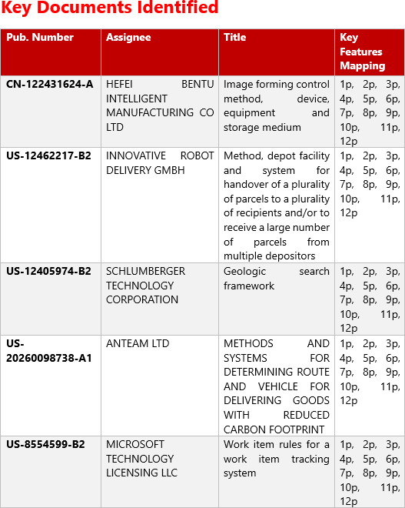

Fig 1.1 Patent Mapping Table – Key Documents Identified (Part 1)

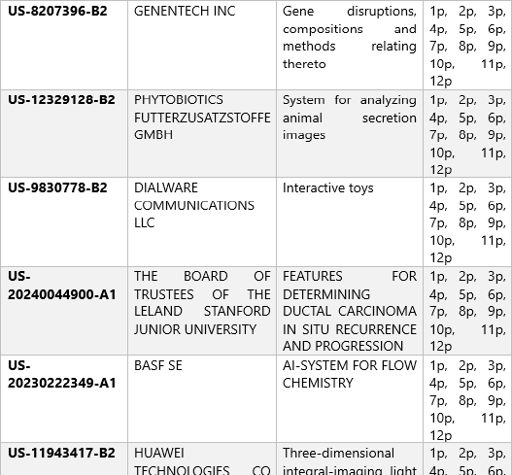

Fig 1.2 Patent Mapping Table – Key Documents Identified (Part 2)
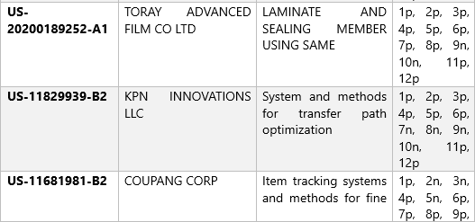

Fig 1.3 Patent Mapping Table – Key Documents Identified (Part 3)


Fig 1.4 Patent Mapping Table – Key Documents Identified (Part 4)
The review shows that existing work covers parts of the problem: material screening, produce-specific perforation design, forward shelf-life prediction and hardware-based sensing.

None of the reviewed approaches combines, in a single software workflow, uncertainty-aware inference of food properties from verified evidence, a physics-derived requirement envelope, interval-aware feasibility classification with an explicit UNKNOWN state, multi-objective Pareto search and counterfactual explanations with a trial-feedback record. The established physics equations used in the system are not claimed as new; the contribution is the way they are combined into an evidence-gated inverse-design pipeline.
The system differentiates itself from the traditional practice as summarised in Table 1.2.

Table 1.2 Traditional packaging selection versus the proposed system

Traditional Practice | Proposed System
Material chosen from a food-name lookup table | Required OTR, CO₂TR and WVTR derived from the food, conditions and target shelf life
Missing data silently replaced by defaults | Missing data stay UNKNOWN and are never converted to feasible
One "best" material | Exact Pareto front of non-dominated candidates
"Recommended because the tool says so" | Constraint-level explanations and counterfactual thresholds
No link between recommendation and trial results | Feedback records compare predicted and observed performance

ATTORNEY REVIEW SUGGESTION:
Following the review of the proposed project, an important direction for further development was suggested: extending the system beyond packaging recommendations made before a food packet is opened to include guidance on preserving food after the packet has been opened.
In its current intended scope, the project focuses on recommending suitable packaging materials for different food commodities using food-property evidence, packaging requirements, physics-based evaluation, candidate optimization and explainable recommendations. The proposed extension would address a further stage of the food's lifecycle: what a customer should do with the remaining food after opening the original package.
Under this extended concept, the system could consider the food commodity, its physical and quality characteristics, the original packaging, the quantity remaining, the conditions under which it is stored and the customer's intended period of use. Based on validated food-science

evidence and applicable preservation guidance, it could recommend suitable post-opening preservation methods. Depending on the food and the available evidence, these methods could include resealing the original package, transferring the food to a suitable airtight container, protecting it from moisture or oxygen exposure, controlling temperature and humidity, refrigerating or freezing where appropriate, and providing evidence-based storage-duration guidance.
For example, a system serving a customer who has opened a biscuit packet could prioritize protection against moisture and loss of crispness. For nuts, it could consider exposure to oxygen, moisture, heat and associated quality deterioration. For perishable foods, it could provide appropriate temperature-control and storage-container guidance when supported by reliable food-safety evidence. These examples illustrate the proposed direction; the appropriate recommendation would depend on the food type, its processing and handling conditions, and the evidence available for that specific application.
The proposed extension should not be limited to displaying a fixed list of generic storage tips. Its longer-term objective could be to develop a food-specific, evidence-driven post-opening preservation recommendation capability that explains why a method is recommended, what conditions it requires, which quality risks it addresses and what limitations apply. Where reliable evidence is unavailable, the system should communicate that limitation instead of generating unsupported preservation or food-safety claims.
This direction could broaden the project's intended contribution from selecting suitable packaging before purchase or use to supporting food preservation during actual consumer use. It could also provide a basis for future investigation into the relationship between packaging design, package-opening events, post-opening exposure and subsequent food-quality deterioration. Any such capability would require additional scientific evidence, appropriate preservation models, clearly defined recommendation boundaries and validation before being presented as an implemented or scientifically verified feature.
From an intellectual-property perspective, the proposed extension should be investigated as a potential additional technical contribution rather than automatically assumed to be novel. Further work should identify the specific technical mechanism by which the system determines and recommends post-opening preservation methods, compare that mechanism with relevant prior art, and assess how it interacts with the existing food-property inference, physics-based evaluation, optimization and explainability architecture. The attorney should review the

resulting technical specification and advise whether this extension warrants additional claim drafting or a separate patentability investigation.

LITERATURE SURVEY

Modern food-packaging design draws on several interconnected areas of research, including shelf-life prediction, data-driven and AI-based methods, produce respiration and modified-atmosphere packaging (MAP), moisture transfer, predictive microbiology, post-opening food stability and multi-objective optimization. Together, these areas provide the scientific foundations for determining packaging requirements, evaluating candidate packaging and identifying trade-offs between competing performance objectives.
Shelf-life prediction has been reviewed extensively. Cui et al. [11] classify shelf-life models and describe their structure, application mechanisms and numerical relationships. They also discuss applications such as predicting freshness indices and remaining shelf life, and they note that real-time quality monitoring could help screen more reliable packaging, processing and transport methods. More recent reviews examine machine-learning (ML) and artificial-intelligence (AI) approaches. Rashvand et al. [3] assess ML, deep learning and hybrid methods for shelf-life prediction, including the use of data from non-destructive sensing techniques, and identify limitations such as data availability, model generalizability and computational cost. Li et al. [7] compare traditional dynamic models with ML models for fruits and vegetables, while Pandey et al. [10] review ML as a tool in food packaging, processing and safety. Sagar and Rani [1] review AI-integrated smart packaging, including freshness sensors, traceability systems and biodegradable materials. These works primarily address prediction, monitoring and sensing for a given food and storage condition. As described in their abstracts, they do not focus on working backwards from a required outcome to a packaging specification. Their emphasis on data availability and generalizability also highlights the importance of treating missing evidence explicitly.
For fresh produce, MAP design depends on describing respiration as a function of gas composition and temperature. Maleki et al. [15] modelled the respiration of cucumbers using a Michaelis–Menten equation whose constants follow an Arrhenius-type temperature relationship, and validated the model in commercial passive and active MAP. The model predicted oxygen change well but was less satisfactory for carbon dioxide, mainly at 20 °C, which the authors attributed to possible anaerobic conditions. Irazoqui et al. [4] compared phenomenological models (Michaelis–Menten and Langmuir) with non-phenomenological

models (generalized linear and quadratic) for ready-to-eat strawberries. They used a factorial experiment covering oxygen, carbon dioxide and temperature, and selected models using adjusted R², RMSE and AIC. Both studies show that respiration models are commodity-specific, depend on the experimental range and can lose accuracy outside the conditions for which they were validated. Applying such models in a recommendation system therefore requires suitable input data, explicit treatment of missing properties and verification that the model’s assumptions are satisfied.
Moisture management is another important aspect of food packaging. Zardetto et al. [6] developed a two-component model for packed fresh-filled pasta, combining GAB-fitted moisture sorption isotherms with the packaging’s water transmission rate to predict moisture gain or loss. A correction factor was needed because sensors indicated a humidity gradient inside the package. Lopriore et al. [2] showed that, for a biopolymer-based package, water vapor transmission rate depends on environmental humidity, and predicted it from sorption data using a non-Fickian model. The reported relative difference between predicted and measured values was 32.2, which the authors considered acceptable given the complexity of the phenomena. Together, these studies show that barrier requirements depend on both food-specific sorption behaviour and humidity-dependent packaging properties, and that model-based estimates carry quantifiable uncertainty.
Predictive microbiology provides methods for studying how environmental conditions affect microbial behaviour. Tarlak [8] reviews modelling approaches for shelf-life prediction, including two-step and one-step approaches that use primary and secondary models, as well as ML approaches that do not require them. Verheyen and Van Impe [13] note that predictive models were traditionally developed in liquid laboratory media and therefore did not represent the effects of food microstructure, which limits their applicability when microstructure is ignored. These methods can inform food-safety and shelf-life assessments, but their use requires suitable organism, food-matrix and storage-condition information. A model-based estimate should not be treated as a validated food-safety determination unless the relevant model assumptions and conditions have been established.
Packaging design also involves competing objectives, such as material thickness, barrier performance, cost, moisture protection and shelf life. Xu et al. [5] review multi-objective optimization for ML-assisted materials design, covering Pareto-front-based strategies, scalarization functions and the constraint method. They note that weighted-sum scalarization

can bias solutions toward heavily weighted objectives, and that a Pareto front computed on virtual samples is not necessarily the true front. They also observe that ML-based inverse design has mostly addressed single-objective problems, identifying multi-objective inverse design as a future direction. Evolutionary algorithms such as NSGA-II appear in their case studies as established tools for computing Pareto fronts. In the present project, the existing search engines use deterministic candidate search and adaptive heuristic exploration to identify candidate solutions and construct a Pareto front. Evolutionary algorithms are considered possible future alternatives rather than a description of the current implementation.
A further body of work concerns food stability after a package has been opened, often called secondary shelf life. Cruz et al. [12] stored opened canned sardines at 4 °C for seven days and found that the outcome depended strongly on the sauce type. Sardines in brine and in vegetable oil were best consumed within one day, while sardines in tomato sauce remained stable for up to three days. Nicosia et al. [14] used domestic-use simulations in five households and found that two industrial pesto products remained acceptable for at least 20 days after opening, compared with the labelled five. Nicosia et al. [9] similarly found that a Bolognese sauce could have a secondary shelf life longer than 13 days, two to three times the current label, and that consumer behaviour influenced the result. These studies show that post-opening guidance is product-specific and evidence-dependent, and that current labelling may be conservative for some products.
A central design consideration for PackWise is the relationship between scientific evidence, uncertainty and packaging recommendations. Food-property values may be unavailable, supported by a single source or reported as intervals, and these situations should not automatically be treated as equivalent levels of certainty. The reviewed studies reinforce this concern: reported model errors [2], limited validity ranges [4], [15], and the dependence on data quality and generalizability [3] all indicate that predictions carry uncertainty. The project therefore adopts an explicit approach to representing unknown properties, deterministic values and evidence intervals, with the intention of preventing unsupported defaults and making the limitations of available evidence visible during recommendation generation.
Based on these research areas, PackWise aims to integrate food-property evidence, packaging-requirement calculations, candidate generation, scientific evaluation, feasibility assessment, multi-objective optimization and explainable recommendations within a unified decision-support workflow. Its intended contribution is the integration of these functions with

explicit treatment of uncertainty and scientific applicability, rather than the claim that the underlying physical equations or optimization techniques are individually new. The extent to which this integration differs from existing systems must be assessed against relevant prior art and supported by the project’s verified implementation.
A further proposed direction is to extend the system beyond selecting packaging before opening to provide food-specific preservation guidance after a package has been opened. The studies on secondary shelf life [9], [12], [14] indicate that suitable storage time and conditions vary by product and can be established through domestic-use simulation and microbiological, sensory and physicochemical testing. Such a capability would require additional literature review, suitable preservation guidance and validation. It is therefore identified as a future development direction, not as an already implemented or validated feature.

ADDITIONAL FEATURES
The system incorporates several features that raise the scientific reliability and transparency of its recommendations.
Property inference follows an evidence hierarchy: the engine first searches for an exact match on commodity, variety, product form, maturity stage, and temperature; it then traces explicitly tracked fallbacks in sequence—variety, product form, and temperature bounds—each of which is recorded and surfaced as a labelled inference warning. The full range of all supporting observations is retained as the uncertainty envelope of the inferred value, and every inferred property carries its associated literature citations. If no numerical evidence exists for a given commodity–property combination the property is returned as UNKNOWN and no value is fabricated or assumed.
The physics layer reports every result in one of three epistemic states: CALCULATED, PARTIALLY_CALCULATED, or UNKNOWN. Additionally, volumetric CO₂ units (mL or cc) are blocked from conversion to O₂ even when an RQ is present, unless verified gas-volume reference conditions (STP vs NTP) accompany the measurement. Every result carries a complete traceability record comprising the model name, equation form, literature reference, parameter sources, validity range, and all inputs used.
The search layer is pluggable through an algorithm-neutral abstract interface. Three concrete implementations are provided. The deterministic exhaustive-enumeration engine (M9) is retained as the reference baseline: it evaluates every eligible candidate design in full before constructing the Pareto front. The adaptive inverse-design engine (M10) uses evaluation

feedback to sequence candidates: before any feasible solution is found it selects the candidate closest to the requirement bounds (lowest combined barrier sum); once a feasible solution exists it selects the candidate that best extends the diversity and coverage of the current Pareto front (maximum distance in thickness–WVTR space). A third surrogate-prioritised engine (M11) applies a four-tier lexicographic priority cascade—design validity, surrogate applicability class (IN_DOMAIN > OUT_OF_DOMAIN), AI-predicted shelf-life ranking, and a deterministic canonical tie-breaker—to order expensive exact-physics evaluations without substituting surrogate inference for feasibility decisions. A progressive-tier contract governs state reuse: Tier-1 performs exact canonical lookup of precomputed optimisation states; on a miss, Tier-2 packages available stored states as an unranked warm-start handoff requiring mandatory target re-evaluation before any refinement.
The AI-surrogate preparation layer (Phase 3A Layer 4) generates provenance-tagged physics-reference datasets, performs leakage-resistant splitting across six strategies (interpolation, food holdout, material holdout, thickness holdout, storage-condition holdout, and combined out-of-domain holdout), benchmarks four candidate regression families (Gradient Boosting, Gaussian Process, MLP, and Ridge regression baseline), conducts applicability-domain checks, and produces an immutable versioned model manifest. The surrogate is explicitly architectured as an approximation of exact physics for speed-up purposes; it is not a feasibility authority and is not connected to the live recommendation path.
The feedback module accepts observed trial measurements and deterministically validates them against physical non-negativity constraints and unit-range limits (e.g., temperature −50
°C to +100 °C, relative humidity 0–100 %). Validated observations are compared with the stored prediction intervals using interval-containment analysis that preserves interval boundaries without midpoint collapse. Discrepancies that fall outside the prediction interval generate structured model-update candidate records, which are queued for human expert review without triggering automatic model retraining or equation mutation. Observations are tagged with one of four origin classifications—REAL_PRODUCTION, REAL_PILOT, SYNTHETIC_TEST, or DEMO—so that test fixtures and demonstration data are permanently distinguishable from real-world trial measurements.

CHAPTER 2 OBJECTIVE

GENERAL
The proposed PackWise system presents the technical domain, the existing industrial problem and the objectives of the proposed PackWise system. It introduces the scientific and technological foundations of the project, explains the challenges faced by food producers and packaging engineers in selecting suitable packaging materials, and establishes the need for an evidence-based, explainable packaging recommendation system.

TECHNICAL DOMAIN
The PackWise belongs to the domains of Food and Packaging Engineering, Scientific Computing, Multi-Objective Optimisation, Data Engineering and Software Engineering. It focuses on evidence-based, explainable decision support for the packaging of perishable foods. It is developed as a full-stack application using Python, FastAPI and Pydantic for the backend, PostgreSQL with SQLAlchemy and Alembic for data storage, and React with TypeScript for the frontend. It incorporates respiration kinetics, modified-atmosphere gas exchange, moisture transfer, predictive microbiology, interval arithmetic, Pareto optimisation and counterfactual analysis, exposed through REST APIs.

EXISTING INDUSTRIAL PROBLEM
Food producers, processors and exporters must choose packaging that protects the product for a required shelf life at reasonable cost and material use. In practice this choice is often made from experience, supplier recommendations or a short list of familiar materials. Several problems follow from this. First, the required barrier performance is rarely calculated from the food: a respiring fruit needs a film that lets oxygen in and carbon dioxide out at the right rates, whereas a dry product needs mainly a moisture and oxygen barrier. A material that is excellent for one product can be harmful for another.
Second, input data are frequently incomplete. A farmer or small processor may not know the respiration rate, water activity or pH of the product, and tools that demand exact values either fail or silently substitute defaults. Third, recommendations are given as a single answer without a reason, so a user cannot see which requirement a rejected material failed or how close it came to passing. Fourth, packaging choice involves trade-offs between thickness, barrier margin and achievable shelf life that a one-answer tool hides. Finally, there is no routine way to connect a

recommendation with what actually happened in a storage or transport trial, so the knowledge gained in practice is not captured.

Existing Solutions
Existing solutions address the problem only in parts. Classical materials-selection methods screen and rank materials against property limits. Produce-packaging services design microperforation from respiration measurements using dedicated instruments. Machine-learning models predict shelf life from packaging and storage conditions, and rule-based recommenders suggest a material for a named food. Table 2.1 summarises the limitation of each approach with respect to the problems listed above.

Table 2.1 Limitations of existing approaches

Existing approach | Strength | Limitation addressed by the proposed system
Materials-selection methods [1] | Provide a systematic process for screening, ranking and selecting materials. | Do not necessarily derive food-specific packaging barrier requirements, preserve uncertainty in food-property evidence or provide constraint-level counterfactual explanations.
Produce microperforation services [17] | Use respiration-related information to support packaging design for fresh produce. | Address a more specialized application and do not, by themselves, establish a general food-packaging inverse-design workflow.
Forward shelf-life prediction models | Estimate shelf life for specified food, packaging and storage conditions. | Forward prediction alone does not search for packaging configurations that satisfy a specified target shelf life.
Rule-based or lookup-table recommenders | Are relatively simple to use and computationally efficient. | May be limited by predefined mappings and may not adequately represent missing evidence, physics-based constraints or trade-offs between competing objectives.
Single-score recommendation systems | Provide a straightforward ranking of alternatives. | Can conceal trade-offs between objectives and may obscure why a candidate fails a particular constraint if the underlying explanation is not exposed.

The limitations summarized above describe the general capabilities and potential limitations of these approach categories. The extent to which a particular product or publication exhibits each limitation must be established from its technical documentation.

Products, Patents and Publications

Products. Materials-selection methods based on the Ashby approach [1] provide a structured basis for engineering material selection. PerfoTec [17] offers specialized solutions for respiration-based packaging design and microperforation of fresh produce. These examples illustrate existing approaches to material selection and produce-pack optimization. PackWise aims to address a broader decision-support problem by connecting food-property evidence, packaging requirements, candidate evaluation, multi-objective optimization and explainable recommendations within a unified workflow.
Patents and preliminary novelty analysis. A preliminary novelty and prior-art analysis was conducted using XLSCOUT.ai for the proposed PackWise system. The report examined fifteen patent documents and compared their disclosed features with the combination of features identified in the project. According to the report, none of the reviewed documents disclosed the complete combination mapped in the analysis. However, the report also identified potential overlap with general AI-based decision support and multi-objective optimization, and cautioned that some feature mappings may overstate the relevance of documents from different technical fields. The results should therefore be treated as preliminary findings rather than proof of novelty, inventive step or patentability. Further technical review, targeted prior-art searching and independent professional assessment are required. The report's suggested areas for further investigation are discussed in Section 1.3.
Publications. The EMAP mass-balance equations [2], [3], respiration kinetics [4], [5],
moisture-transfer and sorption relations [10], [11], and microbial growth models [8], [9] provide scientific foundations for the project's relevant calculations. These established methods are used as scientific references rather than claimed as original contributions of the project. Multi-objective optimization techniques such as NSGA-II [12] are considered as background and potential future alternatives; they should not be described as the current search algorithm unless subsequently implemented and verified.
Overall, the project's intended contribution lies in the integration of food-specific evidence, physics-informed packaging requirements, uncertainty-aware evaluation, candidate search and explainable multi-objective recommendations. The distinctiveness and technical effectiveness of this integration require assessment against relevant prior art and evidence from appropriate validation.

Objectives of the Proposed System:

- To validate packaging requests and infer food properties from available evidence while preserving uncertainty, recording supporting sources and representing unsupported properties as UNKNOWN rather than assigning fabricated defaults.
- To derive relevant packaging requirements, including oxygen and carbon dioxide transmission, water-vapour transmission, headspace atmosphere and shelf-life-related limits, where the required inputs and applicable scientific models support those calculations.
- To evaluate candidate packaging designs against applicable constraints and distinguish FEASIBLE, INFEASIBLE and UNKNOWN outcomes without treating missing evidence as proof of infeasibility.
- To explore the candidate design space and identify non-dominated alternatives through multi-objective optimization, preserving uncertainty and avoiding the concealment of trade-offs within an unexplained single score.
- To provide constraint-level explanations of candidate decisions and, where supported by the evaluation architecture, identify counterfactual thresholds or design changes that could alter an outcome.
- To support the collection and review of empirical packaging-trial observations, compare eligible observations with compatible model predictions and create reviewable model-update candidates without assuming automatic retraining or claiming real-world validation before sufficient evidence is available.
- To provide a typed REST API and web interface for submitting packaging requests and reviewing candidate recommendations, relevant feasibility outcomes and trade-offs, while maintaining traceability of the evidence and computational models used.
- To investigate a future extension for post-opening food preservation, in which the system could recommend suitable resealing, storage containers, temperature and humidity conditions, and other food-specific preservation methods based on reliable evidence. This objective is a proposed extension and requires additional scientific design and validation before it can be claimed as an implemented capability.

CHAPTER 3 DESCRIPTION

SYSTEM ARCHITECTURE DIAGRAM

The proposed system follows a layered client–server architecture that integrates the user interface, backend services, scientific computation modules and database management. The frontend is developed using React 19 and TypeScript, with Vite and Tailwind CSS supporting the application interface. The FastAPI backend handles request validation, authentication-related services, packaging recommendations and feedback operations. The scientific processing pipeline performs property inference, packaging requirement calculations, hard-constraint evaluation, inverse-design search, Pareto front construction and explainability. PostgreSQL stores the evidence records, packaging material properties, feedback observations and model-update candidates, while SQLAlchemy and Alembic support database interaction and schema migration. This architecture separates the scientific engine from the web layer, enabling individual calculations and rules to be tested independently.
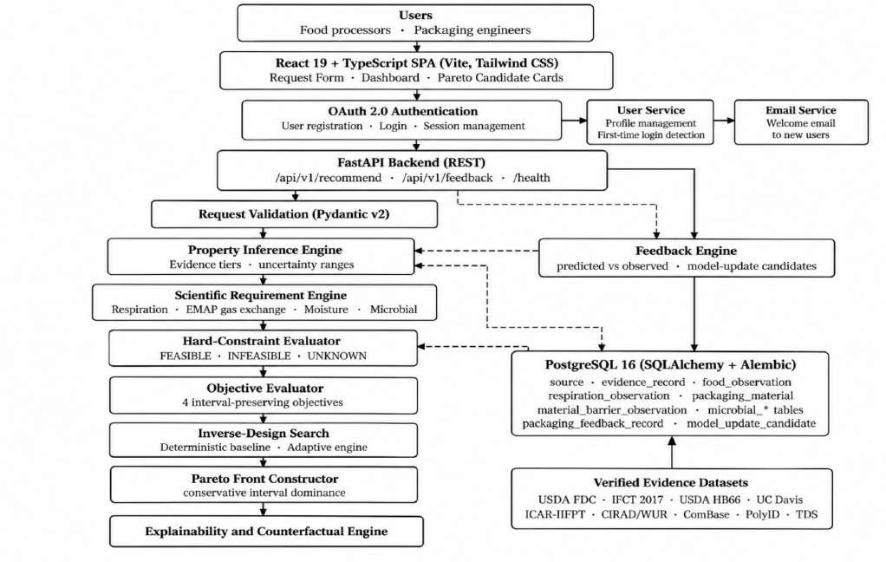

Fig 3.1 System Architecture Diagram of the PackWise

Fig 3.1 illustrates the interaction between the frontend, backend, scientific processing modules and database. Users submit packaging requests and view recommendations through the frontend, while the FastAPI backend validates inputs and executes the scientific pipeline. The pipeline performs property inference, packaging requirement calculations, feasibility evaluation, Pareto front construction and explainability. PostgreSQL stores evidence, material, feedback and model-update records. The feedback engine compares predicted and observed results, supporting a modular and traceable packaging recommendation workflow.

Table 3.1 Technology stack

Layer | Technologies
Frontend | React 19, TypeScript, Vite, Tailwind CSS 4, lucide-react icons, typed API client
Backend | Python 3.14, FastAPI, Uvicorn, Pydantic v2, CORS middleware
Scientific engine | Pure-Python physics, inference, constraint and optimisation modules; NumPy, SciPy and scikit-learn for the surrogate-preparation layer
Database | PostgreSQL 16, SQLAlchemy 2, Alembic migrations, psycopg; SQLite in-memory for isolated tests
Evidence data | JSON datasets (raw and processed) with source manifest, validation results and data-profile reports
Testing | pytest and httpx; milestone audit reports for each stage

DATA AND EVIDENCE MODULE
The Data and Evidence Module holds everything the scientific engine is allowed to believe. Evidence is collected from nine datasets in a five-tier priority order: direct experimental evidence, government and authoritative databases, manufacturer datasheets, test-method standards and secondary literature. Standards such as ASTM D3985, ASTM F1249 and ISO 15106-2 define how barrier values are measured and are recorded as test methods rather than as numerical data.
    - Source and evidence records: every value belongs to an evidence record linked to a source, an evidence classification (for example experimental literature data or model-predicted) and a verification status.
    - Food data: commodities with proximate composition, pH and water activity, respiration observations (with an explicit gas species), postharvest storage limits and gas tolerances, including Indian commodities such as Alphonso and Kesar mango, guava, okra, papaya, paneer and basmati rice.

    - Material data: packaging materials with layer sequence and thickness and their barrier observations (OTR, CO₂TR, WVTR) with the test temperature and relative humidity;
11 canonical materials, of which 10 are experimentally supported and 1 is a model-predicted (QSAR) value kept separate from measured data.
    - Microbial data: organisms, cardinal parameters, growth kinetics and gas-inhibition responses from ComBase.
    - Lineage: validation results and data-transformation records connect each stored value to the processing steps applied to it. A missingness status distinguishes NOT_REPORTED, BELOW_DETECTION_LIMIT and UNKNOWN so that absent values are never collapsed into a silent NULL.

REQUEST AND INTERFACE MODULE
The Request and Interface Module accepts the user’s packaging request and returns the recommendation. A request names the commodity, product form, ripeness stage, target shelf life and storage type as mandatory fields. Variety, transportation type and duration, storage temperature, relative humidity, moisture, fat, pH, respiration rate, package surface area, headspace volume and product mass are optional; any of the food properties left blank is inferred from evidence. The web form groups these fields into product context, storage and transport, food properties (labelled "Blank to infer") and package geometry. Table 3.2 lists the REST endpoints.

Table 3.2 REST API endpoints

Method and path | Purpose | Response
GET /health | Confirms that the service is running | Status message
POST /api/v1/recommend | Runs the full pipeline from request to Pareto front | Recommendation run with inference profile, requirement envelope, candidate counts, Pareto front, summaries, warnings, traceability log and explainability
POST /api/v1/feedback | Submits an observed packaging-trial measurement | Stored feedback with  predicted-vs-observed comparison and model-update candidates
GET /api/v1/feedback/{id} | Retrieves one feedback record | Feedback record or 404
GET  /api/v1/feedback/model-up dates | Lists all model-update candidates | List of candidates for expert review

The recommendation response always states how many candidates were evaluated and how many were FEASIBLE, INFEASIBLE or UNKNOWN. When no candidate can be established as feasible the dashboard shows an explicit "No Feasible Recommendation Established" message and lists the reasons, rather than showing a best guess.

INFERENCE, PHYSICS AND OPTIMIZATION MODULE
This module contains the intelligent services of the system.
Property inference. The inference engine resolves moisture, fat, pH, respiration rate, water activity and ethylene production from the evidence store. It uses exact contextual filtering first and tracked fallbacks next, keeps the minimum and maximum of all supporting observations as the uncertainty range, attaches citations and returns UNKNOWN when nothing is available.
Scientific requirement engine. Four mechanism models (respiration kinetics, EMAP gas exchange, moisture transfer and evidence-gated predictive microbiology) turn the inferred properties and the storage conditions into a requirement envelope: the oxygen, carbon dioxide and water-vapour transmission that the package must provide or may not exceed. The engine answers "what performance is required", not "which material is chosen".
Constraint, objective and search services. A hard-constraint evaluator classifies candidate packaging, an objective evaluator computes four interval-preserving objectives, a Pareto constructor keeps the non-dominated set, and a search engine decides in which order candidates are evaluated. An explainability engine and a feedback engine complete the module.

CHAPTER 4 METHODOLOGY

METHODOLOGY FLOW CHART

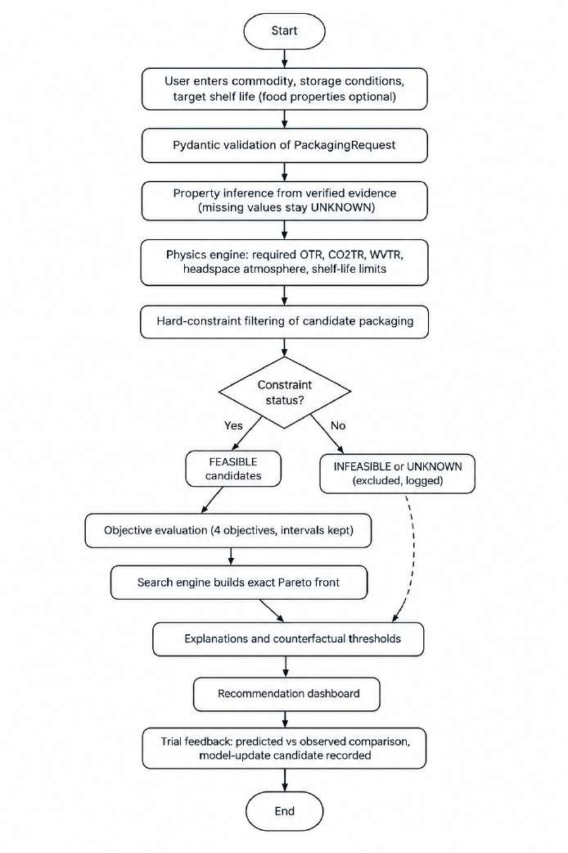 .

Fig 4.1 Methodology Flow Chart of the PackWise
Fig 4.1 shows the end-to-end methodology followed by the system, from the packaging request to the recommendation and the feedback record.

  - METHODOLOGY FLOW CHART

Use Case Diagram

The use case diagram illustrates the interactions between the proposed PackWise system and its primary actors: the Food Producer/Processor, Evidence Curator and Domain Expert/Reviewer. It presents the major functionalities available to users, including packaging request submission, evidence verification, candidate evaluation, feasibility assessment, Pareto-optimal packaging selection and feedback management. The diagram also represents the relationships between use cases through the include and extend relationships.
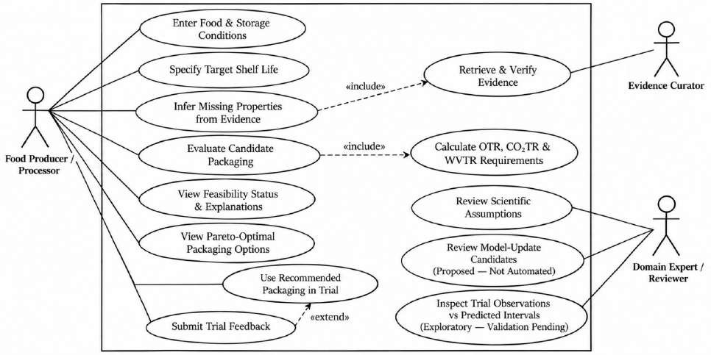

Fig. 4.2 Use Case Diagram of the Proposed System

Fig 4.2 describes the functional interactions between the system and its actors. The Food Producer/Processor enters food and storage conditions, specifies the target shelf life, reviews feasibility status and explanations, and views Pareto-optimal packaging options. The system infers missing properties from available evidence and calculates the required oxygen transmission rate (OTR), carbon dioxide transmission rate (CO₂TR) and water vapour transmission rate (WVTR).
The Evidence Curator is responsible for retrieving and verifying supporting evidence. The Domain Expert/Reviewer reviews scientific assumptions, examines model-update candidates and inspects trial observations against predicted intervals. The diagram also includes trial

feedback and recommended-packaging trials, highlighting the intended connection between packaging recommendations and subsequent observations. Model updates are proposed for review rather than performed automatically, while comparison of trial observations with predictions remains exploratory pending validation.

OVERVIEW OF SYSTEM WORKFLOW

The proposed system follows a structured workflow consisting of seven stages, starting with verified evidence collection and ending with feedback-based model refinement. The workflow integrates evidence management, food-property inference, physics-based packaging requirement calculations, candidate classification, multi-objective optimization, explainability and feedback evaluation. Each stage performs a specific function and passes its output to the subsequent stage to support traceable and evidence-based packaging recommendations.
The overall system workflow is illustrated in Fig 4.2
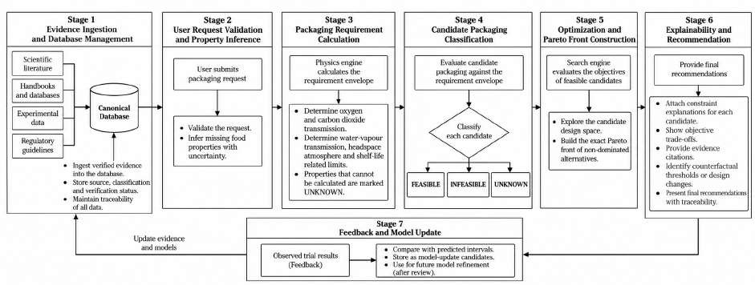

Fig 4.2 System Workflow for the PackWise

The workflow illustrated in Fig 4.2 consists of the following seven stages:

Stage 1: Evidence Ingestion and Database Management
Verified scientific literature, handbooks, experimental data and regulatory guidelines are collected and stored in the canonical database. Each record maintains its source, classification and verification status to ensure evidence traceability.

Stage 2: User Request Validation and Property Inference
The user submits a food-packaging request containing the available commodity properties and

storage conditions. The system validates the request and infers missing food properties when sufficient supporting evidence is available. Uncertainty is retained, and unsupported properties are marked as UNKNOWN.

Stage 3: Packaging Requirement Calculation
The physics engine calculates the packaging requirement envelope using applicable scientific models and available input data. The calculations may include oxygen and carbon dioxide transmission rates, water-vapour transmission, headspace atmosphere and shelf-life-related limits. Properties that cannot be reliably calculated are marked as UNKNOWN.

Stage 4: Candidate Packaging Classification
Candidate packaging designs are evaluated against the calculated requirement envelope. Based on the applicable constraints and available evidence, each candidate is classified as FEASIBLE, INFEASIBLE or UNKNOWN. This distinction prevents insufficient evidence from being incorrectly interpreted as proof of infeasibility.

Stage 5: Optimization and Pareto Front Construction
The search engine evaluates the objectives of feasible candidates and explores the candidate design space. It constructs the exact Pareto front for the evaluated candidate set, identifying non-dominated alternatives and highlighting trade-offs between competing objectives.

Stage 6: Explainability and Recommendation
The explainability engine provides constraint-level explanations for candidate decisions, presents objective trade-offs, attaches supporting evidence citations and identifies counterfactual thresholds or design changes where supported. The resulting recommendations include traceable reasoning and relevant limitations.

Stage 7: Feedback and Model Update
Observed packaging-trial results are submitted as feedback and compared with compatible predicted intervals. The observations are stored as model-update candidates for review and potential future model refinement. Any subsequent model updates depend on the review and validation of the available evidence.
Overall, the workflow establishes a traceable process from scientific evidence and user requirements to packaging evaluation, optimization and explainable recommendations. The feedback stage provides a mechanism for incorporating reviewed experimental observations

into future model improvements while preserving the distinction between predicted results and experimentally observed outcomes.

EVIDENCE ACQUISITION, VERIFICATION AND DATABASE SETUP
Evidence was acquired in stages. A source catalogue defined the five-tier hierarchy; raw datasets were then collected, profiled, cleaned and normalised, mapped to a canonical data model and ingested into PostgreSQL by a reconciliation-checked pipeline. All nine processed datasets passed schema validation with no invalid records (USDA FoodData Central 6 records, Indian Food Composition Tables 8, USDA Handbook 66 4, UC Davis 3, ICAR/IIFPT Indian postharvest 8, CIRAD/WUR 5, PolyID 4, manufacturer datasheets 4 and ComBase 5).
A separate verification protocol (DV0 to DV5) audited the scientific values against their primary sources. Of 21 evidence records audited, 19 were verified and 2 were retained as rejected because the 50 µm thickness scaling had no direct primary table row; no synthetic values were admitted. The audit also found that two respiration values had been converted with an undocumented factor before storage. The original source values (mL CO₂/kg/h) were restored, and the engine was changed so that a CO₂ production rate is never converted to an O₂ consumption rate without an explicit respiratory quotient. This verification step is a deliberate part of the methodology: the pipeline is only as trustworthy as its data.

REQUEST VALIDATION AND PROPERTY INFERENCE
The request is first checked structurally by Pydantic (types, ranges such as relative humidity 0 to 100 % and pH 0 to 14, positive shelf life). The inference engine then resolves each food property in the following order: an exact match on commodity, variety, product form, maturity and temperature; a variety fallback; a product-form fallback; and a temperature-bound fallback. Each fallback is recorded in the output. If several observations support the value, the result is the range [minimum, maximum] and not a single averaged number. A property with no evidence receives the status UNKNOWN and a null value, and an inference warning is raised. A user-supplied value takes precedence over an inferred one.

PHYSICS-BASED REQUIREMENT CALCULATION
The requirement engine uses four established mechanism models based on standard equations. The project’s primary contribution lies in the evidence gating and traceability mechanisms built around these models.

Respiration kinetics. Oxygen consumption follows Michaelis-Menten kinetics with uncompetitive CO₂ inhibition [4], [5]:
r_{O2} = V_{m}[O₂] / ( K_{m} + (1 + [CO₂]/K_{i}) [O₂] ), r_{CO2} = RQ · r_{O2}
EMAP gas exchange. The package transmission needed to hold a target equilibrium atmosphere is obtained from the steady-state mass balance [2], [3]:
OTRreq = rO2 · M · 24 / ( yO2,ext − yO2,target )

CO2TRreq = RQ · rO2 · M · 24 / ( yCO2,target − yCO2,ext ), βideal = CO2TRreq / OTRreq

where M is the product mass and y denotes gas fractions. When the package area A is known the requirement is also given per unit area.
Moisture transfer. The saturation vapour pressure is P_{sat}(T) = 0.61078 exp(17.27T / (T + 237.3)) kPa [11]. The driving force is the difference between the external vapour pressure (RH
× P_{sat}) and the food vapour pressure (a_{w} × P_{sat}); the allowable moisture change ΔM gives the maximum permitted rate and the moisture-limited shelf life:
WVTRreq = ΔM / ttarget, tmoisture = ΔM / WVTRpkg

Sorption isotherms (GAB, Oswin, Halsey and linear models) relate moisture content to water activity within their validity ranges.
Predictive microbiology. When the target organism, initial count, critical count and growth rate are all supplied with evidence, the microbial shelf life is estimated from a lag-then-exponential model [8], with the temperature dependence of the growth rate described by the Ratkowsky square-root model [9]:
log₁₀N(t) = log₁₀N₀ + (μ_{max}/ln 10) · max(0, t − λ)
If any required input is missing the model returns UNKNOWN. Each model result carries one of the three epistemic states of Table 4.1 together with a traceability record.

Table 4.1 Epistemic result states of the physics engine

Status | Meaning | Example
CALCULATED | All required inputs, parameters and verified evidence exist | Complete EMAP balance with known respiration and product mass
PARTIALLY_CALCU LATED | Per-kg or per-area quantities are computed, but missing geometry prevents closing the whole-package requirement | OTR per kg computed, package mass omitted

Status | Meaning | Example
UNKNOWN | Essential properties are absent; no guess or placeholder is used | Microbial shelf life when organism kinetics are unmeasured

HARD-CONSTRAINT FEASIBILITY FILTERING

The hard-constraint feasibility filtering stage evaluates each candidate packaging material against the calculated requirement envelope using three barrier constraints: oxygen transmission rate (OTR), carbon dioxide transmission rate (CO₂TR) and water vapour transmission rate (WVTR). These constraints ensure that the packaging provides sufficient gas exchange for the intended application while limiting moisture transfer to an acceptable level.
Table 4.2 summarizes the comparison operators and the scientific rationale for each constraint. Since material properties may be represented as intervals based on multiple measurements, the system uses interval-aware comparisons to determine whether a candidate satisfies the requirements.

Table 4.2 Hard-constraint comparison semantics

Constraint | Operator | Rationale
Oxygen transmission rate (OTR) | material ≥ required | Film must supply enough O₂ to avoid anaerobic respiration
Carbon dioxide transmission rate (CO₂TR) | material ≥ required | Film must release enough CO₂ to avoid injury and fermentation
Water vapour transmission rate (WVTR) | material ≤ allowable | Moisture flux must not exceed the allowable limit over the shelf life

The feasibility filtering process compares the measured or estimated material-property intervals with the corresponding requirement intervals. For greater-than-or-equal-to (GE) constraints, a candidate is considered satisfied when the minimum material value is at least the maximum required value. It is considered violated when the maximum material value is below the minimum required value.
For less-than-or-equal-to (LE) constraints, a candidate is satisfied when the maximum material value does not exceed the minimum allowable value. It is violated when the minimum material value exceeds the maximum allowable value.

When the intervals overlap, a required value is missing, units are inconsistent or test conditions are incompatible, the constraint is classified as uncertain. The final candidate status is determined by considering all applicable constraints.
The following pseudocode summarizes the classification procedure.
for each candidate c:
for each applicable constraint k (OTR, CO2TR, WVTR):
GE constraint: satisfied if mat_min >= req_max
violated if mat_max < req_min LE constraint: satisfied if mat_max <= req_min
violated if mat_min > req_max
otherwise (overlap / missing / unit or test-condition mismatch): UNCERTAIN if any constraint violated: status = INFEASIBLE
elif all constraints satisfied: status = FEASIBLE else: status = UNKNOWN

PERFORMANCE CRITERIA AND PARETO FRONT CONSTRUCTION

Only FEASIBLE candidates are evaluated against the four packaging performance criteria defined in Table 4.3. Each criterion retains its interval bounds to represent uncertainty in material properties and predicted shelf life. No weighted sum or other scalarisation method is applied, allowing trade-offs between competing performance criteria to remain visible to the user.

Table 4.3 Packaging Candidate Performance Criteria

Objective | Direction | Definition
fthickness | Minimise | Total thickness, the sum of all layer thicknesses (µm)
fmoisture_margin | Maximise | (WVTR_{allowable} − WVTR_{mat}) / WVTR_{allowable}; computed with the upper bound of the material interval
fgas_alignment | Minimise | |OTRmat − OTRtarget| / OTRtarget + λ|βmat − βideal| / βideal, with λ = 0.5 when CO₂ tolerance applies
fshelf_life_margin | Maximise | (tachievable − ttarget) / ttarget, where tachievable is the minimum over all active deterioration modes

Candidate A dominates candidate B only if A is no worse than B across every performance criterion and strictly better in at least one. Dominance is evaluated conservatively by comparing A’s worst-case value with B’s best-case value for each criterion, taking the minimisation or maximisation direction into account. If any performance criterion is UNKNOWN, dominance cannot be established, and the comparison returns false.

The Pareto front constructor identifies non-dominated candidates using an exact O(N²) pairwise comparison. Cost, carbon footprint and recyclability are excluded from the active performance criteria because the database does not contain verified cost or life-cycle impact data. These factors are recorded as deferred data gaps for future investigation.

INVERSE-DESIGN SEARCH ENGINES
The recommendation service depends on an abstract search interface so that the algorithm can be replaced without changing the scientific evaluation. Two engines implement it. The deterministic enumeration engine evaluates every candidate in the authorised space and serves as the exact reference baseline. The intelligent adaptive engine selects the next candidate using feedback from earlier evaluations. While no feasible candidate has been found it picks the unevaluated candidate whose OTR and WVTR are closest to the requirement bounds; once a feasible set exists it picks the candidate that most increases the diversity and trade-off coverage of the current Pareto front. It keeps a set of evaluated identifiers so that no candidate is evaluated twice, stops when the space is exhausted or the iteration budget is reached, and is reproducible. In both engines every candidate is still evaluated by the same frozen physics, constraint and objective code, so the search order changes only the effort, not the correctness. On the baseline dataset the adaptive engine evaluated 11 candidates in about 10 to 15 ms per request.
Evolutionary and Bayesian optimisers (for example NSGA-II or MOEA/D) are not implemented. An optimiser algorithm and its evaluation budget were not authorised during the design audits, so they remain future work; the controlled benchmark infrastructure that will compare them against the exact baseline has been built and tested with synthetic adapters only.

EXPLAINABILITY AND COUNTERFACTUAL ANALYSIS
For every candidate the explainability engine produces a report with the overall feasibility status, a per-constraint explanation, an objective explanation, a provenance reference to the evidence used and a Pareto explanation. The counterfactual part uses only the data already computed to find the threshold at which a constraint or the whole candidate would change status, for example the WVTR reduction that would make a candidate feasible or the OTR increase it would need. When the data for a threshold are missing, the counterfactual is returned as unresolved (is_resolved = false) with the reason UNRESOLVED_DUE_TO_UNKNOWN, and no numeric penalty or zero is substituted. Intervals are preserved in both the objective and the counterfactual output.

FEEDBACK AND MODEL-UPDATE FOUNDATION
The feedback module closes the loop between recommendation and reality. A user submits observed measurements for a recommended candidate. The engine validates them against physical non-negativity and unit limits, compares each observation with the stored prediction interval (MATCHED_WITHIN_INTERVAL or OUTSIDE_PREDICTION_INTERVAL) and,
when a discrepancy is found, records a model-update candidate for expert review. Missing observations remain UNKNOWN, repeated trials of the same design are stored as separate records and never averaged, and each record carries its observation origin. The module does not retrain or recalibrate any model automatically; it creates the traceable data on which a controlled update can later be based.

AI-SURROGATE PREPARATION LAYER AND PRECOMPUTED STATES
Two supporting designs prepare the system for larger design spaces. The first is an AI-surrogate layer, which builds a provenance-tagged dataset from exact physics calculations, excludes unknown and deferred targets, splits the data without leakage, benchmarks several regression families (gradient boosting, Gaussian process, neural-network and ridge regression), checks the applicability domain and physical validity and stores an immutable model manifest. The surrogate approximates the exact physics, it is not treated as physical truth, and it cannot act as an unverified feasibility gate. In the implemented recommendation pipeline, the surrogate is integrated as a candidate-prioritization heuristic (search_engine=ai_surrogate_prioritized), wherein surrogate ranking orders exploration while exact physics remains the sole and final authority for constraint satisfaction and Pareto dominance. Candidates near constraint boundaries are strictly evaluated by the authoritative physics engine.
The second is the progressive-tier contract for precomputed optimization states. A state is identified by the requirement envelope, package geometry, active objectives and eligible candidate set. Tier-1 returns a stored Pareto front only on an exact identity match; Tier-2 may use a similar stored state as a warm-start seed that must be fully re-evaluated, because a seed does not inherit feasibility; Tier-3 is the cold, full search.

FRONTEND RECOMMENDATION INTERFACE
The frontend provides a Packaging Request Builder, a Recommendation Dashboard, an interactive Explainability and Constraint Audit Modal, an Empirical Trial Feedback Modal, and a Trial Feedback & Model Audit Ledger. The dashboard shows summary counts (candidates evaluated, feasible, infeasible, unknown and Pareto candidates), the status of each stage of the scientific pipeline, the inferred food properties, the scientific requirements, and interactive cards for candidate packaging materials displaying objective intervals. Each candidate card provides direct access to an Explainability Audit (displaying per-constraint margins, counterfactual thresholds, and literature provenance) and a Trial Feedback submission workflow. The Feedback Ledger displays logged empirical observations alongside residual discrepancies and review-flagged model update candidates. If the Pareto front is empty, the dashboard displays the empty-state message explaining that no verified feasible recommendation could be established under current constraints.

CHAPTER 5 TESTING AND RESULTS

SYSTEM TESTING AND RESULT
The system was verified at the level of each milestone. Unit-level tests check the pure scientific functions (respiration kinetics, saturation vapour pressure, EMAP mass balance, sorption isotherms, microbial growth, interval arithmetic and Pareto dominance). Service-level and API-level tests run the full recommendation pipeline and the feedback endpoints against an isolated test database using pytest and httpx. Each milestone ended with an audit report and a full regression run. The documented results are summarised in Table 5.1.

Table 5.1 Milestone verification results

Milestone | Scope verified | Documented result
M9 | Pluggable inverse-design search interface and deterministic enumeration baseline | Verified
M10 | Adaptive search engine; 8 focused tests including reproducibility, no duplicate evaluation and empty-feasible-set handling; full regression | 356 of 356 tests passed  (33.18 s)
M11 | Explainability and counterfactual engine; full regression | 363 of 363 tests passed (15.02 s); interactive explainability modal & counterfactual API verified
M12 | Feedback validation, predicted-vs-observed comparison and model-update candidates (test_feedback.py) | 18 tests passed (test_feedback.py); live feedback API, residual analysis, ledger UI, and PostgreSQL migration scripts verified

Table 5.2 lists representative functional and safety test cases. They concentrate on the rules that protect the user from a wrong recommendation: invalid input is rejected, missing data stay UNKNOWN, an unknown is never promoted to feasible, and uncertainty is never collapsed.

Table 5.2 Functional and safety test cases

No. | Module | Test case | Expected result | Status
1 | Request validation | Shelf life zero or negative; relative humidity below 0 or above 100; moisture outside 0  to 100 | Request rejected by schema validation | Pass
2 | Request validation | Minimum valid request and full request | Request accepted | Pass

No. | Module | Test case | Expected result | Status
3 | Property inference | User-supplied value and inferred value both present | User value takes precedence | Pass
4 | Property inference | Variety, product-form and temperature fallbacks; conflicting evidence | Fallback recorded; uncertainty spans all supporting observations | Pass
5 | Property inference | Commodity with no evidence (incomplete input) | Property stays UNKNOWN; no value invented | Pass
6 | Respiration | Missing respiration parameters | Result UNKNOWN | Pass
7 | Physics audit | CO₂ production rate without explicit RQ | O₂ rate not derived (UNKNOWN) | Pass
8 | Physics audit | Impossible driving force in gas exchange; temperature below T_{min} | Result UNKNOWN; growth arrest handled | Pass
9 | Moisture | Unknown moisture content | Moisture result UNKNOWN | Pass
10 | Pareto dominance | Equal objectives; UNKNOWN objective; overlapping intervals | No dominance established | Pass
11 | Recommendat ion pipeline | Apple, chilled at 4 °C, 14-day target | Counts of feasible, infeasible and unknown add up to candidates evaluated | Pass
12 | Recommendat ion pipeline | Candidates marked UNKNOWN | Never present in the feasible Pareto front | Pass
13 | Search engines | Adaptive engine run twice on one input | Identical, reproducible result; M9 baseline unchanged | Pass
14 | Explainability | Feasible, infeasible and unknown candidates | Counterfactual produced or marked unresolved; no midpoint collapse | Pass
15 | Feedback | Observation inside and outside the prediction interval | Correct containment status; model-update candidate for the latter | Pass
16 | Feedback | Missing, repeated and synthetic observations | Missing stays UNKNOWN; repeats kept separately; origin tagged | Pass
17 | API | GET /health; CORS with allowed and disallowed origins | HTTP 200 with status body; origin policy enforced | Pass

The backend regression test suite was executed using pytest across all 12 project milestones. The suite collected exactly 492 tests across 28 test modules, and all 492 tests passed successfully (0 failures, 0 errors, 492 passed in 28.20 seconds). These tests verify the end-to-end correctness of the scientific physics engine, hard-constraint filtering, interval arithmetic, multi-objective Pareto dominance, all three search engines (deterministic, intelligent adaptive, and surrogate-prioritized), explainability and counterfactual calculations, and trial feedback with model-update candidate tracking.
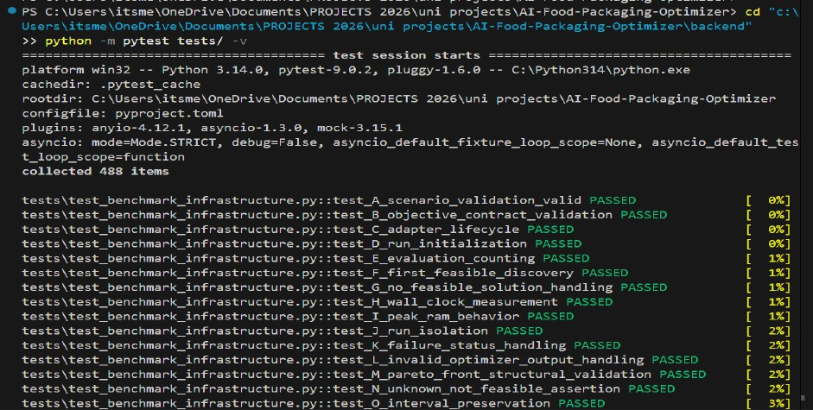

Fig 5.1 Full regression test run of the backend test suite

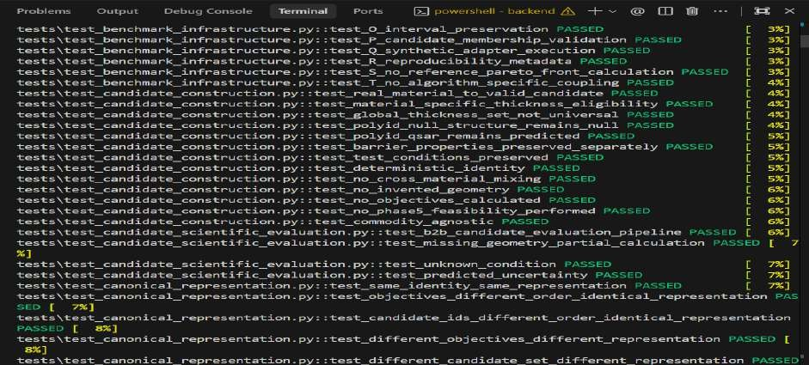

Fig 5.2 Full regression test run of the backend test suite

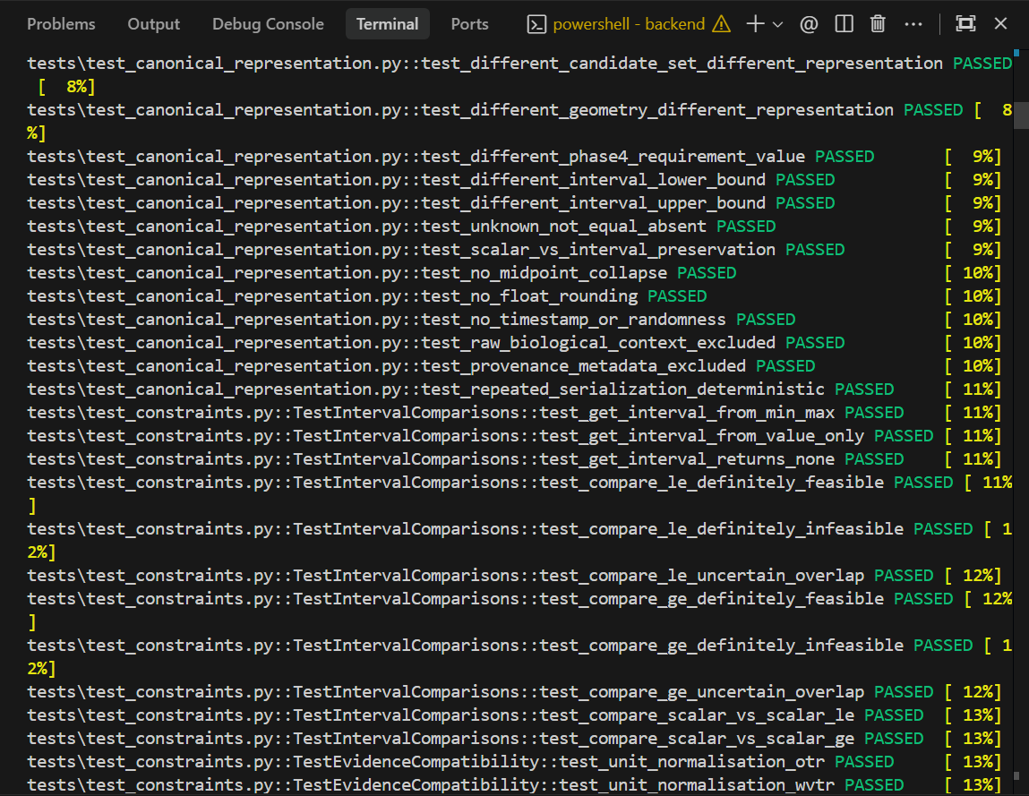

Fig 5.3 Full regression test run of the backend test suite
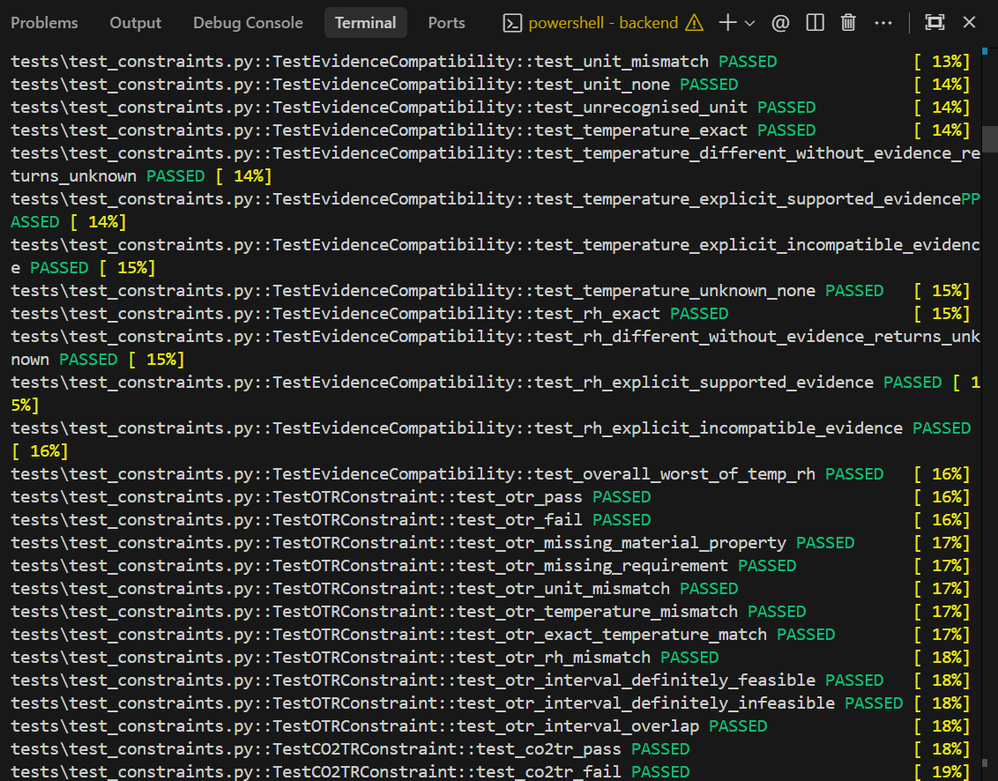

Fig 5.4 Full regression test run of the backend test suite

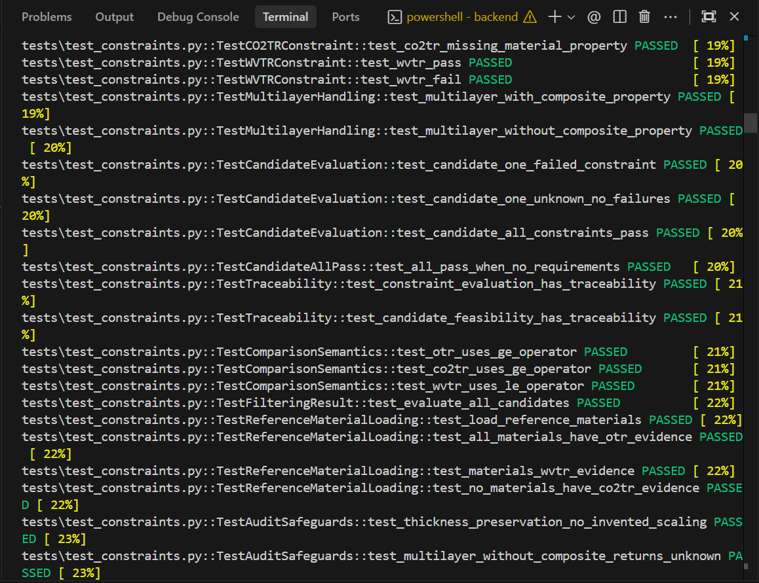

Fig 5.5 Full regression test run of the backend test suite
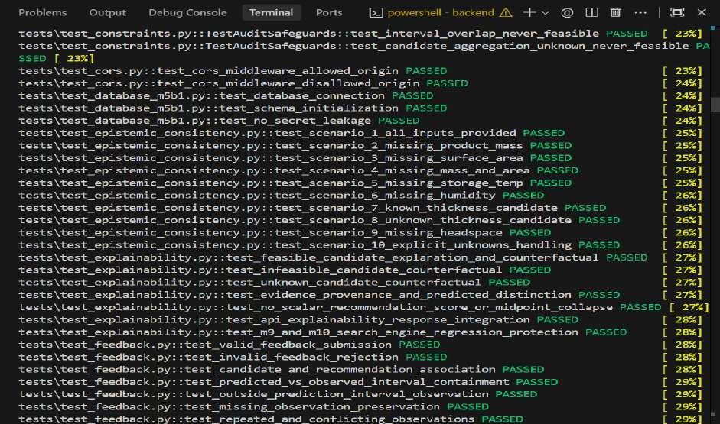

Fig 5.6 Full regression test run of the backend test suite

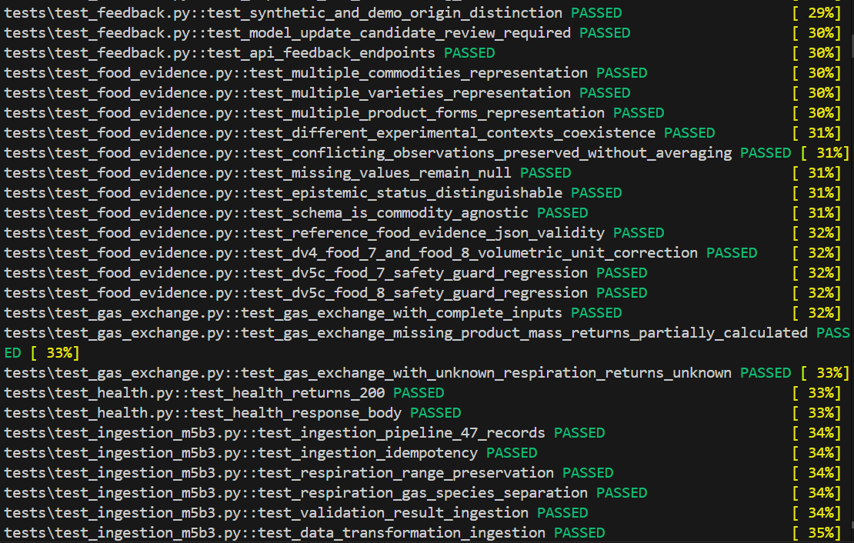

Fig 5.7 Full regression test run of the backend test suite
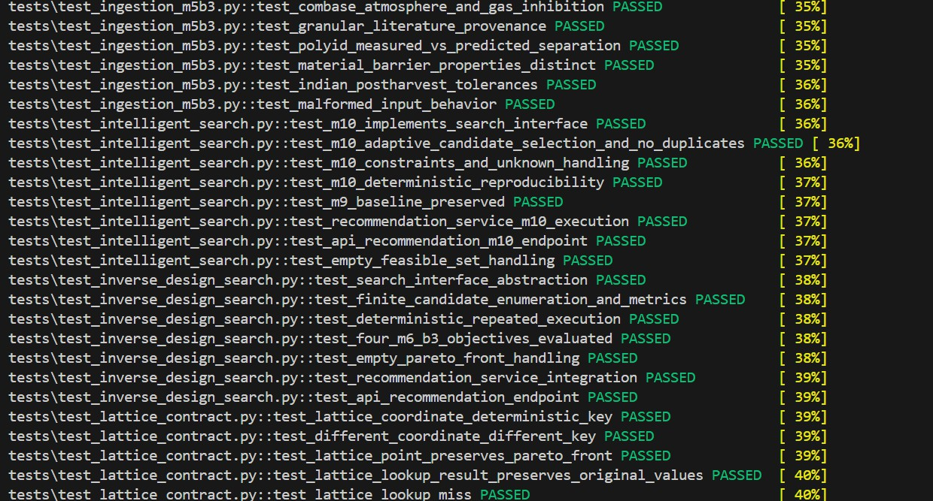

Fig 5.8 Full regression test run of the backend test suite

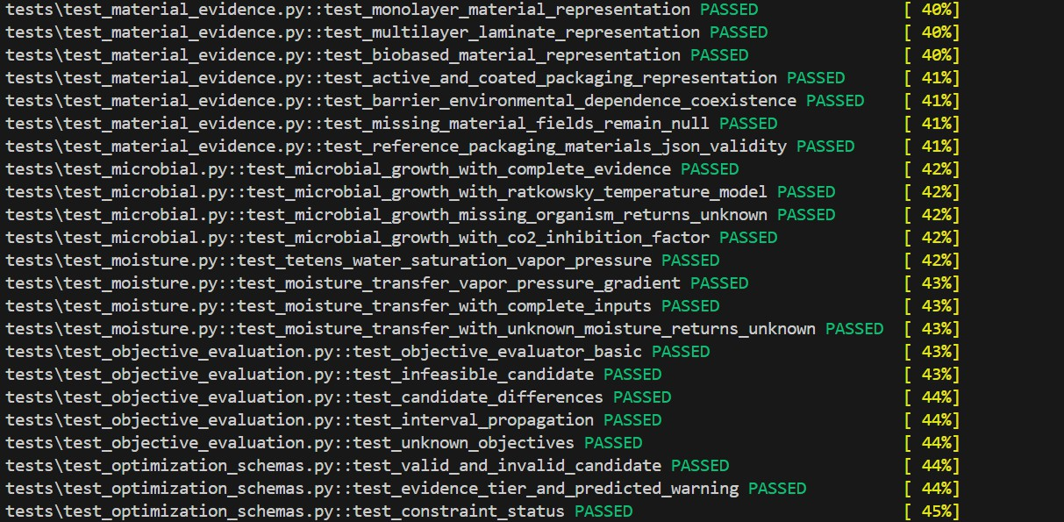

Fig 5.9 Full regression test run of the backend test suite

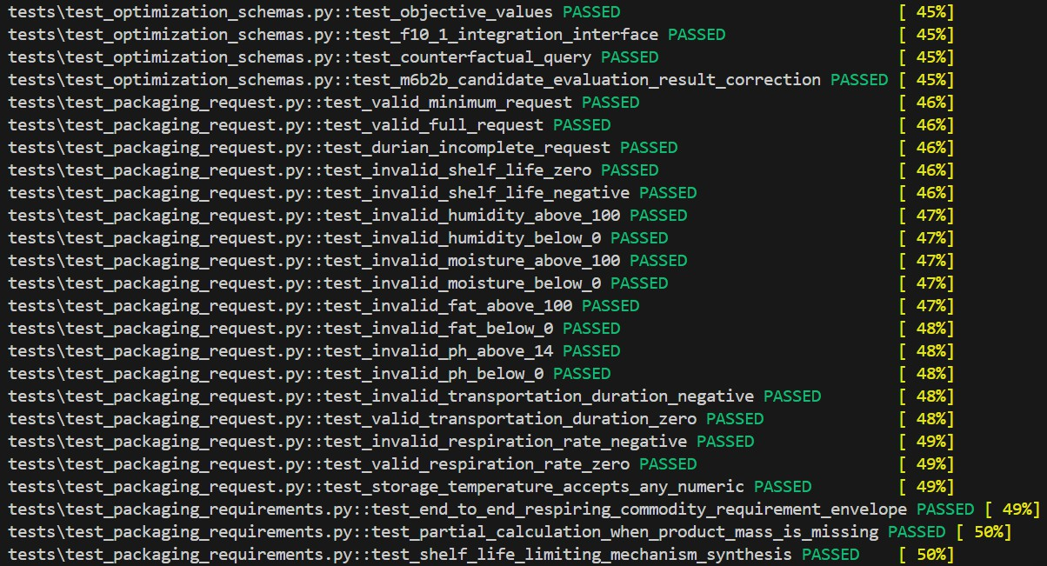

Fig 5.10 Full regression test run of the backend test suite

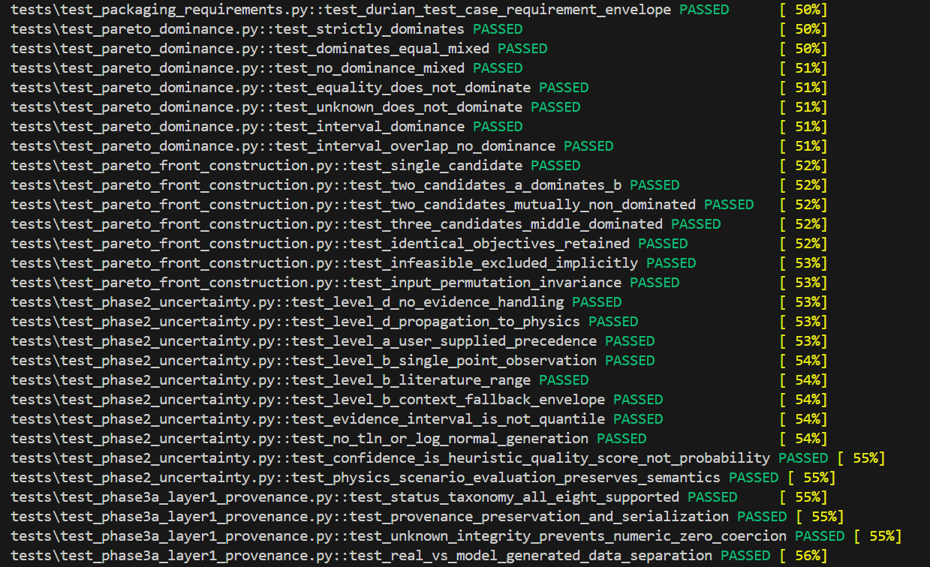

Fig 5.11 Full regression test run of the backend test suite

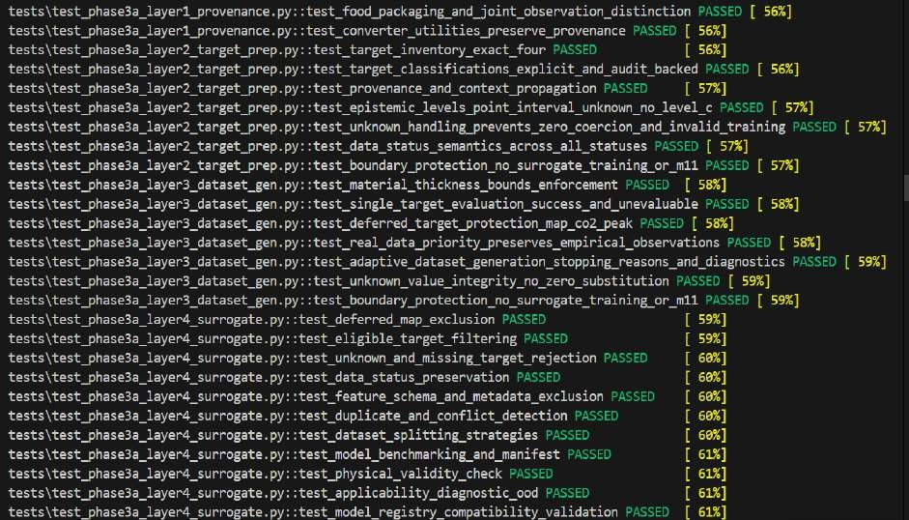

Fig 5.12 Full regression test run of the backend test suite

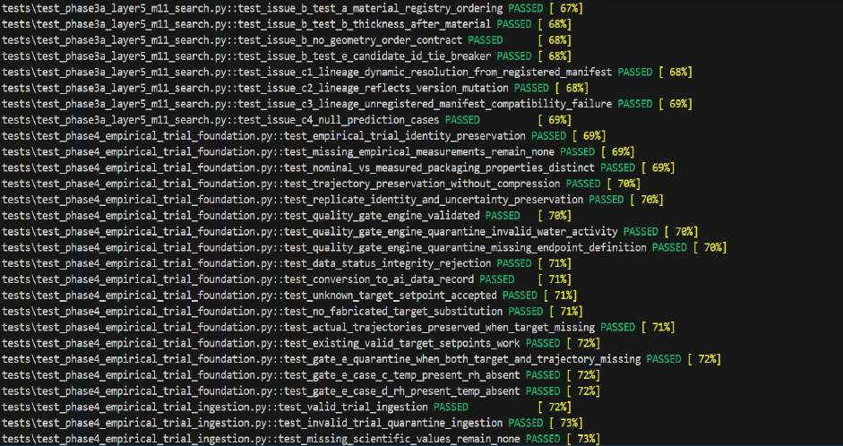

Fig 5.13 Full regression test run of the backend test suite

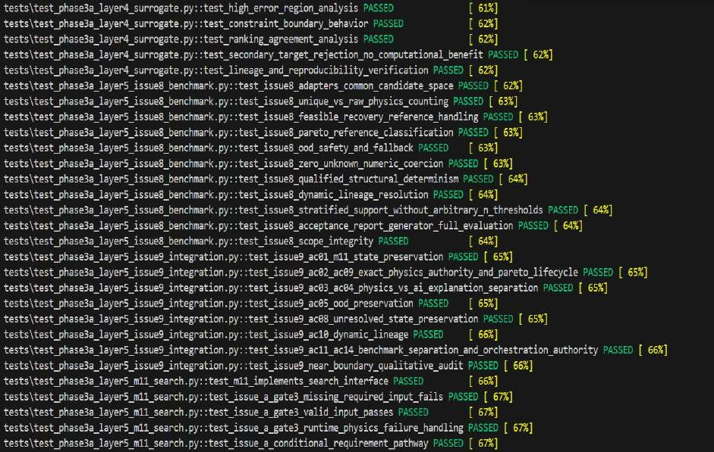

Fig 5.14 Full regression test run of the backend test suite

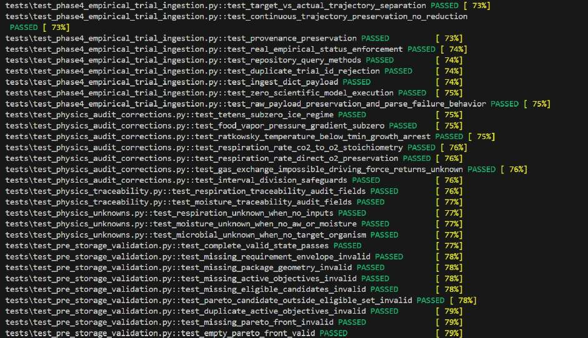

Fig 5.15 Full regression test run of the backend test suite

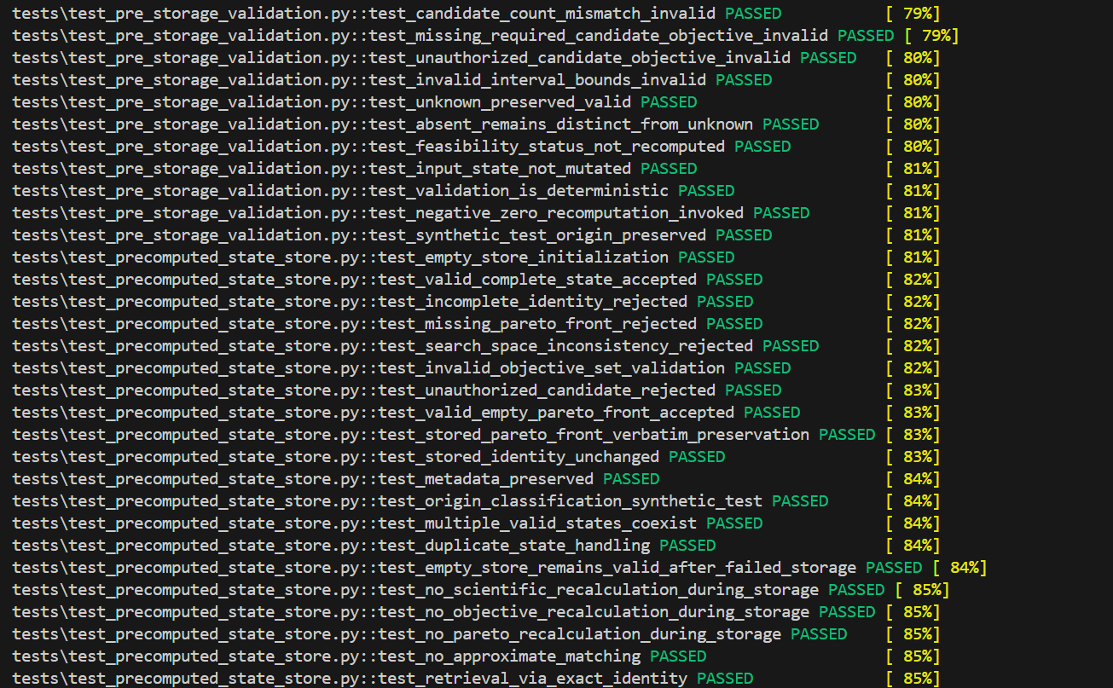

Fig 5.16 Full regression test run of the backend test suite

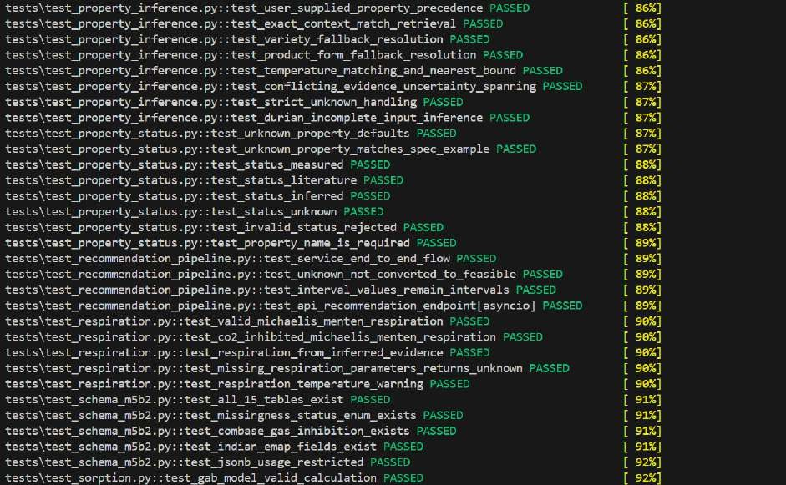

Fig 5.17 Full regression test run of the backend test suite

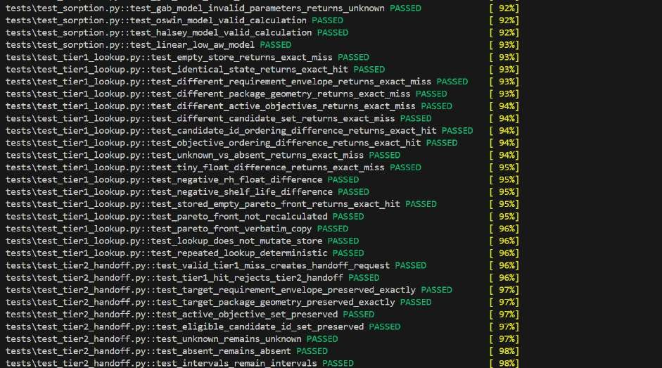

Fig 5.18 Full regression test run of the backend test suite

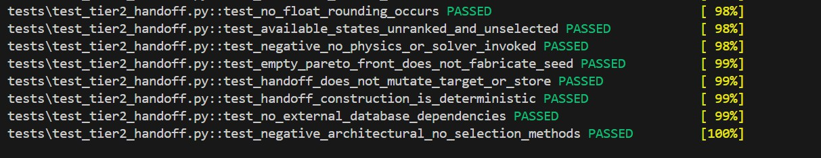

Fig 5.19 Feedback API response

The API documentation of the proposed system is presented through Swagger UI, providing an overview of the available REST API endpoints and their associated data schemas. The interface covers packaging recommendations, feedback submission and retrieval, model-update candidates, candidate evaluation, constraint validation, explainability and evidence management.
Figures 5.20–5.23 illustrate the API endpoints and schema definitions, showing how the system structures requests, responses and evaluation-related data to support communication between components and maintain consistency in data exchange.
These screenshots demonstrate the documented API structure and available operations; successful execution of individual endpoints requires separate testing and verification.
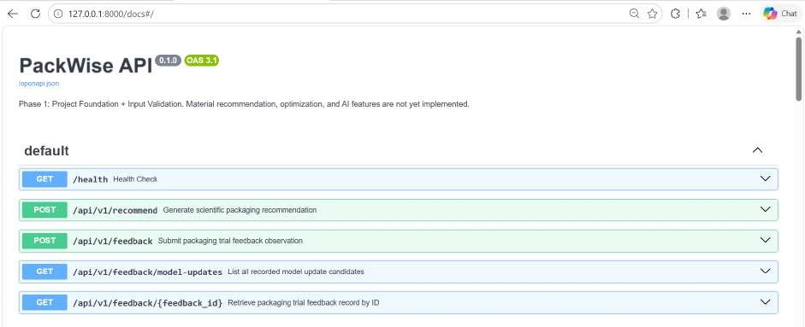

Fig 5.21 Feedback API response

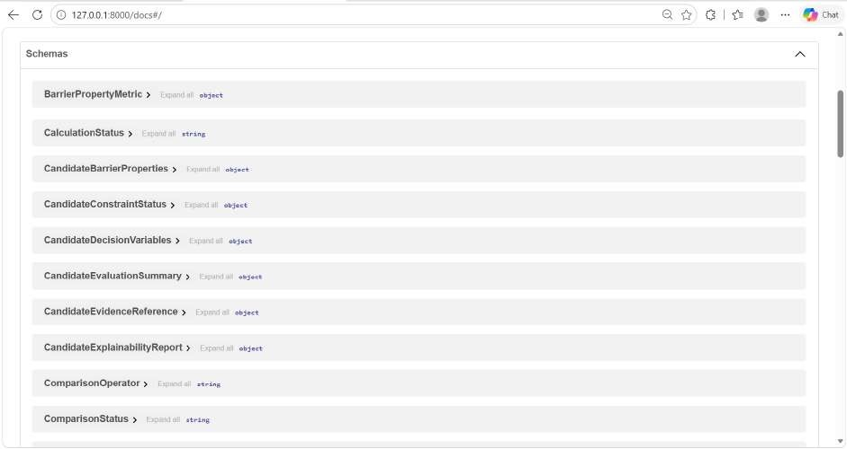

Fig 5.22 Feedback API response

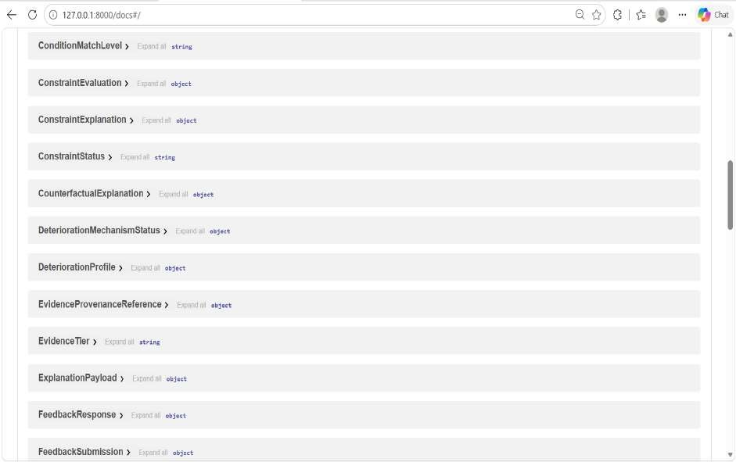

Fig 5.23 Feedback API response

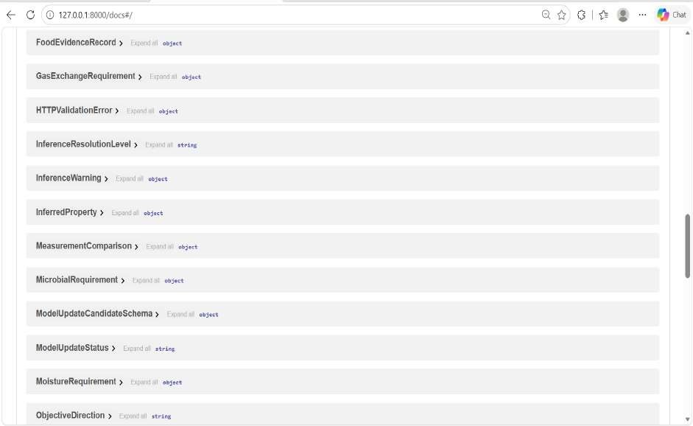

Fig 5.24 Feedback API response

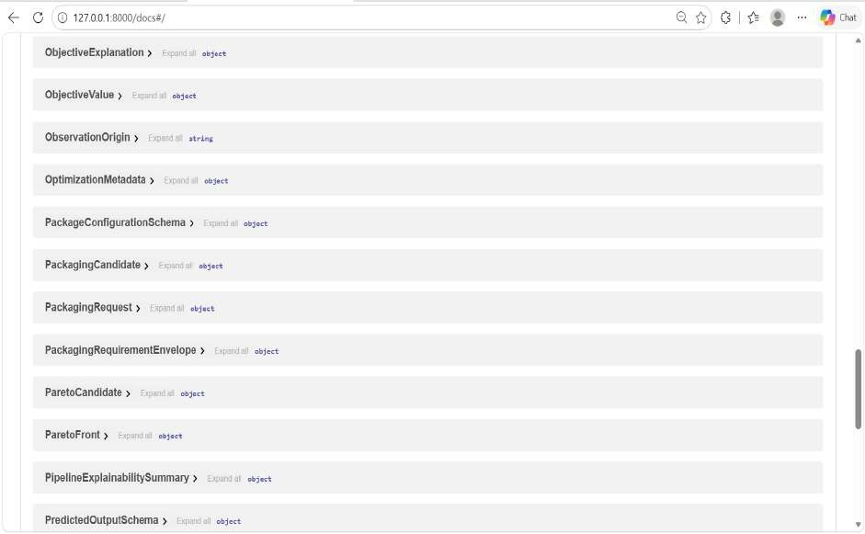

Fig 5.25 Feedback API response

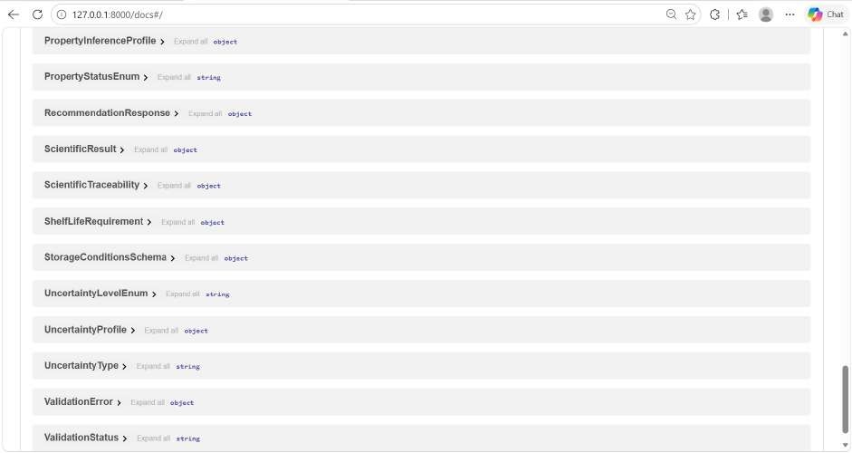

Fig 5.25 Feedback API response

The screenshots provide visual evidence of the system's functionality, including candidate evaluation, constraint verification, handling of incomplete evidence, and generation of explanations. As illustrated in Figures 5.21 to 5.25, the proposed pipeline demonstrates consistent evaluation, transparent decision-making, and traceability across different test scenarios. These results support the effectiveness of the system in ensuring that feasibility decisions are based on sufficient evidence and that missing information is clearly identified.
Current limitations. The evidence base is small (47 processed records in nine datasets and 11 canonical packaging materials), so for many commodity–material combinations the required evidence at the required test conditions is missing and the honest result is UNKNOWN rather than FEASIBLE. The candidate space is the set of stored materials and structures, not a free synthesis of new layer sequences. Only the four physics-based objectives are active; cost, carbon footprint and recyclability are deferred for lack of verified data. No evolutionary or Bayesian optimiser is implemented, the surrogate layer is not connected to the search, the feedback module does not retrain any model, and the frontend does not yet display explanations or feedback forms. The recommendations have been verified against the physics and the evidence, but they have not yet been validated by physical packaging trials.

FUTURE ENHANCEMENTS
    - Expand the evidence base with more commodities, packaging structures and barrier measurements at several temperatures and humidities, so that fewer candidates remain UNKNOWN.
    - Extend the decision space to multilayer structures, layer sequence, thickness, coatings, microperforation and modified-atmosphere settings.
    - Authorise, implement and benchmark multi-objective optimisers such as NSGA-II or Bayesian optimisation against the exact enumeration baseline using the existing benchmark infrastructure.
    - Add verified cost, life-cycle carbon and recyclability data so that cost, sustainability and compliance objectives can be added to the Pareto front, including India-specific regulatory checks such as FSSAI requirements.
    - Expand surrogate model training datasets with wider temperature-humidity grids while maintaining the exact physics engine as the authoritative validation gate.
    - Run pilot packaging trials for selected commodities and use the feedback module to calibrate the models under expert review.
    - Extend the frontend with multilingual support (regional Indian languages) for farmers and small packaging processors, and add automated batch-export capabilities for audit reports.
    - Implement the Tier-1 and Tier-2 precomputed-state store to return repeated requests instantly.

CHAPTER 6 INTERPRETATION AND RESULTS

PackWise PROJECT FLOW

The project flow illustrates the interaction between the frontend, backend services, scientific calculation modules and feedback mechanism. The user submits a packaging request through the frontend, after which the backend validates the input and initiates the recommendation service. The system performs property inference using available evidence, calculates packaging requirements, evaluates hard constraints, constructs the Pareto front and generates explainable recommendations. A separate feedback workflow allows users to submit trial observations, which are compared with predicted results and stored in feedback and model-update tables for future calibration.
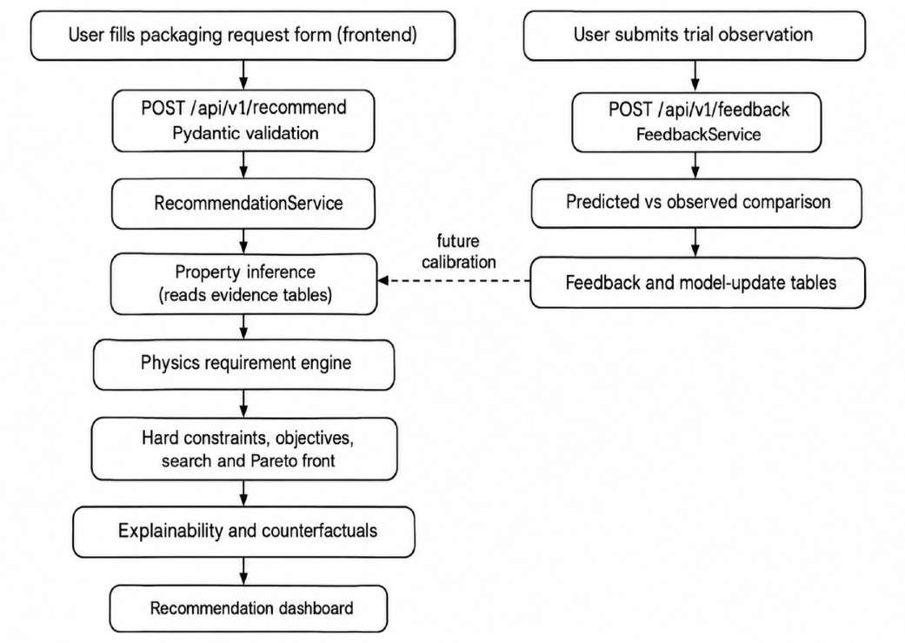

Fig 6.1 PackWise Project Flow

Fig 6.1 presents the overall execution flow of the project and the relationship between its recommendation and feedback processes. The left-hand flow shows how a packaging request progresses from frontend submission through backend validation, property inference, physics-based requirement calculations, feasibility filtering, Pareto front construction and
|-- frontend/ # React + TypeScript + Vite
| |-- src/api, src/components, src/types
|-- data/ # raw, processed, reference (evidence datasets)
|-- docs/ # milestone, audit and specification reports
|-- migrations/ # Alembic versions
|-- alembic.ini, requirements.txt, pyproject.toml, README.md
search, explainability, feedback
#
# respiration, gas exchange, moisture, microbial # property inference engine
# barrier constraints, evaluator # candidates, objectives, pareto,
|-- physics/
|-- inference/
|-- constraints/
|-- optimization/
|
|
|
|
|
|-- scientific_engine/
# routes.py (REST endpoints) # config, database session
# SQLAlchemy: evidence.py, feedback.py # Pedantic request/response models
# recommendation_service, feedback_service # evidence ingestion pipeline
# pytest suite
|-- tests/
|-- api/
|-- core/
|-- models/
|-- schemas/
|-- services/
|-- ingestion/
|
|
|
|
|
|
|-- app/
|
|
|
|
|
|
|
|
# FastAPI application
AI-Food-Packaging-Optimizer/
|-- backend/
explainability before reaching the recommendation dashboard. The right-hand flow illustrates the feedback process, in which submitted trial observations are compared with predicted results and recorded in feedback and model-update tables. The connection between the two flows represents the potential use of reviewed feedback for future model calibration. Together, these processes demonstrate how the system integrates packaging recommendations with a structured feedback mechanism.

FOLDER STRUCTURE
The repository contains the backend, the scientific engine and the frontend as separate parts:

DATABASE DESIGN (ER DIAGRAM)
The database separates food, material and microbial evidence, because each has its own structure, but links all of them to a common evidence record and source. Fig 6.2 shows the entity relationship diagram and Table 6.1 lists the main tables.

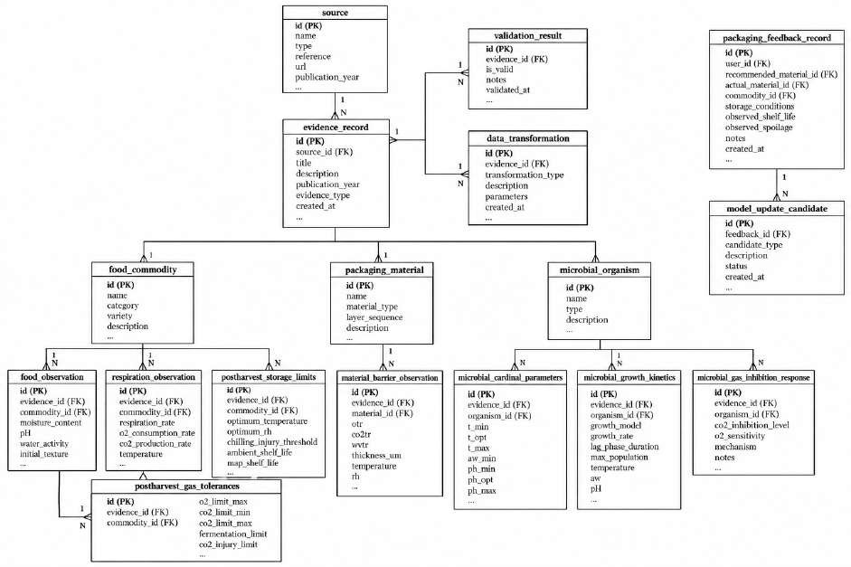

Fig 6.2 Entity Relationship (ER) Diagram of the Evidence and Feedback Database Table 6.1 Main database tables
Table | Purpose
source, evidence_record | Bibliographic source and the evidence record with classification (experimental or model-predicted) and verification status
validation_result, data_transformation | Validation outcomes and the transformations applied to a stored value (lineage)
food_commodity, food_observation | Commodities and their moisture, fat, protein, pH and water-activity observations
respiration_observation | O₂ consumption or CO₂ production rates with explicit gas species, temperature and units
postharvest_storage_limits, postharvest_gas_tolerances | Chilling-injury limits and fermentation / injury gas limits for EMAP
packaging_material, material_barrier_observation | Material structure, layer sequence and thickness; OTR, CO₂TR and WVTR with test conditions
microbial_organism, microbial_cardinal_parameters, microbial_growth_kinetics, microbial_gas_inhibition_response | Predictive-microbiology data from ComBase

Table | Purpose
packaging_feedback_record, model_update_candidate | Observed trial results with origin and comparison status; reviewable model-update candidates

USER INTERFACE SCREENS
This section presents the main screens of the PackWise web application (SIH26236) in the order in which a user normally meets them: sign-in, dashboard, scenario setup, AI recommendations, what-if analysis, history, analytics and system information.
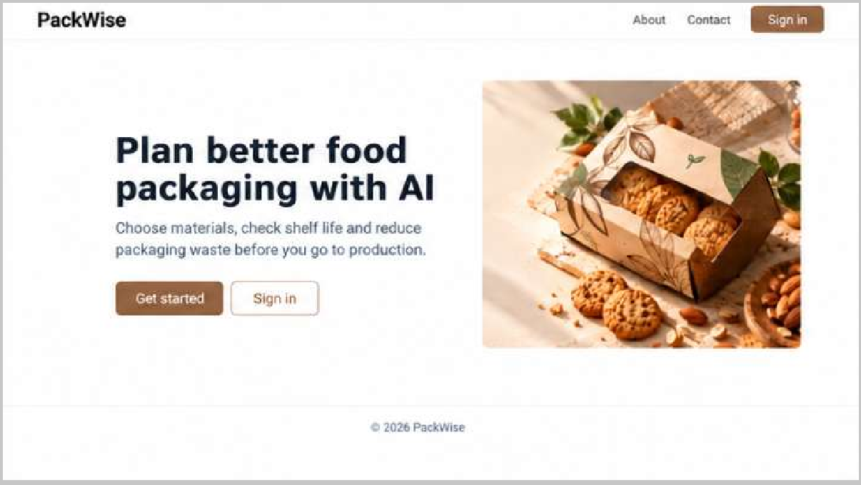

Fig 6.3 Login Page
Login Page. The entry screen of PackWise. The user signs in with an email address and password; links for password recovery and new-account sign-up are provided.

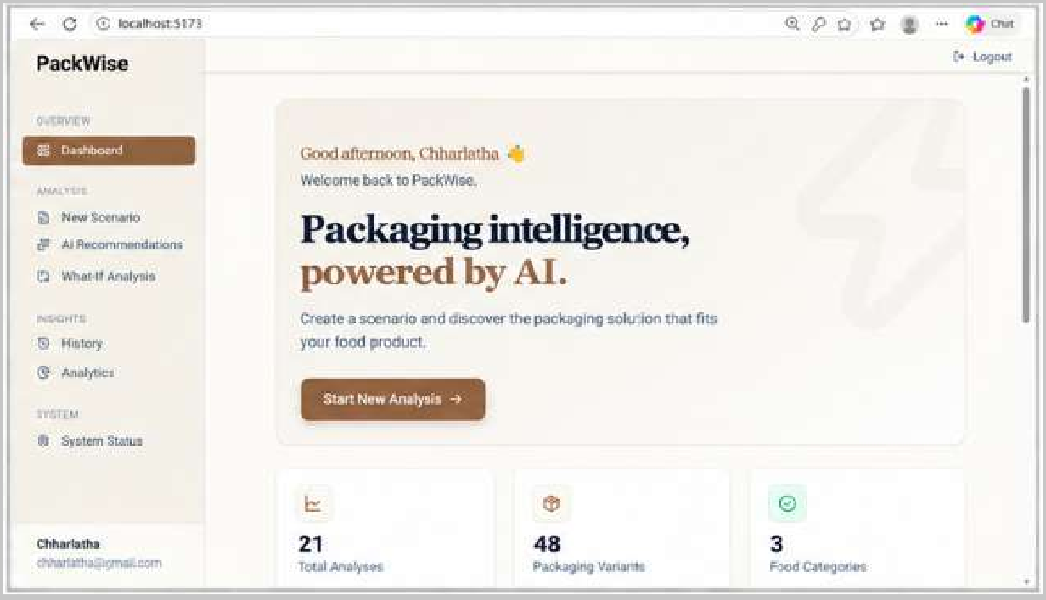

Fig 6.4 Dashboard
Dashboard. The home screen after sign-in, with a personalized greeting, the sidebar navigation (Dashboard, New Scenario, AI Recommendations, What-If Analysis, History, Analytics and System Status), a Start New Analysis button and summary cards showing 21 total analyses, 48 packaging variants and 3 food categories.

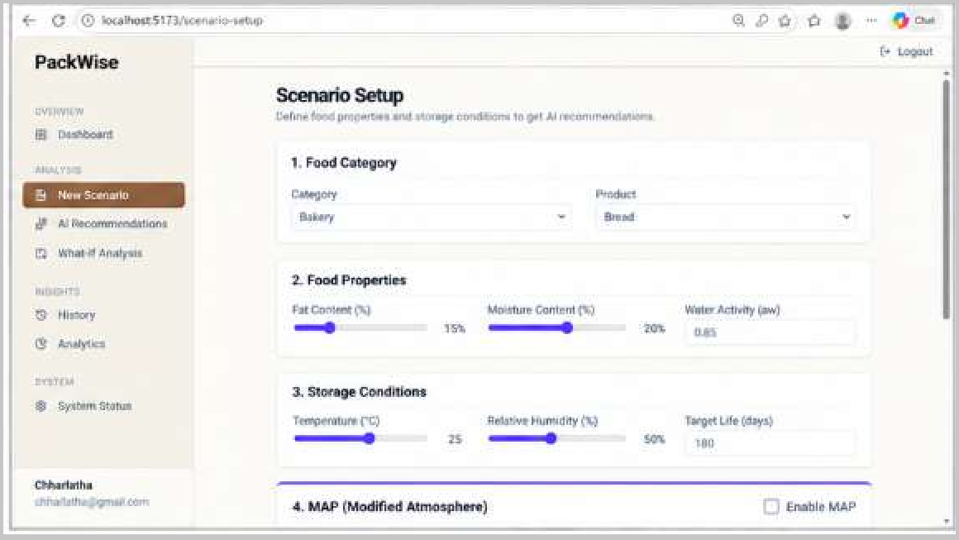

Fig 6.5 Scenario Setup

Scenario Setup. The input form for a new analysis. The user selects the food category and product (Bakery, Bread), sets fat content, moisture content and water activity, defines the storage conditions (temperature, relative humidity and target life in days) and can optionally enable Modified Atmosphere Packaging (MAP).

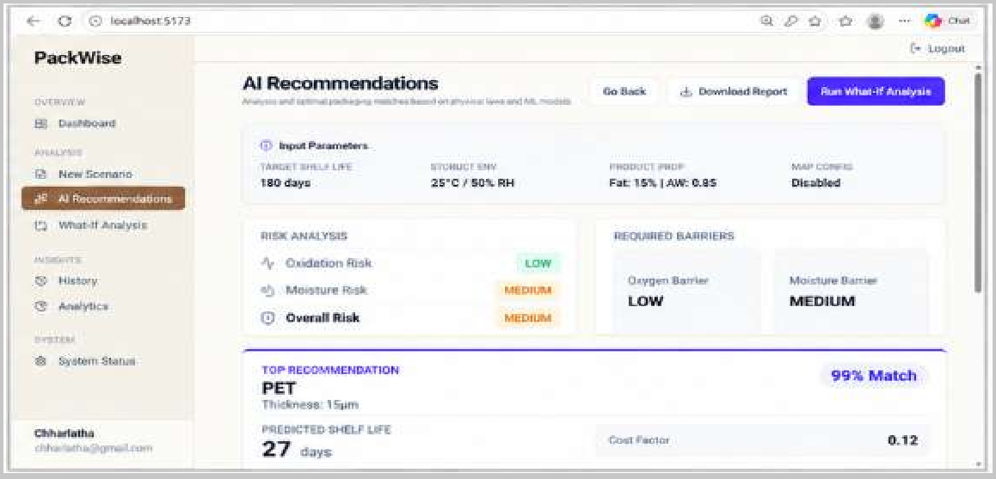

Fig 6.6 AI Recommendations
AI Recommendations. The result screen for a scenario. It restates the input parameters (180 days, 25°C / 50% RH, Fat 15%, aw 0.85, MAP disabled), reports the oxidation, moisture and overall risk levels and the required oxygen and moisture barriers, and shows the top recommendation (PET, 15 µm thickness, 99% match) with its predicted shelf life and cost factor. Buttons allow going back, downloading the report and running a what-if analysis.
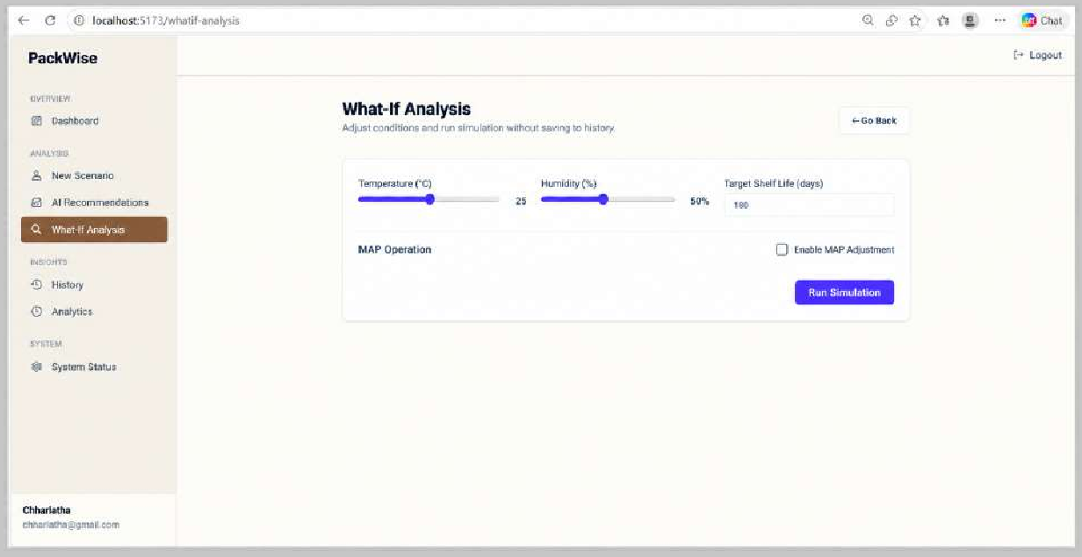

Fig 6.7 What-If Analysis

What-If Analysis. A simulation screen in which temperature, humidity, target shelf life and the MAP assessment option can be changed, and a simulation run without saving the result to history.

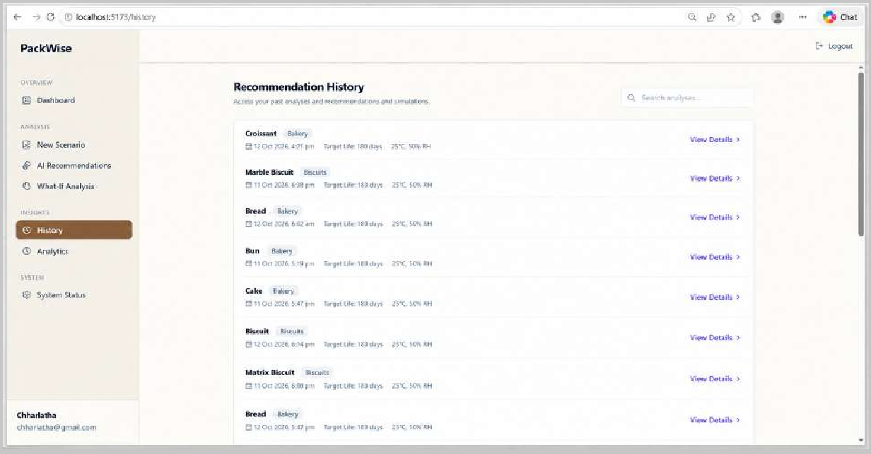

Fig 6.8 Recommendation History
Recommendation History. A searchable list of previous recommendations and simulations. Each entry shows the product, its category, the date and time, the target life and the storage conditions, with a View Details link to open the stored result.
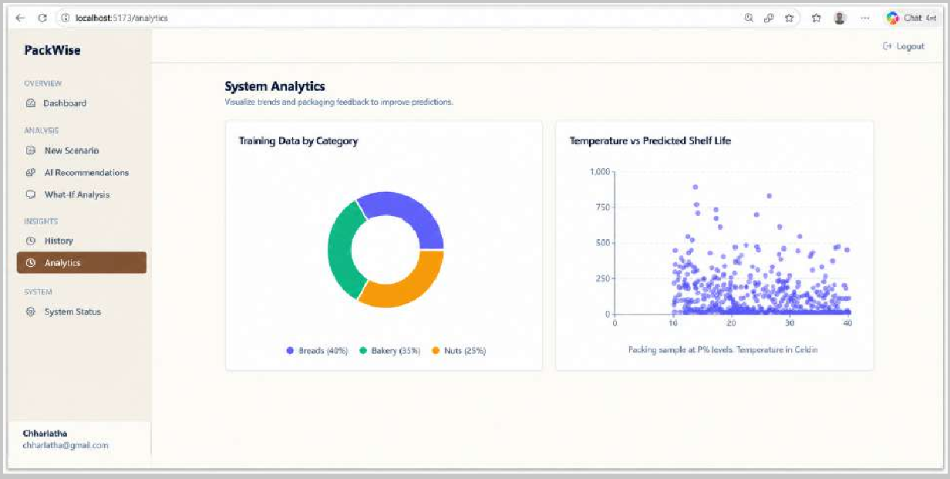

Fig 6.9 System Analytics

System Analytics. Visualization of the training data behind the models: a donut chart of the training records by category (Biscuits 40,800, Bakery 39,792 and Nuts 39,408) and a scatter plot of temperature against predicted shelf life for a sample of 500 records from a dataset of 1,20,000.
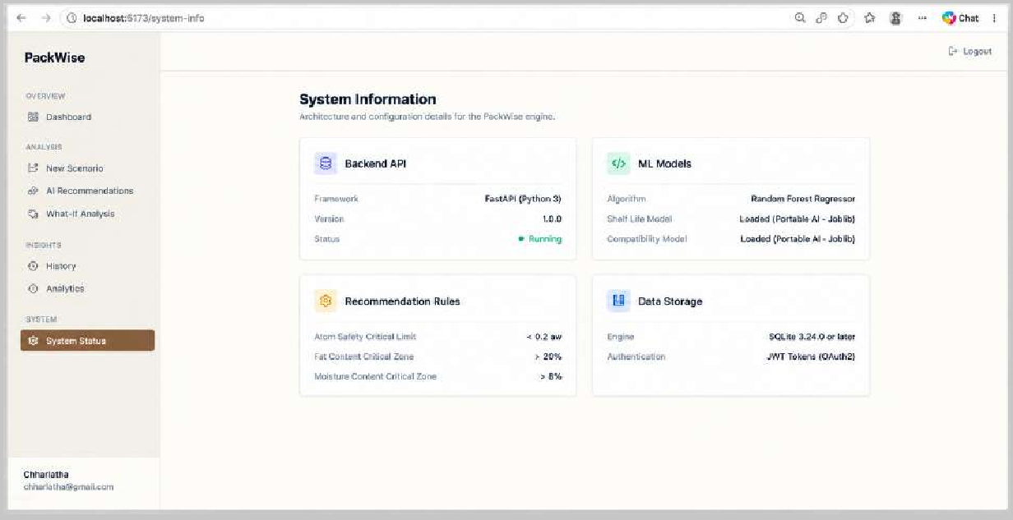

Fig 6.10 System Information
System Information. The architecture and configuration summary of the PackWise engine: the backend API (Fast API, version 1.0.0, active), the ML models (Random Forest Regressor, with the shelf-life and compatibility models loaded), the recommendation rule limits (water activity above 0.7, fat content above 20% and moisture content above 15%) and the data storage and authentication (SQLite / SQL Alchemy and JWT tokens).

CHAPTER 7 CONCLUSION AND SUMMARY

CONCLUSION
The PackWise system replaces food-name lookup and single-score recommendation with an evidence-driven inverse-design pipeline. The system infers missing food properties with explicit uncertainty, derives the oxygen, carbon dioxide and water-vapour transmission that the package must meet, classifies candidate packaging with a three-state, interval-aware rule, and returns an exact Pareto front with constraint-level explanations and counterfactual thresholds. Its most important behaviour is restraint: where evidence is missing, the property, the constraint or the objective remains UNKNOWN, and no candidate is called feasible on the strength of an assumption.
The engineering of the project supports this behaviour. The data layer keeps source, classification and verification status for every value and was audited against primary sources, which led to correction of a unit-conversion error before it could reach the physics. The scientific engine is separate from the web layer, the search engine is replaceable behind a stable interface, and each milestone is verified by a regression suite of more than 360 tests. The feedback module provides the route by which real trial data can later improve the models under expert review. The present results are verified against physics and evidence; validation through physical packaging trials, a larger evidence base, multilayer design variables and cost and sustainability objectives remain as the next steps.

SUMMARY
Chapter 1 introduced the problem, the prior-art analysis, the IP considerations, the literature survey and the additional features. Chapter 2 described the technical domain, the existing industrial problems and solutions and the objectives. Chapter 3 presented the architecture and the data, interface and scientific modules. Chapter 4 explained the methodology, including evidence verification, the physics models, the constraint rule, the objectives, the search engines, explainability, feedback and the supporting designs. Chapter 5 reported the testing and results and listed the limitations and future enhancements, and Chapter 6 presented the project flow, folder structure, database design and user interface screens.

APPENDIX 1
PROJECT SUBMISSION CONTENT

Title: AI-Based Food Packaging Material Recommendation System
Problem statement : “Al-Based Intelligent Food Packaging Material Recommendation System for Food Commodities In practice” , packaging for perishable food is chosen from experience, supplier advice or fixed lookup tables. The barrier performance that the food actually needs is rarely calculated, missing food data are replaced by defaults, a single answer is given without reasons, and recommendations are never compared with what happens in storage and transport.
Proposed solution. A software system that validates a packaging request and infers missing food properties from verified evidence with uncertainty, calculates required OTR, CO₂TR, WVTR and shelf-life limits using respiration, EMAP, moisture and predictive-microbiology models, classifies candidate packaging as FEASIBLE, INFEASIBLE or UNKNOWN, builds an exact Pareto front over four objectives, explains each decision with counterfactual thresholds and records trial feedback for expert-reviewed model updates.
Key features. Evidence-gated physics pipeline; explicit UNKNOWN propagation; interval-preserving constraints and objectives; pluggable deterministic and adaptive search engines; counterfactual explanations; feedback and model-update candidates; provenance-tracked evidence database; typed REST API and React dashboard.

APPENDIX 2
EVIDENCE SOURCES AND DATA PROFILING

The evidence sources recorded in the project source manifest are summarized in Table A2.1. These sources cover food composition, postharvest respiration and storage conditions, packaging material properties, predictive microbiology, thermophysical constants and standardized barrier-testing methods. Each source is classified according to its role and evidence tier to support source traceability and the assessment of data reliability. Figures A2.1 and A2.2 present the profiling results generated during data profiling and illustrate the Indian commodity coverage and packaging material barrier properties represented in the project data.

Table A2.1 Evidence sources used by the system

Source | Role | Tier
USDA FoodData Central | Food proximate composition | Group A data source
Indian Food Composition Tables (IFCT 2017) | Indian food composition | Group A data source
USDA Agriculture Handbook 66 | Postharvest respiration and storage limits | Tier 2 government handbook
UC Davis Postharvest Technology Center | Produce fact sheets | Tier 2 university centre
ICAR / IIFPT / NIFTEM | Indian postharvest evidence | Tier 1 research and Tier 2 institutional
FAO Postharvest Compendium | Postharvest reference | Tier 2 international organisation
ComBase | Predictive microbiology | Tier 1 validated database
CIRAD / WUR packaging barrier database | Packaging barrier measurements | Tier 1 institutional open database
PolyID | Polymer properties (experimental and QSAR) | Tier 1 experimental / Tier 5 QSAR
Commercial Polymer Manufacturer Datasheets (EVAL / Ingeo / Amcor) | Polymer barrier datasheets | Tier 3 datasheet
NIST Chemistry WebBook | Thermophysical constants | Tier 2 government agency
ASTM D3985, ASTM F1249, ISO 15106-2 | Barrier test methods | Tier 4 standard

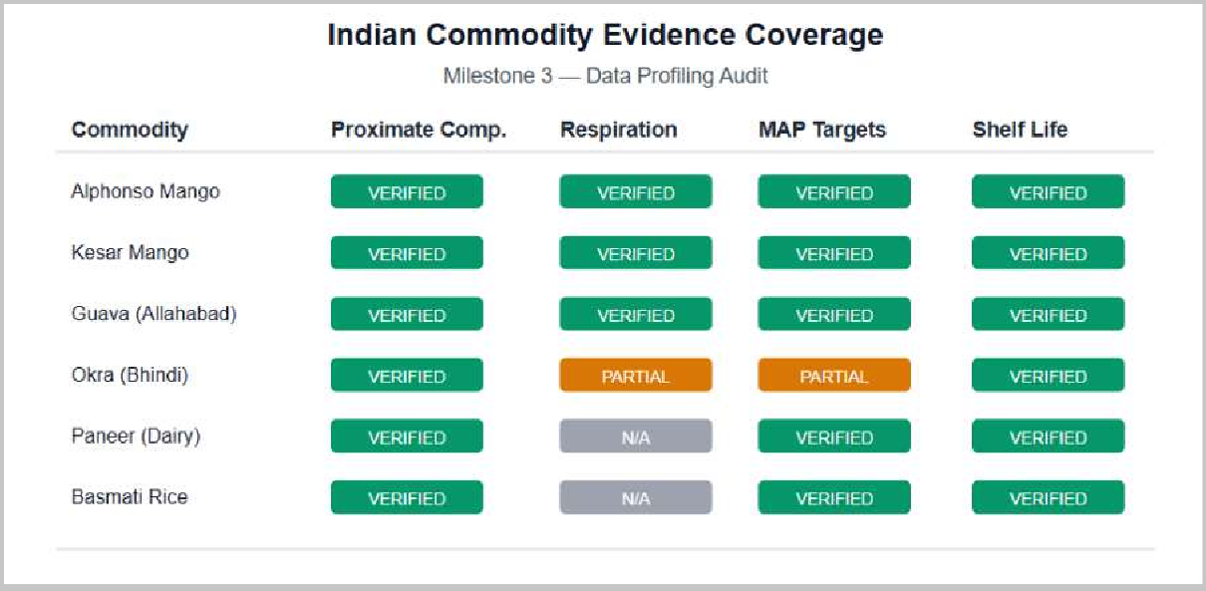

Fig A2.1 Indian commodity coverage figure from data profiling

Figure A2.1 illustrates the Indian commodity coverage identified during data profiling. It provides an overview of the commodities represented in the available data and helps assess the extent to which the evidence base covers relevant Indian food products.

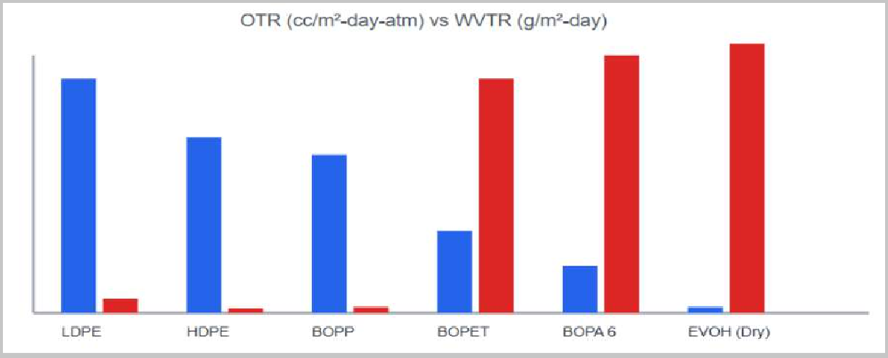

Fig A2.2 Packaging material barrier properties figure from data profiling

Figure A2.2 presents the packaging material barrier properties identified during data profiling. These properties support the characterization and comparison of candidate packaging materials based on their barrier performance. Together, Figures A2.1 and A2.2 provide an overview of the commodity coverage and packaging material data available to the system.

APPENDIX 3 PROCESSED DATASET SUMMARY

Table A3.1 gives the number of records in each processed dataset and the result of schema validation.

Table A3.1 Processed datasets and validation result

Dataset | Records | Valid | Invalid
USDA FoodData Central | 6 | 6 | 0
Indian Food Composition Tables 2017 | 8 | 8 | 0
USDA Handbook 66 (respiration) | 4 | 4 | 0
UC Davis produce facts | 3 | 3 | 0
ICAR / IIFPT Indian postharvest | 8 | 8 | 0
CIRAD / WUR packaging dataset | 5 | 5 | 0
PolyID experimental vs predicted | 4 | 4 | 0
Manufacturer datasheets | 4 | 4 | 0
ComBase microbial kinetics | 5 | 5 | 0
Total | 47 | 47 | 0

The evidence verification audit covered 21 records, comprising 11 material barrier observations and 10 food-property observations. Of these, 19 records were verified, while 2 were rejected. No synthetic values were included in the verified evidence dataset.

APPENDIX 4 CONFIGURATION PARAMETERS

Table A4.1 Main configurable parameters

Parameter | Meaning | Default / example
DATABASE_URL | PostgreSQL connection string used by the evidence and feedback database | Set in .env
TEST_DATABASE_URL | Test database connection setting defined by the backend configuration | sqlite:///:memory:
FRONTEND_URL | Frontend origin permitted by the backend CORS policy | http://localhost:5173
VITE_API_BASE_URL | Base URL of the backend API used by the frontend client | http://127.0.0.1:8000
search_engine_type | Internal selection of the  inverse-design search strategy used by the recommendation service | deterministic_exhaustive (default), intelligent, or ai_surrogate_prioritized
execution_tier | Optimization execution tier used by the recommendation run | LATTICE_LOOKUP
max_iterations | Maximum candidate-evaluation budget available to the search engine | 100
population_size | Population-size parameter defined in the optimization solver configuration | 50
tolerance | Numerical tolerance parameter defined in the optimization solver configuration | 1 × 10⁻⁴

REFERENCES

- N. A. Sagar and N. Rani, "Recent trends and innovations in smart and AI-based food packaging: A review," Front. Food Sci. Technol., vol. 5, Art. no. 1665055, Jan. 2026 (published 9 Jan. 2026), doi: 10.3389/frfst.2025.1665055.

- M. Lopriore, M. Libralato, G. Cortella, S. Maiandi, M. C. Nicoli, A. Conte, and M. A. Del Nobile, "Water vapor transmission rate prediction: The case-study of a biopolymer-based capsule for food applications," Food Package. Shelf Life, vol. 52, Art. no. 101633, Dec. 2025, doi: 10.1016/j.fpsl.2025.101633.

- M. Rashvand et al., "Artificial intelligence for prediction of shelf-life of various food products:Recent advances and ongoing challenges," Trends Food Sci. Technol., vol. 159, Art. no. 104989,May 2025, doi: 10.1016/j.tifs.2025.104989.

- M. Irazoqui, S. Barrios, and P. Lema, "Evaluation of alternative models for respiration rate of ready-to-eat strawberry (cv. 'Ágata')," Biol. Life Sci. Forum, vol. 40, no. 1, Art. no. 54, 2024 (published 16 Apr. 2025), doi: 10.3390/blsf2024040054.

- P. Xu, Y. Ma, W. Lu, M. Li, W. Zhao, and Z. Dai, "Multi-objective optimization in machine learning assisted materials design and discovery," J. Mater. Inform., vol. 5, no. 2, Art. no. 26, Mar.2025 (published 24 Mar. 2025), doi: 10.20517/jmi.2024.108.

- S. Zardetto, A. Dal Martello, and G. Pasini, "Moisture migration model of packed fresh-filled pasta during storage under different humidity conditions," Innov. Food Sci. Emerg. Technol., Art. no. 103930, Jan. 2025 (available online 12 Jan. 2025), doi: 10.1016/j.ifset.2025.103930.

- D. Li, L. Bai, R. Wang, and S. Ying, "Research progress of machine learning in extending and regulating the shelf life of fruits and vegetables," Foods, vol. 13, no. 19, Art. no. 3025, Sep. 2024 (published 24 Sep. 2024), doi: 10.3390/foods13193025.

- F. Tarlak, "The use of predictive microbiology for the prediction of the shelf life of food products," Foods, vol. 12, no. 24, Art. no. 4461, Dec. 2023, doi: 10.3390/foods12244461.

- C. Nicosia, I. Mezza, A. Pulvirenti, and F. Licciardello, "Assessment of the secondary shelf life of Bolognese sauce based on domestic use simulation," Food Package. Shelf Life, vol. 40,Sep.2023 (first published 28 Sep. 2023), doi: 10.1016/j.fpsl.2023.101172.

- V. K. Pandey, S. Srivastava, K. K. Dash, R. Singh, S. A. Mukarram, B. Kovács, and E. Harsányi, "Machine learning algorithms and fundamentals as emerging safety tools in Preservation of fruits and vegetables: A review," Processes, vol. 11, no. 6, Art. no. 1720, Jun. 2023 (published 4 Jun. 2023), doi: 10.3390/pr11061720.

- F. Cui, S. Zheng, D. Wang, X. Tan, Q. Li, J. Li, and T. Li, "Recent advances in shelf life prediction models for monitoring food quality," Compr. Rev. Food Sci. Food Saf., vol. 22, no. 2,
pp. 1257-1284, Mar. 2023 (first published 30 Jan. 2023), doi: 10.1111/1541-4337.13110.

- R. Cruz, V. Pereira, T. Pinho, I. M. P. L. V. O. Ferreira, C. Novais, and S. Casal, "Safety and quality of canned sardines after opening: A shelf-stability study," Foods, vol. 11, no. 7, Art. no. 991, Mar. 2022 (published 29 Mar. 2022), doi: 10.3390/foods11070991.

[13]D.Verheyen and J. F. M. Van Impe, "The inclusion of the food microstructural influence in predictive microbiology: State-of-the-art," Foods, vol. 10, no. 9, Art. no. 2119, Sep.
2021(published 8 Sep. 2021), doi: 10.3390/foods10092119.

[14]C. Nicosia, P. Fava, A. Pulvirenti, A. Antonelli, and F. Licciardello, "Domestic use simulation and secondary shelf life assessment of industrial pesto alla genovese," Foods, vol. 10, no. 8, Art. no. 1948, Aug. 2021, doi: 10.3390/foods10081948.

[15]G.Maleki, N.Sedaghat, E. J. Woltering, and M. Farhoodi, "Modeling respiration characteristics of cucumber to design a proper modified atmosphere packaging," J. Agric. Sci. Technol., vol. 22, no. 6, pp. 1463-1472, Oct. 2020 (published 13 Oct. 2020).

PROJECT OUTCOME

The project titled “AI-Based Food Packaging Material Recommendation System”, developed by Aarabhi Shen S.A (2303957610422001), Chharlatha UN (2303957610422009), and Pooja M (2303957610422033) under the guidance of Ms. S.G. Janani Ratthna, M.E., Assistant Professor, Department of Computer Science and Engineering, focuses on developing an intelligent, science-driven system for recommending suitable food packaging materials based on food properties, storage conditions, packaging requirements, and target shelf life.The system integrates evidence-based food-property inference, physics-based packaging requirement calculations, candidate feasibility assessment, multi-objective optimization, Pareto-optimal packaging selection, and explainable recommendations. It incorporates explicit uncertainty handling to distinguish unknown properties, deterministic inputs, evidence-based intervals, and deferred evaluations, thereby reducing unsupported assumptions and preventing missing information from being silently replaced with arbitrary values. The architecture also incorporates a surrogate-assisted inverse-design approach, in which learned model predictions guide candidate search while exact physics evaluation remains authoritative for scientific verification.The project establishes a traceable framework for combining scientific evidence, computational physics, optimization, and AI-assisted packaging design. It also provides a foundation for incorporating real-world experimental observations through a controlled feedback mechanism, with model-update candidates subject to expert review rather than automatic retraining. Real-world validation and further empirical calibration remain important next steps before claiming demonstrated performance under practical storage and packaging conditions.The project has potential for further development into a research-oriented food packaging decision-support system, particularly for identifying packaging options that balance shelf-life requirements, material properties, feasibility, and other design objectives.

Project Guide
Ms. S.G. Janani Ratthna, M.E. Assistant Professor,
Department of Computer Science and Engineering

