Hiver SDE Intern — Take-Home Assignment
AmazonHelp AI Support Agent — Assignment Report
Selected brand | @AmazonHelp
Dataset | Customer Support on Twitter (TWCS)
Repository | Chharlatha23/hiver-ai-customer-support-agent

Executive Summary
This report covers an AI-assisted customer-support agent prototype built for AmazonHelp on the Customer Support on Twitter (TWCS) dataset. Given a customer message, the system discovers a likely intent, retrieves similar historical AmazonHelp conversations as evidence, applies deterministic safety and escalation rules, and produces a grounded reply or a routed escalation. It is intentionally an offline, reproducible prototype rather than an autonomous production system: every design choice below trades some automation for inspectability and safety, on the view that a wrong autonomous reply from a brand-support bot is more costly than a slower, correctly escalated one.
The rest of this report follows the assignment's required structure: what “good” means for this brand and what was deliberately not built, results against two baselines, a top-5 failure analysis, a dedicated section on why the headline diagnostic numbers should not be read as accuracy, a one-week improvement plan, and a decision log of the non-obvious calls made along the way.
Dataset at a glance
The TWCS dataset contains customer-support conversations with the fields tweet_id, author_id, inbound, created_at, text, response_tweet_id, in_response_to_tweet_id, and conversation_id. Repository exploration over the full export records 2,811,774 rows, 1,537,843 inbound (customer) messages, 1,273,931 outbound (brand) messages, 702,777 unique authors, and a date range from May 2008 through December 2017, across dozens of brands. Conversations are reconstructed by tracing parent tweets backward from a reply to its root, so a full thread — not just an isolated tweet — is available as context and as historical evidence for retrieval.

System Architecture
The end-to-end workflow is: customer message → preprocessing → intent discovery → intent-aware historical retrieval → safety and escalation checks → response generation → final output. Both the command-line response generator and the escalation-policy workflow reuse the same underlying modules, so the two entry points stay behaviorally consistent rather than drifting apart.
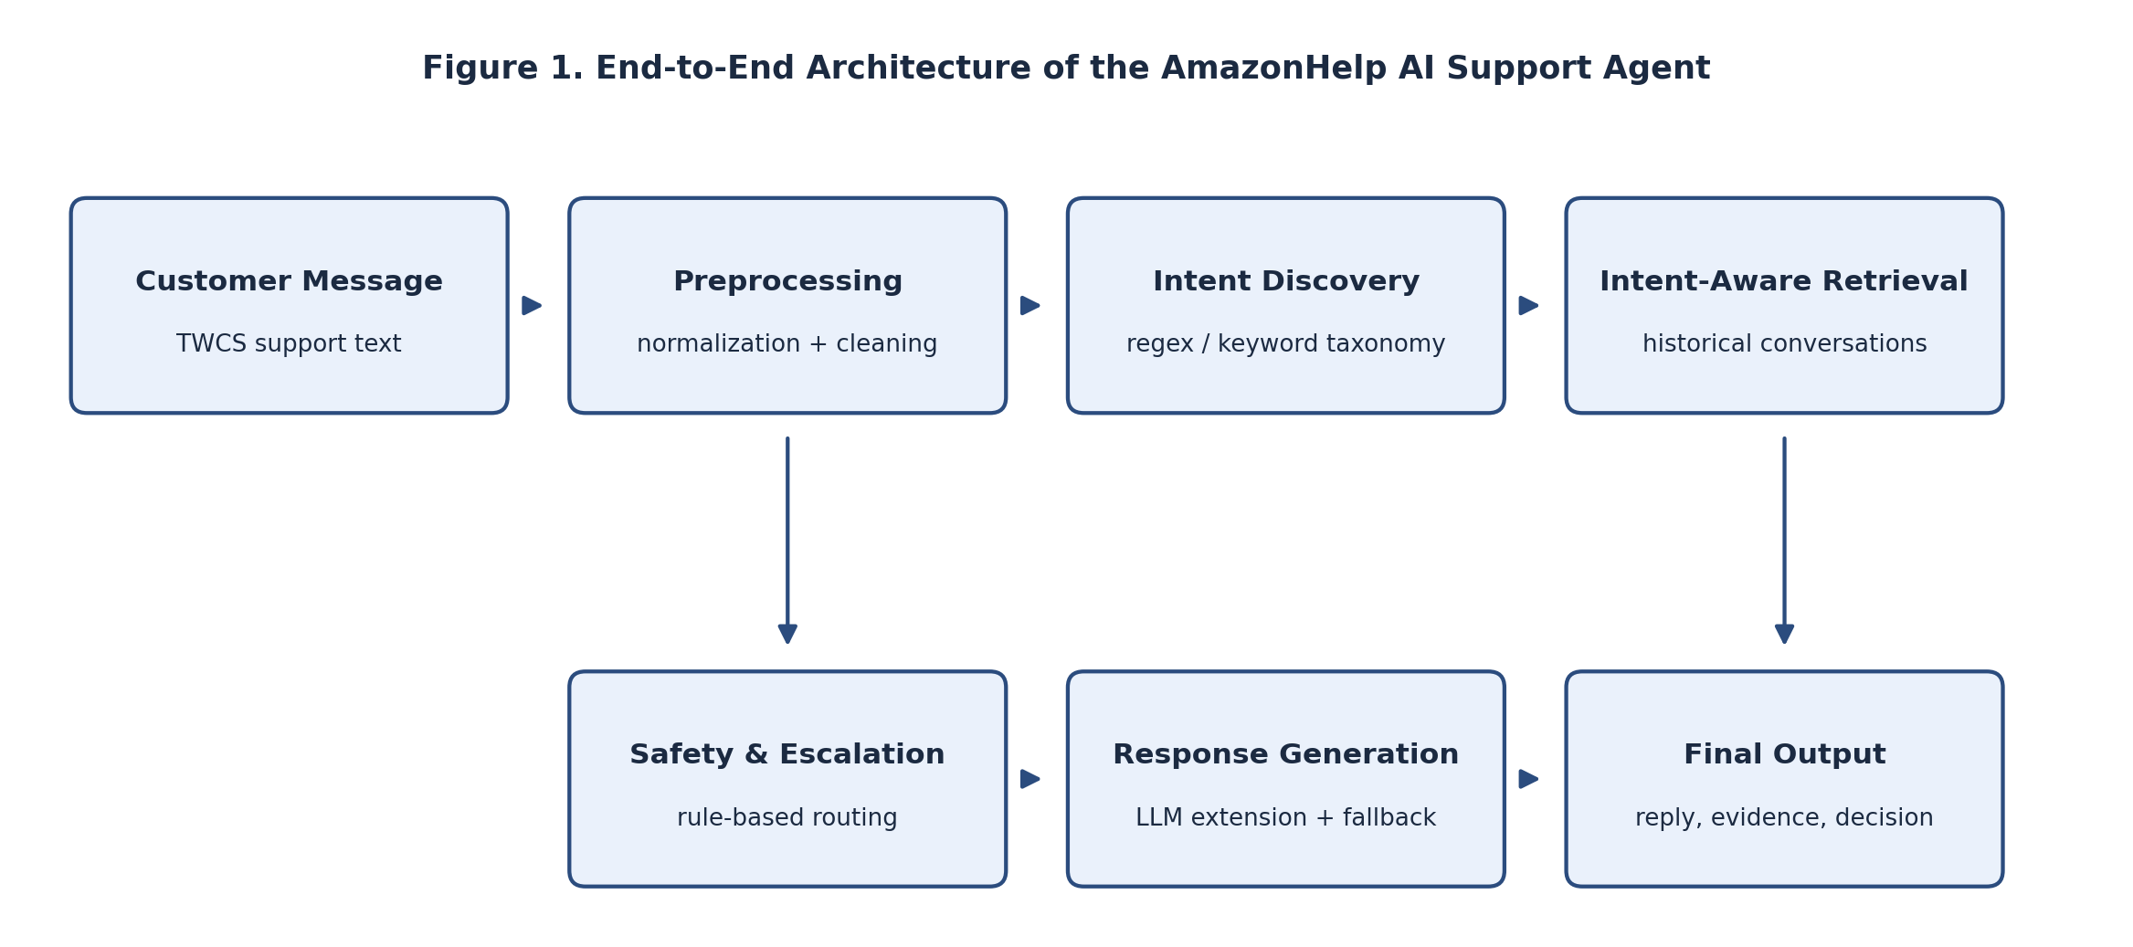
Historical AmazonHelp messages are used as evidence; response generation can optionally call an LLM, but deterministic templates remain available whenever the LLM is disabled or unavailable.
Intent discovery is a deterministic regex/keyword baseline rather than a learned embedding model: messages are normalized and assigned exactly one intent using a strict priority order across a taxonomy of missing or lost packages, delivery delays, wrong or damaged items, returns and refunds, payment and billing, account and security, Prime and subscriptions, digital services, seller issues, app or website problems, customer-service complaints, orders, and Other/Unclear. This design is simple and easy to audit line-by-line, at the cost of sensitivity to wording, class imbalance, sarcasm, unseen vocabulary, and multi-intent messages — trade-offs revisited directly in the failure analysis below.

1. Problem Framing
What “good” means for this brand
AmazonHelp cannot execute refunds, cancellations, or account changes through a bot, and its customers arrive with short, informal, often multi-issue tweets. Given that, “good” for this agent is defined as: (1) correctly separating messages into a small set of actionable intents instead of one catch-all bucket; (2) grounding every reply in a real historical AmazonHelp resolution rather than a plausible-sounding guess; (3) refusing to promise anything the system cannot verify — order status, refund approval, or account changes — and (4) escalating to a human whenever confidence is low or the message contains risk signals (fraud, stolen items, account compromise), rather than auto-handling and hoping. In short: fewer wrong answers matter more than more auto-handled tickets, because the downside of a confidently wrong brand reply on a public support channel is asymmetric to the upside of shaving a few seconds off resolution time.
This definition also shapes what counts as a false positive versus a false negative for this system. A false negative — escalating a message the agent could safely have handled — costs a human a few extra minutes of routine triage. A false positive — auto-handling a message that needed a human, especially one involving fraud or a factual promise the system can't back up — risks real customer harm and reputational damage. The escalation thresholds throughout the pipeline are set with that asymmetry in mind, not to maximize the raw auto-handle rate.
What was intentionally not built
- Live Twitter/X integration or real-time social-media ingestion — the prototype runs offline against the static TWCS export.
- Any write access to Amazon’s order-management, payment, refund, cancellation, or account systems — the agent is read-only and advisory, never autonomous.
- Guaranteed multi-turn conversational memory across a full thread beyond what's needed for evidence retrieval.
- A learned/embedding intent classifier — the first pass uses a deterministic regex/keyword taxonomy, chosen for inspectability over recall.
- Any final accuracy claim based only on heuristic labels — the evaluation harness is deliberately blocked until a human-reviewed Gold Set exists.
- Production-scale infrastructure: no cloud deployment, autoscaling, or monitoring stack — out of scope for a one-week prototype and a distraction from the core classification/retrieval/escalation problem.

2. Results vs. Two Baselines
Two baselines bound the problem before the intent-aware system is judged against them, so the comparison isn't just the system against itself.
- Baseline A — trivial (escalate everything): every message is forwarded to a human with no classification or reply. By construction this has 0% automation and 0% unsupported-claim risk — it is the safety floor the real system must beat without regressing on safety.
- Baseline B — simple (keyword intent + generic template, no retrieval): the same regex/keyword taxonomy picks an intent, but the reply is a fixed template for that intent with no historical evidence behind it. By construction this auto-handles close to 100% of traffic but with 0% evidence grounding, so its real-world unsupported-claim rate is unmeasured and unbounded — it is fast but unsafe.
- Current system — intent-aware retrieval + rule-based escalation: measured on the 250-record provisional Silver Set below.
Approach | Automation rate | Evidence grounding | Unsupported-claim risk
Baseline A — escalate all | 0% (by design) | n/a (no reply generated) | None — no reply is produced
Baseline B — keyword + generic reply | ~100% (by design) | 0% (no retrieval) | Unmeasured / unbounded
Current — intent-aware retrieval + escalation rules | 56% auto-handled (141/250) | 100% evidence found; 0.908 grounded-response rate | 0.000 on the provisional Silver Set

Baselines A and B are defined by construction, not separately re-run on the dataset; their rates follow directly from what each design can and cannot do — there is no code path in either baseline that could produce a different number. Only the current system's numbers are measured, and even those come from heuristic labels pending human review (Section 4 covers this in detail). The honest reading is directional, not a leaderboard: the current system trades some of Baseline A's safety for automation, while avoiding Baseline B's ungrounded-reply risk by construction — not that it has been proven “accurate” against real customer outcomes.
A secondary way to read the same table: automation rate and unsupported-claim risk move in opposite directions as you go from A to B to the current system's intended design. Baseline A is maximally safe and minimally useful; Baseline B is maximally useful and minimally safe; the current system tries to sit closer to A on risk while capturing more of B's automation — the escalation count (109 of 250) is effectively the price paid for that safety margin.

3. Failure Analysis — Top 5 Failure Modes
These five failure modes are ordered roughly by how often the underlying pattern is expected to occur in TWCS-style traffic, based on the taxonomy's own documented blind spots, not by a ranked count from human-reviewed labels (which don't exist yet).
# | Failure mode | Illustrative example | Hypothesis
1 | Ambiguous or short messages | “@AmazonHelp still nothing??” | No keyword matches any intent, so it falls into Other/Unclear and gets escalated even when it is likely a delivery follow-up.
2 | Overuse of Other/Unclear | “@AmazonHelp your app keeps crashing when I check my order” | Keywords for two intents (app, order) collide; the strict priority order picks one or neither, defaulting to Other/Unclear.
3 | Multi-intent messages | “@AmazonHelp charged twice AND item never arrived” | The single-label taxonomy keeps only the first-matched intent (billing), so the reply silently drops the delivery complaint.
4 | Sensitive wording missed | “@AmazonHelp someone used my saved card without permission” | If the phrasing doesn’t match the fraud/account-compromise keyword list exactly, the safety override may not fire and a risk case gets auto-handled instead of forced to a human.
5 | Irrelevant retrieval | A delivery-delay tweet retrieves evidence from an unrelated wrong-item complaint | Lexical similarity conflates messages that merely share common words (“package,” “order”) rather than topic, so the retrieved evidence can misdirect the drafted reply.
Note: examples above are representative of the message patterns the taxonomy is known to struggle with (per the repository’s own failure-mode notes), not a verbatim log from a specific run — that log will come from the human-reviewed Gold Set.
Modes 1 and 2 share a root cause — a strict, single-pass keyword match with no fallback reasoning step — so fixing the Other/Unclear bucket (Section 5) is likely to improve both at once. Modes 3 and 4 share a different root cause: the taxonomy assumes one intent and one risk level per message, which breaks down exactly when a message is most worth getting right. Mode 5 is orthogonal to the other four; it's a property of lexical retrieval rather than the intent taxonomy, which is why it's called out separately as the clearest candidate for a semantic-retrieval upgrade.

4. What Is Misleading About My Headline Number
The most quotable numbers from this project — a 1.000 evidence-found rate and a 0.908 grounded-response rate — sound like accuracy, but they are not. Both are computed against the 250-record Silver Set, and that set's labels were generated by the same heuristic rules the system uses to classify intent in the first place. A high match rate on heuristic labels mostly proves the retrieval step is internally consistent with its own labeling rule, not that the underlying intent or reply is correct for the customer. The report and evaluation harness treat this explicitly as diagnostic: final accuracy is intentionally blocked until data/golden_set.csv contains human-reviewed labels.
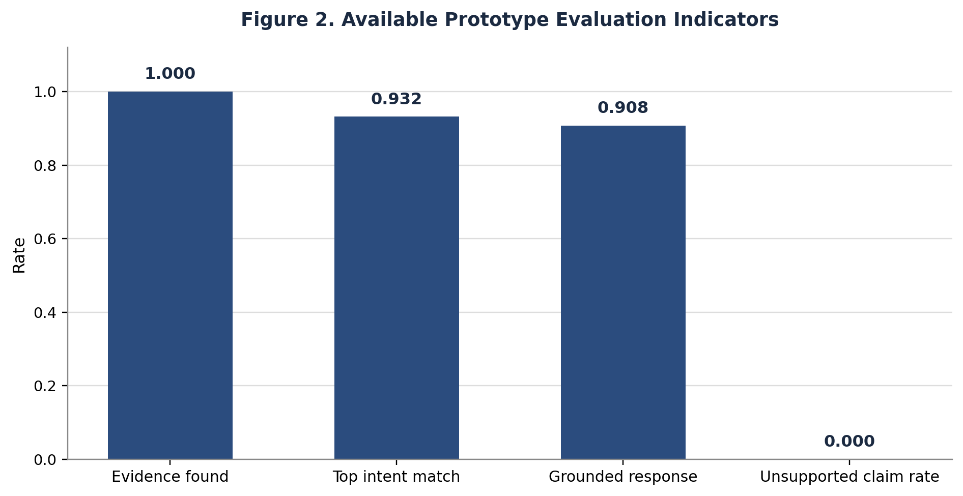
Diagnostic indicators from the provisional Silver Set — not independent accuracy estimates.
Two other numbers are especially easy to over-read. The 0.000 unsupported-claim rate looks like a safety guarantee, but it only reflects cases the deterministic fallback template caught — it says nothing about replies an enabled LLM extension might generate on unseen phrasing that the heuristic labels never exercised. And the 56% auto-handle rate (141 of 250) is a design choice encoded in the escalation thresholds, not a measured success rate; tightening or loosening those thresholds would move that number without changing whether any individual reply was actually correct.
The safest way to state the current results, and the one used throughout this report, is: the evaluation infrastructure is implemented and produces sensible diagnostic signals on a provisional set, while the accuracy, safety, and generalization claims that would justify wider trust are still pending human-reviewed labels. Any number in this report that isn't qualified that way should be treated with the same skepticism.

5. Decision Log
A plain list of the non-obvious calls made while building this, and why.
- Used a deterministic regex/keyword intent layer instead of a learned classifier on the first pass, trading recall for inspectability.
- Enforced a strict single-label priority order rather than multi-label classification, accepting under-coverage on multi-intent messages for a simpler, debuggable decision path.
- Made the LLM response generator optional and gated behind an API-key check, so the pipeline runs end-to-end with zero external dependencies.
- Built intent-aware retrieval as a second stage layered on top of a plain lexical-retrieval baseline instead of replacing it, so the improvement's effect stays visible and comparable in code.
- Defined “grounded response” as requiring at least one retrieved evidence match, not merely a non-empty reply — a confident but unsupported answer does not count as grounded.
- Biased the system toward escalation by default for low-confidence or unsupported cases, rather than defaulting to auto-handle.
- Implemented sensitive-wording overrides (stolen items, account compromise, fraud) as a separate deterministic layer that can force escalation regardless of the discovered intent.
- Generated the 250-record Silver Set with heuristic labels rather than skipping evaluation entirely while waiting for human review, but labeled it “provisional” everywhere it appears.
- Deliberately blocked the evaluation harness from producing a final accuracy claim until data/golden_set.csv contains human-reviewed labels, even though that means this report cannot state a validated accuracy number.
- Excluded any code path capable of executing a refund, cancellation, or account change, keeping the system strictly read-only/advisory.
- Kept the raw TWCS dataset out of version control and expected it to be supplied locally, to avoid redistributing a third-party dataset.
- Wrote automated tests per pipeline stage (retrieval, intent discovery, response generation, escalation, annotation helpers) rather than only an end-to-end test, so failures are localized to one stage.
- Reported multiple diagnostic indicators (evidence-found rate, grounded-response rate, escalation count, etc.) instead of a single headline accuracy figure, specifically to reduce the temptation to over-claim from provisional labels.

Conclusion
The AmazonHelp AI Support Agent demonstrates a complete, inspectable workflow for assisted customer support: intent discovery, historical evidence retrieval, grounded response drafting, and safety-aware escalation, built and tested end-to-end on real TWCS conversations. Measured against the two baselines in Section 2, it captures meaningfully more automation than always escalating while avoiding the unbounded reply risk of an ungrounded keyword-and-template system — but that comparison is directional, not a validated accuracy result.
Its strongest contribution is not a headline number but the discipline around one: the evaluation harness is deliberately blocked from claiming final accuracy until the Gold Set is human-reviewed, every diagnostic figure is labeled provisional, and the system is built to escalate rather than guess whenever it is unsure. The clearest next step, and the one that unlocks everything else, is finishing that human review so the diagnostic signals in this report can be replaced with real accuracy, precision, and recall numbers.
GitHub Repository: https://github.com/Chharlatha23/hiver-ai-customer-support-agent

